**Pos Tagger**

Name: Mustafa Ahmad Al-Hunaiti

ID: 31909304005

**GUI:**

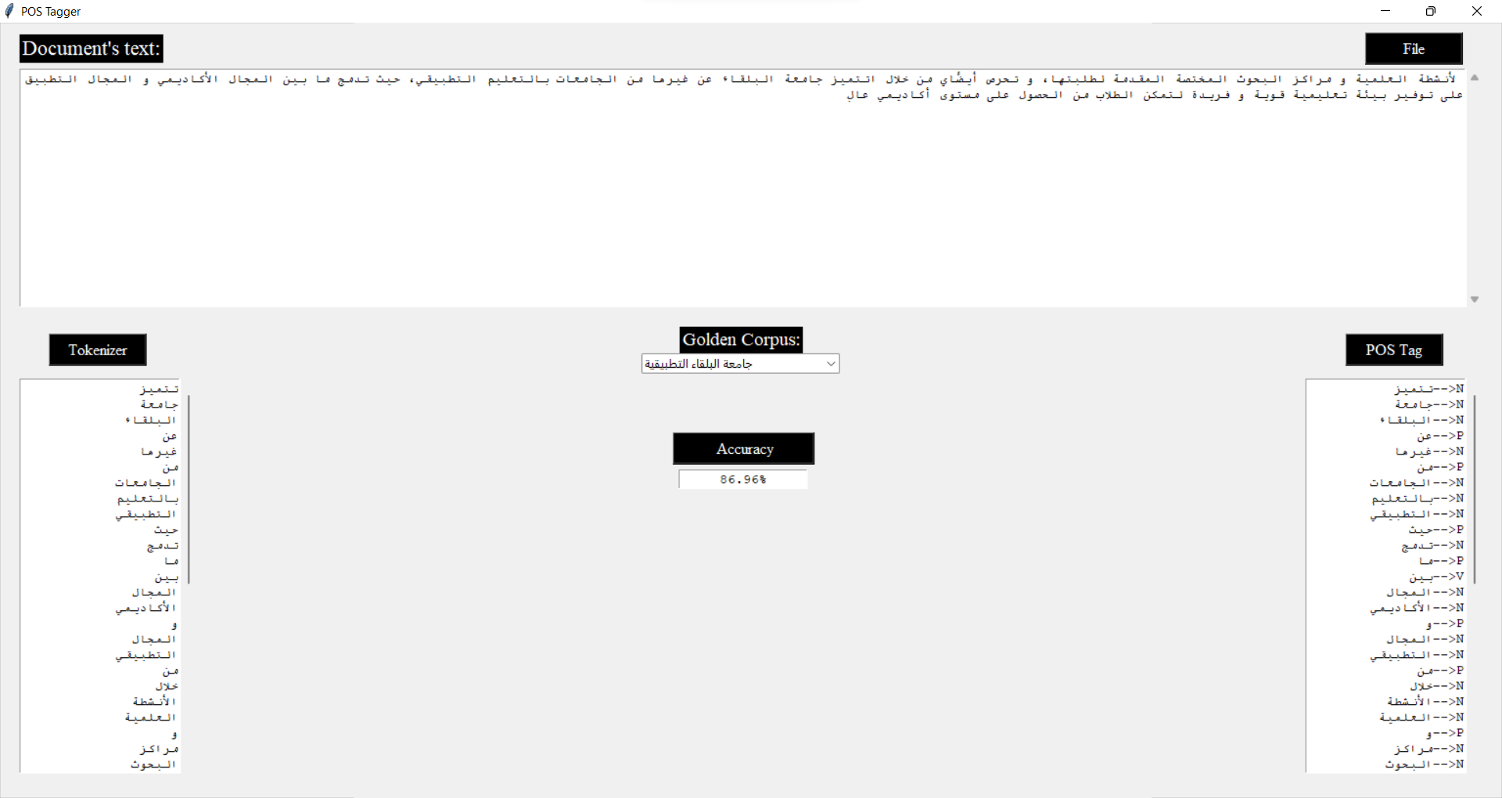

**Code:**

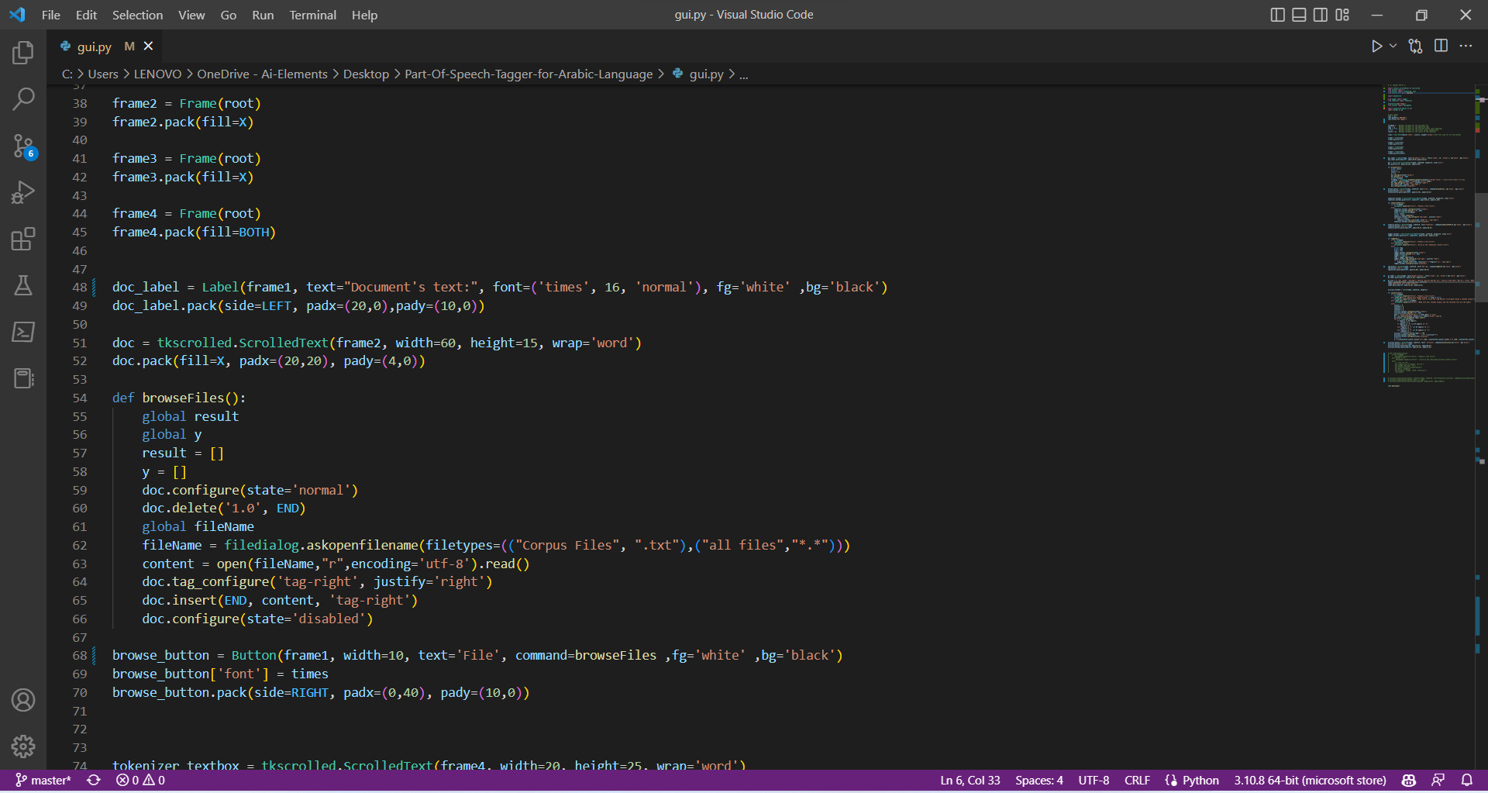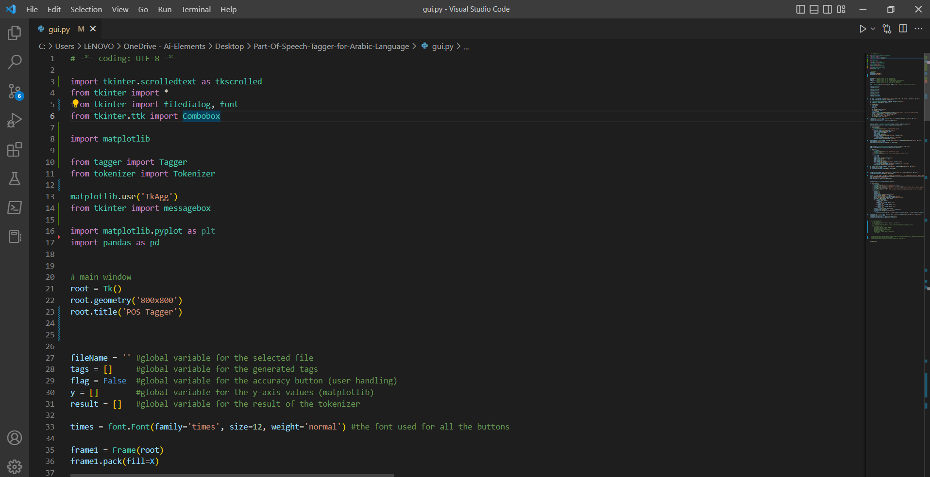

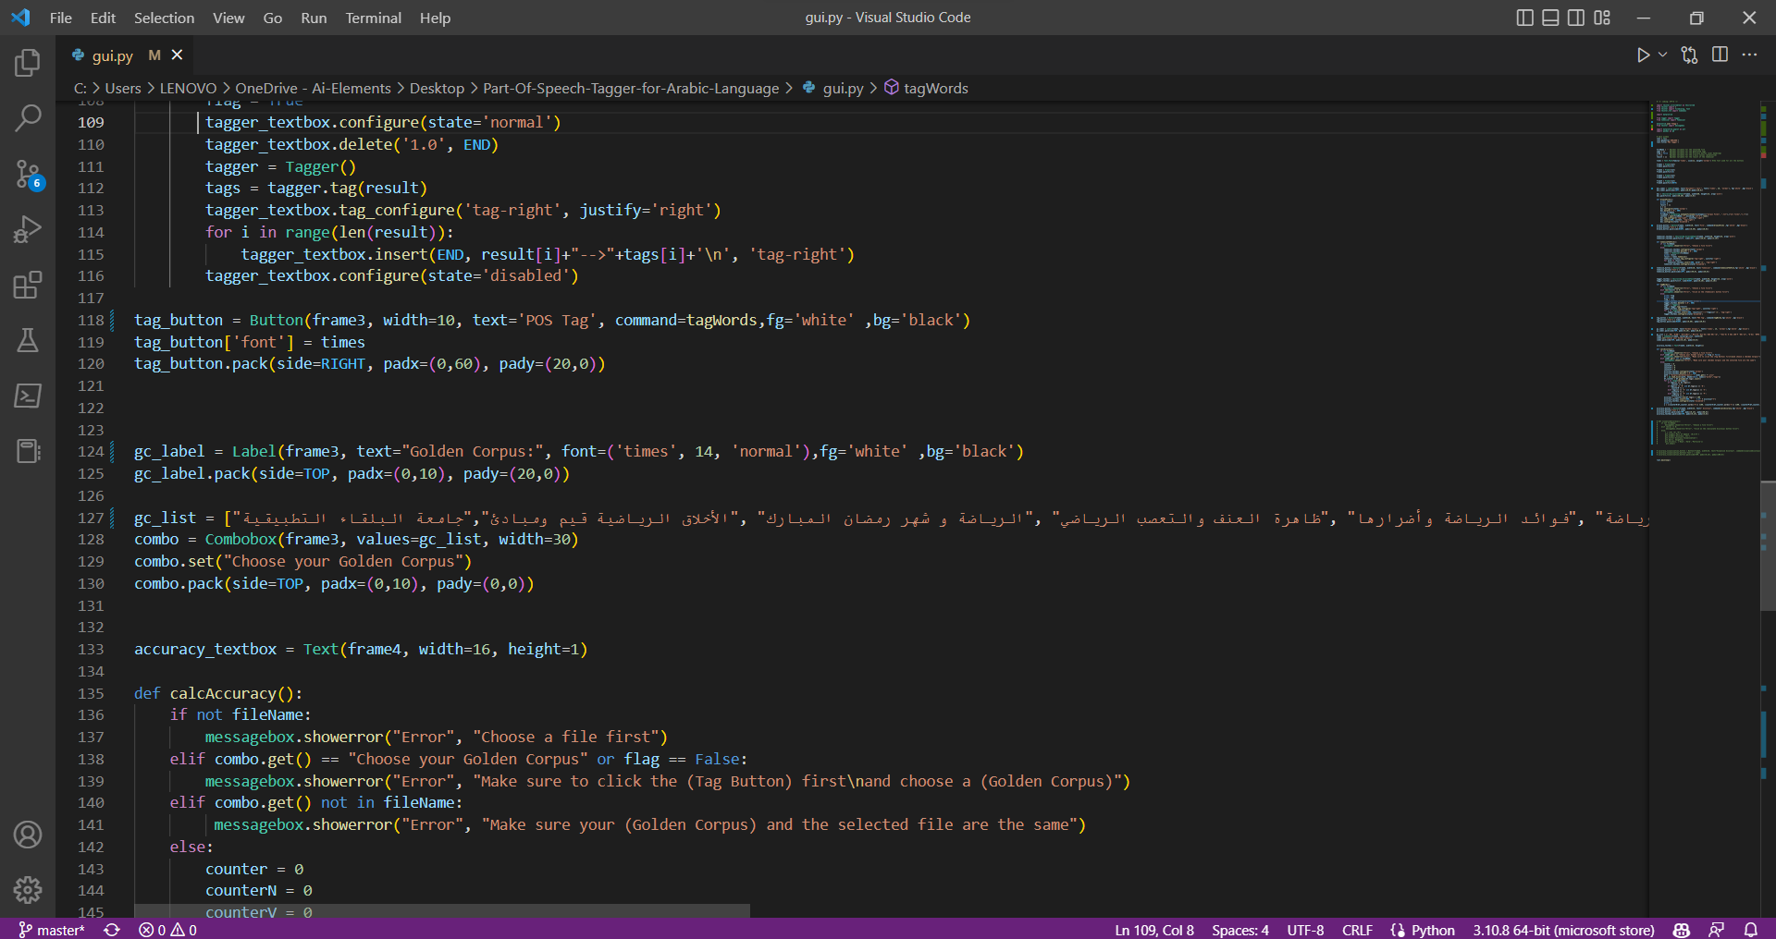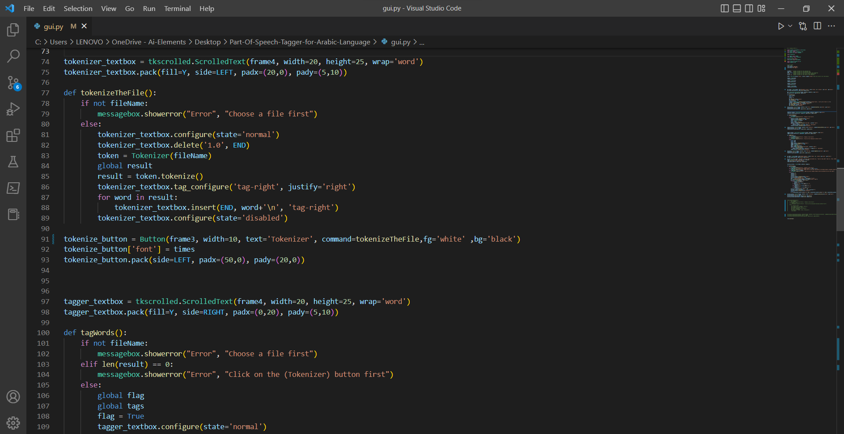

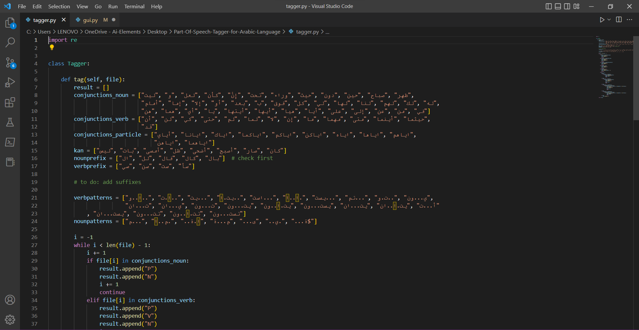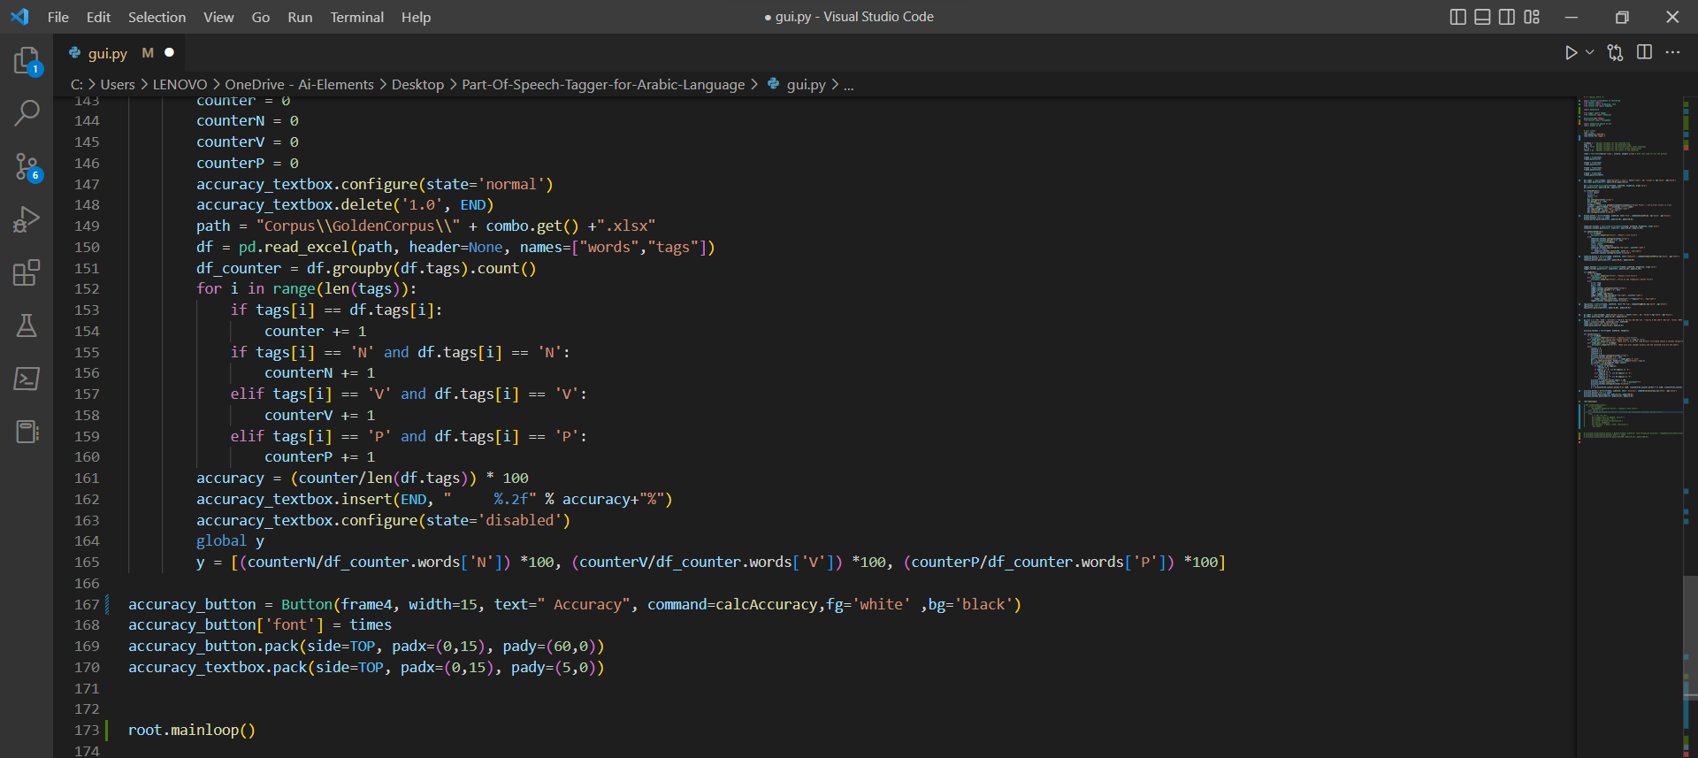

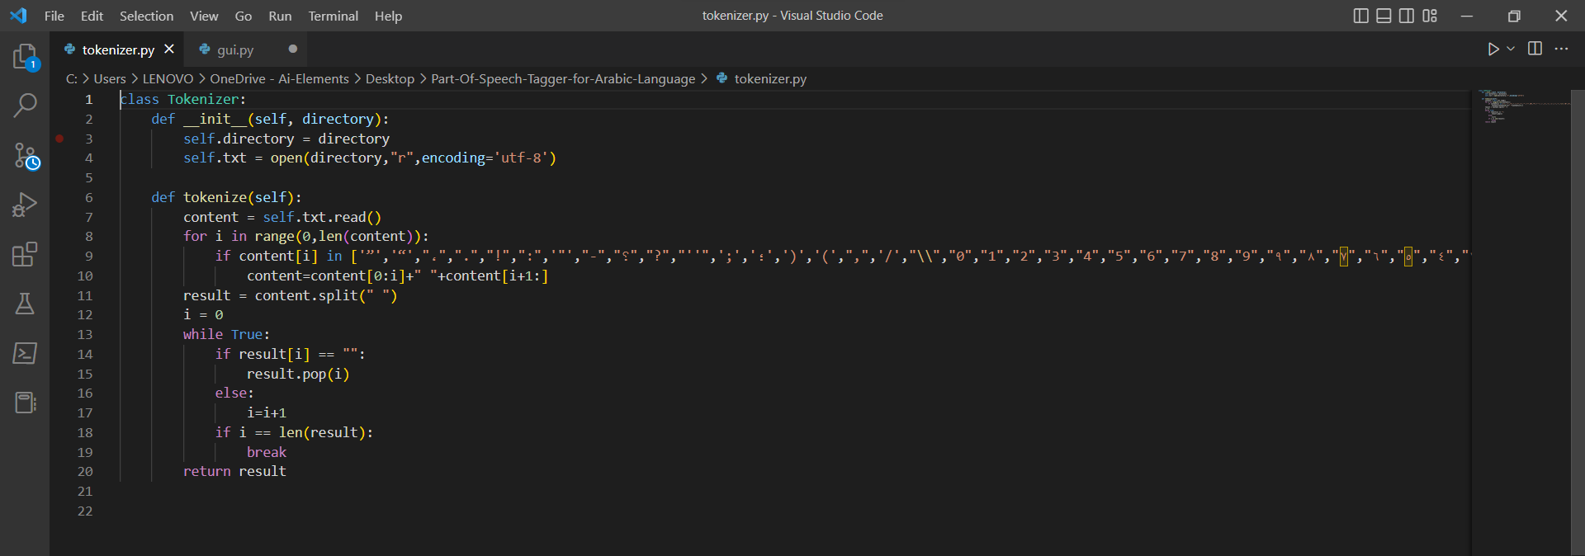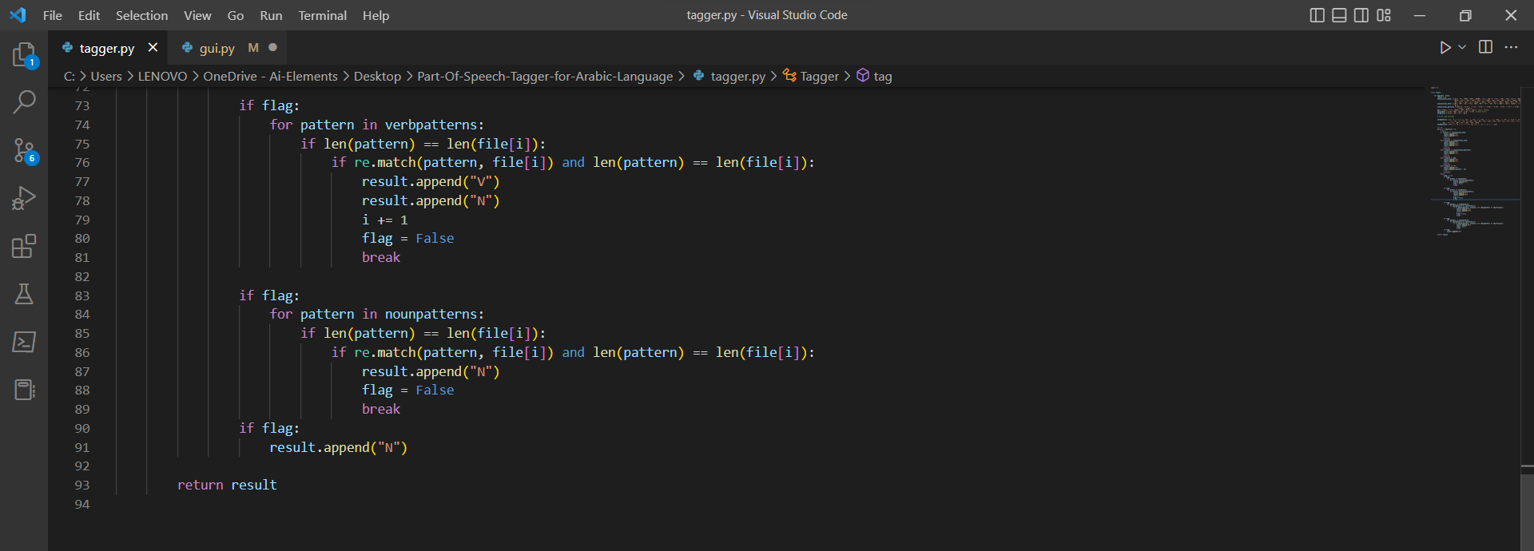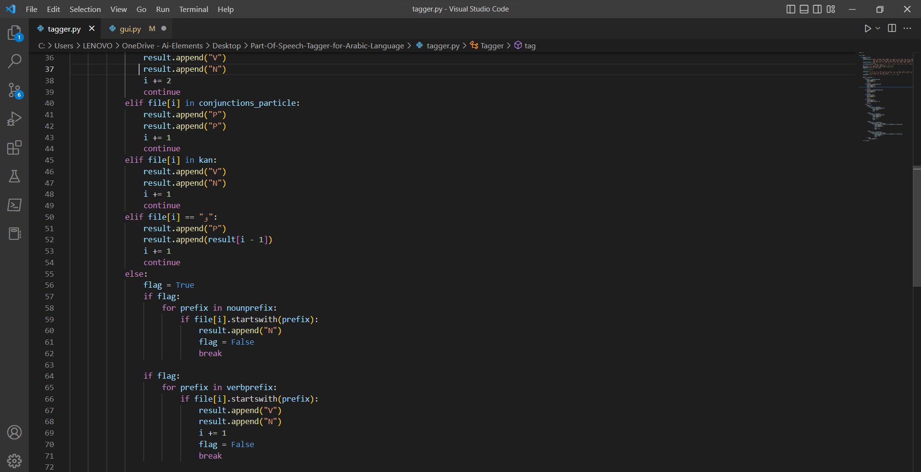

One of the most important things in natural language processing (NLP) is part-of-speech (POS) tagging. For numerous languages, there exist efficient POS taggers. Because modern standard Arabic (MSA) is the dialect used in formal textbooks and the news, we attempted to create a POS tagger for the Arabic language.

I adopted the hybrid strategy, which combines the strengths of the rule-based and pattern-based techniques. First, the rule-based approach checks the word to see if any of the rules apply, and if not, the pattern-based approach looks for any patterns that match the word pattern.

1. **Rule Based Approach:** This was our primary strategy because it was more dependable and effective than the Pattern Based Approach. There are some sets of rules that can define what the tag for this word is and what the tag for the next word is, and these rules work in the majority of Arabic sentences.
2. **Pattern approach:** Because the Arabic language has a large number of patterns, we employed it as a complementary technique to the Rule Based approach to achieve improved accuracy.

**Rule based:** the following rules are implemented with the same order as its listed

Conjunctions that are followed by a noun like: ليت, لعل, من, الى, على, في, حيث, …etc.

Conjunctions that are followed by a verb like: ان, لن, كي, حتى, مهما, … etc.

Conjunctions that are followed by a Conjunction like: اياك, اياكم, اياهم, …etc.

Kan verbs followed by a noun like: كان, ليس, امسى, ظل, etc.

Words with prefixes that tag it as a noun like: ال, لل, فال, كال, بال.

Words with prefixes that tag it as a verb like: سي, سن, ست, سأ.

Any verb will be followed by a noun like: قال محمد, ذهب الرجل, …etc.

The particle و the tag for the word before it is the same as the word after it like: محمد و

علي , يأكل و يشرب , …etc.

**Patterns:**

Patterns that will tag the word as a verb: يفعلون, تفوعل, يستفعل, افعال, استفعل, يتفاعل, يتفعل, افتعل, افعوعل, يتفاعلان,

يتفعلان , يستفعلون , يتفاعلون , يتفعلون , تفعلون , يفعلان , تفعلان , تستفعلون , تتفاعلون , يستفعلان , تمفعل .

noun patterns: مفعول, مفعل, مفعال, مفاعلة, مفعلة, فعلى, فعيل, فعلة.