# Deployment Architecture

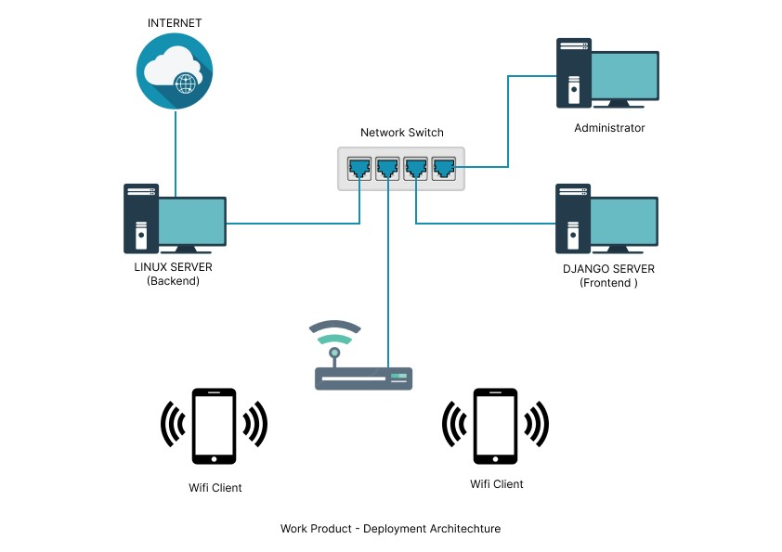

Deployment architecture refers to the structure and arrangement of components and resources that make up a system or application when it is deployed for use. It outlines how various hardware and software elements interact and work together to ensure the application's functionality, reliability, scalability, and security. The deployment architecture is crucial as it determines how the system operates and how users can access and utilize it. Below the deployment architecture of High-Speed Network Traffic Analyzer consists of the following components:

**Internet:** The primary source of internet connectivity for the entire deployment. It connects to the Linux Server to provide internet access to the organization.

**Linux Server (Backend):** This server acts as the backbone of the deployment architecture. It serves multiple purposes:

* Internet Gateway: It receives the internet connection from the Internet provider and distributes it to the rest of the network.
* XDP (eBPF) Program: The Linux Server is equipped with an XDP (eBPF) program, which stands for eXpress Data Path, to capture and analyze network packets. It has the ability to block specific application packets based on IP addresses and URLs that are specified in its rules.
* Network Switch Connectivity: The Linux Server connects to the Network Switch, allowing the creation of a private network within the organization.

**Django Server (Frontend):** This server hosts the frontend of the web application. It provides the graphical user interface and serves as the access point for the Administrator to interact with the application. The Django Server is hosted on the Linux Server and accessible via LAN connection, ensuring secure communication within the organization.

**Network Switch:** The Network Switch acts as a central hub for all the connected devices within the organization. It receives internet connectivity from the Linux Server and distributes it to all the connected devices, including the Wifi Clients (mobile devices) and the Administrator's device.

**Wi-Fi Client (Mobile Device or PC**): These are mobile devices that can connect to the Network Switch via Wi-Fi. The Wi-Fi Clients are provided with internet access through the Linux Server's internet gateway, and they can interact with the Django Server's web application for various functionalities.

**Administrator:** The Administrator is an authorized user who manages and controls the deployed system. They can access the Django Server's web application through a LAN connection, typically through a desktop or laptop computer. The Administrator can utilize the web application to perform various administrative tasks and access the features provided by the Django Server.

This deployment architecture enables the organization to have a secure and controlled network environment. The Linux Server plays a central role by acting as the internet gateway, packet analyzer, and provider of network services. The Django Server provides front-end access to the application for the Administrator, while the Network Switch ensures connectivity and communication among all the connected devices within the organization.

# Bug List

|  |  |  |  |
| --- | --- | --- | --- |
| **S.No.** | **System Page** | **Error Reason** | **Error Generated by System** |
| **1.** | **Login Page** | User does not enter both (Username and Password) or anyone. | Please fill to Proceed! |
| Users enter wrong credentials  (Username and Password) | Invalid Credentials! |
| User enters all fields correctly and then clicks on Login button. Error is received, such as 404 Not Found. | Network error possibility.  Check your internet connection. |
| **2.** | **Advance Filter** | User does not enter date. | Please fill out this field. |
| User does not enter Start time and End time | Please select a start and end time. |
| User enters all fields correctly and then clicks on Login button. Error is received, such as 404 Not Found. | Network error possibility.  Check your internet connection. |
| **3.** | **Top N Conversation** | User does not enter date. | Please fill out this field. |
| User does not enter Start time and End time | Please select a start and end time. |
| User enters all fields correctly and then clicks on Login button. Error is received, such as 404 Not Found. | Network error possibility.  Check your internet connection. |
| **4.** | **Protocol Filter** | User does not enter date. | Please fill out this field. |
| User does not enter Start time and End time | Please select a start and end time. |
| User enters all fields correctly and then clicks on Login button. Error is received, such as 404 Not Found. | Network error possibility.  Check your internet connection. |
| **5.** | **Home page** | User generates the report before capturing and analyzing the packets. | A black report will be generated. |
| User enters all fields correctly and then clicks on Login button. Error is received, such as 404 Not Found. | Network error possibility.  Check your internet connection. |
| **6.** | **Dropped packets** | Error is received, such as 404 Not Found. | Network error possibility.  Check your internet connection. |

|  |  |  |  |  |  |
| --- | --- | --- | --- | --- | --- |
| S.No | **System** | Bug Occured | Severity | Status | Description |
| 1 | Environment Scanning | On continuous scanning the application generates buggy planes in AR Environment. The longer the program runs the more planes it adds above the existing planes. | Low | In Progress |  |
| 2 | UI Glitch in AR Marker Detection |  |  |  |  |
| 3 | Inconsistent Image Tracking |  |  |  |  |
| 4 |  |  |  |  |  |
| 5 |  |  |  |  |  |
| 6 |  |  |  |  |  |
| 7 |  |  |  |  |  |

**SE03**

Bug Title: Environment Scanning

Bug ID: AR-001

Severity: Low

Status: Open

Description: On continuous scanning the application generates buggy planes in AR Environment. The longer the program runs the more planes it adds above the existing planes. This can be fixed by moving around the environment.

Bug Title: UI Glitch in AR Marker Detection

Bug ID: AR-002

Severity: Medium

Status: In Progress

Description: When identifying AR markers, the AR application displays a UI bug. The marker detection overlay rapidly flickers when the camera detects a marker, making it difficult for the user to focus on the associated AR content and generating visual discomfort.

Bug Title: Inconsistent Image Tracking

Bug ID: AR-003

Severity: High

Status: In Progress

Description: The image tracking functionality in the AR application works inconsistently for different models. While some tracked images work well and reliably display associated AR content, others fail to trigger any content or exhibit erratic behavior when tracked.

Bug Title: Crash of Application on changing of venue

Bug ID: AR-004

Severity: High

Status: In Progress

Description: The AR application crashes when the user changes the venue while an AR scene is active. This issue occurs across different devices and OS versions.

Bug Title: Crash of Application on change of venue

Bug ID: AR-004

Severity: High

Status: In Progress

Description: The AR application crashes when the user changes the venue while an AR scene is active. This issue occurs across different devices and OS versions.

Bug Title: Incorrect Scroll Position on Model Load

Bug ID: AR-005

Severity: Low

Status: Open

Description: When models are loaded in the application, the scroll bar that contains the models moves to the very left, even when there are models present on the right side. This issue causes inconvenience to users as they need to manually scroll back to the right to access the loaded models.