**Product Requirement Document**

*Project title: Pinnacle Technological Improvement Phase 1 – Online Portal Development*

*Creation date: 23 Oct*

*Created by: Ying Gao*

*Version 5.0 Final*

# Introduction

This 5th version of PRD recorded some testing results before the official launch of the portal.

# Client Portal Testing Result

**Signup**

* Risk 1: Hyperlink is not effective.

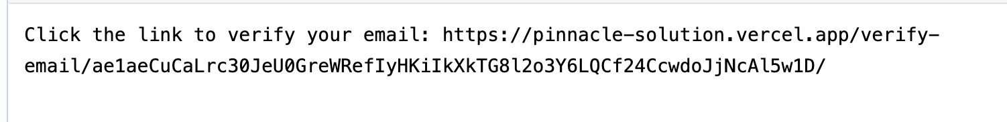

* Requirement 1: Make the Hyperlink effective and clickable.

**Apply Process**

* Risk 2: Unclear warning when inputting incorrect format of ‘Amount Required’.

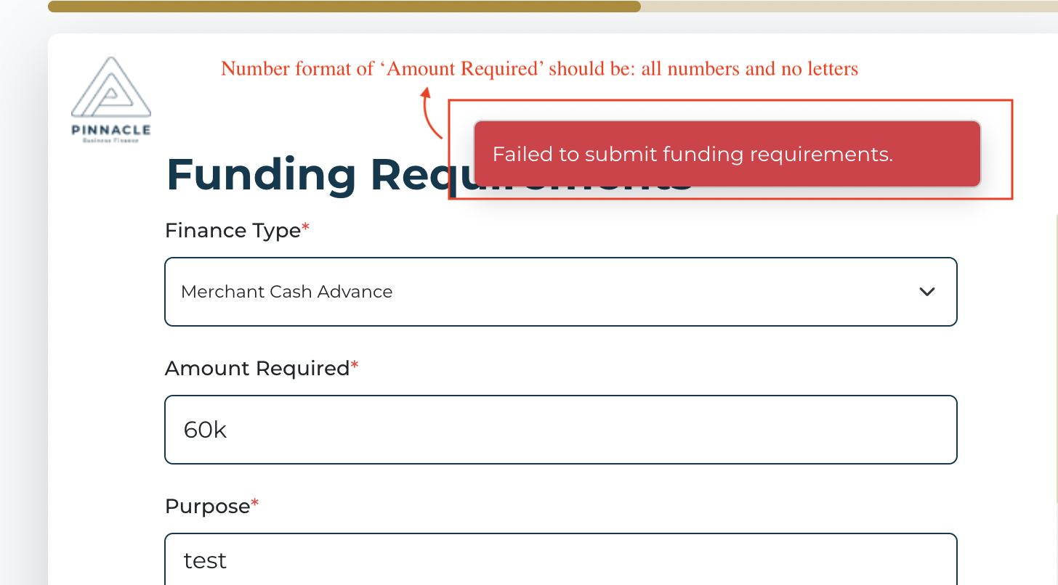

* Requirement 2: Change the warning into: “The number format of ‘Amount Required’ should be: all numbers and no letters.”
* Risk 3: Invalid referral. After clicking “Send Invite”, the invite was NOT sent to the corresponding email.

图形用户界面, 文本

* Requirement 3: make the referral valid.

# Admin Portal Testing Result

* Risk 4: No line chart showing on “Application Insights”.

* Requirement 4: Display line charts here.
* Risk 5: The display of “Amount of Funding” wasn’t modified according to PRD V4.

* Requirement 5: Change the calculation logic into: **Sum up** the **funding amount** of all the **Approved Application**
* Risk 6: Invalid referral. Invite was NOT sent.

* Requirement 6: make the referral valid.