**.prop()**

Get the value of a property for the first element in the set of matched elements or set one or more properties for every matched element

Display the checked property and attribute of a checkbox as it changes.

**<!doctype html>**

<html lang="en">

<head>

<meta charset="utf-8">

<title>prop demo</title>

<style>

p {

margin: 20px 0 0;

}

b {

color: blue;

}

</style>

<script src="https://code.jquery.com/jquery-1.10.2.js"></script>

</head>

<body>

<input id="check1" type="checkbox" checked="checked">

<label for="check1">Check me</label>

<p></p>

<script>

$( "input" ).change(**function**() {

**var** $input = $( **this** );

$( "p" ).html(

".attr( \"checked\" ): <b>" + $input.attr( "checked" ) + "</b><br>" +

".prop( \"checked\" ): <b>" + $input.prop( "checked" ) + "</b><br>" +

".is( \":checked\" ): <b>" + $input.is( ":checked" ) ) + "</b>";

}).change();

</script>

</body>

</html>

 Check me

.attr( "checked" ): **checked**  
.prop( "checked" ): **true**  
.is( ":checked" ): **true**

Disable all checkboxes on the page.

**!doctype html>**

<html lang="en">

<head>

<meta charset="utf-8">

<title>prop demo</title>

<style>

img {

padding: 10px;

}

div {

color: red;

font-size: 24px;

}

</style>

<script src="https://code.jquery.com/jquery-1.10.2.js"></script>

</head>

<body>

<input type="checkbox" checked="checked">

<input type="checkbox">

<input type="checkbox">

<input type="checkbox" checked="checked">

<script>

$( "input[type='checkbox']" ).prop({

disabled: true

});

</script>

</body>

</html>

   

# .remove()

*Remove the set of matched elements from the DOM.*

Removes all paragraphs from the DOM

**<!doctype html>**

<html lang="en">

<head>

<meta charset="utf-8">

<title>remove demo</title>

<style>

p {

background: yellow;

margin: 6px 0;

}

</style>

<script src="https://code.jquery.com/jquery-1.10.2.js"></script>

</head>

<body>

<p>Hello</p>

how are

<p>you?</p>

<button>Call remove() on paragraphs</button>

<script>

$( "button" ).click(**function**() {

$( "p" ).remove();

});

</script>

</body>

</html>

Hello

how are

you?

Call remove() on paragraphs

Removes all paragraphs that contain "Hello" from the DOM. Analogous to doing $("p").filter(":contains('Hello')").remove().

**<!doctype html>**

<html lang="en">

<head>

<meta charset="utf-8">

<title>remove demo</title>

<style>

p {

background: yellow;

margin: 6px 0;

}

</style>

<script src="https://code.jquery.com/jquery-1.10.2.js"></script>

</head>

<body>

<p class="hello">Hello</p>

how are

<p>you?</p>

<button>Call remove( ":contains('Hello')" ) on paragraphs</button>

<script>

$( "button" ).click(**function**() {

$( "p" ).remove( ":contains('Hello')" );

});

</script>

</body>

</html>

Hello

how are

you?

Call remove( ":contains('Hello')" ) on paragraphs

# .removeAttr()

*Remove an attribute from each element in the set of matched elements.*

Clicking the button changes the title of the input next to it. Move the mouse pointer over the text input to see the effect of adding and removing the title attribute.

**<!doctype html>**

<html lang="en">

<head>

<meta charset="utf-8">

<title>removeAttr demo</title>

<script src="https://code.jquery.com/jquery-1.10.2.js"></script>

</head>

<body>

<button>Change title</button>

<input type="text" title="hello there">

<div id="log"></div>

<script>

(**function**() {

**var** inputTitle = $( "input" ).attr( "title" );

$( "button" ).click(**function**() {

**var** input = $( **this** ).next();

**if** ( input.attr( "title" ) === inputTitle ) {

input.removeAttr( "title" )

} **else** {

input.attr( "title", inputTitle );

}

$( "#log" ).html( "input title is now " + input.attr( "title" ) );

});

})();

</script>

</body>

</html>

Change title 

# .removeClass()

*Remove a single class, multiple classes, or all classes from each element in the set of matched elements.*

Remove the class 'blue' from the matched elements.

**<!doctype html>**

<html lang="en">

<head>

<meta charset="utf-8">

<title>removeClass demo</title>

<style>

p {

margin: 4px;

font-size: 16px;

font-weight: bolder;

}

**.blue** {

color: blue;

}

**.under** {

text-decoration: underline;

}

**.highlight** {

background: yellow;

}

</style>

<script src="https://code.jquery.com/jquery-1.10.2.js"></script>

</head>

<body>

<p class="blue under">Hello</p>

<p class="blue under highlight">and</p>

<p class="blue under">then</p>

<p class="blue under">Goodbye</p>

<script>

$( "p:even" ).removeClass( "blue" );

</script>

</body>

</html>

**Hello**

**and**

**then**

**Goodbye**

Remove the class 'blue' and 'under' from the matched elements.

**<!doctype html>**

<html lang="en">

<head>

<meta charset="utf-8">

<title>removeClass demo</title>

<style>

p {

margin: 4px;

font-size: 16px;

font-weight: bolder;

}

**.blue** {

color: blue;

}

**.under** {

text-decoration: underline;

}

**.highlight** {

background: yellow;

}

</style>

<script src="https://code.jquery.com/jquery-1.10.2.js"></script>

</head>

<body>

<p class="blue under">Hello</p>

<p class="blue under highlight">and</p>

<p class="blue under">then</p>

<p class="blue under">Goodbye</p>

<script>

$( "p:odd" ).removeClass( "blue under" );

</script>

</body>

</html>

**Hello**

**and**

**then**

**Goodbye**

Remove all the classes from the matched elements.

**<!doctype html>**

<html lang="en">

<head>

<meta charset="utf-8">

<title>removeClass demo</title>

<style>

p {

margin: 4px;

font-size: 16px;

font-weight: bolder;

}

**.blue** {

color: blue;

}

**.under** {

text-decoration: underline;

}

**.highlight** {

background: yellow;

}

</style>

<script src="https://code.jquery.com/jquery-1.10.2.js"></script>

</head>

<body>

<p class="blue under">Hello</p>

<p class="blue under highlight">and</p>

<p class="blue under">then</p>

<p class="blue under">Goodbye</p>

<script>

$( "p:eq(1)" ).removeClass();

</script>

</body>

</html>

**Hello**

**and**

**then**

**Goodbye**

# .removeProp()

*Remove a property for the set of matched elements*

Set a numeric property on a paragraph and then remove it.

**<!doctype html>**

<html lang="en">

<head>

<meta charset="utf-8">

<title>removeProp demo</title>

<style>

img {

padding: 10px;

}

div {

color: red;

font-size: 24px;

}

</style>

<script src="https://code.jquery.com/jquery-1.10.2.js"></script>

</head>

<body>

<p></p>

<script>

para = $( "p" );

para

.prop( "luggageCode", 1234 )

.append( "The secret luggage code is: ", String( para.prop( "luggageCode" ) ), ". " )

.removeProp( "luggageCode" )

.append( "Now the secret luggage code is: ", String( para.prop( "luggageCode" ) ), ". " );

</script>

</body>

</html>

The secret luggage code is: 1234. Now the secret luggage code is: undefined.

# .replaceAll()

*Replace each target element with the set of matched elements.*

Replace all the paragraphs with bold words.

**<!doctype html>**

<html lang="en">

<head>

<meta charset="utf-8">

<title>replaceAll demo</title>

<script src="https://code.jquery.com/jquery-1.10.2.js"></script>

</head>

<body>

<p>Hello</p>

<p>cruel</p>

<p>World</p>

<script>

$( "<b>Paragraph. </b>" ).replaceAll( "p" );

</script>

</body>

**Paragraph. Paragraph. Paragraph..**

# .replaceWith()

*Replace each element in the set of matched elements with the provided new content and return the set of elements that was removed.*

On click, replace the button with a div containing the same word.

**<!doctype html>**

<html lang="en">

<head>

<meta charset="utf-8">

<title>replaceWith demo</title>

<style>

button {

display: block;

margin: 3px;

color: red;

width: 200px;

}

div {

color: red;

border: 2px solid blue;

width: 200px;

margin: 3px;

text-align: center;

}

</style>

<script src="https://code.jquery.com/jquery-1.10.2.js"></script>

</head>

<body>

<button>First</button>

<button>Second</button>

<button>Third</button>

<script>

$( "button" ).click(**function**() {

$( **this** ).replaceWith( "<div>" + $( **this** ).text() + "</div>" );

});

</script>

</body>

</html>

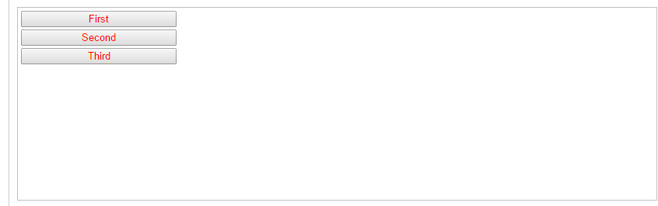

Replace all paragraphs with bold words.

|  |
| --- |
| **<!doctype html>**  <html lang="en">  <head>  <meta charset="utf-8">  <title>replaceWith demo</title>  <script src="https://code.jquery.com/jquery-1.10.2.js"></script>  </head>  <body>    <p>Hello</p>  <p>cruel</p>  <p>World</p>    <script>  $( "p" ).replaceWith( "<b>Paragraph. </b>" );  </script>    </body>  </html> |

#### Demo:

**Paragraph. Paragraph. Paragraph.**

On click, replace each paragraph with a div that is already in the DOM and selected with the $() function. Notice it doesn't clone the object but rather moves it to replace the paragraph.

**<!doctype html>**

<html lang="en">

<head>

<meta charset="utf-8">

<title>replaceWith demo</title>

<style>

div {

border: 2px solid blue;

color: red;

margin: 3px;

}

p {

border: 2px solid red;

color: blue;

margin: 3px;

cursor: pointer;

}

</style>

<script src="https://code.jquery.com/jquery-1.10.2.js"></script>

</head>

<body>

<p>Hello</p>

<p>cruel</p>

<p>World</p>

<div>Replaced!</div>

<script>

$( "p" ).click(**function**() {

$( **this** ).replaceWith( $( "div" ) );

});

</script>

</body>

</html>

Hello

cruel

World

Replaced!

On button click, replace the containing div with its child divs and append the class name of the selected element to the paragraph.

**<!doctype html>**

<html lang="en">

<head>

<meta charset="utf-8">

<title>replaceWith demo</title>

<style>

**.container** {

background-color: #991;

}

**.inner** {

color: #911;

}

</style>

<script src="https://code.jquery.com/jquery-1.10.2.js"></script>

</head>

<body>

<p>

<button>Replace!</button>

</p>

<div class="container">

<div class="inner">Scooby</div>

<div class="inner">Dooby</div>

<div class="inner">Doo</div>

</div>

<script>

$( "button" ).on( "click", **function**() {

**var** $container = $( "div.container" ).replaceWith(**function**() {

**return** $( **this** ).contents();

});

$( "p" ).append( $container.attr( "class" ) );

});

</script>

</body>

</html>

Replace!

Scooby

Dooby

Doo

# .text()

Get the combined text contents of each element in the set of matched elements, including their descendants, or set the text contents of the matched elements

Find the text in the first paragraph (stripping out the html), then set the html of the last paragraph to show it is just text (the red bold is gone).

**<!doctype html>**

<html lang="en">

<head>

<meta charset="utf-8">

<title>text demo</title>

<style>

p {

color: blue;

margin: 8px;

}

b {

color: red;

}

</style>

<script src="https://code.jquery.com/jquery-1.10.2.js"></script>

</head>

<body>

<p><b>Test</b> Paragraph.</p>

<p></p>

<script>

**var** str = $( "p:first" ).text();

$( "p:last" ).html( str );

</script>

</body>

</html>

**Test** Paragraph.

Test Paragraph.

Add text to the paragraph (notice the bold tag is escaped).

|  |
| --- |
| **<!doctype html>**  <html lang="en">  <head>  <meta charset="utf-8">  <title>text demo</title>  <style>  p {  color: blue;  margin: 8px;  }  </style>  <script src="https://code.jquery.com/jquery-1.10.2.js"></script>  </head>  <body>    <p>Test Paragraph.</p>    <script>  $( "p" ).text( "<b>Some</b> new text." );  </script>    </body>  </html> |

#### Demo:

<b>Some</b> new text.

# .toggleClass()

*Add or remove one or more classes from each element in the set of matched elements, depending on either the class's presence or the value of the state argument.*

Toggle the class 'highlight' when a paragraph is clicked.

**<!doctype html>**

<html lang="en">

<head>

<meta charset="utf-8">

<title>toggleClass demo</title>

<style>

p {

margin: 4px;

font-size: 16px;

font-weight: bolder;

cursor: pointer;

}

**.blue** {

color: blue;

}

**.highlight** {

background: yellow;

}

</style>

<script src="https://code.jquery.com/jquery-1.10.2.js"></script>

</head>

<body>

<p class="blue">Click to toggle</p>

<p class="blue highlight">highlight</p>

<p class="blue">on these</p>

<p class="blue">paragraphs</p>

<script>

$( "p" ).click(**function**() {

$( **this** ).toggleClass( "highlight" );

});

</script>

</body>

</html>

**Click to toggle**

**highlight**

**on these**

**paragraphs**

Add the "highlight" class to the clicked paragraph on every third click of that paragraph, remove it every first and second click

**!doctype html>**

<html lang="en">

<head>

<meta charset="utf-8">

<title>toggleClass demo</title>

<style>

p {

margin: 4px;

font-size: 16px;

font-weight: bolder;

cursor: pointer;

}

**.blue** {

color: blue;

}

**.highlight** {

background: red;

}

</style>

<script src="https://code.jquery.com/jquery-1.10.2.js"></script>

</head>

<body>

<p class="blue">Click to toggle (<span>clicks: 0</span>)</p>

<p class="blue highlight">highlight (<span>clicks: 0</span>)</p>

<p class="blue">on these (<span>clicks: 0</span>)</p>

<p class="blue">paragraphs (<span>clicks: 0</span>)</p>

<script>

**var** count = 0;

$( "p" ).each(**function**() {

**var** $thisParagraph = $( **this** );

**var** count = 0;

$thisParagraph.click(**function**() {

count++;

$thisParagraph.find( "span" ).text( "clicks: " + count );

$thisParagraph.toggleClass( "highlight", count % 3 === 0 );

});

});

</script>

</body>

</html>

**Click to toggle (clicks: 0)**

**highlight (clicks: 0)**

**on these (clicks: 0)**

**paragraphs (clicks: 0)**

*Toggle the class name(s) indicated on the buttons for each div.*

**<!doctype html>**

<html lang="en">

<head>

<meta charset="utf-8">

<title>toggleClass demo</title>

<style>

**.wrap** > div {

float: left;

width: 100px;

margin: 1em 1em 0 0;

padding-left: 3px;

border: 1px solid #abc;

}

div**.a** {

background-color: aqua;

}

div**.b** {

background-color: burlywood;

}

div**.c** {

background-color: cornsilk;

}

</style>

<script src="https://code.jquery.com/jquery-1.10.2.js"></script>

</head>

<body>

<div class="buttons">

<button>toggle</button>

<button class="a">toggle a</button>

<button class="a b">toggle a b</button>

<button class="a b c">toggle a b c</button>

<a href="#">reset</a>

</div>

<div class="wrap">

<div></div>

<div class="b"></div>

<div class="a b"></div>

<div class="a c"></div>

</div>

<script>

**var** cls = [ "", "a", "a b", "a b c" ];

**var** divs = $( "div.wrap" ).children();

**var** appendClass = **function**() {

divs.append(**function**() {

**return** "<div>" + ( **this**.className || "none" ) + "</div>";

});

};

appendClass();

$( "button" ).on( "click", **function**() {

**var** tc = **this**.className || undefined;

divs.toggleClass( tc );

appendClass();

});

$( "a" ).on( "click", **function**( event ) {

event.preventDefault();

divs.empty().each(**function**( i ) {

**this**.className = cls[ i ];

});

appendClass();

});

</script>

</body>

</html>

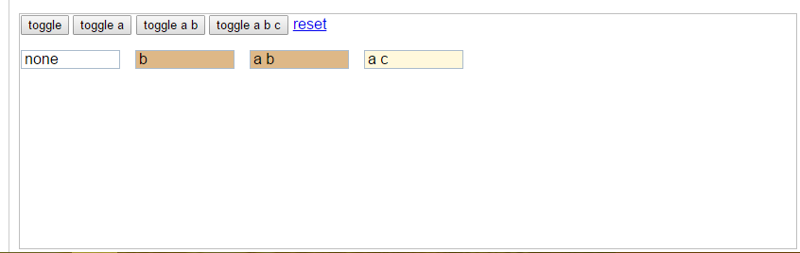

# .val()

Get the current value of the first element in the set of matched elements or set the value of every matched element..

Get the single value from a single select and an array of values from a multiple select and display their values.

**!doctype html>**

<html lang="en">

<head>

<meta charset="utf-8">

<title>val demo</title>

<style>

p {

color: red;

margin: 4px;

}

b {

color: blue;

}

</style>

<script src="https://code.jquery.com/jquery-1.10.2.js"></script>

</head>

<body>

<p></p>

<select id="single">

<option>Single</option>

<option>Single2</option>

</select>

<select id="multiple" multiple="multiple">

<option selected="selected">Multiple</option>

<option>Multiple2</option>

<option selected="selected">Multiple3</option>

</select>

<script>

**function** **displayVals**() {

**var** singleValues = $( "#single" ).val();

**var** multipleValues = $( "#multiple" ).val() || [];

*// When using jQuery 3:*

*// var multipleValues = $( "#multiple" ).val();*

$( "p" ).html( "<b>Single:</b> " + singleValues +

" <b>Multiple:</b> " + multipleValues.join( ", " ) );

}

$( "select" ).change( displayVals );

displayVals();

</script>

</body>

</html>

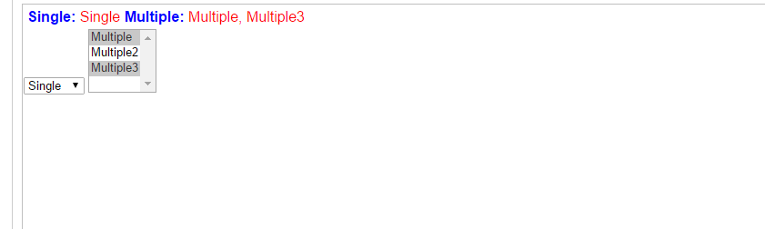

Find the value of an input box.

**<!doctype html>**

<html lang="en">

<head>

<meta charset="utf-8">

<title>val demo</title>

<style>

p {

color: blue;

margin: 8px;

}

</style>

<script src="https://code.jquery.com/jquery-1.10.2.js"></script>

</head>

<body>

<input type="text" value="some text">

<p></p>

<script>

$( "input" )

.keyup(**function**() {

**var** value = $( **this** ).val();

$( "p" ).text( value );

})

.keyup();

</script>

</body>

</html>



some text

Set the value of an input box.

**!doctype html>**

<html lang="en">

<head>

<meta charset="utf-8">

<title>val demo</title>

<style>

button {

margin: 4px;

cursor: pointer;

}

input {

margin: 4px;

color: blue;

}

</style>

<script src="https://code.jquery.com/jquery-1.10.2.js"></script>

</head>

<body>

<div>

<button>Feed</button>

<button>the</button>

<button>Input</button>

</div>

<input type="text" value="click a button">

<script>

$( "button" ).click(**function**() {

**var** text = $( **this** ).text();

$( "input" ).val( text );

});

</script>

</body>

</html>

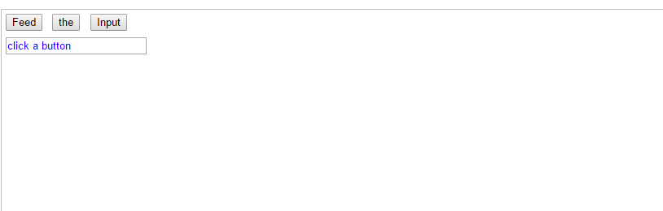

Use the function argument to modify the value of an input box.

**<!doctype html>**

<html lang="en">

<head>

<meta charset="utf-8">

<title>val demo</title>

<script src="https://code.jquery.com/jquery-1.10.2.js"></script>

</head>

<body>

<p>Type something and then click or tab out of the input.</p>

<input type="text" value="type something">

<script>

$( "input" ).on( "blur", **function**() {

$( **this** ).val(**function**( i, val ) {

**return** val.toUpperCase();

});

});

</script>

</body>

</html>

Type something and then click or tab out of the input.



Set a single select, a multiple select, checkboxes and a radio button .

**!doctype html>**

<html lang="en">

<head>

<meta charset="utf-8">

<title>val demo</title>

<style>

body {

color: blue;

}

</style>

<script src="https://code.jquery.com/jquery-1.10.2.js"></script>

</head>

<body>

<select id="single">

<option>Single</option>

<option>Single2</option>

</select>

<select id="multiple" multiple="multiple">

<option selected="selected">Multiple</option>

<option>Multiple2</option>

<option selected="selected">Multiple3</option>

</select>

<br>

<input type="checkbox" name="checkboxname" value="check1"> check1

<input type="checkbox" name="checkboxname" value="check2"> check2

<input type="radio" name="r" value="radio1"> radio1

<input type="radio" name="r" value="radio2"> radio2

<script>

$( "#single" ).val( "Single2" );

$( "#multiple" ).val([ "Multiple2", "Multiple3" ]);

$( "input").val([ "check1", "check2", "radio1" ]);

</script>

</body>

</html>

