

Final Year Project
Broom And Zoom
Project Team:
Nandni
2212299
Mumta Bai
2212319

Project Supervisor:
Sadia Aziz

4 july 2026

Submitted in partial fulfillment of the requirements for the degree of Bachelor of Science in Computer Science in the
Faculty of Computing and Engineering Sciences
Shaheed Zulfiqar Ali Bhutto Institute of Science and Technology University (SZABIST University) Karachi Campus

Table of Contents
1. Introduction 17
2. Objective 17
3. Problem Description 17
4. Target Industry 17
5. Methodology 17
5.1 Tech Stack 18
5.2 Development Approach 18
6. Project Scope 18
7. Feasibility Study 18
7.1 Risk Involved 18
7.2 Resource Requirements 18
8. Scientific Areas/Application Covered 18
9. Emerging Technologies Used 19
9.1 Hardware Requirements 19
9.2 Software Requirements 19
10. Expertise Of Team Members 19
11. Milestones 19
11.1 FYP(Phase_1):16_Weeks 20
11.1.1 Week 1–2: Project Setup & Planning 20
11.1.2 Week 3–4: User Registration & Login 20
11.1.3 Week 5–6: Profile Management 20
11.1.4 Week 7_8: Data Management System 20
11.1.5 Week 9–10: Search & Filter (by Location) 20
11.1.6 Week 11–12: Admin Dashboard (Basic) 20
11.1.7 Week 13–14: Prototype Testing 20
11.1.8 Week 15–16: FYP 1 Submission 20
11.2 FYP(Phase_2):16_Weeks 21
11.2.1 Week 1–2: Ratings & Reviews 21
11.2.2 Week 3–4: Advanced Admin Panel 21
11.2.3 Week 5–6: Notifications System 21
11.2.4 Week 7–8: Booking Management 21
11.2.5 Week 9–10: Emergency Button 21
11.2.6 Week 11–12: Integration & Testing 21
11.2.7 Week 13–14: Documentation and Polishing 21
11.2.8 Week 15–16: Final Submission 21
12. Correlation with Industrial Practices and Trends 22
13. Actor Goal Matrix Project Schedule 22
14. Project Schedule 23
15. Work Breakdown Structure 25
16. References 26
17. Business Model Diagram 26
1. Introduction 28
1.1 Purpose 28
1.2 Document Conventions 28
1.3 Intended Audience and Reading Suggestions 28
1.4 Product Scope 28
1.5 References 28
2. Overall Description 29
2.1 Product Perspective 29
2.2 Diagram 1 29
2.3 Product Functions 29
2.4 User Classes and Characteristics 30
2.5 Operating Environment 30
2.6 Design and implementation constraints 30
2.7 User Documentation 31
2.8 Assumptions and Dependencies 31
2.8.1 Assumptions 31
2.8.2 Dependencies 31
3. External Interface Requirements 32
3.1 User Interfaces 32
3.1.1 Sign-up Diagram: 32
3.1.2 Role Page Diagram 32
3.1.3 OTP Verify Diagram 33
3.1.4 Maid Signup Form Diagram 34
3.1.5 Maid Signup Form Diagram 2 34
3.2 Hardware interface 35
3.3 Software Interface 35
3.4 Communication Interface 35
4. System Features 36
4.1 Login System (For Maid, Driver, Admin & Customer) 36
4.1.1 Description 36
4.1.2 Stimulus and Response Sequences 37
4.1.3 Functional Requirements 38
4.2 Forgot Password 38
4.2.1 Description 38
4.2.2 Stimulus and Response Sequences 38
4.2.3 Functional Requirements 39
4.3 Role Selection System (For Maid, Driver & Customer) 40
4.3.1 Description 40
4.3.2 Stimulus and Response Sequences 40
4.3.3 Functional Requirements 41
4.4 Customer Signup 41
4.4.1 Description 41
4.4.2 Stimulus and Response Sequences 42
4.4.3 Functional Requirements 42
4.5 Customer Dashboard 43
4.5.1 Description 43
4.5.2 Stimulus and Response Sequences 43
4.5.3 Functional Requirements 43
4.6 Profile Management (Customer) 44
4.6.1 Description 44
4.6.2 Stimulus and Response Sequences 44
4.6.3 Functional Requirements 44
4.7 Search & Filter Services 45
4.7.1 Description 45
4.7.2 Stimulus / Response Sequences 45
4.7.3 Functional Requirements 45
4.8 Booking Management (Customer) 46
4.8.1 Description 46
4.8.2 Stimulus / Response Sequences 46
4.8.3 Functional Requirements 46
4.9 View Booking History 47
4.9.1 Description 47
4.9.2 Stimulus / Response Sequences 47
4.9.3 Functional Requirements 47
4.10 Rating and Reviews 48
4.10.1 Description 48
4.10.2 Stimulus / Response Sequences 48
4.10.3 Functional Requirements 48
4.11 Anti-Harassment (Customer) 49
4.11.1 Description 49
4.11.2 Stimulus / Response Sequences 49
4.11.3 Functional Requirements 49
4.12 Maid Signup 50
4.12.1 Description 50
4.12.2 Stimulus / Response Sequences 50
4.12.3 Functional Requirements 50
4.13 Maid Dashboard 51
4.13.1 Description 51
4.13.2 Stimulus / Response Sequences 51
4.13.3 Functional Requirements 52
4.14 Profile Management (Maid) 52
4.14.1 Description 52
4.14.2 Stimulus / Response Sequences 52
4.14.3 Functional Requirements 52
4.15 Booking Management (Maid) 53
4.15.1 Description 53
4.15.2 Stimulus / Response Sequences 53
4.15.3 Functional Requirements 53
4.16 Anti-Harassment (Maid) 53
4.16.1 Description 53
4.16.2 Stimulus / Response Sequences 54
4.16.3 Functional Requirements 54
4.17 Feedback System (Maid) 54
4.17.1 Description 54
4.17.2 Stimulus / Response Sequences 55
4.17.3 Functional Requirements 55
4.18 Driver Signup 56
4.18.1 Description 56
4.18.2 Stimulus / Response Sequences 56
4.18.3 Functional Requirements 57
4.19 Driver Dashboard 57
4.19.1 Description 57
4.19.2 Stimulus / Response Sequences 57
4.19.3 Functional Requirements 58
4.20 Profile Management 58
4.20.1 Description 58
4.20.2 Stimulus / Response Sequences 58
4.20.3 Functional Requirements 58
4.21 Vehicle Information Management 59
4.21.1 Description 59
4.21.2 Stimulus / Response Sequences 59
4.21.3 Functional Requirements 59
4.22 Booking Management (Driver) 59
4.22.1 Description 59
4.22.2 Stimulus / Response Sequences 60
4.22.3 Functional Requirements 60
4.23 End Trip & Feedback 60
4.23.1 Description 60
4.23.2 Stimulus / Response Sequences 60
4.23.3 Functional Requirements 61
4.24 Admin Signup 61
4.24.1 Description 61
4.24.2 Stimulus / Response Sequences 61
4.24.3 Functional Requirements 62
4.25 Admin Dashboard 62
4.25.1 Description 62
4.25.2 Stimulus / Response Sequences 62
4.25.3 Functional Requirements 63
4.26 Maid Approval Management 63
4.26.1 Description 63
4.26.2 Stimulus / Response Sequences 63
4.26.3 Functional Requirements 64
4.27 Driver Approval Management 64
4.27.1 Description 64
4.27.2 Stimulus / Response Sequences 64
4.27.3 Functional Requirements 65
4.28 Customer Account Management 65
4.28.1 Description 65
4.28.2 Stimulus / Response Sequences 65
4.28.3 Functional Requirements 66
4.29 Feedback & Complaint Management 66
4.29.1 Description 66
4.29.2 Stimulus / Response Sequences 66
4.29.3 Functional Requirements 66
4.30 Performance Reports & Analytics 67
4.30.1 Description 67
4.30.2 Stimulus / Response Sequences 67
4.30.3 Functional Requirements 67
4.31 Account Suspension / Reactivation 68
4.31.1 Description 68
4.31.2 Stimulus / Response Sequences 68
4.31.3 Functional Requirements 68
5. Other Non-Functional Requirements 69
5.1 Performance Requirements 69
5.2 Safety Requirements 69
5.3 Security Requirements 70
5.4 Software Quality Attributes 70
5.5 Business Rules 70
5.6 Other Requirements 71
6. Appendix A: Glossary 71
7. Appendix B: Analysis Models 72
7.1 Use cases 72
7.1.1 Admin Diagram 73
7.1.2 Customer Diagram 74
7.1.3 Maid Diagram 75
7.1.4 Driver Diagram 76
7.1.5 ERD Diagram 77
1. Introduction 79
1.1 Purpose 79
1.2 Scope 79
1.3 Definitions, Acronyms, and Abbreviations 79
1.4 Document Overview 79
2. System Architecture Design 80
2.1 Section Overview 80
2.2 General Constraints 80
2.3 Data Design 81
2.4 Program Structure 82
2.4.1 User Management 82
2.4.2 Service Booking Module 82
2.4.3 Payment Module 82
2.4.4 Rating and Review Module 82
2.4.5 Safety and Emergency Module 82
2.4.6 Complaint Management Module 82
2.4.7 Admin Module 82
2.4.8 Core Functionalities 83
2.5 Alternatives Considered 83
2.5.1 Monolithic Architecture: 83
2.5.2 Microservices Architecture 83
2.5.3 Layered Architecture (Chosen) 83
3. Detailed Description of Components 84
3.1 System Overview 84
3.2 Component And Detail 84
3.2.1 Customer Sign Up 84
3.2.2 Maid Sign Up 86
3.2.3 Driver Signup 87
3.2.4 Login 87
3.2.5 Customer Dashboard 88
3.2.6 Search Maid/Driver 89
3.2.7 Service Booking 90
3.2.8 Booking Management 90
3.2.9 Feedback and Rating 91
3.2.10 Maid Dashboard 92
3.2.11 View Booking Request 93
3.2.12 Accept / Reject Booking (Maid) 94
3.2.13 Service Status Update Maid 95
3.2.14 Driver Dashboard 95
3.2.15 View Ride Requests 96
3.2.16 Accept / Reject Ride 97
3.2.17 Trip Status Update 98
3.2.18 Admin Dashboard(User Management) 99
3.2.19 Service Approval & Verification 100
3.2.20 Booking Monitoring 100
3.2.21 Feedback Management 101
4. User Interface Design 102
4.1 Section Overview 102
4.2 Interface Design Rules 102
4.3 GUI Components 103
4.4 Detailed User Interface Description 103
4.4.1 Admin Home Page 104
4.4.2 Admin Login Page 104
4.4.3 Admin Dashboard 105
4.4.4 Emergency Request 105
4.4.5 User Bookings 106
4.4.6 Customer Dashboard 106
4.4.7 Driver Dashboard 107
4.4.8 Notification 107
4.4.9 Maid Edit Profile 108
4.4.10 Language Page 108
5. Reuse and Relationship to other products 109
6. Design Decisions and Tradeoffs 109
7. Pseudocode for components 109
7.1 Login / Registration 109
7.2 Admin(User Management) 111
7.3 Maid (Service Status Update) 111
7.4 Driver 112
7.5 Customer 113
7.6 Booking Management 113
7.7 Maid/Driver Approval 114
7.8 Service Status Update (Maid/Driver) 114
7.9 Emergency Button (Customer Maid) 114
7.10 Feedback & Rating 115
8. Design Diagrams 115
8.1 Class Diagram 115
8.2 State Chart Diagrams 116
8.2.1 Admin State Chart Diagram 116
8.2.2 Customer State Chart Diagram 117
8.2.3 Maid State Chart Diagram 117
8.2.4 Driver State Chart Diagram 117
8.3 Activity Diagrams 118
8.3.1 Login 118
8.3.2 Roles(Customer Maid Driver) 118
8.3.3 Customer signup 119
8.3.4 Customer Dashboard 119
8.3.5 Customer Profile Management 120
8.3.6 Customer Search and Filter 120
8.3.7 Customer Booking Management 121
8.3.8 Customer Booking History 122
8.3.9 Customer Rating and Reviews 122
8.3.10 Customer Anti-Harassment 123
8.3.11 Maid Signup 123
8.3.12 Maid Dashboard 124
8.3.13 Maid Profile Management 124
8.3.14 Maid Booking Management 125
8.3.15 Maid Anti-Harassment 125
8.3.16 Maid Feedback 126
8.3.17 Driver Signup 126
8.3.18 Driver Dashboard 127
8.3.19 Driver Profile Management 128
8.3.20 Driver Vehicles Information 128
8.3.21 Driver Booking Management 129
8.3.22 Driver End Trip 129
8.3.23 Admin Login 129
8.3.24 Admin Dashboard 130
8.3.25 Maid Approval Management 131
8.3.26 Driver Approval Management 131
8.3.27 Customer Account Management 132
8.3.28 Feedback Complaint Management 132
8.3.29 Account Suspension/Reactivation 133
8.4 Sequence Diagram 134
8.4.1 Login 134
8.4.2 Customer Signup 134
8.4.3 Roles(Customer , Maid , Driver) 135
8.4.4 Customer Dashboard 136
8.4.5 Customer Profile Management 137
8.4.6 Customer Search And Filter 137
8.4.7 Customer Booking Management 138
8.4.8 Customer Rating And Review 139
8.4.9 Customer Anti-Harassment 139
8.4.10 Maid Signup 140
8.4.11 Maid Profile Management 140
8.4.12 Maid Dashboard 141
8.4.13 Maid Booking Management 141
8.4.14 Maid Anti-Harassment 142
8.4.15 Maid Feedback 143
8.4.16 Driver Signup 143
8.4.17 Driver Dashboard 144
8.4.18 Driver Profile Management 144
8.4.19 Vehicle Information 145
8.4.20 Driver Booking Management 146
8.4.21 Driver End-Trip Feedback 147
8.4.22 Admin Login 148
8.4.23 Admin Dashboard 149
8.4.24 Approval Management System (Customer, Maid, Driver) 149
8.4.25 Feedback and Complaint 150
8.4.26 Account Suspension And Reactivation 151
8.5 Use Case Diagrams 152
8.5.1 Admin 152
8.5.2 Customer 154
8.5.3 Maid 155
8.5.4 Driver 156
8.6 Component Diagram 157
1. Signup Customer 159
2. Signup Maid 161
3. Signup Driver 163
4. Login(Customer, Maid, Driver) 165
5. Admin Login 167
6. Forgot Password(All Roles) 169
7. Reset Password OTP 172
8. Verify OTP 174
9. Customer Dashboard 176
10. Maid Dashboard 179
11. Driver Dashboard 181
12. Admin Dashboard 183
13. Complete Profile Customer 186
14. Complete Profile Miad 189
15. Complete Profile Driver 191
16. Edit Profile Customer 194
17. Edit Profile Maid 196
18. Edit Profile Driver 198
19. Booking Process (Customer, Maid, Driver) 201
20. Notification System (Booking & Updates) 203
21. Ratings & Reviews System 206
22. Admin Approve User (Maid/Driver) 209
23. Admin Block And Unblock User 211
24. Customer Emergency Request 213
25. Maid Emergency Alert 216
26. Admin Receives Emergency Notification 219
1. Introduction 223
1.1 Purpose 223
1.2 Scope 223
1.3 Intended Audience 223
1.4 System Overview 223
2. System Requirements 224
2.1 Hardware Requirements 224
2.2 Software Requirements 224
3. Installation & Setup 224
3.1 Installation Steps 224
3.2 Configuration 225
4. System Features 225
4.1 User Authentication & Profile Management 225
4.2 Customer Service Module 226
4.3 Maid Management Module 226
4.4 Driver Management Module 226
4.5 Booking Management Module 227
4.6 Notification & Emergency Module 227
4.7 Admin Dashboard 227
5. User Interface Guide 228
5.1 Navigation Overview 228
5.1.1 Home screen 229
5.1.2 Role Screen 229
5.1.3 Language Page 230
5.1.4 OTP Verification Page 230
5.1.5 Login Page 231
5.1.6 Sign Up Page driver 231
5.1.7 Customer Dashboard 232
5.1.8 Driver Dashboard 232
5.1.9 Maid Dashboard 233
5.1.10 Admin Dashboard 233
5.1.11 Emergency Alert 234
5.1.12 Notification Page 234
6. How to Use the System 235
6.1 Basic Workflow 235
6.2 Use Case Scenarios 235
7. Project-Specific Section (Mobile Application) 236
7.1 User Roles 236
7.2 API Usage 236
7.3 Data Input / Output 237
7.4 System Security Features 237
8. Troubleshooting 237
9. FAQs 238
10. Limitations 239
11. Future Enhancements 239
12. Contact / Support 239

Table 1:Document Convention 31
Table 2:Intended Audience and Reading Suggestions 31
Table 3:Stimulus and Response Sequences 41
Table 4:Functional Requirements 41
Table 5:Stimulus and Response Sequences 42
Table 6:Functional Requirements 43
Table 7:Stimulus and Response Sequences 44
Table 8:Functional Requirements 44
Table 9:Stimulus and Response Sequences 45
Table 10:Functional Requirements 46
Table 11:Stimulus and Response Sequences 46
Table 12:Functional Requirements 47
Table 13:Stimulus and Response Sequences 47
Table 14:Functional Requirements 48
Table 15:Stimulus and Response Sequences 48
Table 16:Functional Requirements 49

Project Proposal

Introduction
The Broom and Zoom project is a mobile application. It helps people hire trusted maids and drivers. In today’s busy lifestyle finding best and trust-worthy helpers is difficult. This app solves that problem by acting as a bridge between customers and service providers. Customers can easily search and book helpers. Maids can offer services such as cleaning, cooking, babysitting, elderly care, and laundry services. Drivers can provide personal driving services. To ensure safety, this app also includes an emergency button.

Objective
The main objective of this project is to develop a mobile-based application that allows customers to hire maids and drivers easily.

Problem Description
The Broom and Zoom project address a common daily problem like finding best and trust-worthy maids and drivers. Normally, customers find helpers through friends or neighbors which can be time consuming. This often leads to issues such as delay in finding help poor service quality, or lack of availability when needed. Our app provides a simple and convenient solution. The system includes separate signups for customers, maids, and drivers to keep everything clear and well-organized. Customers can easily search for maids or drivers, view their profiles, and make bookings directly through the app. Customers can quickly find services like cleaning, cooking, babysitting, elderly care, laundry, and driving. An emergency button is provided for customers and maids if they face any problem while working they can use this button.

Target Industry
Household Services (maids, cleaning, babysitting, elderly care)
- Driving Services
- Consumer Market (home users)
- IT Industry (on-demand service apps)

Methodology
We will build the Broom and Zoom app with a mobile-first design to ensure smooth functionality on smartphones. The app will have different sign-ups and dashboards for customers, maids, and drivers.

Tech Stack
- Frontend: Flutter
- Backend: Node.js
- Database: MongoDB
- APIs & Services: APIs & Services: Google Maps API for location, JWT Authentication for secure login signup and One Signal for push notifications.

Development Approach
We follow the Software Development Life Cycle from design to coding, testing, and final launch.

Project Scope
The Broom and Zoom app is made for customers who want to hire maids and drivers easily. In this project customers will register login and search for services by location. Maids and drivers will create their profiles with basic personal details, work experience, and availability. The app will also allow booking, showing ratings, reviews, and notifications. Emergency button will also be provided for customers and maids. Admin will manage the whole system.

Feasibility Study

Risk Involved
- Possible delay in API integration (Google Maps, JWT Authentication, One-Signal).
- Time management challenges during testing due to unexpected bugs.
- Internet disruptions or system crashes.

Resource Requirements
- Hardware: Laptop PCs with good specifications, Android devices for testing.
- Software: Flutter, Node.js, MongoDB, Google-Maps API , JWT Authentication, One Signal, VS Code/Android Studio, Git & GitHub.
- Connectivity: Stable internet connection for real-time data exchange and cloud services.

Scientific Areas/Application Covered
Our project is useful in daily life. Customers can easily find maids and drivers without wasting time. Workers can also get a proper platform to find jobs and manage their work through the app. The target users include households and individuals who need maids or drivers. The app provides quick booking options and an emergency feature for both customers and maids when needed. This makes the process convenient for everyone.

Emerging Technologies Used
To develop the Broom and Zoom app the following hardware and software tools/technologies may be required:

Hardware Requirements
- Computers laptops with sufficient processing power and memory.
- Android devices for testing and debugging.

Software Requirements
- Frontend: Flutter (mobile app development)
- Backend: Node.js Express (server-side logic)
- Database: Mongo dB (for data storage)
- APIs & Services: Google Maps API for location, JWT Authentication for secure user login signup, and One Signal for notifications.
- Code Editor: VS Code / Android Studio
- Version Control: Git & GitHub

Expertise Of Team Members
Both team members possess the required knowledge and skills for the successful development of the Broom and Zoom project.
We have studied courses such as:
- Software Engineering
- Software Quality Assurance
- Databases
- Web & Mobile Application Development
- Software Construction & Development
- Object-Oriented Programming
We are proficient in both frontend and backend development, covering UI/UX design, database management, server-side logic, and system integration. With this expertise we can effectively support each other in all stages of the project requirement analysis, design, development, testing, and deployment.

Milestones
Our project will be completed in two phases: FYP-I and FYP-II. Each phase will include specific tasks and features to make sure the app is developed step by step.

FYP(Phase_1):16_Weeks
Goal: Working prototype with registration, profiles, search/filter, and basic admin.

Week 1–2: Project Setup & Planning
- Finalize tech stack (Flutter + Mongo DB or Node.js).
- Set up project repository, design initial app wireframes/UI mockups.
- Database schema design (users profiles, admin).

Week 3–4: User Registration & Login
- Implement signup/login (maids and drivers separate roles).
- Secure authentication (JSON Web Token (JWT) Auth system).
- Profile creation after login.

Week 5–6: Profile Management
- Add edit personal details (name, phone, location).
- Separate profile dashboards for maids and drivers.

Week 7_8: Data Management System
- Store use and profile data in database
- Implement booking and data handling updates

Week 9–10: Search & Filter (by Location)
- Basic search by name, service type (maid, driver).
- Filter by location (city, area).
- Display list with simple results page.

Week 11–12: Admin Dashboard (Basic)
- Admin login.
- Display all registered users, bookings, and basic statistics.
- Allow admin to monitor system activities.

Week 13–14: Prototype Testing
- Test full flow (register, search, admin view).
- Fix bugs, improve UI/UX.

Week 15–16: FYP 1 Submission
- Prepare documentation (ERD, use cases, system design).
- Finalize working prototype demo.
Outcome: Profiles + working search system + admin overview.

FYP(Phase_2):16_Weeks
Goal: Advanced version with reviews, advanced admin, notifications, bookings, emergency system.

Week 1–2: Ratings & Reviews
- Add rating system (stars , text feedback).

Week 3–4: Advanced Admin Panel
- Approve, reject, block users.
- Manage reported users.
- Better analytics (active users, pending docs).

Week 5–6: Notifications System
- Push notifications for bookings, approval updates.
- Basic notification inside the app.

Week 7–8: Booking Management
- Allow user to book maids, drivers.
- Track booking status (pending, accepted, completed).
- Store booking history.

Week 9–10: Emergency Button
- Urgent Request button for instant maid Customer need.
- Emergency Button for maid safety purpose.
- Send priority notifications to the admin for both emergency types.

Week 11–12: Integration & Testing
- Test all modules including notifications, bookings, and emergency buttons.
- Improve performance and fix identified bugs.

Week 13–14: Documentation and Polishing
- Prepare user manual, system design, and architecture diagrams.
- Review UI/UX and finalize all screens.

Week 15–16: Final Submission
- Full demo with all advanced features.
- Documentation: user manual, architecture, testing reports.
- Final polishing + presentation slides.
Outcome: Full-featured app with admin controls, users, ratings/reviews, bookings, and emergency services.

Correlation with Industrial Practices and Trends
The Broom and Zoom system is designed with modern industrial practices and software development trends used in real-world service-based applications. It follows an on-demand service model similar to popular platforms where users can book services instantly and track their requests. The system is designed using a role-based structure (Customer, Maid, Driver, Admin) which reflects industry-standard role-based access control for better security and management.

Actor Goal Matrix Project Schedule
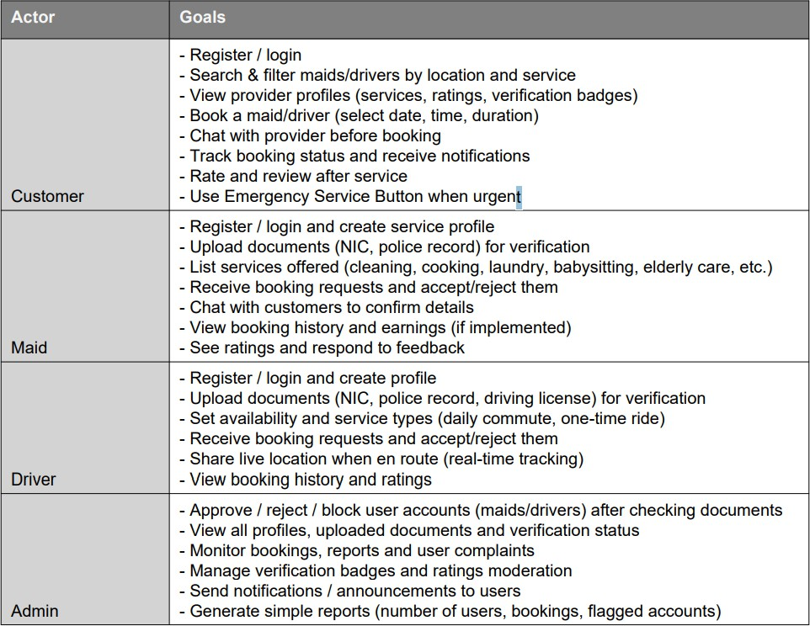

Project Schedule
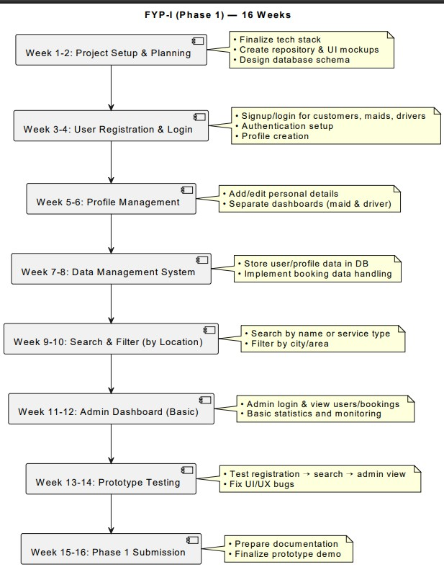

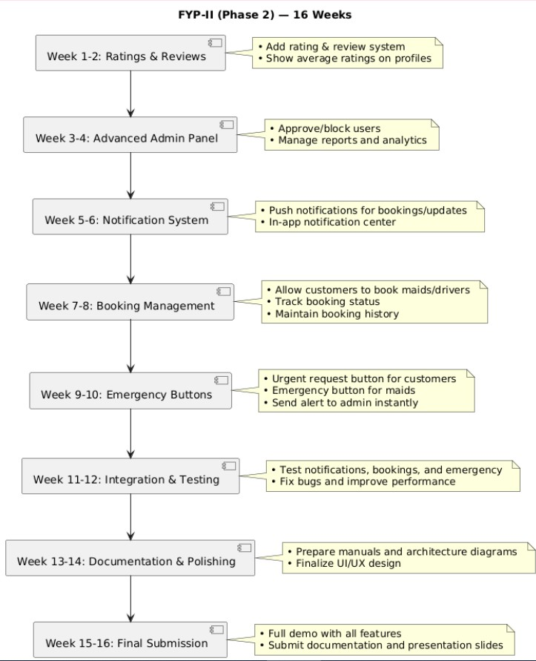

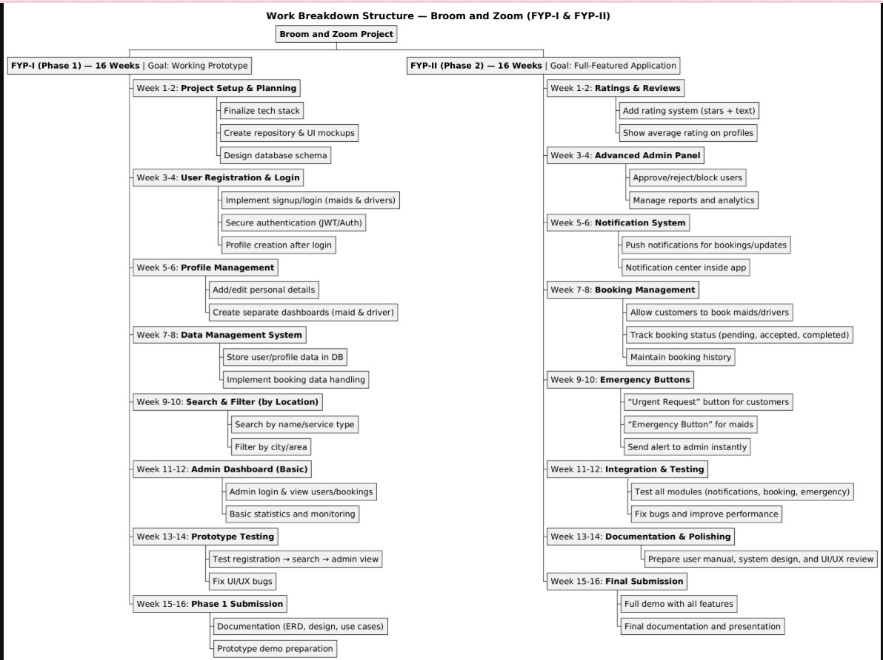
Work Breakdown Structure
10

References
- [1] Sommerville, Ian. Software Engineering. Boston: Addison-Wesley, 2015. pp. 35–60.
- [2] Fowler, Martin. UML Distilled: A Brief Guide to the Standard Object Modeling Language. Boston: Addison-Wesley, 2004. pp. 22–45.
- [3] Gamma, Erich, Richard Helm, Ralph Johnson, and John Vlissides. Design Patterns: Elements of Reusable Object-Oriented Software. Boston: Addison-Wesley, 1995.
- [4] Google Developers. “Flutter Documentation.” 2025. Google. Last accessed: 20 Sept 2025 https://docs.flutter.dev
- [5] Node.js Foundation. “Node.js Documentation.” 2025. Node.js Foundation. Last accessed: 20 Sept 2025. https://nodejs.org/en/docs
- [6] MongoDB Inc. “MongoDB Manual.” 2025. MongoDB Inc. Last accessed: 20 Sept 2025. https://www.mongodb.com/docs/manual
- [7] TechTarget. “What is Online Marketplace and How Does It Work?” TechTarget, 2023. Last accessed: 20 Sept 2025. https://www.techtarget.com
- [8] Ullah, Saad, and Khurram Shahzad. "Mobile Application Development in Pakistan: Challenges and Opportunities." Journal of Software Engineering Research and Development, 2021, pp. 112–125.

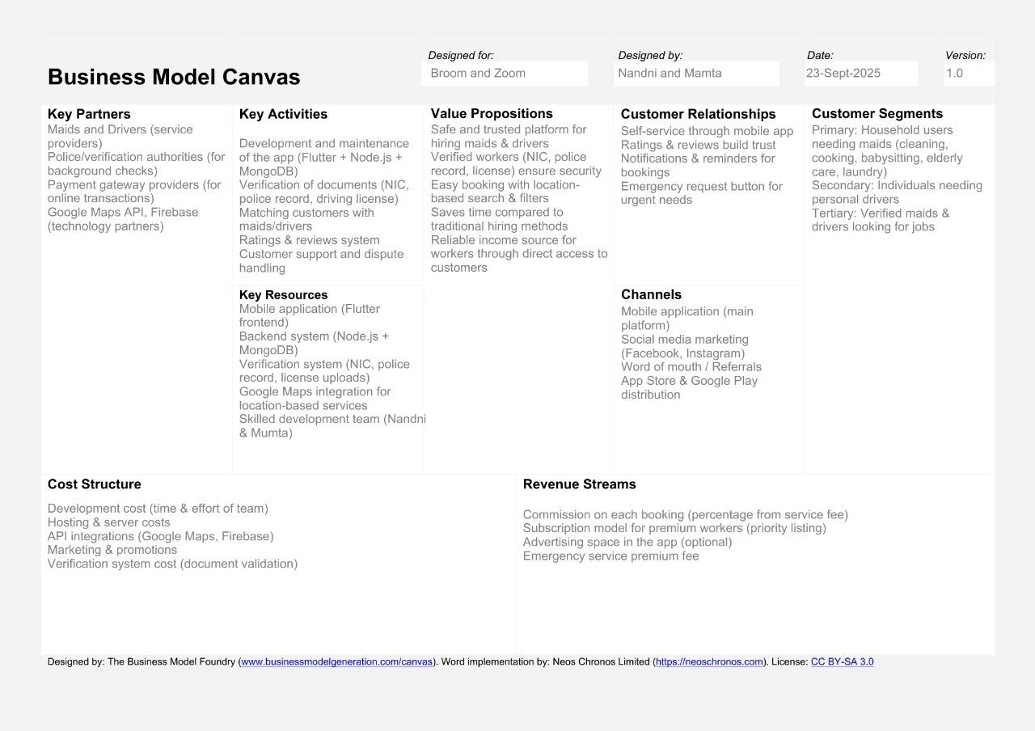
Business Model Diagram

Software Requirements Specifications

Introduction

Purpose
Broom and Zoom is a mobile platform designed to connect households in Pakistan with trusted maids and drivers. As busy lifestyles become more common, finding reliable domestic help can be challenging. Broom and Zoom addresses this need by offering a verified network of maids and drivers, ensuring quality, trust, and convenience.

Document Conventions
Heading | Times New Roman | 16
Subheading | Times New Roman | 14
Paragraph | Times New Roman | 12
Table 1:Document Convention

Intended Audience and Reading Suggestions
Team | Nandni And Mumta Bai
Advisor | Sadia Aziz
FYP Coordinator | Usama Khalid
Tester | Developers (Nandni and Mumta Bai)
User | Service Provider
Table 2:Intended Audience and Reading Suggestions

Product Scope
Broom and Zoom is an innovative mobile platform designed to seamlessly connect households in Pakistan with reliable maids and drivers. Through a user-friendly interface, Broom and Zoom enhances the experience of managing household tasks by offering quick and secure access to verified maids and drivers all in one place.

References
The following documents and resources were referenced in preparing this Software Requirements Specification (SRS):
[1] Google Developers, "Flutter Documentation", 2025.Available at: https://docs.flutter.dev
[2] MongoDB Documentation, MongoDB Inc., 2025. Available at:
https://www.mongodb.com/docs/
IEEE 830-1998 — IEEE Recommended Practice for Software Requirements Specifications, Institute of Electrical and Electronics Engineers (IEEE), 1998.
Available at: https://ieeexplore.ieee.org/document/720574

Overall Description

Product Perspective
Broom and Zoom is a new, self-contained mobile-based platform designed to address the growing need for reliable household services in Pakistan. It is not a follow-on product nor a replacement of any existing system but an innovative solution developed to fill a gap in the local market, where no centralized digital platform currently exists to connect customers with trusted maids and drivers.

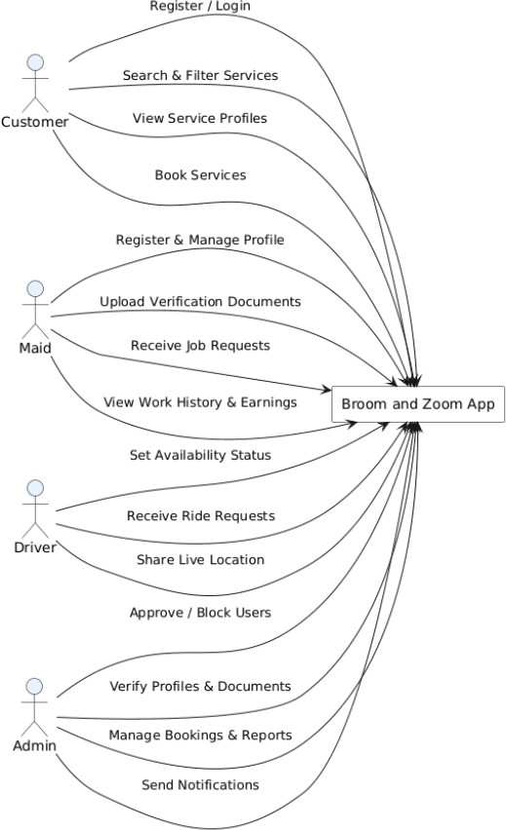
Diagram 1

Product Functions
- Service Listing: A directory of household services, including cleaning, cooking, babysitting, elderly care, laundry, and driving.
- User Profiles: Personalized profiles for customers, maids, and drivers to enhance trust and transparency.
- Search and Filters: Easy search options to find maids or drivers based on location, service type, availability, and ratings.
- Booking System: A simple interface for customers to book, schedule, and manage service appointments.
- Ratings and Reviews: Users can provide feedback to maintain service quality and help others make informed choices.
- Complaint Management: A system for customers to report and resolve issues with maids or drivers efficiently.
- Profile Verification: Verification process to ensure all maids and drivers are genuine and meet safety standards.
- Customer Support: Quick and responsive assistance to handle user inquiries, issues, or emergencies.
- Safety and Emergency Feature: Emergency button for customers and service providers to request urgent help or immediate response.

User Classes and Characteristics
- Customers: Individuals or families looking to hire maids or drivers for household tasks. They are the primary users of the platform, Their main functions include searching for services, viewing profiles, booking maids or drivers, and providing ratings and reviews. Customers have access to their personal profiles, booking history, and notifications.
- Service Providers:(Maids and Drivers): Individuals offering domestic services such as cleaning, cooking, babysitting, elderly care, laundry, or driving. They log in regularly to manage their profiles, view and accept bookings, and communicate with customers. Most service providers possess basic technical skills.
- Administrator: The admin oversees the entire system, ensuring smooth operations and maintaining data integrity. They manage user registrations, handle complaints, verify service providers and monitor overall platform activity.

Operating Environment
- Frontend: Flutter(Android)
- Backend: Node.js with Express
- Database: Mongo DB
- APIS/Services: JWT based-authentication implemented in Node.js
- Development Tools: Visual Studio Code and Android Studio

Design and implementation constraints
- Hardware: The Broom and Zoom mobile application must operate smoothly across a variety of Android smartphones and tablets.
- Specific Technologies and Tools: The project will utilize Flutter for the front-end mobile development and Node.js for the back-end services, with Mongo DB used for database management. The system will integrate Google Maps API for location services, JWT Authentication for authentication, and One Signal for notifications. Design prototypes and wireframes will be created using Figma to guide the overall UI/UX design process.
- Security Considerations: User data security and privacy are top priorities
- Scalability and Performance: The system architecture will be designed to handle a growing number of users, bookings, and service providers.

User Documentation
- Introduction: Overview of the app, its purpose, and key features such as booking services, profiles, and emergency assistance.
- Getting Started: Steps for downloading, installing, and signing up as a Customer, Maid, or Driver.
- User Roles: Description of features available to each user type Customers (service booking), Maids/Drivers (profile and service management), and Admin (system monitoring).
- App Navigation: Guide on using main features such as searching for helpers, viewing profiles, booking services, and managing notifications.
- Troubleshooting: Common issues (e.g., login errors, booking problems, or notification delays) and their solutions, along with contact information for support.

Assumptions and Dependencies
The development and operation of the Broom and Zoom mobile application are based on several assumptions and dependencies that may affect the system’s requirements and performance.

Assumptions
- Stable Mobile Environment: It is assumed that Android devices used by the target audience will continue to support the latest versions of Flutter and Node.js technologies used in the app’s development.
- Reliable Internet Connectivity: Users (customers, maids, and drivers) are expected to have access to stable internet connections to enable smooth operation of features such as registration, booking, real-time updates, and notifications.
- User Technical Familiarity: It is assumed that users possess basic mobile application skills to navigate the app independently.
- Compliance with Local Regulations: The system assumes compliance with Pakistan’s local labor and data protection laws. Any future regulatory changes may require system updates or policy modifications.
- Availability of Project Resources: It is presumed that necessary development tools, software licenses, and testing devices will remain accessible throughout the project lifecycle.

Dependencies
- Third-Party Services: The system depends on external APIs such as Google Maps API (location services), JWT Authentication , and One Signal (notifications). Any service interruptions or API changes may impact certain app functionalities.
- Development Frameworks and Tools: Project depends on continuous support and compatibility of Flutter, Node.js, and Mongo DB. Major updates or deprecated components could necessitate architectural revisions.
- Hosting and Server Reliability: The platform relies on stable backend hosting and database servers..
- Stakeholder Feedback: Continuous feedback from users, the supervisor, and stakeholders is essential for refining requirements and improving usability
- Team Expertise: The project’s success depends on the team’s ability to maintain and enhance technical proficiency in the chosen tech stack. Skill gaps or resource limitations may slow down development progress.

External Interface Requirements

User Interfaces

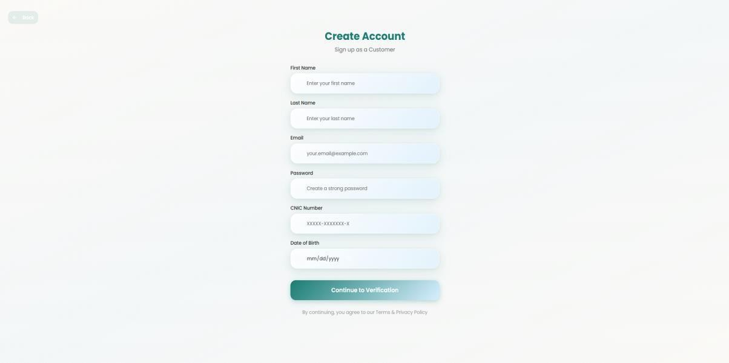
Sign-up Diagram:

Role Page Diagram

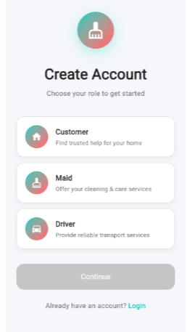

OTP Verify Diagram
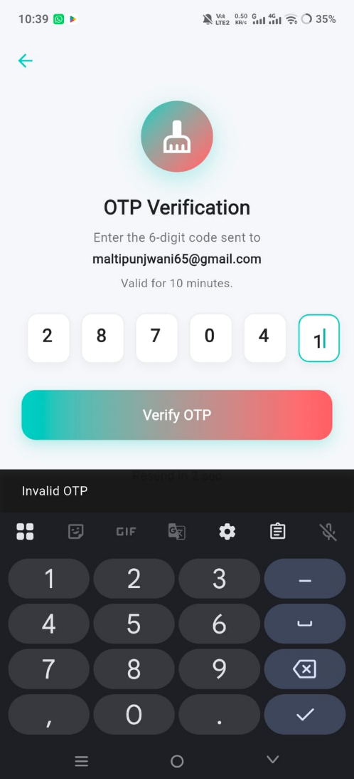

Maid Signup Form Diagram
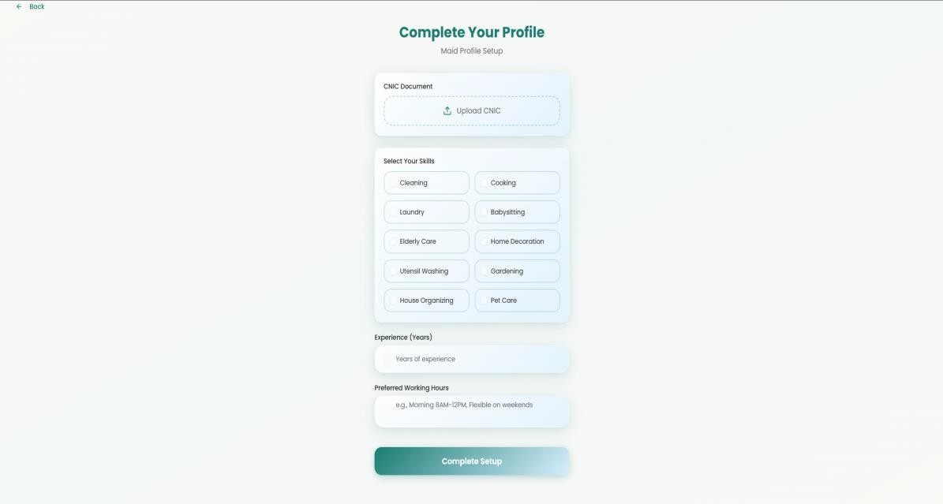

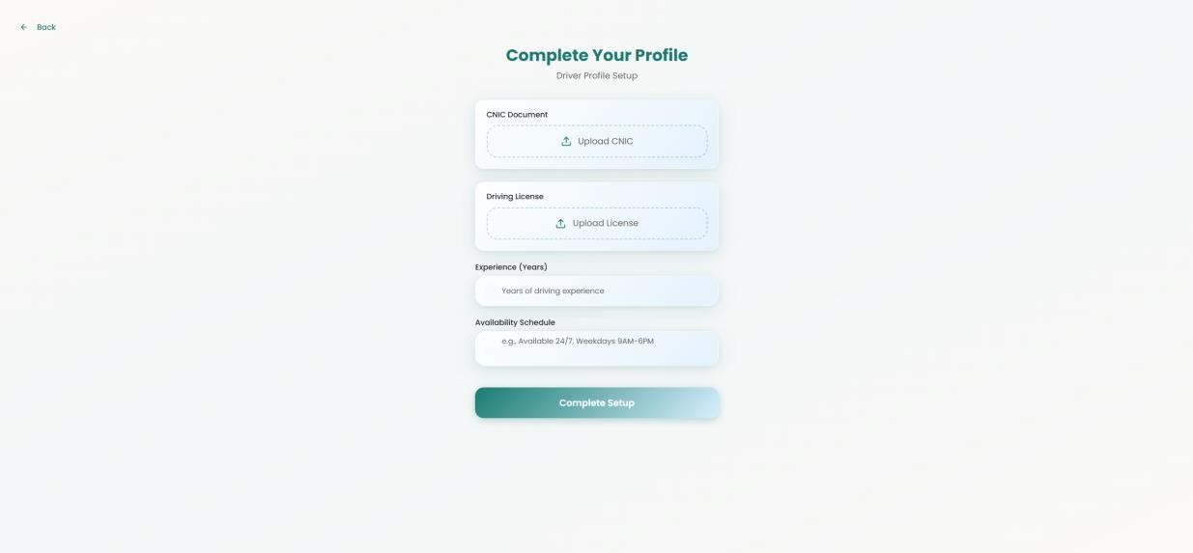
Maid Signup Form Diagram 2

Hardware interface
No special hardware requirements are needed for the Broom and Zoom mobile application. It is designed for use on standard Android smartphones and tablets. The app should operate smoothly on devices with moderate specifications, ensuring accessibility for a wide range of users, including both customers and service providers.

Software Interface
- Mobile Framework: Built using Flutter (Version 3.24.0 or later) for developing a cross-platform, responsive, and user-friendly mobile interface.
- Backend Server: Developed with Node.js with Express to handle API requests, manage data, and implement the system’s business logic.
- Database: Uses Mongo DB to securely store user profiles, service listings, booking details, and feedback records in a NoSQL document-based format.
- Authentication Service: Uses JWT-based authentication in Node.js for secure user registration, login, and role-based access (customers, maids, and drivers).
- Notification Service: Implements One Signal for real-time notifications about bookings, approvals, and emergency alerts.
- Mapping and Location API: Utilizes Google Maps API to enable location-based service search, display nearby maids or drivers, and assist with route tracking.
- Development and Design Tools: Wireframes and UI designs are created in Figma, while Visual Studio Code and Android Studio are used for coding and debugging.
- Version Control: Managed with Git (Version 2.x) and hosted on GitHub for team collaboration and version management.
- API Documentation Tools: Uses Postman for testing and documenting restful APIs to ensure smooth communication between the frontend and backend components.

Communication Interface
The Broom and Zoom mobile application incorporate several communication interfaces to ensure smooth and efficient interaction between customers, service providers (maids and drivers), administrators, and the backend system.
- User Interface (UI): The mobile user interface serves as the main communication channel between users and the application. It includes all screens, menus, buttons, and input forms that allow customers to search for maids or drivers, book services, manage profiles, and view notifications. The interface is designed in Flutter to ensure responsiveness and ease of use across Android devices.
- API Integration: The system uses RESTful APIs to enable communication between the mobile app and the backend server. These APIs handle operations such as user authentication, service listings, booking management, and emergency requests. Endpoints will use standard HTTP methods (GET, POST, PUT, DELETE) and JSON as the primary data exchange format.
- Push Notifications: Automated push notifications powered by One Signal will inform customers and service providers about booking confirmations, cancellations, approvals, and emergency alerts. Notifications will appear directly on mobile devices to ensure timely updates.
- Real-Time Communication: The platform supports real-time data updates for critical actions such as booking status changes and emergency responses. This is achieved through WebSocket or similar real-time event communication mechanisms integrated into the Node.js backend.
- Email Notifications: Email alerts will be sent to registered users for important updates such as account verification, booking summaries, and password reset instructions. Emails will be formatted in HTML for clarity and a professional appearance.
- Stable Internet Connection: A consistent and reliable internet connection is required for smooth app operation. Users need active mobile data or Wi-Fi connectivity to access features like searching, booking, and notifications.
- Data Transfer Protocols: All communication between the mobile app and the server will adhere to secure HTTP/HTTPS protocols to ensure safe and encrypted data transmission. This protects sensitive user information such as login credentials, contact details, and booking data. By implementing these communication interfaces, Broom and Zoom ensures reliable, fast, and secure interaction among all stakeholders, enhancing both user experience and operational efficiency.

System Features
The broom and zoom mobile application provide a wide range of features designed to meet the need of customers, maids and drivers. This section outlines the major functionalities of the system
organized by feature and user role.

Login System (For Maid, Driver, Admin & Customer)

Description
The Login System is a unified authentication feature that allows all registered users Maids, Drivers, Customers, and Admins to securely access the Broom and Zoom platform using a single login interface. Each user type logs in using their registered email/phone number and password, and based on the role, the system redirects them to their respective dashboard (Customer Dashboard, Maid Dashboard, Driver Dashboard, or Admin Dashboard). The system validates user credentials against the database, ensures that accounts are approved (for Maids and Drivers), and applies security measures like password encryption, account status checks, and failed login attempt tracking. This feature is essential to maintain data security, controlled access, and smooth navigation within the Broom and Zoom ecosystem.

Stimulus and Response Sequences
Use Case Name: Multi-Role Login System Actors: Customer, Maid, Driver, Admin, System
Goal: Authenticate registered users and redirect them to role-based dashboards.
Pre-Conditions:
- User must already be registered.
- Maid and Driver accounts must be approved by Admin before login.
- Valid internet connection must be available
Basic Course of Events / Main Flow
User Action (Step 1): The user opens the login page.
System Response: The system displays input fields for email/phone number and password along with a “Login” button.
User Action (Step 2): The user enters valid credentials (email/phone and password) and clicks the “Login” button.
System Response: The system validates the entered data, checks for proper format, and verifies the credentials against the database records.
User Action (Step 3): The system successfully authenticates the user.
System Response: The system identifies the user’s role and redirects them to their
respective dashboard: Customer Dashboard, Maid Dashboard, Driver Dashboard, Admin Dashboard It then logs the login time and records device information for security purposes.
Alternate Flow
- If invalid credentials are entered, the system displays: If invalid username or password. Please try again.
- If Maid or Driver tries to log in before admin approval, the system displays: Your account is awaiting admin verification.
- If the user forgets the password, a Forgot Password option is provided for recovery via email or SMS OTP.
- Exception Flow
- If database or server connection fails, system displays: Login service temporarily unavailable. Please try again later.
- If network error occurs, displays:
- No internet connection. Please check your network and retry.
Exception Flow
- If database or server connection fails, system displays: Login service temporarily unavailable. Please try again later.
- If network error occurs, displays:
- No internet connection. Please check your network and retry.
Pre-Conditions
- User is successfully authenticated and redirected to their respective dashboard.
- The system updates the user’s last login time and maintains audit logs for security monitoring.
Table 3:Stimulus and Response Sequences

Functional Requirements
Req ID | Description | Priority | Status
Req 1 | The system shall provide a unified login page for all roles (Customer, Maid, Driver, Admin). | High | Pending
Req 2 | The system shall verify user credentials (email/phone and password) with database records. | High | Pending
Req 3 | The system shall redirect authenticated users to their respective dashboards based on role. | High | Pending
Req 4 | The system shall restrict Maid and Driver logins until approved by Admin. | High | Pending
Req 5 | The system shall encrypt all passwords for secure authentication. | High | Pending
Req 6 | The system shall display appropriate error messages for invalid credentials or blocked accounts. | Medium | Pending
Req 7 | The system shall allow password recovery through a "Forgot Password" option. | Medium | Pending
Req 8 | The system shall record login timestamps and user activity for audit purposes. | Medium | Pending
Table 4:Functional Requirements

Forgot Password

Description
The Forget Password feature allows users (Customer, Maid, Driver, Admin) to recover access to their account when they are unable to remember their password. Users enter their registered email or phone number, and the system sends an OTP or password-reset link for verification. After successful verification, the system allows the user to create a new password. This feature ensures secure account recovery and prevents unauthorized access by validating user identity before resetting the password.

Stimulus and Response Sequences
Use Case Name: Forget Password
Actors: Customer, Maid, Driver, Admin, System
Goal: Allow users to recover their account when they forget their password.
Pre-Conditions
User must have an existing registered account.
User must have access to registered email/phone number.
Main Flow / Basic Course of Events
User Action Step 1: User clicks “Forgot Password” on login page.
System Response: Shows input field for email/phone number.
User Action Step 2: User enters registered email/phone and submits.
System Response: System verifies if user exists.
User Action Step 3: System sends an OTP / reset link to user’s email/phone. System Response: System sends an OTP / reset link to user’s email/phone.
User Action Step 4: User enters new password and confirms it.
System Response: System validates password format (length, characters, etc.)
User Action Step 5: System successfully resets the password.
System Response: Displays message: “Password reset successful. Please log in.”
Alternate Flow
If email/phone is not registered:
System shows: “No account found with this email/phone number.”
If OTP is incorrect or expired:
System shows: “Invalid/expired OTP. Please request a new one.”
Exception Flow
If server/database is down
System displays: “Service unavailable. Please try again later.”
Post-Conditions
User’s old password is replaced with new password.
Table 5:Stimulus and Response Sequences

Functional Requirements
Req ID | Description | Priority | Status
Req 1 | The system shall provide a "Forgot Password" option on login screen. | High | Pending
Req 2 | The system shall validate whether the entered email/phone exists. | High | Pending
Req 3 | The system shall send OTP/reset link to registered contact. | High | Pending
Req 4 | The system shall allow users to enter and confirm a new password. | High | Pending
Req 5 | The system shall validate password format and strength. | Medium | Pending
Req 6 | The system shall update password securely after verification. | High | Pending
Req 7 | The system shall show error messages for invalid/expired OTP. | Medium | Pending
Table 6:Functional Requirements

Role Selection System (For Maid, Driver & Customer)

Description
The Role Selection System enables users to select their specific role Customer, Maid, or Driver during the registration process. This role determines which features, services, and dashboard the user will have access to after signing up and logging in.
- Customers can hire services (maids or drivers).
- Maids can offer cleaning services once approved by the Admin.
- Drivers can offer driving/hiring services once approved by the Admin.
This feature ensures proper role-based access control within the system, preventing unauthorized use of other user functionalities. It also triggers different registration flows depending on the role selected, sending Maid and Driver applications for Admin verification before they gain access to their dashboards.

Stimulus and Response Sequences
Use Case Name: Role Selection System
Actors: User (Customer, Maid, Driver), Admin, System
Goal: Allow the user to choose their role during registration and enable correct feature access. Pre-Conditions: The user must not already have a registered account.
Basic Course of Events / Main Flow
User Action (Step 1): The user clicks on “Sign Up” on the homepage. System Response: The system opens the registration form.
User Action (Step 2): The system prompts the user to select a role (Customer, Maid, or Driver). System Response: Displays available role options with brief descriptions for each.
User Action (Step 3): The user selects a specific role.
System Response: The system dynamically loads the registration form corresponding to the chosen role.
User Action (Step 4): The user fills out all the required details (such as personal information and contact details) and submits the form.
System Response: The system validates all input fields to ensure accuracy and completeness. User Action (Step 5): If the user is a Maid or Driver, the system forwards their profile for Admin approval.
System Response: Displays a confirmation message: “Your account will be activated after admin verification.”
User Action (Step 6): If the user is a Customer, the system immediately creates and activates the account. System Response: Displays a confirmation message: “Registration successful! You can now log in.”
Alternate Flow: If use does not select a role and tries to proceed the system displays: please select a role to continue registration.
If a Maid or Driver re-applies with an already existing email, the system displays: An account with this email already exists
Exception Flow: If server or database fails during registrations the system displays: “Service temporarily unavailable. Please try again later
Post Conditions:
- The user’s role is stored in database
- The system routes each user to the proper role-based flow and dashboard after approval/login. Maid and Driver accounts remain inactive until Admin approval.
Table 7:Stimulus and Response Sequences

Functional Requirements
Req ID | Description | Priority | Status
Req 1 | The system shall display available roles (Customer, Maid, Driver) during signup. | High | Pending
Req 2 | The system shall allow users to select exactly one role. | High | Pending
Req 3 | The system shall load role-specific registration forms based on the selected role. | High | Pending
Req 4 | The system shall store the selected role with the user's record in the database. | High | Pending
Req 5 | The system shall automatically route Maid and Driver applications for Admin approval. | High | Pending
Req 6 | The system shall allow Customer accounts to activate immediately after registration. | High | Pending
Req 7 | The system shall restrict access to non-relevant dashboards or services based on role. | High | Pending
Table 8:Functional Requirements

Customer Signup

Description
The Customer Signup feature enables new users to register as customers in the Broom and Zoom platform. Customers provide their full name, contact number, email address, home address, password, and optional documents (CNIC). The system ensures each account has a unique email and phone number, validates all inputs, sends OTP to the customer’s email for verification, and securely stores information in the database. Password reset prevents reuse of the old password. Successful registration allows customers to log in and book maids or drivers.

Stimulus and Response Sequences
Use Case Name: Customer Signup
Description: Allows customers to create a new account in the system. Actors: Customer, System
Goal: Successfully register a new customer profile.
Pre-Conditions: The customer must not already have an existing account.
Basic Course of Events / Main Flow:
User Action (Step 1): The customer clicks on Signup as Customer.
System Response: The system displays a registration form with required fields Name Last-named, Email, Password, CNIC Number, DOB.
User Action (Step 2): The customer enters personal information and submits the form. System Response: The system validates the inputs (email format, password strength).
User Action (Step 3): The customer submits valid details.
System Response: Sends OTP to customer’s email for verification. After OTP verification, stores all details securely in the database and displays a success message.
Alternative Flow:
If email or phone number already exists, the system shows: “Account already exists.”
If the password is weak, the system prompts the user to strengthen it. If OTP verification fails, system allows retry.
Exception Flow:
If the database is unavailable, the system shows: “Unable to process registration. Please try again later.
Post-Conditions:
The customer account is created successfully.
The user receives confirmation via email or SMS.
Table 9:Stimulus and Response Sequences

Functional Requirements
Req ID | Description | Priority | Status
Req 1 | System shall provide a registration form for customers with name, contact number, email, password, and document upload. | High | Pending
Req 2 | System shall validate email, password, phone number, and uploaded document formats. | High | Pending
Req 3 | System shall prevent duplicate account creation. | High | Pending
Req 4 | System shall send OTP to the customer’s email for verification. | High | Pending
Req 5 | System shall store all customer details and uploaded documents securely in the database. | High | Pending
Req 6 | System shall prevent reuse of old password during password reset. | High | Pending
Req 7 | System shall display confirmation message after successful signup and verification. | Medium | Pending
Table 10:Functional Requirements

Customer Dashboard

Description
The Customer Dashboard provides customers with an overview of their account, including bookings, available services, notifications, and service history. It acts as the main control center for customer interactions within the Broom and Zoom platform. Customers can easily access options like booking services, viewing ongoing jobs, and checking completed tasks.

Stimulus and Response Sequences
Use Case Name: Access Customer Dashboard
Description: Display a personalized dashboard with service details. Actors: Customer, System
Goal: Provide customers with quick access to account features and booking details. Pre-Conditions: The customer must be logged in.
Basic Course of Events / Main Flow:
User Action (Step 1): The customer logs in successfully. System Response: The system loads the dashboard view.
User Action (Step 2): The customer navigates through menu options like “Book Services,” “My Bookings,” or “Profile.”
System Response: The system retrieves and displays relevant data.
Alternative Flow:
If data is unavailable, the system shows: “No recent activity to display.”
Exception Flow:
If the dashboard fails to load, the system displays: “Dashboard temporarily unavailable.”
Post-Conditions:
- The customer can view and interact with all dashboard features.
- Customer dashboard loads successfully with user-specific data.
Dashboard state is updated based on latest bookings and notifications.
Table 11:Stimulus and Response Sequences

Functional Requirements
Req ID | Description | Priority | Status
Req 1 | The system shall provide a personalized customer dashboard. | High | Pending
Req 2 | The system shall display recent bookings, payments, and notifications. | High | Pending
Req 3 | The system shall retrieve user-specific data dynamically. | High | Pending
Req 4 | The system shall update dashboard data automatically. | Medium | Pending
Table 12:Functional Requirements

Profile Management (Customer)

Description
The Profile Management feature allows customers to view and update their personal information within the Broom and Zoom application. This includes details such as name, contact number, email, password, and address. Customers can also update profile pictures and communication preferences. All updates are validated for data accuracy before being saved securely in the system database. This ensures customer records remain current and accurate.

Stimulus and Response Sequences
Use Case Name: Manage Customer Profile
Description: Enables customers to update or view their account details. Actors: Customer, System
Goal: To keep customer information accurate and up to date. Pre-Conditions: The customer must be logged in.
Basic Course of Events / Main Flow:
User Action (Step 1): The customer selects “My Profile” from the dashboard. System Response: The system displays the current profile details.
User Action (Step 2): The customer clicks “Edit” and updates information. System Response: The system validates all updated fields.
User Action (Step 3): The customer clicks “Save Changes.”
System Response: The system stores updates in the database and confirms success.
Alternative Flow:
If invalid data is entered (e.g., invalid phone format), the system displays an appropriate error message.
Exception Flow:
If the server connection fails, the system shows: “Unable to update profile. Please try again later.”
Post-Conditions:
The profile is updated successfully and the database reflects the latest information.
Table 13:Stimulus and Response Sequences

Functional Requirements
Req ID | Description | Priority | Status
Req 1 | The system shall display user profile details after login. | High | Pending
Req 2 | The system shall allow editing of personal information. | High | Pending
Req 3 | The system shall validate updated data before saving. | High | Pending
Req 4 | The system shall update records in the database securely. | High | Pending
Req 5 | The system shall display error messages for invalid inputs. | Medium | Pending
Table 14:Functional Requirements

Search & Filter Services

Description
The Search and Filter Services feature allows customers to find suitable maids or drivers based on criteria such as location, price range, availability, and ratings. The system retrieves and displays relevant service providers that match the search filters. This helps customers make informed decisions quickly and efficiently.

Stimulus / Response Sequences
Use Case Name: Search and Filter Services
Description: Enables customers to locate service providers matching desired criteria. Actors: Customer, System
Goal: To find service providers efficiently based on specific filters.
Pre-Conditions: The customer must be logged in and the system must have available service records.
Basic Course of Events / Main Flow:
User Action (Step 1): The customer clicks “Search Services.”
System Response: The system displays search filters (type, location, price, rating).
User Action (Step 2): The customer enters desired criteria.
System Response: The system retrieves and lists matching results from the database.
User Action (Step 3): The customer clicks on a service provider’s profile to view details. System Response: The system displays detailed profile information.
Alternative Flow:
If no services match the criteria, the system displays: “No service providers found.”
Exception Flow:
If database access fails, the system displays: “Search temporarily unavailable.”
Post-Conditions:
The search results are displayed based on the user’s filters.
Table 15:Stimulus and Response Sequences

Functional Requirements
Req ID | Description | Priority | Status
Req 1 | The system shall provide search and filter options to customers. | High | Pending
Req 2 | The system shall display results based on selected criteria. | High | Pending
Req 3 | The system shall retrieve only verified service providers. | High | Pending
Req 4 | The system shall display service provider profiles on selection. | Medium | Pending
Table 16:Functional Requirements

Booking Management (Customer)

Description
The Booking Management feature allows customers to book, modify, or cancel services. Customers can choose a maid or driver, select a date, time, and duration, and confirm bookings.The system then sends notifications to the assigned service provider and updates the booking status in real time.

Stimulus / Response Sequences
Use Case Name: Manage Customer Booking
Description: Allows customers to create and manage bookings. Actors: Customer, Maid /Driver, System
Goal: To book a service provider successfully.
Pre-Conditions: The customer must be logged in and have a valid account.
Basic Course of Events / Main Flow:
User Action (Step 1): The customer clicks “Book Now” from a provider’s profile.
System Response: The system displays booking options (date, time, duration).
User Action (Step 2): The customer selects preferences and submits the booking.
System Response: The system verifies availability and confirms the booking.
User Action (Step 3): The system sends a notification to both the customer and service provider.
Alternative Flow:
If the provider is unavailable, the system displays: “Service not available for selected time.”
Exception Flow:
If payment or booking confirmation fails, the system displays: “Booking process failed. Please retry.”
Post-Conditions:
The booking is stored and visible on both the customer and provider dashboards.

Functional Requirements
Req ID | Description | Priority | Status
Req 1 | The system shall allow customers to make new bookings. | High | Pending
Req 2 | The system shall check availability before confirmation. | High | Pending
Req 3 | The system shall notify the provider and customer upon booking. | High | Pending
Req 4 | The system shall allow customers to modify or cancel bookings. | Medium | Pending

View Booking History

Description
The View Booking History feature enables customers to view all previous and ongoing bookings. It provides details such as booking date, service provider, duration, price, and service status. This helps customers keep track of their service usage and payments.

Stimulus / Response Sequences
Use Case Name: View Booking History
Description: Allows customers to view all their past and current bookings. Actors: Customer, System
Goal: To provide an organized view of the customer’s booking history. Pre-Conditions: The customer must be logged in.
Basic Course of Events / Main Flow:
User Action (Step 1): The customer navigates to “Booking History.” System Response: The system retrieves all booking records.
User Action (Step 2): The customer views details for each record.
System Response: Displays booking details like provider, time, cost, and rating.
Alternative Flow:
If no bookings exist, the system displays: “No history available.”
Exception Flow:
If the database query fails, the system shows: “Unable to fetch booking history.”
Post-Conditions:
The system displays all relevant booking records for the logged-in customer.

Functional Requirements
Req ID | Description | Priority | Status
Req 1 | The system shall retrieve and display all past and current bookings. | High | Pending
Req 2 | The system shall allow filtering of booking records by date. | Medium | Pending
Req 3 | The system shall store booking history securely. | High | Pending

Rating and Reviews

Description
The Ratings and Reviews feature enables customers to rate maids or drivers after service completion. Customers can assign star ratings and write optional comments about the service experience. These reviews are displayed on the provider’s profile and used for quality monitoring.

Stimulus / Response Sequences
Use Case Name: Submit Rating and Review
Description: Allows customers to evaluate service providers
Actors: Customer, Maid/Driver, System
Goal: To collect user feedback and display it publicly.
Pre-Conditions: The booking must be completed successfully.
Basic Course of Events / Main Flow:
User Action (Step 1): The customer clicks “Rate Service.”
System Response: Displays rating form with stars and comment box.
User Action (Step 2): The customer submits feedback.
System Response: Stores data in the database and updates provider rating.
Alternative Flow:
If customer skips feedback, system displays: “Feedback optional.”
Exception Flow:
If database update fails, system displays: “Unable to submit review.”
Post-Conditions:
The feedback is saved and visible on the provider’s profile.

Functional Requirements
Req ID | Description | Priority | Status
Req 1 | The system shall allow customers to rate providers. | High | Pending
Req 2 | The system shall store feedback in the database. | High | Pending
Req 3 | The system shall display average ratings on provider profiles. | High | Pending

Anti-Harassment (Customer)

Description
The Anti-Harassment feature for customers ensures their safety while using maid or driver services through the Broom and Zoom app. If a customer feels threatened or uncomfortable during a service, pressing the Anti-Harassment button instantly sends an alert to the admin with customer ID, booking ID, and live location details. The admin can then respond promptly to provide support or take necessary action.

Stimulus / Response Sequences
Use Case Name: Anti-Harassment Alert (Customer)
Description: Allows customers to alert the admin in case of harassment or unsafe conditions. Actors: Customer, Admin, System
Goal: Enable customers to instantly report and receive support for harassment-related incidents. Pre-Conditions: The customer must be logged in and have an active booking.
Basic Course of Events / Main Flow:
User Action (Step 1): The Customer presses the “Anti-Harassment” button during a booking.
System Response: The system immediately sends an alert to the Admin, containing the customer ID, booking ID, and live GPS coordinates.
User Action (Step 2): The Admin receives the alert notification in real time.
System Response: The system displays all alert details, allowing the Admin to view the customer’s information and contact them if necessary.
User Action (Step 3): The Admin initiates the appropriate action or escalates the issue for further investigation.
System Response: The system logs the alert and related information in the report database for safety tracking and future reference.
Alternative Flow:
If location tracking is unavailable, system sends alert with stored customer and booking details.
Exception Flow:
If there’s a network issue, the system retries sending the alert automatically.
Post-Conditions:
Admin receives notification and ensures follow-up action for the customer’s safety.

Functional Requirements
Req ID | Description | Priority | Status
Req 1 | The system shall provide an Anti-Harassment button on the customer’s interface. | High | Pending
Req 2 | The system shall send customer details, booking ID, and GPS data to admin. | High | Pending
Req 3 | The system shall notify admin through multiple channels (dashboard, SMS, email). | High | Pending
Req 4 | The system shall retry sending alerts if initial attempt fails. | High | Pending
Req 5 | The system shall store all alerts in a secured incident log. | High | Pending

Maid Signup

Description
The Maid Signup feature enables new users to register as maids on the Broom and Zoom platform. Maids provide their full name, contact number, email address, home address, password, and required documents (CNIC). The system ensures each account has a unique email and phone number, validates all inputs, sends OTP to the maid’s email for verification, and securely stores information in the database. Password reset prevents reuse of the old password. Successful registration allows maids to log in and access their booking dashboard.

Stimulus / Response Sequences
Use Case Name: Maid Signup
Description: Allows maids to register by submitting personal details. Actors: Maid, Admin, System
Goal: Register maid accounts and send them for admin approval.
Pre-Conditions: The maid must not already have an existing account.
Basic Course of Events / Main Flow:
User Action (Step 1): Maid selects Signup as Maid. System Response: Displays the maid registration form.
User Action (Step 2): Maid fills in personal information and uploads CNIC. System Response: Validates all inputs and file formats.
User Action (Step 3): Maid submits registration form.
System Response: Sends OTP to maid’s email for verification. After OTP verification, stores all details securely in the database and displays a success message.
Alternative Flow:
If email or phone number already exists, system shows: Account already exists.
If password is weak, system prompts the user to strengthen it.
If OTP verification fails, system allows retry.
Exception Flow:
If the file upload fails, the system shows: File upload unsuccessful. Try again later.
Post-Conditions:
Maid account is created successfully.
OTP verification via email is completed.
Uploaded documents (CNIC) are stored securely in the database.

Functional Requirements
Req ID | Description | Priority | Status
Req 1 | System shall provide a registration form for maids with name, contact number, email, password, and document upload. | High | Pending
Req 2 | System shall validate email, password, phone number, and uploaded document formats. | High | Pending
Req 3 | System shall prevent duplicate account creation. | High | Pending
Req 4 | System shall send OTP to the maid’s email for verification. | High | Pending
Req 5 | System shall store all maid details and uploaded documents securely in the database. | High | Pending
Req 6 | System shall prevent reuse of old password during password reset. | High | Pending
Req 7 | System shall display confirmation message after successful signup and verification. | Medium | Pending

Maid Dashboard

Description
The Maid Dashboard provides a personalized view for registered and approved maids. It displays upcoming and completed jobs, total earnings, performance metrics, and user ratings. This dashboard helps maids manage their schedules, accept new bookings, and monitor their work history efficiently.

Stimulus / Response Sequences
Use Case Name: View Maid Dashboard
Description: Displays a summary of maid’s bookings, ratings, and earnings. Actors: Maid, System
Goal: To allow maids to view and manage job-related data.
Pre-Conditions: Maid must be logged in and verified by the admin.
Basic Course of Events / Main Flow:
User Action (Step 1): Maid logs into her account.
System Response: Displays the dashboard view.
User Action (Step 2): Maid views details of current, pending, and completed job.
System Response: Displays job history, earnings, and ratings.
Alternative Flow:
If no jobs exist, system displays: “No bookings available.”
Exception Flow:
If the server fails, system displays: “Dashboard temporarily unavailable.”
Post-Conditions:
Maid views and interacts with dashboard modules successfully.
Maid dashboard shows updated job requests, availability, and earnings.

Functional Requirements
Req ID | Description | Priority | Status
Req 1 | The system shall display all job details on the maid’s dashboard. | High | Pending
Req 2 | The system shall show total earnings and ratings. | High | Pending
Req 3 | The system shall update dashboard content dynamically. | Medium | Pending

Profile Management (Maid)

Description
The Profile Management feature allows maids to edit and maintain their personal profiles. They can update information such as phone number, address, service category, and hourly rate. Maids can also upload updated verification documents if needed. This ensures that their records remain current for admin and customers.

Stimulus / Response Sequences
Use Case Name: Edit Maid Profile
Description: Allows maids to modify personal and professional details. Actors: Maid, System
Goal: Maintain accurate and up-to-date maid information. Pre-Conditions: Maid must be logged
in and approved.
Basic Course of Events / Main Flow:
User Action (Step 1): Maid opens “My Profile.” System Response: Displays current profile information.
User Action (Step 2): Maid updates phone number, rate, or category. System Response: Validates and saves updated information.
Alternative Flow:
If maid enters invalid data, the system highlights incorrect fields.
Exception Flow:
If server error occurs, system displays: “Unable to update profile.”
Post-Conditions:
Maid profile successfully updated and reflected in the database.

Functional Requirements
Req ID | Description | Priority | Status
Req 1 | The system shall display editable profile details. | High | Pending
Req 2 | The system shall validate and save updated data. | High | Pending
Req 3 | The system shall update database records after changes. | High | Pending

Booking Management (Maid)

Description
The Booking Management feature allows maids to view, accept, or reject service requests from customers. Accepted bookings appear in their active jobs list, while rejected ones are removed from the queue. This gives maids control over their work schedule and ensures effective resource allocation.

Stimulus / Response Sequences
Use Case Name: Manage Maid Bookings
Description: Allows maids to respond .
Goal: Enable maids to manage service requests efficiently.
Pre-Conditions: Maid must be logged in and verified.
Basic Course of Events / Main Flow:
User Action (Step 1): Maid views pending service requests. System Response: Displays a list of available bookings.
User Action (Step 2): Maid clicks “Accept” or “Reject.”
System Response: Updates booking status accordingly and notifies customer.
Alternative Flow:
If booking is already accepted by another maid, system displays: “Job unavailable.”
Exception Flow:
If network fails, system retries booking status update.
Post-Conditions:
Maid’s booking list is updated with current job statuses.

Functional Requirements
Req ID | Description | Priority | Status
Req 1 | The system shall display all pending booking requests. | High | Pending
Req 2 | The system shall allow maids to accept or reject bookings. | High | Pending
Req 3 | The system shall update booking status in real time. | High | Pending
Req 4 | The system shall notify customers of maid responses. | High | Pending

Anti-Harassment (Maid)

Description
The Anti-Harassment feature for maids ensures their safety while providing services to customers through the Broom and Zoom app. If a maid feels threatened or uncomfortable during a service, pressing the Anti-Harassment button instantly sends an alert to the admin with maid ID, booking ID, and live location details. The admin can then respond promptly to provide support or take necessary action.

Stimulus / Response Sequences
User Action (Step 1): Maid presses the “Anti-Harassment” button during a booking.
System Response: The system immediately sends an alert to the Admin, containing the maid ID, booking ID, and live GPS coordinates.
User Action (Step 2): Admin receives the alert notification in real time.
System Response: The system displays all alert details, allowing the Admin to view the maid’s information and
contact them if necessary.
User Action (Step 3): Admin initiates the appropriate action or escalates the issue for further investigation.
System Response: The system logs the alert and related information in the report database for safety tracking and
future reference.
Alternative Flow: If location tracking is unavailable, system sends alert with stored maid and booking details.
Exception Flow: If there’s a network issue, the system retries sending the alert automatically.
Post-Conditions:
Admin receives notification and ensures follow-up action for the maid’s safety.

Functional Requirements
Req ID | Description | Priority | Status
Req 1 | The system shall provide an Anti-Harassment button on the maid’s interface. | High | Pending
Req 2 | The system shall send maid details, booking ID, and GPS data to admin. | High | Pending
Req 3 | The system shall notify admin through multiple channels (dashboard, SMS, email). | High | Pending
Req 4 | The system shall retry sending alerts if initial attempt fails. | High | Pending
Req 5 | The system shall store all alerts in a secured incident log. | High | Pending

Feedback System (Maid)

Description
The Feedback System allows customers to provide ratings and written feedback to maids after the completion of a service. This feature ensures transparency, service quality evaluation, and performance tracking for maids. The system records all feedback, calculates an average rating, and displays it on the maid’s profile for future reference. Additionally, maids can view their ratings and comments to understand their performance and identify areas of improvement. Admins can access all feedback to handle disputes or reward high- performing maids.

Stimulus / Response Sequences
Use Case Name:
Feedback System (Maid) Actors: Customer, Maid, Admin, System
Goal: Collect and display service feedback from customers for maids.
Pre-Conditions: The service must be marked as completed.
Basic Course of Events / Main Flow
User Action (Step 1): The Customer navigates to the “Completed Services “section. System Response: The system displays a list of all completed maid services.
User Action (Step 2): The Customer selects a specific service and clicks on “Provide Feedback.”
System Response: The system opens a feedback form containing a rating scale (1–5 stars) and a comment box for written feedback.
User Action (Step 3): The Customer enters a rating and comments, then submits the form.
System Response: The system validates the input and securely stores the feedback in the database.
User Action (Step 4): The System updates the maid’s average rating based on the new feedback. System Response: The maid receives a notification informing her that new feedback has been submitted. User Action (Step 5): The Maid logs into her account and opens the feedback section.
System Response: The system displays the customer’s rating, date of feedback, and written comments for review.
Alternate Flow:
If the customer skips feedback, system marks the booking as completed without rating.
If the customer provides invalid input (e.g., empty fields), system highlights the error.
Exception Flow:
If the database fails to save feedback, system shows: “Feedback submission failed. Please try again later.”
Post-Conditions:
Feedback is stored, average rating updated, and accessible to maid and admin for review.

Functional Requirements
Req ID | Description | Priority | Status
Req 1 | The system shall provide a feedback form with rating and comments. | High | Pending
Req 2 | The system shall validate and store customer feedback in the  database. | High | Pending
Req 3 | The system shall update maid’s average rating after each feedback  submission. | High | Pending
Req 4 | The system shall notify maids of new feedback received. | Medium | Pending
Req 5 | The system shall allow admin to view all feedback for analysis or  dispute resolution. | Medium | Pending
Req 6 | The system shall allow maids to view their ratings and feedback  history. | Medium | Pending

Driver Signup

Description
The Driver Signup feature enables new users to register as drivers on the Broom and Zoom platform. Drivers provide their full name, contact number, email address, home address, password, and required documents (CNIC, driving license). The system ensures each account has a unique email and phone number, validates all inputs, sends OTP to the driver’s email for verification, and securely stores information in the database. Password reset prevents reuse of the old password. Successful registration allows drivers to log in and manage bookings.

Stimulus / Response Sequences
Use Case Name: Driver Signup
Actors: Driver
Goal: Successfully register a new driver profile.
Pre-Conditions: Driver is not already registered.
Basic Course of Events / Main Flow
User Action (Step 1): Driver selects signup as driver. System Response: Displays driver registration form.
User Action (Step 2): Driver enters details, uploads required documents, and submits form. System Response: Validates formats and fields.
User Action (Step 3): Driver submits form.
System Response: Sends OTP to driver’s email for verification. After OTP verification, stores all details securely in the database and displays a success message.
User Action (Step 4): Admin reviews and approves/rejects. System Response: Updates driver account status accordingly.
Alternative Flow:
If email or phone number already exists, system shows: “Account already exists.”
If password is weak, system prompts the user to strengthen it.
If OTP verification fails, system allows retry.
Exception Flow: If upload fails, system shows Upload error try again later.
Post Conditions:
Driver account is created successfully .OTP verification via email is completed.
Uploaded documents (CNIC/license) are stored securely in the database

Functional Requirements
Req ID | Description | Priority | Status
Req 1 | System shall provide a registration form for drivers with name, contact number, email, password, and document upload. | High | Pending
Req 2 | System shall validate email, password, phone number, and uploaded document formats. | High | Pending
Req 3 | System shall prevent duplicate account creation. | High | Pending
Req 4 | System shall send OTP to the driver’s email for verification. | High | Pending
Req 5 | System shall store all driver details and uploaded documents securely in the database. | High | Pending
Req 6 | System shall prevent reuse of old password during password reset. | High | Pending
Req 7 | System shall display confirmation message after successful signup and verification. | Medium | Pending

Driver Dashboard

Description
The Driver Dashboard serves as the control center for each verified driver. It summarizes active and completed bookings, total earnings, ratings, and notifications. Drivers can view pending requests, upcoming jobs, and performance insights. The dashboard updates dynamically to reflect real-time changes in bookings or payments.

Stimulus / Response Sequences
Use Case Name: View Driver Dashboard
Actors: Driver, System
Goal: Give drivers a central view of their tasks and earnings.
Pre-Conditions: Driver must be logged in and approved.
Basic Course of Events / Main Flow
User Action(Step 1): Driver Logs in
System Response:
Loads dashboard with active/pending/completed jobs.
User Action (Step 2): Driver selects a booking to see details.
System Response: Displays customer info, date, fare, status. User Action (Step 3): Driver checks earnings or ratings.
System Response: Shows updated totals and average ratings.
Alternative Flow: If no bookings, system shows “No current jobs available.”
Exception Flow: If data load fails, shows “Dashboard temporarily unavailable.”
Post-Condition: Driver views current data successfully.

Functional Requirements
Req ID | Description | Priority | Status
Req 1 | Display summary of all bookings and earnings. | High | Pending
Req 2 | Show driver ratings and notifications. | High | Pending
Req 3 | Update dashboard data in real time. | Medium | Pending

Profile Management

Description
The Profile Management feature lets drivers update their personal information such as phone number, address, and service category. They can also edit vehicle information and availability status. This keeps driver data accurate for admin and customers.

Stimulus / Response Sequences
Use Case Name: Edit Driver Profile
Actors: Driver, System
Goal: Allow drivers to keep their details current.
Pre Conditions:
Driver is Registered.
Basic Course of Events / Main Flow
User Action (Step 1): Driver opens “My Profile.” System Response: Displays existing data.
User Action (Step 2): Driver edits phone, vehicle info, or status. System Response: Validates input.
User Action (Step 3): Driver Save Changes
System Response: Updates database and shows confirmation.
Alternative Flow: If invalid data, system highlights error fields.
Exception Flow: If server error, shows “Unable to update profile.”
Post-Condition: Updated profile stored successfully.

Functional Requirements
Req ID | Description | Priority | Status
Req 1 | Display editable driver details. | High | Pending
Req 2 | Validate and save updates to database. | High | Pending
Req 3 | Allow status toggle between available/unavailable. | Medium | Pending

Vehicle Information Management

Description
Allows drivers to add or update vehicle details including model, registration number, and insurance status. The admin can verify these records to ensure authentic service vehicles are used.

Stimulus / Response Sequences
Use Case Name: Manage Vehicle Information
Actors: Driver, Admin, System
Goal: Allow drivers to add or update their vehicle details and ensure accurate records for admin verification and service authenticity.
Post Conditions:
Driver is registered and logged into the platform. Driver has an existing profile on the system.
System has the vehicle information module available. Network/server is operational to save and validate updates.
Basic Course of Events / Main Flow
User Action (Step 1): Driver opens “Vehicle Info.” System Response: Displays current vehicle data.
User Action (Step 2): Driver updates details or uploads documents. System Response: Validates and stores updates.
User Action (Step 3): System notifies admin for review. System Response: Admin approves/rejects changes.
Alternative Flow: If file format invalid, prompt “Upload PDF or Image only.”
Exception Flow: If server fails, show “Unable to save vehicle details.”
Post-Condition: Updated records saved for admin verification.

Functional Requirements
Req ID | Description | Priority | Status
Req 1 | Allow drivers to manage vehicle records. | High | Pending
Req 2 | Validate vehicle registration and license data. | High | Pending
Req 3 | Notify admin after vehicle data update. | Medium | Pending

Booking Management (Driver)

Description
Enables drivers to view, accept, or reject booking requests from customers. Accepted bookings move to the “Active Jobs” list. This feature helps drivers organize their work schedule and respond to requests efficiently.

Stimulus / Response Sequences
Use Case Name: Manage Driver Bookings
Actors: Driver, Customer, System
Goal: Allow drivers to efficiently manage booking requests by viewing, accepting, or rejecting them, ensuring smooth scheduling and communication with customers.
Pre conditions:
Driver is registered and logged into the platform. Driver has an active profile with verified status.
There are pending booking requests from customers in the system. Network/server is operational to update booking statuses.
User Action (Step 1): Driver opens “Bookings.”
System Response: Displays pending requests.
User Action (Step 2): Driver accepts or rejects a booking. System Response: Updates status and notifies customer.
User Action (Step 3): Accepted booking moves to Active Jobs System Response: Shows confirmation.
Alternate Flow: If driver delays decision on a booking, system keeps booking in pending status and reminds driver later.
Exception Flow: If network/server fails, system does not update status immediately but saves changes once online.
Post-Condition: Booking status updated correctly (Accepted, Rejected, or Pending) and customer is notified

Functional Requirements
Req ID | Description | Priority | Status
Req 1 | Show pending and active bookings to drivers. | High | Pending
Req 2 | Allow accept/reject action and notify customers. | High | Pending
Req 3 | Update booking status in real time. | High | Pending

End Trip & Feedback

Description
Once the service is completed, the driver marks the trip as “Completed.” The system records end time and updates the trip status. The driver can then rate the customer and add comments. This feature improves transparency and performance tracking.

Stimulus / Response Sequences
Use Case Name: End Trip & Provide Feedback
Actor: Driver, Admin, Customer
Goal: Allow drivers to mark trips as completed, log trip details, and provide feedback on
Customers ensure transparency, performance ,tracking and accurate record-keeping.
Pre conditions:
Driver is registered and logged into the platform. Trip is currently active and assigned to the driver.
Customer is registered on the platform and associated with the trip. System/network is operational to record trip completion and feedback
Basic Course of Events / Main Flow
User Action(Step 1): Driver clicks “End Trip.”
System Response: System marks trip as completed and log time. User Action(Step 2): Driver rates customer and adds comments. System Response: Stores feedback securely.
User Action(Step 3): System updates record for admin review.
System Response: Confirms submission
Alternative Flow: If driver skips feedback, system still marks trip as completed.
Exception Flow: If server fails, system saves data later when online.
Post-Condition: Trip and feedback recorded successfully.

Functional Requirements
Req ID | Description | Priority | Status
Req 1 | Allow drivers to end trips and log completion time. | High | Pending
Req 2 | Allow drivers to submit feedback on customers. | Medium | Pending
Req 3 | Update trip status in database. | High | Pending

Admin Signup

Description
The Admin Signup feature enables new users to register as admins on the Broom and Zoom platform. Admins provide their full name, contact number, email address, password, and required documents (CNIC). The system ensures each account has a unique email and phone number, validates all inputs, sends OTP to the admin’s email for verification, and securely stores information in the database. Password reset prevents reuse of the old password. Successful registration allows admins to log in and manage platform operations, monitor users, and respond to reports.

Stimulus / Response Sequences
Use Case Name: Admin Signup
Actors: Admin, System
Goal: Successfully register a new admin profile.
Pre-Conditions: Admin must have valid credentials or register if not existing.
Basic Course of Events / Main Flow
User Action (Step 1): Admin clicks “Sign Up as Admin.” System Response: Displays admin registration form.
User Action (Step 2): Admin fills out details and submits.
System Response: System validates input and stores data securely.
User Action (Step 3): Admin later opens login page and enters credentials. System Response: System verifies credentials and grants access to dashboard.
Alternate Flow: If admin enters wrong credentials, system displays “Invalid username or password.”
Exception Flow: If the database connection fails, system shows “Login service temporarily unavailable.”
Post condition: Admin successfully registered or logged into system dashboard

Functional Requirements
Req ID | Description | Priority | Status
Req 1 | Provide registration and login form for admin. | High | Pending
Req 2 | Validate all input fields during registration. | High | Pending
Req 3 | Authenticate admin credentials before dashboard access. | High | Pending
Req 4 | Encrypt admin passwords before storing. | High | Pending

Admin Dashboard

Description
The Admin Dashboard serves as the control hub for all administrative operations. It provides an overview of registered users (maids, drivers, customers), pending approvals, feedback reports, and system statistics. Admins can access quick actions like approval, suspension, and performance tracking from this interface.

Stimulus / Response Sequences
Use Case Name: View Admin Dashboard
Actors: Admin, System
Goal: Provide admins with a centralized interface to monitor system activities, manage
approvals, track
performance, and access key metrics efficiently.
Pre conditions:
Admin is registered and logged into the platform.
System contains data on users, bookings, feedback, and requests. Network/server is
operational to load real-time dashboard data. Admin has the required access rights to view dashboard sections.
Basic Course of Events / Main Flow
User Action(Step 1):Admin logs in
System Response: Displays dashboard overview with key metrics. User Action(Step 2): Admin selects section (e.g., Approvals, Reports). System Response: Loads selected section dynamically.
User Action(Step 3): Admin views pending tasks.
System Response: System shows relevant counts and links.
Alternate Flow:
If no pending tasks, shows “No items pending review.”
Exception Flow:
If load fails, shows “Dashboard unavailable.”
Post-Condition: Admin views all critical system information in one place.

Functional Requirements
Req ID | Description | Priority | Status
Req 1 | Display real-time data for users and requests. | High | Pending
Req 2 | Provide quick access to approval modules. | High | Pending
Req 3 | Show graphical representation of system statistics. | Medium | Pending

Maid Approval Management

Description
The Maid Approval Management feature allows the admin to review, verify, and approve or reject maid registration requests. Admins examine documents such as CNIC, experience details, and service type before approval. This ensures only verified maids are allowed to work in the system.

Stimulus / Response Sequences
Use Case Name: Maid Approval
Actors: Admin, Maid, System
Goal: To ensure that only verified and trustworthy maids are allowed to operate in the system by enabling the admin to review, validate, and approve or reject maid registration requests.
Pre conditions:
Maid must have submitted a registration request with all required details (e.g., CNIC, experience, service type).
Admin must be logged into the system with appropriate access rights.
The system must have access to the maid registration database to fetch pending requests.
Basic Course of Events / Main Flow
User Action(Step 1): Admin opens “Pending Maid Approvals.” System Response: Displays list of all pending maids.
User Action(Step 2): Admin reviews maid details.
System Response: System retrieves data from database User Action(Step 3): Admin clicks “Approve” or “Reject
System Response: Updates maid status accordingly and sends notification.
If maid information is incomplete, admin can mark as “Request Additional Info.”
Alternative Flow:
If maid information is incomplete: The admin selects “Request Additional Info,” and the system sends a notification to the maid requesting the missing details. If verification fails The admin rejects the request, and the system updates the maid’s status to rejected .
Exception Flow: If approval fails, shows “Unable to update maid status.”
Post-Condition: Approved maids gain access to system features.

Functional Requirements
Req ID | Description | Priority | Status
Req 1 | Display all pending maid approval requests. | High | Pending
Req 2 | Allow admin to review maid documents. | High | Pending
Req 3 | Update maid account status based on admin decision. | High | Pending
Req 4 | Notify maid of approval or rejection. | Medium | Pending

Driver Approval Management

Description
Driver Approval Management feature allows the admin to verify driver registrations vehicle details. Only verified drivers are allowed to access bookings, ensuring safety and trust within the platform.

Stimulus / Response Sequences
Use Case Name: Driver Approval
Actors: Admin, Driver, System
Goal: To ensure that only verified and reliable drivers are allowed to operate on the platform by enabling the admin to review, validate, and approve or reject driver registration requests based on submitted documents such as driving license and vehicle details.
Pre conditions:
Driver must have submitted a registration request with required information (e.g., license, vehicle details, personal ID).
Admin must be logged into the system with authorization to manage driver approvals.
The system must have access to the driver registration database to retrieve pending applications.
Basic Course of Events / Main Flow
User Action(Step 1):Admin views pending driver registrations.
System Response: Lists all unverified drivers.
User Action(Step 2): Admin checks driver requests. System Response: Displays Driver info.
User Action(Step 3): Admin approves or rejects driver.
System Response: System updates status and sends notification.
Alternate Flow: If incomplete info, system allows admin to request more data.
Exception Flow: If update fails, shows “Error in approval process.”
Post-Condition: Driver’s account becomes active upon approval.

Functional Requirements
Req ID | Description | Priority | Status
Req 1 | Display all pending driver registrations. | High | Pending
Req 2 | Allow admin to view driver verification documents. | High | Pending
Req 3 | Enable approve/reject functionality. | High | Pending
Req 4 | Notify driver of decision. | Medium | Pending

Customer Account Management

Description
This feature allows the admin to view, monitor, and manage customer accounts. Admins can verify identity details, deactivate suspicious accounts, and handle customer queries. Ensures safe usage and prevents misuse of the platform.

Stimulus / Response Sequences
Use Case Name: Manage Customer Accounts
Actors: Admin, System
Goal: To maintain a secure and trustworthy environment by allowing the admin to monitor, verify, and manage customer accounts, ensuring that only legitimate users continue to access platform services while preventing
misuse or suspicious activities.
Pre conditions:
Admin must be logged into the system with permissions to manage customer accounts. Customer accounts must already exist in the database.
The system must have access to customer activity records and feedback data
Basic Course of Events / Main Flow
User Action(Step 1): Admin opens “Customer Accounts.” System Response: Displays list of all customers.
User Action(Step 2):Admin reviews customer history and feedback. System Response: Fetches data from database.
User Action(Step 3): Admin can suspend or warn user. System Response: Updates account status and logs action
Alternate Flow: If admin skips reviewing some accounts, system flags accounts with unusual activity for later review.
Exception Flow: If server/database fails, system queues admin actions and applies them once the system is back online.
Post-Condition: Customer account status updated correctly (Active, Suspended, or Warned) and all actions logged in the system.

Functional Requirements
Req ID | Description | Priority | Status
Req 1 | Display customer details and activity history. | High | Pending
Req 2 | Allow admin to suspend or warn customers. | High | Pending
Req 3 | Log all actions for accountability. | High | Pending

Feedback & Complaint Management

Description
The Feedback & Complaint Management feature allows the admin to review feedback provided by customers and maids/drivers. Admins can handle reported complaints, investigate issues, and take corrective action.

Stimulus / Response Sequences
Use case name: Feedback & Complaint Management
Actors: Admin, Customer, Maid/Driver, System
Goal: To ensure service quality and user satisfaction by allowing the admin to review, manage, and resolve feedback or complaints submitted by customers and service providers (maids/drivers), promoting transparency and trust within the platform.
Pre conditions:
Admin must be logged into the system with rights to access feedback and complaint records. Feedback or complaint entries must already exist in the database.
The system must be connected to the notification service to inform users about status updates
Basic Course of Events / Main Flow
User Action(Step 1):Admin opens “Feedback/Complaints.”
System Response: Displays list of submitted feedback.
User Action(Step 2): Admin filters by role or type. System Response: Loads relevant entries.
User Action(Step 3): Admin reviews and responds or flags issue. System Response: Updates record and notifies concerned party.
Alternate Flow: If complaint already resolved, system displays “Resolved.”
Exception Flow: If DB fails, shows “Error loading feedback.”
Post-Condition: All feedback reviewed and tracked.

Functional Requirements
Req ID | Description | Priority | Status
Req 1 | Display all feedback and complaints. | High | Pending
Req 2 | Allow admin to respond and mark status. | High | Pending
Req 3 | Notify user upon resolution. | Medium | Pending

Performance Reports & Analytics

Description
Allows admin to generate detailed performance reports for maids, drivers, and customers. Reports include ratings, booking counts, and earnings summaries. Helps identify top performers and detect issues.

Stimulus / Response Sequences
Use case name: Performance Reports & Analytics
Actors: Admin System
Goal: To provide the admin with insights into platform performance by generating detailed reports and analytics for maids, drivers, and customers helping identify top performers, monitor trends, and support data-driven decision-making.
Pre-conditions:
Admin must be logged into the system with permissions to access reporting and analytics features. Performance data (ratings, bookings, earnings, etc.) must already be stored in the database. The system must be
able to compile and display reports and analytics within the platform.
Basic Course of Events / Main Flow
User Action(Step 1):Admin selects generates report
System Response: Displays report options (by role, time period).
User Action(Step 2): Admin chooses category and filters. System Response: System compiles and displays analytics charts. User Action(Step 3):Admin views report on dashboard
System Response: System presents the report and analytics data for review.
Alternate Flow: If no data, system shows “No records found.”
Exception Flow: If generation fails, shows “Report unavailable.”
Post-Condition: Report successfully created and exported.

Functional Requirements
Req ID | Description | Priority | Status
Req 1 | Generate reports by user type and date. | High | Pending
Req 2 | Display performance analytics charts. | Medium | Pending
Req 3 | Allow export of reports in multiple formats. | Medium | Pending

Account Suspension / Reactivation

Description
The Account Suspension / Reactivation feature allows the admin to temporarily or permanently deactivate user accounts (maids, drivers, or customers) in case of misconduct or violation. Admin can also restore access after issue resolution

Stimulus / Response Sequences
Use case name: Account Suspension / Reactivation
Actor: Admin, User (Maid ,Driver ,Customer), System
Goal: To maintain platform safety and compliance by allowing the admin to temporarily or permanently suspend accounts in case of misconduct or violations, and to reactivate accounts once issues are resolved.
Pre-conditions:
Admin must be logged into the system with permissions to manage user accounts. The user account to be suspended or reactivated must exist in the database.
The system must have access to update account status and log admin actions for auditing
Basic Course of Events / Main Flow
User Action(Step 1): Admin selects a user.
System Response: Displays user profile and status.
User Action(Step 2): Admin clicks “Suspend” or “Reactivate System response: Updates status in database.
User Action(Step 3): System notifies the user of status change. System Response: Logs the action for auditing
Alternate Flow: If user already suspended, disables “Suspend” button.
Exception Flow: If DB error occurs, shows “Action failed.”
Post-Condition: User status updated successfully

Functional Requirements
Req ID | Description | Priority | Status
Req 1 | Allow admin to suspend/reactivate accounts. | High | Pending
Req 2 | Notify user of account status changes. | Medium | Pending
Req 3 | Log all admin actions for transparency. | High | Pending

Other Non-Functional Requirements

Performance Requirements
- The Broom and Zoom application is designed to perform efficiently under normal and peak usage conditions, ensuring smooth functionality for customers, maids, drivers, and administrators.
- Response Time: The system shall respond to user actions (e.g., login, search, booking) within 3 seconds under normal network conditions. Location-based searches using the Google Maps API shall display results within 5 seconds.
- Concurrent Users: The system shall support at least 100 active users simultaneously during peak usage without performance degradation.
- Data Handling: The backend (Node.js + Mongo DB) shall handle up to 500 booking records and 1,000 registered users efficiently in the initial version. The system shall be scalable to support a growing number of users and bookings in future updates.
- Resource Utilization: The mobile app shall consume minimal device resources, using less than 150 MB RAM and 200 MB storage on Android devices calls and database queries shall be optimized to reduce network bandwidth and response latency.
- Notification Delivery: Push notifications (via One Signal) for bookings, cancellations, and emergencies must be delivered in real time (under 2 seconds).
- System Availability: The application shall maintain an uptime of 95% during normal operation. Scheduled maintenance periods shall be pre-notified to users through the app or email.
- Backup and Recovery: The database shall be backed up automatically once every 24 hours to prevent data loss. In case of system failure, recovery shall be completed within 30 minutes using the latest backup.

Safety Requirements
The Broom and Zoom application ensures safety for both customers and service providers during use. The following measures are implemented to maintain a secure and reliable environment:
- Emergency Button: Provides instant alerts to the admin in case of danger or urgent help for both customers and maids.
- User Verification: All maids and drivers must verify their identity before offering services to ensure authenticity and trustworthiness.
- Data Protection: User data such as location, contact details, and booking information must remain private and securely stored.
- Fraud Prevention: The admin continuously monitors the system to detect and prevent fake profiles, spam accounts, or misuse of the platform.
- Backup: Regular database backups are maintained to protect against data loss or system failures.

Security Requirements
The Broom and Zoom application includes multiple security measures to protect user data and ensure safe access for all users.
- User Authentication: Every user (Customer, Maid, Driver, and Admin) must log in using verified credentials through a JWT-based authentication system in Node.js to prevent unauthorized access.
- Data Encryption: All sensitive information such as passwords, addresses, and contact details is encrypted during both storage and transmission.
- Secure Communication: The app uses HTTPS protocol for all data exchanges between the mobile app and the server, ensuring safe communication.
- Access Control: Each user role (Customer, Maid, Driver) has restricted access based on permissions, allowing them to view or edit only relevant data.
- Privacy Protection: Personal data will not be shared with third parties or other users without explicit consent.
- Session Management: Users are automatically logged out after a period of inactivity to prevent unauthorized access.
- Backup Security: All database backups are securely stored to avoid data breaches or accidental loss.

Software Quality Attributes
The Broom and Zoom application is designed with the following software quality attributes to ensure high performance and user satisfaction:
- Reliability: The system performs consistently under normal and peak conditions, ensuring that users can book and manage services without interruption.
- Usability: The interface is simple and easy to navigate, allowing customers, maids, and drivers to use the app without prior training.
- Security: All sensitive user information, such as personal details and bookings, is encrypted and protected against unauthorized access.
- Maintainability: The system’s modular design allows easy debugging, updates, and future enhancements.
- Availability: The app maintains an uptime of 95%, with regular backups to prevent data loss during failures.
- Scalability: The system can efficiently handle an increasing number of users and bookings as demand grows.

Business Rules
The Broom and Zoom application follows specific operating principles to ensure proper use of the system and role-based access for all users:
- User Registration: All users (customers, maids, and drivers) must register and verify their accounts before accessing any service.
- Role Permissions: Customers can search for, book, and review maids or drivers. Maids and drivers can accept or reject bookings assigned to them. The admin can monitor users, manage bookings, and handle reported issues.
- Service Booking: Customers can make only one active booking per service category at a time.
- Verification Rule: Only verified maids and drivers are allowed to provide services through the platform.
- Emergency Use: The emergency button can only be used by registered customers and service providers in urgent situations.
- Data Integrity: Users are responsible for providing accurate personal and service-related information during registration and booking.

Other Requirements
The Broom and Zoom application has the following additional requirements to ensure smooth and secure operation:
- Partnerships: Collaborate with verified maid and driver service agencies to ensure quality and reliability of workers listed on the platform.
- User Support: Provide in-app tutorials or FAQs to help users (customers, maids, and drivers) understand app features and navigation easily.
- Mobile Compatibility: The app must maintain a responsive and user-friendly design for smooth performance across Android devices.
- Growth Readiness: The system should be scalable to handle an increasing number of users, bookings, and service providers over time.
- Analytics Integration: Integrate analytics tools to monitor user engagement, service usage, and app performance for continuous improvement.
- Feedback Channels: Allow users to share their feedback, complaints, or suggestions directly within the app for service enhancement.
- Accessibility Standards: Ensure the interface is easy to use and accessible for all users, including those with limited technical knowledge.

Appendix A: Glossary
Term | Definition
Broom and Zoom | A mobile application that connects customers with trusted maids and drivers for household and driving services.
Customer | A registered user who books maids or drivers through the application.
Maid | A verified service provider offering household services such as cleaning, cooking, babysitting, or elderly care.
Driver | A verified service provider offering personal or family driving services.
Admin | The system administrator who manages users, bookings, and monitors overall app activity.
Booking | A confirmed request made by a customer to hire a maid or driver for a specific date and time.
Emergency Button | A quick-access feature that allows users to send immediate alerts to the admin in case of urgent help or danger.
JWT Authentication | A secure authentication mechanism used in the Broom and Zoom app for user login, signup, token generation, and role-based access control using Node.js and MongoDB.
Node.js | The backend runtime environment used to handle server-side operations of the application.
Flutter | The mobile app development framework used to build the frontend (user interface) of Broom and Zoom.
MongoDB | The database system used to store user profiles, bookings, and other application data.
Google Maps API | A service used to display location-based search results for nearby maids and drivers.
One-Signal | A notification service used to send real-time alerts about bookings, updates, or emergencies.
User Verification | The process of validating user identity to ensure that only trusted maids and drivers provide services.

Appendix B: Analysis Models

Use cases

Admin Diagram
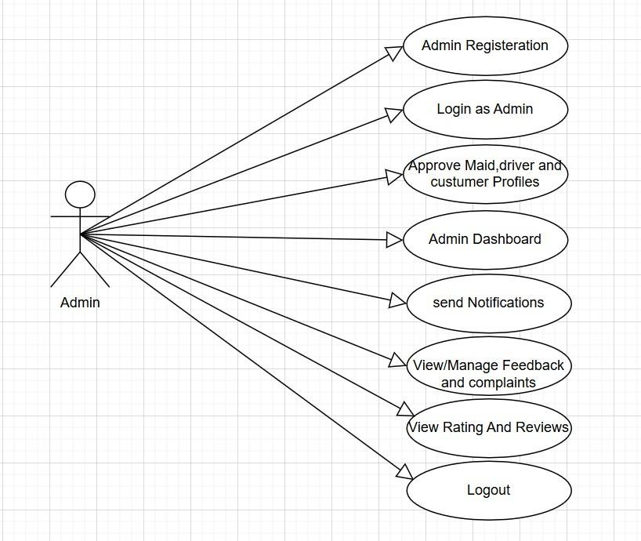

Customer Diagram
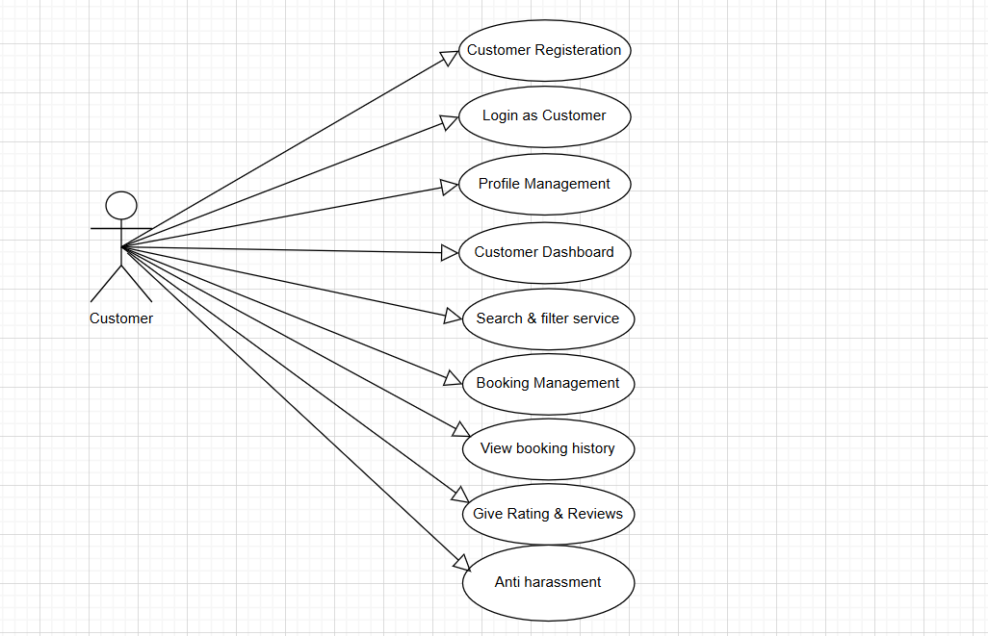

Maid Diagram
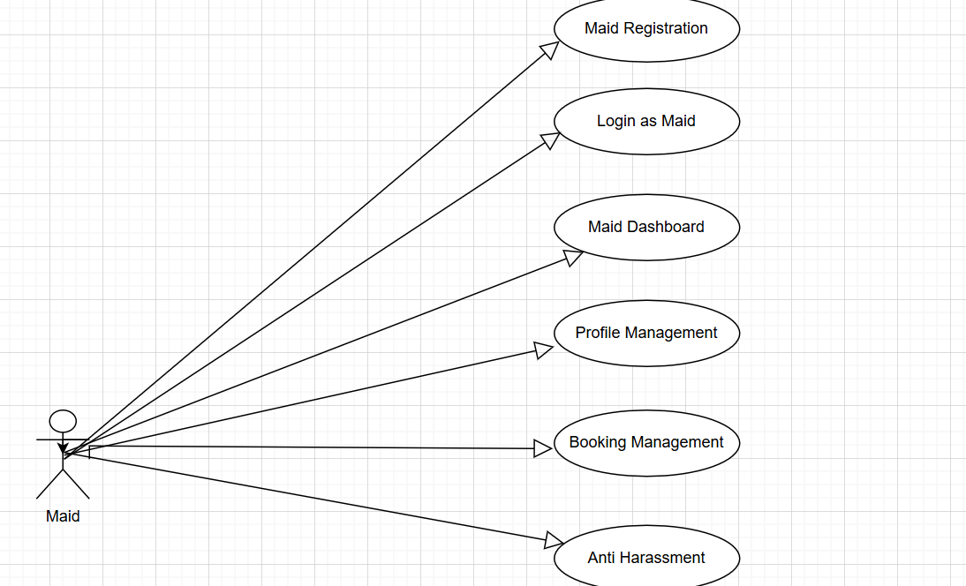

Driver Diagram
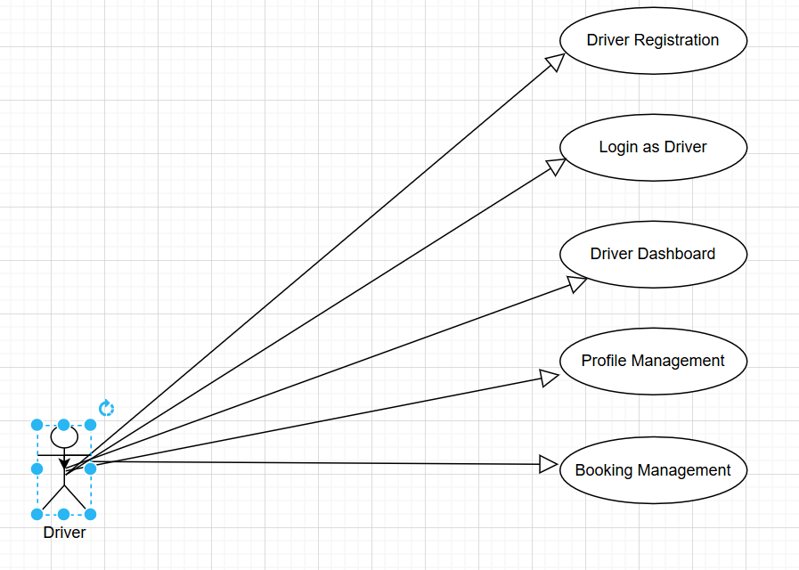

ERD Diagram
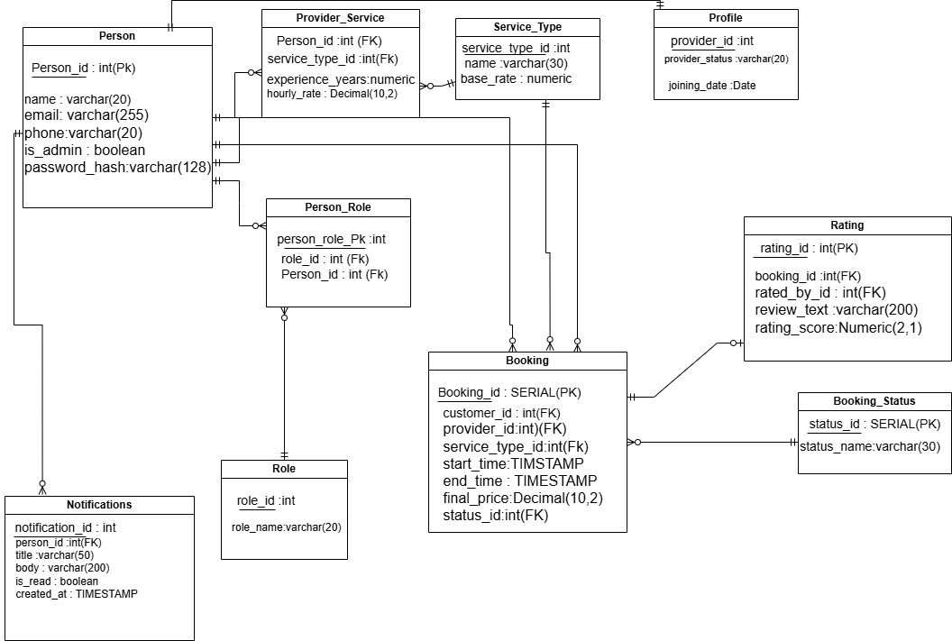

Software Design Specification

Introduction

Purpose
This Software Design Specification (SDS) document provides a detailed design description of the Broom and Zoom system. The purpose of this document is to define the system architecture, component design, data flow, and interaction between different modules of the system. This document serves as a guideline for developers, testers, and project stakeholders to understand how the system will be implemented at the design level.

Scope
Broom and Zoom is a mobile-based service platform designed to connect customers with verified household service providers such as maids and drivers. The system allows customers to search, book, and manage services, while service providers can register, manage availability, and receive service requests. Administrators control the system by managing users, approving service providers, handling complaints, and ensuring system security.
The system focuses on:
- Efficient service booking and management
- Secure user authentication
- Role-based access control
- Safety and verification mechanisms
- Smooth communication between users and service providers

Definitions, Acronyms, and Abbreviations
Term | Description
SDS | Software Design Specification
SRS | Software Requirements Specification
Admin | System administrator responsible for system management
Customer | User who books maid or driver services
Maid | Service provider offering household services
Driver | Service provider offering driving services
OTP | One-Time Password used for verification
UI | User Interface
API | Application Programming Interface

Document Overview
This Software Design Specification (SDS) document is structured to provide a clear and comprehensive understanding of the technical and functional design of the Broom and Zoom system. The document is organized into the following sections:

- Introduction: Describes the purpose, scope, definitions, and overall context of the Broom and Zoom system, offering a foundational understanding of the project objectives.
- System Architecture: Presents an overview of the system’s architectural design, including major components, layered structure, and interaction between the client, server, and database.
- System Module Design: Details the core modules of the system such as user management, service booking, payment handling, safety features, and administrative controls.
- Interface Design: Explains the user interface design for customers, maids, drivers, and administrators, focusing on usability, navigation, and interaction flow.
- Database Design: Describes the data structures, entities, and relationships required to store and manage system data efficiently and securely.
- Security and Control Mechanisms: Defines authentication, authorization, data protection, and safety features implemented to ensure system reliability and user trust.
- Testing and Validation: Outlines the testing strategies used to verify system functionality, performance, and reliability.
- Glossary and References: Provides definitions of technical terms and references used throughout the document for better clarity.
- Each section is designed to address the needs of developers, testers, and stakeholders, enabling efficient understanding, implementation, and maintenance of the Broom and Zoom system.

System Architecture Design

Section Overview
This section provides a detailed description of the architectural design of the Broom and Zoom system. It covers the following aspects:
- General Constraints: Key limitations and conditions that influence the system design and implementation.
- Data Design: An overview of how system data is structured, stored, and managed.
- Program Structure: Description of the overall architectural framework and interaction between system components.
- Alternatives Considered: Discussion of different design approaches evaluated and the rationale behind the selected solution.

General Constraints
The design of the Broom and Zoom system is influenced by the following global constraints:

- Hardware Constraints: The system must operate efficiently on commonly available mobile devices, including Android smartphones, as well as standard desktop and laptop systems used by administrators.
- Software Environment: The system is developed as a mobile application supported by a backend server and a centralized database. The chosen software technologies define the architectural structure, scalability, and maintainability of the system.
- Interface Requirements: The system must provide an intuitive and responsive user interface for customers, maids, drivers, and administrators. It should support smooth interaction across different screen sizes and devices.
- Performance Requirements: The system should handle multiple concurrent users efficiently. Booking requests, notifications, and real-time status updates must be processed with minimal delay to ensure a reliable user experience.
- Network Requirements: A stable internet connection is required for core functionalities such as user authentication, service booking, real-time updates, and data synchronization between the client application and the server.
- Security Constraints: The system must implement strong security mechanisms, including secure authentication, role-based access control, and data protection techniques, to safeguard sensitive user information and system resources.


Data Design

Program Structure

User Management
Sign Up/Login: Users can register as Customer, Maid, or Driver. Maid and Driver accounts. require admin verification before activation. Secure login functionality with role-based access control for different user types.
Account Settings: Users can update personal profile information such as name, phone number, and address. Password change and account recovery options are available. Service providers can manage availability status.

Service Booking Module
Browse Services: Customers can browse available maid and driver services based on service type and availability.
Book Service: Customers can create service bookings by selecting date, time, and service provider. Booking status is updated throughout the service lifecycle (pending, accepted, completed).

Payment Module
Payment Processing: Customers can pay using supported payment methods such as cash on delivery or online payment. Payment status is updated after successful transaction.
Invoice Generation: The system generates a booking invoice after payment confirmation.

Rating and Review Module
Submit Reviews: Customers can rate and review maids or drivers after service completion.
View Feedback: Service providers can view ratings and feedback to improve service quality.

Safety and Emergency Module
Emergency Button: Customers and service providers can trigger an emergency request during active bookings. Emergency alerts are forwarded to the admin for immediate action.

Complaint Management Module
Submit Complaints: Users can submit complaints regarding services or system issues.
Complaint Resolution: Admin reviews complaints and updates their status accordingly.

Admin Module
User Verification: Admin reviews and approves or rejects maid and driver registration requests.
System Management: Admin manages users, bookings, complaints, and monitors overall system activity.

Core Functionalities
Role-Based Access Control: System functionalities are restricted based on user roles (Customer, Maid, Driver, Admin).
Responsive Design: The application interface adapts to different screen sizes, ensuring usability on mobile devices.
Real-Time Updates: Booking status updates and notifications are delivered in real time.

Alternatives Considered

Monolithic Architecture:
Description: In this approach, all system components such as user interfaces, business logic, and database operations are tightly integrated into a single unified application.
Advantages: Simpler initial development and deployment process. Easier to manage for small-scale applications. Minimal communication overhead between components.
Disadvantages: Difficult to scale as system functionality increases. High coupling makes maintenance and updates challenging. Limited flexibility in modifying individual features.
Reason for Rejection: This approach was rejected because Broom and Zoom requires modular handling of multiple user roles, service bookings, payments, and safety features, which would be difficult to manage in a tightly coupled system.

Microservices Architecture
Description: This architecture divides the system into independent services, such as user management, booking management, payment processing, and complaint handling, each running as a separate service.
Advantages: High scalability and flexibility. Independent development and deployment of services. Better fault isolation.
Disadvantages: Complex to design, deploy, and maintain. Requires advanced infrastructure and service orchestration. Increased communication overhead between services. Reason for Rejection: Microservices architecture was not selected due to its complexity and operational overhead, which is unsuitable for a medium-scale academic project and initial deployment of the Broom and Zoom platform.

Layered Architecture (Chosen)
Description: The system is organized into distinct layers, including the presentation layer (user interface), application layer (business logic), and data layer (database management).
Advantages: Clear separation of concerns between system components. Easier maintenance and scalability. Supports role-based access control and secure data handling. Simplifies testing and future enhancements.
Disadvantages: Slight performance overhead due to layered processing. Reason for Selection: Layered architecture provides the best balance between simplicity and scalability. It effectively supports the diverse functionalities of Broom and Zoom, including multi-role user management, service booking, payment handling, and safety mechanisms, making it the most suitable choice for the system.

Detailed Description of Components

System Overview
This section provides a detailed description of the major components of the Broom and Zoom system. It explains the purpose, functionality, and internal behavior of each component involved in the system. The section focuses on how individual modules interact with each other and how they collectively contribute to the overall system operation. Each component is described in terms of its responsibilities, processing logic, dependencies, interfaces, and data handling mechanisms. The design highlights how user requests are processed, how data flows between different modules, and how system resources are utilized. The objective of this section is to ensure a clear understanding of the internal structure of the system, enabling developers, testers, and stakeholders to comprehend how each component supports the system’s core functionalities such as user management, service booking, safety features, and administrative control.

Component And Detail
The Broom and Zoom system is divided into major components including the Mobile Application, Backend Server, Database, and External Services. The mobile application (Flutter) handles user interaction, role-based dashboards, and service booking features. The backend (Node.js with Express) manages business logic, authentication, booking processing, and admin controls. MongoDB stores user data, bookings, feedback, and reports, while external services like Google Maps, JWT, and One Signal support location, security, and notifications.

Customer Sign Up

Identification | The unique name for the component is Customer Sign Up located on the customer registration screen of the Broom and Zoom mobile application.
Type | Module: Handles customer account creation and role assignment.
Purpose | Allows new customers to register on the platform to book maid and driver services.  Ensures secure authentication and proper role-based access for customers.
Function | Handles: Customer registration using email and phone number. Password creation and validation Role assignment as Customer  Processes: Input validation for mandatory fields (name, email, phone, password, address)  Outputs: Error messages for invalid inputs or existing email/phone number Success message on successful account creation
Subordinates | Consists of subcomponents:  Input Validator: Validates required fields and formats Account Creator: Creates customer profile  Password Hasher: Secures customer password
Dependencies | Relies on: Database for storing customer information  Password hashing service for secure storage  Interaction: Database interaction to check existing users  Stores customer role and profile data
Interfaces | External Interface: None  Internal Interface: Database for storing customer records  User Interface: Input fields for name, email, phone, address, and password: Error messages for invalid or missing data  Confirmation message after successful registration
Resources | Requires: CPU processing for validation and encryption  Network access for database communication  Database storage for customer data
Processing | Follows these steps:  Validate customer input fields  Check email and phone uniqueness  Hash the password  Store customer data in the database  Redirect customer to login screen
Data | Handles and stores in the database:  Customer Name Email Address Phone Number Home Address Hashed Password  User Role (Customer) Data Representation:  Data is entered through text fields and securely stored in the database.

Identification | The unique name for the component is Maid Sign Up located on the maid registration screen of the Broom and Zoom mobile application.
Type | Module: Handles maid account creation and role assignment.
Purpose | Allows service providers (maids) to register on the platform to offer cleaning and household services. Ensures proper verification and role-based access for maids.
Function | Handles:  Maid registration with personal/professional details, password validation, and role assignment.  Processes:  Input validation for mandatory fields.  Outputs: Error/Success messages.
Subordinates | Consists of subcomponents: Input Validator (validates details), Profile Creator (creates service profile), and Password Hasher (secures password).
Dependencies | Relies on:  Database for storage and password hashing service. Interaction:  Database checks for existing accounts and stores profile/role data.
Interfaces | External: None.  Internal: Database for records. User Interface:  Input fields (Name, Email, Phone, CNIC, Experience, Password), error and confirmation messages.
Resources | Requires: CPU execution time for validation/encryption, Network access for database operations, and Database storage for maid data.
Processing | Follows these steps:  - Validate inputs,  - Check uniqueness (Email/Phone),  - Hash password,  - Store data in database,  Redirect to login screen.
Data | Handles and stores:  Maid Name, Email, Phone, CNIC, Experience, Hashed Password, User Role.  Representation:  Entered via text fields and stored securely.

Maid Sign Up

Identification | The unique name for the component is “Driver Sign Up”, located on the driver registration screen of the Broom and Zoom mobile application.
Type | Module: Handles driver account creation and role assignment.
Purpose | Allows drivers to register on the platform to provide driving services to customers. Ensures secure registration and correct role-based access for drivers.
Function | Handles:  Driver registration (personal/license), password validation, and role assignment.  Processes: Input validation for mandatory fields. Outputs: Error/Success messages.
Subordinates | Consists of subcomponents: Input Validator (validates driver info), Profile Creator (creates driver profile), and Password Hasher (encrypts password).

Driver Signup
Dependencies | Relies on: Database for storage and password hashing service.  Interaction: Database verification for existing accounts and stores driver profile/role.
Interfaces | External: None.  Internal: Database for records. User Interface:  Input fields (Name, Email, Phone, CNIC, License, Password), error and confirmation messages.
Resources | Requires:  CPU processing for validation/encryption, Network access for database communication, and Database storage for driver data.
Processing | Follows these steps:  - Validate driver details,  - Check uniqueness (Email/Phone),  - Hash password,  - Save data in database,  - Redirect to login screen.
Data | Handles and stores:  Driver Name, Email, Phone, CNIC,  Hashed Password, and User Role.  Representation:  Entered via text fields and securely stored.

Login

Identification | The unique name for the component is “User Login”, located on the main login screen of the Broom and Zoom mobile application.
Type | Module:  Handles authentication and role-based redirection for all users.
Purpose | Allows registered users (Customer, Maid, Driver, Admin) to log in using valid credentials and ensures secure redirection to dashboards.
Function | Handles: User login, role-based access control, and secure authentication. Processes:  Input validation and credential verification. Outputs:  Error messages or role-specific dashboard redirection.
Subordinates | Consists of subcomponents: Credential Validator (verifies inputs), Authentication Handler (matches credentials), and Role Redirector (directs to correct dashboard).
Dependencies | Relies on:  Database for verification and password hashing service.
Interaction:
Database lookup for roles and session/token generation after login.
Interfaces | External: None.  Internal: Database for authentication data.  User Interface: Email/Password input fields, error messages, and successful login confirmation.
Resources | Requires: CPU processing for authentication, Network access for database queries, and Memory for session or token handling.
Processing | Follows these steps:  - Accept/Validate inputs,  - Verify credentials with database,  - Identify user role,  - Redirect user to respective dashboard.
Data | Handles and retrieves:  Email Address, Hashed Password,  User Role (Customer, Maid, Driver, Admin). Representation:  Processed securely via text fields.

Customer Dashboard
Identification | The unique name for the component is “Customer Dashboard”, accessible after successful customer login in the Broom and Zoom mobile application.
Type | Module: Provides customer access to system features and account overview.
Purpose | Allows customers to view available services, manage bookings, and access account-related features from a single screen. Acts as the main interaction point.
Function | Handles:  Viewing services (maid/driver), booking, payment, and feedback options. Processes: Loading customer-specific data.  Outputs: Display of dashboard features.
Subordinates | Consists of subcomponents: Service Viewer (displays services), Booking Access Panel (booking options), and Profile Access (account management).  Fetch customer data from database,  Display available services and options,  Allow navigation to features.
Data | Handles and retrieves: Customer profile, booking history, feedback records.  Representation: Displayed using lists,  Cards  text fields.

Identification | The unique name for the component is “Search Maid / Driver”, accessible from the Customer Dashboard in the Broom and Zoom mobile application.
Type | Module: Handles service searching and filtering functionality.
Purpose | Allows customers to search for available maids or drivers based on their requirements to find suitable service providers quickly.
Function | Handles: Searching services, filtering by location/availability, and viewing details.  Processes: Fetching data and applying criteria. Outputs: List of providers or "not found" message.
Subordinates | Consists of subcomponents: Search Handler (processes requests), Filter Manager (applies filters), and Result Viewer (displays results).
Dependencies | Relies on:  Database for provider data and Location service for nearby searches. Interaction:  Fetches records and displays filtered results to the customer.
Interfaces | External: Location service (if enabled). Internal: Database for data retrieval.  User Interface: Search bar, filter options, results list, and booking selection.
Resources | Requires: CPU processing for search operations, Network access for database queries, and Memory for result handling.
Processing | Follows these steps:  - Enter search criteria,  - Fetch relevant providers from database,  - Apply filters to the data,  - Display results to the customer.
Data | Handles and retrieves:  Maid/driver profiles, availability status, and location information. Representation:  Results are displayed in list or card format on the screen.

Search Maid/Driver

Service Booking
Identification | The unique name for the component is “Service Booking”, accessible after selecting a maid or driver from search results in the Broom and Zoom mobile application.
Type | Module: Handles creation and management of service bookings.
Purpose | Allows customers to book services by selecting date, time, and details. Ensures accurate booking information and proper communication with providers.
Function | Handles:  Creating booking requests, selecting service type/date/time, and assigning tasks.  Processes: Validating and storing details. Outputs: Confirmation or error messages.
Subordinates | Consists of subcomponents: Booking Validator (validates inputs), Booking Creator (generates record), and Notification Trigger (notifies provider).
Dependencies | Relies on:  Database for storage and Notification service for alerts. Interaction:  Stores requests in database and sends notifications to maids or drivers.
Interfaces | External: Notification service.  Internal: Database for booking records.  User Interface: Booking form, confirmation/error messages, and status display.
Resources | Requires:  CPU processing for validation, Network access for database operations, and Database storage for booking data.
Processing | Follows these steps:  - Select provider,  - Enter booking details,  - Validate information,  - Save in database,  - Notify service provider.
Data | Handles and stores:  Booking ID, Customer ID, Maid/Driver ID, Service type, Date/Time, Status.  Representation:  Entered via forms and stored securely.

Booking Management

Identification | The unique name for the component is “Booking Management”, accessible from the Customer Dashboard in the Broom and Zoom mobile application.
Type | Module: Handles viewing, updating, and managing customer bookings.
Purpose | Allows customers to view details, track status, and cancel bookings. Provides complete control over history and current services.
Function | Handles: Viewing active/completed bookings and history. Processes: Retrieving records and updating status.  Outputs: Booking details and cancellation confirmation.
Subordinates | Consists of subcomponents: Booking Viewer (displays info), Status Manager (updates status), and Cancellation Handler (processes cancellation).
Dependencies | Relies on:  Database for retrieval and Authentication module for validation. Interaction:  Fetches data linked to account and updates status.
Interfaces | External: None.  Internal: Database for management.  User Interface: List of bookings, status indicators, and cancel options.
Resources | Requires:  CPU processing for data handling, Network access for communication, and Database storage for records.
Processing | Follows these steps:  - Access management screen,  - Retrieve records,  - Display details/status,  - Process cancellation if requested,  - Update database.
Data | Handles and updates:  Booking ID, Customer ID, Provider ID, Date/Time, Status.  Representation:  Displayed in list and detail view formats.

Feedback and Rating
Identification | The unique name for the component is “Feedback and Rating”, accessible after service completion from the Customer Dashboard in the Broom and Zoom mobile application.
Type | Module: Handles customer feedback and rating for completed services.
Purpose | Allows customers to provide feedback and ratings for maids or drivers to improve service quality and maintain trust within the platform.
Function | Submitting feedback comments, rating services, and viewing submitted feedback.  Processes: Input validation and data storage. Outputs: Confirmation or error messages.

Maid Dashboard
Identification | The unique name for the component is “Maid Dashboard”, accessible after successful maid login in the Broom and Zoom mobile application.
Type | Module: Provides maids access to service requests and profile management.
Purpose | Allows maids to view booking requests, manage service status, and access profile information. Acts as the main control panel for maid users.
Function | Handles:  Viewing booking requests, managing accepted/completed services, and profile access.  Processes:  Loading maid-specific data. Outputs:  Dashboard feature display.

Subordinates | Consists of subcomponents: Feedback Validator (validates inputs), Rating Handler (manages values), and Feedback Recorder (stores data).
Dependencies | Relies on:  Database for storage and Booking module to verify completion. Interaction:  Associates feedback with bookings and updates provider ratings.
Interfaces | External: None.  Internal: Database for feedback management.  User Interface: Rating scale (stars), feedback text area, and submit button.
Resources | Requires:  CPU processing for validation, Network access for database operations, and Database storage for feedback records.
Processing | Follows these steps: Select completed booking, Enter rating/comments, Validate input,  Save in database, Display confirmation.
Data | Handles and stores:  Feedback ID, Booking ID, Customer ID, Provider ID, Rating value, Comments.  Representation:  Entered via rating controls and text fields.

Subordinates | Consists of subcomponents: Booking Request Viewer (displays requests), Service Status Panel (shows progress), and Profile Manager (manages profile).
Dependencies | Relies on:  Database for data/bookings and Authentication module for validation. Interaction:  Fetches linked requests and redirects to selected modules.
Interfaces | External: None.  Internal: Database for data retrieval.  User Interface: Dashboard screen with request list, status indicators, profile, and logout options.
Resources | Requires:  CPU processing for data loading, Network access for database communication, and Memory for session handling.
Processing | Follows these steps:  - Verify authenticated session,  - Retrieve booking requests from database,  - Display dashboard options,  - Allow navigation to features.
Data | Handles and retrieves:  Maid profile info, booking request details, service status records. Representation:  Displayed using lists and status indicators.

View Booking Request
Identification | The unique name for the component is “View Booking Requests”, accessible from the Maid Dashboard in the Broom and Zoom mobile application.
Type | Module: Handles display of customer booking requests for maids.
Purpose | Allows maids to view incoming service booking requests from customers and helps them decide whether to accept or reject a booking.
Function | Handles:  Displaying pending requests, viewing customer/service details, and access to accept/reject options.  Processes: Retrieving and filtering requests. Outputs: List of requests or notification.
Subordinates | Consists of subcomponents: Request Viewer (displays requests), Request Filter (filters by status), and Detail Viewer (shows specific details).
Dependencies | Relies on:  Database for retrieving requests and Authentication module for maid access. Interaction:  Fetches pending requests assigned to the maid and provides details.
Interfaces | External: None.  Internal: Database for booking request retrieval.  User Interface: List of requests with details, accept/reject buttons, and detail view screen.
Resources | Requires:  CPU processing for data retrieval, Network access for database communication, and Memory for request handling.
Processing | Follows these steps:  - Access booking request screen,  - Retrieve pending requests,  - Display request details,  Provide options to accept or reject.
Data | Handles and retrieves:  Booking ID, Customer details, Service date and time, and Booking status. Representation:  Displayed in list and detail formats.

Identification | The unique name for the component is “Accept / Reject Booking”, accessible from the booking request details screen in the Broom and Zoom mobile application.
Type | Module: Handles maid decision-making for customer booking requests.
Purpose | Allows maids to accept or reject incoming booking requests based on availability. Ensures customers are informed about the booking decision.
Function | Handles:  Accepting/rejecting booking requests and updating status. Processes: Validating request status and updating the database. Outputs: Confirmation messages and updated status for customers.
Subordinates | Consists of subcomponents: Decision Handler (processes actions), Status Updater (updates status), and Notification Trigger (notifies customer).
Dependencies | Relies on:  Database for status updates and Notification service for customer alerts. Interaction:  Updates booking status in database and sends notifications to customers.
Interfaces | External: Notification service.  Internal: Database for booking status management. User Interface:  Accept/Reject buttons, decision confirmation, and updated status view.
Resources | Requires:  CPU processing for status updates, Network access for database communication, and Database storage for booking status.
Processing | Follows these steps:  Maid selects a request,  Choose accept or reject option, System updates booking status, Notify customer of decision.
Data | Handles and updates:

Accept / Reject Booking (Maid)

Service Status Update Maid
Identification | The unique name for the component is “Service Status Update”, accessible after accepting a booking in the Broom and Zoom mobile application.
Type | Module: Handles updating the progress of maid services.
Purpose | Allows maids to update service status (In Progress, Completed) during and after execution to keep customers informed about service progress.
Function | Handles: Updating service status and marking service completion. Processes: Validating status changes and updating the database. Outputs: Confirmation messages and updated status for customers.
Subordinates | Consists of subcomponents: Status Validator (validates changes), Status Updater (updates service status), and Notification Trigger (notifies customer).
Dependencies | Relies on:  Database for status updates and Notification service for customer updates. Interaction:  Updates booking status and sends progress notifications.
Interfaces | External: Notification service.  Internal: Database for service status updates.  User Interface: Status update options (In Progress, Completed), confirmation messages, and status view.
Resources | Requires: CPU processing for validation, Network access for database operations, and Database storage for status records.
Processing | Follows these steps:  Select active booking, Choose service status, Update status in the database,  Notify customer of service progress.
Data | Handles and updates:  Booking ID, Maid ID, service status. Representation:  Stored as predefined status values in the database.

Driver Dashboard
Identification | The unique name for the component is “Driver Task Management”, accessible after login to the Broom & Zoom mobile application for drivers.
Type | Module: Handles driver tasks and delivery status updates.
Purpose | Allows drivers to view assigned tasks and update delivery progress. Keeps customers informed about delivery status.

Function | Handles:  Viewing assigned delivery tasks, updating status (On the Way, Delivered), and marking task completion.  Processes: Validating status changes.  Outputs: Updated status and confirmation messages.
Subordinates | Consists of subcomponents: Task Validator (validates changes), Task Updater (updates database), and Notification Trigger (sends notifications).
Dependencies | Relies on:  Database for updating delivery status and Notification service to inform customers.  Interaction: Updates status in database and sends progress notifications.
Interfaces | External: Notification service.  Internal: Database for delivery status updates.  User Interface: Task list, status update options, confirmation messages, and updated task status view.
Resources | Requires:  CPU processing for status validation, Network access for database operations, and Database storage for task records.
Processing | Follows these steps:  - Driver logs into the app,  - Selects assigned delivery task,  - Chooses delivery status,  - Updates status in the database,  - Notifies customer.
Data | Handles and updates:  Booking ID, Driver ID, Delivery status. Representation:  Delivery status is stored as predefined status values in the database.

View Ride Requests
Identification | The unique name for the component is “View Ride Requests”, accessible from the Driver Dashboard in the Broom & Zoom mobile application.
Type | Module: Handles displaying and managing ride requests assigned to the driver.
Purpose | Allows drivers to see all pending and accepted ride requests. Helps drivers choose and accept new ride requests efficiently.
Function | Handles:  Displaying available ride requests, accepting/rejecting requests, and showing details (pickup, destination, customer info).  Processes:  Fetching and validating requests. Outputs:  Updated status and confirmation.

Subordinates | Consists of subcomponents: Request Fetcher (retrieves data), Eligibility Validator (checks driver ability), Status Updater (updates status), and Notification Trigger (notifies customer).
Dependencies | Relies on:  Database for ride requests and Notification service for customer updates. Interaction:  Updates status in database and sends acceptance/rejection notifications.
Interfaces | External: Notification service.  Internal: Database for requests and status updates.  User Interface: List of requests with details, Accept/Reject buttons, and confirmation messages.
Resources | Requires:  CPU processing for fetching/validating, Network access for database operations, and Database storage for ride requests and statuses.
Processing | Follows these steps:  - Open Dashboard,  - Select “View Ride Requests”,  - System fetches pending requests,  - Driver accepts or rejects,  - System updates database and notifies customer.
Data | Handles and updates:  Ride Request ID, Driver ID, Customer ID,  Ride status (Pending / Accepted / Rejected). Representation:  Stored with predefined status values in the database.

Accept / Reject Ride
Identification | The unique name for the component is “Accept / Reject Ride”, accessible from the Driver Dashboard after viewing ride requests in the Broom & Zoom mobile application.
Type | Module: Handles driver’s decision to accept or reject assigned ride requests.
Purpose | Allows drivers to respond to ride requests by accepting or rejecting them. Updates ride status in real-time and keeps customers informed.
Function | Handles:  Accepting/rejecting ride requests and notifying customers. Processes: Validating driver action and updating the database.  Outputs: Updated status (Accepted/Rejected) and driver confirmation.
Subordinates | Consists of subcomponents: Action Validator (validates choice), Status Updater (updates database), and Notification Trigger (notifies customer).
Dependencies | Relies on:  Database for ride request status updates and Notification service to inform the customer.  Interaction: Updates status in the database and sends notifications.

Interfaces | External: Notification service.  Internal: Database for ride request management. User Interface:  Accept/Reject buttons, confirmation messages, and updated status view.
Resources | Requires:  CPU processing for validating action, Network access for database operations, and Database storage for ride request records.
Processing | Follows these steps:  - Driver views requests,  - Chooses Accept or Reject,  - System validates action,  - Database updates status,  - Customer receives notification.
Data | Handles and updates:  Ride Request ID, Driver ID, Customer ID,  Ride Status (Accepted / Rejected). Representation:  Stored as predefined values in the database.

Trip Status Update
Identification | The unique name for the component is “Trip Status Update”, accessible from  the Driver Dashboard after accepting a ride in the Broom & Zoom mobile application.
Type | Module: Handles updating the progress of the driver’s trip during and after the ride.
Purpose | Allows drivers to update the trip status in real-time (e.g., On the Way, Completed) to keep customers informed about the progress of their ride.
Function | Handles:  Updating trip status and marking completion.  Processes: Validating status changes and updating the database. Outputs: Updated status for customer and driver confirmation.
Subordinates | Consists of subcomponents: Status Validator (validates changes), Status Updater (updates database), and Notification Trigger (notifies customer).
Dependencies | Relies on:  Database for updating trip status and Notification service to inform the customer.  Interaction: Updates status in the database and sends real-time notifications.
Interfaces | External: Notification service.  Internal: Database for trip status updates.  User Interface: Status update options (On the Way, Completed), confirmation messages, and status view.
Resources | Requires:

 | CPU processing for status validation, Network access for database operations, and Database storage for trip status records.
Processing | Follows these steps:  Select active ride,  Choose current status (On the Way / Completed), Update status in database,  System triggers customer notification.
Data | Handles and updates:  Ride/Booking ID, Driver ID,  Trip Status.  Representation:  Trip status is stored as predefined status values in the database.

Admin Dashboard(User Management)
Identification | The unique name for the component is “User Management”, accessible from the Admin Dashboard in the Broom & Zoom application.
Type | Module: Handles creation, update, deletion, and management of all user accounts.
Purpose | Manage all registered users: Customers, Maids, and Drivers. Ensure only valid and authorized users can access the system.
Function | Handles:  Adding, editing, deleting, or suspending users and filtering search. Processes: Validating user info and updating records.  Outputs: Updated user list and confirmation.
Subordinates | Consists of subcomponents: User Validator (validates input), User Updater (updates records), and Notification Trigger (sends alerts).
Dependencies | Relies on:  Database for storage and an optional Notification service for user alerts. Interaction:  Updates user records and sends notifications if required.
Interfaces | External: Notification service. Internal: Database.  User Interface: User list with search/filters, Add/Edit/Delete buttons, and confirmation messages.
Resources | Requires:  CPU processing for validations and Network access for database operations.
Processing | Follows these steps:  - Open User Management panel,  - Select action (Add/Edit/Delete),  - Validate input,  - Update database  - show confirmation.
Data | Handles and updates: User ID,
Name, Email, Phone,
Role (Customer/Maid/Driver), Account Status.
Representation:
Stored with predefined roles and status values.

Service Approval & Verification
Identification | The unique name for the component is “Service Approval & Verification”, accessible from the Admin Dashboard.
Type | Module:  Handles approval and verification of service listings submitted by Maids.
Purpose | Ensure only verified services are available to customers. Review and approve/reject maid-submitted services.
Function | Handles: Approve/reject service requests and verify credentials. Processes: Validate service info and update database.  Outputs: Status updates and notifications.
Subordinates | Consists of subcomponents: Service Validator (validates data), Status Updater (updates status), and Notification Trigger (notifies maid).
Dependencies | Relies on:  Database for service records and Notification service for decision updates. Interaction:  Updates status and sends notifications.
Interfaces | External: Notification service. Internal: Database.  User Interface:  List of pending requests, Approve/Reject buttons, and confirmation messages.
Resources | Requires:  CPU for validation/status updates and Network access for database operations.
Processing | Follows these steps:  - Admin views pending requests,  - Reviews details,  - Approves or rejects service,  - Database updated and maid notified.
Data | Handles and updates:  Service ID, Maid ID, Service details, Approval status. Representation:  Stored with predefined values (Approved/Rejected).

Booking Monitoring

Identification | The unique name for the component is “Booking Monitoring”, accessible from the Admin Dashboard.
Type | Module: Monitors all customer bookings.
Purpose | Allows admin to view booking statuses and helps detect issues to manage operations efficiently.
Function | Handles:  Viewing all bookings, filtering by status, and generating reports. Processes: Fetching records and displaying status details.  Outputs: Booking list and reports.
Subordinates | Consists of subcomponents: Booking Fetcher (retrieves data), Status Analyzer (checks progress), and Report Generator (creates reports).
Dependencies | Relies on: Database for booking data.  Interaction: Reads booking data and generates analytics/reports.
Interfaces | Internal: Database. User Interface:  Booking table with filters, status indicators, and search options.
Resources | Requires:  CPU for processing data and Network access for database.
Processing | Follows these steps: Open Monitoring panel, Fetch all bookings,  Filter or search bookings, Display status for analysis.
Data | Handles and updates:  - Booking ID,  - Customer ID,  - Maid/Driver ID,  - Service date/time,  - Booking status. Representation:  Stored with predefined status values.

Feedback Management
Identification | The unique name for the component is “Feedback Management”, accessible from the Admin Dashboard.
Type | Module: Handles customer and service feedback.
Purpose | Review feedback to improve service quality and resolve complaints efficiently.
Function | Handles:  Viewing customer feedback, responding/flagging, and analyzing ratings. Processes: Fetching and categorizing feedback.  Outputs: Reports and action notifications.
Subordinates | Consists of subcomponents: Feedback Fetcher (retrieves data), Feedback Analyzer (highlights issues), and Status Updater (updates feedback status).
Dependencies | Relies on:
Database for feedback and an optional Notification service for alerts. Interaction:
Reads and updates feedback in the database.
Interfaces | External: Notification system (optional). Internal: Database.  User Interface: Feedback list view, Respond/Flag options, and Search/Filter options.
Resources | Requires:  CPU processing for data categorization and Network access for database operations.
Processing | Follows these steps:  - Open Feedback panel,  - Fetch all feedback,  - Review and take actions,  - Update database and send notifications if needed.
Data | Handles and updates:  Feedback ID, Customer ID, Service ID, Feedback text, Status/Rating. Representation:  Stored with predefined status and rating values.

User Interface Design

Section Overview
This section describes the user interface design of the Broom and Zoom mobile application. It explains the design principles, graphical components, and overall layout used to ensure a smooth and user-friendly experience for all users. The interface has been designed separately for Customers, Maids, Drivers, and Admin, keeping simplicity, clarity, and usability in focus. This section includes:
Interface Design Rules: Design principles followed to ensure usability, responsiveness, and accessibility using Flutter.
GUI Components: Core UI components and services used in the application, including Flutter widgets and integrated APIs.
Detailed Description: Explanation of screen layouts, navigation flow, and major interface features supported by UI mockups and screenshots.

Interface Design Rules
The Broom and Zoom user interface follow standard mobile application design practices to provide an intuitive and efficient user experience:
Flutter Framework: Used to build a responsive and consistent user interface across Android devices.
Simplicity: Clean layouts with minimal clutter to help users easily understand and navigate the application.
User-Centric Design: Interfaces are designed keeping non-technical users in mind, ensuring ease of use for customers, maids, and drivers.
Consistency: Uniform color schemes, fonts, buttons, and layouts are used throughout the app to maintain visual consistency.
Accessibility: Clear text, readable fonts, and touch-friendly buttons are used to support all user types.
Role-Based UI: Different dashboards and screens are displayed based on the user role (Customer, Maid, Driver, Admin).

GUI Components
The following GUI components, frameworks, and services are used in the development of the Broom and Zoom application:
GUI Components: Flutter widgets such as Buttons, Text Fields, Cards, Lists, Forms, and Navigation Drawers are used to create responsive and interactive user interfaces.
Google Maps API: Used for location-based service search and displaying nearby maids and drivers.
WT Authentication: Ensures secure login and role-based access.
One Signal: Used for push notifications related to bookings, approvals, and emergency alerts.
Flutter is used for frontend mobile development, while Node.js with Express handles backend logic and API communication.
MongoDB is used to store user profiles, service details, booking records, ratings, and feedback data securely.

Detailed User Interface Description
The Broom and Zoom application interface is organized into multiple screens according to different user roles. Each role, including Customer, Maid, Driver, and Admin, is provided with a dedicated dashboard and relevant features to perform their tasks efficiently. The application includes authentication screens such as signup, login, role selection, OTP verification, and password recovery to ensure secure access. All screens are designed with clear navigation, real-time updates, and a user-friendly layout. UI screenshots and wireframes are included to visually demonstrate the interface structure and workflow.

Admin Home Page

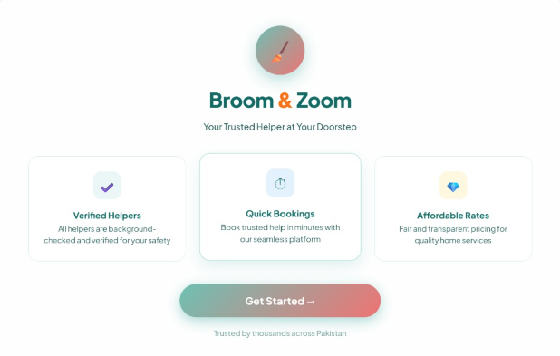

Admin Login Page

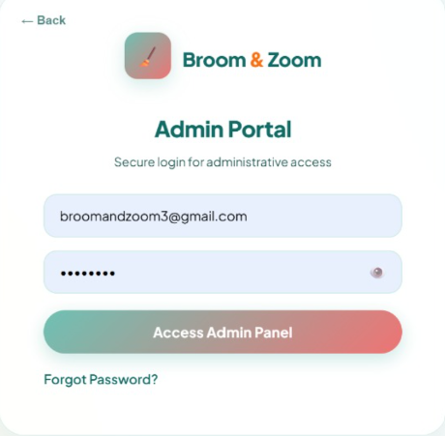

Admin Dashboard
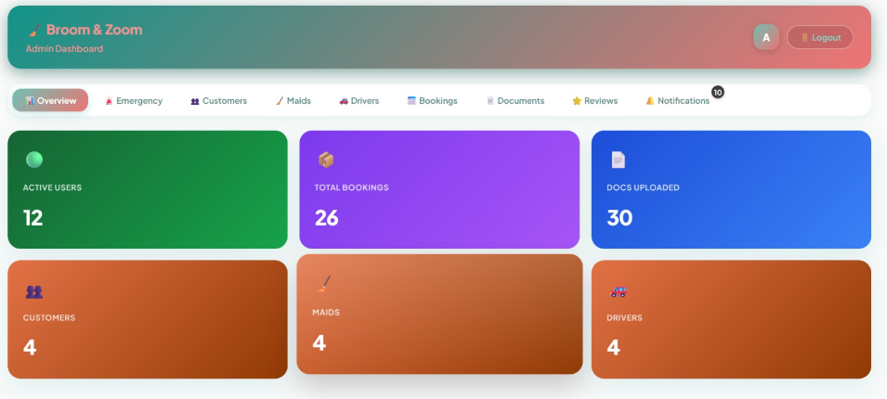

Emergency Request

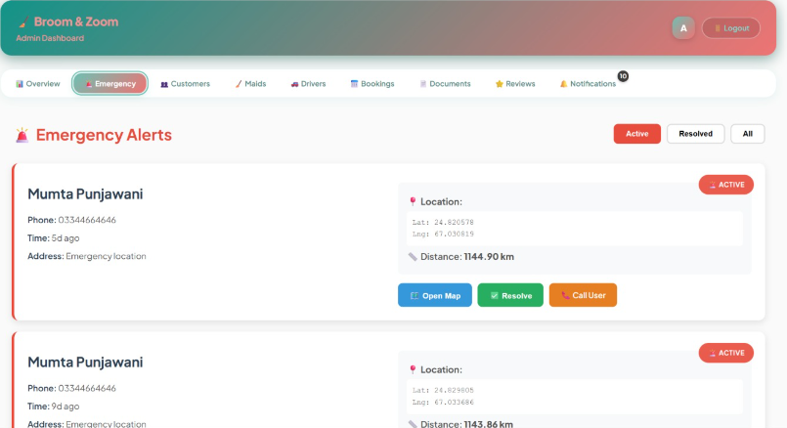

User Bookings
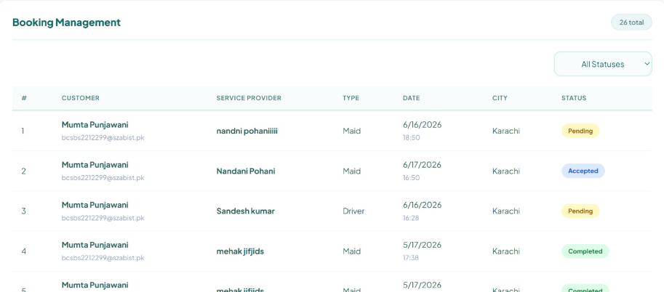

Customer Dashboard
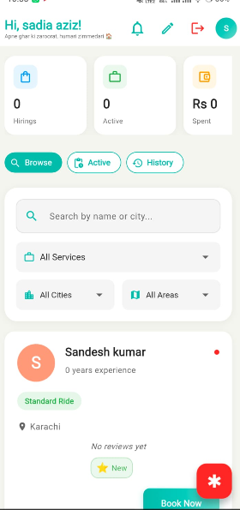

Driver Dashboard
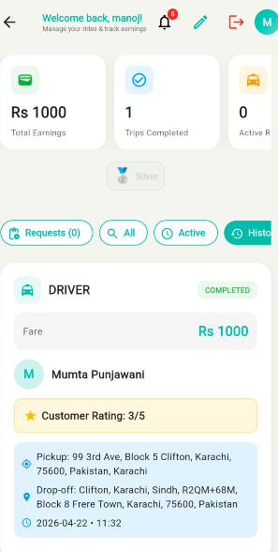

Notification
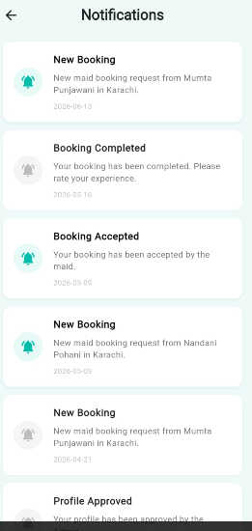

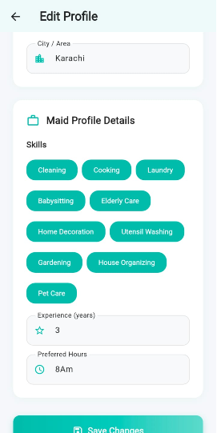
Maid Edit Profile

Language Page
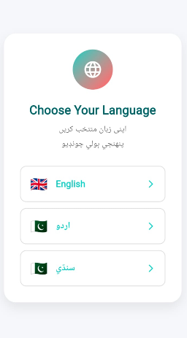

Reuse and Relationship to other products
Role in Product Design: The Broom and Zoom project applies reuse by using Flutter for UI development and Node.js with Express for backend services, ensuring consistent and efficient design practices.
Role in Product Implementation: Existing services such as Google Maps API and JWT authentication are reused to support location-based services and secure user access, reducing development time. Reuse is implemented through reusable Flutter widgets, which help maintain consistency across screens and minimize code duplication.
Motivation for Non-Reuse: Some components were not reused due to role-specific requirements or compatibility issues, and were developed separately to meet project needs.

Design Decisions and Tradeoffs
This section highlights the key design decisions made during the development of the Broom and Zoom application and the tradeoffs considered during the process:
Consistency vs Flexibility: A consistent user interface was implemented using reusable Flutter widgets to maintain uniformity across all screens, even though it limited customization for role-specific pages.
Performance vs Features: The design prioritizes application performance and smooth functionality over heavy animations to ensure fast loading and better performance on low-end mobile devices.
Mobile-First Design: A mobile-first approach was adopted to improve accessibility and ease of use, which required compromising on complex layouts designed for larger screens.
Abandoned Ideas: Features such as advanced animations and real-time video monitoring were excluded due to performance limitations and limited development resources.
These decisions reflect a balance between usability, performance, and efficient resource utilization.

Pseudocode for components

Login / Registration
BEGIN
STEP 1: RECEIVE user input: email, selected role (Customer / Maid / Driver) VALIDATE email:
Email is required
Email must be in valid format
Email must not already be registered
IF email validation fails THEN
RETURN error: "Invalid or already registered email"
ELSE
GENERATE OTP
SAVE OTP with expiry time SEND OTP to user's email DISPLAY OTP verification screen
END IF
STEP 2: RECEIVE OTP input VALIDATE OTP:
OTP must match the generated OTP
OTP must not be expired
IF OTP validation fails THEN
RETURN error: "Invalid or expired OTP" ELSE
DISPLAY registration form:
Name
Password
Contact number END IF
STEP 3: RECEIVE user input: name, password, contact number VALIDATE inputs:
Name is required
Password is required (minimum length: 4)
Contact number is required
IF validation fails THEN
RETURN validation errors ELSE
HASH the password
CREATE new user record with role, name, email, and hashed password SAVE user record to database
LOG registration activity
REDIRECT user to login screen with success message END IF

STEP 4: LOGIN PROCESS
RECEIVE login credentials: email, password VERIFY credentials
IF credentials are valid THEN GENERATE JWT token
REDIRECT user to role-based dashboard ELSE
RETURN error: "Invalid login credentials" END IF
CATCH any exceptions LOG error details
DISPLAY error message: "Login or registration failed. Please try again.
END

Admin(User Management)
BEGIN
STEP 1: SELECT user role (Customer, Maid, Driver) STEP 2: FETCH all users with selected role from database
FILTER users by: hasAccess = 0 → Pending
hasAccess = 1 → Approved hasAccess = 2 → Rejected
STEP 3: DISPLAY dashboard with Pending, Approved, and Rejected users lists
STEP 4: IF admin clicks "Approve" on a user THEN VALIDATE admin comments (must be provided) UPDATE user hasAccess = 1 in database
SEND approval email/notification to user DISPLAY success message
END IF
STEP 5: IF admin clicks "Reject" on a user THEN VALIDATE admin comments (must be provided) UPDATE user hasAccess = 2 in database
SEND rejection email/notification to user DISPLAY success message
END IF
CATCH exceptions LOG errors
DISPLAY "Action failed. Please try again." END

Maid (Service Status Update)
BEGIN
STEP 1: FETCH all bookings assigned to the maid FILTER bookings by:
status = Pending → Waiting to start status = InProgress → Currently working status = Completed → Finished
STEP 2: DISPLAY maid dashboard with bookings
STEP 3: IF maid updates booking status THEN
VALIDATE new status (Pending, InProgress, Completed) UPDATE booking status in database
NOTIFY customer about status update DISPLAY success message
END IF
CATCH exceptions LOG errors
DISPLAY "Status update failed. Please try again." END

Driver
BEGIN
STEP 1: FETCH all ride requests assigned to driver FILTER rides by:
status = Pending → Awaiting acceptance status = Accepted → Ride started
status = Completed → Ride finished
STEP 2: DISPLAY driver dashboard with ride requests
STEP 3: IF driver clicks "Accept" on a ride THEN
UPDATE ride status = Accepted NOTIFY customer about acceptance DISPLAY success message
END IF
STEP 4: IF driver clicks "Reject" on a ride THEN UPDATE ride status = Rejected
NOTIFY customer about rejection DISPLAY success message
END IF
STEP 5: IF driver updates ride progress THEN VALIDATE progress input
UPDATE ride status in database NOTIFY customer about progress DISPLAY success message
END IF
CATCH exceptions LOG errors
DISPLAY "Ride action failed. Please try again." END

Customer
BEGIN
STEP 1: RECEIVE booking input from customer INPUTS: service type, date, time, address VALIDATE all inputs (must not be empty or invalid)
IF validation fails THEN
DISPLAY error message: "Please fill all required fields" STOP
END IF
STEP 2: SAVE booking in database SET booking status = Pending
NOTIFY assigned maid/driver about new booking
DISPLAY confirmation message: "Booking created successfully"
STEP 3: IF customer cancels booking THEN UPDATE booking status = Cancelled NOTIFY maid/driver about cancellation
DISPLAY message: "Booking cancelled successfully"
CATCH exceptions LOG error details
DISPLAY error message: "Booking failed. Please try again." END

Booking Management
BEGIN
STEP 1: RECEIVE booking input from customer INPUTS: service type, date, time, address VALIDATE all inputs (must not be empty)
IF validation fails THEN
DISPLAY error message: "Please fill all required fields" STOP
END IF
STEP 2: SAVE booking in database SET booking status = Pending
NOTIFY assigned maid/driver about new booking DISPLAY message: "Booking created successfully"
STEP 3: IF customer cancels booking THEN UPDATE booking status = Cancelled NOTIFY maid/driver about cancellation
DISPLAY message: "Booking cancelled successfully"
CATCH exceptions LOG error details
DISPLAY message: "Booking action failed. Please try again." END

Maid/Driver Approval
BEGIN
STEP 1: FETCH all pending maids/drivers from database FILTER users where hasAccess = 0
STEP 2: DISPLAY list of pending maids/drivers in admin dashboard
STEP 3: IF admin clicks "Approve" THEN VALIDATE admin comments (required) UPDATE user has Access = 1 in database SEND approval notification/email DISPLAY success message
END IF
STEP 4: IF admin clicks "Reject" THEN VALIDATE admin comments (required) UPDATE user has Access = 2 in database SEND rejection notification/email DISPLAY success message
END IF
CATCH exceptions LOG errors
DISPLAY message: "Approval action failed. Please try again." END

Service Status Update (Maid/Driver)
BEGIN
STEP 1: FETCH all bookings/assigned tasks
FILTER by status: Pending, InProgress, Completed STEP 2: DISPLAY tasks in dashboard
STEP 3: IF maid/driver updates status THEN
VALIDATE new status (Pending, InProgress, Completed) UPDATE booking status in database
NOTIFY customer about status update
DISPLAY message: "Status updated successfully" END IF
CATCH exceptions LOG errors
DISPLAY message: "Status update failed. Please try again." END

Emergency Button (Customer Maid)
BEGIN

STEP 1: IF customer clicks "Emergency" THEN CAPTURE current booking/location details SEND alert to assigned maid/driver
SEND alert to admin
DISPLAY message: "Emergency alert sent successfully" END IF
CATCH exceptions LOG errors
DISPLAY message: "Failed to send emergency alert. Try again." END
STEP 2: IF maid clicks "Emergency" THEN CAPTURE current service/booking details SEND alert to assigned customer
SEND alert to admin
DISPLAY message: "Emergency alert sent successfully" END IF
CATCH exceptions LOG errors
DISPLAY message: "Failed to send emergency alert. Try again." END

Feedback & Rating
BEGIN
STEP 1: DISPLAY completed bookings for customer
STEP 2: RECEIVE feedback and rating input INPUTS: rating (1-5), comments
VALIDATE inputs (rating required, comments optional) IF validation fails THEN
DISPLAY error message: "Please provide valid rating" STOP
END IF
STEP 3: SAVE feedback and rating in database DISPLAY message: "Feedback submitted successfully"
CATCH exceptions LOG errors
DISPLAY message: "Failed to submit feedback. Try again." END

Design Diagrams

Class Diagram

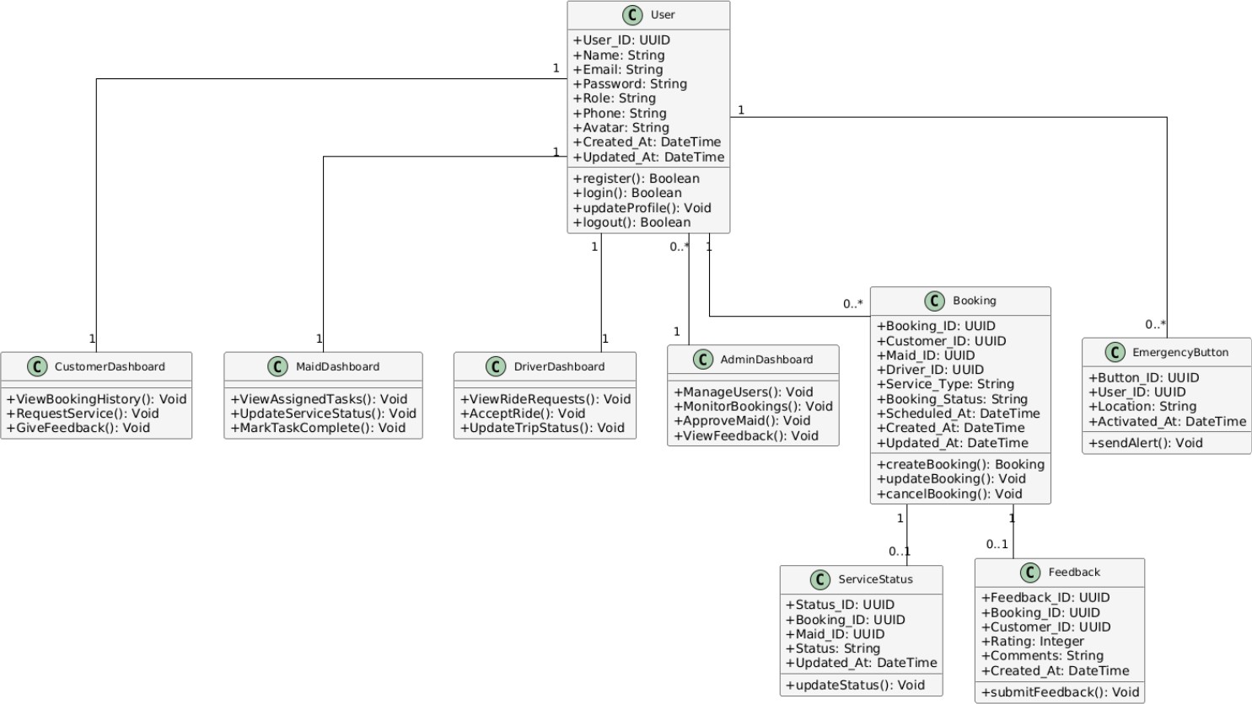

State Chart Diagrams

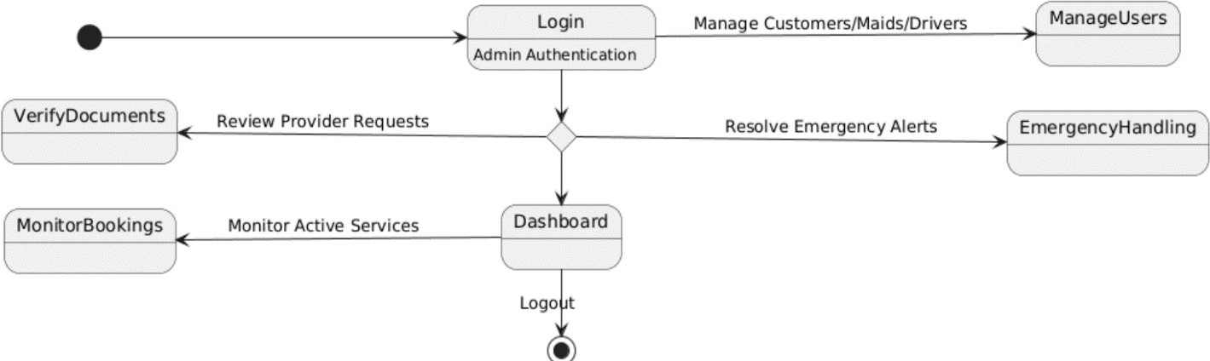
Admin State Chart Diagram

Customer State Chart Diagram
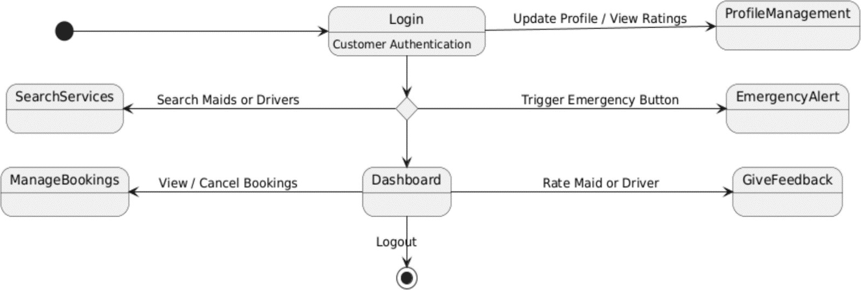

Maid State Chart Diagram
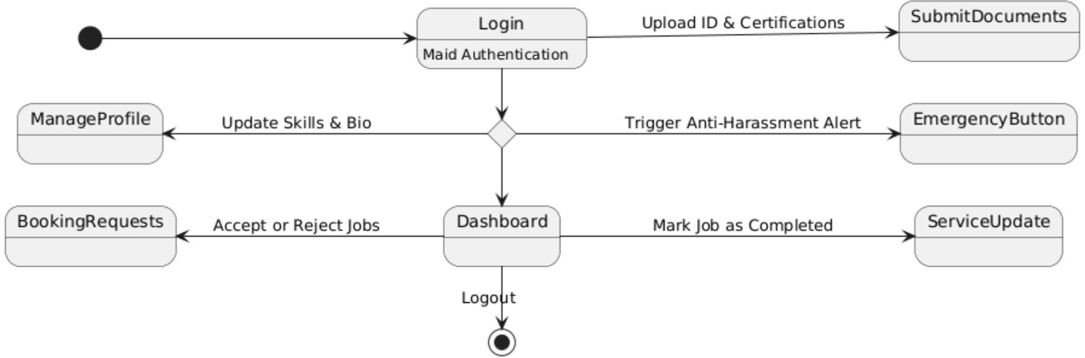

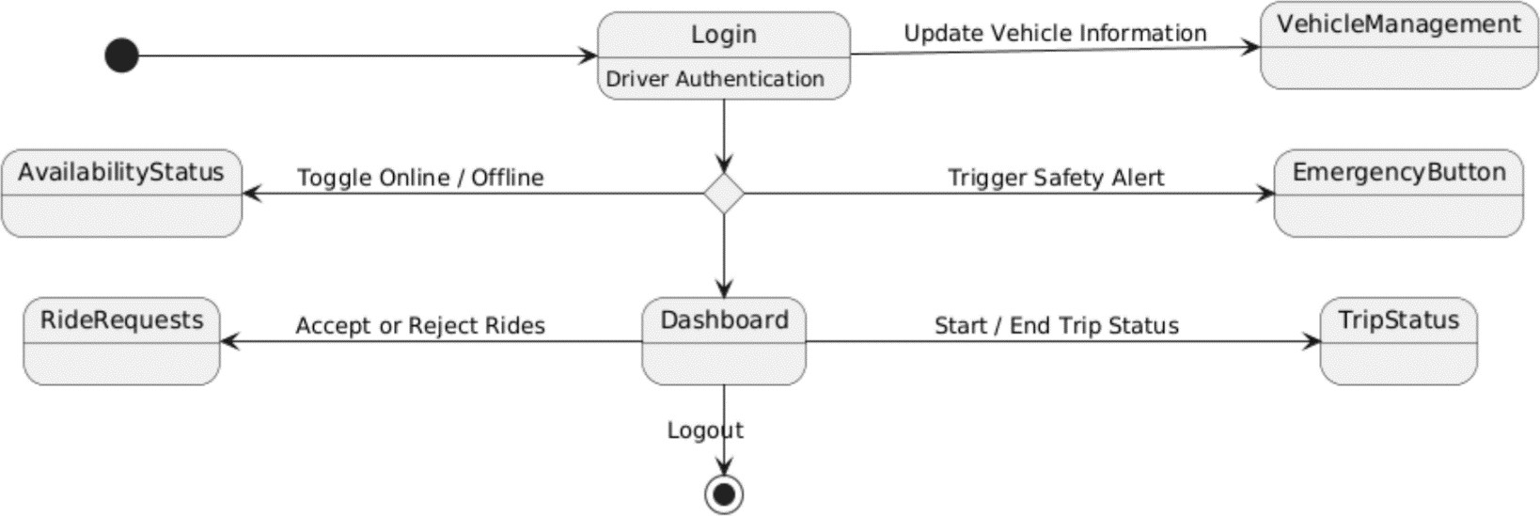
Driver State Chart Diagram

Activity Diagrams

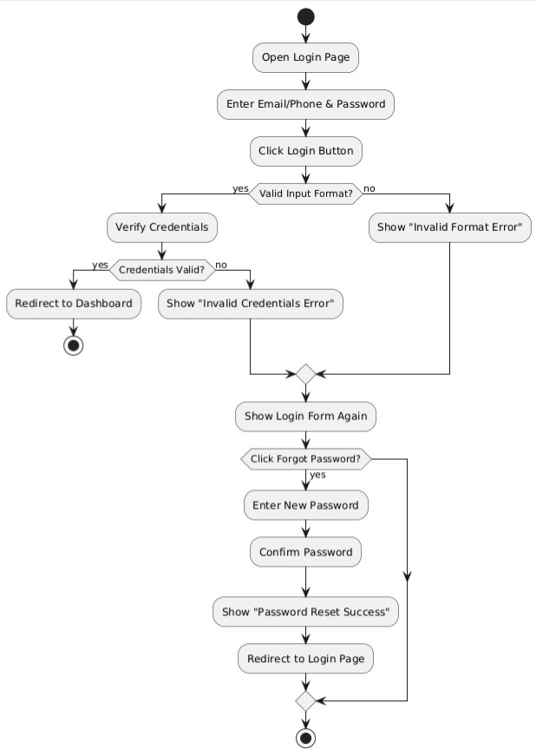
Login

Roles(Customer Maid Driver)

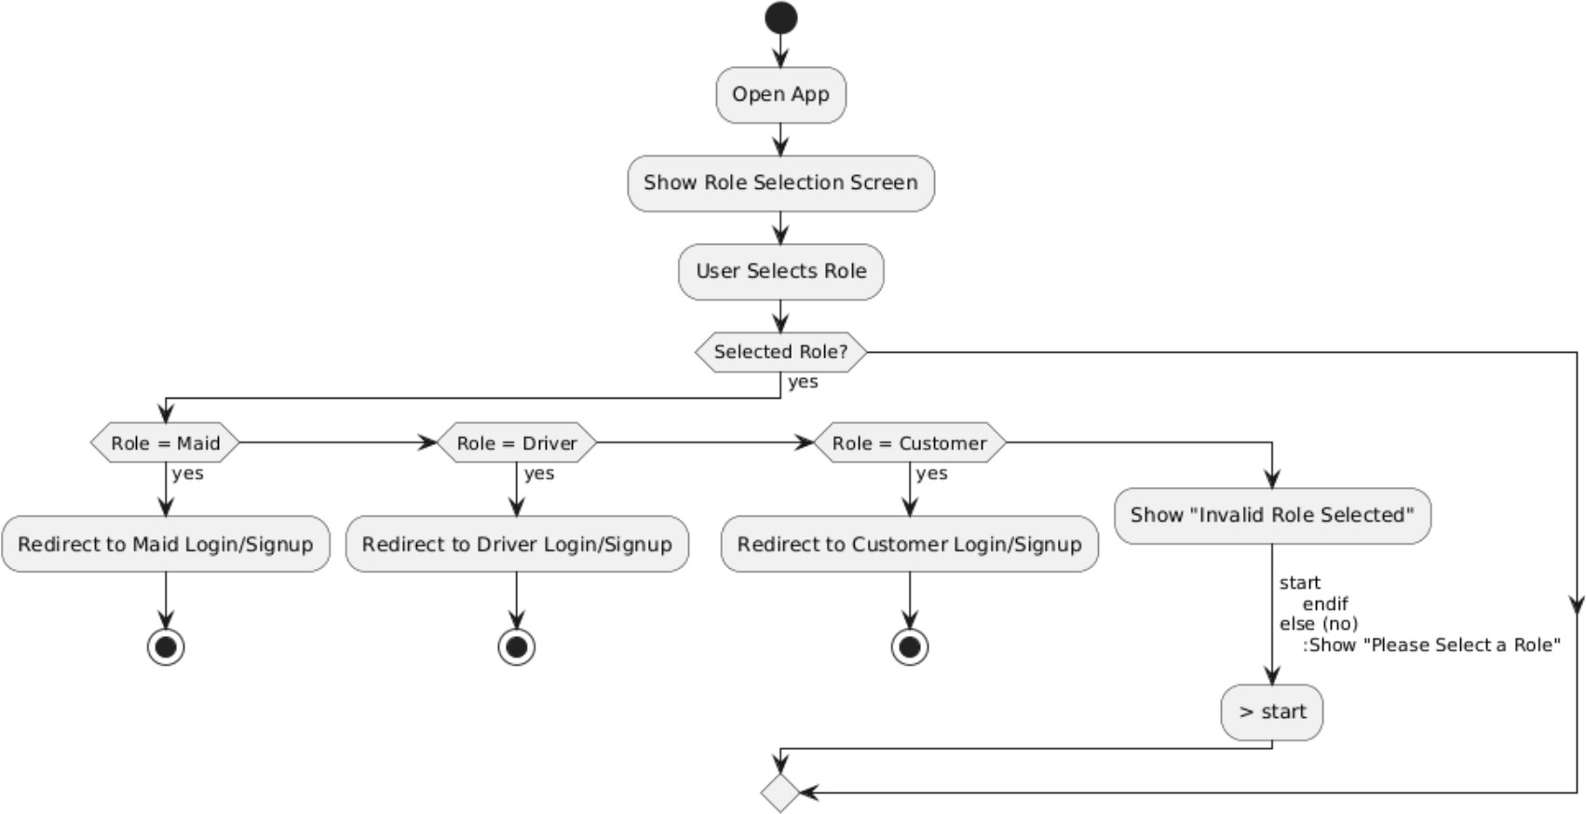

Customer signup
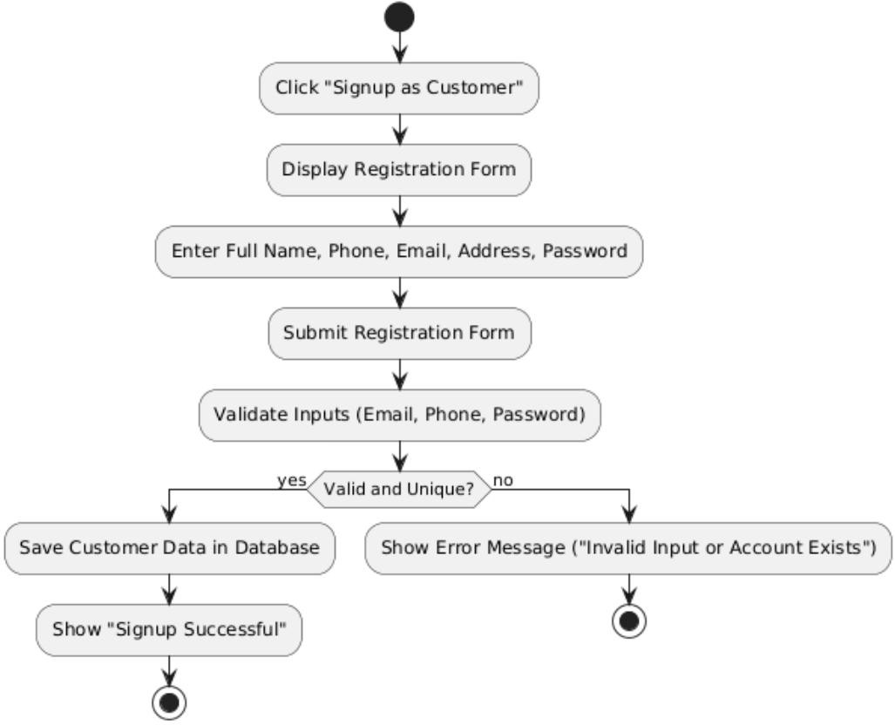

Customer Dashboard

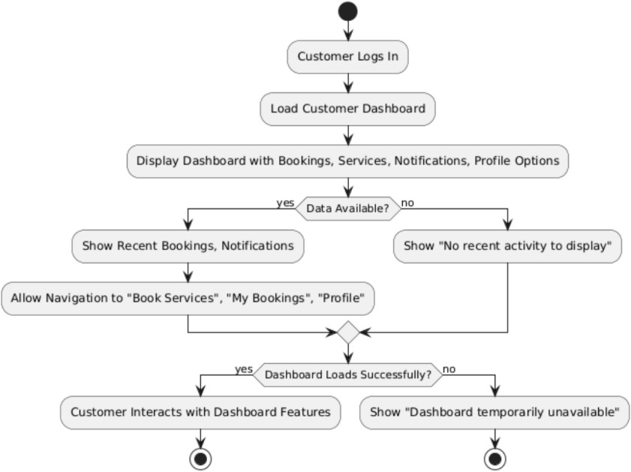

Customer Profile Management
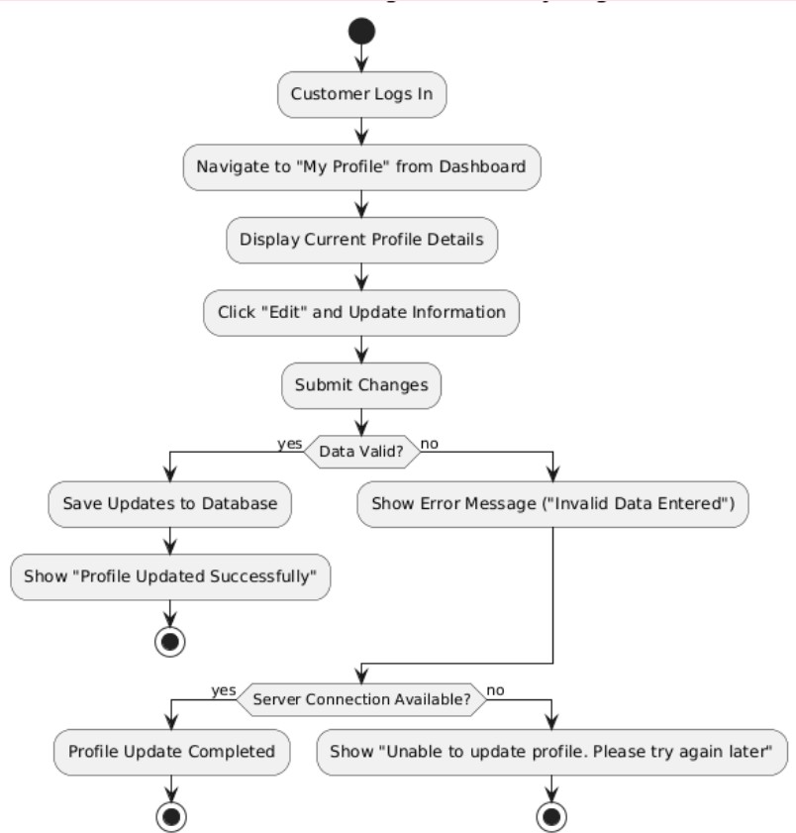

Customer Search and Filter

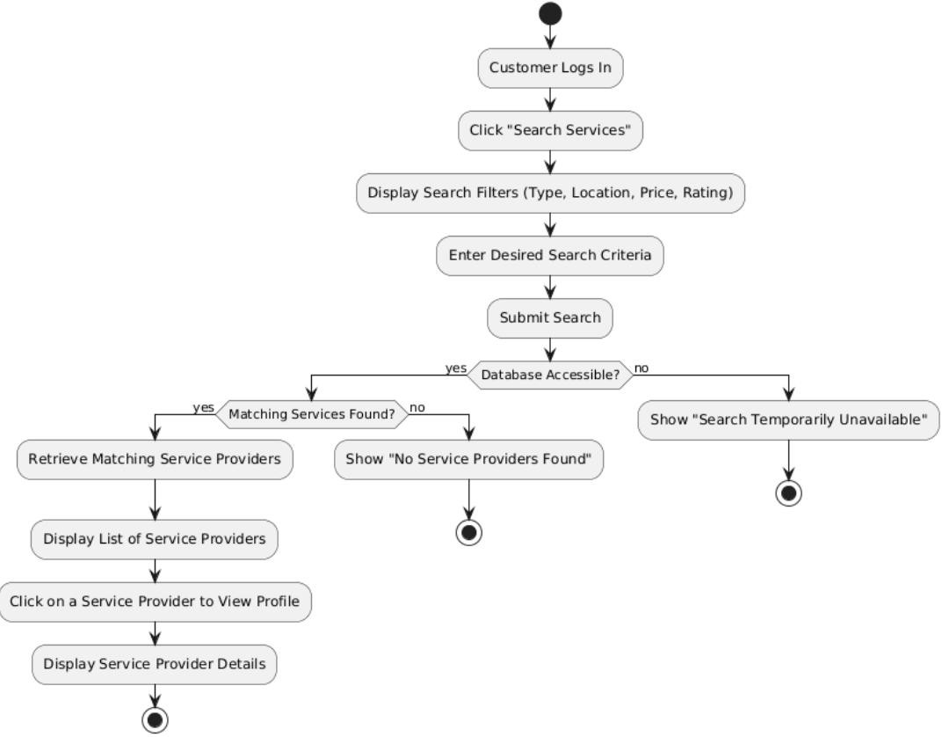

Customer Booking Management
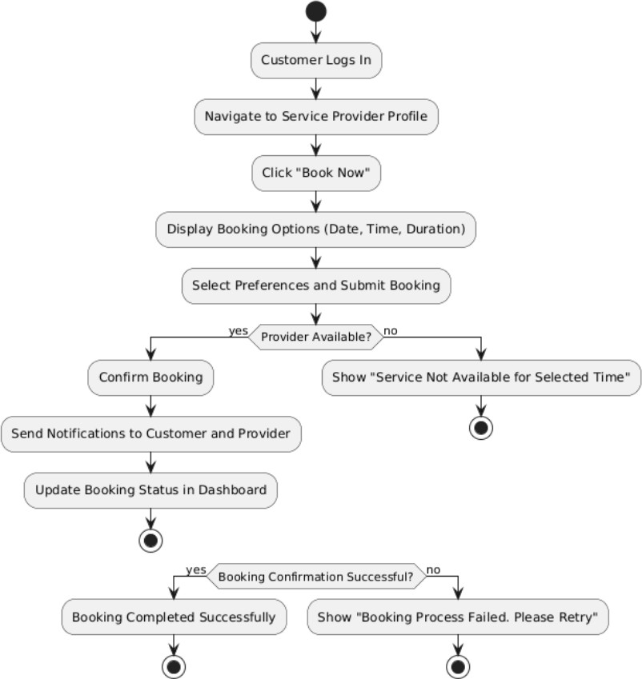

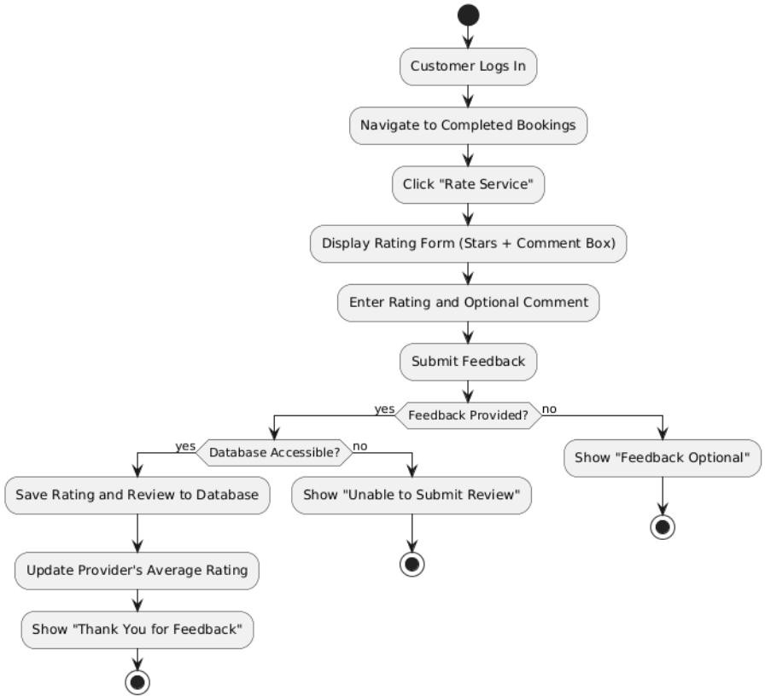
Customer Booking History

Customer Rating and Reviews


Customer Anti-Harassment
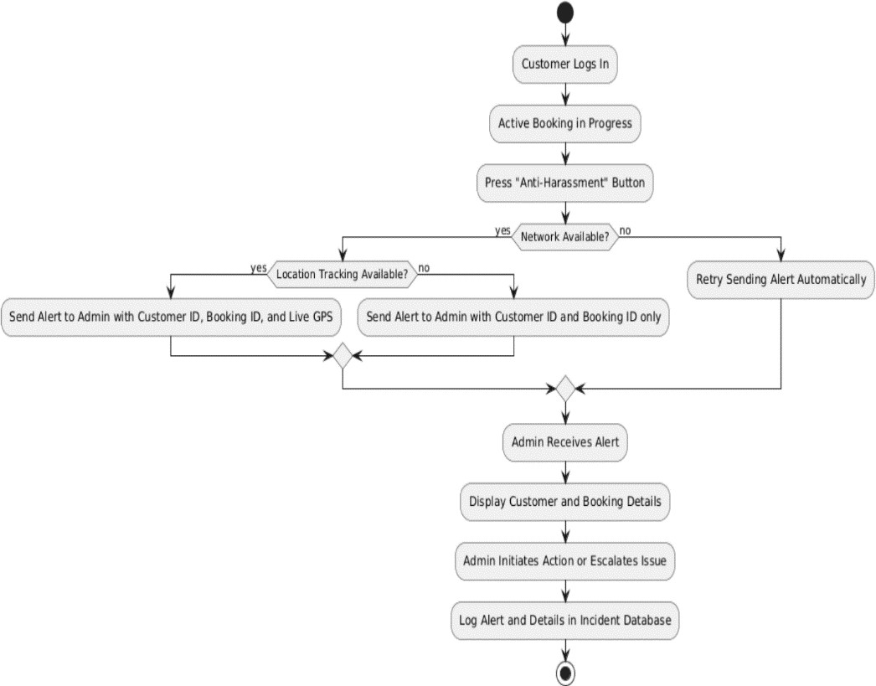

Maid Signup
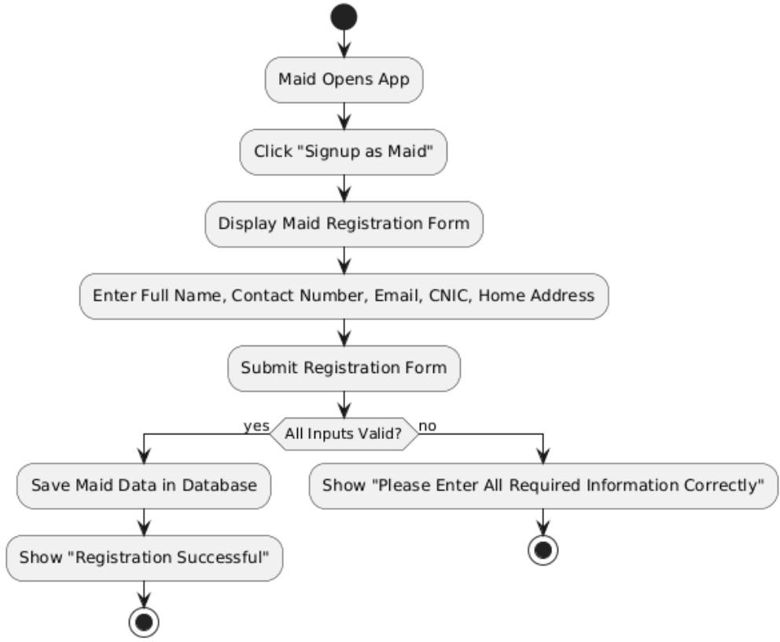

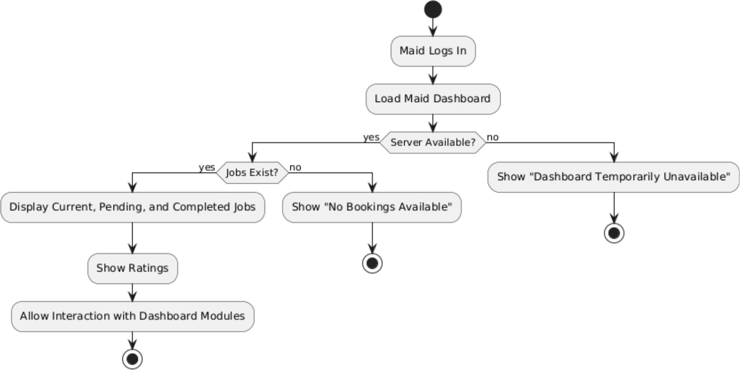
Maid Dashboard

Maid Profile Management
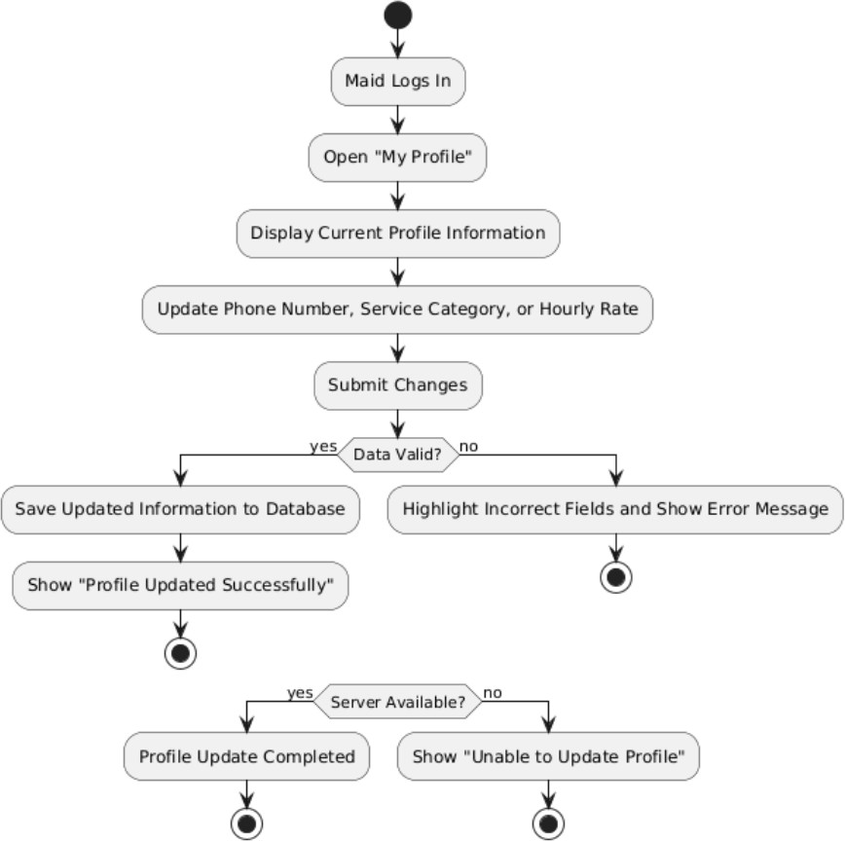

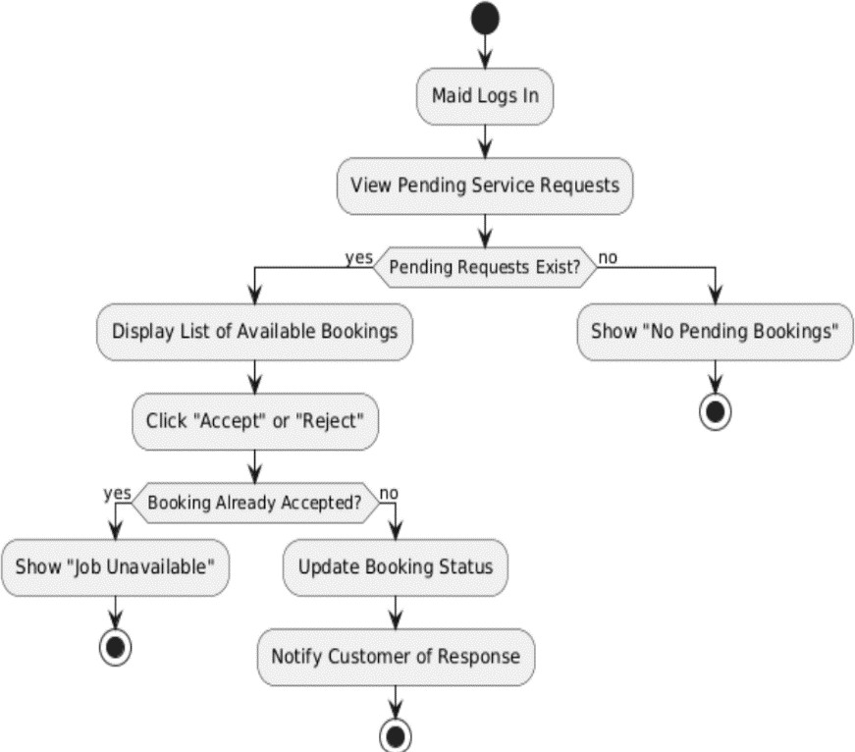
Maid Booking Management

Maid Anti-Harassment
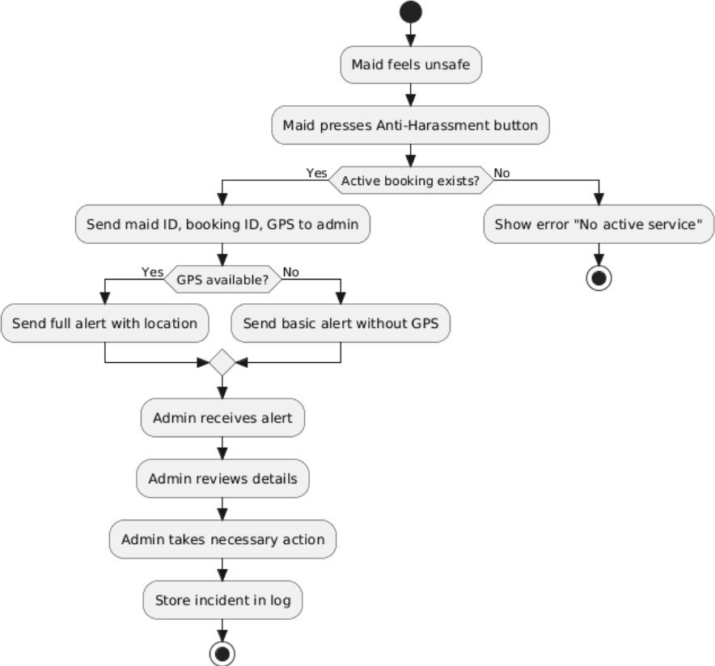

Maid Feedback
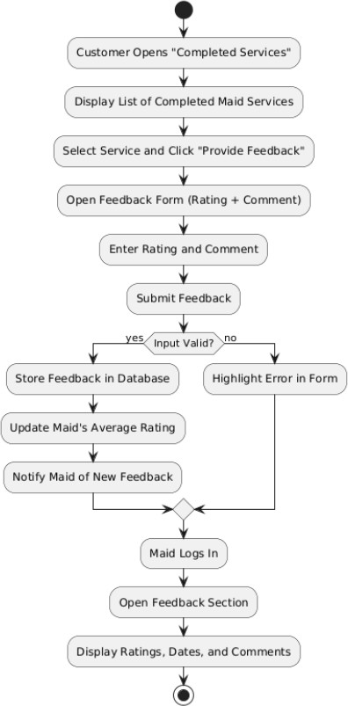

Driver Signup

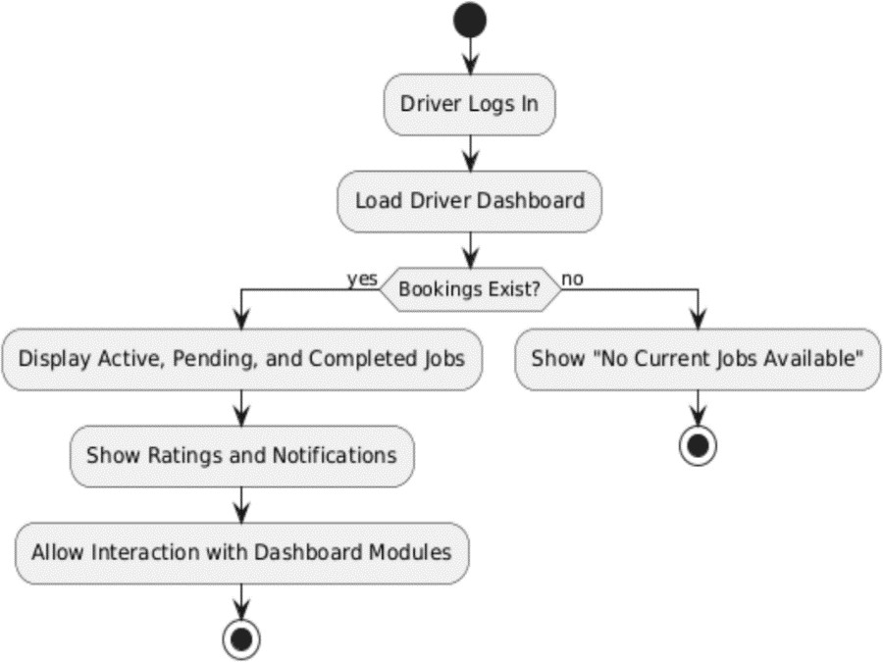


Driver Dashboard

Driver Profile Management
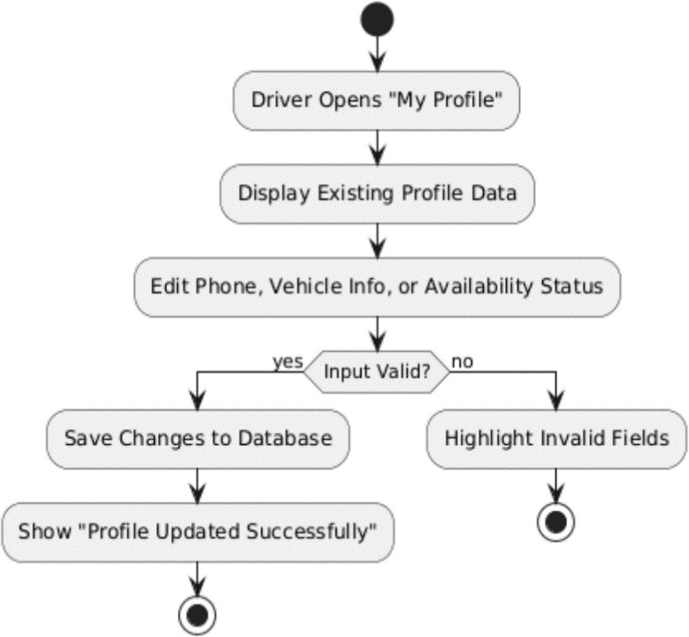

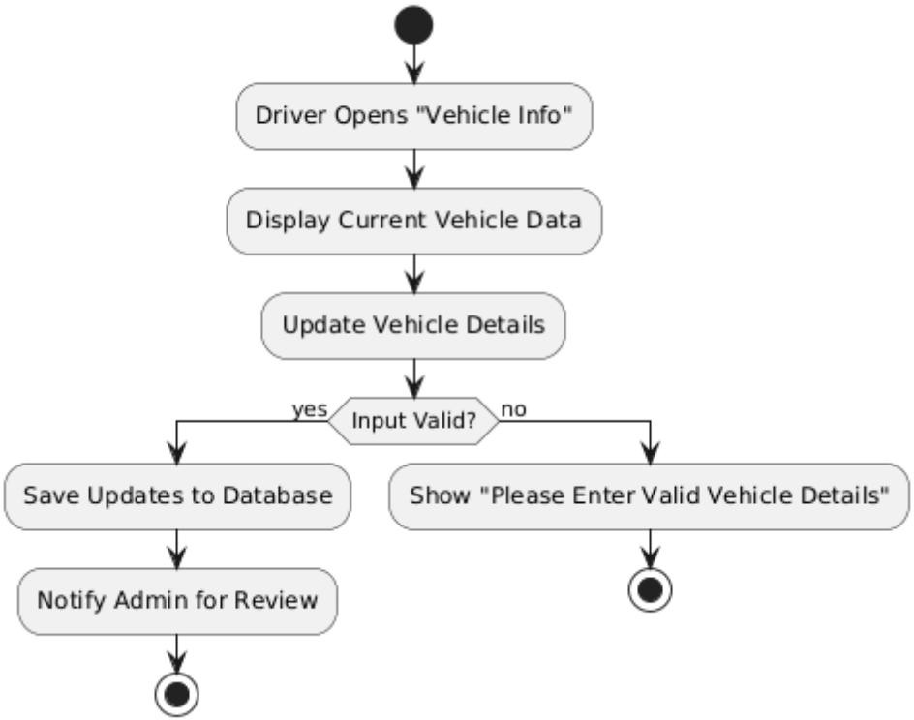
Driver Vehicles Information

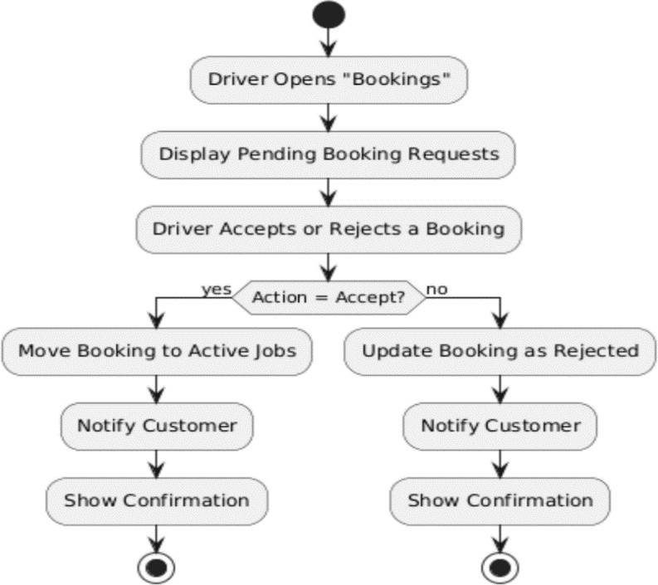
Driver Booking Management

Driver End Trip
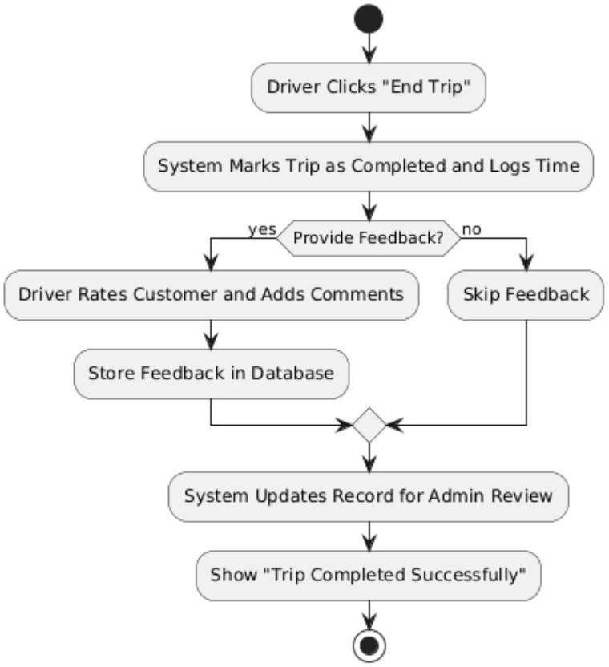

Admin Login

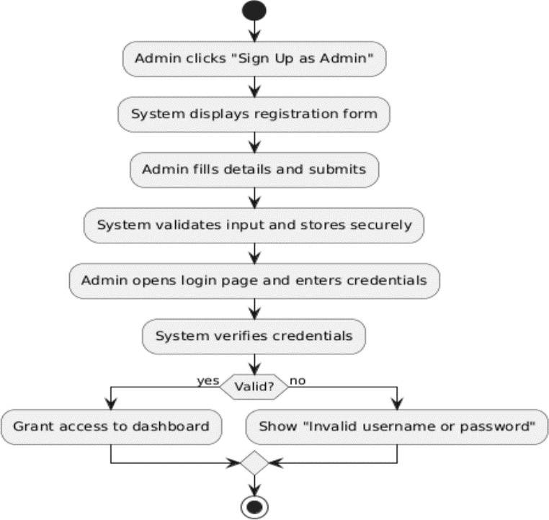

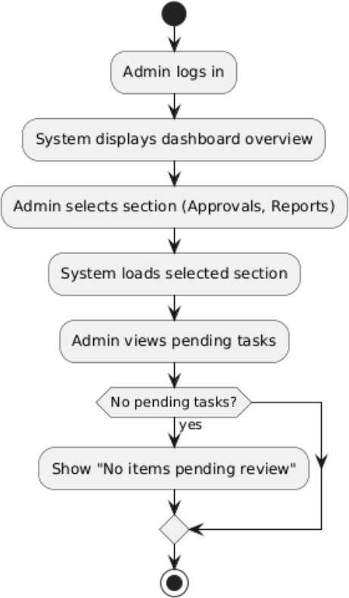
Admin Dashboard

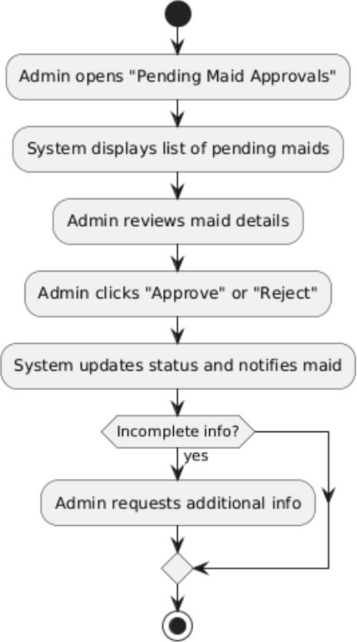
Maid Approval Management

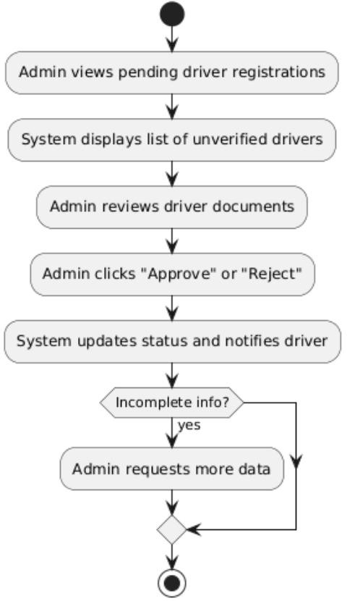
Driver Approval Management

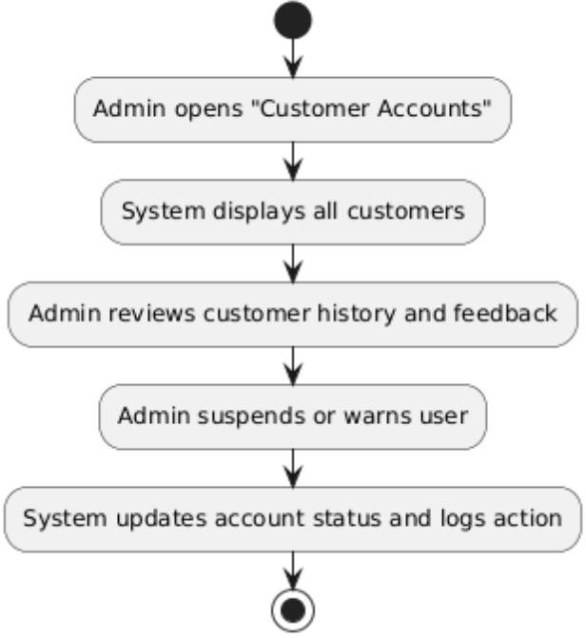
Customer Account Management

Feedback Complaint Management
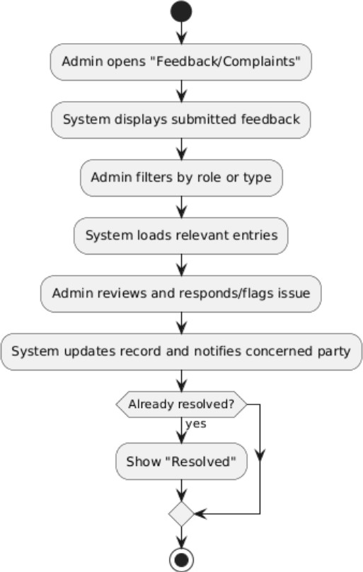

Account Suspension/Reactivation
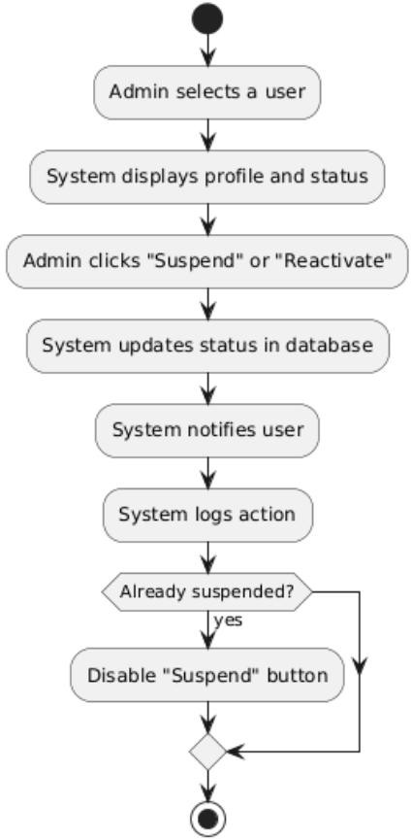

Sequence Diagram

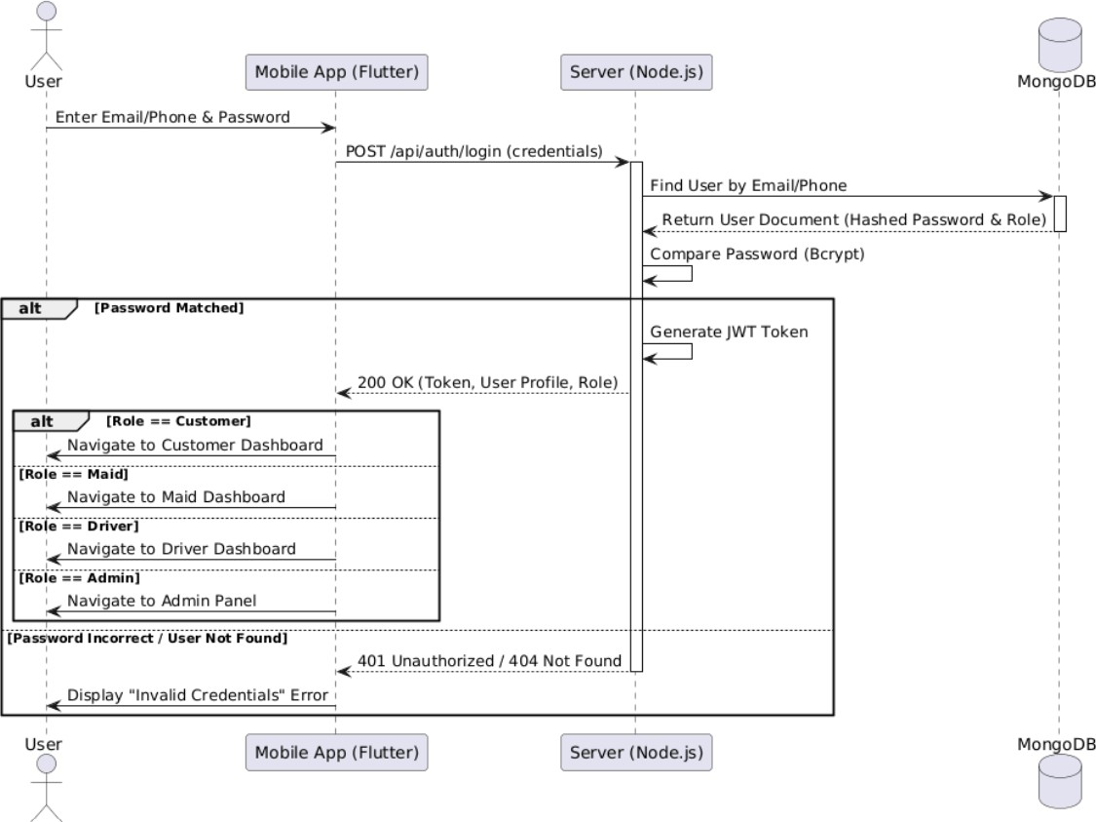
Login

Customer Signup

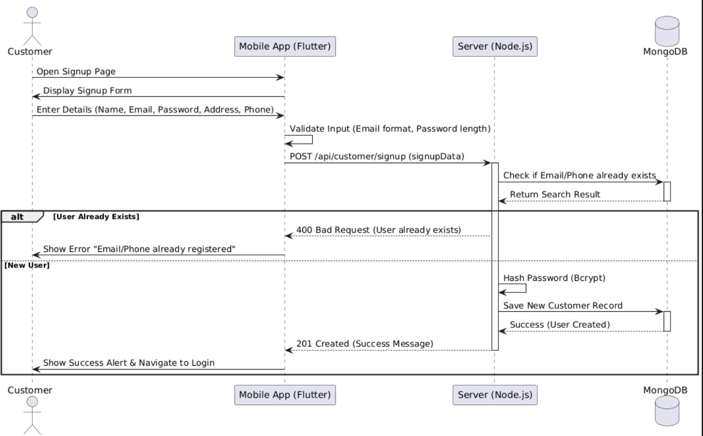

Roles(Customer , Maid , Driver)

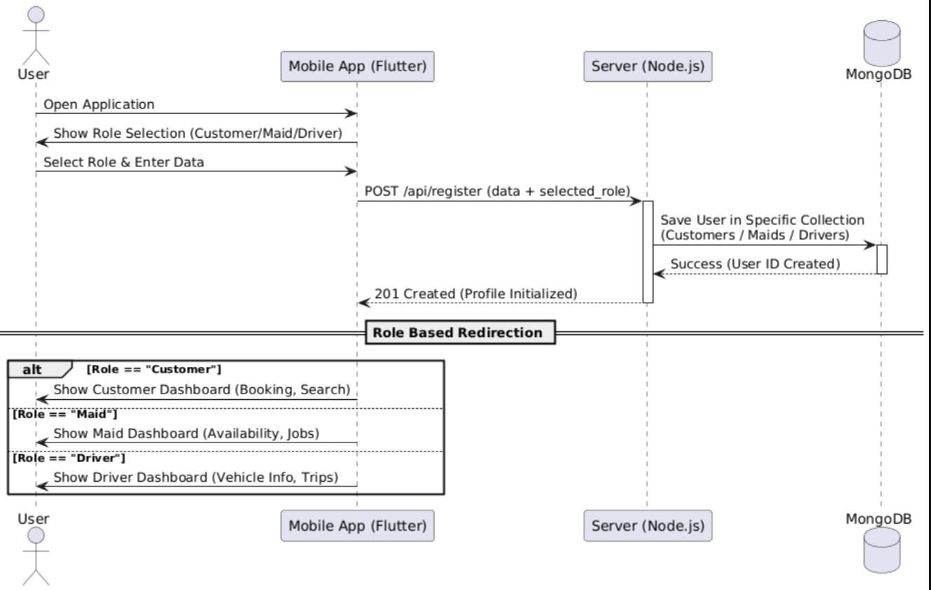

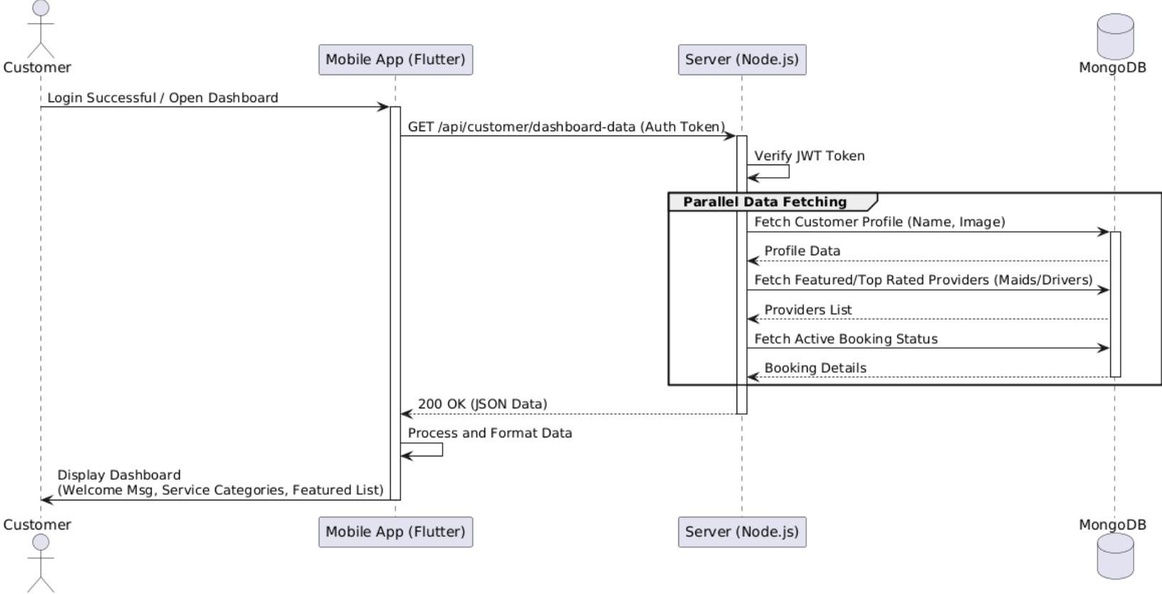
Customer Dashboard

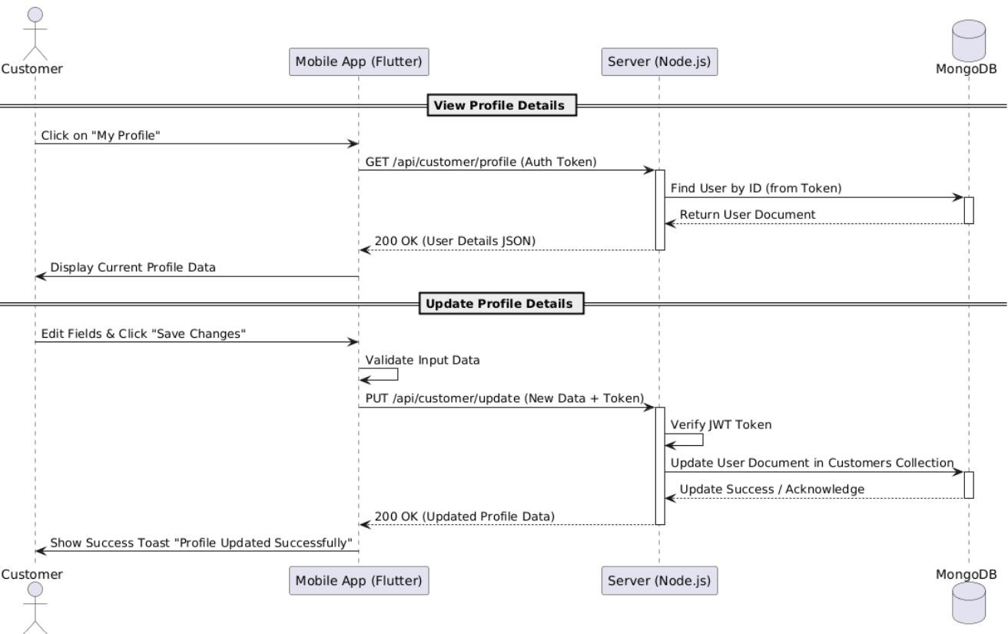
Customer Profile Management

Customer Search And Filter

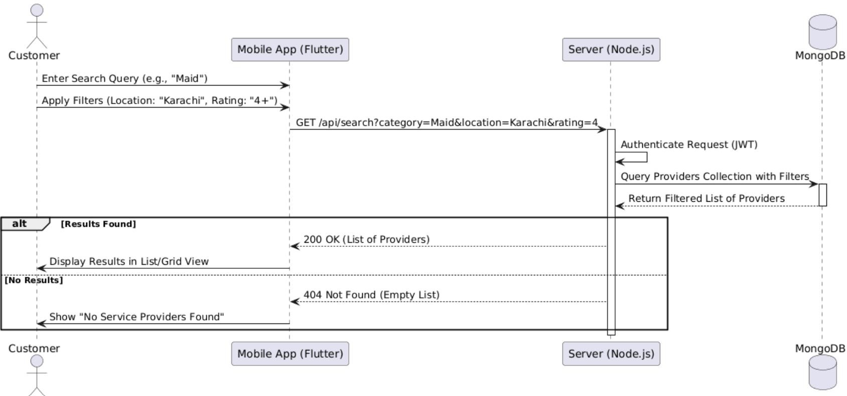

Customer Booking Management
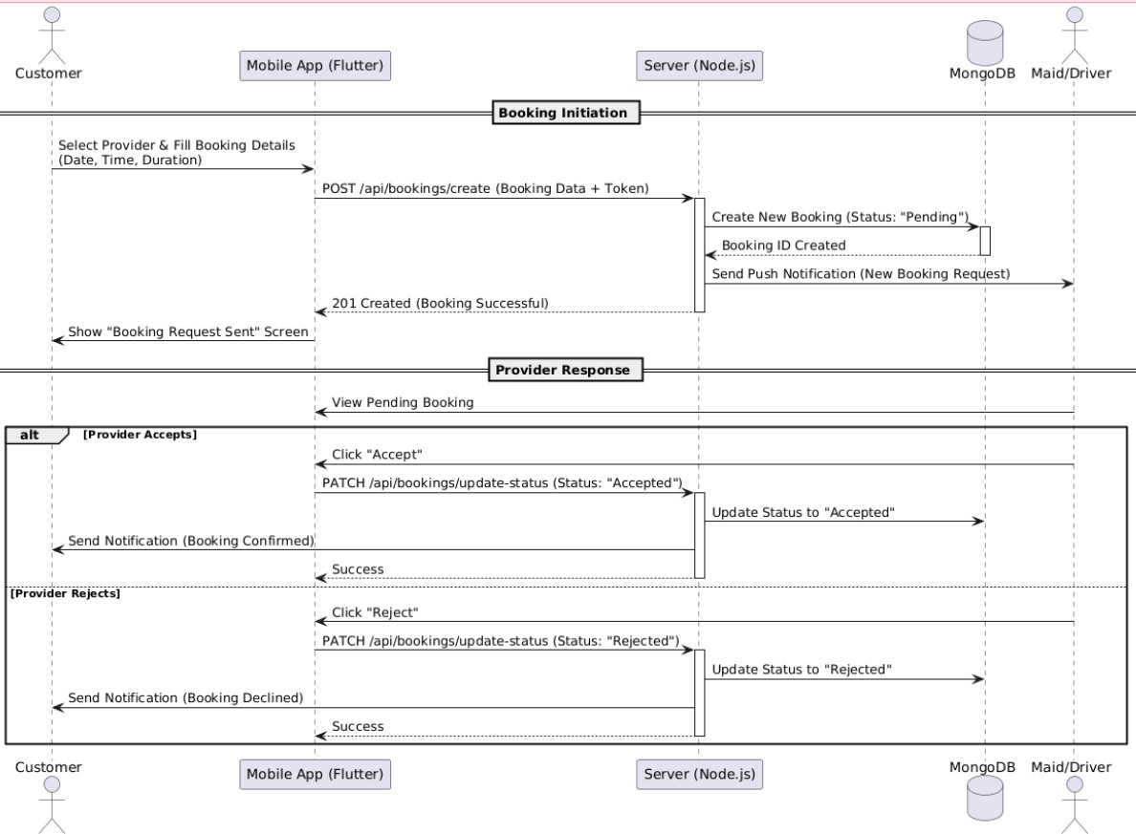

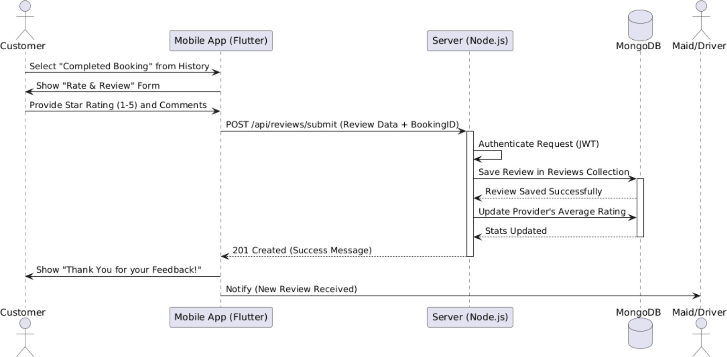
Customer Rating And Review

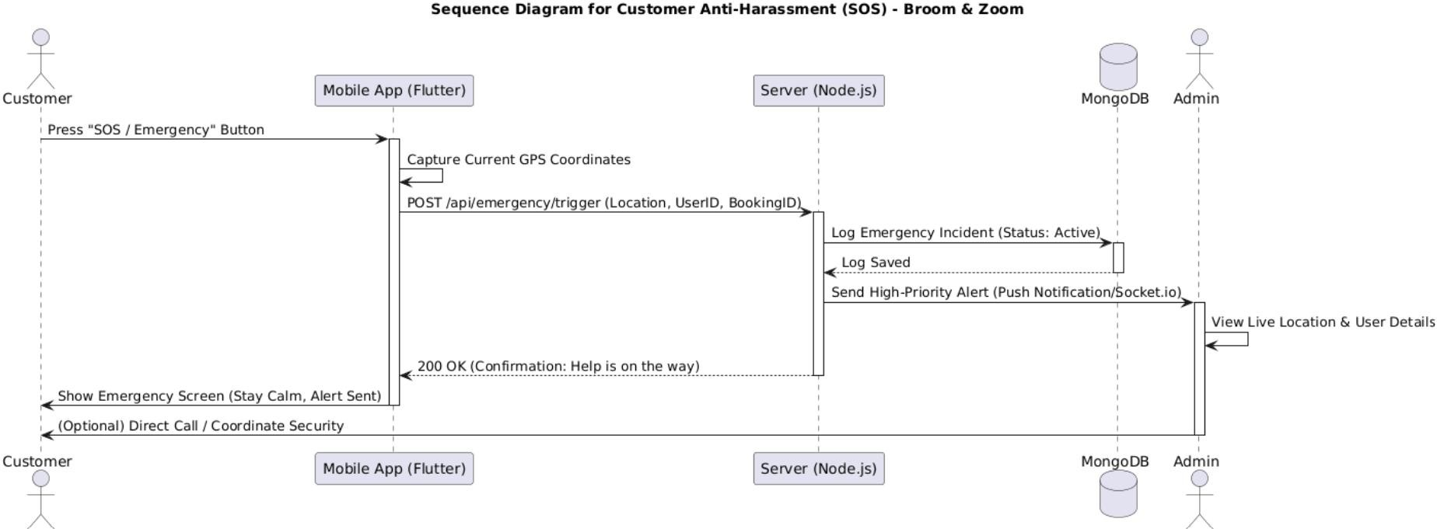
Customer Anti-Harassment

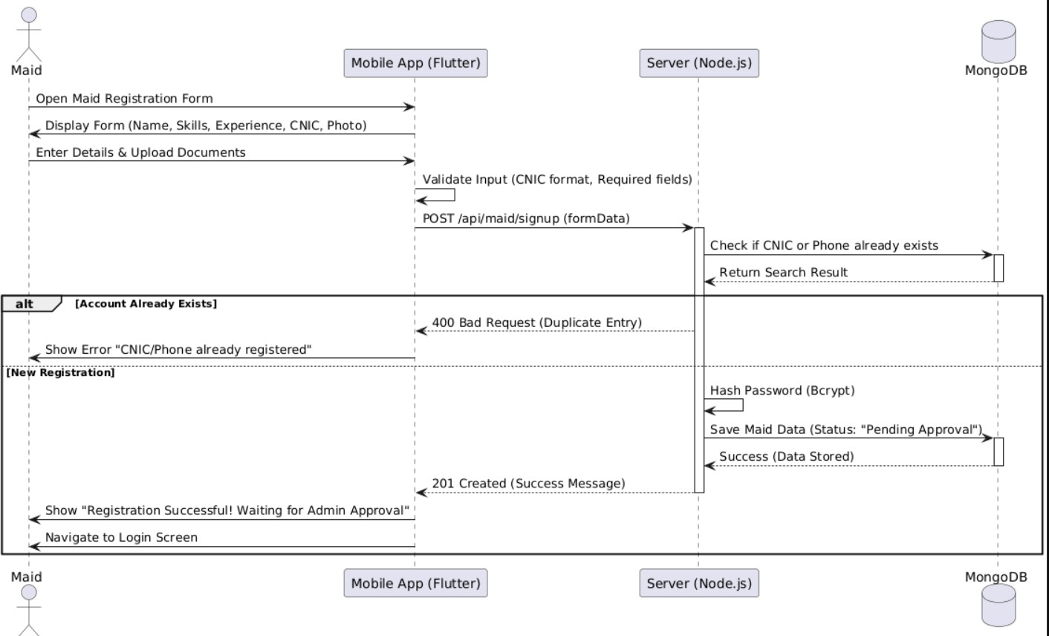
Maid Signup

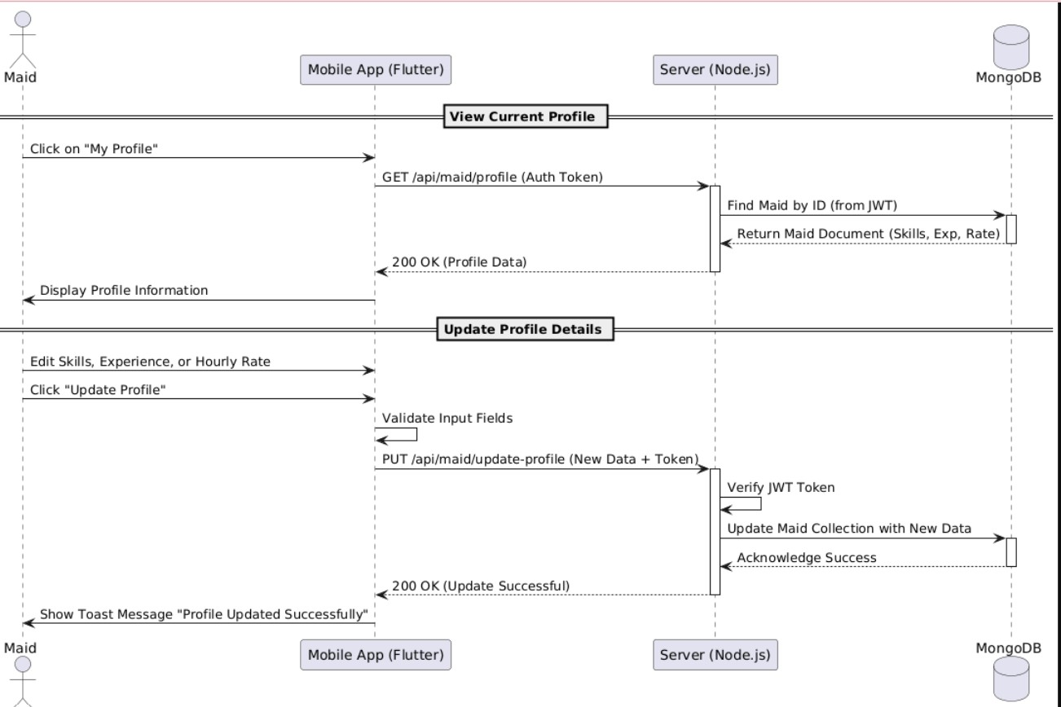
Maid Profile Management

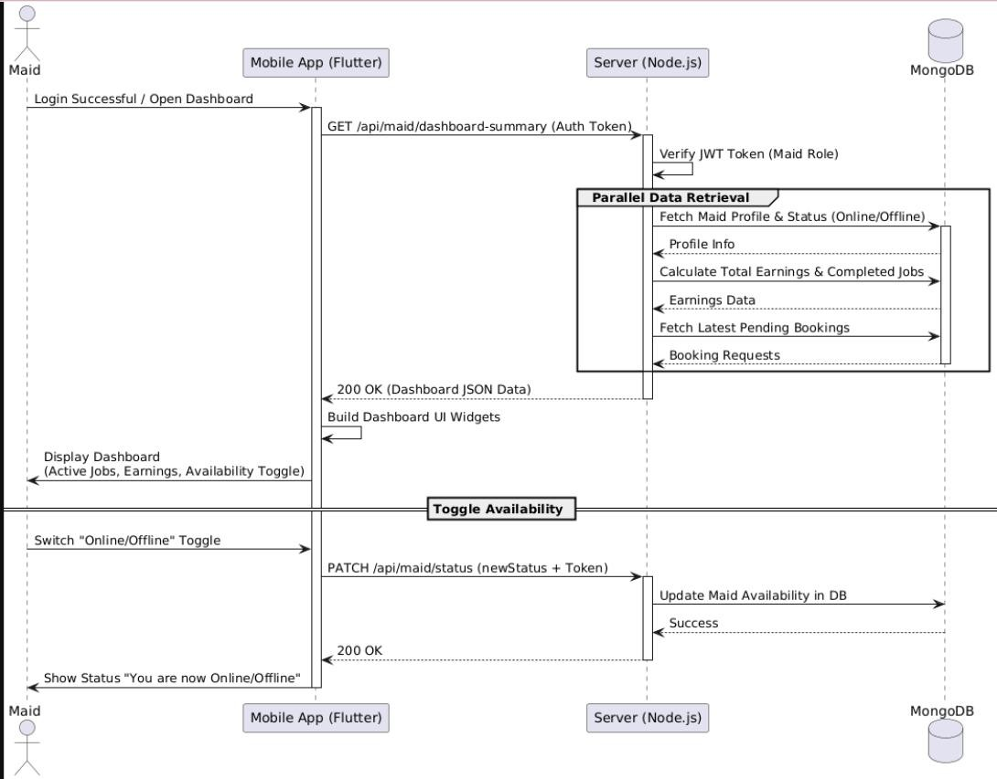
Maid Dashboard

Maid Booking Management

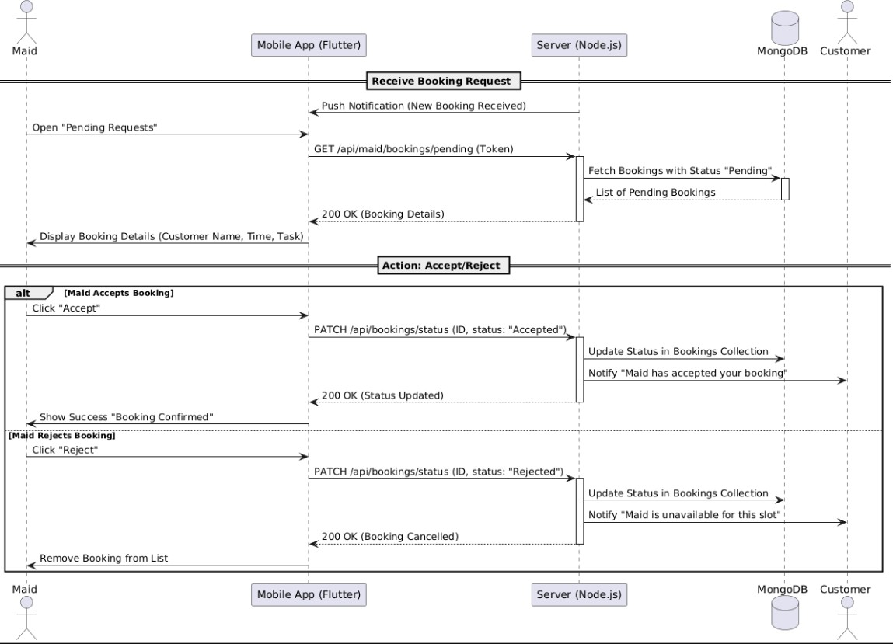

Maid Anti-Harassment
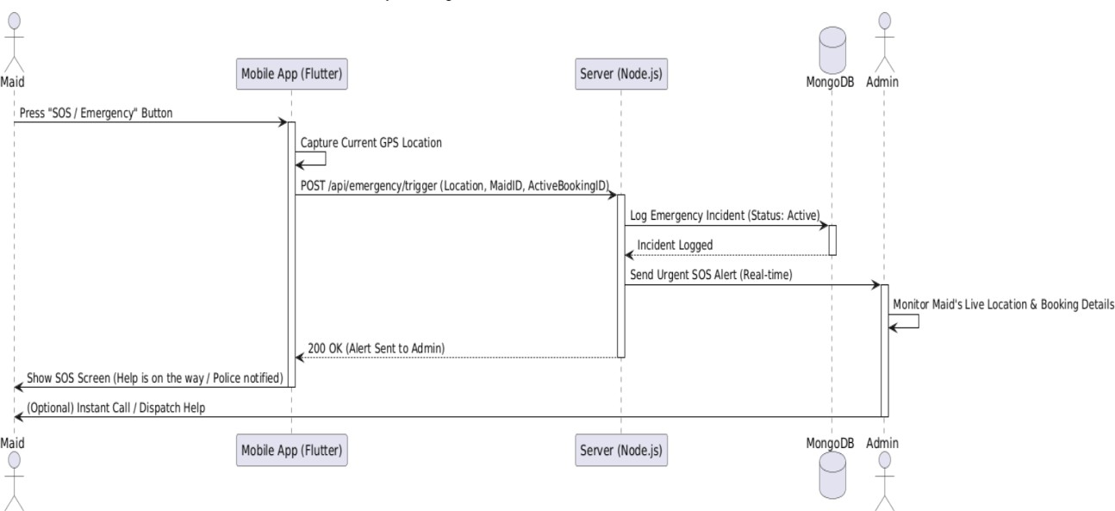

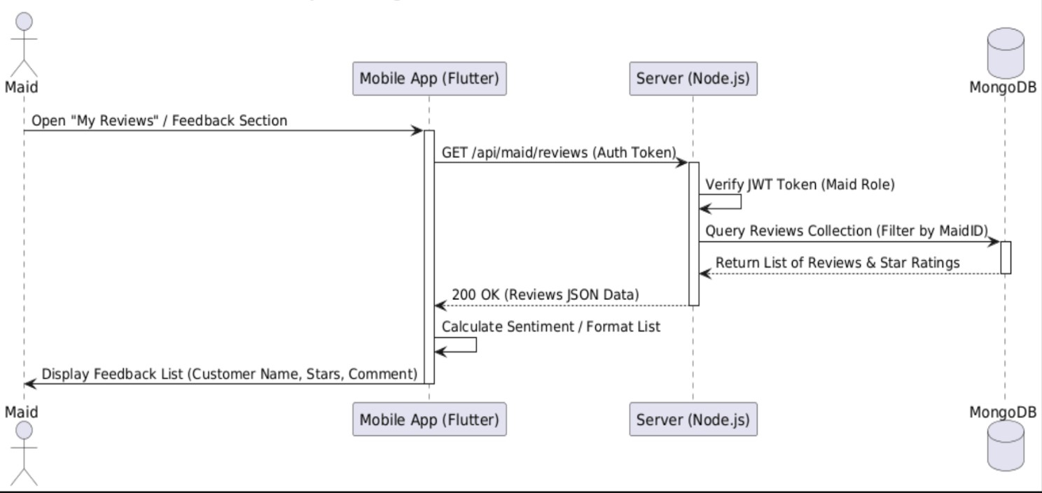
Maid Feedback

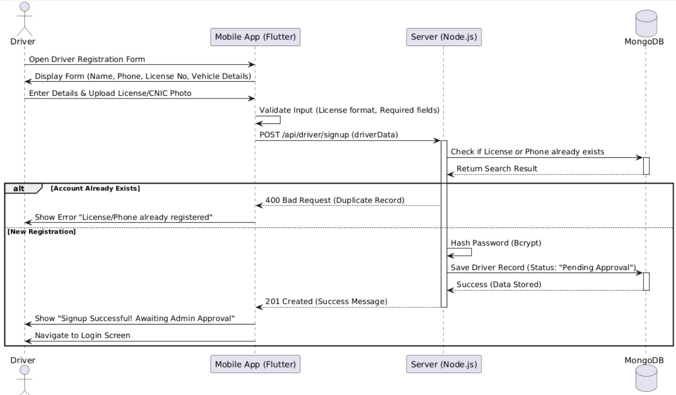
Driver Signup

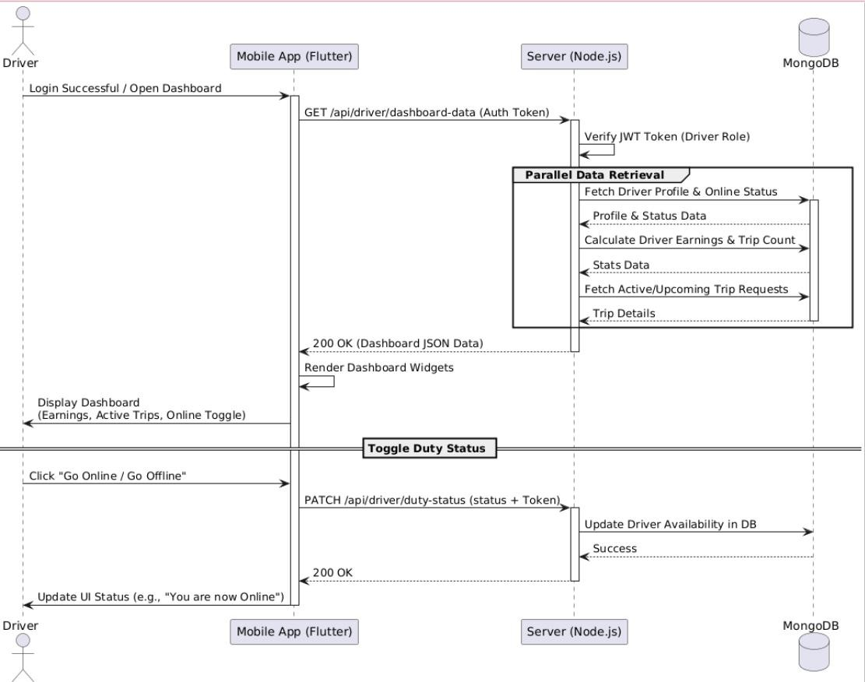
Driver Dashboard

Driver Profile Management

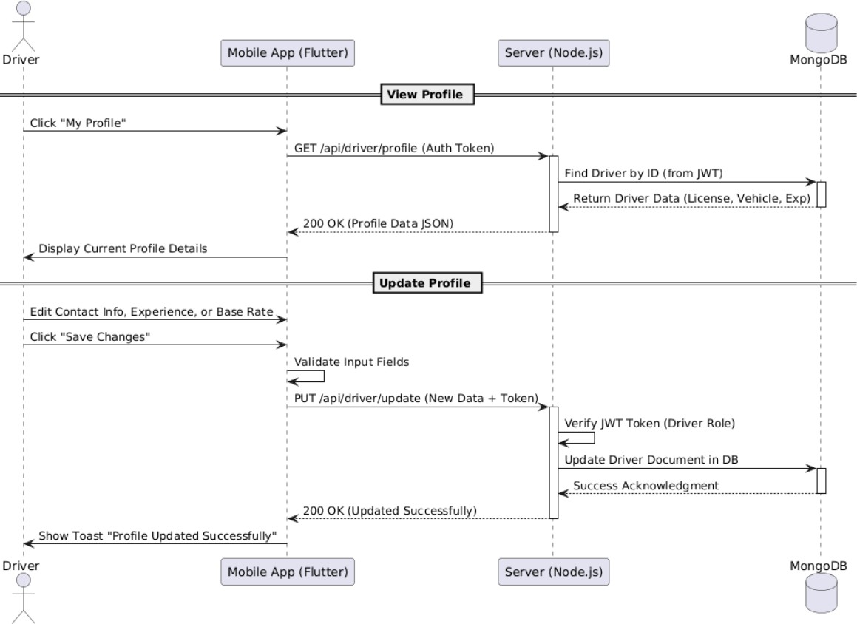

Vehicle Information

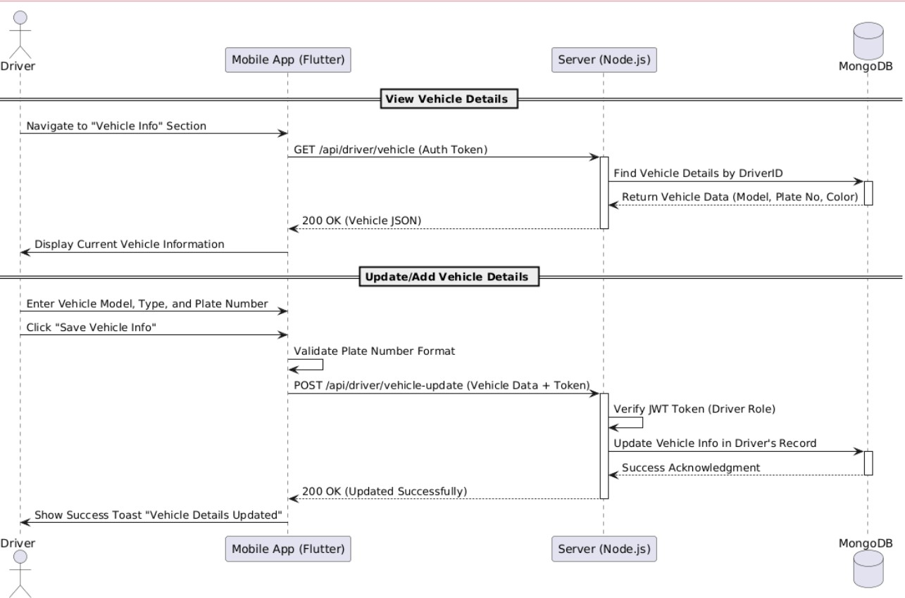

Driver Booking Management

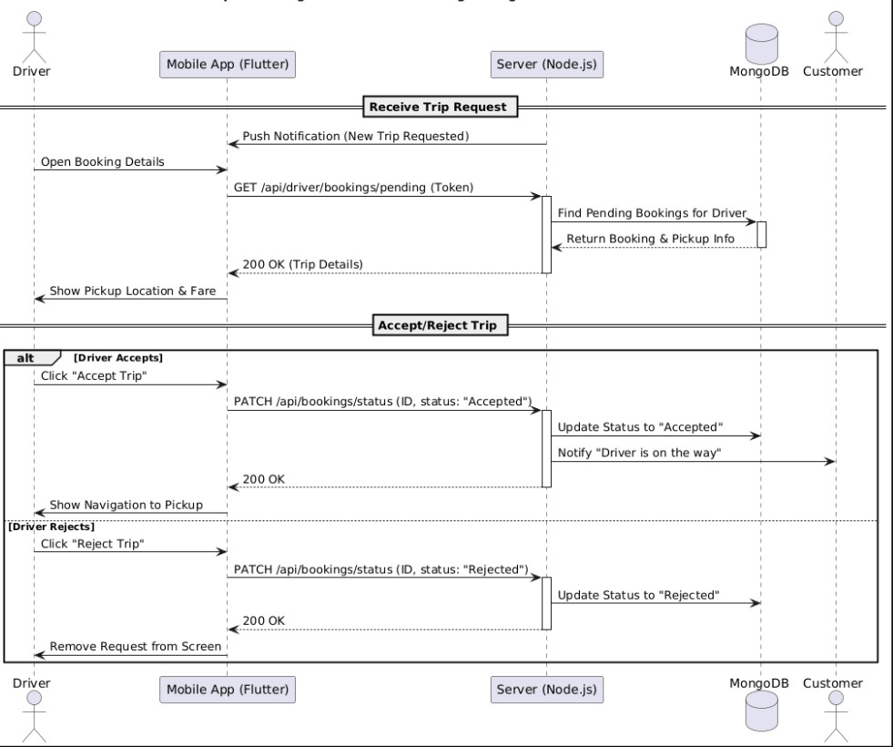

Driver End-Trip Feedback

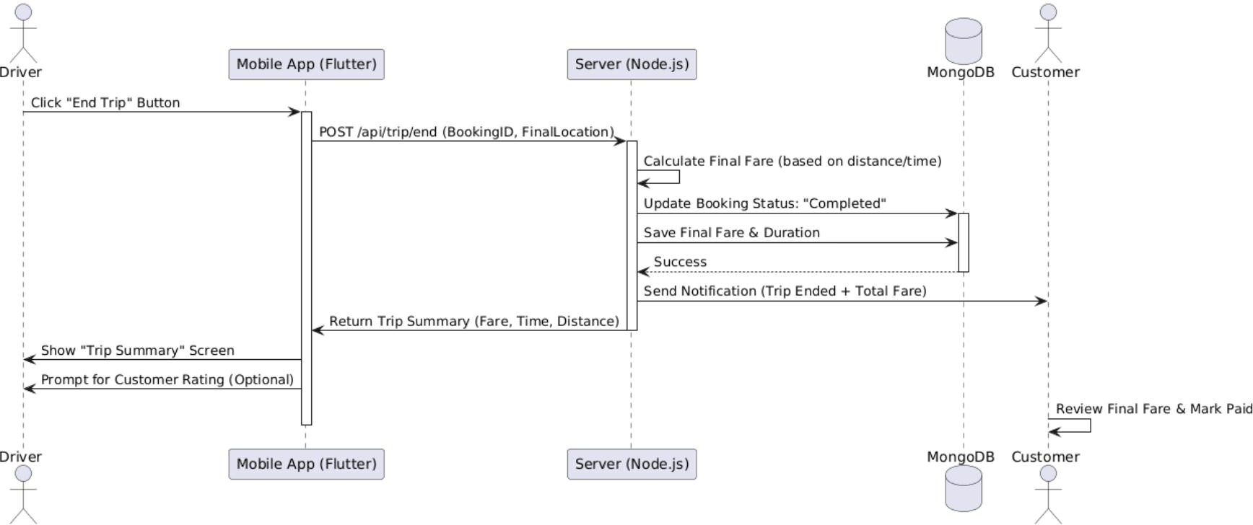

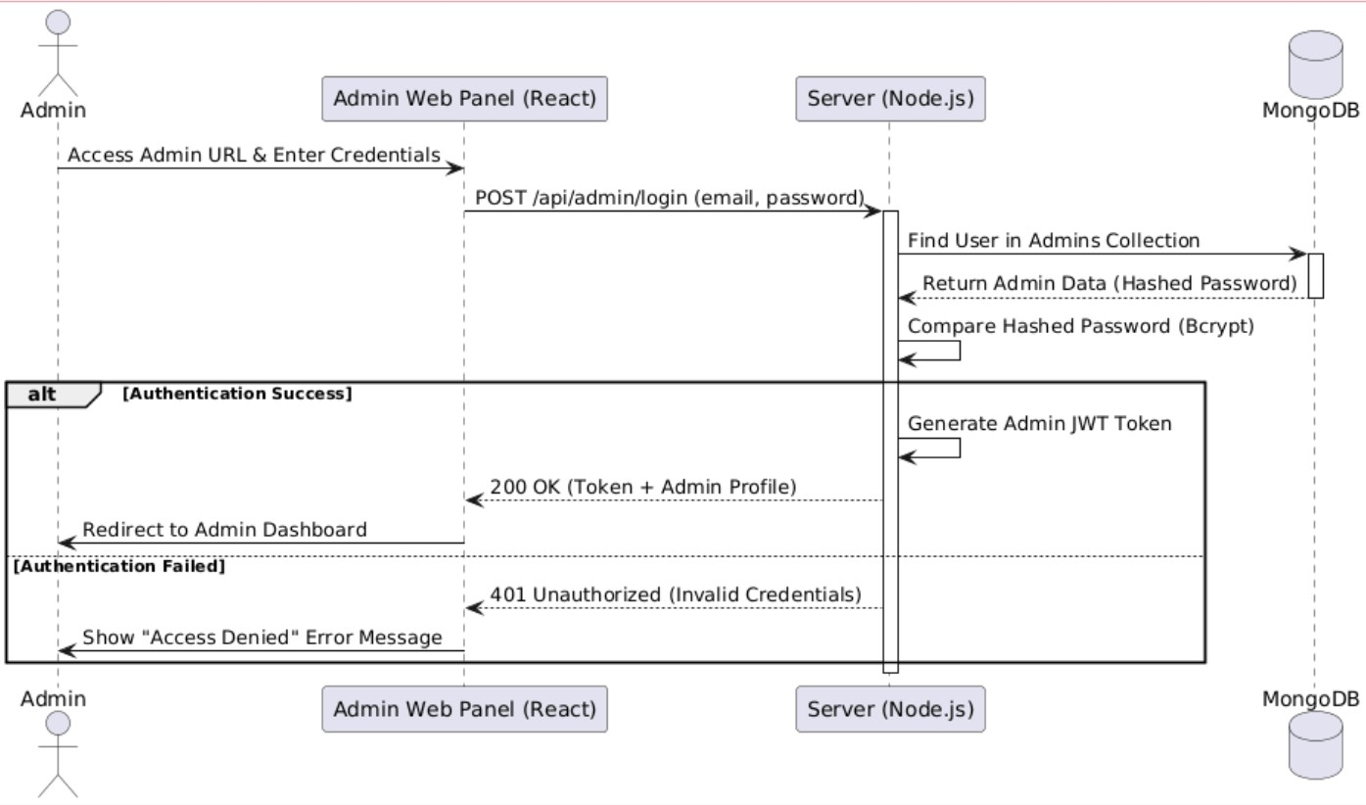
Admin Login

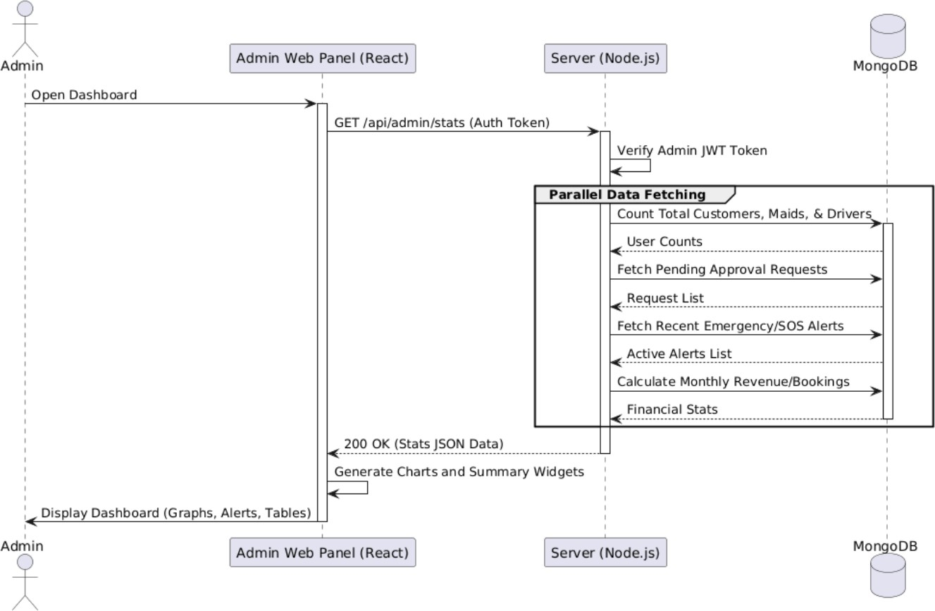
Admin Dashboard

Approval Management System (Customer, Maid, Driver)

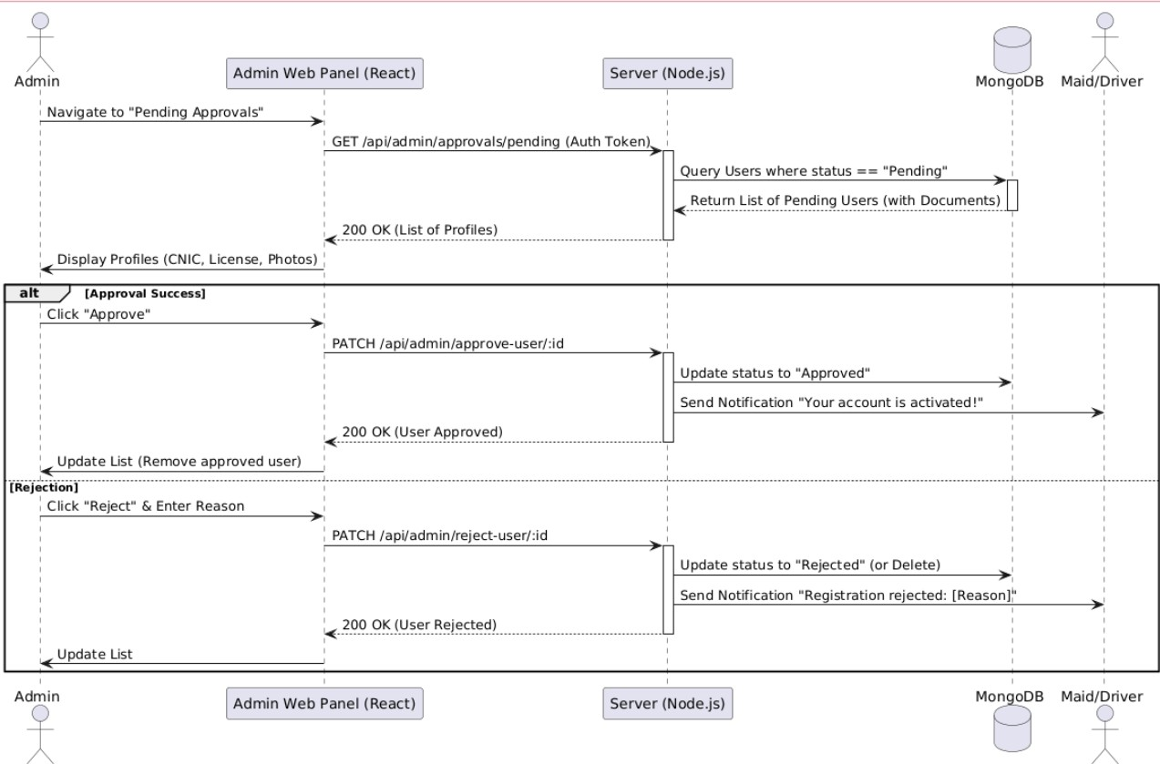

Feedback and Complaint

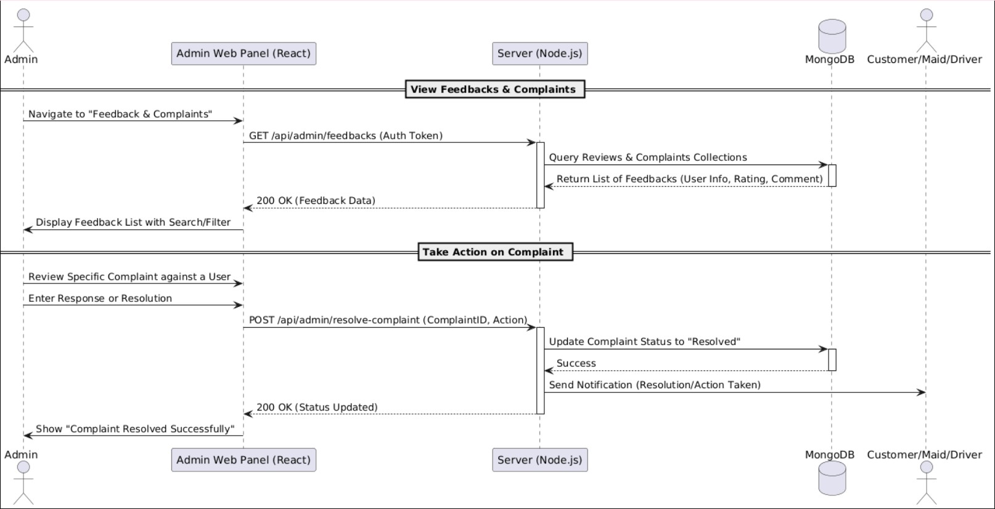

Account Suspension And Reactivation

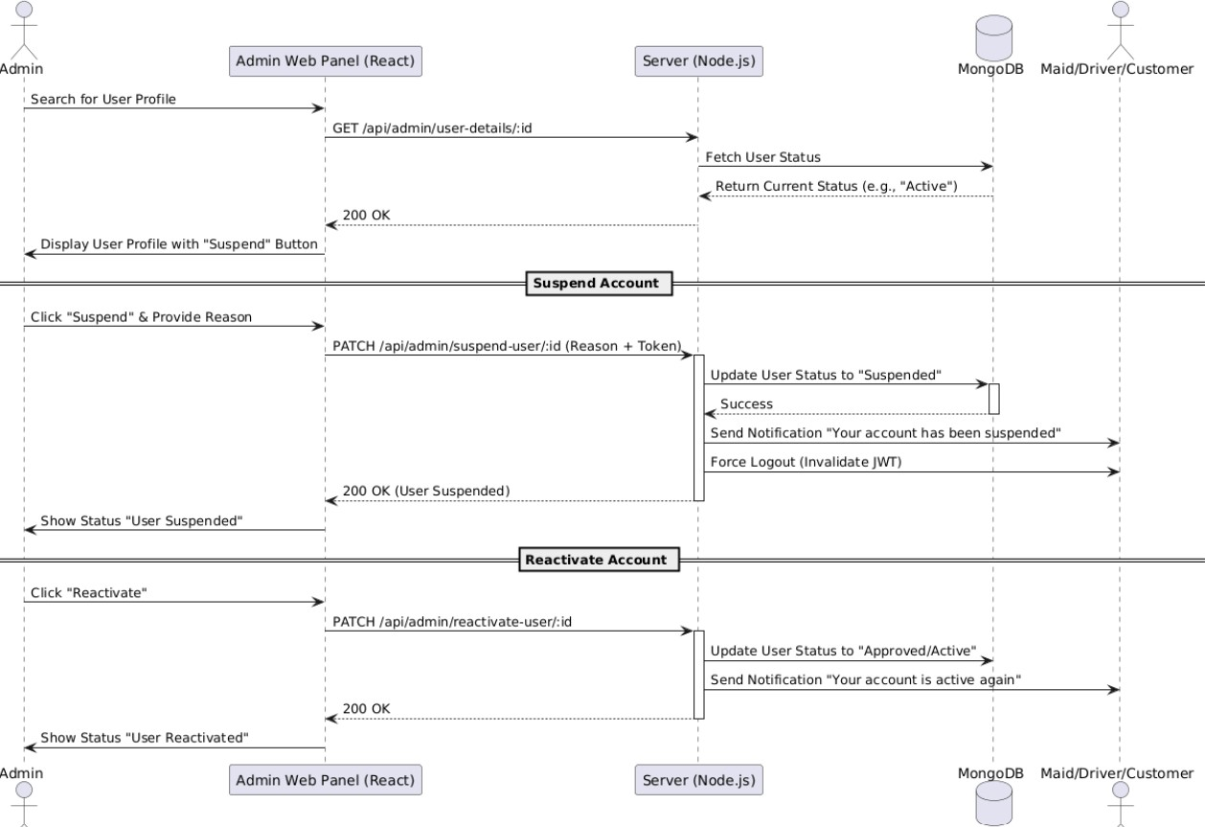

Use Case Diagrams

Admin




Customer


Maid


Driver

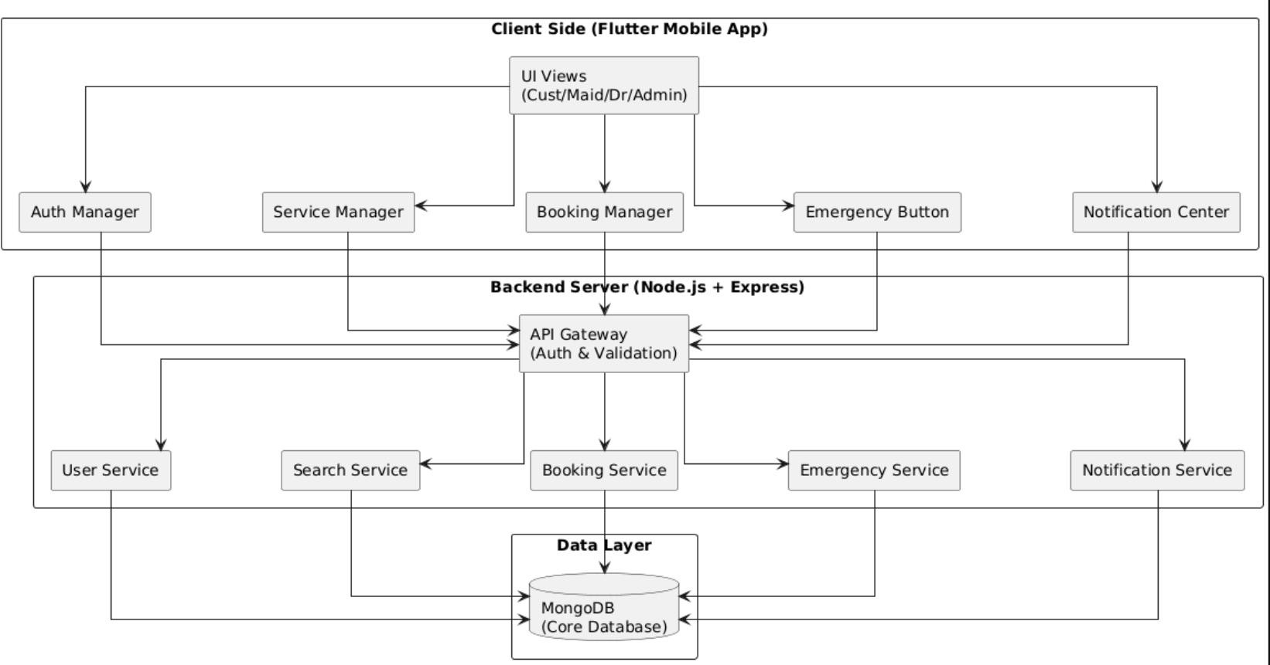
Component Diagram

Test Cases

Test Case ID | BZ-01-01
Test Case Name | Sign Up (Customer) | Test Case Description | Verifies that a customer can successfully create an account on the Broom & Zoom application by entering valid details and completing OTP verification. It also validates error handling for invalid inputs.
Created By | Nandni/Mumta | Version | 1.1 | Date | 26 Dec 2025

Signup Customer
S. No | Prerequisites:
1 | User must have a valid mobile number / email.
2 | Broom & Zoom mobile application must be installed.
3 | Internet connection must be available.
4 | OTP service must be active.
Initial Execution
Test Scenario | User attempts to create an account using valid and invalid signup information.
Step no. | Step Details | Expected Results | Actual Results | Pass / Fail / Not  executed / Suspended
1 | Open Broom & Zoom application | App should launch successfully | App launched | Pass
2 | Click on Sign Up button | Sign Up screen should appear | Sign Up screen displayed | Pass
3 | Click Sign Up without entering data | Validation errors shown | Validation messages displayed | Pass

4 | Enter invalid email / phone number | Error message displayed | Error shown | Pass
5 | Enter valid name, email/phone, password | Inputs accepted | Inputs accepted | Pass
6 | Click Register button | OTP sent to user | OTP not sent due to backend issue | Fail
7 | Enter invalid OTP | OTP validation error | Error displayed | Pass
8 | Click Back to Sign Up | Redirect to signup screen | Redirected successfully | Pass
Reset Execution
Test Scenario | Customer retries signup after fixing backend OTP service.
Step no. | Step Details | Expected Results | Actual Results | Pass / Fail / Not executed / Suspended
1 | Open Broom & Zoom application | App opens successfully | App opened | Pass
2 | Navigate to Sign Up screen | Signup screen displayed | Displayed | Pass
3 | Enter valid customer details | Inputs accepted | Accepted | Pass
4 | Click Register | OTP sent successfully | OTP received | Pass

5 | Enter valid OTP | OTP verified | OTP verified | Pass
6 | System creates customer account | Account created | Account created | Pass
7 | User redirected to Home screen | Home screen displayed | Displayed | Pass

Signup Maid
Test Case ID | BZ-01-02
Test Case Name | Sign Up (Maid) | Test Case Description | Verifies that a maid can successfully register on the Broom & Zoom application by providing personal details, CNIC, experience information, and completing OTP verification. It also validates error handling for invalid inputs and incomplete  information.
Created By | Nandni/Mumta | Version | 1.1 | Date | 26 Dec 2025

S. No | Prerequisites:
1 | Maid must have a valid mobile number.
2 | Maid must have a valid CNIC.
3 | Broom & Zoom mobile application must be installed.
4 | Internet connection must be available.
5 | OTP service must be active.
Initial Execution
Test Scenario | Maid attempts to register using valid and invalid signup information.
Step No | Step Details | Expected Result | Actual Result | Pass / Fail / Not  executed / Suspended
1 | Open Broom & Zoom application | App should launch successfully | App  launched | Pass
2 | Click on Sign Up | Sign Up options displayed | Options displayed | Pass
3 | Select Sign Up as Maid | Maid registration form opens | Form opened | Pass
4 | Click Register without entering data | Validation errors displayed | Errors shown | Pass
5 | Enter invalid CNIC format | CNIC validation error | Error displayed | Pass
6 | Enter valid personal details (Name, CNIC, Phone) | Inputs accepted | Inputs accepted | Pass
7 | Select experience and availability | Data accepted | Data accepted | Pass
8 | Click Register button | OTP sent to maid | OTP not sent due to backend  issue | FAIL
9 | Enter invalid OTP | OTP validation error | Error displayed | Pass
10 | Click Back to Signup | Redirect to signup screen | Redirected | Pass
Reset Execution
Test Scenario | Maid retries signup after OTP service issue is resolved.
Step no. | Step Details | Expected Results | Actual Results | Pass / Fail / Not  executed / Suspended
1 | Open Broom & Zoom application | App opens successfully | App opened | Pass
2 | Navigate to Sign Up  as Maid | Maid signup form displayed | Displayed | Pass
3 | Enter valid maid details | All inputs accepted | Accepted | Pass
4 | Click Register | OTP sent successfully | OTP received | Pass
5 | Enter valid OTP | OTP verified successfully | Verified | Pass
6 | System creates maid account | Account created | Account created | Pass
7 | Maid account sent for admin approval | Status set to “Pending” | Pending approval | Pass
8 | Maid redirected to waiting screen | Confirmation displayed | Displayed | Pass

Signup Driver
Test Case ID | BZ-01-03
Test Case Name | Sign Up (Drive) | Test Case Description | Verifies tha
Created By | Nandni/Mumta | Version | 1.1 | Date | 26 Dec 2025

S. No | Prerequisites:
1 | Driver must have a valid mobile number.
2 | Driver must have a valid CNIC.
3 | Driver must have a valid driving license.
4 | Broom & Zoom mobile application must be installed.
5 | Internet connection must be available.
6 | OTP service must be active.

Test Scenario | Driver attempts to register using valid and invalid signup information.
Step no. | Step Details | Expected Results | Actual Results | Pass / Fail / Not  executed / Suspended
1 | Open Broom & Zoom application | App should launch successfully | App opened | Pass
2 | Click on Sign Up | Sign Up options displayed | Options displayed | Pass
3 | Select Sign Up as Driver | Driver registration form opens | Form opened | Pass
4 | Click Register without entering data | Validation errors displayed | Errors shown | Pass
5 | Enter invalid CNIC or License number | Validation error shown | Error displayed | Pass
6 | Enter valid personal details (Name, CNIC, Phone) | Inputs accepted | Accepted | Pass
7 | Enter valid vehicle details (Type, Number) | Vehicle details accepted | Accepted | Pass
8 | Click Register button | OTP sent to driver | OTP not sent (Backend issue) | Fail
9 | Enter invalid OTP | OTP validation error | Error displayed | Pass
10 | Click Back to Signup | Redirect to signup screen | Redirected | Pass
Initial Execution

Reset Execution

Login(Customer, Maid, Driver)
Test Scenario | Driver retries signup after OTP service issue is resolved.
Step no. | Step Details | Expected Results | Actual Results | Pass / Fail / Not  executed / Suspended
1 | Open Broom & Zoom application | App opens successfully | App opened | Pass
2 | Navigate to Sign Up as Driver | Driver signup form displayed | Displayed | Pass
3 | Enter valid driver details | All inputs accepted | Accepted | Pass
4 | Click Register | OTP sent successfully | OTP received | Pass
5 | Enter valid OTP | OTP verified successfully | Verified | Pass
6 | System creates driver account | Account created | Account created | Pass
7 | Driver account sent for admin approval | Status set to “Pending” | Pending approval | Pass
8 | Driver redirected to waiting screen | Confirmation displayed | Displayed | Pass
Test Case ID | BZ-01-04
Test Case Name | Sign Up (Drive) | Test Case Description | Verifies that registered users (Customer, Maid, and Driver) can log in to the Broom & Zoom application using valid credentials and that the system correctly redirects users to their respective dashboards based on role. It also validates error handling for invalid login attempts.
Created By | Nandni/Mumta | Version | 1.1 | Date | 26 Dec 2025

S. No | Prerequisites:
1 | Customer, Maid, and Driver accounts must be registered.
2 | Maid and Driver accounts must be approved by Admin.
3 | Broom & Zoom mobile application must be accessible.
4 | Internet connection must be available.

Initial Execution
Test Scenario | Customer, Maid, and Driver attempt to log in using valid and invalid credentials.
Step no. | Step Details | Expected Results | Actual Results | Pass / Fail / Not  executed / Suspended
1 | Open Broom & Zoom application | App opens successfully | App opened | Pass
2 | Navigate to Login screen | Login screen displayed | Displayed | Pass
3 | Click Login without credentials | Validation messages displayed | Errors shown | Pass
4 | Enter unregistered phone/email | Error message displayed | Error shown | Pass
5 | Enter valid Customer credentials | Dashboard loaded successfully | Dashboard loaded | Pass
6 | Logout from Customer account | Session terminated | Logged out | Pass
7 | Enter valid Maid credentials | Maid dashboard redirected | Login failed (Not approved) | FAIL
8 | Enter valid Driver credentials | Driver dashboard redirected | Dashboard loaded | Pass

Reset Execution

Test Scenario | Maid account is approved and login is retried.
Step no. | Step Details | Expected Results | Actual Results | Pass / Fail / Not  executed / Suspended
1 | Open Broom & Zoom application | App opens | App opened | Pass
2 | Navigate to Login screen | Login screen displayed | Displayed | Pass
3 | Enter approved Maid credentials | Maid logged in successfully | Login successful | Pass
4 | System redirects to Maid Dashboard | Maid dashboard displayed | Displayed | Pass
5 | Logout Maid account | Session ended | Logged out | Pass
6 | Enter valid Driver credentials | Driver logged in successfully | Login successful | Pass
7 | System redirects to Driver Dashboard | Driver dashboard displayed | Displayed | Pass

Admin Login
Test Case ID | BZ-01-05
Test Case Name | Admin Login | Test Case Description | Verifies that the admin can successfully log in to the Broom & Zoom application using valid credentials and access the admin dashboard. It also validates error handling for invalid login attempts.
Created By | Nandni/Mumta | Version | 1.1 | Date | 26 Dec 2025

S. No | Prerequisites:
1 | Admin account must already exist in the system.
2 | Admin role must be correctly assigned in the backend.
3 | Broom & Zoom application must be accessible.
4 | Internet connection must be available.
Initial Execution
Test Scenario | Admin attempts to log in using valid and invalid credentials.
Step no. | Step Details | Expected Results | Actual Results | Pass / Fail / Not  executed / Suspended
1 | Open Broom & Zoom application | Application opens successfully | App opened | Pass
2 | Navigate to Login screen | Login screen displayed | Login screen displayed | Pass
3 | Click Login without credentials | Validation errors displayed | Validation messages shown | Pass
4 | Enter invalid admin credentials | Error message displayed | Error shown | Pass
5 | Enter valid admin credentials | Admin authenticated | Auth failed (Backend role issue) | FAIL
6 | Click Retry Login | System allows retry | Retry allowed | Pass
7 | Click Back to Login | Redirect to login screen | Redirected | Pass

Reset Execution
Test Scenario | Admin retries login after backend role issue is resolved
Step no. | Step Details | Expected Results | Actual Results | Pass / Fail / Not  executed / Suspended
1 | Open Broom & Zoom application | App opens successfully | App opened | Pass
2 | Navigate to Login screen | Login screen displayed | Displayed | Pass
3 | Enter valid admin credentials | Admin logged in successfully | Login successful | Pass
4 | System redirects to Admin Dashboard | Admin dashboard displayed | Dashboard displayed | Pass
5 | Admin session created successfully | Session active | Session active | Pass

Forgot Password(All Roles)
Test Case ID | BZ-01-06
Test Case Name | Forgot Password (All Roles) | Test Case Description | Verifies that users of all roles (Customer, Maid, Driver, and Admin) can recover their account password using the forgot password functionality by  receiving and verifying OTP, and successfully updating their password.
Created By | Nandni/Mumta | Version | 1.1 | Date | 26 Dec 2025

S. No | Prerequisites:
1 | Customer, Maid, Driver, and Admin accounts must exist.
2 | Registered email/phone number must be accessible.
3 | Broom & Zoom application must be accessible.
4 | Internet connection must be available.
5 | OTP service must be active.
Initial Execution
Test Scenario | User attempts to reset password using invalid and valid information.
Step no. | Step Details | Expected Results | Actual Results | Pass / Fail / Not  executed / Suspended
1 | Open Broom & Zoom application | App opens successfully | App opened | Pass
2 | Navigate to Login screen | Login screen displayed | Displayed | Pass
3 | Click Forgot Password | Forgot password screen opens | Screen opened | Pass
4 | Enter unregistered email/phone | Error message displayed | Error shown | Pass
5 | Enter registered email/phone | OTP sent to user | OTP not sent (Backend issue) | FAIL
6 | Enter invalid or expired OTP | OTP validation error | Error displayed | Pass
7 | Click Resend OTP | New OTP sent | OTP sent | Pass
8 | Enter valid OTP | OTP verified | OTP verified | Pass
9 | Enter new password and confirm | Password updated in DB | Not updated in database | FAIL
10 | Redirect to Login screen | Login screen displayed | Displayed | Pass

Reset Execution
Test Scenario | User retries forgot password after backend issue is resolved.
Step no. | Step Details | Expected Results | Actual Results | Pass / Fail / Not  executed / Suspended
1 | Open Broom & Zoom application | App opens successfully | App opened | Pass
2 | Navigate to Forgot Password screen | Screen displayed | Displayed | Pass
3 | Enter registered email/phone | OTP sent successfully | OTP received | Pass
4 | Enter valid OTP | OTP verified successfully | Verified | Pass
5 | Enter new password and confirm | Password updated successfully | Updated | Pass
6 | User redirected to Login screen | Login screen displayed | Displayed | Pass
7 | Login with new password (all roles) | Login successful | Login successful | Pass

Reset Password OTP
Test Case ID | BZ-01-07
Test Case Name | Reset Password OTP | Test Case Description | Verifies that a user (Customer/Maid/Driver) can successfully reset their password by verifying a valid OTP sent to their registered contact and entering a new password.
Created By | Nandni/Mumta | Version | 1.1 | Date | 26 Dec 2025

S. No | Prerequisites:
1 | User must have a registered account in Broom & Zoom.
2 | User must have access to the registered email/phone for OTP.
3 | Internet connection must be available.
4 | Backend OTP service (Node.js) must be operational.
Initial Execution
Test Scenario | User attempts to reset password with invalid OTP and database update failure.
Step no. | Step Details | Expected Results | Actual Results | Pass / Fail / Not  executed / Suspended
1 | Click on "Forgot Password" from Login | OTP screen displayed | Screen displayed | Pass
2 | Enter registered email/phone | OTP sent successfully | OTP received | Pass
3 | Enter an incorrect/invalid OTP | Error: "Invalid OTP" shown | Error displayed | Pass
4 | Wait for OTP expiry and enter it | Error: "OTP Expired" shown | Expired message shown | Pass
5 | Click "Resend OTP" | New OTP sent successfully | OTP not sent (Backend issue) | FAIL
6 | Enter valid OTP and new password | OTP verified & Password updated | Not updated in DB | FAIL
Reset Execution
Test Scenario | User successfully resets password after backend and Resend OTP issues are fixed.
Step no. | Step Details | Expected Results | Actual Results | Pass / Fail / Not  executed / Suspended
1 | Initiate Forgot Password flow | OTP screen displayed | Displayed | Pass
2 | Enter valid OTP within time limit | OTP verified successfully | Verified | Pass
3 | Enter new password and confirm | Password fields accepted | Accepted | Pass
4 | Click "Reset Password" button | Password updated in database | Updated | Pass
5 | Verify OTP is marked as used | OTP cannot be reused | Reuse blocked | Pass
6 | Redirect to Login screen | Login screen displayed | Displayed | Pass
7 | Login with the newly set password | User logged in successfully | Successful | Pass

Verify OTP
Test Case ID | BZ-01-08
Test Case Name | Verify OTP | Test Case Description | Verifies that the system correctly validates the 6-digit OTP, handles incorrect entries, manages expiry time, and prevents the reuse of the same OTP in the Broom & Zoom application.
Created By | Nandni/Mumta | Version | 1.1 | Date | 26 Dec 2025

S. No | Prerequisites:
1 | User must have initiated a process that requires OTP (Signup/Forgot Password).
2 | OTP must have been sent to the user's registered device/email.
3 | OTP verification screen must be active.
4 | Internet connection must be stable.
Initial Execution
Test Scenario | System handles incorrect, expired, and duplicate OTP entries.
Step no. | Step Details | Expected Results | Actual Results | Pass / Fail / Not  executed / Suspended
1 | Enter a 4-digit OTP instead of 6 | System prompts for 6 digits | Error displayed | Pass
2 | Enter an incorrect 6-digit OTP | Error: "Invalid OTP" message | Error displayed | Pass
3 | Wait for OTP to expire and enter it | Error: "OTP Expired" message | Expired message shown | Pass
4 | Click "Resend OTP" after expiry | New OTP generated and sent | OTP not sent (Backend issue) | FAIL
5 | Enter a previously used OTP | Error: "OTP already used" | Accepted (Security flaw) | FAIL

Reset Execution
Test Scenario | User successfully verifies OTP after backend fixes for resending and reuse prevention.
Step no. | Step Details | Expected Results | Actual Results | Pass / Fail / Not  executed / Suspended
1 | Click "Resend OTP" | New OTP received successfully | Received | Pass
2 | Enter the newly received valid OTP | OTP verified successfully | Verified | Pass
3 | Attempt to re-enter the same OTP | Reuse is blocked by system | Reuse blocked | Pass
4 | Check system logs for verification | Entry logged in Audit logs | Logged | Pass
5 | Proceed to next screen automatically | Redirection successful | Redirected | Pass

Customer Dashboard
Test Case ID | BZ-01-09
Test Case Name | Customer Dashboard | Test Case Description | Verifies that a logged-in customer can successfully access the customer dashboard, view available services, navigate through dashboard options, and perform basic actions such as searching services and  viewing profile information.
Created By | Nandni/Mumta | Version | 1.1 | Date | 26 Dec 2025

S. No | Prerequisites:
1 | Customer must be registered and logged in successfully.
2 | Customer account must be active.
3 | Broom & Zoom application must be accessible.
4 | Internet connection must be available.
Initial Execution
Test Scenario | Customer accesses the dashboard and interacts with available features
Step no. | Step Details | Expected Results | Actual Results | Pass / Fail / Not  executed / Suspended
1 | Login with valid Customer credentials | Customer logged in successfully | Login successful | Pass
2 | Redirect to Customer Dashboard | Dashboard displayed | Dashboard displayed | Pass
3 | View available services (Maid/Driver) | Services list visible | Services displayed | Pass
4 | View banner & promotional section | Banner visible | Banner displayed | Pass
5 | Click on Search Service | Search screen opens | Search screen opened | Pass
6 | Apply filter (location/service type) | Filtered results displayed | Not filtered (Backend issue) | FAIL
7 | Click on service provider profile | Profile details displayed | Profile displayed | Pass
8 | Navigate back to dashboard | Dashboard displayed | Displayed | Pass
Reset Execution
Test Scenario | Customer retries dashboard actions after backend issue is resolved.
Step no. | Step Details | Expected Results | Actual Results | Pass / Fail / Not  executed / Suspended
1 | Login with valid customer credentials | Login successful | Successful | Pass
2 | Dashboard loads completely | All components visible | Components displayed | Pass
3 | Apply service filters | Results filtered correctly | Filtered results shown | Pass
4 | View service provider profile | Profile details visible | Profile visible | Pass
5 | Navigate to Profile section | Profile page opens | Profile page opened | Pass
6 | Return to dashboard | Dashboard displayed | Displayed | Pass

Maid Dashboard
Test Case ID | BZ-01-10
Test Case Name | Maid Dashboard | Test Case Description | Verifies that a logged-in maid can successfully access the maid dashboard, view assigned jobs, manage availability, update profile information, and navigate through dashboard features of the Broom & Zoom application.
Created By | Nandni/Mumta | Version | 1.1 | Date | 26 Dec 2025

S. No | Prerequisites:
1 | Maid must be registered and logged in successfully.
2 | Maid account must be approved by admin.
3 | Maid profile must be completed.
4 | Broom & Zoom application must be accessible.
Initial Execution
Test Scenario | Maid accesses the dashboard and interacts with available features.
Step no. | Step Details | Expected Results | Actual Results | Pass / Fail / Not  executed / Suspended
1 | Login with valid Maid credentials | Maid logged in successfully | Login successful | Pass
2 | Redirect to Maid Dashboard | Dashboard displayed | Dashboard displayed | Pass
3 | View assigned jobs | Job list displayed | Jobs displayed | Pass
4 | View job details | Job details visible | Details visible | Pass
5 | Update availability status | Status updated successfully | Status not updated (Backend issue) | FAIL
6 | Navigate to profile section | Profile page opens | Profile opened | Pass
7 | Update profile information | Profile updated successfully | Profile updated | Pass
8 | Navigate back to dashboard | Dashboard displayed | Displayed | Pass
Reset Execution
Test Scenario | Maid retries dashboard actions after backend issue is resolved.
Step no. | Step Details | Expected Results | Actual Results | Pass / Fail / Not  executed / Suspended
1 | Login with valid maid credentials | Login successful | Successful | Pass
2 | Dashboard loads fully | All components visible | Components visible | Pass
3 | Update availability status | Status updated successfully | Status updated | Pass
4 | View assigned jobs | Jobs list visible | Jobs visible | Pass
5 | Accept or reject job request | Action processed successfully | Processed | Pass
6 | Logout from dashboard | Maid logged out | Logged out | Pass

Driver Dashboard
Test Case ID | BZ-01-11
Test Case Name | Driver Dashboard | Test Case Description | Verifies that a logged-in driver can successfully access the driver dashboard, view assigned rides/jobs, manage availability status, update profile details, and navigate through dashboard features of the Broom & Zoom application.
Created By | Nandni/Mumta | Version | 1.1 | Date | 26 Dec 2025

S. No | Prerequisites:
1 | Driver must be registered and logged in successfully.
2 | Driver account must be approved by admin.
3 | Driver profile must be completed.
4 | Broom & Zoom application must be accessible.
5 | Internet connection must be available.
Test Scenario | Driver accesses the dashboard and interacts with available features.
Step no. | Step Details | Expected Results | Actual Results | Pass / Fail / Not  executed / Suspended
1 | Login with valid Driver credentials | Driver logged in successfully | Login successful | Pass
2 | Redirect to Driver Dashboard | Dashboard displayed | Dashboard displayed | Pass
3 | View assigned rides/jobs | Ride list displayed | Rides displayed | Pass
4 | View ride/job details | Details visible | Details visible | Pass
5 | Update availability status | Status updated successfully | Status not updated (Backend issue) | FAIL
6 | Navigate to profile section | Profile page opens | Profile opened | Pass
7 | Update profile information | Profile updated successfully | Profile updated | Pass
8 | Navigate back to dashboard | Dashboard displayed | Displayed | Pass
Reset Execution
Test Scenario | Driver retries dashboard actions after backend issue is resolved
Step no. | Step Details | Expected Results | Actual Results | Pass / Fail / Not  executed / Suspended
1 | Login with valid driver credentials | Login successful | Successful | Pass
2 | Dashboard loads completely | All components visible | Components visible | Pass
3 | Update availability status | Status updated successfully | Status updated | Pass
4 | Accept or reject ride request | Request processed successfully | Processed | Pass
5 | View updated ride status | Status updated correctly | Updated | Pass
6 | Logout from dashboard | Driver logged out | Logged out | Pass

Admin Dashboard
Test Case ID | BZ-01-12
Test Case Name | Admin Dashboard | Test Case Description | Verifies that the admin can successfully access the admin dashboard, view system statistics, manage users (customers, maids, drivers), approve or reject service providers, and monitor overall system activities in the Broom and Zoom application.
Created By | Nandni/Mumta | Version | 1.1 | Date | 26 Dec 2025

S. No | Prerequisites:
1 | Admin must be registered and logged in successfully.
2 | Admin account must be active.
3 | Broom & Zoom application must be accessible.
4 | Internet connection must be available.
Initial Execution
Test Scenario | Admin accesses dashboard and performs management operations
Step no. | Step Details | Expected Results | Actual Results | Pass / Fail / Not  executed / Suspended
1 | Login with valid Admin credentials | Admin logged in successfully | Login successful | Pass
2 | Redirect to Admin Dashboard | Dashboard displayed | Dashboard displayed | Pass
3 | View system statistics (Users, Bookings) | Statistics visible | Stats visible | Pass
4 | Navigate to Approval section | Approval list displayed | List displayed | Pass
5 | Approve a Maid account | Maid approved successfully | Not saved (DB issue) | FAIL
6 | Reject a Driver account | Driver rejected successfully | Rejection successful | Pass
7 | View list of Customers | Customer list displayed | List displayed | Pass
8 | Disable a Customer account | Account disabled | Account disabled | Pass
9 | Navigate back to dashboard | Dashboard displayed | Displayed | Pass

Test Scenario | Admin retries dashboard actions after backend issue is resolved.
Step no. | Step Details | Expected Results | Actual Results | Pass / Fail / Not  executed / Suspended
1 | Login with valid admin credentials | Login successful | Successful | Pass
2 | Dashboard loads completely | All admin modules visible | Modules visible | Pass
3 | Approve maid account | Approval saved successfully | Approved | Pass
4 | View updated approval status | Status updated successfully | Updated | Pass
5 | Manage user accounts | Actions applied successfully | Applied | Pass
6 | View reports/logs | Reports/Logs visible | Visible | Pass
7 | Logout from admin dashboard | Admin logged out | Logged out | Pass

Complete Profile Customer
Test Case ID | BZ-01-13
Test Case Name | Complete profile customer | Test Case Description | Verifies that a customer can successfully complete and update their profile by uploading CNIC picture, entering address details, selecting city/area, and saving the information in the Broom & Zoom application.
Created By | Nandni/Mumta | Version | 1.1 | Date | 26 Dec 2025

S. No | Prerequisites:
1 | Customer must be registered and logged in.
2 | Customer account must be active.
3 | Profile completion page must be accessible.
4 | Internet connection must be available.
5 | Maid CNIC image file must be available on device.
Initial Execution
Test Scenario | Customer completes profile with invalid and valid data.
Step no. | Step Details | Expected Results | Actual Results | Pass / Fail / Not  executed / Suspended
1 | Login with valid credentials | Customer logged in successfully | Login successful | Pass
2 | Navigate to Complete Profile | Profile page opens | Page opened | Pass
3 | Upload invalid CNIC format | Error message displayed | Error displayed | Pass
4 | Upload valid CNIC (jpg/png) | Image uploaded successfully | Image uploaded | Pass
5 | Leave address field empty | Validation error shown | Validation shown | Pass
6 | Enter complete address | Address accepted | Address accepted | Pass
7 | Select city/area from dropdown | City/area selected | Selected | Pass
8 | Click Save Profile | Profile saved successfully | Not saved (DB issue) | FAIL
9 | Redirect to dashboard | Customer dashboard displayed | Not redirected | FAIL
Reset Execution
Test Scenario | Customer retries profile completion after backend issue is resolved.
Step no. | Step Details | Expected Results | Actual Results | Pass / Fail / Not  executed / Suspended
1 | Login as customer | Login successful | Successful | Pass
2 | Open Complete Profile page | Page displayed | Displayed | Pass
3 | Upload CNIC image | Image uploaded | Uploaded | Pass
4 | Enter address | Address saved | Saved | Pass
5 | Select city/area | City/area saved | Saved | Pass
6 | Click Save Profile | Profile updated successfully | Updated | Pass
7 | View profile summary | Updated info visible | Visible | Pass
8 | Redirect to customer dashboard | Dashboard displayed | Displayed | Pass

Complete Profile Miad
Test Case ID | BZ-01-14
Test Case Name | Complete profile maid | Test Case Description | Verifies that a maid can successfully complete her profile by uploading CNIC, entering experience details, selecting skills/services, and saving the information.
Created By | Nandni/Mumta | Version | 1.1 | Date | 26 Dec 2025

S. No | Prerequisites:
1 | Maid must be registered and logged in.
2 | Maid account must be in "Pending" or "Active" status.
3 | Profile completion page must be accessible from the dashboard.
4 | Internet connection must be available.
5 | Valid CNIC image file must be available on the device.
Initial Execution
Test Scenario | Maid completes profile with missing and valid professional data.
Step no. | Step Details | Expected Results | Actual Results | Pass / Fail / Not  executed / Suspended
1 | Login with valid maid credentials | Maid logged in successfully | Login successful | Pass
2 | Navigate to Complete Profile | Profile page opens | Page opened | Pass
3 | Upload invalid CNIC format | Error message displayed | Error displayed | Pass
4 | Upload valid CNIC (jpg/png) | Image uploaded successfully | Image uploaded | Pass
5 | Leave Experience/Skills fields empty | Validation error shown | Validation shown | Pass
6 | Enter Experience and select Skills | Data accepted | Data accepted | Pass
7 | Select service area/city | Area selected successfully | Selected | Pass
8 | Click Save Profile | Profile saved successfully | Not saved (DB issue) | FAIL
9 | Redirect to Maid Dashboard | Dashboard displayed | Not redirected | FAIL
Reset Execution
Test Scenario | Maid retries profile completion after backend database issue is resolved.
Step no. | Step Details | Expected Results | Actual Results | Pass / Fail / Not  executed / Suspended
1 | Login as maid | Login successful | Successful | Pass
2 | Open Complete Profile page | Page displayed | Displayed | Pass
3 | Upload CNIC image | Image uploaded | Uploaded | Pass
4 | Enter experience details | Experience saved | Saved | Pass
5 | Select skills and service area | Skills/Area saved | Saved | Pass
6 | Click Save Profile | Profile updated successfully | Updated | Pass
7 | View profile summary | Updated info visible | Visible | Pass
8 | Redirect to maid dashboard | Dashboard displayed | Displayed | Pass

Complete Profile Driver
Test Case ID | BZ-01-15
Test Case Name | Complete profile Driver | Test Case Description | Verifies that a driver can successfully complete their profile by uploading CNIC and License pictures, entering vehicle details, and saving the information in the Broom & Zoom application.
Created By | Nandni/Mumta | Version | 1.1 | Date | 26 Dec 2025

S. No | Prerequisites:
1 | Driver must be registered and logged in.
2 | Driver account status must be "Pending" or "Active".
3 | Profile completion page must be accessible.
4 | Internet connection must be available.
5 | Valid CNIC and Driving License images must be available on the device.
Initial Execution
Test Scenario | Driver completes profile with invalid and valid professional data.
Step no. | Step Details | Expected Results | Actual Results | Pass / Fail / Not  executed / Suspended
1 | Login with valid driver credentials | Driver logged in successfully | Login successful | Pass
2 | Navigate to Complete Profile | Profile page opens | Page opened | Pass
3 | Upload invalid file format for License | Error message displayed | Error displayed | Pass
4 | Upload valid CNIC and License (jpg/png) | Images uploaded successfully | Images uploaded | Pass
5 | Leave Vehicle Number field empty | Validation error shown | Validation shown | Pass
6 | Enter valid Vehicle Details (Type/Number) | Details accepted | Details accepted | Pass
7 | Select city and service areas | Area selected successfully | Selected | Pass
8 | Click Save Profile | Profile saved successfully | Not saved (DB issue) | FAIL
9 | Redirect to Driver Dashboard | Driver dashboard displayed | Not redirected | FAIL
Reset Execution
Test Scenario | Driver retries profile completion after backend issue is resolved.
Step no. | Step Details | Expected Results | Actual Results | Pass / Fail / Not  executed / Suspended
1 | Login as driver | Login successful | Successful | Pass
2 | Open Complete Profile page | Page displayed | Displayed | Pass
3 | Upload CNIC and License images | Images uploaded successfully | Uploaded | Pass
4 | Enter vehicle information | Vehicle details saved | Saved | Pass
5 | Select city/area | City/area saved | Saved | Pass
6 | Click Save Profile | Profile updated successfully | Updated | Pass
7 | View profile summary | Updated info visible | Visible | Pass
8 | Redirect to driver dashboard | Dashboard displayed | Displayed | Pass

Edit Profile Customer
Test Case ID | BZ-01-16
Test Case Name | Edit profile Customer | Test Case Description | Verifies that a registered customer can successfully modify their existing profile information, such as name, contact details, and address, and save changes in the Broom & Zoom application.
Created By | Nandni/Mumta | Version | 1.1 | Date | 26 Dec 2025

S. No | Prerequisites:
1 | Customer must be logged in.
2 | Customer must have a completed profile.
3 | Edit Profile option must be visible in the account settings/dashboard.
4 | Stable internet connection must be available.
Initial Execution
Test Scenario | Customer attempts to edit profile with invalid and valid updated data.
Step no. | Step Details | Expected Results | Actual Results | Pass / Fail / Not  executed / Suspended
1 | Login with valid credentials | Customer logged in successfully | Login successful | Pass
2 | Navigate to Edit Profile screen | Profile editing form opens | Form opened | Pass
3 | Clear the "Name" field and click save | Validation error "Name is required" shown | Error displayed | Pass
4 | Enter new valid Name and Phone | Changes accepted in form | Data accepted | Pass
5 | Update the residential address | Address field updated | Address updated | Pass
6 | Change the City/Area from dropdown | New area selected | Area selected | Pass
7 | Click Update/Save Profile | Profile updated in database | Not saved (Backend error) | FAIL
8 | Check for success message | "Profile Updated" message shown | No message shown | FAIL
Reset Execution
Test Scenario | Customer retries editing profile after backend update issue is fixed.
Step no. | Step Details | Expected Results | Actual Results | Pass / Fail / Not  executed / Suspended
1 | Login as Customer | Login successful | Successful | Pass
2 | Open Edit Profile screen | Existing data loaded in fields | Data loaded | Pass
3 | Modify profile information | Data edited successfully | Edited | Pass
4 | Click Save/Update button | Profile updated successfully | Updated | Pass
5 | Verify changes in profile view | New information is visible | Changes visible | Pass
6 | Redirect to Customer Dashboard | Dashboard displayed | Displayed | Pass

Edit Profile Maid
Test Case ID | BZ-01-17
Test Case Name | Edit profile Maid | Test Case Description | Verifies that a registered maid can successfully modify her profile information, including professional experience, skills/services, and service area in the Broom & Zoom application.
Created By | Nandni/Mumta | Version | 1.1 | Date | 26 Dec 2025

S. No | Prerequisites:
1 | Maid must be logged in with a valid account.
2 | Maid must have a previously completed profile.
3 | The account must be in "Active" or "Approved" status to allow modifications.
4 | Stable internet connection must be available.

Initial Execution
Test Scenario | Maid attempts to update profile with valid and invalid data changes.
Step no. | Step Details | Expected Results | Actual Results | Pass / Fail / Not  executed / Suspended
1 | Login with maid credentials | Maid logged in successfully | Login successful | Pass
2 | Navigate to Edit Profile screen | Profile editing form opens | Form opened | Pass
3 | Clear the "Experience" field and save | Validation error shown | Error displayed | Pass
4 | Update experience (e.g., from 2 to 3 years) | New value accepted | Data accepted | Pass
5 | Modify selected skills/services | New skills selected | Skills updated | Pass
6 | Change the Service Area/City | New area selected | Area selected | Pass
7 | Click Update/Save Profile | Data updated in database | Not saved (Backend issue) | FAIL
8 | Check for success notification | "Profile Updated" message shown | No message shown | FAIL
Reset Execution
Test Scenario | Maid retries profile update after the database connectivity/backend issue is fixed.
Step no. | Step Details | Expected Results | Actual Results | Pass / Fail / Not  executed / Suspended
1 | Login as Maid | Successful login | Successful | Pass
2 | Open Edit Profile screen | Existing data loaded correctly | Data loaded | Pass
3 | Re-enter updated professional info | Data modified successfully | Edited | Pass
4 | Click Save/Update button | Profile updated successfully | Updated | Pass
5 | Verify changes in profile view | New details are visible | Changes visible | Pass
6 | Redirect to Maid Dashboard | Dashboard displayed | Displayed | Pass

Edit Profile Driver
Test Case ID | BZ-01-18
Test Case Name | Edit profile Driver | Test Case Description | Verifies that a registered driver can successfully modify their profile information, including vehicle details, license status, and service area in the Broom & Zoom application.
Created By | Nandni/Mumta | Version | 1.1 | Date | 26 Dec 2025

S. No | Prerequisites:
1 | Driver must be logged in with a valid account.
2 | Driver must have a previously completed profile.
3 | Driver account must be active.
4 | Stable internet connection must be available.
Initial Execution
Test Scenario | Driver attempts to update profile with valid and invalid data changes.
Step no. | Step Details | Expected Results | Actual Results | Pass / Fail / Not  executed / Suspended
1 | Login with driver credentials | Driver logged in successfully | Login successful | Pass
2 | Navigate to Edit Profile screen | Profile editing form opens | Form opened | Pass
3 | Clear the "Vehicle Number" field and save | Validation error shown | Error displayed | Pass
4 | Update Vehicle Details (e.g., Change car model) | New details accepted | Data accepted | Pass
5 | Modify selected Service Areas | New areas selected | Areas updated | Pass
6 | Upload a new License image (valid format) | Image uploaded successfully | Image uploaded | Pass
7 | Click Update/Save Profile | Data updated in database | Not saved (Backend issue) | FAIL
8 | Check for success notification | "Profile Updated" message shown | No message shown | FAIL
Reset Execution
Test Scenario | Driver retries profile update after the backend/database issue is fixed.
Step no. | Step Details | Expected Results | Actual Results | Pass / Fail / Not  executed / Suspended
1 | Login as Driver | Successful login | Successful | Pass
2 | Open Edit Profile screen | Existing data loaded correctly | Data loaded | Pass
3 | Re-enter updated vehicle/personal info | Data modified successfully | Edited | Pass
4 | Click Save/Update button | Profile updated successfully | Updated | Pass
5 | Verify changes in profile view | New details are visible | Changes visible | Pass
6 | Redirect to Driver Dashboard | Dashboard displayed | Displayed | Pass

Booking Process (Customer, Maid, Driver)
Test Case ID | BZ-02-19
Test Case Name | Booking Process (Customer, Maid, Driver) | Test Case Description | Verifies that the complete booking process works correctly, including booking creation by the customer, and acceptance or rejection by maid/driver in the Broom & Zoom application
Created By | Nandni/Mumta | Version | 1.1 | Date | 16 March 2026

S. No | Prerequisites:
1 | Customer and Maid/Driver must be registered and logged in.
2 | Service providers (maid/driver) must be available.
3 | Customer profile must be completed.
4 | Stable internet connection must be available.
Initial Execution
Test Scenario | Customer creates a booking, but maid/driver response or system update fails.
Step no. | Step Details | Expected Results | Actual Results | Pass / Fail / Not  executed / Suspended
1 | Login as Customer | Customer logged in successfully | Login successful | Pass
2 | Search for maid/driver | List of providers displayed | List shown | Pass
3 | Select a provider | Profile opened | Opened | Pass
4 | Click “Book Now” | Booking form opened | Opened | Pass
5 | Enter booking details (date, time, location) | Input accepted | Accepted | Pass
6 | Confirm booking | Booking created successfully | Not created | FAIL
7 | Login as Maid/Driver | Login successful | Successful | Pass
8 | View booking request | Request displayed | Displayed | Pass
9 | Accept booking | Booking accepted | Not accepted | FAIL
Reset Execution
Test Scenario | Customer and service provider retry booking after fixing system issues.
Step no. | Step Details | Expected Results | Actual Results | Pass / Fail / Not  executed / Suspended
1 | Login as Customer | Successful login | Successful | Pass
2 | Create booking with valid details | Booking created | Created | Pass
3 | Login as Maid/Driver | Successful login | Successful | Pass
4 | View booking request | Request visible | Visible | Pass
5 | Accept booking | Booking accepted | Accepted | Pass
6 | Verify booking status (Customer) | Status updated to “Accepted” | Updated | Pass
7 | Complete booking | Status updated to “Completed” | Completed | Pass
8 | Check booking history | Booking visible in history | Visible | Pass

Notification System (Booking & Updates)
Test Case ID | BZ-02-20
Test Case Name | Notification System (Booking & Updates) | Test Case Description | Verifies that notifications are correctly sent and received by customer and maid/driver for booking actions such as booking creation, acceptance, and updates in the Broom & Zoom application.
Created By | Nandni/Mumta | Version | 1.1 | Date | 26 Dec 2025

S. No | Prerequisites:
1 | Customer and Maid/Driver must be registered and logged in.
2 | Notification permissions must be enabled on the device.
3 | Internet connection must be active.
4 | A booking action must be triggered (create/accept/update).
Initial Execution
Test Scenario | System fails to send or receive notifications during booking actions.
Step no. | Step Details | Expected Results | Actual Results | Pass / Fail / Not  executed / Suspended
1 | Login as Customer | Login successful | Successful | Pass
2 | Create a booking | Booking created | Created | Pass
3 | Trigger notification to Maid/Driver | Notification sent | Not received | FAIL
4 | Login as Maid/Driver | Login successful | Successful | Pass
5 | Check notification panel | Notification visible | Not visible | FAIL
6 | Accept booking | Booking accepted | Accepted | Pass
7 | Trigger notification to Customer | Notification sent | Not received | FAIL
8 | Check notification (Customer side) | Notification visible | Not visible | FAIL
Reset Execution
Test Scenario | System successfully sends and receives notifications after fixing the issue.
Step no. | Step Details | Expected Results | Actual Results | Pass / Fail / Not  executed / Suspended
1 | Login as Customer | Successful login | Successful | Pass
2 | Create booking | Booking created | Created | Pass
3 | Notification sent to Maid/Driver | Notification delivered | Delivered | Pass
4 | Login as Maid/Driver | Successful login | Successful | Pass
5 | Check notification panel | Notification visible | Visible | Pass
6 | Accept booking | Booking accepted | Accepted | Pass
7 | Notification sent to Customer | Notification delivered | Delivered | Pass
8 | Check notification (Customer side) | Notification visible | Visible | Pass

Ratings & Reviews System
Test Case ID | BZ-02-021
Test Case Name | Ratings & Reviews System | Test Case Description | Verifies that a customer can successfully submit ratings and reviews after service completion and that the maid/driver can view the submitted feedback in the Broom & Zoom application.
Created By | Nandni/Mumta | Version | 1.1 | Date | 16 March 2026

S. No | Prerequisites:
1 | Customer and Maid/Driver must be registered and logged in.
2 | A booking must be completed.
3 | Customer must have access to rating option.
4 | Stable internet connection must be available.
Initial Execution
Test Scenario | Customer attempts to submit rating and review, but system fails to save or display it properly.
Step no. | Step Details | Expected Results | Actual Results | Pass / Fail / Not  executed / Suspended
1 | Login as Customer | Login successful | Successful | Pass
2 | Open completed booking | Booking details displayed | Displayed | Pass
3 | Click “Rate & Review” | Rating form opens | Opened | Pass
4 | Enter rating (stars) and review text | Input accepted | Accepted | Pass
5 | Submit rating | Rating saved successfully | Not saved | FAIL
6 | Check review display (Customer side) | Review visible | Not visible | FAIL
7 | Login as Maid/Driver | Login successful | Successful | Pass
8 | Open profile/reviews section | Reviews displayed | Not displayed | FAIL
Reset Execution

Test Scenario | Customer submits rating again after fixing system issue and review is properly displayed.
Step no. | Step Details | Expected Results | Actual Results | Pass / Fail / Not  executed / Suspended
1 | Login as Customer | Successful login | Successful | Pass
2 | Open completed booking | Data loaded | Loaded | Pass
3 | Enter rating and review | Input accepted | Accepted | Pass
4 | Submit rating | Rating saved | Saved | Pass
5 | Verify review display (Customer side) | Review visible | Visible | Pass
6 | Login as Maid/Driver | Successful login | Successful | Pass
7 | Open reviews section | Reviews displayed | Displayed | Pass
8 | Verify new review | New review visible | Visible | Pass

Admin Approve User (Maid/Driver)
Test Case ID | BZ-02-22
Test Case Name | Admin Approve  User(Maid/Driver) | Test Case Description | Verifies that admin can approve a registered maid/driver account.
Created By | Nandni/Mumta | Version | 1.1 | Date | 16 March 2026

S. No | Prerequisites:
1 | Admin must be logged in
2 | Pending user must exist
3 | Internet connection must be active.
4 | Admin panel access must be available
Initial Execution
Test Scenario | Admin attempts to approve a user but system fails to update user status
Step no. | Step Details | Expected Results | Actual Results | Pass / Fail / Not  executed / Suspended
1 | Login as Admin | Admin logged in successfully | Login successful | Pass
2 | Navigate to “User Management” section | User list displayed | Displayed | Pass
3 | Filter pending users | Pending users list shown | Shown | Pass
4 | Select a pending maid/driver | User details opened | Opened | Pass
5 | Click Approve button | User approved successfully | Not approved | FAIL
6 | Check user status | Status updated to Active | Not updated | FAIL
7 | Refresh page | Updated data displayed | Not updated | FAIL

Reset Execution
Test Scenario | Admin retries approving user after fixing system issue.
Step no. | Step Details | Expected Results | Actual Results | Pass / Fail / Not  executed / Suspended
1 | Login as Admin | Successful login | Successful | Pass
2 | Open User Management | Users displayed | Displayed | Pass
3 | Select pending user | User opened | Opened | Pass
4 | Click Approve | User approved | Approved | Pass
5 | Verify user status | Status shows Active | Active | Pass
6 | Refresh page | Data remains updated | Updated | Pass

Admin Block And Unblock User
Test Case ID | BZ-02-23
Test Case Name | Admin Block and Unblock User | Test Case Description | Verifies that the admin can successfully block an active user and later unblock the same user, updating the user status correctly in the system.
Created By | Nandni/Mumta | Version | 1.1 | Date | 16 March 2026

S. No | Prerequisites:
1 | Admin must be logged in with valid credentials.
2 | At least one active user must exist in the system.
3 | Admin panel access must be available.
4 | Stable internet connection must be available.
Initial Execution
Test Scenario | Admin attempts to block and unblock a user, but system fails to update the user status properly.
Step no. | Step Details | Expected Results | Actual Results | Pass / Fail / Not  executed / Suspended
1 | Login as Admin | Admin logged in successfully | Login successful | Pass
2 | Navigate to “User Management” section | User list displayed | Displayed | Pass
3 | Select an active user | User details opened | Opened | Pass
4 | Click “Block” button | User status changed to Blocked | Not blocked | FAIL
5 | Verify user status | Status shows Blocked | Not updated | FAIL
6 | Click “Unblock” button | User status changed to Active | Not updated | FAIL
7 | Refresh page | Updated status displayed | Not updated | FAIL

Reset Execution
Test Scenario | Admin retries block and unblock after fixing system issue.
Step no. | Step Details | Expected Results | Actual Results | Pass / Fail / Not  executed / Suspended
1 | Login as Admin | Successful login | Successful | Pass
2 | Open User Management | Users displayed | Displayed | Pass
3 | Select active user | User details opened | Opened | Pass
4 | Click “Block” button | User blocked successfully | Blocked | Pass
5 | Verify status | Status shows Blocked | Blocked | Pass
6 | Click “Unblock” button | User becomes Active | Active | Pass
7 | Refresh page | Status remains updated | Updated | Pass

Customer Emergency Request
Test Case ID | BZ-02-024
Test Case Name | Customer Emergency Request | Test Case Description | Verifies that a customer can trigger an emergency alert, which sends location and booking details to the Admin.
Created By | Nandni/Mumta | Version | 1.1 | Date | 20 May 2026

S. No | Prerequisites:
1 | Customer must be registered and logged in.
2 | Customer must have an active booking session.
3 | Stable internet connection must be available.
4 | Location services/GPS must be enabled on the device.
Initial Execution
Test Scenario | Customer attempts to trigger emergency alert, but system fails to send alert to Admin
Step no. | Step Details | Expected Results | Actual Results | Pass / Fail / Not  executed / Suspended
1 | Login as Customer | Customer logged in | Logged in | Pass
2 | Start an active booking | Booking active | Active | Pass
3 | Click “Emergency” button | Alert sent to Admin | Not sent | FAIL
4 | Capture GPS location | Location captured | Failed | FAIL
5 | Verify alert details | Details sent to Admin | Not sent | FAIL
6 | Log incident | Incident saved to DB | Not saved | FAIL
7 | Admin receives alert | Alert notification visible | Not visible | FAIL

Reset Execution
Test Scenario | Customer successfully triggers emergency alert after fixing system issue
Step no. | Step Details | Expected Results | Actual Results | Pass / Fail / Not  executed / Suspended
1 | Login as Maid | Successful login | Successful | Pass
2 | Start active service | Service active | Active | Pass
3 | Click “Emergency” button | Alert sent | Sent | Pass
4 | Attach GPS data | Data attached | Attached | Pass
5 | Verify transmission | Admin receives details | Received | Pass
6 | Update Incident log | Log updated in DB | Updated | Pass
7 | Confirm notification | Admin receives alert | Received | Pass

Maid Emergency Alert
Test Case ID | BZ-02-25
Test Case Name | Maid Emergency Alert | Test Case Description | Verifies that a maid can trigger an emergency alert to notify the Admin of unsafe conditions.
Created By | Nandni/Mumta | Version | 1.1 | Date | 20 May 2026

Initial Execution
S. No | Prerequisites:
1 | Maid must be registered and logged in.
2 | Maid must be in an active service session.
3 | Stable internet connection must be available.
4 | GPS/Location services must be active.
Initial Execution
Test Scenario | Maid attempts to trigger emergency button, but system fails to notify Admin.
Step no. | Step Details | Expected Results | Actual Results | Pass / Fail / Not  executed / Suspended
1 | Login as Maid | Maid logged in | Logged in | Pass
2 | Start active service | Service active | Active | Pass
3 | Click “Emergency” button | Alert sent to Admin | Not sent | FAIL
4 | Capture Maid location | GPS data captured | Failed | FAIL
5 | Send Booking ID | Booking ID attached | Not sent | FAIL
6 | System logs incident | Incident saved in DB | Not saved | FAIL
7 | Verify alert arrival | Alert in Admin panel | Not arrived | FAIL

Reset Execution

Test Scenario | Maid successfully triggers emergency alert after fixing system issue
Step no. | Step Details | Expected Results | Actual Results | Pass / Fail / Not  executed / Suspended
1 | Login as Maid | Successful login | Successful | Pass
2 | Start active service | Service active | Active | Pass
3 | Click “Emergency” button | Alert sent | Sent | Pass
4 | Attach GPS data | Data attached | Attached | Pass
5 | Verify transmission | Admin receives details | Received | Pass
6 | Update Incident log | Log updated in DB | Updated | Pass
7 | Confirm notification | Admin receives alert | Received | Pass

Admin Receives Emergency Notification
Test Case ID | BZ-02-26
Test Case Name | Admin Receives Emergency Notification | Test Case Description | Verifies that the Admin dashboard displays emergency alerts in real-time from Customers or Maids.
Created By | Nandni/Mumta | Version | 1.1 | Date | 20 May 2026

S. No | Prerequisites:
1 | Admin must be logged in with valid credentials.
2 | Admin dashboard access must be available.
3 | Stable internet connection must be available.
4 | An emergency alert must be triggered by a user.
Initial Execution
Test Scenario | Admin waits for user emergency but Admin dashboard fails to display notification.
Step no. | Step Details | Expected Results | Actual Results | Pass / Fail / Not  executed / Suspended
1 | Login as Admin | Admin logged in | Logged in | Pass
2 | Open Admin Dashboard | Dashboard visible | Visible | Pass
3 | Wait for user emergency | Alert triggered | Triggered | Pass
4 | Fetch alert from DB | Alert data fetched | Not fetched | FAIL
5 | Display on dashboard | Alert shown | Not shown | FAIL
6 | Show user details | Details displayed | Not displayed | FAIL
7 | Resolve alert | Alert status updated | Not updated | FAIL
Reset Execution
Test Scenario | Admin receives emergency notification successfully after fixing system issue
Step no. | Step Details | Expected Results | Actual Results | Pass / Fail / Not  executed / Suspended
1 | Login as Admin | Successful login | Successful | Pass
2 | Open Admin Dashboard | Dashboard visible | Visible | Pass
3 | Trigger alert | Notification received | Received | Pass
4 | Retrieve data | Alert data fetched | Fetched | Pass
5 | Display notification | Alert shown on screen | Shown | Pass
6 | View User/Booking info | Details displayed | Displayed | Pass
7 | Resolve/Clear alert | Status set to Resolved | Resolved | Pass

User Manual

Introduction

Purpose
The purpose of this user manual is to help users understand how to install, access, and use the Broom and Zoom mobile application. This guide explains the main features of the system in simple steps so that customers, maids, drivers, and administrators can use the application without difficulty.

Scope
Broom and Zoom is a mobile application that connects customers with trusted maids and drivers. The system allows users to register, log in, search for services, make bookings, manage profiles, receive notifications, and contact the admin in case of emergencies. The application provides different features according to the user's role.

Intended Audience
End Users
- Customers
- Maids
- Drivers
Administrators
- Manage users
- Approve maid and driver accounts
- Handle complaints
- Monitor bookings
Technical Users
- Developers
- Testers
- System Administrator

System Overview
Broom and Zoom is a mobile-based household service application developed using Flutter, Node.js, and MongoDB. The application helps customers easily hire trusted maids and drivers. It also provides booking management, profile management, ratings, notifications, and an emergency button for customer and maid safety.

System Requirements

Hardware Requirements
Processor: Intel Core i3 or higher
RAM: Minimum 4 GB, Recommended 8 GB
Storage: At least 2 GB free space
Mobile Device: Android smartphone with internet connection

Software Requirements
Operating System: Android 9.0 or above, Windows 10/11 (for development)
Required Software: Flutter SDK, Node.js, MongoDB, Visual Studio Code, Android Studio
Other Requirements: Internet Connection, Google Maps API, One-Signal Notifications

Installation & Setup

Installation Steps
Follow the steps below to install and run the Broom and Zoom application.
- Download / Clone the Project: Clone the project from the GitHub repository or download the ZIP file. If you downloaded the ZIP file, extract it to your preferred location.
- Open the Project: Open the Flutter project using Visual Studio Code or Android Studio. Open the Backend project using Visual Studio Code.
- Install Dependencies: Open the terminal inside the backend folder and run: npm install. Open the terminal inside the Flutter project and run: flutter pub get. This will install all the required packages for both the frontend and backend.
- Configure Environment Variables: Create a .env file inside the backend folder. Add the required configuration values, such as:
- MongoDB Connection URI
- JWT Secret Key
- One-Signal App ID (if used)
- Server Port
- Keep these values secure and do not include them in the frontend source code.
- Run the Backend Server: Open the backend terminal and run:
- npm start or
- npm run dev
- (depending on your project configuration).
- Run the Flutter Application: Connect an Android device or start an Android Emulator. Run the following command: flutter run. The application will build and launch on the connected Android device or emulator.

Configuration
- Database Setup: The system uses MongoDB as its primary database. Create a database named Broom And Zoom. Configure the following collections: Customers, Maids, Drivers, Admin, Bookings, Notifications, Ratings, Emergency Requests. Make sure the MongoDB connection string is correctly added to the .env file before running the backend server.
- Authentication Configuration: The application uses JWT (JSON Web Token) for secure user authentication. Before running the system, add the JWT Secret Key inside the .env file. This key is used to generate and verify user login tokens.
- Push Notification Configuration: The application uses One-Signal to send push notifications. Before running the application: Create a One-Signal application. Add the One-Signal App ID to the project configuration. Allow notification permission on the user's mobile device. One-Signal should be properly configured to enable booking updates and important notifications.
- Location Configuration: The application uses Google Maps to provide location-based services. Before using location features: Enable Google Maps API, Add the API Key to the project configuration, Grant location permission on the Android device.
- Internet Connection: An active internet connection is required for: User Login, Registration, Booking Services, Profile Updates, Push Notifications, Emergency Requests, Database Synchronization.

System Features

User Authentication & Profile Management
The User Authentication & Profile Management module provides secure access to the Broom and Zoom application for all users. It allows Customers, Maids, Drivers, and Admins to create accounts, log in securely, and manage their personal information. The module includes the following features:
- User Registration
- Secure Login
- Forgot Password and Password Reset
- OTP Verification
- Profile Creation and Management
- Edit Personal Information
- Role Selection (Customer, Maid, Driver)
- Role-Based Access Control
- Secure Authentication using JWT
This module ensures that only authorized users can access the system while providing a personalized experience based on their role.

Customer Service Module
The Customer Service Module allows customers to easily search for and hire trusted maids and drivers according to their needs. The module includes:
- Search for Maids and Drivers
- Filter Services by Location
- View Service Provider Profiles
- Book Services
- View Booking History
- Rate and Review Services
- Receive Booking Notifications
- Emergency Button for Customer Safety
This module provides a simple and convenient way for customers to book household services.

Maid Management Module
The Maid Management Module enables maids to manage their work efficiently after receiving admin approval. The module allows maids to:
- Create and Manage Profile
- View Booking Requests
- Accept or Reject Bookings
- Update Service Status
- View Customer Information
- Receive Ratings and Reviews
- Send Emergency Alerts
- Manage Availability
This module helps maids organize their work and communicate effectively with customers.

Driver Management Module
The Driver Management Module helps drivers manage transportation services offered through the application. Drivers can:
- Register and Complete Profile
- Add Vehicle Information
- View Ride Requests
- Accept or Reject Bookings
- Update Trip Status
- View Customer Details
- Receive Ratings and Reviews
- Manage Availability
This module ensures smooth ride management and improves communication between drivers and customers.

Booking Management Module
The Booking Management Module handles the complete booking process between customers, maids, and drivers. The module includes:
- Create Booking
- Accept or Reject Booking
- View Booking Details
- Track Booking Status
- View Booking History
- Cancel Booking (when applicable)
- Service Completion
This feature allows users to manage bookings quickly and efficiently.

Notification & Emergency Module
The Notification & Emergency Module keeps users informed about important updates and provides additional safety features. The module supports:
- Booking Notifications
- Booking Status Updates
- Admin Approval Notifications
- Rating Notifications
- Emergency Button for Customers
- Emergency Button for Maids
- Emergency Alerts to Admin
This module improves communication and enhances user safety.

Admin Dashboard
The Admin Dashboard provides complete control over the Broom and Zoom platform. It helps administrators manage users, bookings, and overall system activities. The administrator can:
- Approve or Reject Maid Accounts
- Approve or Reject Driver Accounts
- Manage Customer Accounts
- View All Users
- Monitor Bookings
- Handle Complaints
- Manage Ratings and Reviews
- Suspend or Reactivate Accounts
- View Reports and Analytics
- Receive Emergency Notifications
This module ensures smooth system operation, user verification, and platform security.

User Interface Guide
The User Interface (UI) of the Broom and Zoom application is designed to be simple, responsive, and easy to use. Customers, Maids, Drivers, and Administrators can quickly navigate through the application using clear menus and user-friendly screens.

Navigation Overview
After logging into the application, users are redirected to their respective dashboards according to their role. The application includes the following navigation options:
- Home / Dashboard
- Search Services
- Bookings
- Notifications
- Profile
- Ratings & Reviews
- Emergency
- Settings
- Logout
- Admin Dashboard
This navigation structure allows users to access all major features quickly and easily.

Home screen
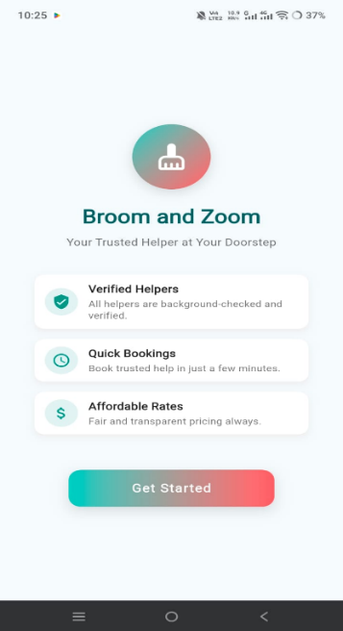
The Home Screen is the first screen displayed when the application is opened. It introduces users to the Broom and Zoom platform and provides quick access to the Login and Sign Up options. The screen is designed with a simple and user-friendly layout, making it easy for new users to get started.

Role Screen
The Role Selection Page allows users to choose their account type during registration. Users can select one of the available roles: Customer, Maid, Driver. After selecting a role, the system redirects the user to the corresponding registration process.
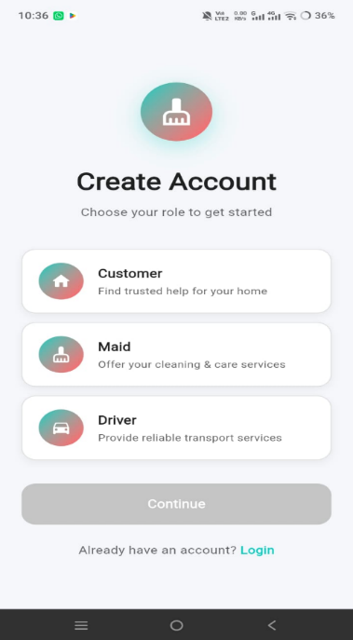

Language Page
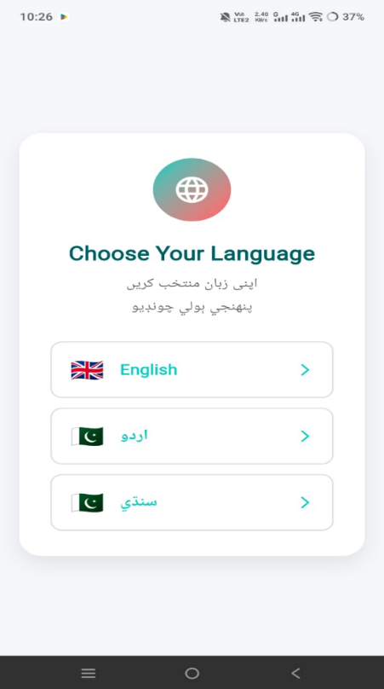
The Language Selection Page allows users to choose their preferred language before using the application. The app currently supports English, Urdu, and Sindhi. Users can select any language to use the application more comfortably and improve their overall experience.

OTP Verification Page
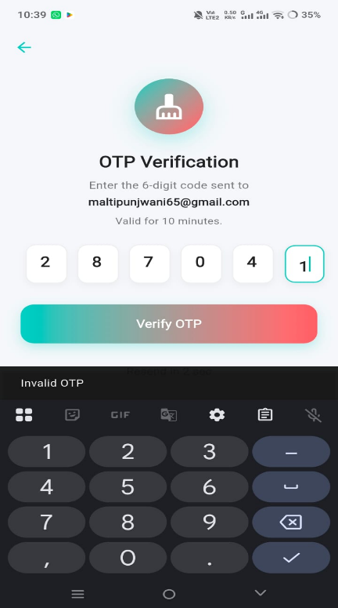
The OTP Verification Page verifies the user's identity by sending a One-Time Password (OTP) to the registered email or phone number. Users must enter the correct OTP before accessing the application.

Login Page
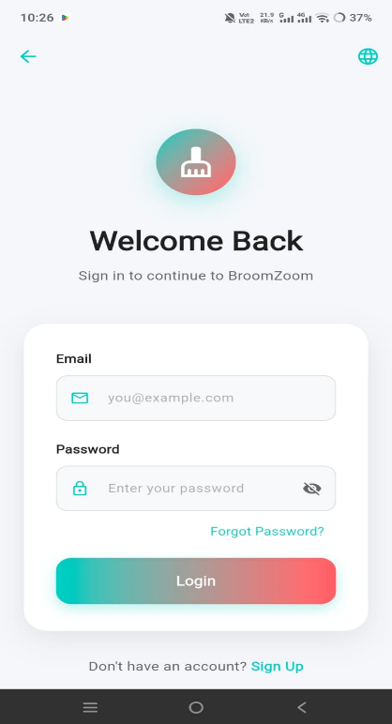
The Login Page allows registered users to securely access their accounts by entering their email and password.

Sign Up Page driver
The Sign Up Page allows new users to create an account by entering their personal information, such as name, last name, email, phone number, date of birth, CNIC, city, area and password. After completing the registration form, users proceed to OTP verification.
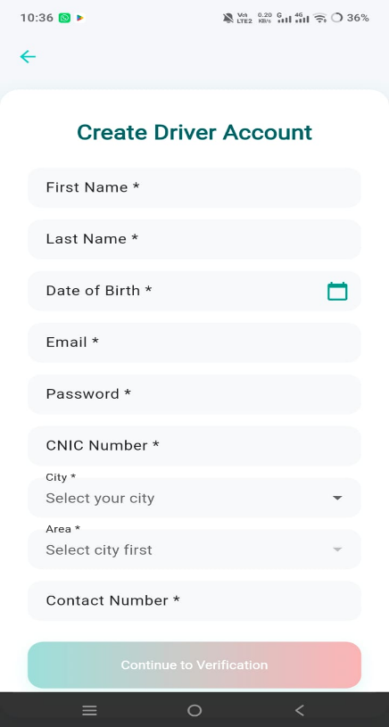

Customer Dashboard
The Customer Dashboard provides customers with all the features required to book household services. Customers can search for maids or drivers, view profiles, make bookings, check booking history, receive notifications, and submit ratings and reviews after the service is completed.
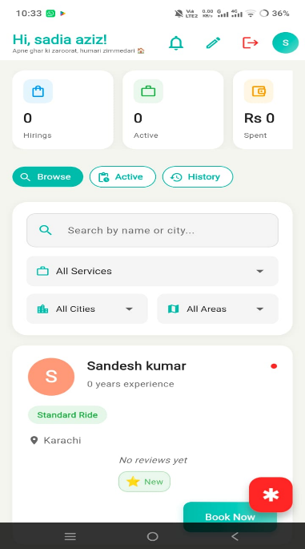

Driver Dashboard
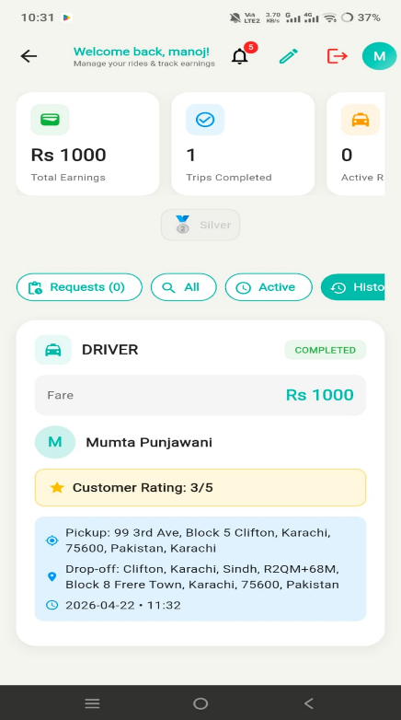
The Driver Dashboard helps drivers manage transportation requests. Drivers can view ride requests, accept or reject bookings, update trip status, manage their profile and vehicle information, and receive customer ratings after completing a trip.

Maid Dashboard
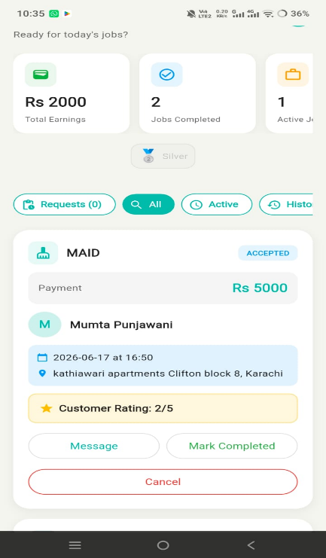
The Maid Dashboard allows maids to manage their daily work. They can view booking requests, accept or reject bookings, update service status, manage their profile, view ratings, and use the emergency button when required.

Admin Dashboard
The Admin Dashboard provides complete control over the system. The administrator can approve or reject maid and driver registrations, manage customer accounts, monitor bookings, handle complaints, manage ratings, and oversee the overall performance of the application.
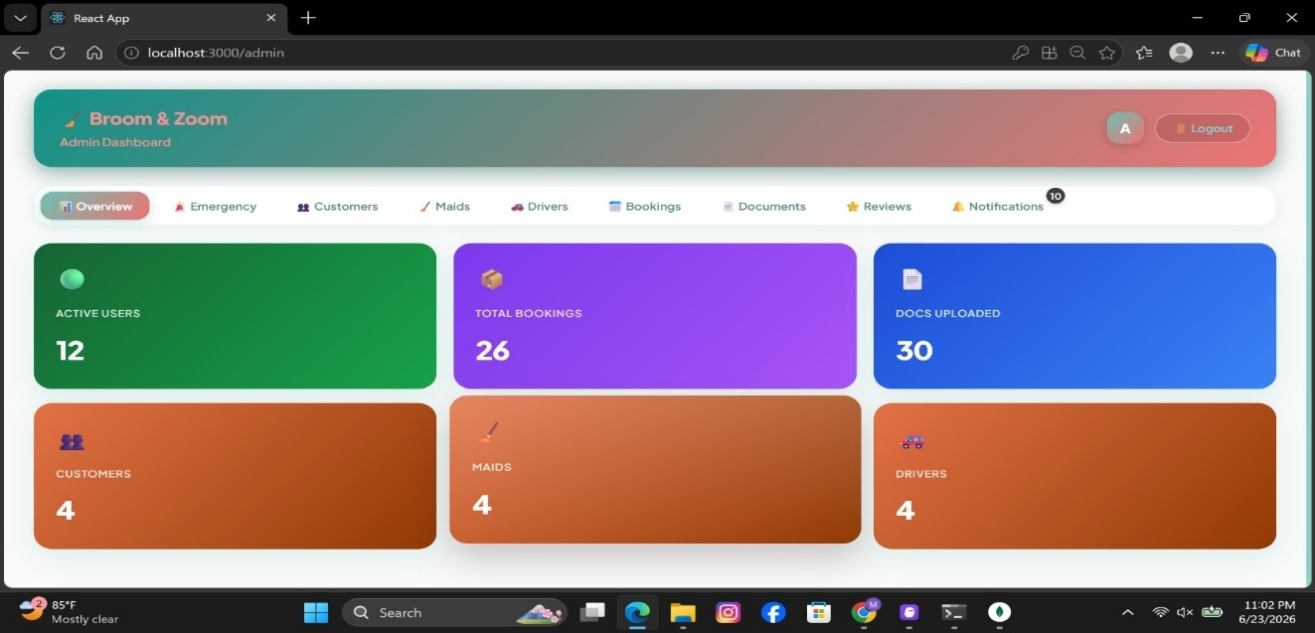

Emergency Alert
The Emergency Alert Page allows customers and maids to send an emergency alert whenever they need immediate assistance. By pressing the Emergency Alert button, an alert is instantly sent to the administrator, allowing a quick response during emergency situations. This feature helps improve user safety and provides additional security while using the application.
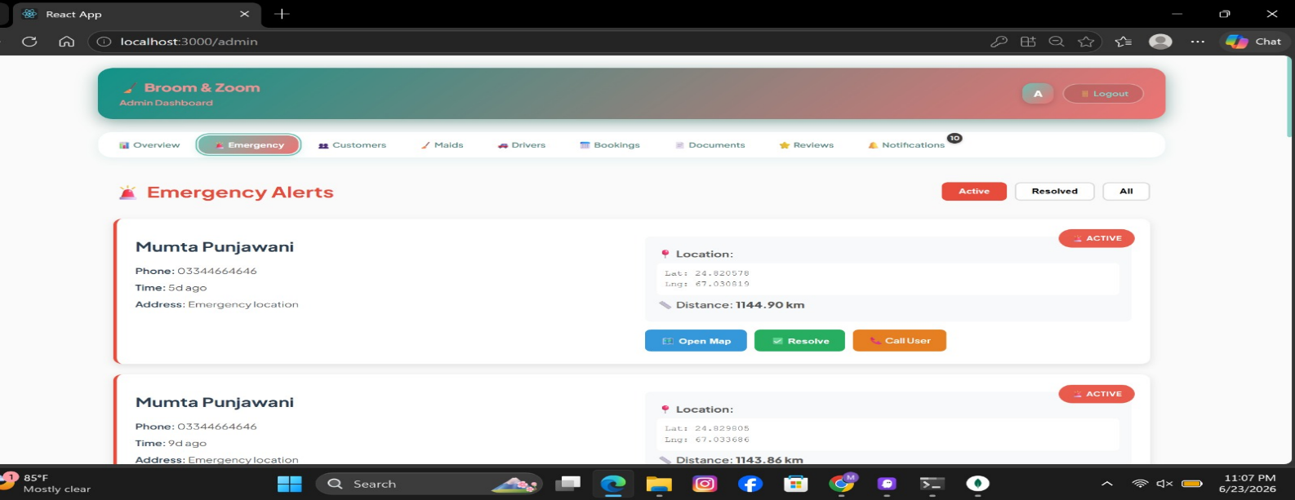

Notification Page
The Notification Page keeps users updated with important activities in the application. It displays alerts such as booking requests, booking status updates, account approval, and other important system notifications, helping users stay informed about their activities.
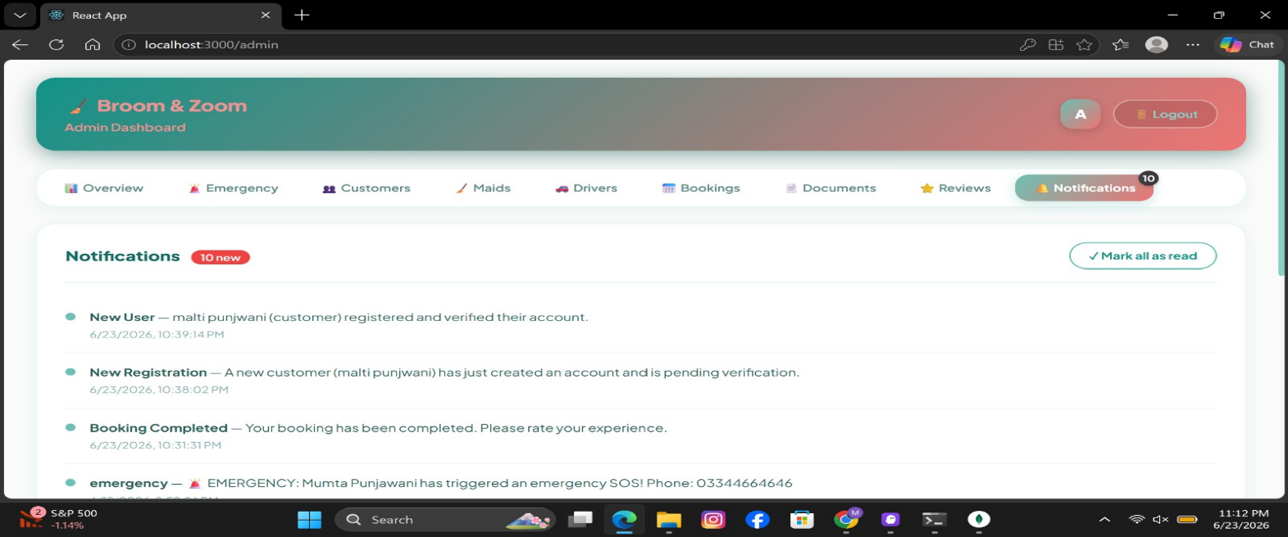

How to Use the System
The Broom and Zoom application is designed to provide a simple and convenient way for customers to hire trusted maids and drivers. This section explains how users can access the system and use its main features.

Basic Workflow
Open the Application: The user starts by opening the Broom and Zoom mobile application. The home screen appears with options such as Login, Sign Up, and Language Selection.
User Registration & Login: To use the application, users must create an account or log in. New users register by providing their personal information. Users select their role (Customer, Maid, or Driver). OTP verification is completed. Existing users can log in using their registered email or phone number and password. After successful login, users are redirected to their respective dashboards.
Dashboard Access: The dashboard provides access to all major features based on the user's role. Customers can search and book services. Maids and Drivers can manage booking requests. Admin can manage the entire system.
Service Booking: Customers can search for maids or drivers, view their profiles, and book the required service. The service provider receives the booking request and can accept or reject it.
Booking Management: After accepting the booking, both the customer and service provider can track the booking status until the service is completed.
Ratings & Reviews: After completing the service, customers can rate and review the maid or driver based on their experience.
Notifications & Emergency Alerts: Users receive notifications for booking updates, account approvals, and other important activities. Customers and maids can also use the Emergency Alert feature to notify the administrator during emergency situations.

Use Case Scenarios
Booking a Maid: A customer logs into the application, searches for a maid, views the available profiles, selects a suitable maid, and confirms the booking. After the service is completed, the customer provides a rating and review.
Booking a Driver: A customer searches for a driver, sends a booking request, and waits for the driver's confirmation. After completing the trip, both users can view the booking history and provide feedback.
Maid or Driver Managing Bookings
A maid or driver logs into the application, views incoming booking requests, accepts or rejects them, updates the service status, and completes the assigned work.
Emergency Alert: If a customer or maid faces an emergency during the service, they can press the Emergency Alert button. The system immediately sends a notification to the administrator for quick assistance.

Project-Specific Section (Mobile Application)

User Roles
Customer: Customers are the primary users of the application. They can: Register and log in, Search for maids and drivers, View service provider profiles, Book services, View booking history, Submit ratings and reviews, Use the Emergency Alert feature, Manage their profile.
Maid: Maids provide household services through the application. They can: Register and complete their profile, Wait for admin approval, View booking requests, Accept or reject bookings, Update service status, Receive ratings and reviews, Use the Emergency Alert feature, Manage their profile.
Driver: Drivers provide transportation services through the application. They can: Register and complete their profile, Add vehicle information, View ride requests, Accept or reject bookings, Update trip status, Receive customer ratings, Manage their profile
Administrator: The administrator manages the complete system and ensures smooth operation. The administrator can: Manage customers, maids, and drivers, Approve or reject maid and driver registrations, Monitor bookings, Handle complaints, Manage ratings and reviews, Block or unblock user accounts, Receive emergency alerts, Monitor overall system activities

API Usage
The Broom and Zoom application uses RESTful APIs to connect the Flutter mobile application with the Node.js backend.
Main API Functions
- User Registration and Login
- OTP Verification
- Profile Management
- Booking Management
- Notifications
- Ratings and Reviews
- Emergency Alert Management
Security: All APIs are protected using JWT (JSON Web Tokens) to ensure secure communication and prevent unauthorized access.

Data Input / Output
Input: The application accepts the following user inputs:
- Registration Information
- Login Credentials
- Profile Details
- Booking Information
- Ratings and Reviews
- Emergency Requests
Output: The application provides the following outputs:
- Booking Confirmation
- Booking Status Updates
- User Profiles
- Notifications
- Ratings and Reviews
- Emergency Alert Confirmation

System Security Features
To ensure secure access and protect user data, the application includes:
- JWT-based User Authentication
- Role-Based Access Control (Customer, Maid, Driver, Admin)
- OTP Verification
- Password Encryption
- Input Validation
- Secure API Communication
- Protected User Data

Troubleshooting
Issue | Possible Cause | Solution
Application not starting | Missing dependencies or incorrect setup | Install the required packages and restart the application.
Login not working | Incorrect email, phone number, or password | Verify your login credentials or reset your password.
OTP not received | Network issue or invalid phone number | Check your internet connection and request the OTP again.
Booking request failed | Internet connection problem or server issue | Check your internet connection and try again later.
Notifications not received | Notification permission is disabled | Enable notification permission from your device settings.
Location not working | GPS or location permission is disabled | Turn on GPS and allow location access for the application.
Database not connecting | Incorrect MongoDB connection string | Verify the MongoDB URI in the .env file.
Emergency Alert not sent | Internet connection or server issue | Ensure you have an active internet connection and send the alert again.
Profile not updating | Incomplete information or network issue | Complete all required fields and try again.
Application loading slowly | Poor internet connection or high server traffic | Refresh the application and use a stable internet connection.

FAQs
Q1: Do I need to create an account to use Broom and Zoom?
Ans: Yes, users must register and create an account before using the application's services.
Q2: Can I update my profile after registration?
Ans: Yes, users can edit and update their profile information at any time.
Q3: How can I book a maid or driver?
Ans: After logging in, search for a maid or driver, view their profile, and send a booking request.
Q4: Can maids and drivers use the application immediately after registration?
Ans: No. Their accounts must be approved by the administrator before they can receive bookings.
Q5: How do I know if my booking is accepted?
Ans: You will receive a notification when the maid or driver accepts or rejects your booking.
Q6: What should I do if I forget my password?
Ans: Use the Forgot Password option to reset your password.
Q7: Can I cancel a booking?
Ans: Yes, bookings can be cancelled before the service starts, subject to the application's policy.
Q8: What is the Emergency Alert feature?
Ans: It allows customers and maids to send an emergency alert to the administrator for immediate assistance.
Q9: Can I rate a maid or driver?
Ans: Yes, after the service is completed, customers can submit ratings and reviews.
Q10: What makes Broom and Zoom different from other service applications?
Ans: Broom and Zoom provides a single platform where customers can hire trusted maids and drivers, manage bookings, receive notifications, and use emergency support features.

Limitations
- The application requires a stable internet connection.
- It is currently available only for Android devices.
- Online payment integration is not available.
- Services are available only in supported locations.
- System performance depends on server availability and internet speed.

Future Enhancements
- Develop an iOS version of the application.
- Integrate secure online payment methods.
- Add live location tracking for drivers and maids.
- Support additional regional languages.
- Improve UI/UX for a better user experience.
- Add AI-based service recommendations.

Contact / Support
For any queries, technical issues, or support regarding the Broom and Zoom application, users can contact the project team or supervisor.
Developer Name(s):
- Nandni (2212299)
- Mumta Bai (2212319)
Project:
Broom and Zoom
Supervisor:
Ms. Sadia Aziz
Faculty of Computing and Engineering Sciences
Shaheed Zulfiqar Ali Bhutto Institute of Science and Technology (SZABIST), Karachi

