Threat Intelligence Dashboard
Project Report and Engineering Summary
Automated monitoring for logistics, ERP, and supply chain infrastructure

Prepared by Mustafa Muhammad
September 2026
github.com/Mustafa-Hazard/threat-intelligence-dashboard

Introduction
Threat Intelligence Dashboard is a full stack application that gives a supply chain or logistics organization a single, continuously updated view of the vulnerabilities most likely to affect it. Rather than asking a security team to manually track multiple threat feeds, the platform pulls live data from AlienVault OTX and the CISA Known Exploited Vulnerabilities catalog, tags each item by relevance to logistics specific systems such as ERP platforms, warehouse IoT devices, and fleet or GPS tracking, and produces a prioritized, explainable list that a non specialist can act on.
The project was built end to end over several sessions: a FastAPI backend with a real ingestion pipeline, a React and TypeScript frontend, a three tier AI fallback system for generating executive summaries, and a containerized deployment verified to run correctly outside of a development environment.

Problem Statement
Organizations that depend on ERP systems, warehouse automation, and connected fleet infrastructure are increasingly targeted through their software supply chain rather than through direct attacks on their own network perimeter. Two practical problems make this hard to manage day to day.
- Threat data is scattered across multiple feeds with different formats, different update frequencies, and different levels of historical depth, making manual correlation slow and error prone.
- Raw vulnerability feeds are not prioritized for a specific business context. A generic CVE feed treats a flaw in a niche hobbyist tool the same as a flaw in the ERP software actually running a company's warehouse, leaving teams to do that triage by hand.
This project addresses both problems directly: it consolidates two real intelligence sources into one pipeline, and it scores and tags each threat specifically against the kind of logistics and supply chain systems the dashboard is meant to protect.

Tools and Technologies Used
Backend | Python 3.11, FastAPI, SQLAlchemy, SQLite, Uvicorn
Frontend | React 19, TypeScript, Vite, Tailwind CSS, Recharts
AI / LLM | Google Gemini and Groq, orchestrated in a three tier fallback chain
Threat Data Sources | AlienVault OTX API and CISA Known Exploited Vulnerabilities catalog
Containerization | Docker, Docker Compose, Nginx (Alpine)
Testing and Automation | Standalone Python verification scripts, Playwright end to end recording
Version Control | Git and GitHub, feature branch and pull request workflow

System Architecture
Two external sources feed a single ingestion service, which tags and scores each threat before writing it to a SQLite database. A FastAPI application exposes that data through three endpoints. The threats and trends endpoints serve raw and aggregated data directly. The summary endpoint builds a prompt from the highest priority threats and passes it through a resilience chain: Google Gemini is tried first, Groq is used if Gemini is unavailable, and a deterministic static template is returned if both AI providers fail, so the executive briefing feature never simply breaks.
The frontend is a React single page application, built and served through Nginx inside a Docker container. Routing is handled entirely client side, which required verifying that Nginx correctly falls back to the application shell on a direct request to a route such as /threats or /trends, rather than returning a server level 404.

Feature Walkthrough
The following screenshots were captured directly from the running application, including the containerized Docker build with a full, real dataset of 1,700 ingested threats.
Overview: an AI generated daily briefing summarizing the highest priority threats in plain language.
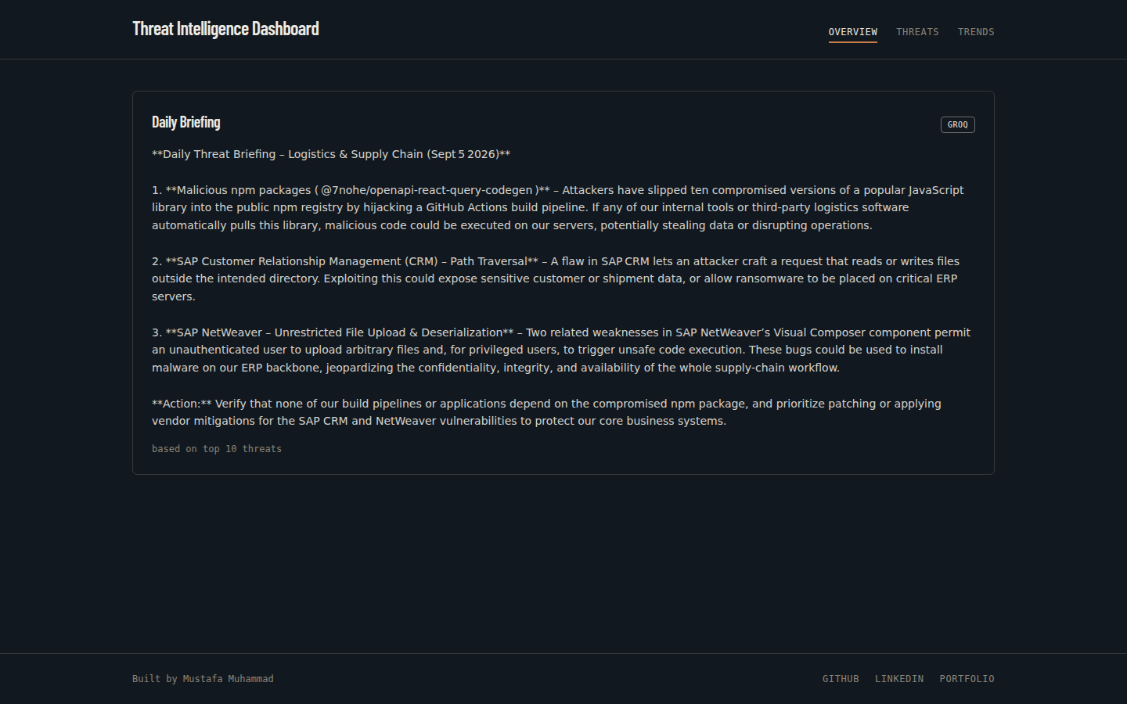
Figure 1. Overview page showing the AI generated daily briefing.
Threats: the full inventory, sortable by priority or publish date and filterable by tag.
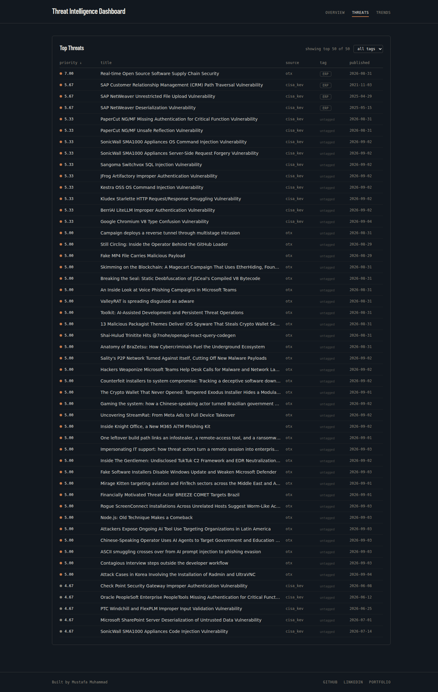
Figure 2. Threats table, sorted by priority score by default.
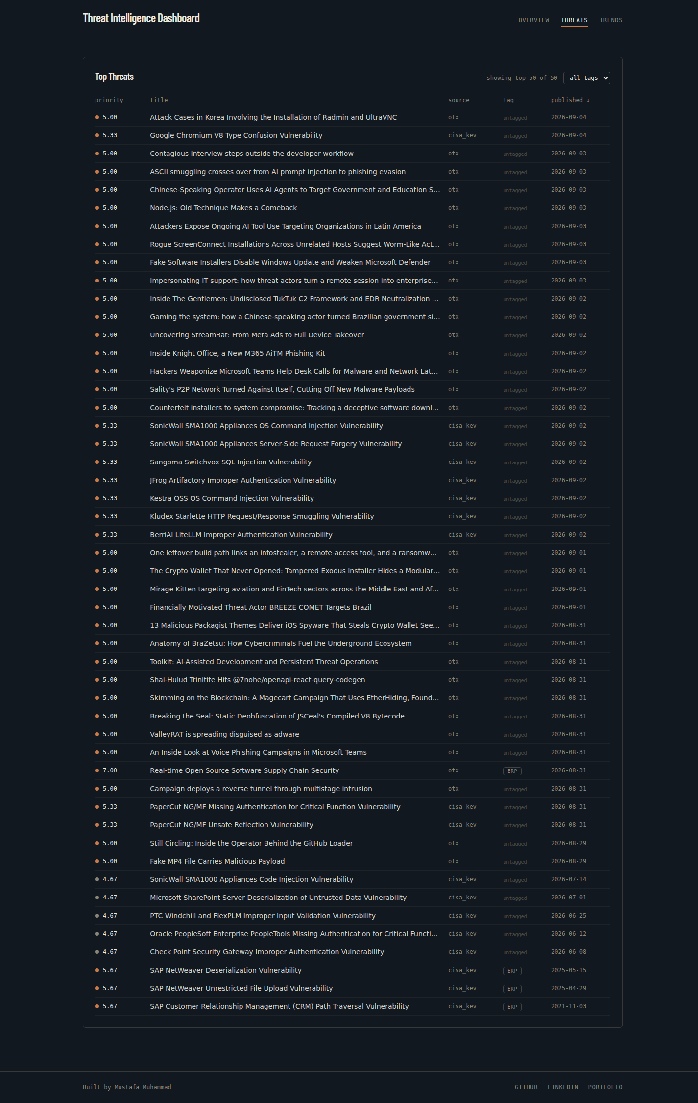
Figure 3. Threats table, re-sorted by publish date to surface the newest entries.

The tag filter narrows the inventory to a specific system category, such as ERP, so a team can focus on the systems most relevant to them.
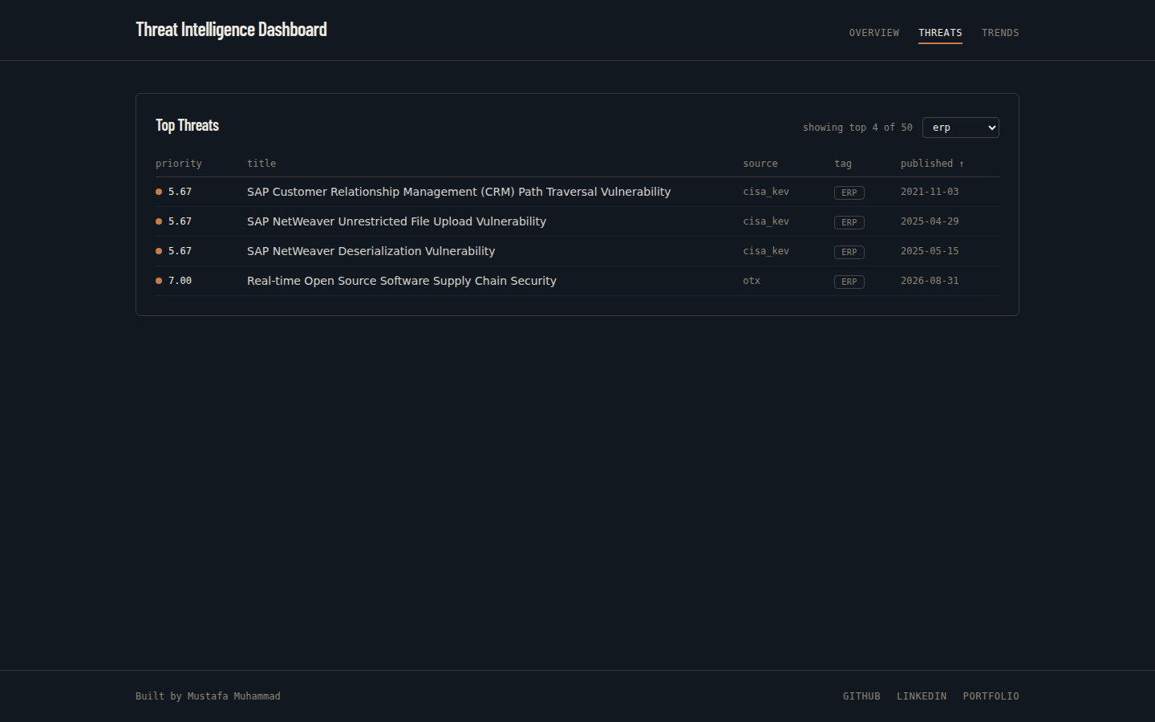
Figure 4. Threats table filtered to ERP related vulnerabilities only.
Trends: weekly aggregate volume across both data sources, with an explicit note about the data asymmetry between them.
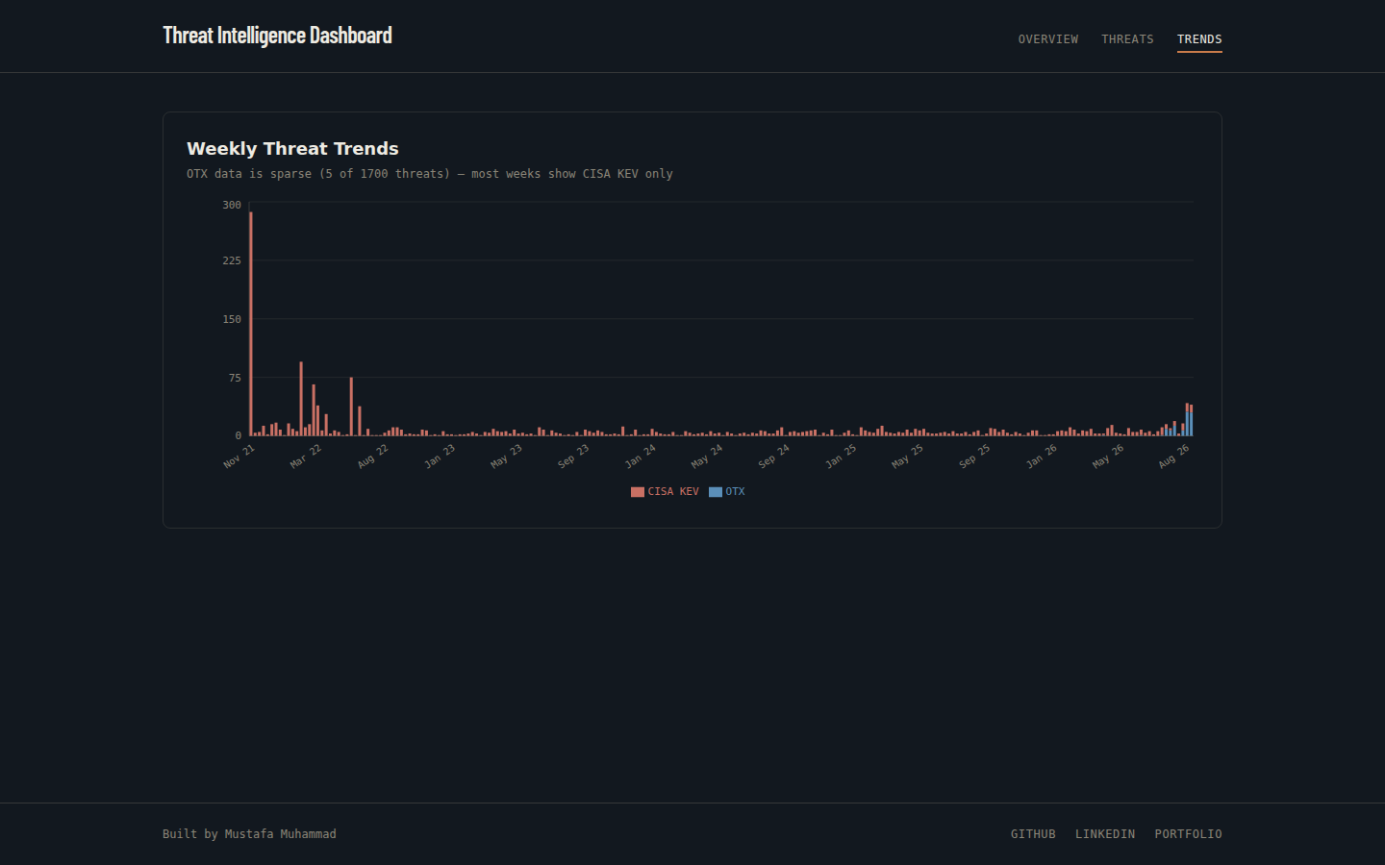
Figure 5. Weekly threat trend chart, combining CISA KEV and OTX volume.

Engineering Challenge and Fix
One of the more instructive problems in this project was not a crash or an error message, but a silent shortfall. The AlienVault OTX API initially returned a 403 response when queried with Python's default request headers, which was straightforward to diagnose and fix with an explicit User-Agent string. A second, quieter issue followed: once authentication succeeded, unpaginated requests were capped at a small number of results per page with no error at all, simply less data than expected.
The fix was to implement real pagination against the OTX API rather than relying on its default page size. The more important lesson was about the category of bug itself: a pipeline that runs successfully and returns a plausible looking result can still be quietly wrong. Catching this required comparing the number of records actually fetched against what should have been available, not just checking whether the request succeeded.
A related, later verification challenge came from the deployment side rather than the code itself. The Nginx single page application fallback and the full Docker Compose build had both been reviewed by reading the configuration files, and looked correct on paper. They had not, however, actually been run. Building and starting the containers, then confirming both the routing and a fresh ingestion pass against the containerized backend, closed that gap and produced a working system that had been demonstrated rather than only reasoned about.

Key Lesson Learned
Verification and confidence are not the same thing. It is easy to build justified confidence in a system by reading its code and configuration carefully, and that confidence is genuinely useful, but it is a different claim from having actually run the system and observed the expected result. Separating those two categories explicitly throughout this project, treating “I reasoned this should work” and “I ran this and confirmed it worked” as distinct statements, turned out to be one of the most transferable habits to come out of building it.

Relevance to SafeX Solutions
SafeX Solutions is a global technology and digital solutions company delivering IT services, cybersecurity, network infrastructure, and cloud solutions to clients across more than fifteen countries. A platform like this Threat Intelligence Dashboard maps directly onto that kind of managed cybersecurity offering: rather than a security team manually monitoring multiple raw threat feeds for each client, a service provider operating at SafeX's scale could run a consolidated, client specific version of this pipeline, tagging and prioritizing vulnerabilities against the exact systems each client actually runs, from ERP platforms to connected infrastructure, and surfacing that as a clear, non technical briefing rather than a raw data feed.
The resilience pattern used for the AI summary feature, falling back from one provider to another before falling back again to a guaranteed static response, is also directly applicable to any client facing service where uptime and consistent output matter more than always using the most sophisticated available tool.

Conclusion
This project delivers a working, end to end threat intelligence platform: real external data sources, meaningful domain specific prioritization, a resilient AI summary pipeline, and a containerized deployment that has been built, run, and verified rather than only designed on paper. The engineering process behind it, particularly the discipline of separating assumptions from verified fact, is as much a part of the deliverable as the running application itself.

