SentinelAuth
Anomalous Login Detection and Automated Response using ELK & Wazuh



Mohammad Mustafa 26100286
Mustafa Hussain 26100399
Muhammad Aaffan Khan Niazi 26100015
Shehroz Faryad 25100022

Advisor: Waqar Ahmed
School of Science and Engineering
Lahore University of Management Sciences
Submission Date: May 4, 2026

Acknowledgement and Dedication
We would like to express our sincere gratitude to our advisor, Dr. Waqar Ahmed, whose guidance, feedback, and encouragement throughout this project were invaluable. His expertise in cybersecurity and system design helped shape the direction of our work and kept us focused on what mattered most.
We are grateful to the School of Science and Engineering at LUMS for providing the academic environment and resources that made this work possible. We also thank our peers and colleagues who provided feedback during project reviews and demonstrations.
This work is dedicated to our families, whose patience and support made it possible for us to pursue this challenge. We also dedicate this to every security engineer and SOC analyst working to protect systems and people from digital threats.

Certificate
I certify that the senior project titled "Anomalous Login Detection and Automated Response using ELK and Wazuh" was completed under my supervision by the following students:

26100286 Mohammad Mustafa
26100399 Mustafa Hussain
26100015 Muhammad Aaffan Khan Niazi
25100022 Shehroz Faryad
and the project deliverables meet the requirements of the program.

------------------------------------- Date:
Advisor (Signature)

------------------------------------- Date:
Co-advisor (if any)

Table of Contents
1. Introduction 5
a. Introduction 5
b. Objective and Scope 6
c. Development Methodology 6
d. Contributions 6
2. System Requirements 7
a. System Actors 7
b. Functional Requirements 7
c. Non-functional Requirements 8
3. System Architecture 9
a. Architecture Diagram 9
b. Architecture Description 9
c. Justification of the Architecture 10
d. Tools and Technologies 11
4. Requirements Specifications 11
a. Use Cases 11
b. Class Diagram 23
c. Sequence Diagrams 25
5. Software Development Methodology and Plan 30
a. Software Process Selection 30
6. Database Design and Web Services 31
a. Database Design 31
b. API Specification 31
7. System User Interface 32
8. Project Security 38
9. Risk Management 39
a. Potential Risks and Mitigation Strategies 39
10. Testing and Evaluation 40
11. Deployment Guidelines 41
12. Conclusion 42
a. Summary 42
b. Challenges 42
c. Future 42
13. Review Checklist 43
14. References 43

List of Figures
Figure 1: UC-003 Detect & Prevent Brute Force Attempts – Use Case Diagram 12
Figure 2: UC-007 Privileged Account Watch – Use Case Diagram 13
Figure 3: UC-009 Contain Account – Use Case Diagram 14
Figure 4: UC-011 Generate Weekly Report – Use Case Diagram 15
Figure 5: UC-016 Auto-Revoke Compromised API Keys – Use Case Diagram 16
Figure 6: UC-020 IPS Rollback on False Positives – Use Case Diagram 17
Figure 7: UC-023 Detect & Prevent Password Spray Attack – Use Case Diagram 18
Figure 8: UC-024 Detect & Prevent Login from Blocked Countries – Use Case Diagram 19
Figure 9: UC-025 Adaptive Threat Risk Scoring – Use Case Diagram 20
Figure 10: UC-026 Investigation Graph View – Use Case Diagram 21
Figure 11: Class Diagram 23
Figure 12: UC-003 Brute Force – Sequence Diagram 25
Figure 13: UC-007 Privileged Account Watch – Sequence Diagram 26
Figure 14: UC-009 Contain Account – Sequence Diagram 26
Figure 15: UC-011 Weekly Report – Sequence Diagram 27
Figure 16: UC-016 API Key Revocation – Sequence Diagram 27
Figure 17: UC-020 IPS Rollback – Sequence Diagram 28
Figure 18: UC-023 Password Spray – Sequence Diagram 28
Figure 19: UC-024 Blocked Countries – Sequence Diagram 29
Figure 20: UC-025 Adaptive Risk Scoring – Sequence Diagram 29
Figure 21: UC-026 Investigation Graph – Sequence Diagram 30
Figure 22: System Architecture Diagram 9
Figure 23: Executive Overview Dashboard 32
Figure 24: Alert Triage Workbench 33
Figure 25: Detection Center 34
Figure 26: Scenario Control & Simulation Workspace 35
Figure 27: Containment Action Center 36
Figure 28: Weekly Report Builder 37

Introduction
This chapter introduces the final implementation of the Anomalous Login Detection System (ALDS), a full-stack security monitoring and response platform built around ELK, Wazuh, FastAPI, SQLite, and a React dashboard. The final system delivers 26 implemented use cases covering log collection, anomaly detection, adaptive risk scoring, graph-based investigation, alert triage, automated containment, reporting, deployment, and administrative monitoring.

Introduction
ALDS operates in the cybersecurity and security-operations domain, where organizations need to identify risky authentication behavior before an account compromise spreads across systems. Instead of relying on manual review of raw authentication logs, the platform centralizes Windows and Linux login data, enriches the events, assigns risk, and exposes them through dashboards and API endpoints that analysts can act on immediately.
The primary users are security engineers, SOC analysts, and system administrators. Security engineers tune detection thresholds and policies, SOC analysts triage alerts and manage containment workflows, and system administrators maintain the log pipeline, endpoint agents, and deployment environment. End users benefit indirectly through faster account protection, forced MFA, blocked malicious IPs, and terminated suspicious sessions.
The final deliverable is a layered solution consisting of a FastAPI backend, a SQLite operational data store, ELK and Wazuh monitoring pipelines, automated mitigation logic for high-risk events, and a React-based admin dashboard for visibility, triage, reporting, and evidence review.

Objective and Scope
The core objective of the project was to move from passive login monitoring to actionable security orchestration. The team aimed to ingest authentication events from heterogeneous sources, detect suspicious patterns such as brute force, impossible travel, blocked-country access, off-hours activity, privileged account misuse, and password spray behavior, and then connect those detections to containment actions that can be audited and reviewed.
The project scope therefore covers the full detection-to-response lifecycle: data collection (UC-001 and UC-002), analyst workflows (UC-008, UC-010, UC-011, and UC-022), automated prevention and containment (UC-009 and UC-012 through UC-020), and deployment or readiness activities (UC-021). The scope intentionally stays focused on anomalous login defense and surrounding SOC workflows rather than general-purpose SIEM functionality.

Development Methodology
The project was developed iteratively across four sprints. Each sprint added a working slice of the platform, starting with ingestion and basic detections, then moving to triage and reporting, then to backend services and runtime mitigations, and finally to advanced containment, dashboard completion, CI/CD, and Kubernetes readiness.
This incremental approach allowed the team to validate each security capability in a demonstrable form before expanding the architecture. A more detailed discussion of the methodology and sprint plan is provided later in the report.

Contributions
The main contribution of this work is the combination of security analytics and operational response in a project that remains demonstrable end to end. Rather than stopping at alert generation, the system records mitigation outcomes such as account locks, IP blocks, session termination, MFA step-up, API key revocation, region-based blocking, admin-console blocking, and containment ticket creation.
A second contribution is traceability. Suspicious events, analyst triage decisions, containment tickets, policy updates, and mitigation evidence are all exposed through the backend and surfaced in the dashboard or evidence files. This makes the system suitable not only for detection demos but also for verification, reporting, and post-incident review.
Finally, the project demonstrates a practical bridge between detection engineering and software engineering: detection rules are backed by test cases, the UI is connected to live APIs, container images are validated in CI/CD, and Kubernetes manifests are prepared for scaled deployment.

System Requirements
This chapter summarizes the operational and quality requirements of ALDS as they appear in the implemented repository. The requirements are derived from the final delivered use cases and organized around the people who operate the platform and the behaviors the system must support.

System Actors
Actor Name | Description
Security Engineer/SOC Analyst | Defines detection policies, blocked-country rules, password spray thresholds, and administrative-console risk thresholds. This actor also tunes rules, reviews false positives, and approves improvements to the detection logic.
System Administrator | Maintains endpoint log collection, backend services, ELK/Wazuh infrastructure, container deployment, and system health. This actor ensures that data sources remain available and that runtime response actions can be executed safely.
End User or Protected Account Holder | Generates the authentication activity that the system monitors. This actor benefits from protections such as account lock, MFA step-up, blocked risky access, and suspicious session termination.

Functional Requirements
1. Log ingestion and platform readiness: The system shall collect Windows authentication events (UC-001), ingest Linux SSH logs (UC-002), and support an end-to-end VM-based deployment path (UC-021) so that detections can be demonstrated on realistic data sources.
2. Threat detection and prevention: The system shall detect and prevent brute-force attempts (UC-003), detect impossible travel (UC-004), off-hours login behavior (UC-005), new device or user-agent anomalies (UC-006), apply stricter monitoring for privileged account activity (UC-007), detect and prevent password spray attacks (UC-023), and detect and prevent login attempts from blocked countries (UC-024).
3. Analyst monitoring and governance: The system shall allow alert triage in Kibana or the dashboard (UC-008), rule tuning and threshold adjustment (UC-010), weekly reporting (UC-011), and centralized visibility through the full-stack admin dashboard (UC-022).
4. Automated containment and enforcement: The system shall support account containment (UC-009), automatic account lock on repeated malicious behavior (UC-012), source IP blocking (UC-013), suspicious session termination (UC-014), forced MFA step-up (UC-015), API key revocation (UC-016), VPN access disablement (UC-017), administrative console blocking (UC-018), automated containment ticket creation (UC-019), and rollback of temporary IPS-style restrictions on false positives (UC-020).
5. Audit and evidence: The system shall persist login events, mitigation decisions, triage updates, containment tickets, policies, and evidence records so that each use case can be verified after execution.

Non-functional Requirements
1. Availability and health monitoring: The backend shall expose a health-style endpoint (/ingestion/health) and Kubernetes readiness or liveness checks so that failed deployments or broken pipelines are detectable automatically.
2. Auditability: Every suspicious event and every mitigation action shall be stored with timestamped metadata in persistent stores such as SQLite tables or JSONL evidence files.
3. Scalability: Core services shall be containerized, and the deployment artifacts shall support horizontal scaling through Kubernetes; the frontend deployment already defines two replicas and the backend deployment defines resource requests and limits.
4. Maintainability: Detection, analytics, simulation, and UI concerns shall remain modular so that new use cases can be added without rewriting the entire system.
5. Performance: The platform shall be capable of continuous seeded traffic generation and repeated UC simulation without manual resets, with CI/CD smoke tests validating the main API and UI paths.
6. Portability: The solution shall run on local Windows and PowerShell development setups as well as Docker or Kubernetes environments using the same repository structure and documented commands.

System Architecture
This chapter describes the implemented runtime structure of ALDS. The architecture separates data collection, detection, response orchestration, storage, and user interaction so that monitoring and containment can be verified independently.

Architecture Diagram
The architecture diagram is maintained in the separate architecture deliverable submitted with the repository. In this report, the focus is on the textual description of the implemented subsystems and their interactions.
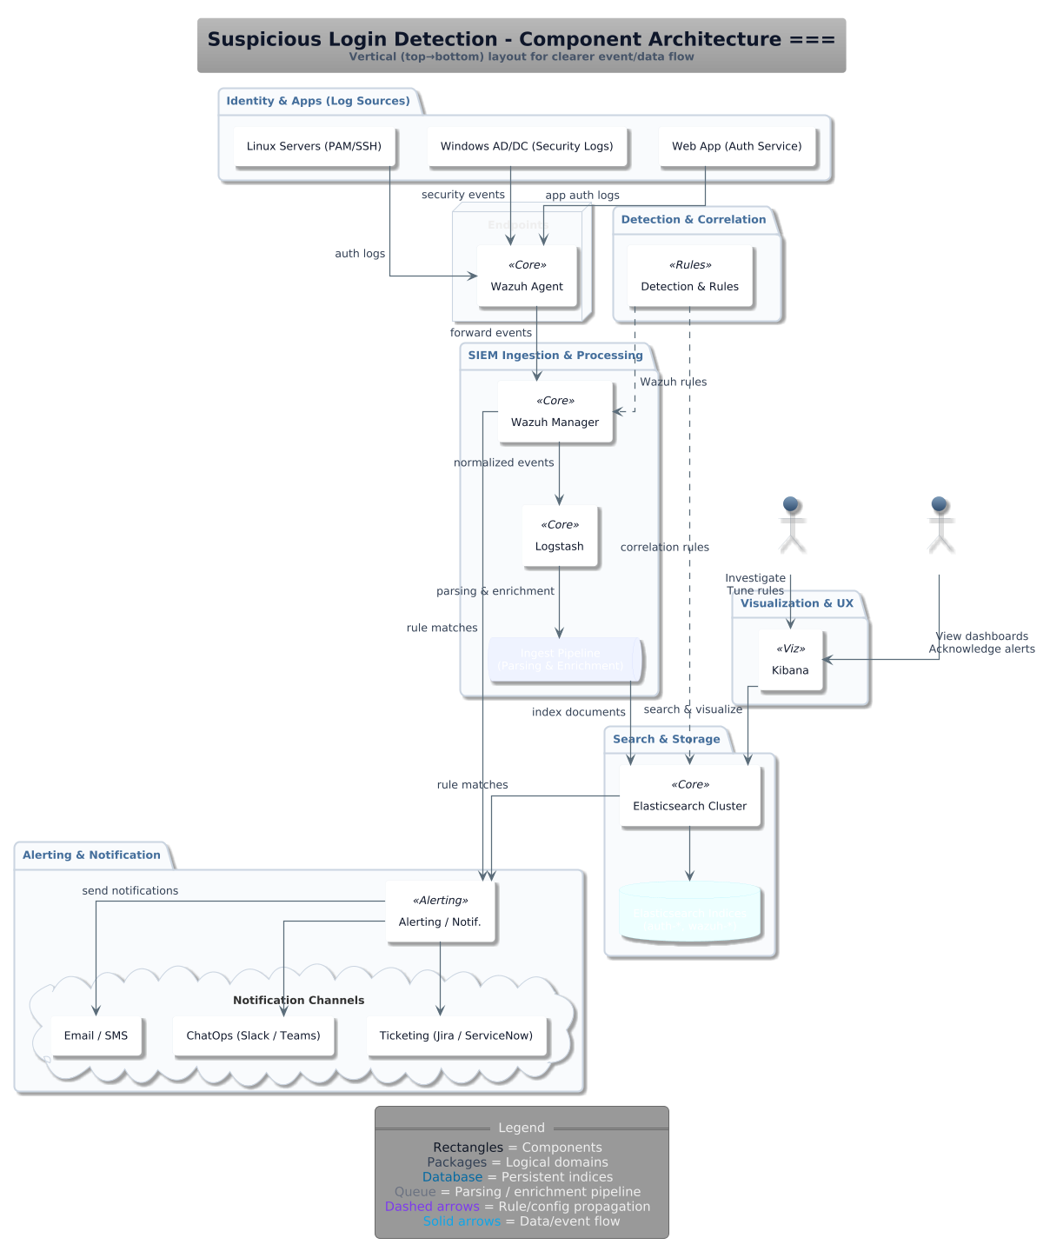

Architecture Description
At the data-source layer, Windows endpoints and Linux hosts generate authentication logs that are collected through endpoint agents and forwarded into the monitoring stack. In the repository, these sources are represented through Windows event collection, Linux SSH log ingestion, and seeded or simulated authentication activity used during repeatable demonstrations.
At the telemetry-processing layer, Logstash normalizes incoming events, enriches them with contextual fields, and sends them to Elasticsearch. Wazuh manager and Wazuh dashboard provide a parallel security-operations view, while Filebeat and synchronization scripts move alert and log artifacts between the application, Elasticsearch, and Wazuh components. This layer implements the detection side of use cases such as brute force, impossible travel, blocked-country access, and password spray monitoring.
At the application-control layer, a FastAPI backend serves as the orchestration and management service. It accepts login attempts, calculates risk, persists events in SQLite, exposes analytics and reporting endpoints, seeds simulation data, records mitigation logs, and invokes the Sprint-4 automation engine for high-risk containment actions. SQLite acts as the operational store for users, login events, sessions, policies, triage status, incident cases, access restrictions, and containment tickets, while JSONL evidence files provide a durable record of automated responses.
At the presentation layer, a React and TypeScript dashboard consumes the backend APIs and gives analysts one place to observe KPIs, inspect events, triage alerts, review evidence, tune policies, manage cases, and execute simulations. This dashboard complements Kibana rather than replacing it: Kibana remains useful for log-centric investigation, while the custom UI focuses on workflow management and end-to-end validation of the implemented use cases.
Finally, the response layer connects detection outcomes to enforcement. Depending on the triggering use case, the system can record or simulate account locking, IP blocking, active session termination, MFA step-up, API key revocation, VPN disablement, admin-console blocking, and automated ticket creation. Where live enterprise integrations are not available in the lab, the repository preserves auditable evidence of the intended response through mitigation logs and Sprint-4 evidence artifacts.

Justification of the Architecture
This architecture has three major strengths. First, it is modular: log collection, detection, orchestration, dashboarding, and response are separated enough that each can be tested independently. Second, it is auditable: the same suspicious action can be traced across login events, mitigation logs, alert files, dashboard views, and test artifacts. Third, it is deployable: the backend, frontend, and monitoring stack can run locally, in Docker, or behind Kubernetes manifests without redesigning the application.
There are also trade-offs. Operating ELK, Wazuh, a custom backend, and a separate frontend increases deployment and troubleshooting complexity. The use of SQLite is practical for demonstrations and JDBC-based log shipping, but it is not the best long-term choice for high-concurrency production workloads. Some containment integrations are implemented as evidence-backed simulations because direct control of enterprise VPNs, identity providers, or API gateways is outside the project lab environment.
Despite those limitations, the architecture is appropriate for ALDS because it directly supports the project's non-functional needs. The dashboard and health endpoints support observability; modular services improve maintainability; containerization and Kubernetes manifests support portability and scaling; and the separation of event storage, analyst workflow, and mitigation evidence improves traceability.
From a security perspective, the architecture also enforces defense in depth. Detection happens at the log and API layers, response is captured through dedicated mitigation logic, and every important action leaves an audit trail. This makes the system suitable for demonstrating both detection engineering and controlled automated response in the same platform.

Tools and Technologies
The implemented stack combines Python 3.12-based backend services with a TypeScript and React frontend and containerized monitoring infrastructure. The backend uses FastAPI 0.110.0, Uvicorn 0.29.0, SQLAlchemy 2.0.39, and Requests 2.31.0. The frontend uses React 19.2.4, React Router DOM 7.14.0, Vite 8.0.4, TypeScript 6.0.x, and Vitest 4.1.2.
For monitoring and data processing, the repository includes Elasticsearch 7.10.1, Logstash 7.10.1, Kibana 7.10.1, Filebeat 7.10.1, and Wazuh 4.14.3 through Docker Compose definitions. CI/CD and quality assurance are handled through GitHub Actions, Coverage.py, unittest, Vitest, React Testing Library, happy-dom, SonarCloud scanning, Docker image builds, GitHub Container Registry publication, and Kubernetes manifest validation with kubeconform.

Requirements Specifications
This chapter summarizes the final functional scope captured in the implemented use cases. The subsection below focuses on ten core use cases that best represent the final architecture, combining detection, prevention, containment, reporting, adaptive scoring, and graph-based investigation.

Use Cases
The following ten core use cases summarize the final implemented scope of ALDS. Together they show how the platform combines ELK and Wazuh ingestion, FastAPI management services, automated response logic, and analyst-facing dashboards to detect, prevent, contain, report, and prioritize anomalous login threats.
UC-003: Detect & Prevent Brute Force Attempts
Repeated failed logins for the same identity or source are ingested from protected applications and correlated over a rolling time window. When the configured threshold is exceeded, ALDS raises an alert, records the evidence in the security data store, and triggers a preventive response path so continued guessing can be blocked or escalated into containment before a valid session is established; the SOC then reviews the incident in Kibana or the dashboard.
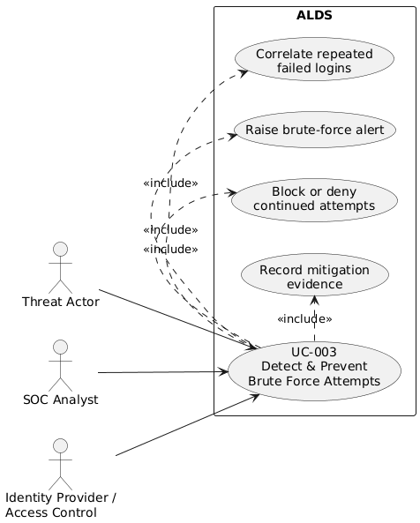
UC-007: Privileged Account Watch
Logins involving privileged or administrative accounts are tagged as high sensitivity and evaluated with stricter thresholds than ordinary users. Any suspicious privileged activity is surfaced immediately for urgent SOC review, allowing analysts to prioritize high-impact identities and pass them into containment or administrative-access control workflows when necessary.
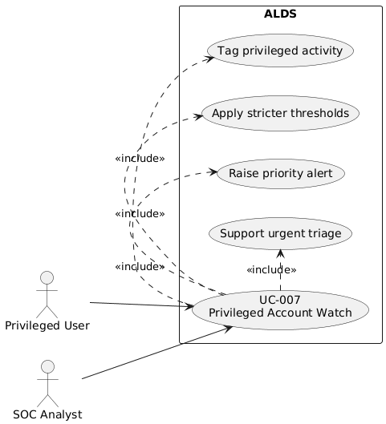
UC-009: Contain Account
Once compromise is confirmed or strongly suspected, the SOC analyst uses the containment workflow to open or update a case and initiate account-protection actions. In the target architecture these actions can include disabling the account, forcing a password reset, revoking tokens or sessions, and tracking the result through containment tickets and mitigation logs; in the lab implementation, the dashboard and APIs manage the auditable case and ticket trail that represents those actions.
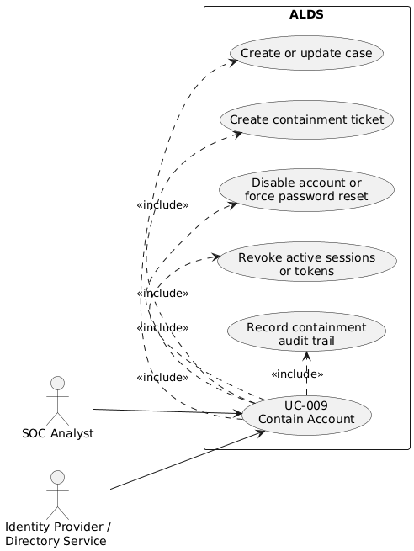
UC-011: Generate Weekly Report
ALDS aggregates authentication events and mitigation activity into a weekly operational summary for governance and review. The reporting service queries stored events and mitigation logs, produces totals and distributions by action and use case, and exposes the result through the Reports page and export endpoint so stakeholders can review detection volume, containment activity, and current security posture without assembling evidence manually.
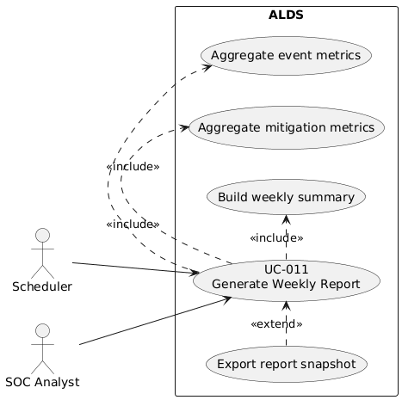

UC-016: Auto-Revoke Compromised API Keys
When suspicious API-key usage or an explicit compromise signal is observed, the Sprint-4 automation engine invokes the API-key revocation workflow. The mitigation is recorded as evidence and, in the target architecture, propagated to the external API gateway or key-management system so the compromised key can no longer be used; the SOC can then verify the outcome through the mitigation log, evidence feed, and dashboard views.
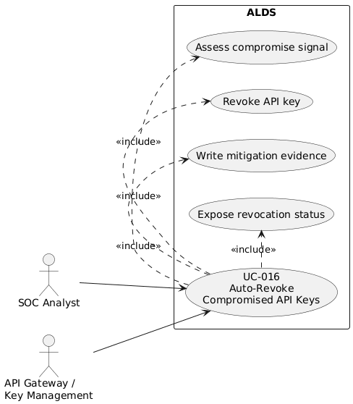

UC-020: IPS Rollback on False Positives
If an automated restriction is later determined to be a false positive, the SOC analyst can roll back the temporary containment action instead of leaving a legitimate entity blocked. The platform supports this by maintaining access restrictions as managed records that can be deactivated through the policy-management workflow while preserving the original alert and mitigation evidence for auditability and future rule tuning.
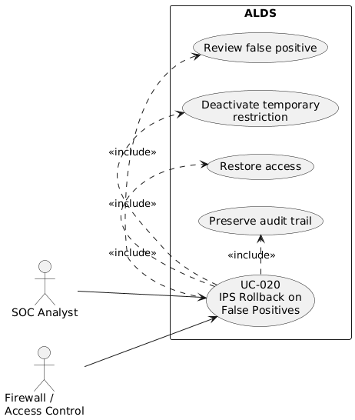

UC-023: Detect & Prevent Password Spray Attack
ALDS correlates failed authentication attempts from one source IP across many distinct usernames within a configurable window to identify password-spray behavior. When the distinct-user threshold is exceeded, the system not only raises a high-risk alert but also creates or extends a temporary access restriction for the offending source so further attempts are prevented during the restriction period, with the evidence exposed to analysts in ELK and the custom dashboard.
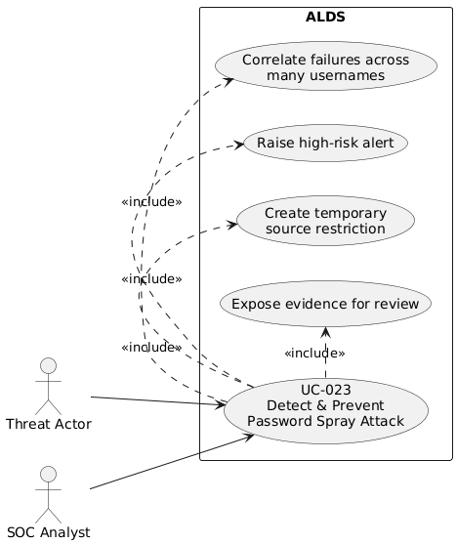

UC-024: Detect & Prevent Login from Blocked Countries
Each login event is evaluated against the organization's blocked-country policy before access is allowed to proceed. If the source country matches the deny list, the system records the event as suspicious, generates an alert, and enforces a preventive region block so the login is denied rather than merely observed; the resulting decision remains visible to the SOC through policy, mitigation, and alert views.
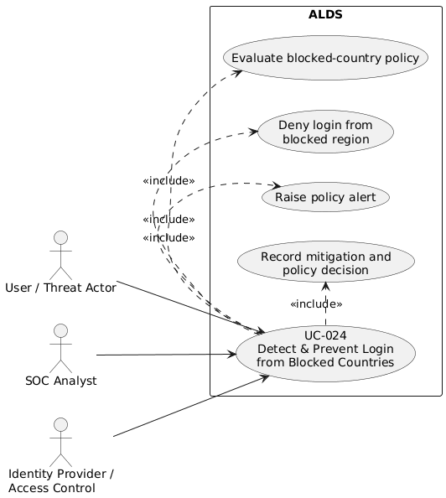

UC-025: Adaptive Threat Risk Scoring and Detection Calibration
Through the Detection Center, analysts review rule health, threat velocity, top risky users, average confidence, false-positive rate, and 24-hour risk drift, then calibrate rule behavior using presets or manual threshold changes. Backtest support allows proposed settings to be evaluated against recent events before they are saved, helping the team prioritize the most dangerous activity without blindly increasing alert volume.
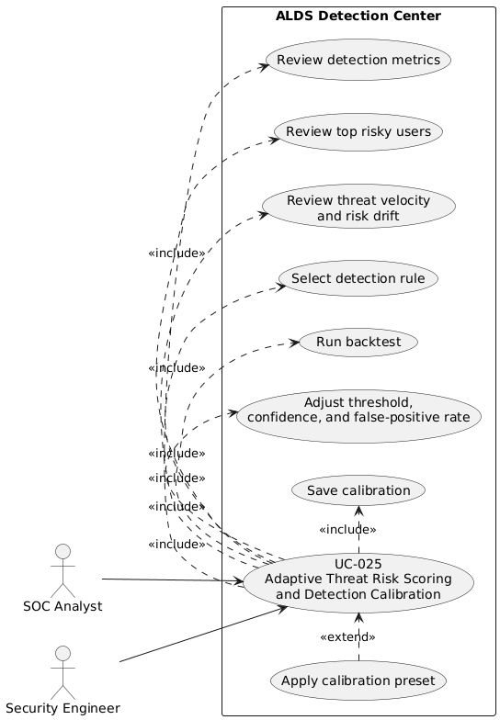
UC-026: Investigation Graph View for Risk Prioritization
The Investigation Graph View transforms current events into an entity relationship map of users, IP addresses, and suspicious interactions. By filtering the graph and inspecting node degree, cumulative risk, and neighborhood size, the SOC analyst can quickly isolate the most exposed or dangerous node and prioritize containment or escalation accordingly.
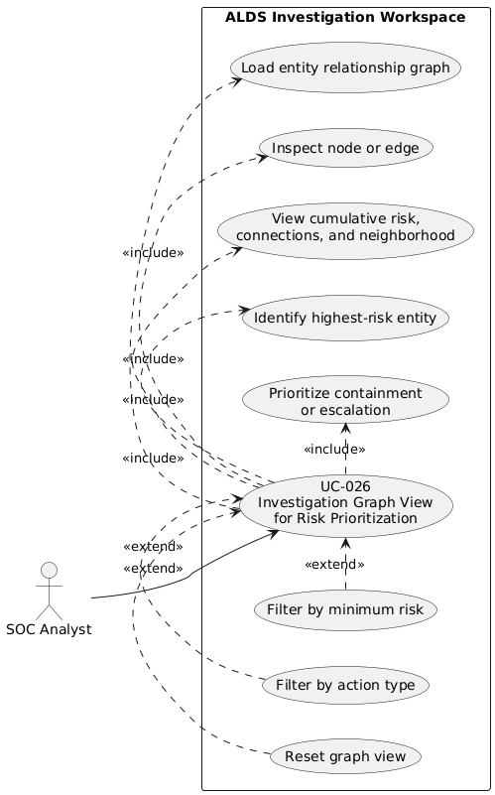

Class Diagram
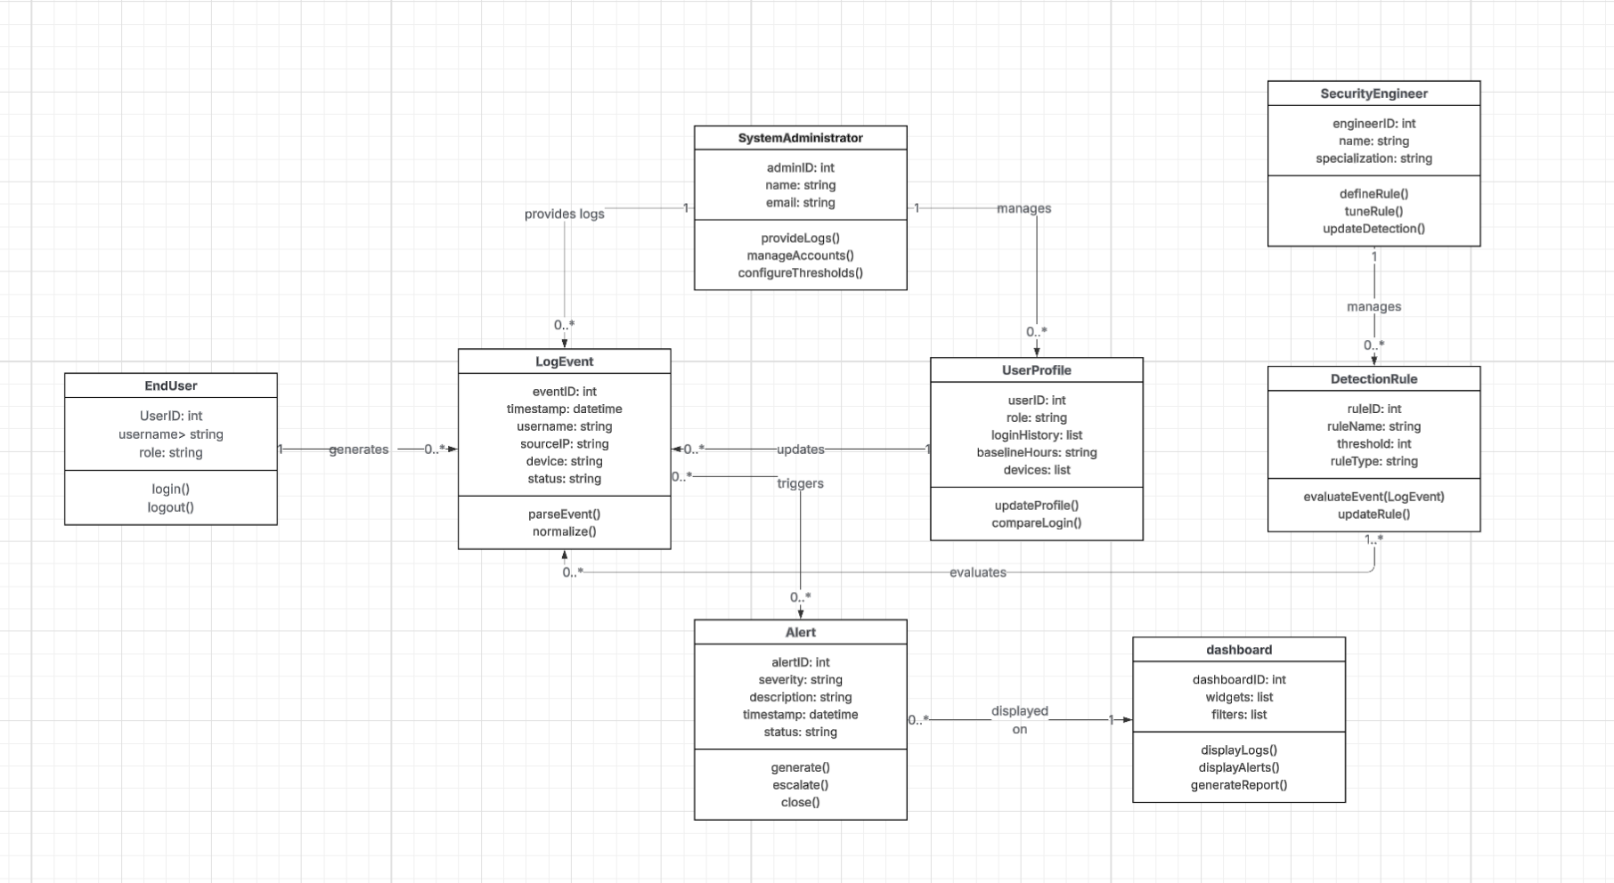
4.2 Description
1. LogEvent:
Represents a single authentication or login attempt from any source (Windows, Linux, VPN, MFA, SSO, API).
● Attributes: eventID, timestamp, username, sourceIP, device, status.
● Operations: parseEvent(), normalize()
● Purpose: Provides a standardized format for authentication events ingested into the
system.
2. UserProfile:
Maintains historical login behavior for each user to help detect anomalies.
● Attributes: userID, role, loginHistory, baselineHours, devices
● Operations: updateProfile(), compareLogin()
● Purpose: Stores baselines (normal login times, locations, devices) and supports anomaly
detection.
3. DetectionRule:
Encapsulates detection logic for identifying anomalous logins (brute force, impossible travel, password spray, etc.).
● Attributes: ruleID, ruleName, threshold, ruleType
● Operations: evaluateEvent(LogEvent), updateRule()
● Purpose: Defines, applies, and manages anomaly detection criteria.
4. Alert:
Represents an anomaly detected by the system that requires review.
● Attributes: alertID, severity, description, timestamp, status
● Operations: generate(), escalate(), close()
● Purpose: Provides structured information about detected anomalies and tracks their
resolution status.
5. Dashboard:
Provides visualization and reporting for logs, anomalies, and alerts.
● Attributes: dashboardID, widgets, filters
● Operations: displayLogs(), displayAlerts(), generateReport()
● Purpose: Allows administrators and security staff to review events, investigate
anomalies, and export reports.
6. SystemAdministrator:
Actor class representing administrators who manage system configurations.
● Attributes: adminID, name, email
● Operations: provideLogs(), manageAccounts(), configureThresholds()
● Purpose: Ensures logs are ingested, thresholds are configured, and system health is
maintained.
7. SecurityEngineer:
Actor class representing engineers who design and refine detection logic.
● Attributes: engineerID, name, specialization
● Operations: defineRule(), tuneRule(), updateDetection()
● Purpose: Manages the continuous improvement of anomaly detection accuracy and
rules.
8. EndUser:
Represents individuals whose authentication activities are being monitored.
● Attributes: userID, username, role
● Operations: login(), logout()
● Purpose: Generates authentication events that are monitored for suspicious behavior.

Sequence Diagrams
UC-003: Detect & Prevent Brute Force Attempts
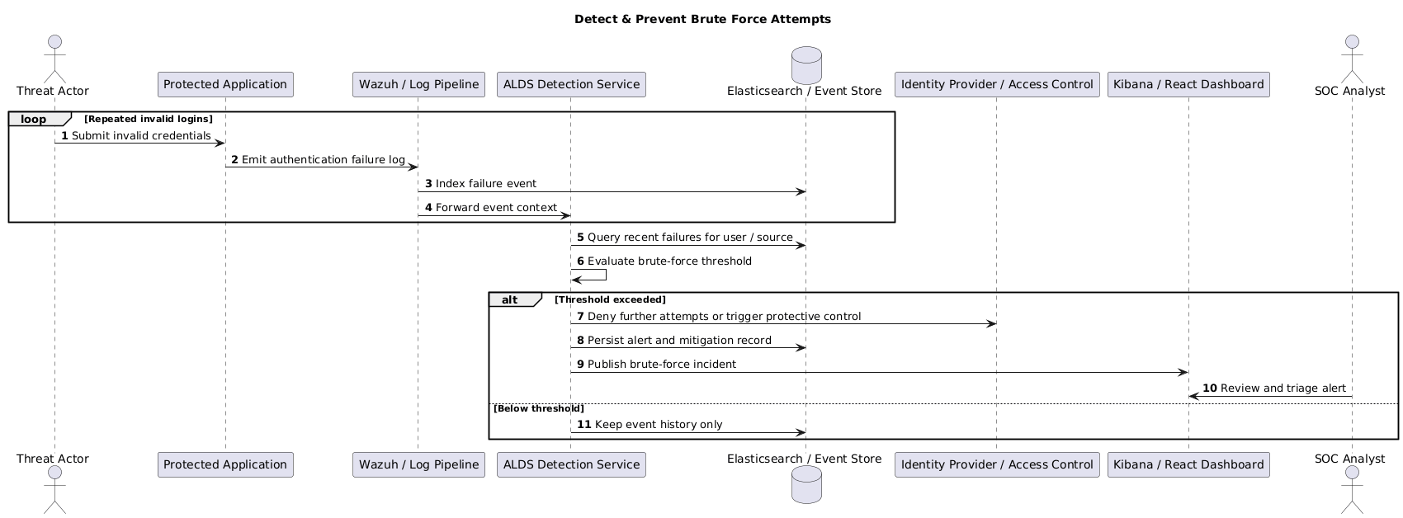
UC-007: Privileged Account Watch
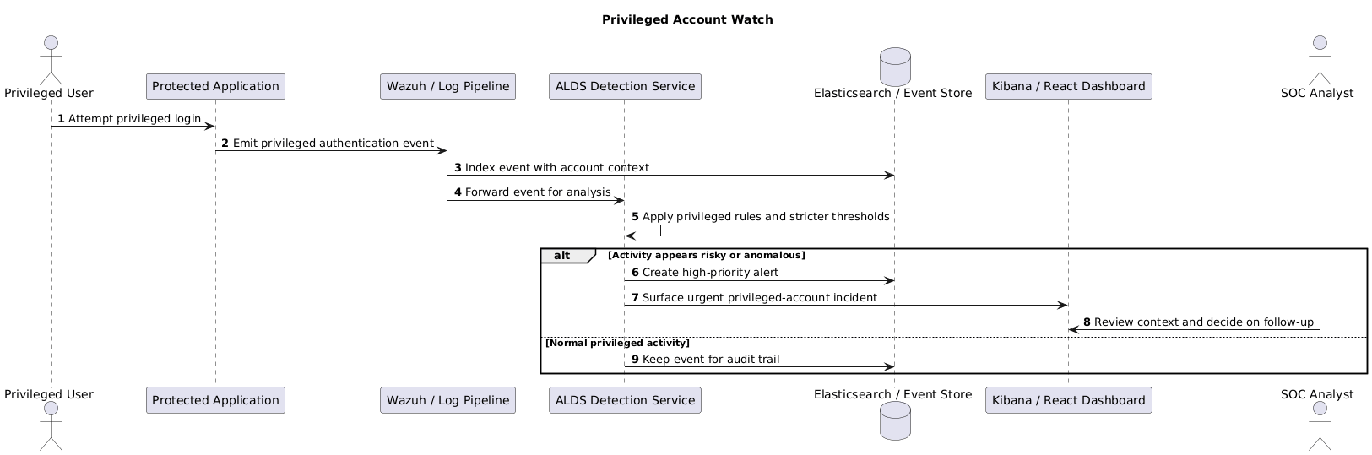
UC-009: Contain Account
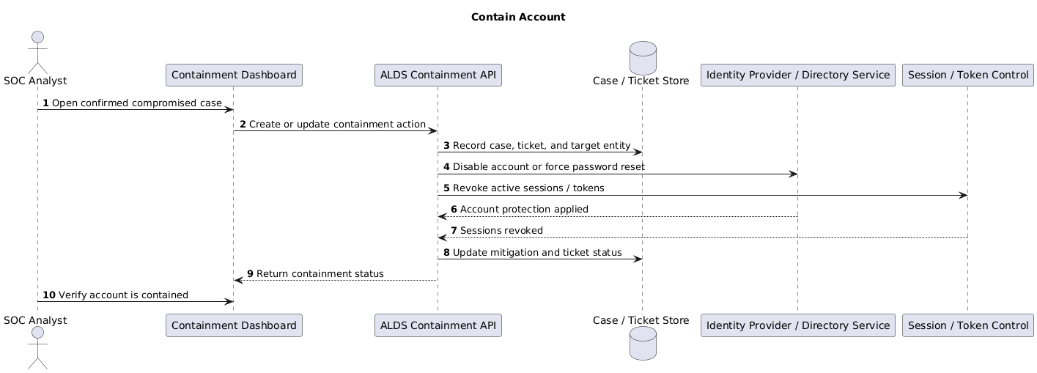
UC-011: Generate Weekly Report
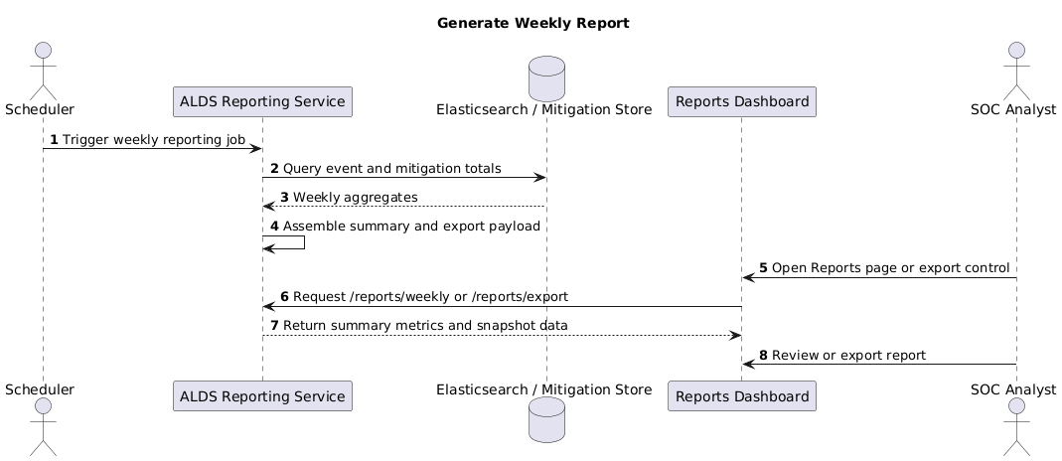
UC-016: Auto-Revoke Compromised API Keys
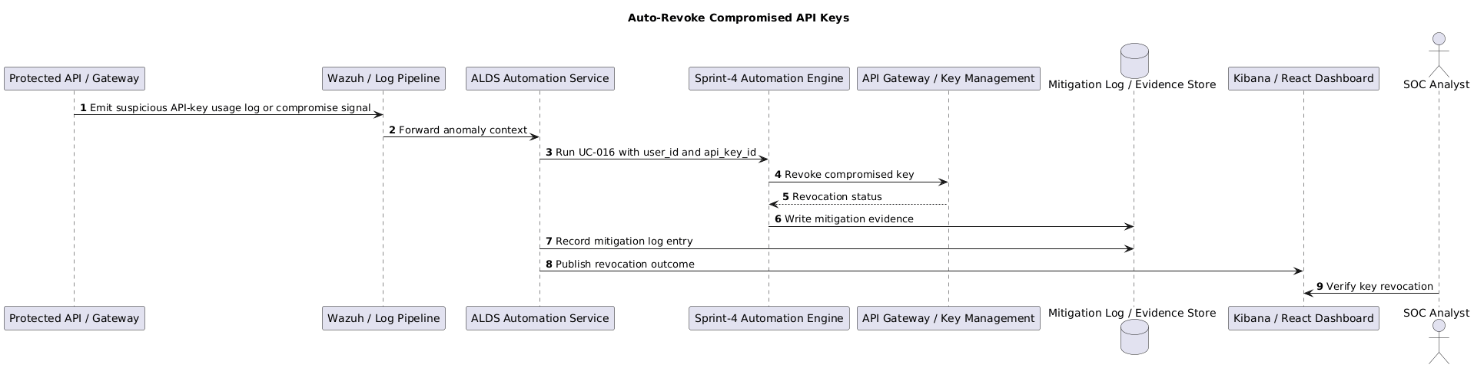
UC-020: IPS Rollback on False Positives
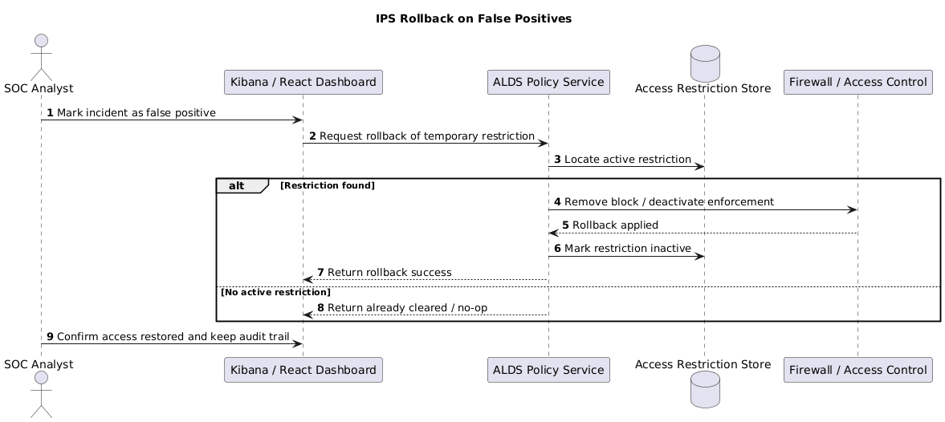
UC-023: Detect & Prevent Password Spray Attack
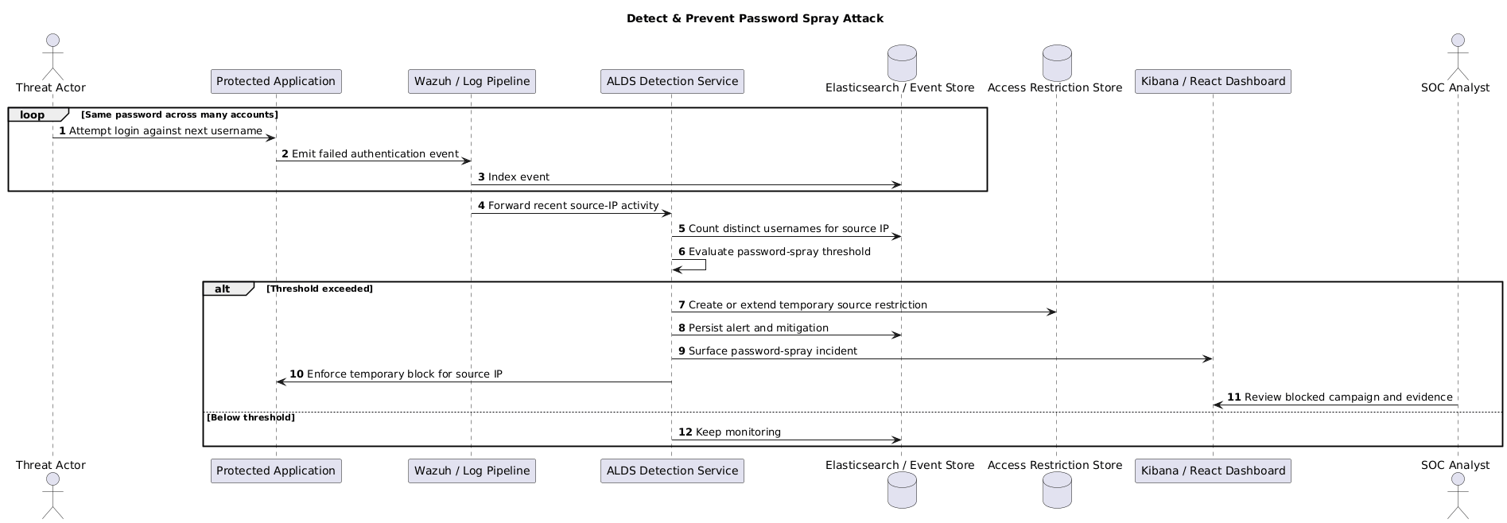
UC-024: Detect & Prevent Login from Blocked Countries
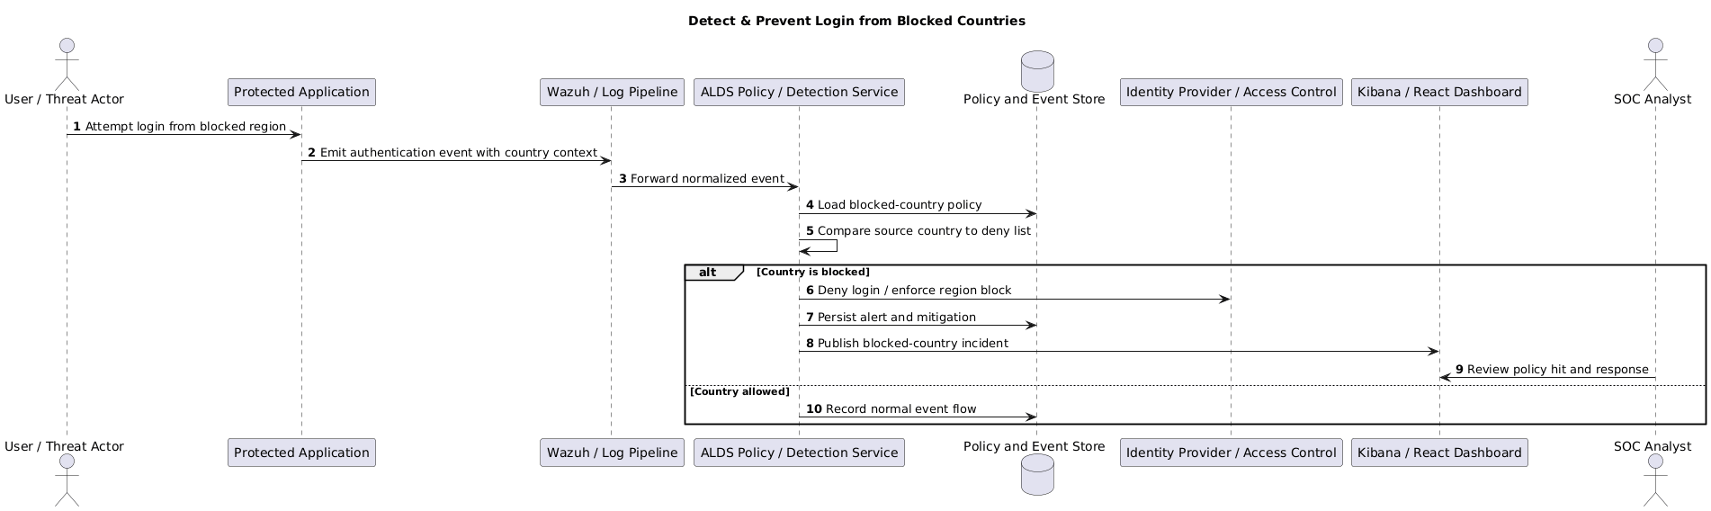
UC-025: Adaptive Threat Risk Scoring and Detection Calibration
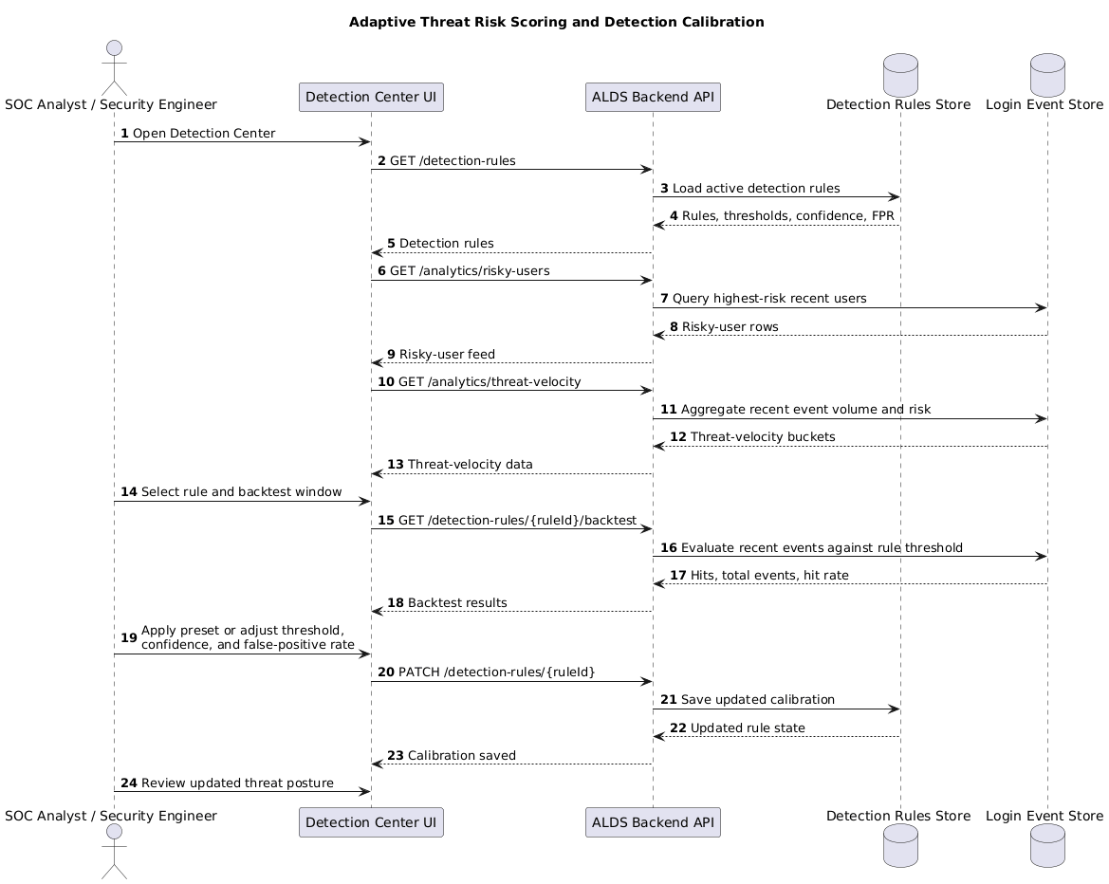
UC-026: Investigation Graph View for Risk Prioritization
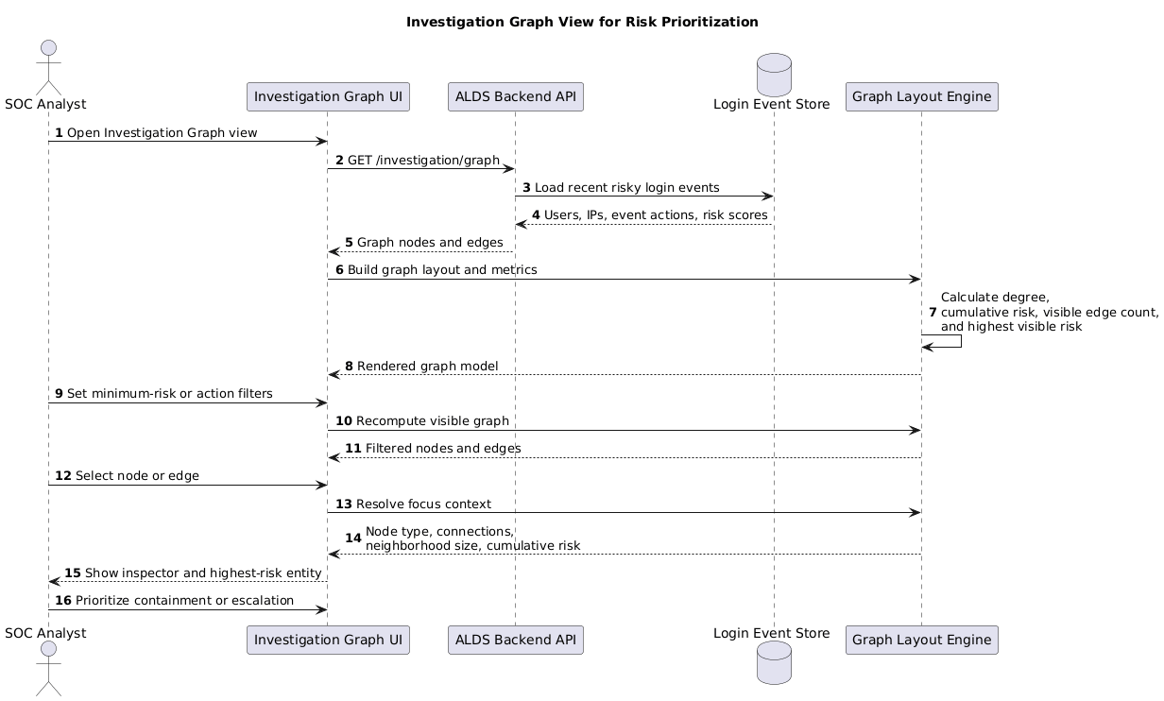

Software Development Methodology and Plan
This chapter explains why the project followed an iterative development process and how that choice shaped delivery across four sprints. The final repository structure, test evidence, and deployment artifacts all reflect incremental development rather than a single end-of-semester build.

Software Process Selection
A waterfall process would have offered strong upfront documentation, stable milestone definitions, and a predictable sequence from requirements to design, implementation, testing, and deployment. Those qualities are useful when the problem is well understood and integrations are unlikely to change. For this project, however, waterfall would have made it hard to respond to evolving detection logic, UI needs, and infrastructure issues discovered only after the ELK, Wazuh, backend, and dashboard components began interacting.
Agile and Scrum-style development fit the project better because each sprint could deliver working security functionality and expose integration risk early. The team could implement a detection, verify it through simulations, add a dashboard or API around it, and then use the findings from testing to refine thresholds, policies, and evidence capture. The trade-off is that agile requires stronger coordination, clearer sprint scoping, and frequent re-prioritization as new issues appear.
The team therefore used an incremental agile approach with sprint-based delivery. Each sprint ended with a demonstrable artifact, documentation updates, and a tighter feedback loop between detection engineering, software development, and operational testing. This was especially important once the project moved from passive alerting to automated response, where incorrect behavior could create false positives or hide real risk.
The delivery plan followed the repository structure. Sprint 1 established the core ELK-based monitoring pipeline and baseline detections such as Windows and Linux log collection, brute-force monitoring, impossible travel, off-hours detection, and privileged account watch. Sprint 2 expanded analyst workflows through alert triage, containment-oriented monitoring, tuning, and weekly reporting inside the ELK and Wazuh environment.
Sprint 3 introduced the FastAPI backend, SQLite data model, simulation endpoints, React-facing services, and runtime containment logic for UC-012 through UC-015. Sprint 4 completed the advanced automated responses and operational packaging: API key revocation, VPN disablement, administrative-console blocking, containment ticket creation, false-positive rollback behavior, blocked-country and password-spray detection, full-stack dashboard completion, CI/CD automation, and Kubernetes deployment assets.

Database Design and Web Services
ALDS uses a hybrid data design. SQLite stores the application's operational state and analyst workflow data, while Elasticsearch and Wazuh store or expose searchable security telemetry for monitoring and visualization.

Database Design
The central operational database is the SQLite file alds.db, created by the FastAPI backend. Its core entities are users and auth_users for application identity, login_events for normalized authentication attempts, mitigation_log for response history, ip_blacklist and access_restrictions for blocked or limited access states, and active_sessions for device or session tracking. These tables support the runtime detection and prevention flow for use cases such as account lock, IP block, session termination, blocked-country access, and MFA step-up.
The analyst workflow is modeled through event_triage, incident_cases, case_event_link, detection_rules, security_policies, and containment_tickets. Together, these entities let analysts annotate events, group related events into cases, tune rule thresholds, manage policy values such as blocked countries or password-spray windows, and create containment records that can be updated through the dashboard.
From a relationship perspective, one user can generate many login events and can own zero or more active sessions. One login event can have one triage record, and multiple login events can be grouped into one incident case through the case_event_link table. Mitigations and containment tickets are stored separately so that response history remains queryable even when an incident spans multiple events.
Outside the operational database, Elasticsearch indexes application and security telemetry for dashboarding, while Sprint-4 JSONL evidence files persist automated response proofs. This separation keeps the transactional workflow lightweight while preserving the search and audit capabilities expected from a monitoring platform.

API Specification
The backend exposes REST-style JSON services through FastAPI, with interactive OpenAPI documentation available at /docs. Authentication and user-management services include /auth/login, /auth/users, and supporting seed-user endpoints used to prepare demo or test accounts. The login workflow itself is exposed through /login, where incoming requests are scored, normalized, persisted, and evaluated against mitigation logic.
Monitoring and investigation services include /events, /events/enriched, /analytics/kpi, /analytics/threat-heatmap, /analytics/threat-velocity, /analytics/risky-users, /investigation/graph, and /ingestion/health. These endpoints supply the dashboard with KPI cards, risky-user lists, graph data, and operational health information, and they also make the platform scriptable for automated smoke tests.
Workflow and governance services include /events/{event_id}/triage, /cases, /detection-rules, /detection-rules/{rule_id}/backtest, /policies, /reports/weekly, and /reports/export. These routes support UC-008, UC-010, and UC-011 by allowing analysts to update alert status, track case ownership, tune thresholds, backtest rule behavior, adjust security policies, and export summarized evidence.
Containment and validation services include /containment/tickets, /access-restrictions, /mitigations, /sprint4/evidence, /traffic/*, and /simulate/uc-*. They expose the operational state behind UC-009 and UC-012 through UC-020. In addition to the internal APIs, the solution integrates with ELK and Wazuh services through Dockerized network endpoints and log-shipping pipelines, while enterprise integrations such as identity-provider, VPN, or API-gateway control are represented by the automation engine and its evidence artifacts in the lab environment.

System User Interface
The SentinelAuth dashboard is the primary interface through which security engineers, SOC analysts, and system administrators interact with the ALDS platform. Built with React and TypeScript, the dashboard provides real-time visibility into login events, anomalies, risk scores, containment actions, and platform health. The following subsections describe the core screens of the application.

Executive Overview Dashboard
The main landing page presents a high-level security posture view. KPI cards display total events, active alerts, mitigations executed, and open incident cases. A threat heatmap and risky-user leaderboard allow analysts to quickly assess which identities and time windows carry the highest risk, enabling faster triage prioritization.
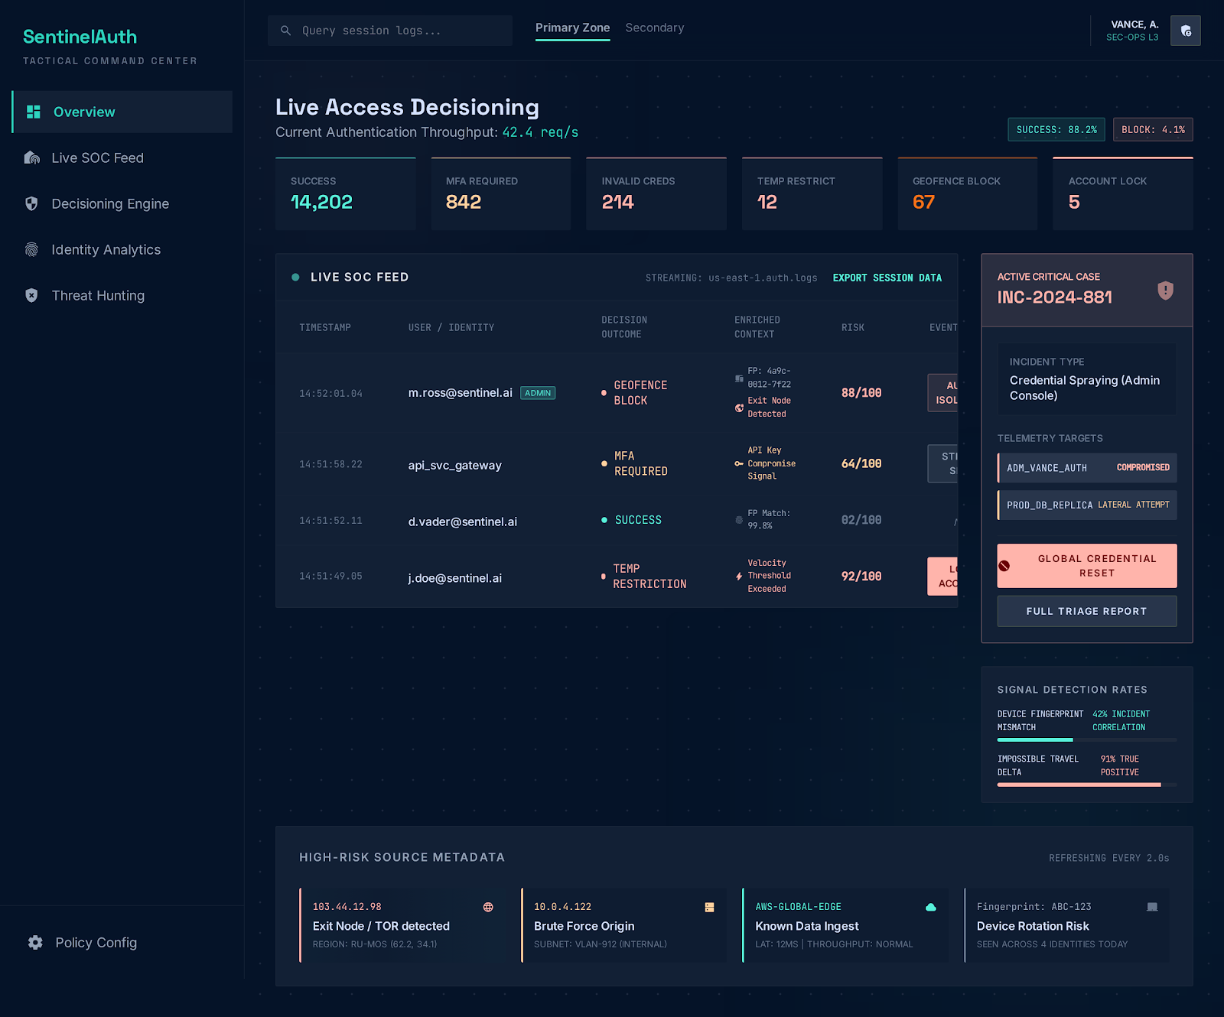

Alert Triage Workbench
Analysts use this screen to review, annotate, and resolve flagged authentication events. Each row shows the event timestamp, username, source IP, detection type, risk score, and current triage status. Clicking an event opens a detail panel where the analyst can update the status, assign it to a case, or escalate for containment. The workbench supports UC-008 and is the primary decision surface for the SOC.
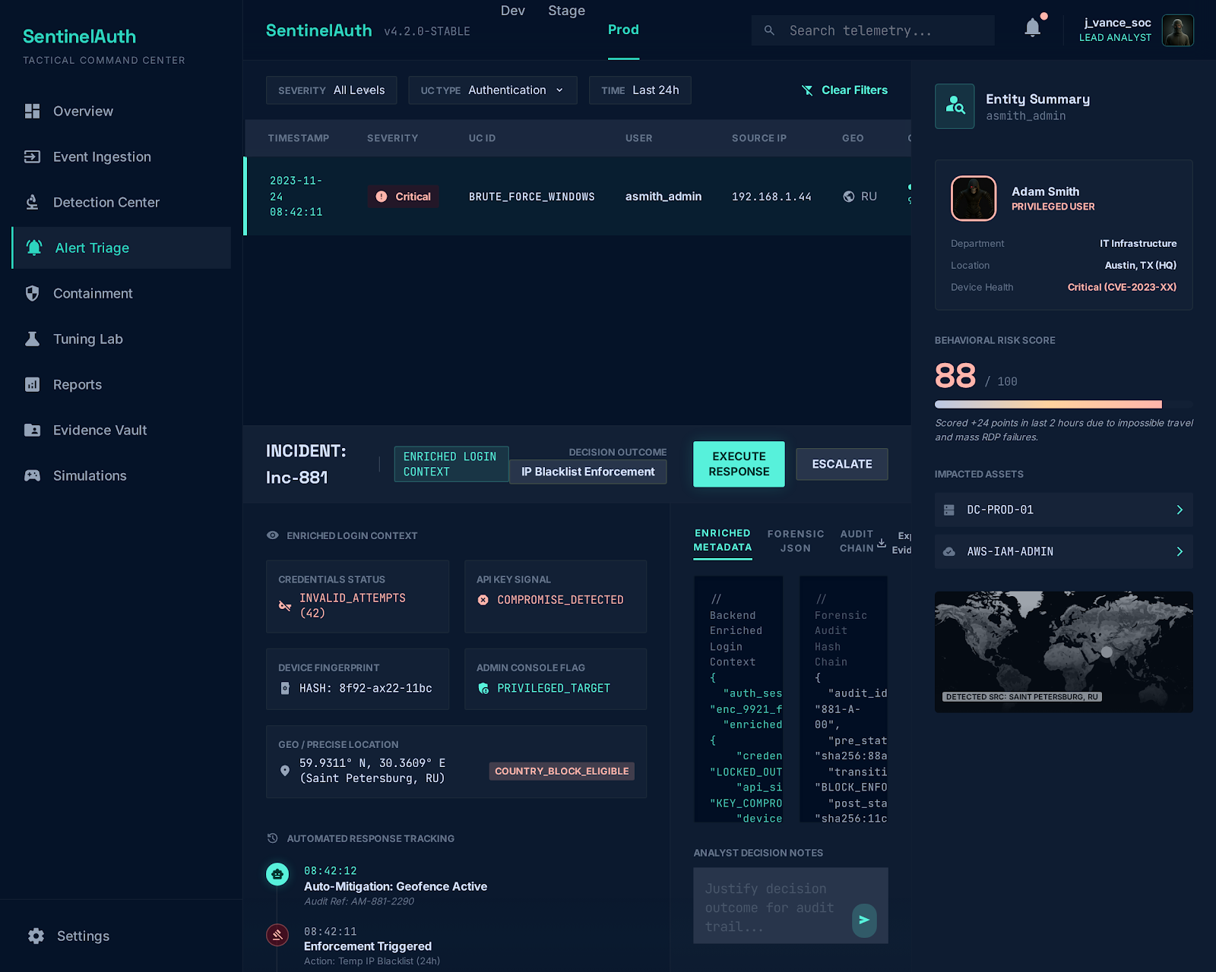

Detection Center
The Detection Center serves as the model operations cockpit for calibration, drift monitoring, and detection strategy control. The top row of metric cards shows enabled rules, average confidence (94.8%), average false-positive rate (5.4%), average threshold, 24-hour risk drift, and cached backtests. The Calibration Workbench panel lets analysts select an active rule, set backtest days, choose a sensitivity preset (Conservative, Balanced, or Aggressive), and adjust threshold, confidence, and false-positive rate sliders before saving the calibration or running a backtest. The Signal Intelligence panel displays the 24-hour threat velocity histogram and a top risky users table, giving the team real-time awareness of detection activity alongside tuning controls.
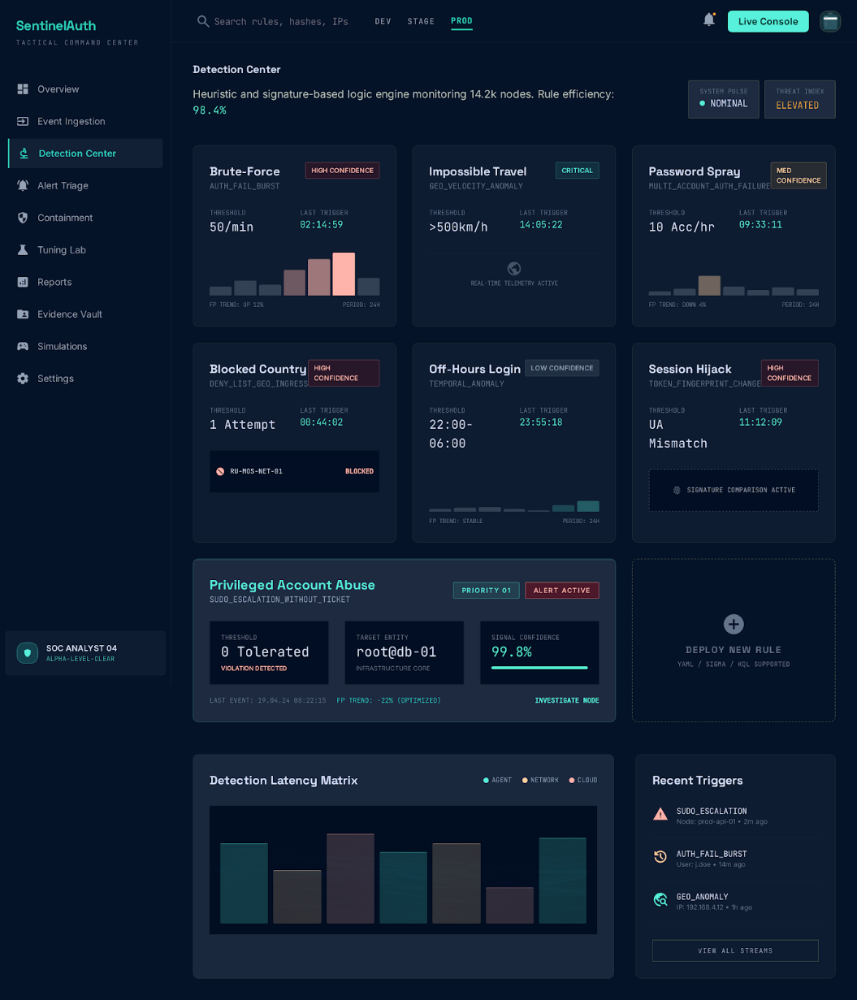

Investigation Graph View
The Investigation Graph View transforms current authentication events into an interactive entity relationship map. User nodes (teal) and IP address nodes (blue) are connected by edges weighted by event count and risk. The Graph Controls panel allows analysts to filter by minimum risk score and action type, while the Inspector panel reports visible nodes, edges, highest visible risk, and node type breakdown. When a node is selected, the Inspector shows its connection count, cumulative risk, and neighborhood size, enabling rapid identification of the most dangerous entity in the graph for prioritization and containment.
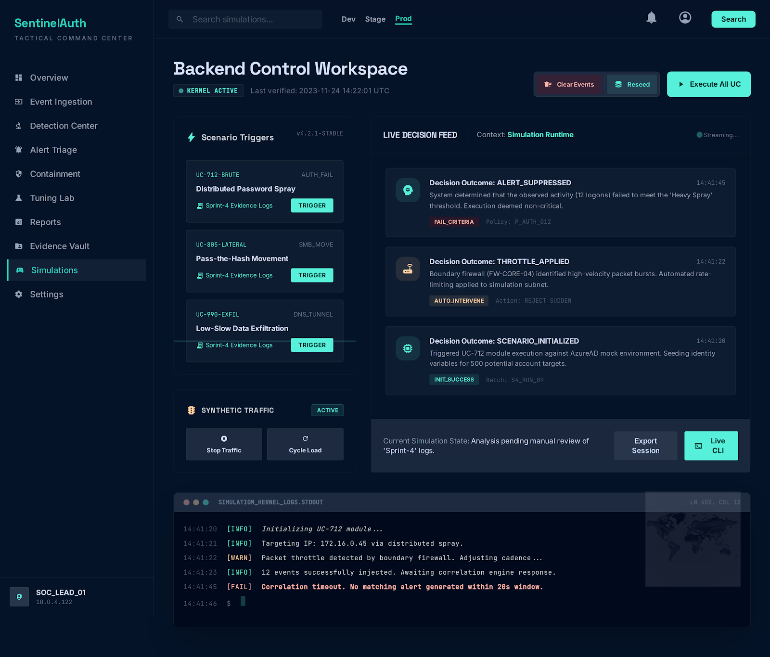

Containment Action Center
The Containment Action Center is where analysts initiate, track, and verify automated response actions. This screen lists all open and resolved containment tickets, showing the associated event, action type, status, and timestamp. Analysts can create new containment tickets, link them to incident cases, and verify execution through mitigation logs and evidence records exported from the Sprint-4 automation engine.
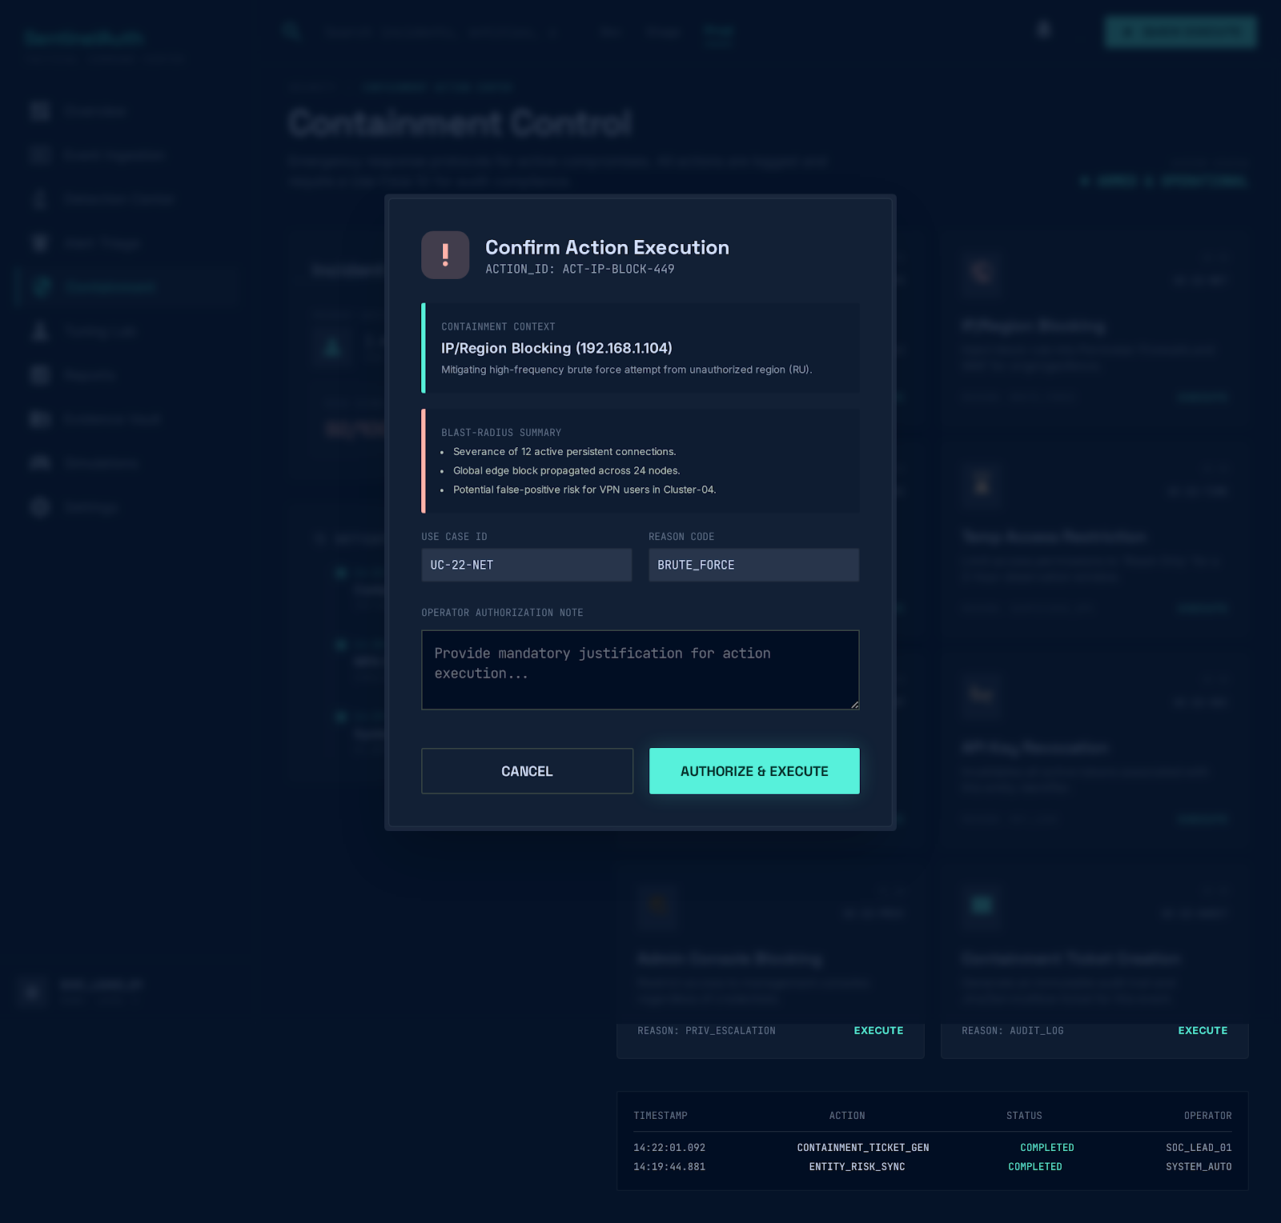

Weekly Report Builder
The Reports page aggregates detection and mitigation data into a structured weekly operational summary. Stakeholders can review event totals, containment action counts broken down by use case, false-positive rates, and current security posture metrics. Reports can be exported for governance review, supporting UC-011 without requiring analysts to manually assemble evidence from multiple systems.
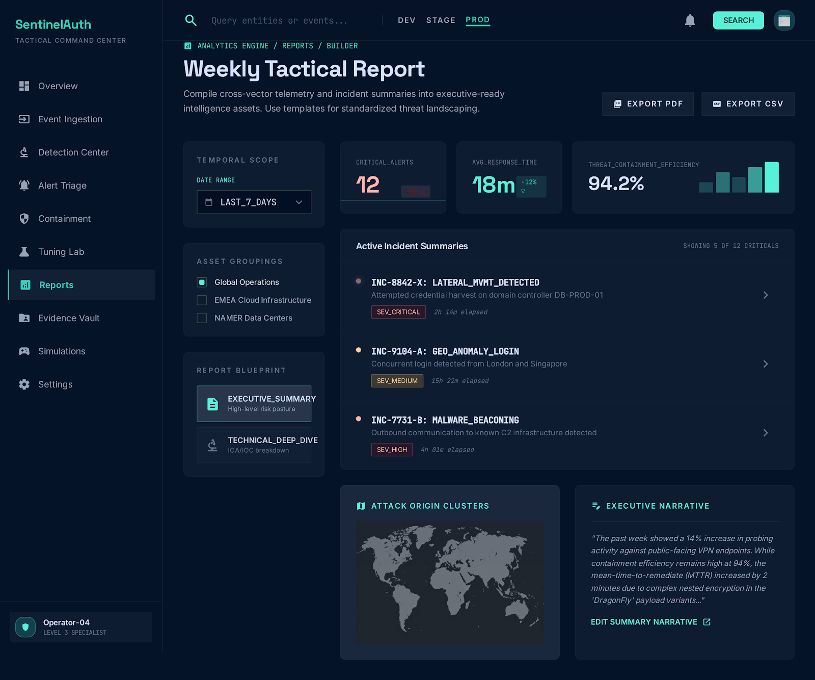

Project Security
Security was treated as a first-class concern rather than an afterthought. Each sprint was accompanied by a STRIDE threat-modeling artifact, and the final implementation translates those threats into concrete controls across ingestion, detection, user workflow, and automated response. The repository also includes SonarCloud scanning, dependency checking, and test gates in CI so that security validation is repeated every time the code changes.
At the detection layer, ALDS reduces account-compromise risk by centralizing Windows and Linux authentication logs and correlating behaviors that commonly precede abuse. The final implemented use cases cover brute-force detection with preventive follow-up, impossible travel, off-hours activity, new device patterns, privileged account monitoring, blocked-country access prevention, password spray detection with temporary restriction, adaptive risk scoring, and graph-based entity investigation for prioritization. These detections and analytical views are surfaced through dashboards, reports, and investigation APIs so that suspicious activity is visible quickly and can be acted on in the right order.
At the response layer, the system goes beyond alerting. High-risk conditions can lead to account lock, IP blocking, session termination, MFA step-up, API key revocation, VPN disablement, administrative console blocking, temporary access restriction, or automated ticket creation. Each response is written to mitigation_log and, for Sprint-4 automations, to JSONL evidence files with timestamps and action details. This design supports repudiation resistance and post-incident review.
At the platform layer, security controls appear in the deployment artifacts as well. Docker and Kubernetes isolate services, the backend deployment disables automatic service-account token mounting, and readiness or liveness probes help prevent failed releases from remaining unnoticed. CI executes backend tests, frontend tests, coverage generation, linting, dependency checks, Sonar scanning, container builds, and manifest validation before deployment steps proceed.
Because the repository is designed for a lab and demonstration environment, some controls remain intentionally lightweight and should be strengthened in a production rollout. Examples include replacing demo password hashing with a strong password-hashing algorithm such as Argon2 or bcrypt, tightening CORS and network exposure, managing secrets through a secret store rather than local files, and enforcing TLS plus role-based access controls on every externally reachable service.

Risk Management
Risk management was continuous throughout the project because the solution combined multiple moving parts: endpoint telemetry, a custom backend, a dashboard, automation logic, and containerized infrastructure. The team reduced delivery risk by using deterministic simulators, version-controlled deployment assets, and evidence-backed gate verification.

Potential Risks and Mitigation Strategies
1. Platform integration drift: ELK, Wazuh, FastAPI, and frontend dependencies can change behavior across versions. Mitigation: pin core versions in requirements, Docker Compose, package-lock, and CI workflows; validate builds and smoke tests on every pipeline run.
2. False positives in detection rules: Aggressive thresholds can disrupt legitimate users. Mitigation: support alert triage, rule tuning, policy editing, and UC-020 rollback behavior before enforcing long-lived restrictions.
3. False negatives or missed attacks: A rule that is too narrow may hide real compromise. Mitigation: combine multiple detections, maintain weekly reporting, backtest rules, and review suspicious-event trends through analytics dashboards.
4. Log source unavailability: Endpoint agents, files, or collectors may stop sending data. Mitigation: provide ingestion health checks, maintain local simulation traffic, and use Wazuh or ELK dashboards to verify data flow continuously.
5. Operational complexity across many services: Multi-container setups are harder to debug during demos and deployment. Mitigation: keep startup guides, one-command scripts, Docker Compose definitions, and Kubernetes manifests under version control.
6. Unsafe automated response: A buggy containment action can block legitimate access. Mitigation: record every mitigation, keep actions evidence-backed, scope temporary restrictions with expiry, and require analyst review through triage and ticketing.
7. Credential or secret exposure: Local configuration files or scripts may leak sensitive data. Mitigation: avoid committing live deployment secrets, keep credentials out of the repository, and move secret handling to environment variables or secret stores in production.
8. Performance bottlenecks in the operational database: SQLite is simple but not ideal for high-write concurrency at scale. Mitigation: use SQLite for the lab environment, containerize services, and plan migration to a server-grade database for production growth.
9. Deployment misconfiguration: A working local system may fail in CI/CD or Kubernetes. Mitigation: publish images through GitHub Actions, validate manifests with kubeconform, and run container smoke tests before promoting deployment artifacts.
10. Scope and schedule slippage: Security features can expand quickly once new attack paths are discovered. Mitigation: work in sprints, keep each use case demonstrable, and treat tests and evidence as gate conditions for closing sprint work.

Testing and Evaluation
Testing followed an evidence-first strategy. Unit tests were used for the isolated Sprint-4 automation engine, API integration tests validated the FastAPI management services against an in-process ASGI app, frontend integration tests verified that the React dashboard rendered backend data and triggered workflows correctly, and gate scripts exercised the implemented use cases end to end. This combination was important because the system includes both business logic and distributed-security behavior.
The executed repository evidence shows strong final stability. On April 6, 2026, the UC gate verification run passed 13 out of 13 checks covering UC-008, UC-009, UC-010, and UC-012 through UC-020. The same evaluation pack reported 90 events, 17 mitigations, 160 evidence entries, and successful artifact generation. Additional backend integration testing ran 8 tests with status OK, the frontend integration suite passed 2 out of 2 tests, and the integrated backend plus frontend smoke run passed 4 out of 4 checks.
Representative tested scenarios include repeated failed logins causing account lock (UC-012), geofence or blocked-country access causing immediate denial (UC-013 and UC-017), impossible travel forcing MFA step-up (UC-015), high-risk administrative-console access being blocked (UC-018), automated containment ticket creation (UC-019), policy and detection-rule updates through the API (UC-010), and dashboard rendering of KPI data and simulation actions (UC-022). The gate notes also record UC-006 as a traceability-validated capability rather than a standalone automated runtime test.
The project also includes an exploratory AI artifact in anomaly_detection_model.ipynb. The notebook trains a RandomForest-based anomaly classifier and reports 0.99 accuracy, 0.9906 ROC AUC, and a confusion matrix of [[13528, 0], [192, 1280]] on a 15,000-sample test split. This notebook was useful for evaluating anomaly-scoring ideas, although the final deployed application path remains primarily rule-driven and evidence-based rather than ML-dependent.
The main automation tools used were Python unittest, httpx ASGI transport, Coverage.py, Vitest, React Testing Library, happy-dom, GitHub Actions, Docker image validation, manifest validation, and PowerShell or Python gate scripts for smoke and UC verification.

Deployment Guidelines
The repository supports two practical deployment modes: a local lab setup for development and grading, and a containerized CI/CD plus Kubernetes path for production-style validation. The canonical source code is the GitHub repository at https://github.com/Mustafa-Hussain-source/P06_Anomalous-Login-Detection-ELK .
1. Obtain the code from the repository and set up the Python backend in Development/Sprint-3 by installing requirements.txt and starting uvicorn app.main:app --reload --host 0.0.0.0 --port 8001. The backend creates or reuses the SQLite database alds.db automatically on first startup.
2. Configure the frontend in Development/Sprint-4/Front-End/sentinelauth-ui by installing npm dependencies, setting VITE_API_BASE_URL=http://localhost:8001 in .env.local, and starting the Vite application.
3. If full telemetry visualization is required, start the ELK and Wazuh stack from Development/Sprint-3/elk-wazuh-compose/docker-compose.yml. This exposes Elasticsearch on port 9200, Kibana on 5601, the Wazuh API on 55000, and the Wazuh Dashboard on 5602.
4. For automated delivery, use the GitHub Actions pipelines in .github/workflows/ci.yml and .github/workflows/cd.yml. The CI pipeline runs backend checks, frontend lint/build/tests, Sonar scanning, and Docker build validation. The CD pipeline renders Kubernetes manifests, validates them, pulls GHCR images, and runs smoke checks against backend and frontend containers.
5. For Kubernetes deployment, apply the namespace, configmap, backend deployment, and backend service from Development/Sprint-4/k8s, then apply the frontend deployment and service from Development/Sprint-4/Front-End/sentinelauth-ui/k8s. The current manifests deploy one backend replica with readiness and liveness probes and two frontend replicas exposed via NodePort services.
6. After deployment, verify platform readiness by checking the backend health endpoint, opening the React dashboard, and, where time permits, running the available smoke or UC verification scripts so that ingestion, triage, and automated response flows are confirmed before demonstration or handover.
7. The repository does not commit a permanent public production URL or shared user credentials. Access is therefore intended through local, lab, or CI-rendered deployments rather than an always-on hosted demo instance.
From a scalability perspective, the architecture is ready for incremental growth because the backend and frontend are containerized and the Kubernetes manifests already separate compute units. For a production rollout, the main scalability improvement would be to replace SQLite with a server-grade database, scale Elasticsearch, Logstash, or Wazuh services horizontally, and add Kubernetes-based autoscaling and secret management.

Conclusion
The project concludes with a working, testable, and deployment-aware platform that demonstrates how anomalous login monitoring can be extended into practical response orchestration.

Summary
The team approached the problem as a full lifecycle security engineering challenge rather than only a log-analytics exercise. Starting from Windows and Linux log ingestion, the project grew into a system that detects suspicious authentication behavior, exposes that behavior through dashboards and APIs, and applies or records containment actions that can be audited later. By the final sprint, the repository contained 26 implemented use cases, a functioning backend and frontend, automated gate tests, CI/CD workflows, and Kubernetes deployment assets.
The most important lesson from this work is that detection quality and operational usability have to evolve together. Rules are only useful if analysts can triage them, justify them, test them, and safely recover from false positives. The project therefore combined monitoring, software design, testing, and security thinking throughout the implementation.

Challenges
The biggest technical challenge was coordinating many moving parts at once: ELK, Wazuh, a custom FastAPI backend, a React dashboard, simulation scripts, and deployment automation. Small changes in one layer could affect detection timing, response behavior, or test stability in another. The team addressed this by adding deterministic simulators, explicit evidence files, health endpoints, and scripted gate checks that made regressions easier to spot.
A second challenge was balancing aggressive containment with user safety. Features such as account lock, blocked-country denial, session termination, and temporary access restriction are valuable only when false positives remain manageable. This is why alert triage, rule tuning, policy management, and rollback behavior became just as important as the underlying detection logic.

Future
There are several natural extensions for future work. The exploratory notebook can be integrated into the live backend as a decision-support component for anomaly scoring, provided the model is retrained on representative datasets and placed behind proper monitoring. The platform can also be strengthened by replacing demo authentication with production-grade identity management, moving from SQLite to a more scalable database, and connecting the response layer to real enterprise services such as identity providers, VPN controllers, firewalls, and ticketing platforms.
Further work can also improve operational maturity through stronger RBAC, secret rotation, TLS everywhere, richer cross-event correlation, autoscaling policies, and more formal performance benchmarking under sustained load. With those extensions, ALDS could evolve from a semester project into a solid prototype for identity-threat monitoring and response.

Review checklist

Before submission of this report, the team must perform an internal review. Each team member will review one or more sections of the deliverable.

Chapter/Section Name | Reviewer Name(s)
Introduction, System Requirements | Mohammad Mustafa
System Architecture, Requirements Specifications | Mustafa Hussain
Database Design, UI, Security, Testing | Muhammad Aaffan Khan Niazi
Deployment Guidelines, Conclusion, References | Shehroz Faryad

References
[1] Elastic N.V., “Elasticsearch Reference 7.10,” Elastic, 2020. [Online]. Available: https://www.elastic.co/guide/en/elasticsearch/reference/7.10/index.html
[2] Elastic N.V., “Logstash Reference 7.10,” Elastic, 2020. [Online]. Available: https://www.elastic.co/guide/en/logstash/7.10/index.html
[3] Elastic N.V., “Kibana Reference 7.10,” Elastic, 2020. [Online]. Available: https://www.elastic.co/guide/en/kibana/7.10/index.html
[4] Wazuh, Inc., “Wazuh Documentation 4.14,” Wazuh, 2024. [Online]. Available: https://documentation.wazuh.com/current/index.html
[5] S. Ramírez, “FastAPI Documentation,” FastAPI, 2024. [Online]. Available: https://fastapi.tiangolo.com
[6] SQLAlchemy Authors, “SQLAlchemy 2.0 Documentation,” SQLAlchemy, 2024. [Online]. Available: https://docs.sqlalchemy.org/en/20/
[7] Meta Platforms, Inc., “React Documentation,” React, 2024. [Online]. Available: https://react.dev
[8] M. Shannon, “STRIDE Threat Modeling,” Microsoft Security Engineering, 2006. [Online]. Available: https://learn.microsoft.com/en-us/azure/security/develop/threat-modeling-tool-threats
[9] SonarSource SA, “SonarCloud Documentation,” SonarCloud, 2024. [Online]. Available: https://docs.sonarsource.com/sonarcloud/
[10] The Linux Foundation, “Kubernetes Documentation,” Kubernetes, 2024. [Online]. Available: https://kubernetes.io/docs/home/
[11] Docker, Inc., “Docker Documentation,” Docker, 2024. [Online]. Available: https://docs.docker.com
[12] GitHub, Inc., “GitHub Actions Documentation,” GitHub, 2024. [Online]. Available: https://docs.github.com/en/actions
[13] Vitest Contributors, “Vitest Documentation,” Vitest, 2024. [Online]. Available: https://vitest.dev
[14] kubeconform Contributors, “kubeconform — Kubernetes manifest validator,” GitHub, 2024. [Online]. Available: https://github.com/yannh/kubeconform

