System Architecture

Architecture Diagram:

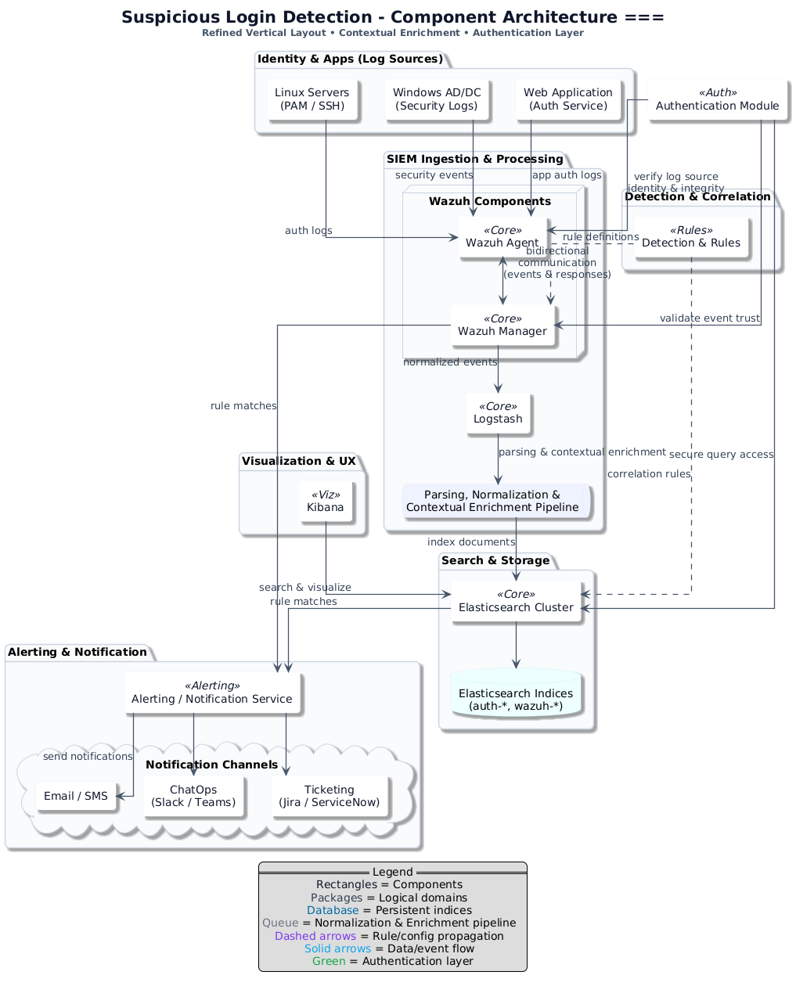

Architecture Description:

The system architecture is designed to support end-to-end security monitoring, automated containment, and SOC-driven investigation using the Elastic Stack and Wazuh. Identity systems, servers, applications, and network services generate authentication, access, and security logs that are collected by Wazuh Agents deployed on endpoints.

Logs are securely forwarded to the Wazuh Manager and Logstash for normalization, enrichment, correlation, and anomaly detection. Detection logic identifies suspicious and anomalous behavior such as brute-force attacks, risky logins, compromised credentials, or abnormal API usage.

When high- or medium-risk conditions are detected, the system can automatically trigger containment actions through Wazuh Active Response or external APIs. These actions include account locking, IP blocking, session termination, VPN access disabling, API key revocation, and step-up MFA challenges. All automated actions are recorded in Elasticsearch for visibility, auditing, and SOC review.

Elasticsearch serves as the central storage and search engine for both security events and automated response outcomes, while Kibana provides dashboards, alert triage views, and investigation workflows for SOC analysts. The architecture supports analyst feedback, allowing false positives to trigger rollback of containment actions and rule tuning to continuously improve detection quality.

Subsystem | Purpose / Description | Key Interactions
Identity & Apps (Log Sources) | Generates raw authentication and security logs from Linux servers (PAM / SSH), Windows AD / DC (security logs), and web applications (auth services). | Sends authentication, security, and application logs to the Wazuh Agent for collection and forwarding after basic source authentication.
Authentication Module | Verifies the integrity and identity of log sources, Wazuh Agents, and SIEM components to ensure trusted data ingestion and secure query access. | Validates source identities before log ingestion; ensures secure communications between Wazuh Agent, Wazuh Manager, and Elasticsearch.
Endpoints (Wazuh Agent) | Installed on servers and applications to collect raw logs and forward them securely to the SIEM ingestion layer. | Receives logs from identity and app sources; communicates bidirectionally with the Wazuh Manager for event forwarding and rule/config updates.
SIEM Ingestion & Processing (Wazuh Manager & Logstash) | The Wazuh Manager normalizes and correlates events using detection rules; Logstash performs parsing, normalization, and contextual enrichment (adding geo-location, user context, asset metadata, privileged account tagging, and time zone normalization); processes authentication events from Windows (Winlogon/NTLM/Kerberos) and Linux (SSH) into structured indices. | Ingests logs from Wazuh Agents; applies rules and contextual enrichment including GeoIP location data (for impossible travel detection), user-agent parsing (for new device detection), privileged account tagging, and time zone normalization; outputs enriched events to Elasticsearch under structured indices (auth-windows-, auth-linux-, alerts-security-*); sends alerts to the notification system; routes malformed events to dead-letter indices for troubleshooting; propagates updated rules back to agents.
Detection & Correlation | Applies advanced rule-based and correlation logic to detect suspicious activity and anomalies such as brute-force attempts, impossible travel, risky logins, API abuse, and anomalous privileged access. Determines severity and whether automated containment actions should be triggered. Includes tuning workflows that allow security engineers to adjust thresholds, exclusions, and rule logic based on false positive feedback. | Receives normalized and enriched events from the SIEM pipeline; maintains historical baselines for user login times (off-hours detection), device/user-agent history (first-seen detection), and privileged account watch lists; performs rolling window queries and threshold evaluations; sends rule matches and alert triggers back to the SIEM for alerting and storage; supports feedback loops where false positives inform rule adjustments and baseline recalculation.
Search & Storage (Elasticsearch Cluster) | Stores normalized and enriched events in persistent indices for efficient search, correlation, and reporting. Also stores records of automated response actions, containment outcomes, rollback events, detection rule versions, and false positive feedback for auditing and investigation. Supports dead-letter indices for malformed events that failed parsing. | Receives processed events from Logstash; organizes data into time-based indices with structured naming conventions (auth-windows-, auth-linux-, alerts-security-, deadletter-); stores session state data for active session tracking; maintains records of automated and manual containment actions, rollbacks, rule changes, and analyst feedback; serves data to Kibana for visualization and investigation; supports secure queries validated by the authentication module; provides data for scheduled and on-demand reporting.
Visualization & UX (Kibana) | Provides dashboards and interactive views for security analysts and administrators to investigate suspicious logins, triage alerts with status updates and notes, refine detection rules, and initiate manual containment actions (account disable, password reset, IP block, device isolation, token revocation). Includes timeline views for detailed event correlation and investigation workflows. | Queries Elasticsearch for indexed events and alerts; displays dashboards and trend visualizations; allows analysts to mark alerts as false positives (triggering rollback of safe automated actions); provides interfaces for security engineers to access and modify detection rules; exposes manual containment action buttons that trigger scripts or API calls via the Manual Response Actions subsystem; feeds rule refinements back into the Detection & Correlation layer.
Alerting & Notification | Delivers alerts and incident notifications for detected anomalies and automated containment actions, supporting SOC workflows, escalation, and tracking. Automatically creates tickets for all automated containment actions (UC-019) with structured data including user, IP, device, triggering rule, and actions taken. Supports bidirectional sync where ticket status updates flow back into the SIEM. | Receives rule matches from the SIEM pipeline (Wazuh Manager and Elasticsearch); creates incident tickets in external ticketing systems with complete context (user, IP, device, triggering rule, actions taken); delivers alerts to response platforms (email, chat, SIEM console) for incident management and tracking; supports bidirectional integration where ticket updates are reflected in Elasticsearch for workflow state tracking.
Manual Response Actions | Provides SOC analysts with tools to manually disable accounts, reset passwords, revoke tokens, isolate devices, and block IPs when automated response controllers, firewalls, is insufficient. | Receives analyst commands from Kibana; executes containment actions via scripts or API calls to identity providers, VPN controllers, firewalls, and endpoint management systems; logs all manual actions to Elasticsearch for audit trail and correlation with automated responses.
Detection Rule Management | Enables security engineers to create, test, validate, and promote detection rules through a controlled change process with version control, rollback capability, and false positive feedback integration. | Retrieves existing rules from Wazuh Manager; provides staging environment for testing; propagates approved rules back to Wazuh Manager and agents; stores rule versions and change history in Elasticsearch; receives false positive feedback from Kibana to inform rule tuning.
Reporting & Analytics | Generates scheduled and on-demand reports summarizing login anomalies, detection trends, containment actions, and system health metrics for stakeholders and compliance purposes. | Queries Elasticsearch for aggregated metrics, trends, and anomaly statistics; formats results into PDF/CSV; delivers reports via email or stores them in shared locations; exposes reporting status and history in Kibana dashboards.

- External System Integrations

The architecture integrates with external systems to enable automated containment actions and manual response workflows:

- Identity Providers (IdP): Used for MFA step-up challenges (UC-015), account disabling, password resets, and token revocation. Integration occurs via REST APIs or LDAP/AD connectors triggered by Wazuh Active Response scripts or manual analyst actions from Kibana.

- Firewall & Network Security Devices: Enable automated IP blocking (UC-013) and manual network isolation. Integration via SSH, API calls, or configuration management tools that update access control lists and firewall rules.
- VPN Controllers: Support automated VPN access disabling (UC-017) and active session termination for suspicious connections. Integration through VPN management APIs or certificate revocation mechanisms.

- API Gateways & Key Management Systems: Enable automated API key revocation (UC-016) when abuse patterns are detected. Integration via management APIs that disable or delete compromised keys.

- Administrative Consoles: Support automated blocking of admin console logins (UC-018) through access control updates. Integration via application-specific APIs or authentication middleware.

- Ticketing Systems: Automatically create incident tickets (UC-019) for all automated containment actions, including user, IP, device, triggering rule, and actions taken. Bidirectional integration allows ticket updates to flow back into the SIEM for workflow tracking.

- Endpoint Management Platforms: Enable device isolation and remote containment actions. Integration through endpoint management APIs or Wazuh agent commands.

Justification of the Architecture

<List down pros and cons of the architecture you have defined in the context of your system. Moreover, give a justification of why this architecture is appropriate for your system. Make sure that you pick each of the non-functional requirements including security requirements and discuss how your proposed architecture helps in implementation of the non-functional requirements. >

- Pros and cons of the architecture
Pros | Cons
End-to-end coverage: From log collection → normalization/correlation → storage/search → alerting/response (fewer blind spots).  Mature OSS stack: Wazuh + Elastic + Kibana + Logstash are widely adopted, well-documented, and extensible.  Rule + enrichment pipeline: Normalization in Wazuh + enrichment in Logstash (geoIP, user/org context) improves signal quality.  Automated containment: High-risk detections can trigger immediate defensive actions such as account locks, IP blocks, session termination, and credential revocation.  Closed-loop SOC workflow: Every automated action is logged, ticketed, reviewable, and reversible, supporting analyst trust and continuous tuning.  Scalable response model: New response actions can be added via scripts or APIs without redesigning the architecture.  Fast investigation: Elasticsearch provides low-latency queries; Kibana gives analysts dashboards and timelines out of the box.  Clear decoupling: Collection, processing, storage, and UX are separate—easier to scale/replace any layer independently.  Alerting fan-out: Email/SMS, ChatOps, and ticketing integrations align with real incident workflows and SLAs.  Feedback loop: Rules/config updates propagate back to agents; continuous tuning reduces false positives. | Operational overhead: Managing multi-component stack (agents, manager, Logstash, ES, Kibana) requires solid SRE discipline.  Elasticsearch cost/footprint: Storage + memory heavy; hot/warm/cold tiers and ILM policies are necessary to control spend.  Rule maintenance burden: Keeping rules current for new TTPs (geo-impossible, MFA bypass, SSO quirks) is ongoing work.  False positives risk: Without tuning and asset/user context, analysts can be alert fatigued.  Agent footprint & coverage: Requires agent rollout and lifecycle; some SaaS sources need alternative collectors/API ingestion.  Single-stack dependency: Heavy reliance on Elastic APIs; migrations to other data lakes require planned export/ETL.  Risk of over-automation: Poorly tuned rules may trigger unnecessary containment actions, making rollback and analyst validation essential.

- Implementation of non-functional requirements in system architecture

Requirement | The system should not utilize more than 1 GB of memory at any time during its execution.
Implementation in the architecture | - At the edge (Wazuh Agents): Forward only the authentication and security attributes needed for detections; drop verbose payloads and duplicates before they enter the pipeline. This limits the amount of data each downstream tier must hold in memory.  - Correlation & processing (Wazuh Manager & Logstash): Normalize events early and keep enrichment minimal and deterministic (for example, add a user or IP context once). Avoid per-event lookups that expand state in memory or create long-lived buffers.  - Storage & search (Elasticsearch): Use compact, time-series indices with lean field sets that match what analysts actually query. Prefer numeric/keyword fields over large text blobs to keep heap usage predictable during searches.  - Visualization (Kibana): Default dashboards to recent time windows and shared queries. This improves cache hit rates and prevents large, memory-hungry aggregations across cold data.

Requirement | The system should not fail more than 3 times every 24 hours; if it does, it should recover within 5 minutes.
Implementation in the architecture | - Fault isolation by tier: Collection, processing, storage, visualization, and alerting are separate. A problem in processing does not prevent agents from collecting or analysts from viewing existing data.  - Health-driven recovery: Each tier exposes a simple notion of “healthy” (e.g., manager available, processing accepting inputs, cluster answering searches, dashboard reachable). When a tier is unhealthy, it is cycled so it can rejoin cleanly without manual steps.  - Stateless fast start: Processing paths avoid local state so they can restart quickly and continue from the current stream.  - Operational observability: A small health overview in Kibana shows current tier status and the time since last successful alert, helping operators verify that recovery stayed within the five-minute window.  - Automated response actions are designed to be idempotent and reversible, allowing safe retries or rollbacks after component restarts.

Requirement | The system should be able to process at least 10,000 log entries per second without performance degradation.
Implementation in the architecture | - Parallel ingestion: Many Wazuh Agents send in parallel to the Manager & Logstash tier, which is sized for concurrent intake and light transformations.  - Throughput-first enrichment: Enrich only with fields that materially improve detection (for example, user role or source geo). Avoid chaining enrichments that introduce variable delays.  - Write-friendly indexing: Store events in time-based indices optimized for frequent writes, keeping shard counts low and field mappings tight to reduce indexing overhead.  - Elastic headroom: Because tiers are decoupled, the ingestion layer can be scaled horizontally if sustained load approaches limits, without touching storage or dashboards.

Requirement | The alerting mechanism should deliver notifications within 30 seconds of anomaly detection.
Implementation in the architecture | - Detect near the source: Wazuh Manager applies rule logic on normalized events (e.g., repeated failures, geo-impossible sign-ins), generating alerts immediately after events arrive.  - Short alert path: Alerts flow directly from processing to the Alerting & Notification component, which is responsible for fan-out to email, chat, and ticketing. This avoids extra hops that add delay.  - Frequent query-based checks: Where correlation requires search (e.g., sliding-window thresholds), run evaluations on tight intervals over a short look-back so new events are captured quickly.  - Measure and prove: A Kibana panel tracks the time between event arrival and notification; if this exceeds the target, a meta-alert informs operators.  - Automated response execution is triggered on the same detection path, ensuring containment actions occur within the same time window as alert delivery.

Requirement | System dashboards must be accessible only to authorized users.
Implementation in the architecture | - Single entry point: Users access only Kibana. Elasticsearch, Logstash, and Wazuh Manager remain on private networking and are not exposed to user networks.  - Least-privilege roles: Assign roles that match user responsibilities. Analysts get read-only access to the indices behind their dashboards; only designated engineers can edit rules or saved objects.  - Data scoping: Align index permissions with dashboards so users cannot pivot into datasets they do not need. Keep system and audit indices visible only to administrators.  - Accountability: Log sign-ins, role changes, and access to sensitive spaces so reviews can catch misuses or misconfigurations.

Requirement | The system should allow simultaneous access by at least 5 users without performance degradation.
Implementation in the architecture | - Cache-friendly dashboards: Build dashboards on shared, reusable queries and aggregations so multiple viewers benefit from cached results in Elasticsearch.  - Responsive defaults: Keep default time ranges recent and avoid very expensive visualizations on landing pages. Heavy, historical views can live on secondary dashboards.  - UX is isolated: Because dashboards are served from Kibana and ingestion happens separately, several investigators can work concurrently without affecting event intake or alerting.

Requirement | The system’s dashboard must refresh with new data every 10 seconds to ensure real-time visibility.
Implementation in the architecture | - Fast path from edge to UI: Events travel a short chain—Wazuh Agent → Wazuh Manager & Logstash → Elasticsearch → Kibana—with minimal enrichment, so new documents become searchable quickly.  - Hot-data focus: Dashboards emphasize the latest time window and use sensible chart intervals, ensuring each refresh touches small, hot indices rather than deep history.  - Time alignment: All tiers keep clocks in sync so event timestamps match dashboard refresh cycles and operators see consistent timelines.

Requirement | The system should undergo daily health checks with results logged for administrators.
Implementation in the architecture | - End-to-end synthetic: Generate a known test event at the Wazuh edge, let it traverse processing and storage, confirm it appears in Kibana, and ensure it triggers the Alerting & Notification fan-out. This validates the full pipeline, not just individual parts.  - Recorded evidence: Store the outcome of the daily check in a small operational dataset and surface a simple “health” dashboard showing pass/fail status and a trend over the last 7–30 days.  - Action on failure: If the synthetic fails more than once in a row, notify administrators and create or update an operations ticket with details and suggested remediation, such as cycling a tier or reviewing recent configuration changes.

Requirement | Scheduled reports must generate successfully 95% of the time and be delivered within 1 hour of scheduled time.
Implementation in the architecture | - Reporting job isolation: Run report generation as a separate scheduled task that does not compete with real-time ingestion or alerting pipelines, ensuring failures in reporting do not affect core detection capabilities.  - Query optimization: Design report queries to use pre-aggregated data or summary indices where possible, reducing execution time and resource consumption.  - Retry and fallback: If a scheduled report fails (e.g., due to transient ES unavailability), retry automatically up to 3 times with exponential backoff; if all retries fail, alert administrators and queue for manual generation.  - Delivery tracking: Log report generation start, completion, and delivery times in a dedicated operational index; expose a Kibana dashboard showing report success rates and delivery SLA compliance.

Requirement | Automated containment actions must execute within 60 seconds of anomaly detection; rollback actions must succeed >98% of the time when triggered.
Implementation in the architecture | - Fast execution path: Wazuh Active Response and API-based containment actions (account lock, IP block, session termination) are triggered directly from the detection pipeline without additional queuing or approval steps, minimizing latency.  - Idempotent actions: Design all automated responses to be safely repeatable; if an action is already applied (e.g., account already locked), the system logs the attempt but does not fail or create errors.  - Action logging and state tracking: Every containment action is recorded in Elasticsearch with timestamps (detection time, action start, action completion), allowing measurement of execution latency and identification of slow paths.  - Rollback reliability: Implement rollback as reverse API calls or script executions (unlock account, unblock IP) with automatic retries on transient failures; log all rollback attempts and outcomes to track the >98% success rate target.  - Monitoring and alerting: If containment action execution exceeds 60 seconds or rollback fails, generate a meta-alert to notify administrators and trigger investigation of the delay or failure.

- Implementation of security requirements in system architecture

Security Risk | Broken Access Control  Users might see or change things they shouldn’t if access rules are weak or misapplied. That can expose sensitive login data or let non-admins alter rules that shape detections.
Implementation in the architecture | - Make Kibana the only user-facing entry point; keep Elasticsearch, Logstash, and Wazuh Manager reachable only on the private network so all access is funneled through one gate.  - Require sign-in on Kibana and assign roles so analysts get read-only dashboards while only security engineers can modify rules or saved objects.  - Enforce index-level permissions aligned to the dashboards users need, and keep system/audit indices restricted to administrators.  - Record access attempts and changes in audit logs and review them regularly to catch repeated denials or privilege changes.

Security Risk | Input Manipulation Attack  Attackers may flood the system with crafted or noisy events so genuine threats are buried. If parsing and validation are loose, the pipeline can ignore real signals or become unstable.
Implementation in the Architecture | - Filter and normalize at the Wazuh Agent and Wazuh Manager so only well-formed authentication and security events enter the pipeline; reject unexpected shapes early.  - Keep Logstash enrichment focused (for example, IP or user context) to avoid heavy per-event work that attackers could exploit; drop malformed fields instead of propagating them.  - Use Alerting & Notification to surface abnormal volumes or patterns (such as sudden spikes in failed logins) so responders act on manipulation attempts promptly.

Security Risk | Data Poisoning Attack  Adversaries try to taint data over time so detections learn the wrong “normal,” reducing quality. If unvetted events persist, future analysis and rule-tuning can drift in the wrong direction.
Implementation in the architecture | - Apply basic hygiene at Wazuh Manager (normalize, categorize, and apply known detection logic first) so clearly bogus records don’t reach long-term storage.  - Keep Logstash enrichments controlled and vetted to avoid introducing untrusted external signals.  - Store only fields needed for investigations in Elasticsearch and separate hot, recent indices from longer-term archives to minimize the blast radius of tainted data.  - Review detection performance in Kibana and feed improvements back into Wazuh rules through a controlled change process.

Security Risk | Using Outdated Client/Server Components  Old versions of agents, processors, or the UI may carry known vulnerabilities. Attackers look for these gaps to gain footholds with little effort.
Implementation in the architecture | - Track versions of Wazuh Agent/Manager, Logstash, Elasticsearch, and Kibana and plan regular updates using official distributions to reduce exposure to known issues.  - Source deployment artifacts from verified locations and align upgrades across layers so protocols and features remain compatible end-to-end (agent → manager → pipeline → storage → UI).  - After each upgrade, validate basic health and alert delivery using the same synthetic checks you run daily.

Security Risk | Hardcoding Credentials  Secrets embedded in code or dashboards tend to leak and are hard to rotate. Once exposed, attackers can read data, change rules, or impersonate services.
Implementation in the architecture | - Keep webhook URLs, service accounts, and API keys out of pipelines, dashboards, and images; reference them through the deployment environment so they never appear in source or UI.  - Rotate credentials on a routine schedule and monitor any emergency “break-glass” access, summarizing results to administrators.  - Limit who can view or edit integration settings in Kibana and who can change rule sets in Wazuh to a small, trusted group.

Security Risk | Excessive Automated Response (False Positives)  Automated containment actions may disrupt legitimate users or services if anomalies are misclassified. Without controlled rollback, this can erode trust in the system.
Implementation in the architecture | - Require SOC confirmation for permanent actions and log all automated containment steps with timestamps, triggering rules, and affected identities.  - Support automated rollback of safe actions (account unlock, IP unblock, API key restore) when alerts are marked as false positives in Kibana.  - Store rollback events and analyst feedback in Elasticsearch so detection rules can be tuned to reduce recurrence.

