**Final Project Proposal**

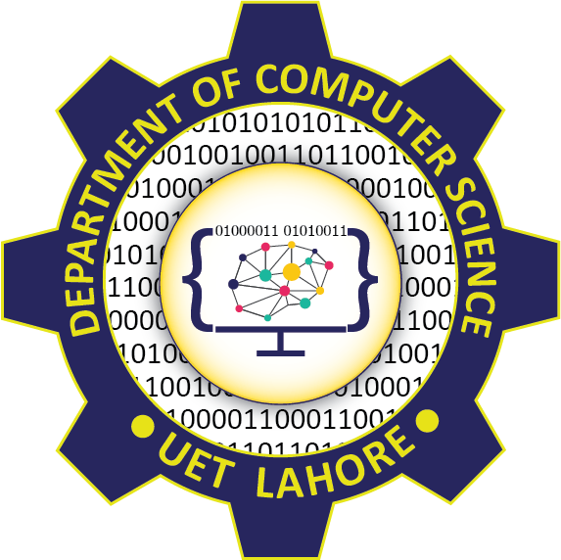

Session: 2023 – 2027

**Submitted by:**

Salman Anas 2023-CS-06

Muhammad Talha 2023-CS-12

Mustafa Noor 2023-CS-17

**Supervised by:**

NAZEEF UL HAQ

Department of Computer Science

**University of Engineering and Technology**

**Lahore Pakistan**

**Marriage Matchmaking Platform**

**Scenario:**

The Marriage Matchmaking Platform is envisioned as a comprehensive application designed to simplify and enhance the matchmaking process. By leveraging advanced data structures and algorithms, the platform aims to provide an efficient and personalized user experience for individuals seeking compatible matches.

**Goals:**

* **Seamless User Experience:** Develop a user-friendly interface for users to create profiles, browse matches, and manage interactions.
* **Efficient Matchmaking**: Implement data-driven matching algorithms to provide accurate recommendations.
* **Customizable Preferences:** Allow users to specify preferences such as age, location, and interests for tailored matches
* **Secure User Interactions:** Prioritize data security and privacy to ensure a safe environment.
* **Insightful Analytics:** Provide users with insights into their interactions and preferences

**Features:**

* **Profile Management:** Users can create and manage detailed profiles.
* **Recommendation System:** Use data structures like hash maps, graphs, and priority queues to suggest the best matches.
* **Search and Filter:** Enable advanced search and filtering options using trees and tries for efficient navigation.
* **Mutual Connections:** Display shared connections between users using graph-based algorithms.
* **Messaging:** Implement a secure and organized messaging system using queues
* **Blocking and Reporting:** Allow users to block or report other profiles using sets for efficient management.

**Requirements:**

* **User Interface (UI):** A clean and intuitive desktop or mobile interface for profile browsing and interactions.
* **Data Storage and Management:** Secure storage of user data using structured databases and efficient data structures.
* **Algorithm Design:** Develop and optimize algorithms for matchmaking and recommendations.
* **Feedback Mechanisms:** Allow users to provide feedback on recommendations to improve algorithms.

**Challenges and Considerations:**

* **Efficient Data Handling**: Managing user profiles and matchmaking processes efficiently using appropriate data structures, especially as the number of users grows.
* **Algorithm Design and Testing**: Designing basic yet effective algorithms for match recommendations and testing them to ensure they work correctly across different dataset
* **Interface Usability**: Designing an intuitive interface for profile management and navigation, ensuring it works well even with minimal design experience.
* **Avoiding Bias in Recommendations**: Ensuring that the matchmaking algorithm doesn't unintentionally favor certain users or preferences due to coding errors or dataset imbalances.

**Expected Outcome:**

The project will deliver a functional prototype of a matchmaking platform, featuring an intuitive interface, basic match recommendations, secure data handling, and the ability to test with a small dataset. It will demonstrate the practical use of data structures and algorithms, serving as a foundation for future improvements.

**Conclusion:**

We are looking forward to the successful development of this matchmaking platform. I believe it will provide an invaluable resource for individuals seeking meaningful connections by leveraging data structures and algorithms effectively. This project represents a significant step toward applying theoretical knowledge to solve real-world problems and enhancing user experiences in the matchmaking domain.