**Moody Mobile App**

**Project Report**



Session: 2023 – 2027

**Submitted by:**

Mustafa Noor 2023-CS-17

**Supervised by:**

Dr. Khaldoon

Department of Computer Science

**University of Engineering and Technology**

**Lahore Pakistan**

Contents

1. Introduction: 3

2. Objectives: 3

3. System Features: 3

4. Technologies Used: 3

5. System Workflow: 3

6. WireFrames: 4

7. Implementation Details: 9

8. Challenges and Solutions: 9

9. Conclusion: 9

10. Future Enhancements: 9

**Moody (Mood Logging App)**

# Introduction:

The Mood Logger App is a mobile application developed using Flutter. It operates completely offline and allows users to track their daily moods, emotions (with color indicators), and notes. The app includes essential features like sign-up, login, mood editing, password change, and logout. Users can also visualize their mood trends through bar charts on a weekly and monthly basis.

# Objectives:

* Enable users to log their daily emotional well-being.
* Provide secure access to user data through sign-in/sign-up.
* Visualize mood history via weekly and monthly bar graphs.
* Allow flexibility in managing and editing mood records.

# System Features:

* User Registration and Login (with email)
* Daily Mood Logging with emotions and notes
* Mood Editing and Deletion
* Password Change and Logout
* Mood History Chart View (Weekly & Monthly)
* Offline Functionality using SQLite

# Technologies Used:

* Front-end/UI Layer: Flutter (Dart)
* Business Logic (BL): Dart Services and Controllers
* Data Layer (DL): SQLite
* IDE: Android Studio / Visual Studio Code
* Charting Library: fl_chart
* State Management: Provider

# System Workflow:

* Sign-in/Sign-up Flow with Validation
* Role-based View (for logged-in user only)
* CRUD Operations on Mood Data
* Navigation and State Management
* Mood Chart Generation (Bar Graphs)

# WireFrames:

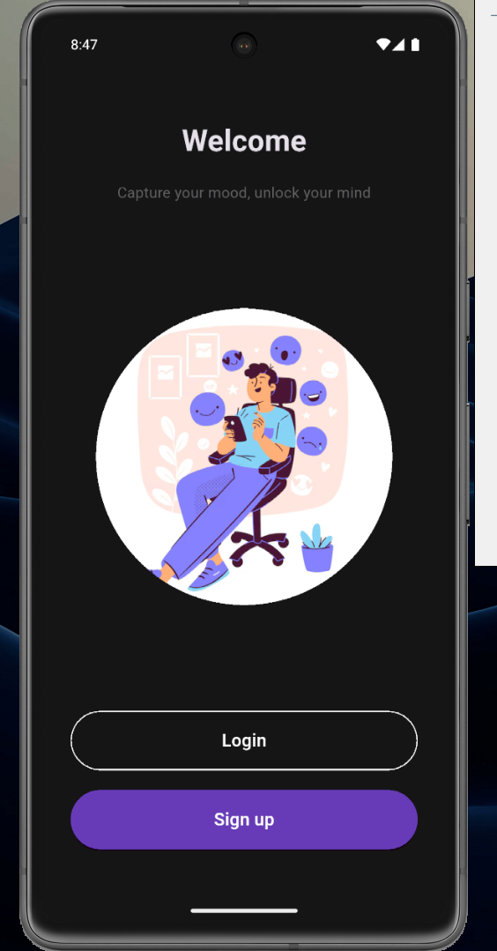

Figure 1: Welcome Page

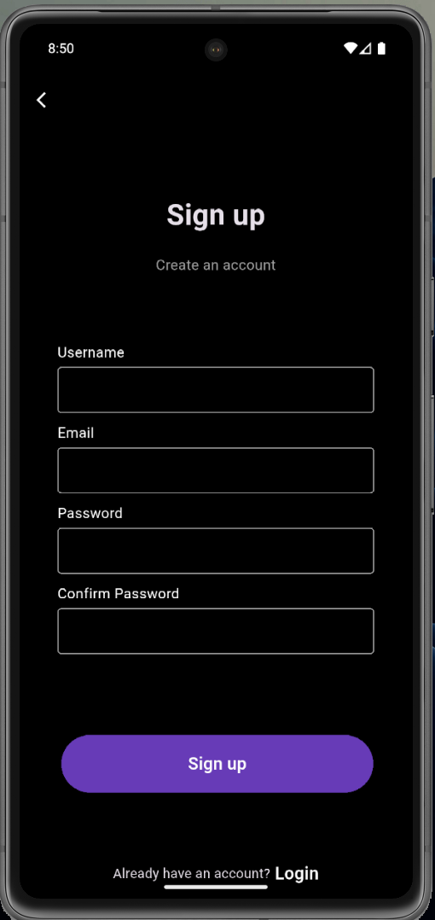

Figure 2: Sign Up Page

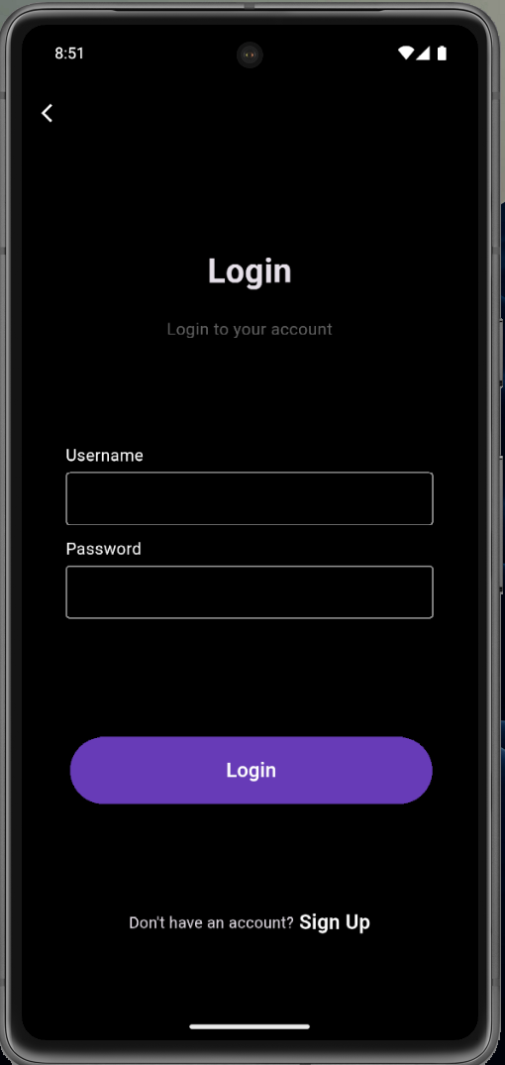

Figure 3: Sign In Page

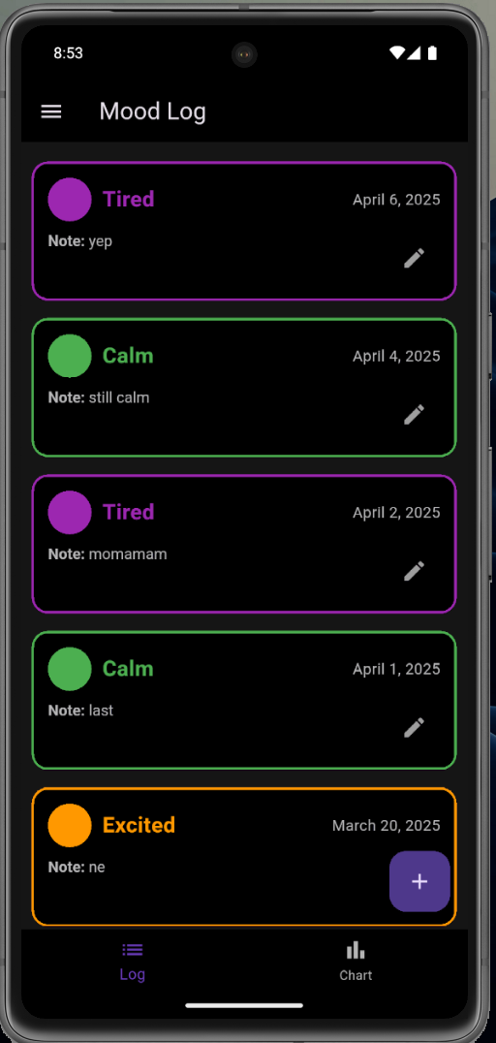

Figure 4: Mood Log Page

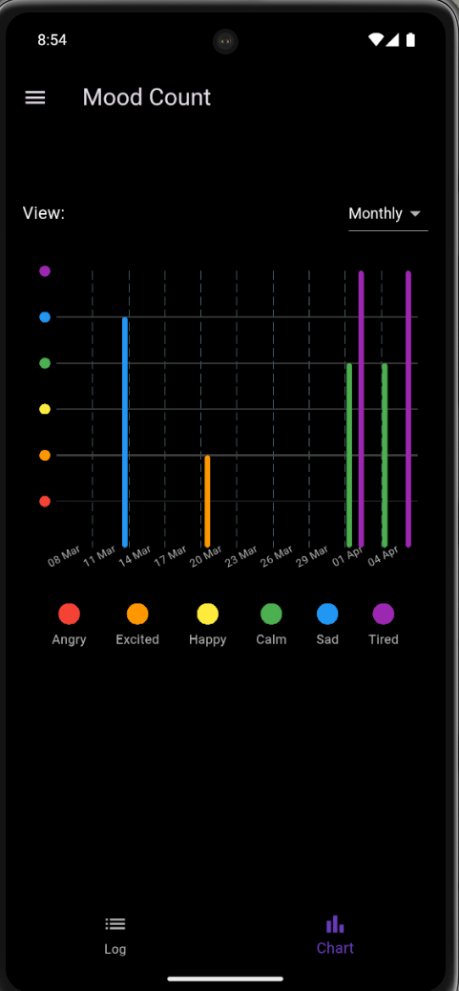

Figure 5: Mood Count Page

# Implementation Details:

The system uses a 3-tier architecture for separation of concerns:

* 1. **UI Layer:**
* Built with Flutter Widgets
* Contains all screens and user interaction
  1. **Business Logic Layer (BL):**
* Handles validation, logic, and state management
* Connects UI to the data layer
  1. **Data Layer (DL):**
* Built on SQLite
* Models and DB Helper classes for data storage

# Challenges and Solutions:

* **SQLite Table Structuring:** Handled by separating models and helpers
* **Validation:** Implemented input validation for email and passwords
* **Local Persistence:** Used SQLite efficiently to maintain offline functionality

# Conclusion:

The Mood Logger App provides an intuitive and offline-first platform to help users reflect on their emotional well-being. With a simple UI, secure access, and mood visualization, the application is a useful self-help tool.

# Future Enhancements:

* Implement password hashing for secure storage
* Add push notifications or reminders for daily mood logging
* Backup mood history to cloud (optional)
* Enhance mood chart with filters and interactivity
* Introduce multi-user support with role separation