Liquidity-Aware Sampling of a Corporate Bond ETF Portfolio
Methodology Notes and Interim Findings — Steps 1 through 3
Benchmark: iShares iBoxx $ Investment Grade Corporate Bond ETF (LQD) | Data as of July 22, 2026

1. Motivation and Research Question
Corporate bond ETFs typically track indices containing hundreds or thousands of individual bonds. Full replication is expensive and often impractical because many bonds trade infrequently and incur higher transaction costs. Portfolio managers instead construct a representative sample that closely matches the benchmark’s risk characteristics while maintaining sufficient liquidity.
This project studies that trade-off using only publicly available data: how does incorporating liquidity constraints affect the construction of a sampled corporate bond ETF portfolio, and what is the trade-off between portfolio liquidity and the accuracy with which the sampled portfolio replicates the benchmark’s characteristics?

2. Data
The benchmark is LQD’s full public holdings file (iShares "Data Download"), which is refreshed daily and requires no login. As of July 22, 2026, the fund held 3,143 bond positions across 591 unique issuers.

2.1 Fields available directly
Name (issuer), Sector, Weight, Market Value, Notional Value, Par Value, Price, Maturity date, Coupon, Effective Duration, Modified Duration, Yield to Maturity, Yield to Worst, Location (issuer country), and Currency.

2.2 Fields not available, and how each gap was resolved
Field | Gap | Resolution
CUSIP / ISIN | Not included in the public holdings file. | Bonds are identified and matched across files using Issuer Name + Coupon + Maturity Date as a composite key.
Credit rating | No rating field, and no fund-level or bond-level rating in the base file. | See Section 2.3 — resolved via cross-matching against two related BlackRock funds.
Issue size / amount outstanding | Only the ETF’s own Par Value (position size) is available, not the bond’s total issue size. | Par Value is used as a liquidity proxy (Section 4.1) with this limitation explicitly noted.
Callable status | The "Yield to Call" column exists but is blank for all 3,143 holdings. | Not used; not currently distinguished in the analysis.

2.3 Resolving the credit rating gap
LQD’s official fact sheet publishes a fund-level rating distribution (ratings sourced by BlackRock from S&P, Moody’s, and Fitch): AAA 1.03%, AA 9.05%, A 47.93%, BBB 40.47%, cash/derivatives 1.52%. This gives a reliable benchmark-level target, but does not identify which rating applies to which individual bond.
To recover a bond-level rating proxy from free data, each LQD bond was matched (by Issuer Name + Coupon + Maturity Date) against the public holdings of two other BlackRock funds built on closely related index methodologies:
- QLTA — iShares Aaa-A Rated Corporate Bond ETF (tracks a Bloomberg Aaa-A index)
- LQDB — iShares BBB Rated Corporate Bond ETF (tracks the iBoxx USD Liquid Investment Grade BBB 0+ Index — the same index family as LQD itself)
A bond found in QLTA’s holdings is labeled "A-or-better"; a bond found in LQDB’s holdings is labeled "BBB". Bonds not directly matched (smaller or less-liquid names excluded from those funds’ own screens) are inferred from whichever bucket the same issuer’s other bonds fall into.
Validation: this method recovers 59.56% A-or-better / 37.63% BBB / 2.81% Unknown-Ambiguous, versus the official 58.01% / 40.47% / 1.52% cash — within roughly 1–3 percentage points, using entirely public data.

3. Step 1: Benchmark Construction
The full LQD holdings file is treated as the benchmark portfolio. Aggregate characteristics are computed on the bond sleeve only (cash and derivatives, 0.74% of the fund, are excluded and weights renormalized to sum to 100%).
Metric | Value
Bond holdings / unique issuers | 3,143 / 591
Weighted average years to maturity | 13.06 years
Weighted average effective duration | 7.86 years
Weighted average YTM | 5.61%
Weighted average coupon | 4.69%
Top 10 issuer weight | 19.05%
Issuer HHI (0–10,000 scale) | 71.0 (≈141 effective issuers)
Rating (A-or-better / BBB / Unknown) | 59.6% / 37.6% / 2.8%

Sanity check: these figures track closely with iShares’ own reported portfolio characteristics (~7.88yr duration, ~12.94yr average maturity as of a slightly earlier date), supporting the correctness of the parsing and aggregation.

4. Step 2: Portfolio Sampling
Reduced portfolios of N = 25, 50, 100, and 200 bonds were constructed using three methods, each evaluated against the Step 1 benchmark targets (sector allocation, maturity profile, rating distribution, duration, and yield).

4.1 Method 1 — Largest Holdings
Selects the top N bonds by benchmark weight, reweighted proportionally to sum to 100%. Simplest method; used as a baseline.

4.2 Method 2 — Stratified Sampling
Strata are defined as Sector × Rating Bucket × Maturity Bucket. Holdings are allocated across strata proportional to benchmark weight (largest-remainder rounding), the largest bonds within each stratum are selected, and each selected bond is reweighted so its stratum retains the benchmark’s exact stratum weight.

4.3 Method 3 — Optimization-Based Sampling
A quadratic program minimizes a weighted sum of squared deviations across sector weights, maturity-bucket weights, rating weights, duration, and yield from the benchmark, subject to: fully invested (weights sum to 1), long-only, a per-issuer concentration cap (3%, relaxed only when a small candidate set makes 3% infeasible), and a per-position cap/floor that guarantees exactly N holdings are used.
Cardinality (exactly N holdings) makes this a mixed-integer problem in principle, which is intractable to solve exactly across 3,143 bonds. A standard relax-and-round heuristic is used instead: an iteratively reweighted-L1 penalty (Candès, Wakin & Boyd, 2008) is applied over a diverse stratified candidate universe (3×N bonds) to induce sparsity, the top N candidates by resulting weight are retained, and a final QP is solved on exactly that support.

4.4 Results
Method | N | Sector dev. (%) | Maturity dev. (%) | Rating dev. (%) | Duration | YTM (%) | Top-10 issuer (%)
Largest Holdings | 25 | 62.24 | 55.64 | 7.77 | 8.83 | 5.91 | 85.45
Largest Holdings | 50 | 58.08 | 27.46 | 22.24 | 8.08 | 5.79 | 62.96
Largest Holdings | 100 | 50.05 | 27.28 | 33.61 | 8.23 | 5.74 | 55.05
Largest Holdings | 200 | 59.60 | 22.91 | 35.24 | 7.58 | 5.66 | 55.34
Stratified | 25 | 65.79 | 14.12 | 34.73 | 7.46 | 5.66 | 70.39
Stratified | 50 | 33.52 | 13.12 | 11.62 | 7.71 | 5.71 | 49.65
Stratified | 100 | 15.59 | 7.53 | 4.71 | 7.77 | 5.70 | 41.05
Stratified | 200 | 11.38 | 2.64 | 4.65 | 7.80 | 5.69 | 37.09
Optimization | 25* | 25.34 | 21.71 | 20.74 | 7.54 | 5.58 | 40.00
Optimization | 50 | 14.59 | 5.54 | 0.19 | 7.87 | 5.56 | 30.00
Optimization | 100 | 2.63 | 0.10 | 0.00 | 7.86 | 5.61 | 25.34
Optimization | 200 | 0.67 | 0.10 | 0.00 | 7.86 | 5.61 | 21.74
Table 1. Sampling method comparison across portfolio sizes. *N=25 optimization hit a solver infeasibility (see Section 6.2) and used an equal-weight fallback — treat with caution.
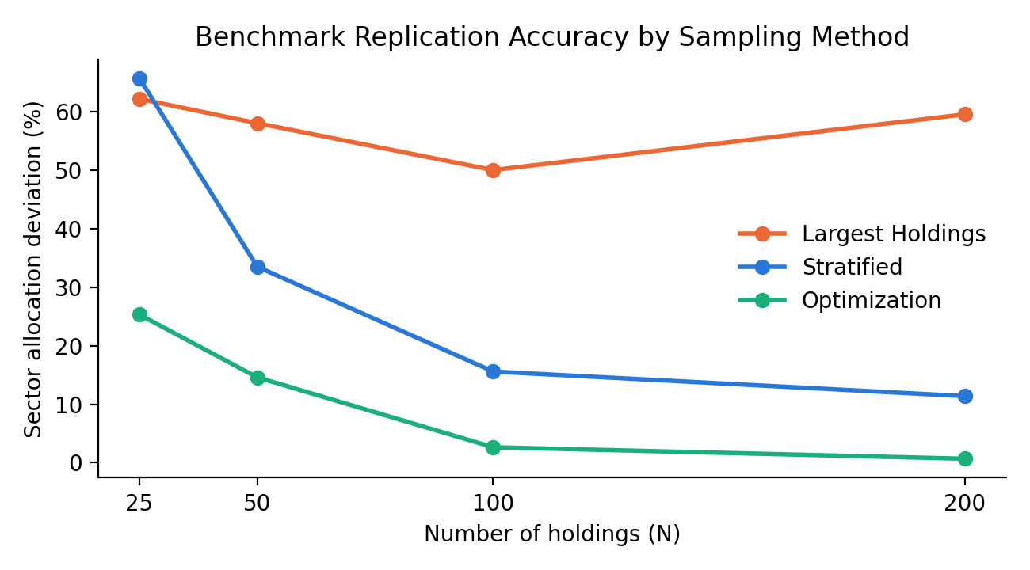
Figure 1. Sector allocation deviation from benchmark, by method and portfolio size.
The ordering is consistent and expected: Largest Holdings is worst and roughly flat with N (it keeps adding smaller positions in the same already-included issuers/sectors rather than diversifying); Stratified improves steadily with N; Optimization dominates at every size and also achieves the tightest issuer concentration, since the issuer cap is an explicit constraint rather than incidental.

5. Step 3: Incorporating Liquidity

5.1 Liquidity proxy
The public holdings file has no bond-level "amount outstanding" field. The ETF’s own Par Value (par amount of the position held) is used as a proxy: larger ETF positions generally correspond to larger, more liquid bond issues, since iBoxx-style indices weight constituents by issue size. This is an approximation — no bid-ask spread or trade volume data is available — and should be caveated explicitly in any downstream write-up. The score is log(Par Value), min-max normalized to [0,1].

5.2 Liquidity-aware optimization
The Step 2 optimizer is extended with a soft penalty: objective = tracking error − λ × (weighted average liquidity score). λ is swept over {0, 0.01, 0.05, 0.1, 0.25, 0.5, 1.0, 2.0} at N = 50, 100, and 200 to trace an accuracy/liquidity frontier.
Modeling note: an early version of this penalty, being linear in portfolio weights, pushed the optimizer to concentrate weight in a handful of the largest-Par-Value bonds up to the issuer cap, collapsing well below the target N. A per-position weight cap and floor were added so the QP is forced to use exactly N distinct holdings even once the liquidity term is active — arguably a more realistic constraint for an index-sampling problem in general, independent of liquidity.

5.3 Results
N | lambda | Liquidity score | Sector dev. (%) | Duration | YTM (%)
50 | 0.00 | 0.877 | 14.59 | 7.87 | 5.56
50 | 0.05 | 0.913 | 14.59 | 7.76 | 5.62
50 | 1.00 | 0.916 | 17.23 | 7.90 | 5.66
100 | 0.00 | 0.861 | 2.63 | 7.86 | 5.61
100 | 0.05 | 0.908 | 4.94 | 7.85 | 5.63
100 | 1.00 | 0.913 | 8.42 | 7.81 | 5.65
200 | 0.00 | 0.853 | 0.67 | 7.86 | 5.61
200 | 0.05 | 0.902 | 1.23 | 7.86 | 5.61
200 | 1.00 | 0.909 | 6.82 | 7.91 | 5.66
Table 2. Liquidity penalty sweep (abridged — full 24-row sweep in step3_liquidity_sweep.csv).
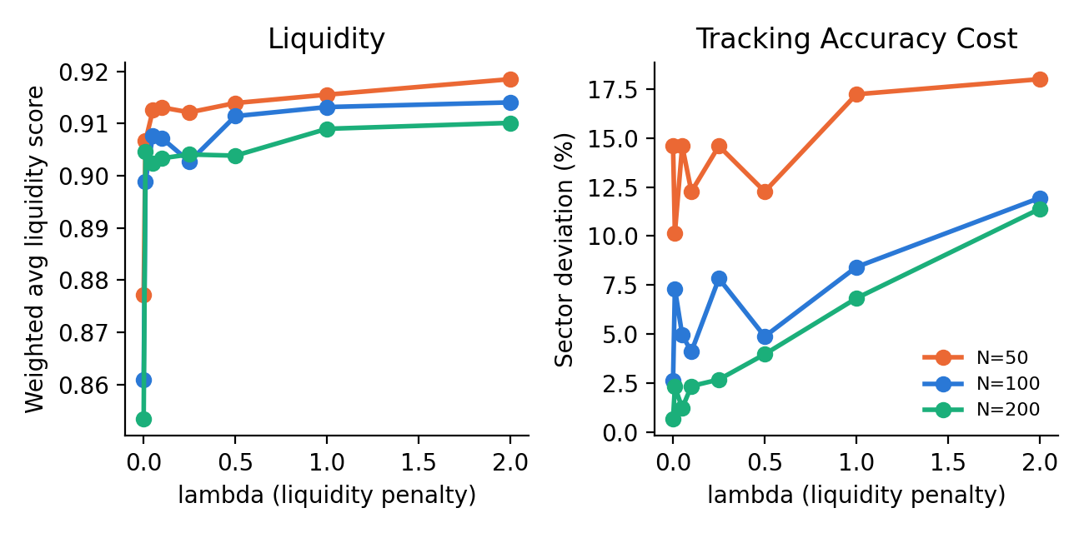
Figure 2. Liquidity score and tracking-accuracy cost as the liquidity penalty (lambda) increases.
Headline finding: even a small liquidity penalty (λ = 0.01) buys a large, immediate liquidity improvement — the weighted-average liquidity score jumps from roughly 0.85–0.88 (λ = 0, pure tracking) to roughly 0.90–0.92. Beyond that initial jump, liquidity gains mostly plateau: pushing λ higher does not buy much more liquidity, but does cost more tracking accuracy, particularly at smaller N. This suggests liquidity and replication accuracy are not in constant tension across the whole range — the real trade-off is concentrated at the low end of λ.

6. Known Limitations

6.1 Rating and liquidity proxies
- The rating bucket is a two-tier proxy (A-or-better vs. BBB) inferred by cross-fund matching, not a true bond-level agency rating; ~2.8% of the portfolio remains unclassified.
- The liquidity score uses ETF par holding size, not the bond’s true amount outstanding or any trading-activity measure (bid-ask spread, trade volume). This is the most significant open data gap in the project.

6.2 Optimization edge cases
- N=25 with the liquidity-and-rating-aware optimizer hit a solver infeasibility (the combination of issuer cap, position floor, and position cap left no feasible region for such a small candidate support) and fell back to equal weighting. This result should not be used as-is; the constraint set needs loosening specifically at very small N.
- The λ-sweep curve (Figure 2) is somewhat noisy rather than perfectly monotonic — an artifact of the reweighted-L1 heuristic responding differently to the liquidity term at each λ. A finer grid or more reweighting iterations would smooth this if a cleaner frontier is needed for the final report.

7. Next Steps
- Step 4: build head-to-head comparison tables/charts, with vs. without liquidity considerations, across all evaluated dimensions.
- Step 5: formalize the trade-off analysis and directly answer the four questions posed in the original proposal (accuracy lost to liquidity, yield impact, which characteristics are hardest to preserve, and how required holdings count scales with tighter liquidity constraints).
- Optionally: revisit the N=25 optimization infeasibility, and consider a finer λ grid for a cleaner trade-off frontier.

