CIRCUIT ANALYSIS LABORATORY

Experiment No: | 2
Experiment Name: | Thévenin Equivalent and Maximum Power Transfer
Student No: | 151220192027
Student Name: | Mustafa YAĞCI
Group: | 1D-1
Date: | 15.11.2021

INTRODUCTION
The purpose of this experiment is to describe the thévenin equivalent technique and how the maximum power is transferred to the load.

EXPERIMENTAL RESULTS
First we find Vth and Rth.
Vth = 1.189 V
Rth = 0.89 KΩ

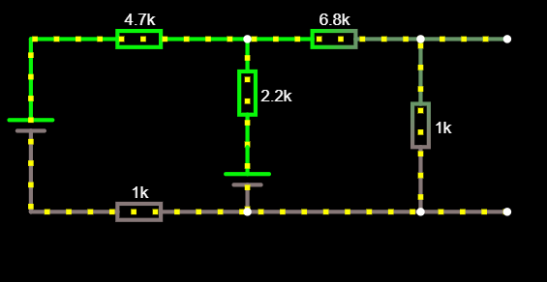
Fig. 1 simple series resistive circuit with two DC Sources

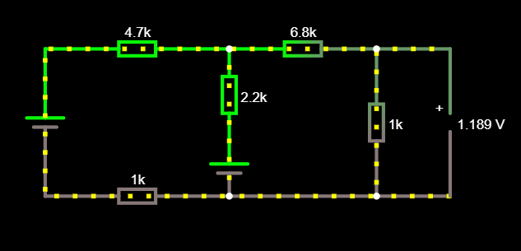
Fig. 2 simple series resistive circuit with two DC Sources with Vth

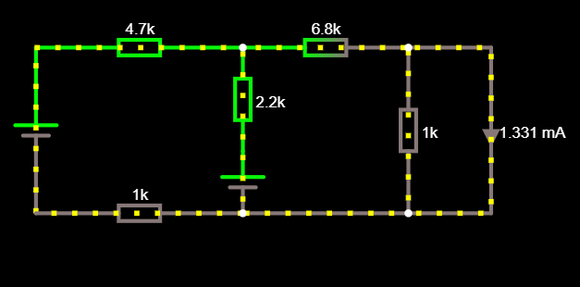
Fig. 3 simple series resistive circuit with two DC Sources with isc

We measure their voltages again by connecting 500 Ω and 5kΩ resistors between terminals a and b.

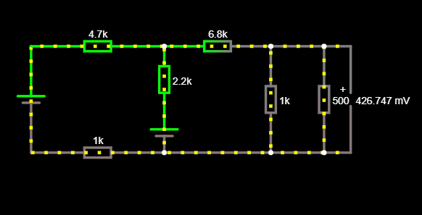
Fig. 4 simple series resistive circuit with two DC Sources with 500Ω

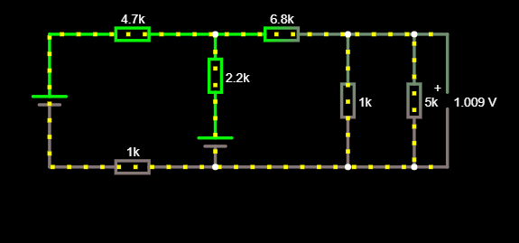
Fig. 5 simple series resistive circuit with two DC Sources with 5kΩ

Experiment results with 5kΩ
Vth = 1.009 V
Experiment results with 500Ω
Vth = 0.426 V

CONCLUSION
The calculated Rth value is the same as the measured Rth value in the experiment without adding resistance. But the measured vth in the experiment with added resistance came out a little different. Because there was a human factor in the potentiometer in the experiment, deviations occurred.

REFERENCES
- Falstad Website: https://www.falstad.com/circuit/, Access Date: November 2021

