CIRCUIT ANALYSIS LABORATORY

Experiment No: | 1
Experiment Name: | Introduction to Voltage, Current, and Resistance Measurements
Student No: | 151220192027
Student Name: | Mustafa YAĞCI
Group: | 1D-1
Date: | 01/11/2021

INTRODUCTION
The purpose of the experiment is to improve our knowledge of the basic elements of the circuit, namely resistance, volts and current.

EXPERIMENTAL RESULTS
For the 1st experimental setup:
-First of all, we find the resistors we will use in the experiment by using color codes.
-Then we set up the circuit given in the experiment.
-Then we calculate the resistances of the points specified in our experiment.
-Then we measure the voltage and current through the resistors.
-Finally, we measure the current flowing through the source.
For the 2nd experimental setup:
-We do the same as in the first experimental setup.
-The only difference is that we measure the current through the resistors by making the voltages in v 0, 3, 6 and 9.
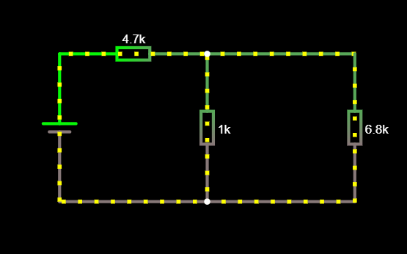
Fig. 1 1. Setup Simple Resistive Circuit [1]

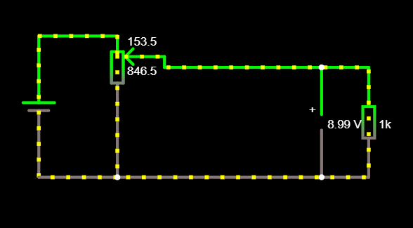
Fig. 2 2. Setup Simple Resistive Circuit – 9 Volt [1]

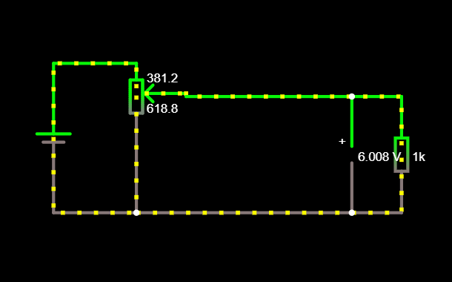
Fig. 3 2. Setup Simple Resistive Circuit – 6 Volt [1]

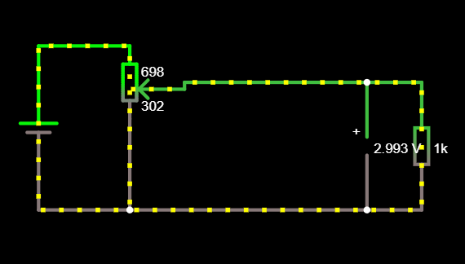
Fig. 4 2. Setup Simple Resistive Circuit – 3 Volt [1]

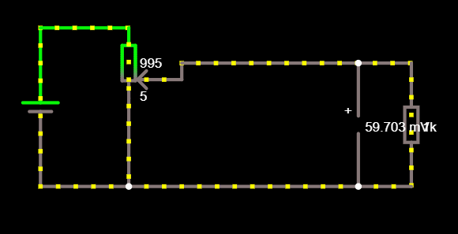
Fig. 5 2. Setup Simple Resistive Circuit - 0 Volt [1]

CONCLUSION
1st Experiment Results:
V1 : 10.22V İ1 : 2.154 mA
V2 : 1.878V İ2 : 1.878 mA
V3 : 1.878V İ3 : 276 µA

2nd Experiment Results:
V=0 V İ = 0 A
V=3 V İ = 3 A
V=6 V İ = 6 A
V=9 V İ = 9 A

As a result, we learned current resistance and volt measurements.
However, since the resistance of the measuring device is involved in the measurements, the measurements show slight differences with the theoretical measurements.
We have learned that this should be taken into account when measuring.

REFERENCES
- Falstad Website: https://www.falstad.com/circuit/, Access Date: November 2021

