ELECTRONICS LABORATORY

Experiment No: | 3
Experiment Name: | Introduction to Bipolar Junction Transistors
Student No: | 151220192027
Student Name: | Mustafa Yağcı
Group Members:  (Student Numbers - Student Names) | 151220194038 – Emirhan Ak 151220192027 – Mustafa Yağcı  151220192091 – Emre Saraç
Date: | 30.10.2022

OBJECTIVES
In this experiment, our aim is to examine the basic functions of Bjt..

EXPERIMENTAL RESULTS
In the first experiment, We found β by setting up the experimental setup and dividing the current Ic by the current Ib.

Vbe = 0,65 V Vce = 1,98 V
Ib = 0 A Ic = 5.1A Ie = 5.1 A

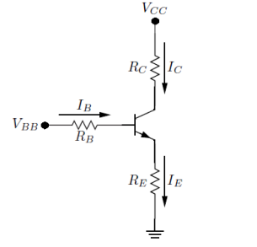
In the second experiment, The experimental setup was prepared and β₁, β₂, β_{TOT} were calculated.
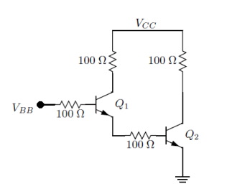
V_{BE1} =643mV V_{BE2} =731mV
I_{B1}=1 I_{B2}=1
I_{C1}=0.93mA I_{C2}=46.8mA
In the third experiment, in this experiment, we substituted the input values of A and B to get the results of the output.
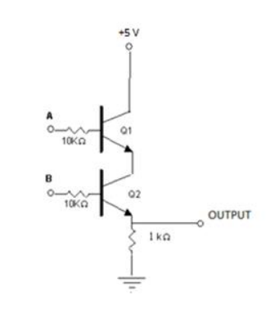
V_{A} | V_{B} | V_{OUT}
0 | 0 | 0
0 | 5 | 0.43V
5 | 5 | 4.24V
5 | 0 | 0

In the fourth experiment, in this experiment, we substituted the input values of A and B to get the results of the output.
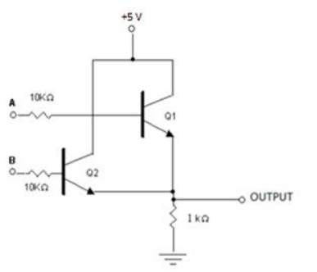

VA | VB | VOUT
0 | 0 | 0
0 | 5 | 4.30V
5 | 0 | 4.33V
5 | 5 | 4.33V

CONCLUSION & DISCUSSION
Bjt as a result of this experiment : Origin flowing from a terminal to a common terminal .It allows the current to increase the voltage and current by controlling the current flowing from the third terminal to the common terminal.

REFERENCES
- IEEE Citation Style Guide, Available: http://www.ijssst.info/info/IEEE-Citation-StyleGuide.pdf, Access Date: October 2021

