ELECTRONICS LABORATORY EXPERIMENT 5 REPORT
Name Surname | : | Emirhan Ak, Emre Saraç, Mustafa Yağcı
Student Number | : | 151220194038, 151220192091, 151220192027
Date | : | 9/12/2022
Group | : | 1B
EXPERIMENT NO: 5
- N-channel JFET Transistor with 20 Gain

OBJECTIVES
- Observing the behavior and understanding the working principal of the n-channel JFET (B245)
- Designing a circuit that would yield 20 gain when connected to an AC power source
LIST OF EQUIPMENTS
- N-channel JFET (B245)
- Resistors
- Oscilloscope
- AC Signal Generator
INTRODUCTION
A JFET or a junction field effect transistor is an active circuit component, that is used to in many applications in electrical circuits. In this experiment we aimed to use the transistor to amplify the output voltage and yield 20 gain. In other words, we want our circuit to output 20 times of the input voltage. We divided our experiment into two parts. The first part will be the simulation and the second part will be constructed in the laboratory.
PRELIMINARY WORK
To simulate our circuit, we decided to use Falstad. We made a thorough search on different JFET circuits and their uses in daily life. After a while, we decided to construct a common source JFET circuit shown below.
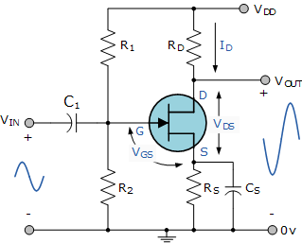
Figure 1. Common Source JFET Circuit
In our simulation, we used various resistor and capacitor values to obtain 20 gain and eventually came up with the circuit below.

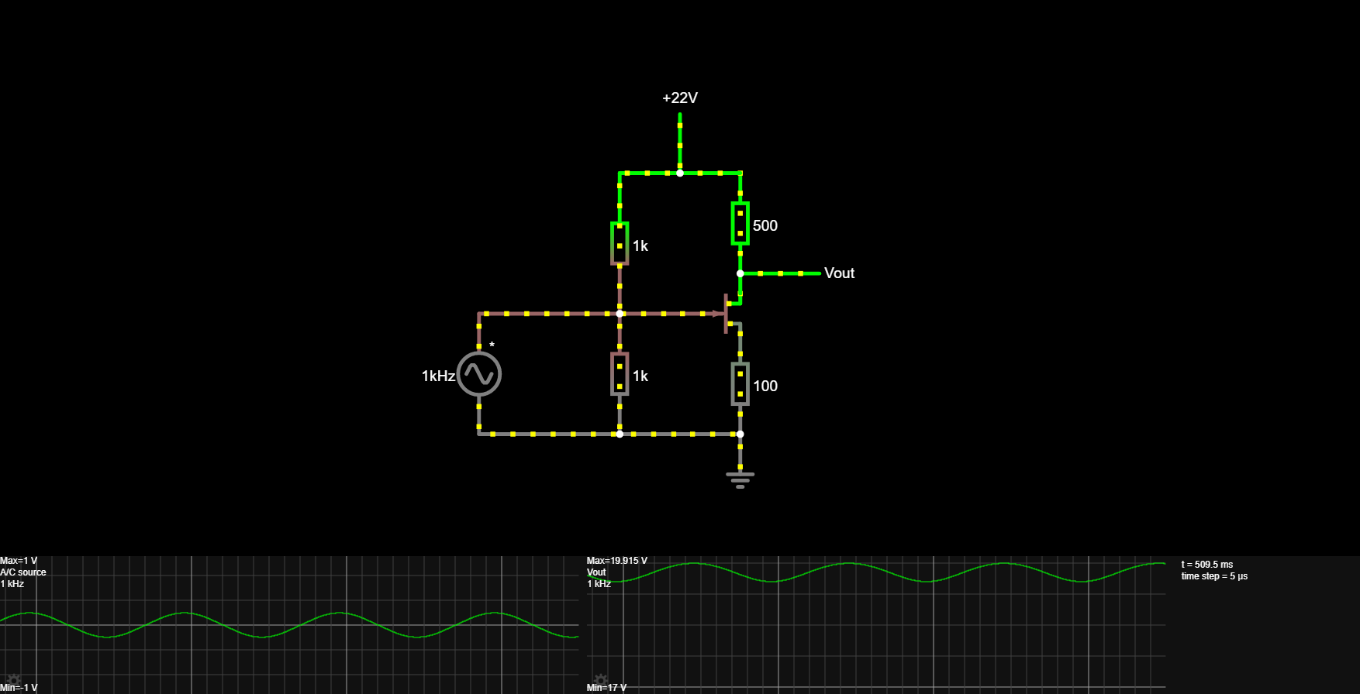
Figure 2. Common Source JFET Circuit in Falstad
In this circuit, we can see that when our max input voltage is 1V, we yield 19.915V of voltage. Which means we successfully constructed the 20 gain JFET circuit.

PROCEDURE
In the second part of the experiment, we tried to construct our circuit in the laboratory. Unfortunately, we couldn’t get the same values from our circuit in the laboratory as we did in the simulation. We kept getting a DC voltage as output which wasn’t supposed to happen.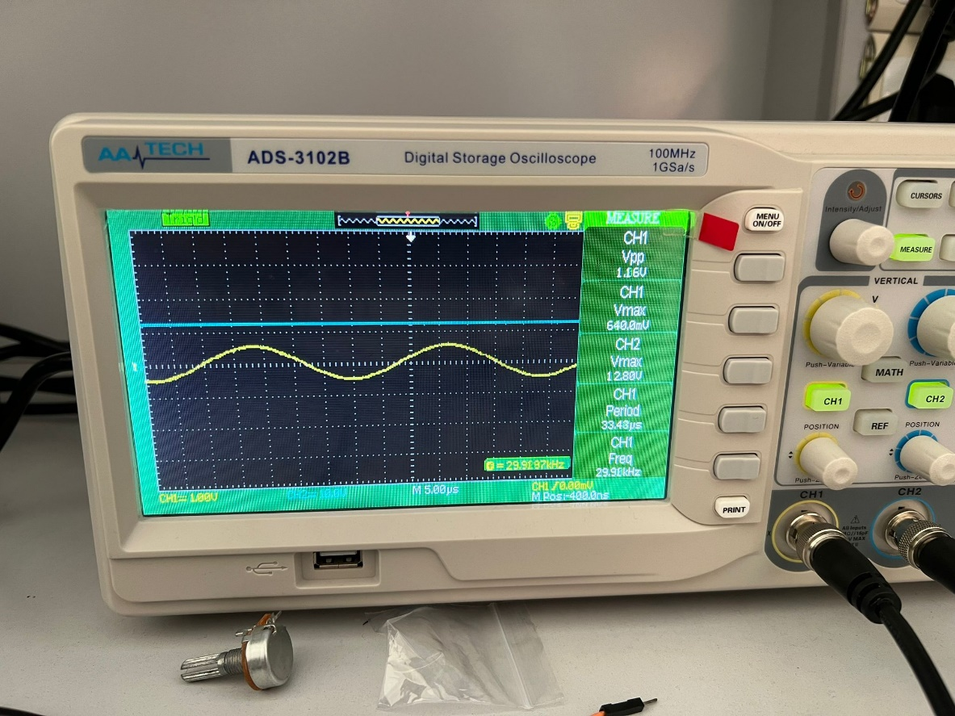
Figure 3. Oscilloscope Screen of the Laboratory Experiment
We searched for different types of circuits while the experiment was still going on, but none of them gave us the result we were supposed to achieve.
CONCLUSION
As a conclusion of this experiment, we failed to achieve the 20 gain that was assigned to us. Despite this failure, we learned a lot about the working principle of the n-channel JFET and its behavior. So in the end, although we failed at the laboratory experiment due to the unfortunate events that occurred, we can say that we learned about JFETs in the simulation part and if we are given a task about JFETs in the future, we are sure that we can solve the problem.

