CIRCUIT ANALYSIS LABORATORY

Experiment No: | 5
Experiment Name: | Natural and Step Response of an RC Circuitand Time Constant Concept
Student No: | 151220192027
Student Name: | Mustafa YAĞCI
Group: | 1D-1
Date: | 27.12.2021

INTRODUCTION
The main purpose of the experiment is to introduce you to an RC circuit and see the natural step responses of the RC circuit. Then, the significance of time constant is explained

EXPERIMENTAL RESULTS
Our 1st RC circuit: 𝐶=1000𝜇𝐹 and 𝑅=4.7𝑘𝛺
Our results :
Time | Volt  (Multimeter) |  | Volt  (osilator) |  |  | Volt  (osilator+Multimeter)
Time | Rise | Drop | Rise | Drop |  | Rise | Drop
T1 | 7.22 | 4.8 | 8.01 |  | 4.31 | 8.1 |  | 4.3
T2 | 10 | 1.9 | 10.6 |  | 1.97 | 10.4 |  | 1.7
T3 | 11.1 | 0.7 | 11.7 |  | 0.892 | 11.4 |  | 0.6
T4 | 11.6 | 0.4 | 11.95 |  | 0.369 | 11.7 |  | 0.3
T5 | 11.8 | 0.1 | 12 |  | 0 | 11.9 |  | 0
1. RC Circuit Volt Results Table

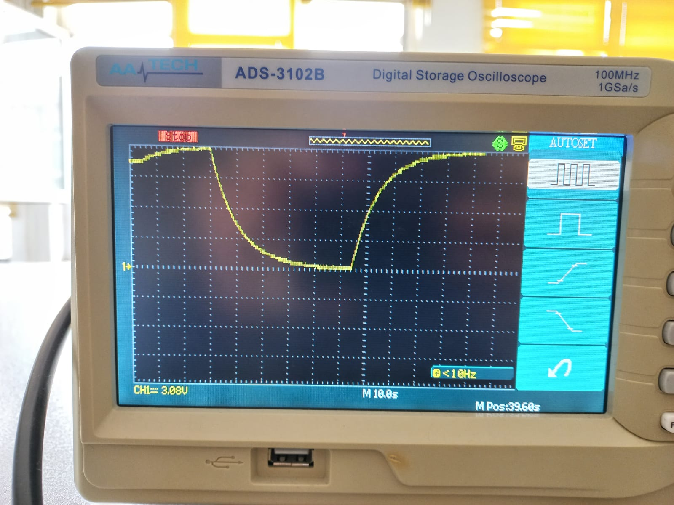
1. RC Circuit Oscilloscope Photo [1]

Our 2nd RC circuit: 𝐶=10𝜇𝐹 and 𝑅=470𝑘𝛺.
Our results :
Time | Volt  (Multimeter) |  | Volt  (osilator) |  |  | Volt  (osilator+Multimeter)
Time | Rise | Drop | Rise | Drop |  | Rise | Drop
T1 | 5.89 | 3.42 | 6.53 |  | 5.05 | 3.70 |  | 4.07
T2 | 7.52 | 0.87 | 7.64 |  | 2.96 | 4.93 |  | 2.71
T3 | 7.84 | 0.87 | 7.88 |  | 1.72 | 5.67 |  | 1.60
T4 | 7.91 | 0.11 | 8.01 |  | 1.11 | 5.91 |  | 0.862
T5 | 7.94 | 0.5 | 8.50 |  | 0.512 | 6.16 |  | 0.126
2. RC Circuit Volt Results Table
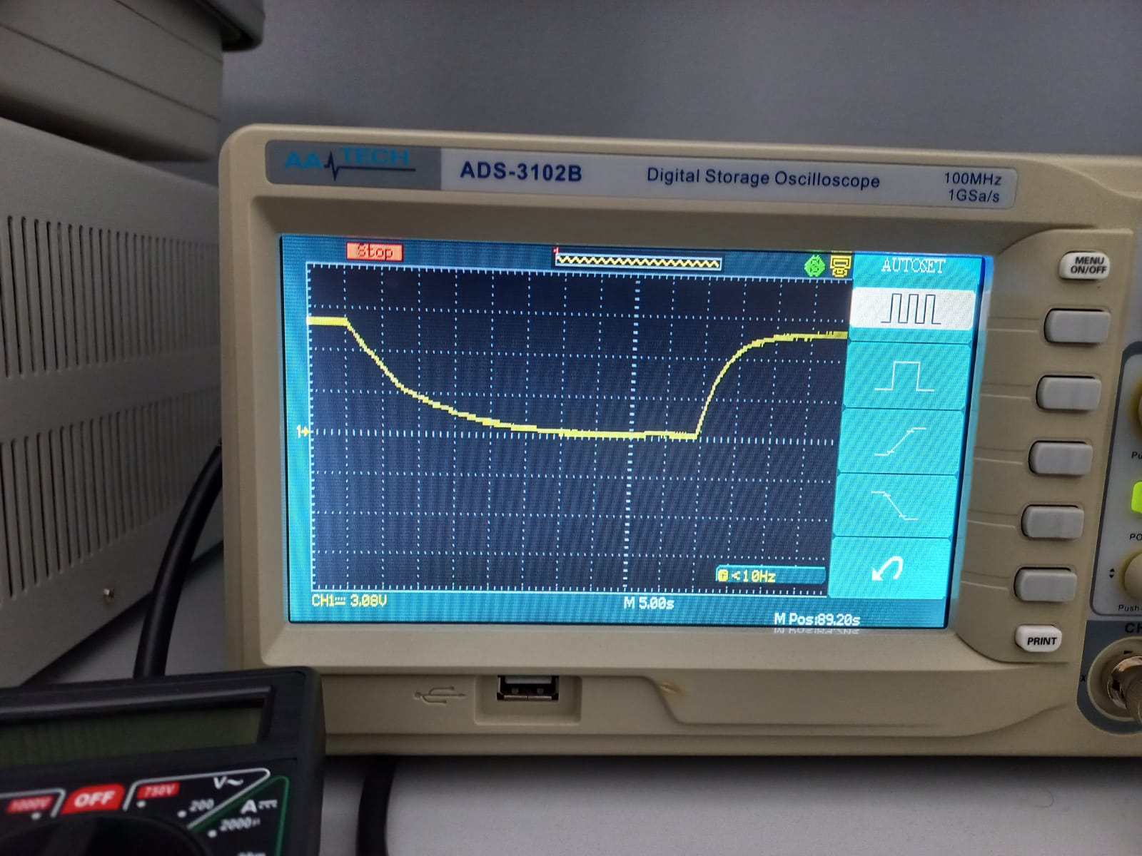
2. RC Circuit Oscilloscope Photo [1]
Our 3rd RC circuit: 𝐶=10𝜇𝐹 and 𝑅=1𝑀𝛺.
Our results :
Time | Volt  (Multimeter) |  | Volt  (osilator) |  |  | Volt  (osilator+Multimeter)
Time | Rise | Drop | Rise | Drop |  | Rise | Drop
T1 | 3.82 | 3.40 | 3.08 |  | 4.19 | 2.34 |  | 2.34
T2 | 5.25 | 1.14 | 4.31 |  | 2.34 | 3.33 |  | 1.48
T3 | 5.73 | 0.38 | 5.17 |  | 1.36 | 3.82 |  | 0.862
T4 | 5.85 | 0.13 | 5.67 |  | 0.862 | 4.07 |  | 0.369
T5 | 5.34 | 0.06 | 5.9 |  | 0.614 | 4.20 |  | 0
3. RC Circuit Volt Results Table

CONCLUSION
In this experiment, the factors that changed the results in the measurements of voltmeters were determined as follows.
1-Depending on the resistors.
2-Varies according to the resistances inside the measuring device.
Our conclusions :
As the resistance increases, the maximum volt obtained decreases.
Since the resistors inside the measuring devices are connected in parallel to the circuit, the capacitor charges faster.

REFERENCES
- Oscilloscope : photo taken by the author , 27 December 2021

