
ESKISEHIR OSMANGAZI UNIVERSITY ELECTRICAL AND ELECTRONICS ENGINEERING 2020-2021 SPRING SEMESTER DIGITAL SYSTEMS LABORATORY
EXPERIMENT 1 TTL Gate Characteristics

Taha Kaçıra - 151220182104

GROUP I-A



ESKISEHIR OSMANGAZI UNIVERSITY
ELECTRICAL AND ELECTRONICS ENGINEERING

EXPERIMENT 1 REPORT

OBJECTIVES

- Monitoring the characteristics of TTL gates.

- Exploring different logic gate properties,including propagation delay,voltage levels, noise margin etc.

INTRODUCTION
Three procedures were examined in the TTL Gate Characteristics experiment.First is the voltage characteristics of the inverter. Second is calculating the noise margins for the gate using the voltage transfer curve. Finally, the tPHL and tPLH of the in-line inverter were measured.

PROCEDURE

1- 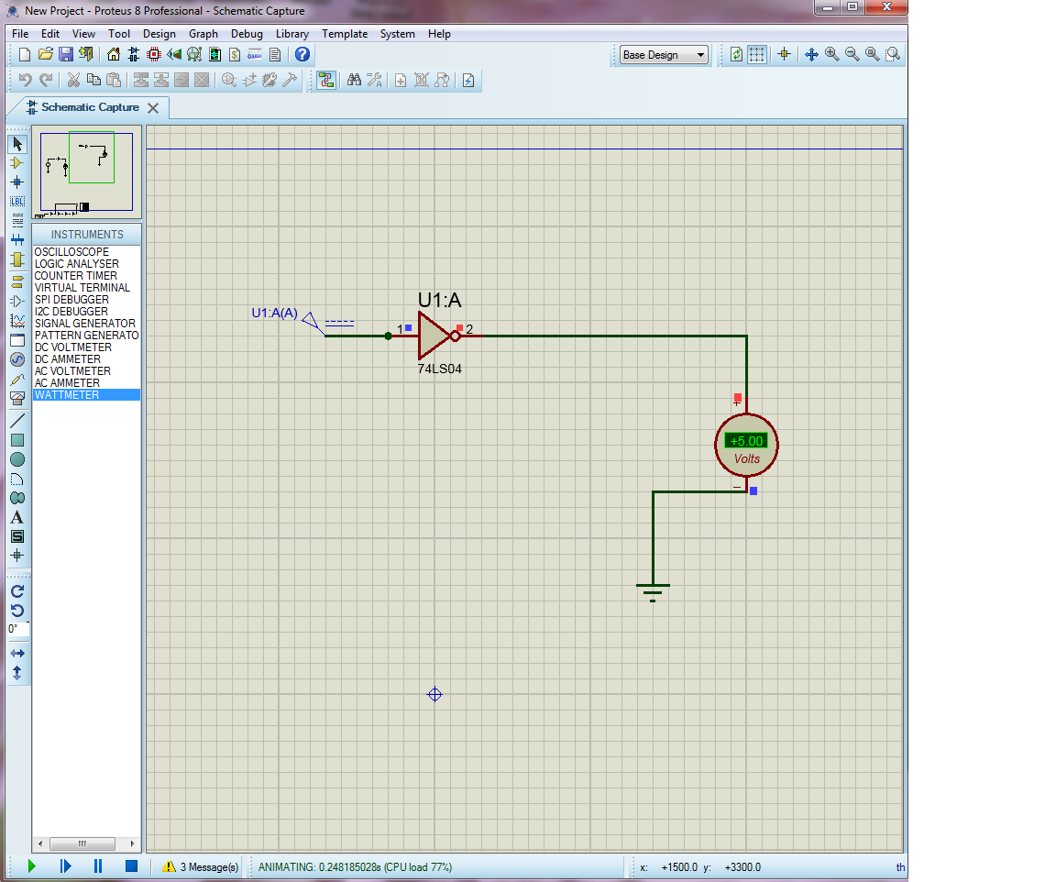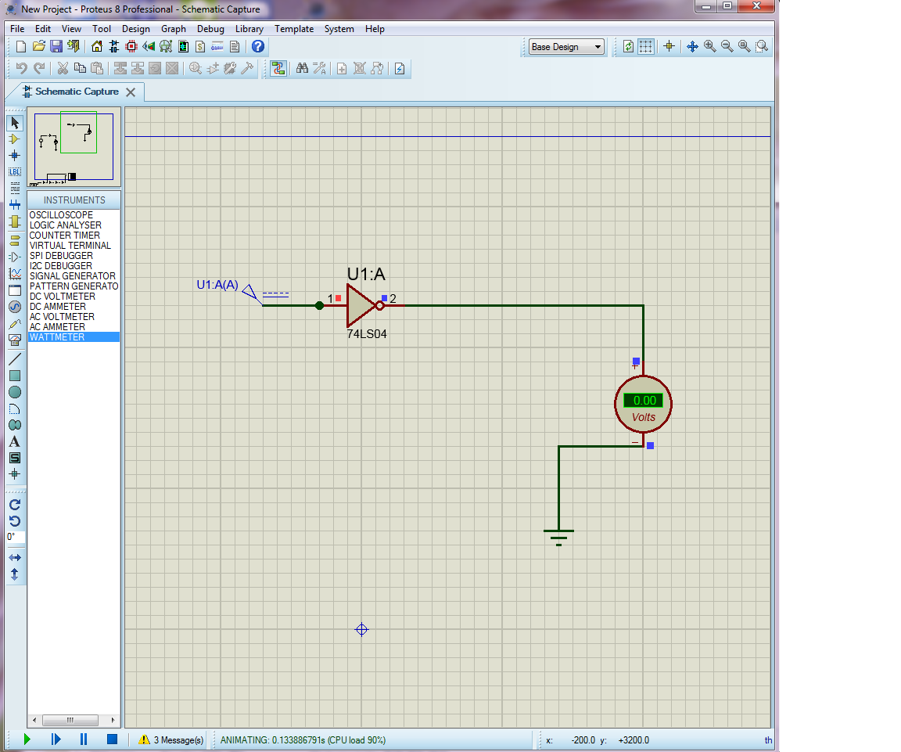
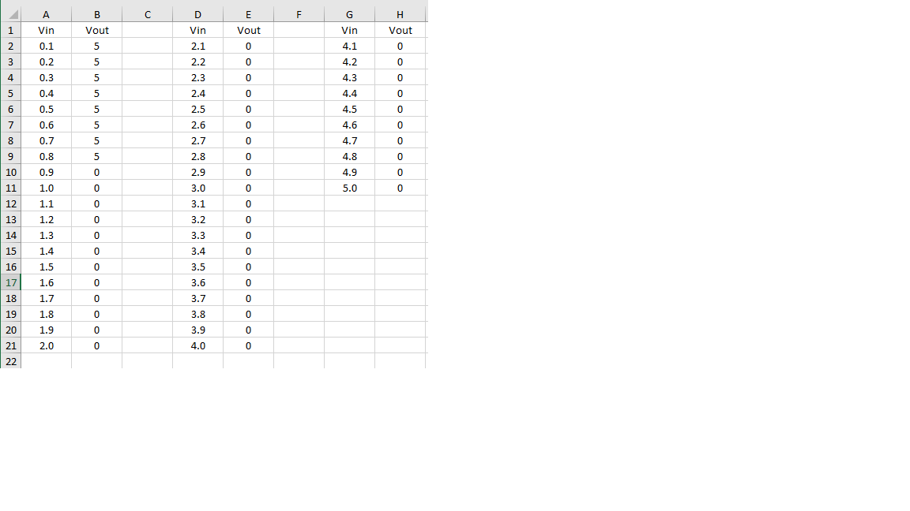
2-
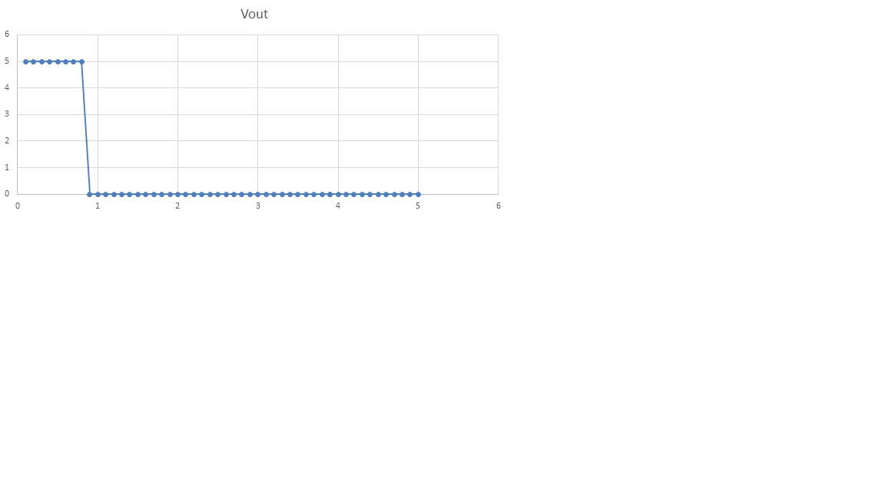
VIL(max) = 0.8V
VIH(min) = 0.9V
VOH(min) = 5V
VOL(max) = 0V
VNL= VIL(max)- VOL(max) = 0.8V
VNH= VOH(min)- VIH(min) =4.1V
3-
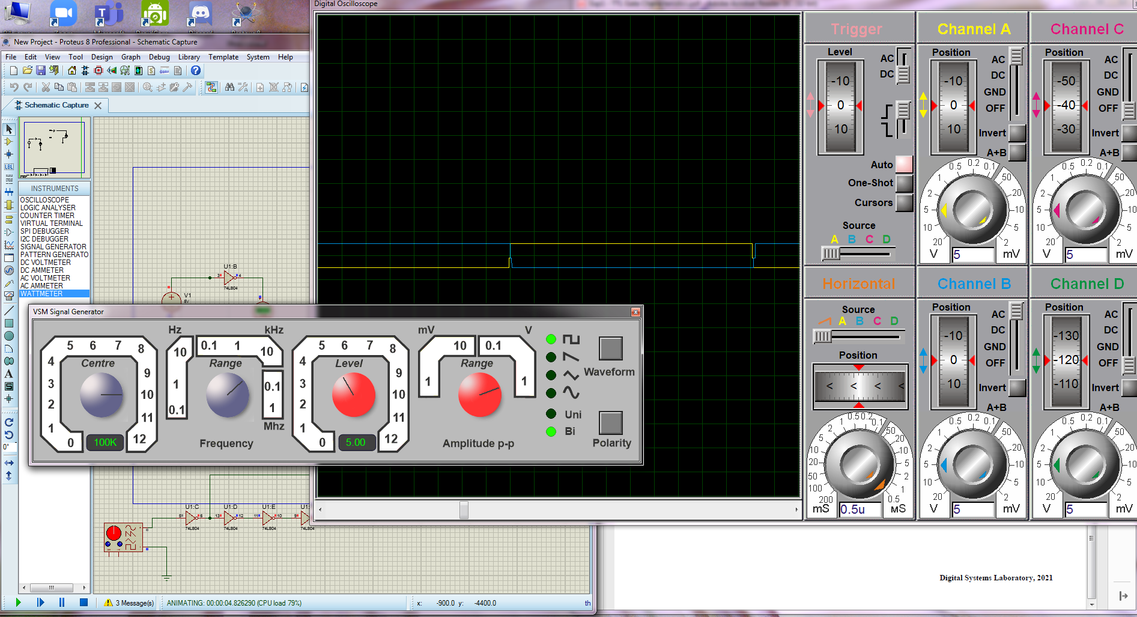

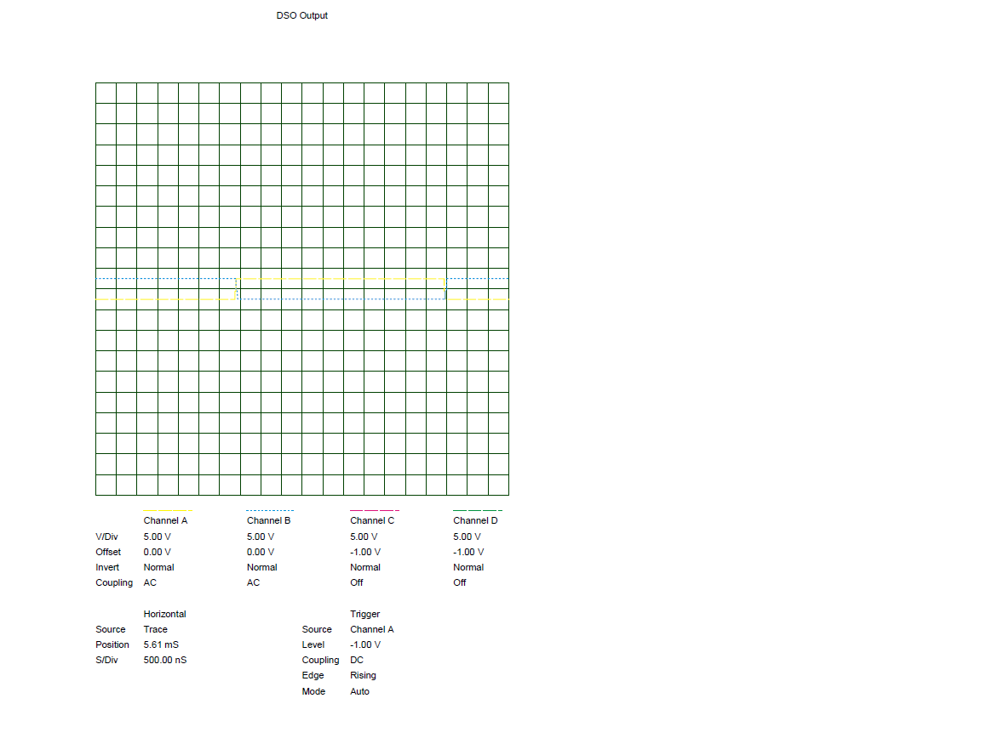

DISCUSSION AND CONCLUSIONS
The output values of the 74ls04 inverter were examined from 0 to 5 Volts.The results were observed by increasing 0.1 from 0 to 5 volts. As we switched from 0.8 volts to 0.9 volts, the output voltage dropped from 5 volts to 0 volts. In addition, in the third procedure, the graph of the in-line inverter was examined together with the alternating voltage source on the oscilloscope and square waves were observed.

