
ESKISEHIR OSMANGAZI UNIVERSITY ELECTRICAL AND ELECTRONICS ENGINEERING 2021-2022 SPRING SEMESTER DIGITAL SYSTEMS LABORATORY
EXPERIMENT 2 COMBINATIONAL LOGIC DESIGN WITH DECODERS AND MULTIPLEXERS

MUSTAFA YAĞCI
151220192027
GROUP II – D



ESKISEHIR OSMANGAZI UNIVERSITY
ELECTRICAL AND ELECTRONICS ENGINEERING

EXPERIMENT 2 REPORT

OBJECTIVES
- Designing combinational a circuit an implement it with decoders and multiplexers.

INTRODUCTION
Two circuits were designed in the experiment. In the first phase decoders were used, and multiplexers were used in the second circuit. Circuits were tested with the Fibonacci sequence.

PROCEDURE
Q1 – Input value 1
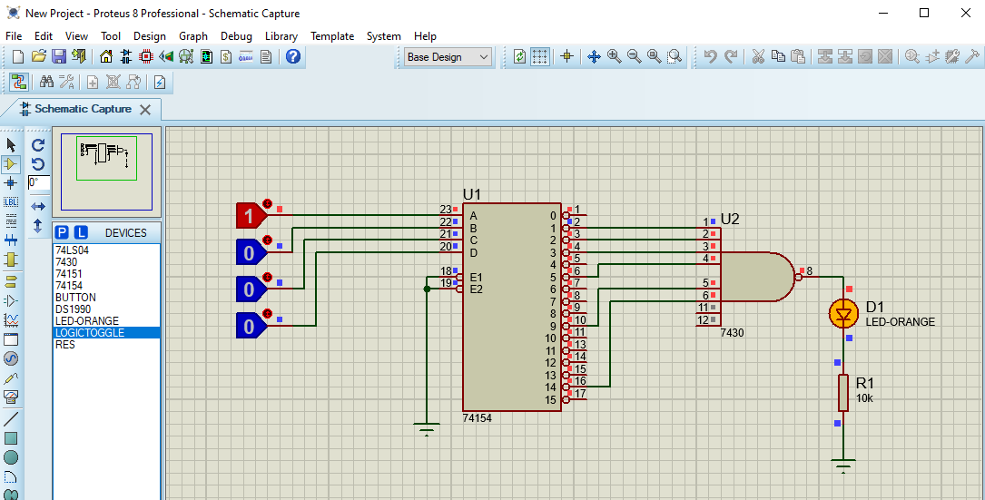

Q1 – Input value 3

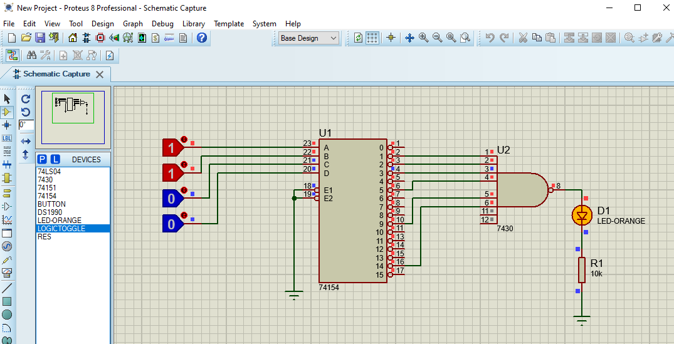

Q1 – Input value 6
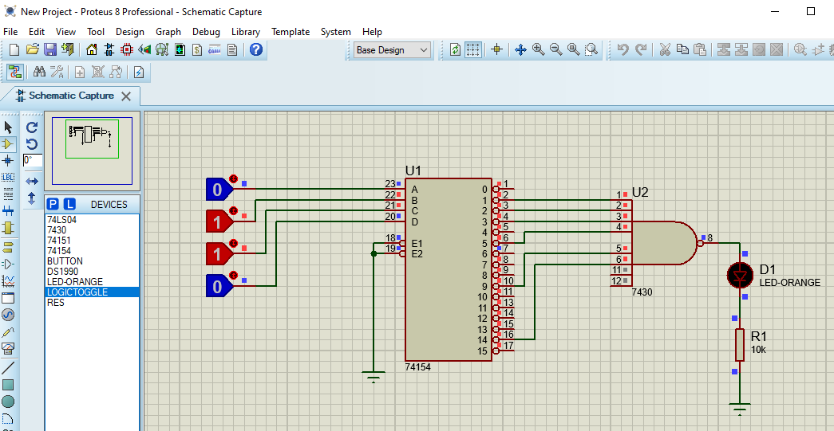

Q2 – Input value 2
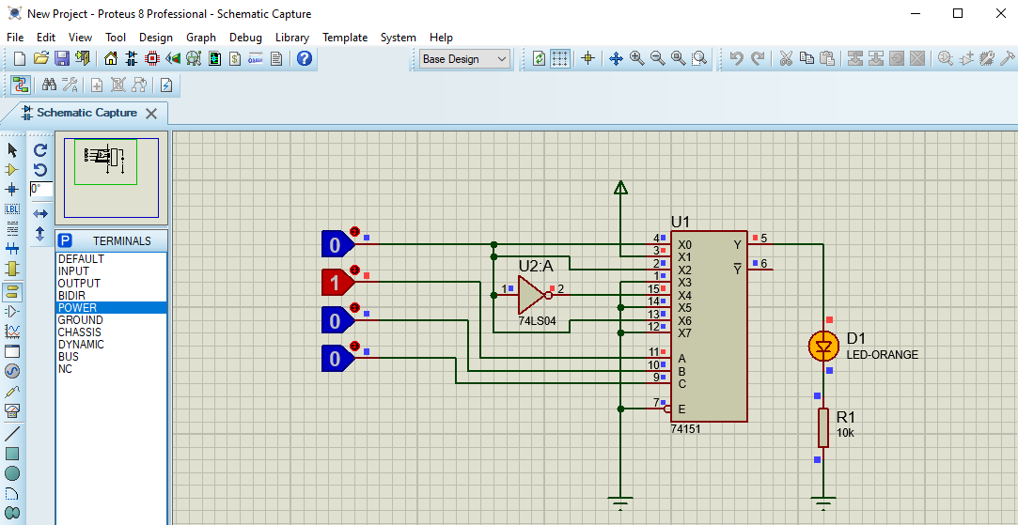

Q2 – Input value 5
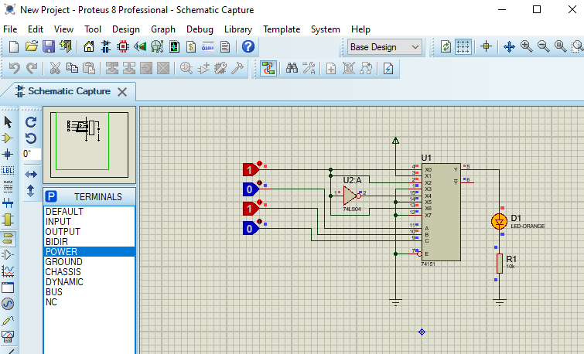

Q2 – Input value 13
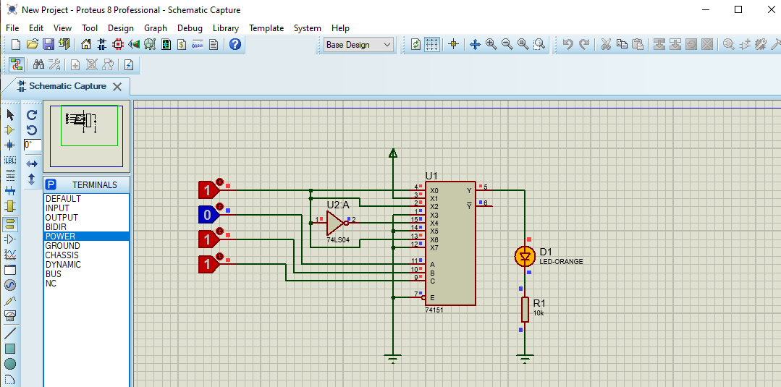

Q2 – Input value 15
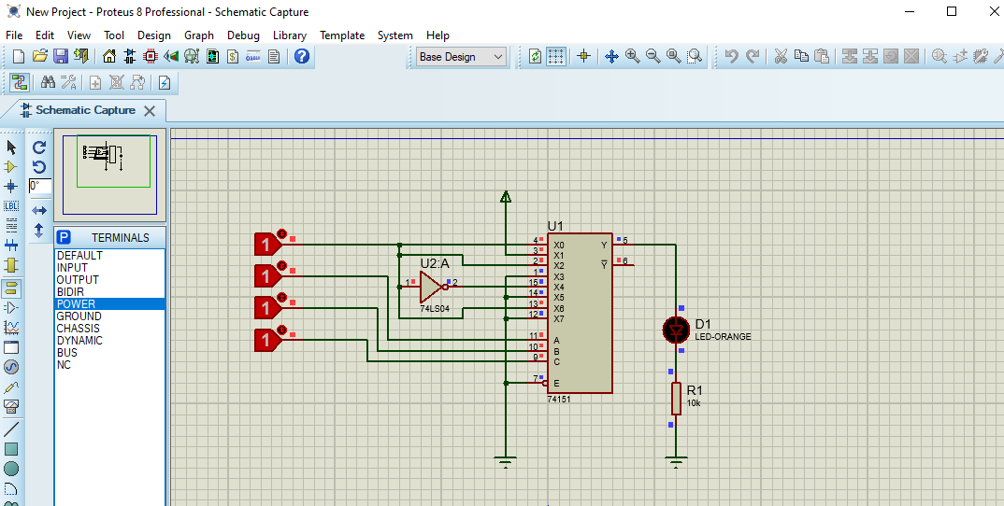

DISCUSSION AND CONCLUSIONS
Since the Fibonacci sequence is a sequence of numbers that is the result of adding each number to the previous one, we entered a bit from the Fibonacci sequence in both circuits in the simulation. If the led is on it means we entered a correct sequence.

