
ESKISEHIR OSMANGAZI UNIVERSITY ELECTRICAL AND ELECTRONICS ENGINEERING 2021-2022SPRING SEMESTER DIGITAL SYSTEMS LABORATORY
EXPERIMENT 3 ADDER / SUBTRACTOR

MUSTAFA YAĞCI
151220192027
GROUP II – D



ESKISEHIR OSMANGAZI UNIVERSITY
ELECTRICAL AND ELECTRONICS ENGINEERING

EXPERIMENT 3 REPORT

OBJECTIVES
- The addition and subtraction of 4-bit binary adder numbers is studied using the integrated circuit.
INTRODUCTION
4 bit binary adders subtraction, addition and binary numbers signed and unsigned representation on the circuit.
PROCEDURE
Q1- Fill the table with the 1’s and 2’s complements of the given binary numbers.

 | 1s Complement | 2s Complement
1011 | 0100 | 0101
1111 | 0000 | 0001
0101 | 1010 | 1011
0000 | 1111 | 0000
0011 | 1100 | 1101

Q2- Fill the table with the 8-bit signed representations of the decimal numbers.

Decimal | Signed Magnitude | Signed 1s complement | Signed 2s complement
-55 | 11001001 | 00110110 | 00110111
-23 | 11101001 | 00010110 | 00010111
-15 | 11110001 | 00001110 | 00001111
-4 | 11111100 | 00000011 | 00000100
-105 | 10010111 | 01101000 | 01101001

Q3- The 4 bit adder/subtractor circuit implemented with IC 7483 is shown in Figure 1. Explain the
operation of the circuit with your own words, briefly.
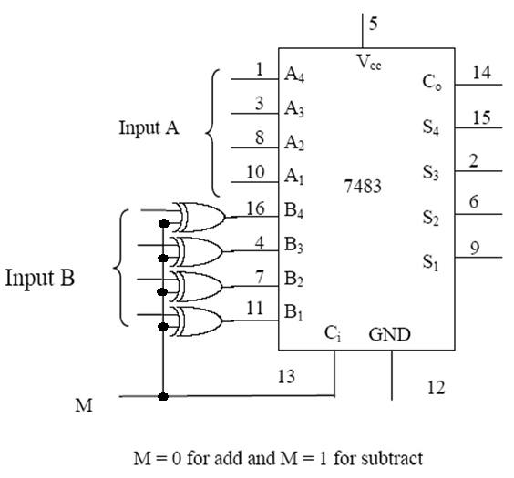
Figure 1

Q4- What is the difference between “half adder”, “full adder”, “ripple carry adder” and “carry look
ahead adder” circuits? Explain with your own words, briefly.

The half adder produces the sum of the two inputs.
The full adder produces the sum of the three inputs and the carry value.
The ripple carry adder contain individual single bit full adders which consist of 3 inputs and 2 outputs. These full adders are connected together in cascade form to create a ripple carry adder.
A carry-look ahead adder (CLA) is a type of electronics adder used in digital logic. A carry-look ahead adder improves speed by reducing the amount of time required to determine carry bits.

Q5- Connect the adder / subtractor circuit given in Fig.1 in your simulation program. Apply the following numbers in 4-bit binary to circuit and select the operation with the select (M), and fill the below table with obtained sum (S) and carry out (C0) values. You must add your circuit drawing and circuit outputs for each input to your report.
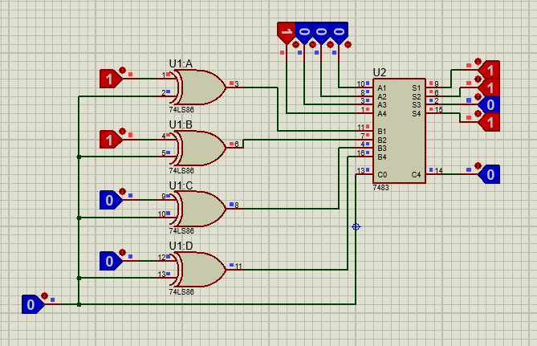

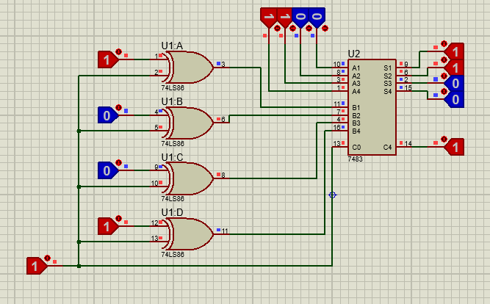

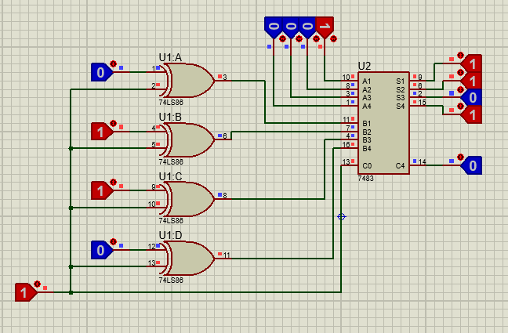
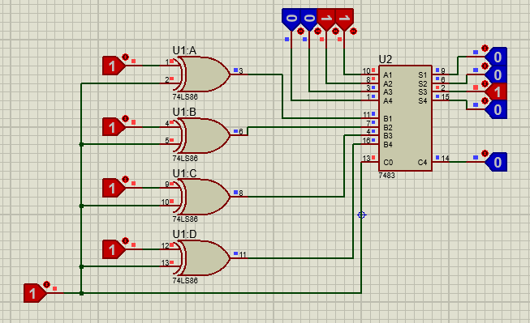
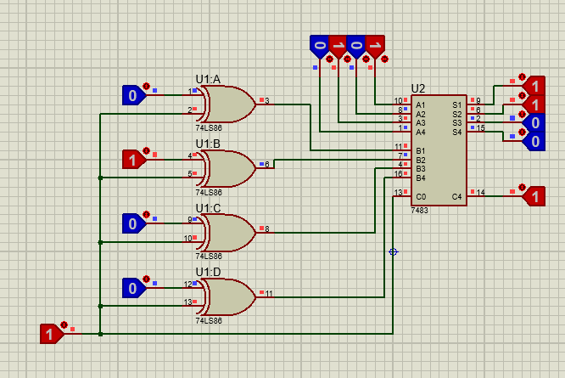
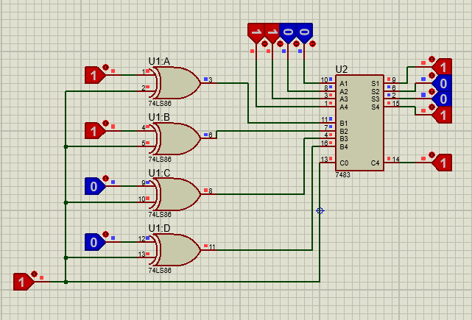

Decimal | Sum |  |  |  | Carry Out
A + B | S3 | S2 | S1 | S0 | C0
8 + 3 | 1 | 0 | 1 | 1 | 0
12 - 9 | 0 | 0 | 1 | 1 | 1
-2 + 5 | 0 | 0 | 1 | 1 | 1
3 - 15 | 1 | 1 | 0 | 0 | 0
(-6) - (-1) | 0 | 1 | 0 | 1 | 0
(-3) - (-12) | 1 | 0 | 0 | 1 | 1

Q6- Comment on “Select” (M) and “Carry Out” (C0) for each operation performed in Q5.

1st:Mod=0 carry out=0 2nd:Mod=1 carry out=1 3rd:Mod=1 carry out=1
4th:Mod=1 carry out=0 5th:Mod=1 carry out=0 6th:Mod=1 carry out=1

DISCUSSION AND CONCLUSIONS
Addition and subtraction processes were implemented for various values with adder and subtractor circuits. I could not get results because I could not fully integrate the cables into the circuit in the classroom. For this, I added the results of the circuit I made over proteus.

