
ESKISEHIR OSMANGAZI UNIVERSITY ELECTRICAL AND ELECTRONICS ENGINEERING 2021-2022 SPRING SEMESTER DIGITAL SYSTEMS LABORATORY
EXPERIMENT 4 SYNCHRONOUS SEQUENTIAL CIRCUITS

MUSTAFA YAĞCI
151220192027
GROUP II – D



ESKISEHIR OSMANGAZI UNIVERSITY
ELECTRICAL AND ELECTRONICS ENGINEERING

EXPERIMENT 4 REPORT

OBJECTIVES
- To be able to design sequential circuits and test them on simulators.

INTRODUCTION
For this experiment, the working principle of D type flip-flops and how to understand whether a designed circuit is Moore or Mealy is debated with the help of state diagrams,k-maps truth tables etc. In addition, circuits with led are built and examined on the proteus circuit simulator.

PROCEDURE
1. Design a 4-bit BCD counter by using D flip-flops.
- Draw the state diagram of the sequential circuit.
- Obtain the state table for the given circuit (take the unused states as don’t cares).
- Design this circuit by using D flip flops and external gates.

2. Design a synchronous sequential circuit with one input x, and one output z. When x=1, this circuit goes through the following repeated binary state sequence: … 00, 01, 11, 10, 00, 01... When x=0, this circuit goes through the following repeated binary state sequence: … 00, 10, 11, 01, 00, 10... The output z=1 if the present state is either 00 or 11.
- Draw the state diagram of the sequential circuit. Is it a Moore or Mealy machine? Explain your answer.
- Obtain the state table for the given circuit.
- Design this circuit by using D flip flops and external gates. Draw the logic circuit.

3. Set up the push button circuit given below and connect it to a led. Then check whether it is working or not.
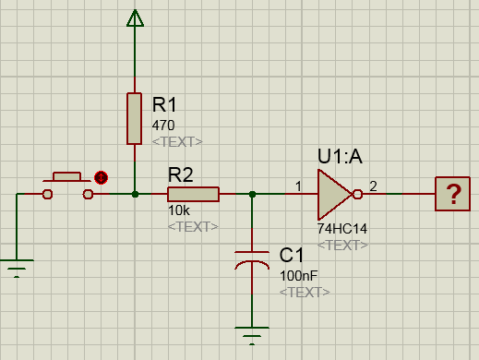
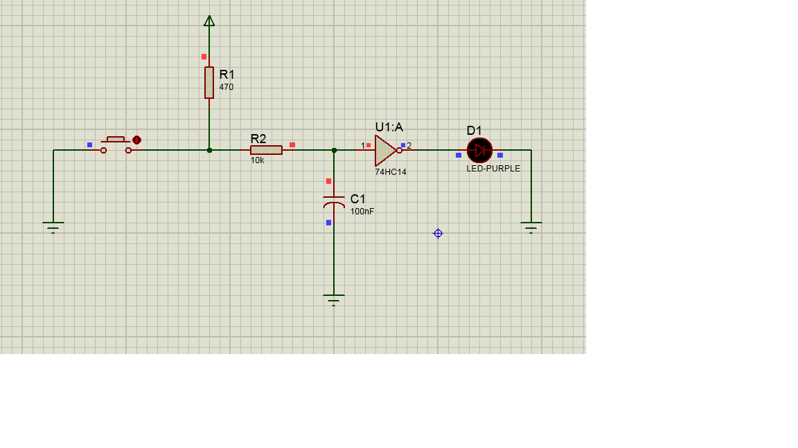
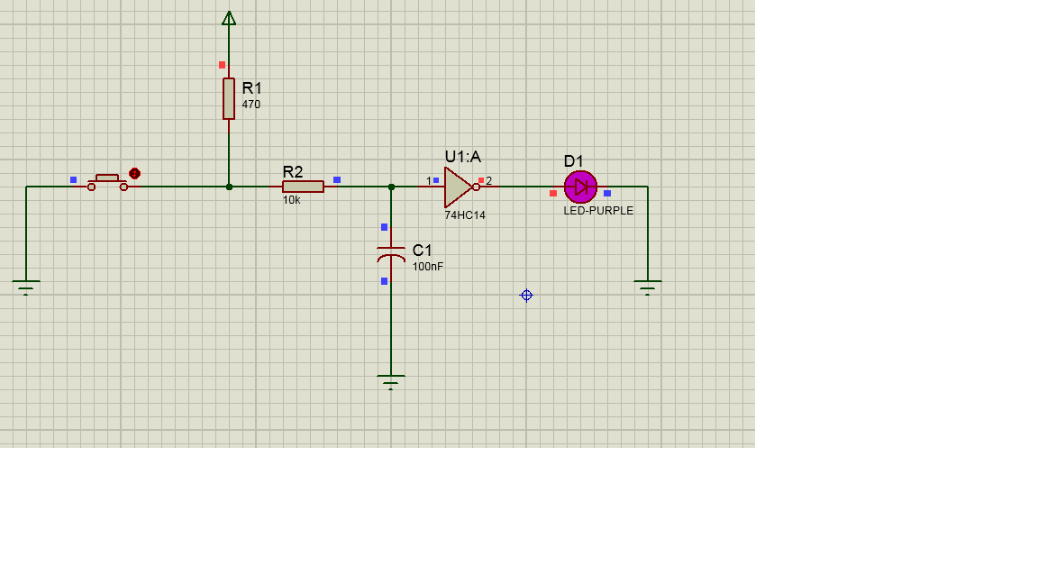

4. Build the sequential circuit you designed in Procedure 2 by using IC 7474 and external gates (if it is required). Use the push button you build in Procedure 3 as clock signal. Also connect the flip flop outputs to the leds to verify the counting sequences.
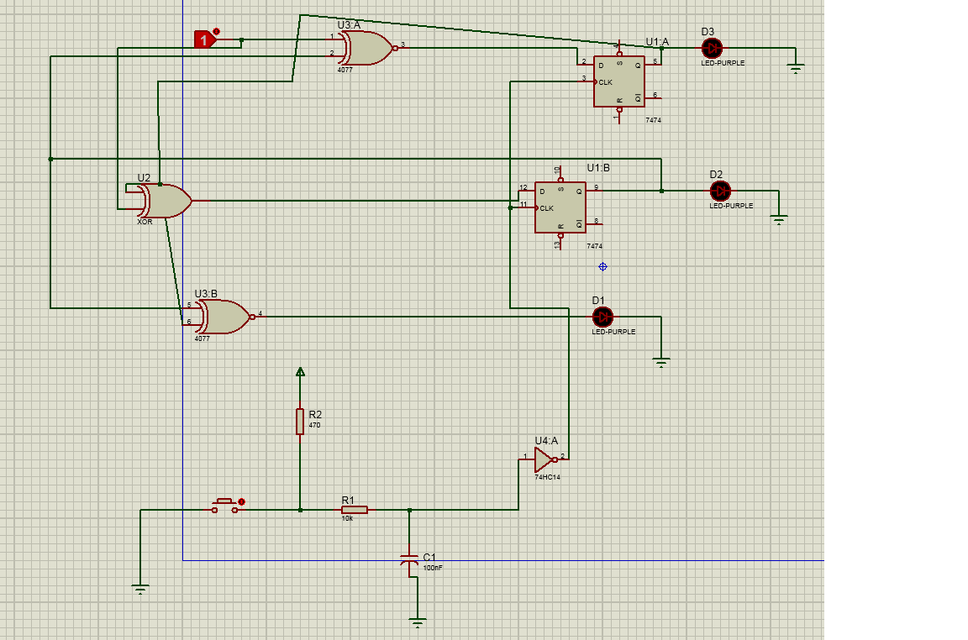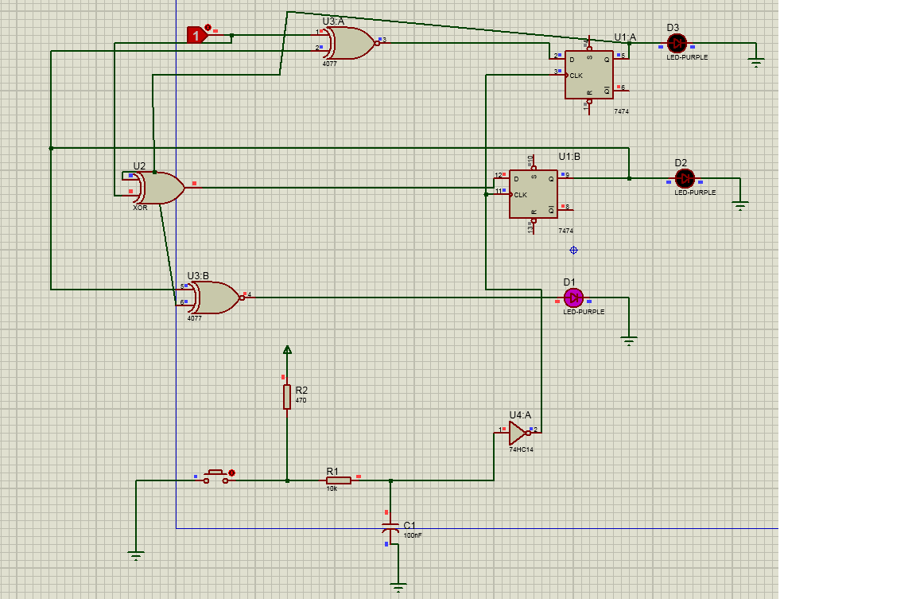

DISCUSSION AND CONCLUSIONS
Here are some of the outcomes are in synchronous sequential circuits.If the output state does not have a relation with the input it means that that circuit is a Moore machine. Another is that in D type-flip flops, whatever the input is, the output becomes the identical as the input with every trigger signal. Also, it has been seen that D type flip-flop is a type that can be used to record information. During the lesson, the experimental setup did not work due to the lack of contact between the cable and the integrated circuits. Therefore, the experimental setup is drawn on the simulator here.

