
ESKISEHIR OSMANGAZI UNIVERSITY ELECTRICAL AND ELECTRONICS ENGINEERING 2021-2022 SPRING SEMESTER DIGITAL SYSTEMS LABORATORY
EXPERIMENT 8 LOGIC DESIGN WITH GATE LEVEL AND DATA FLOW MODELING IN VERILOG-HDL

NAME SURNAME, STUDENT ıd
GROUP



ESKISEHIR OSMANGAZI UNIVERSITY
ELECTRICAL AND ELECTRONICS ENGINEERING

EXPERIMENT 8 REPORT

OBJECTIVES

INTRODUCTION

PROCEDURE
- Write gate-level Verilog HDL description of 2-to-4 line decoder with enable given in Figure 1 on paper with your handwriting. Specify the gates delays as 30, 20, and 10 ns for the gates AND, NOT and OR respectively. Add your answer to your report.

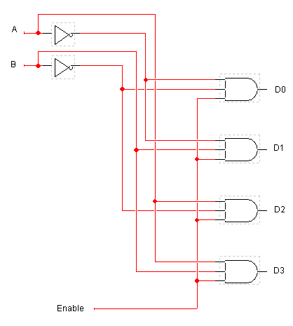
Figure 1: 2-to-4 line decoder with enable

- Enter gate-level Verilog HDL description of 2-to-4 line decoder that you write in Q1 in Xilinx ISE, and create a test bench file for it. All possible input combinations must be included in your test bench files. Inputs should be changed in every 10 ns. By using this test bench file, simulate your design and verify it. Add your codes and simulation outputs to your reports.

- Write Verilog HDL dataflow description of a 2-to-1 line multiplexer with enable given in Figure 2 on paper with your handwriting, and enter it in Xilinx ISE. Create a test bench file for it. All possible input combinations must be included in your test bench files. Inputs should be changed in every 10 ns. By using this test bench, simulate your design and verify it. Add your codes and simulation outputs to your reports.

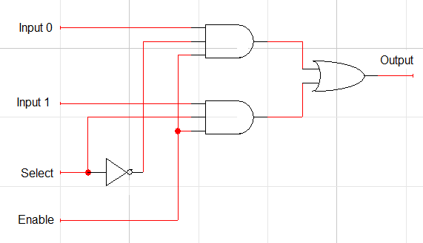
Figure 2: 2-to-1 line multiplexer with enable

Hint: You must add your name, surname and signature to the added papers including your handwritings. All projects will be named in format your NameSurname like AhmetDemir in your report.

DISCUSSION AND CONCLUSIONS

