CONTROL SYSTEMS LABORATORY

Experiment No: | 01
Experiment Name: | Exp_1_Report
Student No: | 151220192027
Student Name: | Mustafa YAĞCI
Date: | 19.04.2023

OBJECTIVES
In this experiment, we aimed to learn some fundamental functions of Octave program, including solving complex polynomials and finding inverse Laplace transforms.

EXPERIMENTAL RESULTS
Firstly, We obtain the data in partial-fraction expansion format using the 'residue' command and perform the reverse operation accordingly.
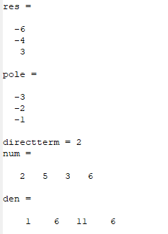
Figure 1. Residue command

Secondly, we observed the functionality of the 'roots' and 'poly' commands.
If you give the coefficients of a polynomial as input to the 'roots' command, it will find the zeros of the system. If you give the zeros of a polynomial as input to the 'roots' command, it will find the coefficients of the polynomial.
The 'poly' command finds the coefficients of a polynomial from its roots.
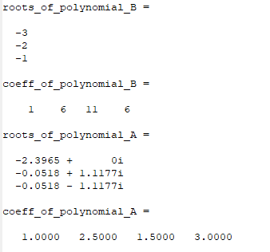
Figure 2. Roots and Poly command

Thirdly,we found the coefficients of the product of two polynomials using the 'conv' command.
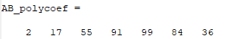
Figure 3. Conv command

Fourthly, we used the 'tf2zp' command to find the roots, gain, and zeros of a system in a single command.
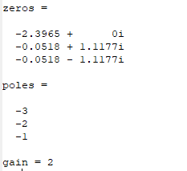
Figure 4. tf2zp command

Finally, we plotted the response of the transfer function that we provided using the 'step' command.
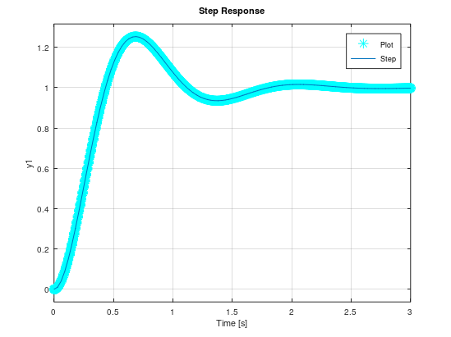
Figure 5. Step command

CONCLUSION & DISCUSSION

At the end of this experiment, we learned about these steps. The "residue" command is used to obtain the partial-fraction expansion of complex polynomials. The "roots" and "poly" commands are used to calculate the roots and coefficients of polynomials, respectively. The "conv" command gives the coefficients of the product of two systems. The "tf2zp" command is used to calculate the zeros, poles, and gain of a system in a single command. Finally, the "step" command is used to plot the time-domain response of a transfer function.

REFERENCES
Write your reference list in this section by using numbering with square brackets - []. You should follow IEEE Citation StyleGuide for referencing format.
- IEEE Citation Style Guide, Available: http://www.ijssst.info/info/IEEE-Citation-StyleGuide.pdf, Access Date: October 2021

