CONTROL SYSTEMS LABORATORY

Experiment No: | 2
Experiment Name: | EXPERIMENT 2
Student No: | 151220192027
Student Name: | Mustafa Yağcı
Date: | 07.05.2023

OBJECTIVES
1. Formulate the representation of a dynamical system by establishing a definition for a function that algebraically relates the output of systems respect to its input.
2. Obtain a Simulink model for a given dynamical system by using the Xcos blocks.

EXPERIMENTAL RESULTS
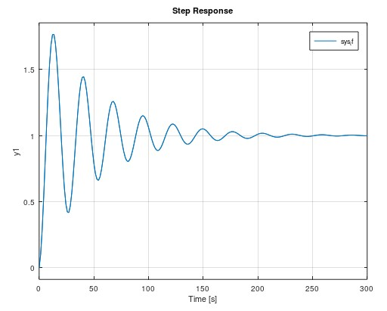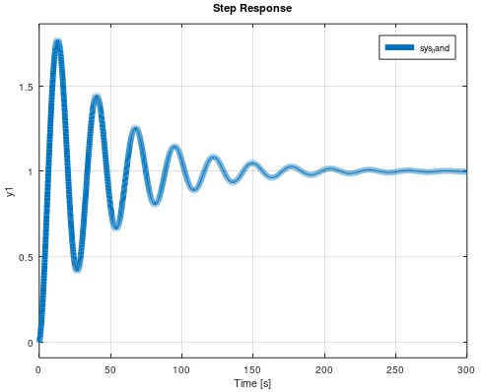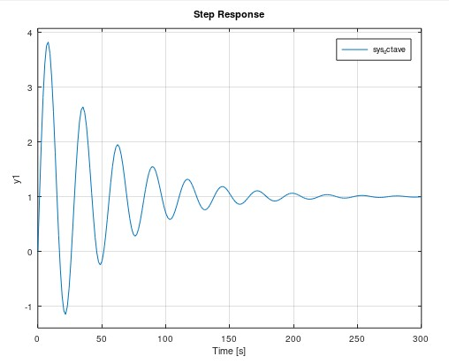

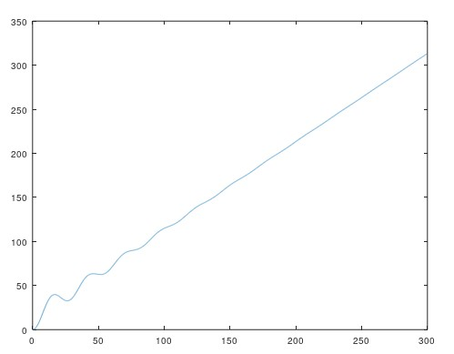
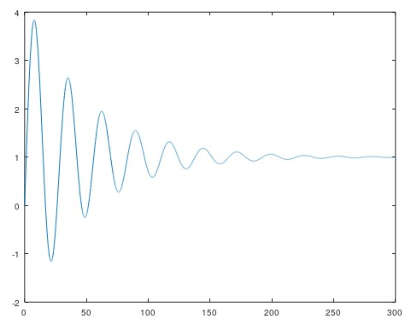
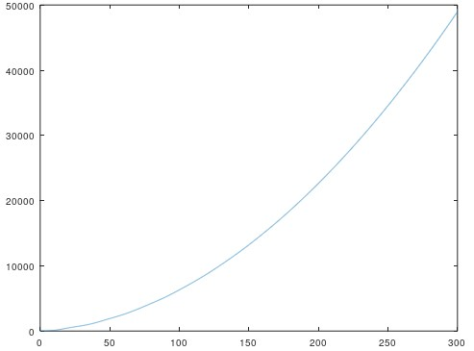

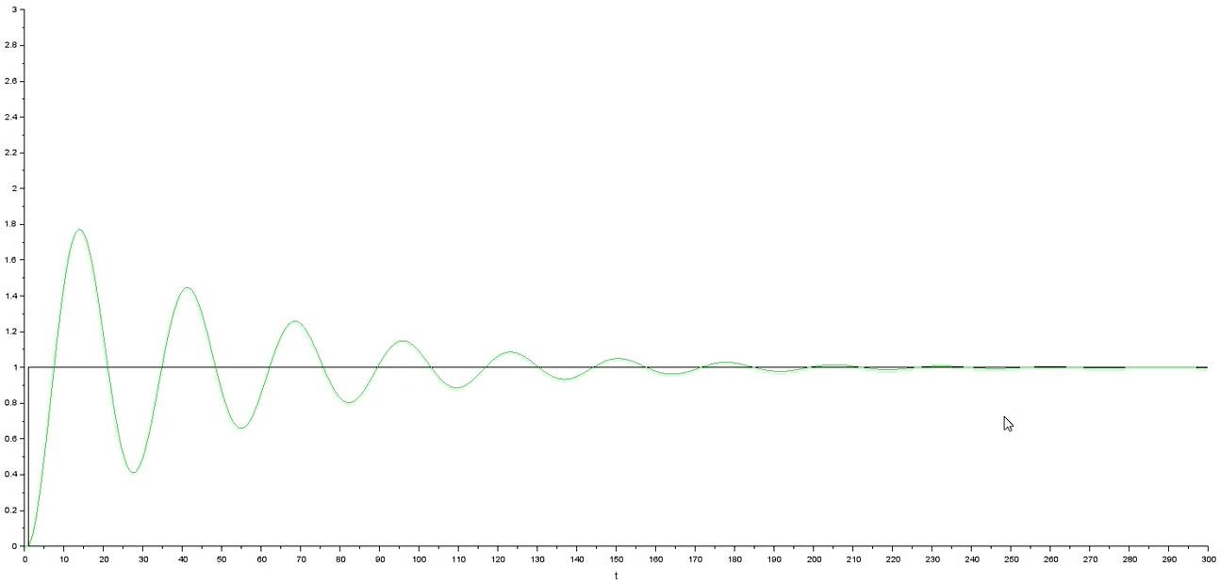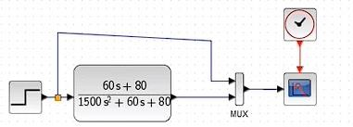

CONCLUSION & DISCUSSION
We tried to formulate a dynamic system, using a transfer function. We learned the lsim command and the step function. We created a function in the Sci-Lab application.

REFERENCES
Write your reference list in this section by using numbering with square brackets - []. You should follow IEEE Citation StyleGuide for referencing format.
- IEEE Citation Style Guide, Available: http://www.ijssst.info/info/IEEE-Citation-StyleGuide.pdf, Access Date: October 2021

