CONTROL SYSTEMS LABORATORY

Experiment No: | 3
Experiment Name: | Experiment 3
Student No: | 151220192027
Student Name: | Mustafa Yağcı
Date: | 10.05.2023

OBJECTIVES
1-Simply the Block Diagrams to obtain a closed-loop transfer function of the dynamics.
2-Obtain a Xcos model for a given dynamical system.
3-Solve a given differential equation by using Octave.

EXPERIMENTAL RESULTS
1-We have found the transfer function from the block diagram.
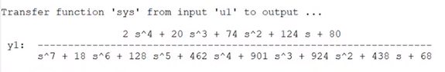

2-We have found the pole-zero map of the transfer function.
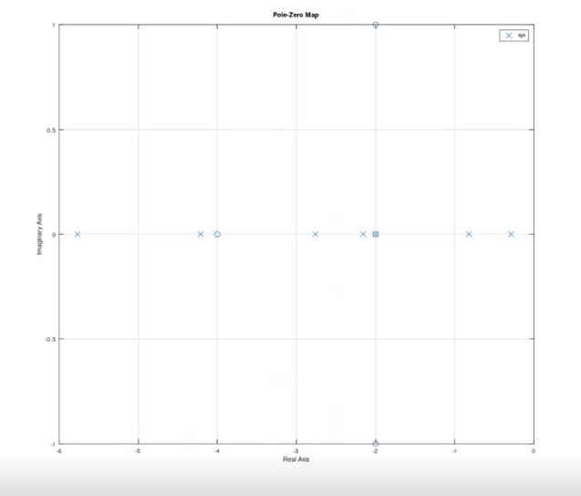

3- Values of k.
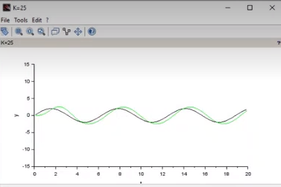
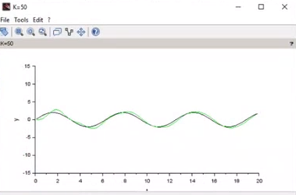
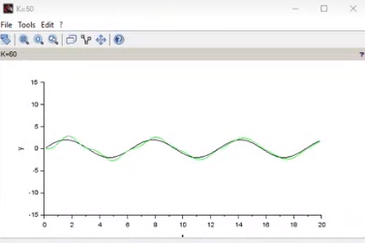
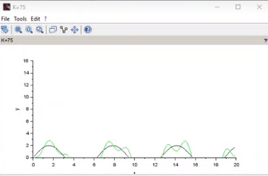
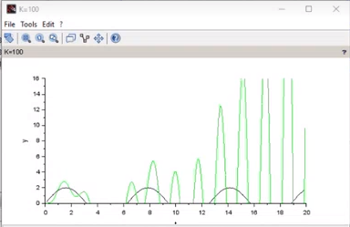
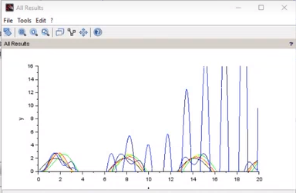

4-Stability analysis.
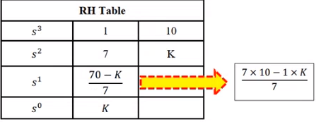
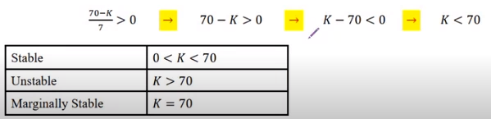
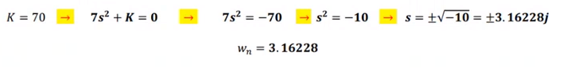

5-
k=25
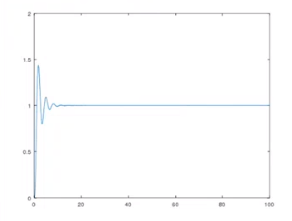

K=70
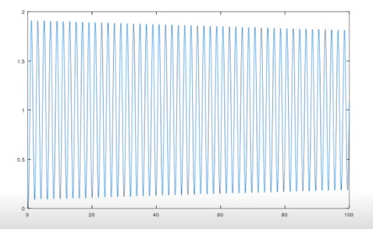
K=170
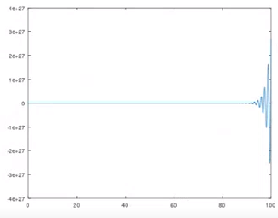

CONCLUSION & DISCUSSION
As a result, If the value of k is in the range up to 70, the system is stable, but beyond that point, the system becomes unstable.

REFERENCES
Write your reference list in this section by using numbering with square brackets - []. You should follow IEEE Citation StyleGuide for referencing format.
- IEEE Citation Style Guide, Available: http://www.ijssst.info/info/IEEE-Citation-StyleGuide.pdf, Access Date: October 2021

