CONTROL SYSTEMS LABORATORY

Experiment No: | 4
Experiment Name: | OPEN-LOOP vs. CLOSED-LOOP CONTROL SYSTEMS
Student No: | 151220192027
Student Name: | Mustafa Yağcı
Date: | 17.05.2023

OBJECTIVES
The main purpose of software experiments is to introduce the computer-aided control system analysis and design. In this experiment, how to use Octave script files and simulink to analyze the systems.

EXPERIMENTAL RESULTS
1.1.A- 𝐺𝑤(𝑠) =
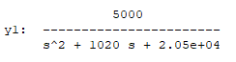
1.1.B- 𝐺𝑝 (𝑠) =
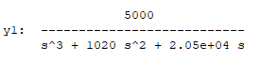
1.2.A-

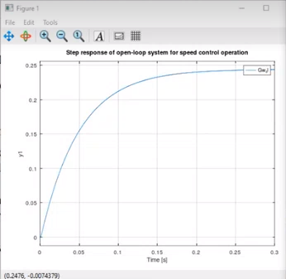

1.2.B-
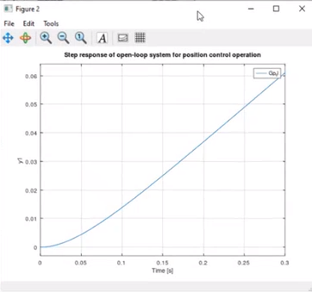

1.3.A-
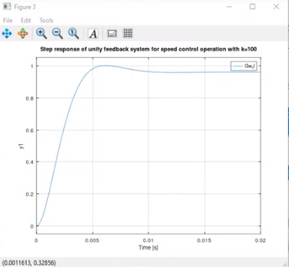

1.3.B-
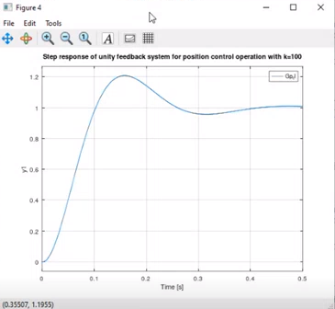
1.4-
Open Loop:
-There is no feedback mechanism
-The output is directly related to the input
-The design is simpler and more cost-effective
-It is less resistant to environmental variables
-Debugging can be difficult
-It usually operates with low precision
-The stability of the system is low and unwanted results may occur
Closed Loop:
-A feedback mechanism is used
-The output is measured by a sensor and the feedback control is used to correct the error signal
-The design is more complex and expensive
-It is more resistant to environmental variables
-Debugging is easier
-It operates with high precision
-The stability of the system is high and unwanted results rarely occur
2.1-
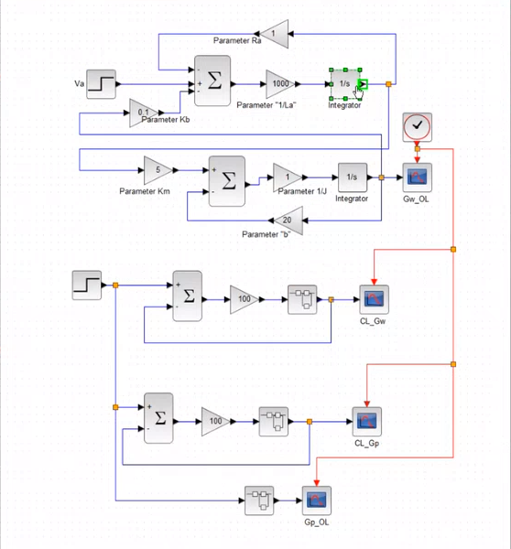

2.2-
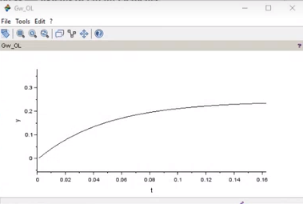

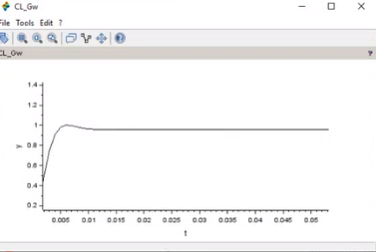
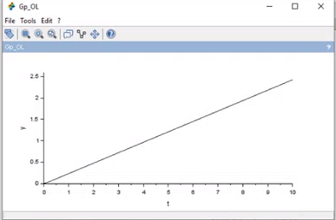
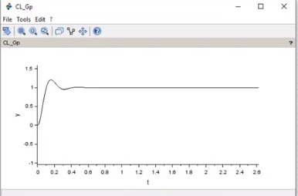

CONCLUSION & DISCUSSION
In conclusion, closed-loop control systems provide better accuracy, stability, and response time compared to open-loop control systems. Feedback from the output allows closed-loop systems to correct errors and adjust the input to achieve the desired response, making them more suitable for precise control applications.

REFERENCES
Write your reference list in this section by using numbering with square brackets - []. You should follow IEEE Citation StyleGuide for referencing format.
- IEEE Citation Style Guide, Available: http://www.ijssst.info/info/IEEE-Citation-StyleGuide.pdf, Access Date: October 2021

