CONTROL SYSTEMS LABORATORY

Experiment No: | 5
Experiment Name: | EXPERIMENT 5
Student No: | 151220192027
Student Name: | Mustafa Yağcı
Date: | 25.05.2023

OBJECTIVES
1. Obtain transient response analysis by using Octave.
2. Obtain steady-state response analysis by using Octave.
3. Explain the controller design strategies for a given dynamics.

EXPERIMENTAL RESULTS
- Rlocus =
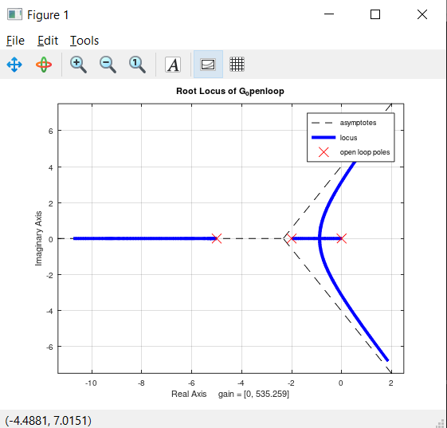

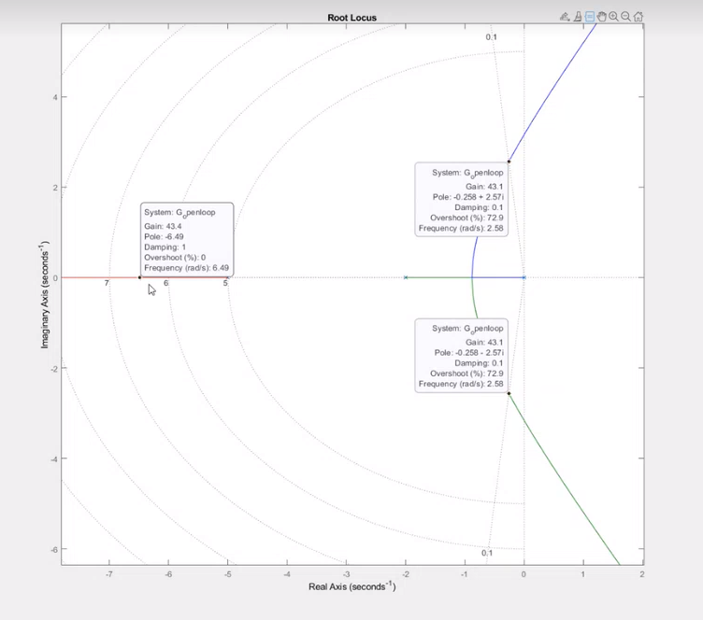

- K=-100
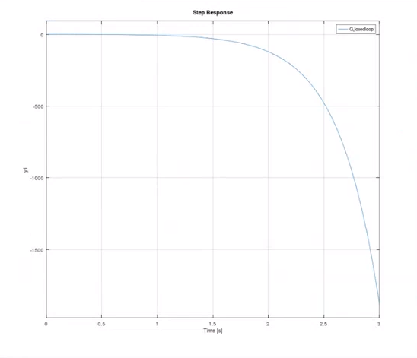
K= - 90
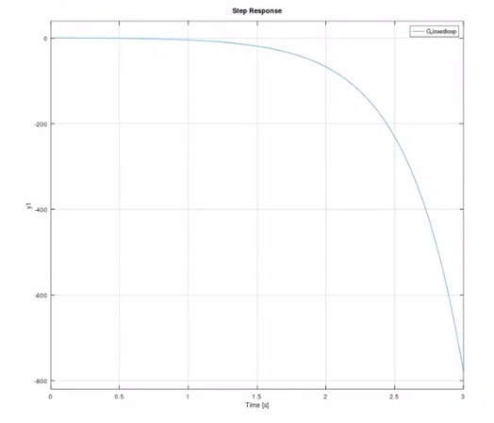
K= - 80
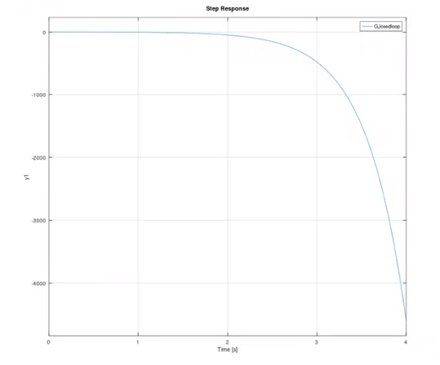
K=-70
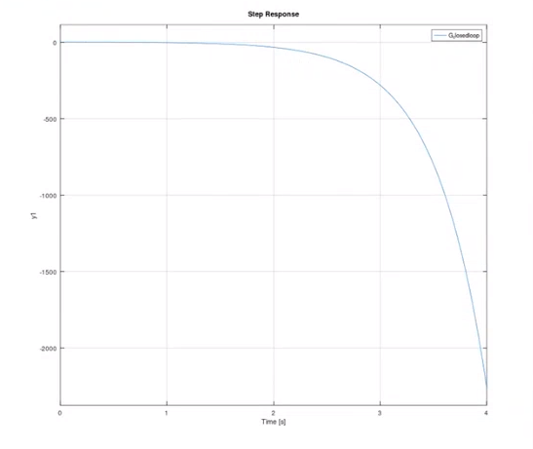
K=-60
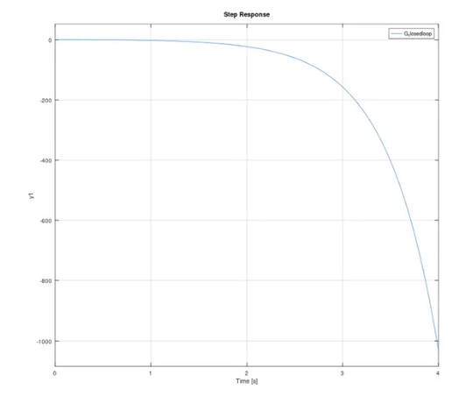
K=-50
K=-40
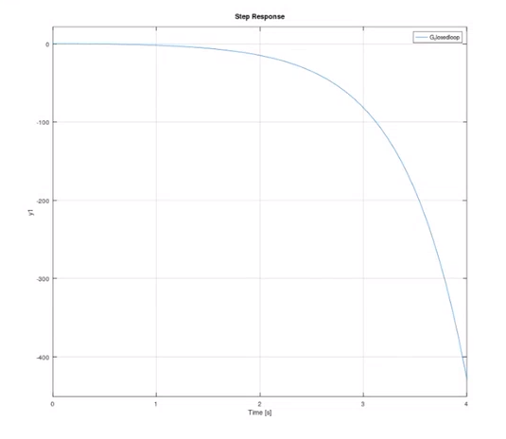
K=-30
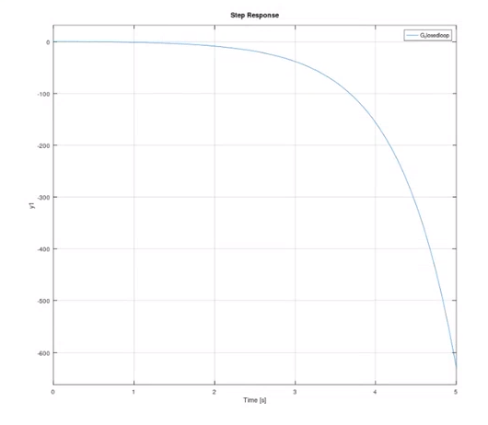
K=-20
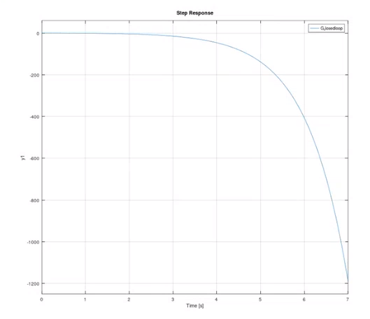
K=-10
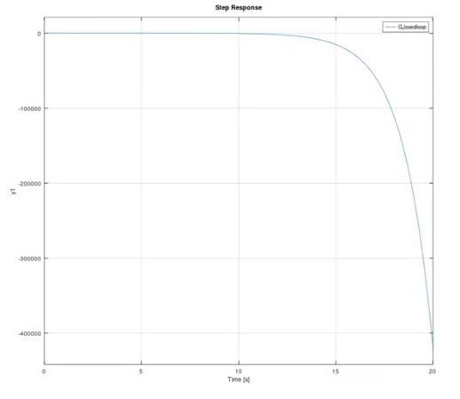
K=0
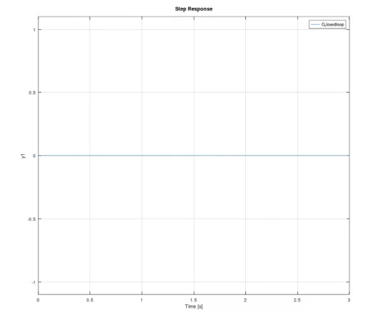
K=10
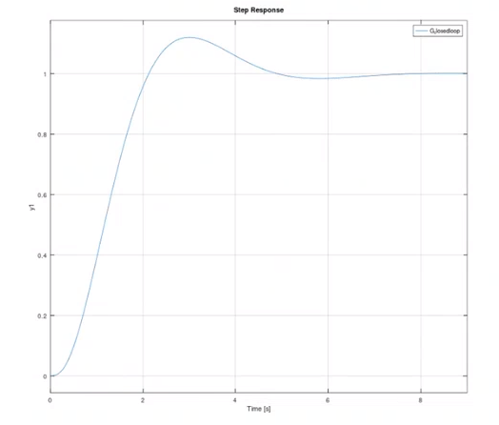
K=20
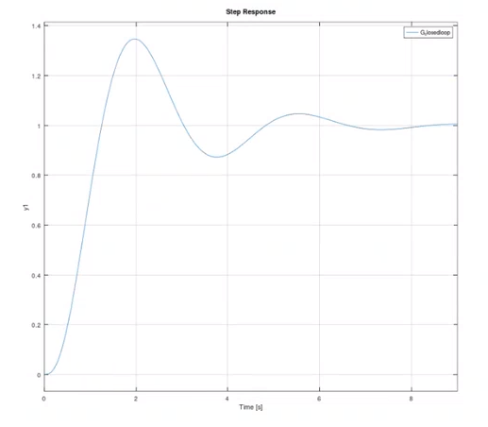
K=30
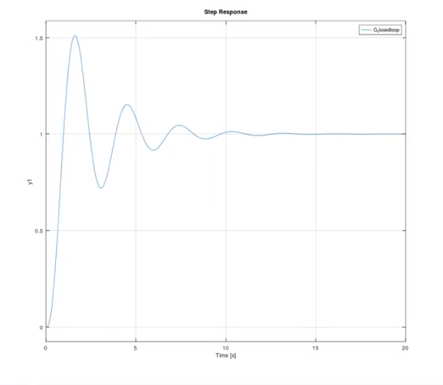
K=40
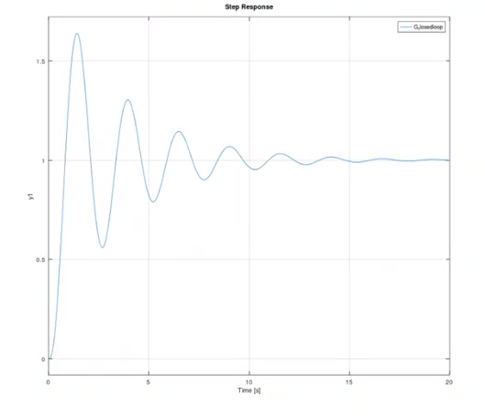
K=50
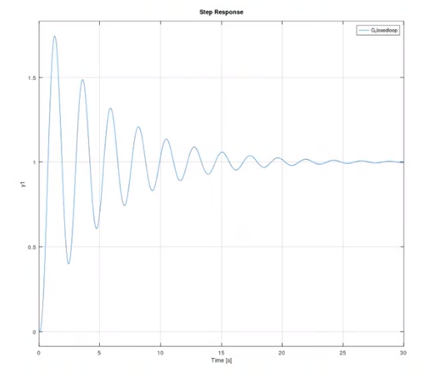
K=60
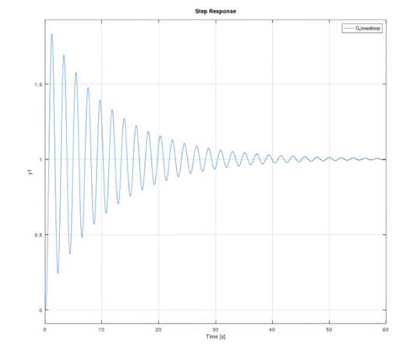
K=70
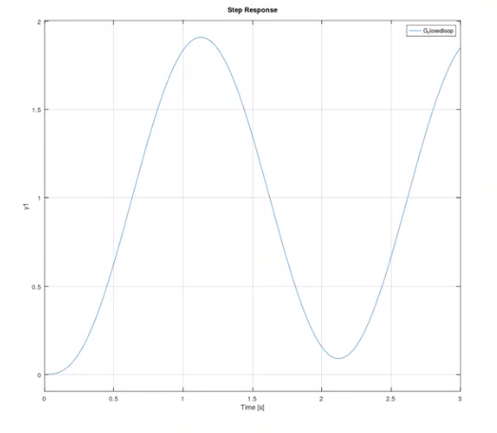
K=80
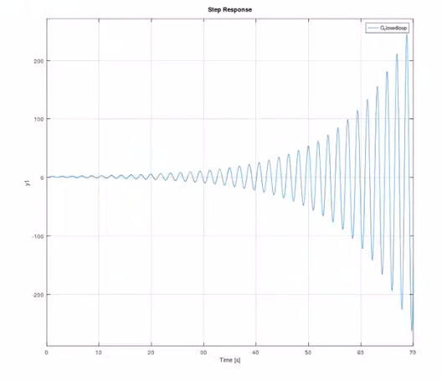
K=90
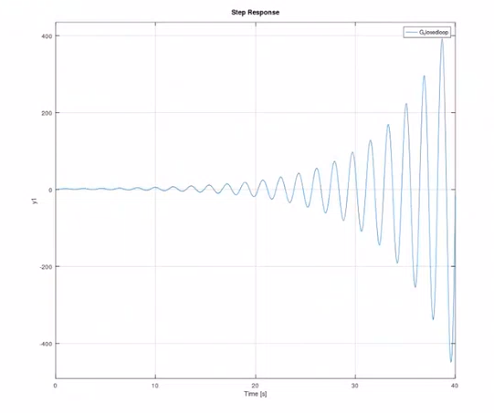
K=100
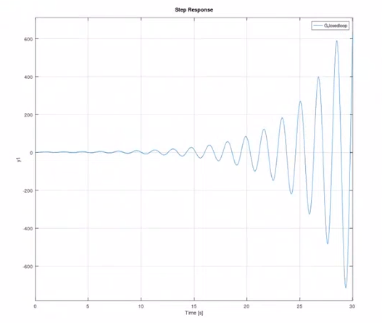

4-
If the desired system is on the root locus, we can find the corresponding value of k that achieves this and use a P-type controller.

CONCLUSION & DISCUSSION

In conclusion, the system is unstable for k values ranging from -100 to 0.
After -50, the root continues to decrease, and the system remains unstable. In the range of k values from 10 to 60, the oscillation increases, but the system reaches a steady state without becoming unstable. When the k value is 70, the system has a stable margin. For k values above 70, the system becomes unstable.

REFERENCES
Write your reference list in this section by using numbering with square brackets - []. You should follow IEEE Citation StyleGuide for referencing format.
- IEEE Citation Style Guide, Available: http://www.ijssst.info/info/IEEE-Citation-StyleGuide.pdf, Access Date: October 2021

