CONTROL SYSTEMS LABORATORY

Experiment No: | 6
Experiment Name: | STABILITY ANALYSIS
Student No: | 151220192027
Student Name: | Mustafa Yağcı
Date: | 31.05.2023

OBJECTIVES
The main purpose of software experiments is to introduce the computer-aided control system analysis and design. In this experiment, you will practice about stability analysis by using MATLAB.

EXPERIMENTAL RESULTS
A-
1,2-
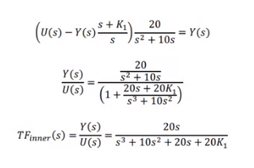
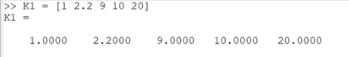
K1= 1
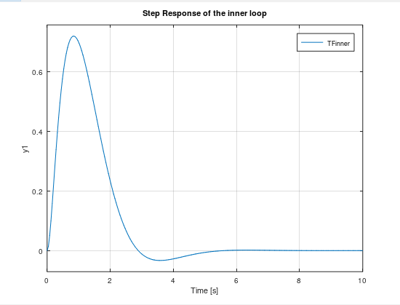
K1=2.2
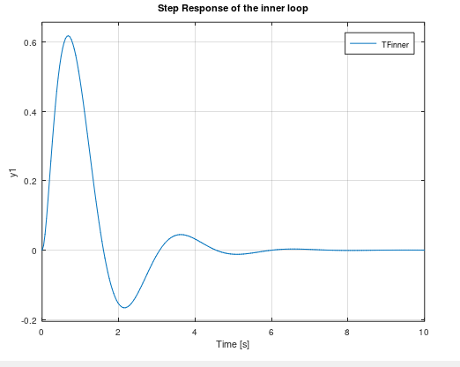
K1=9
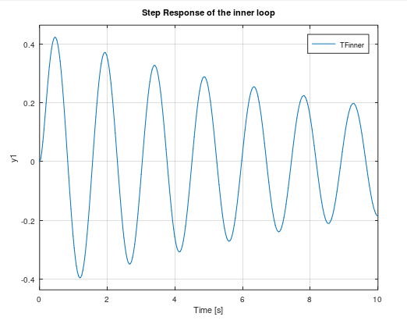

K1=10
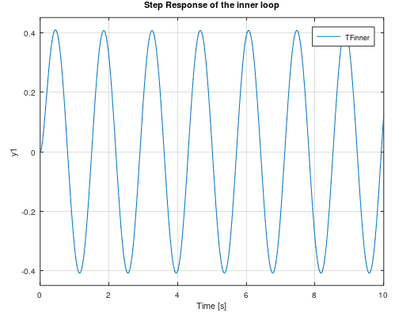
K1=20

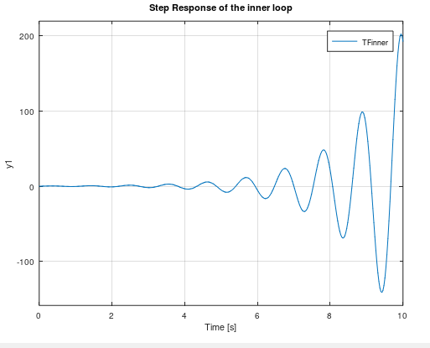

3-
K2=-5
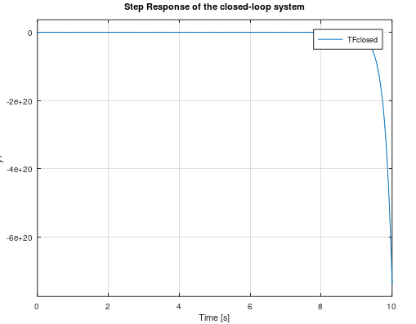
K2=-0.78
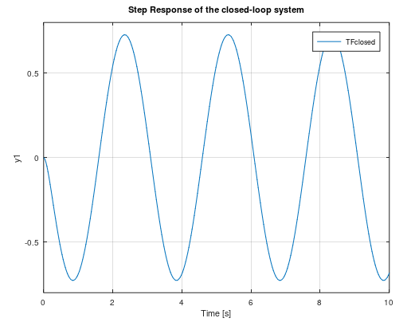

K2=0.1
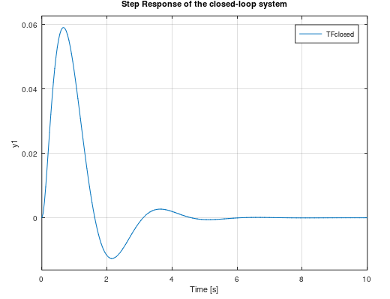
K2=5
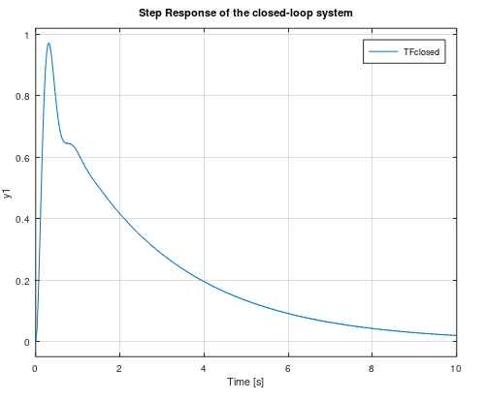

K2=100
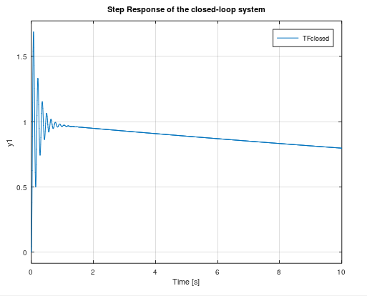
B-
1-
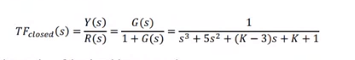
2-
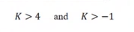

3- K=4

4-
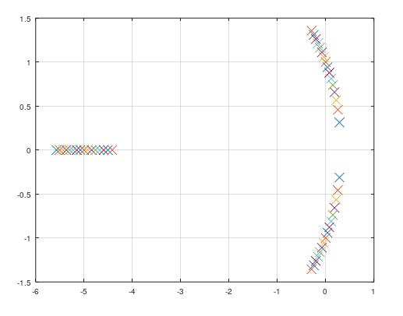

CONCLUSION & DISCUSSION
Discuss your results here. Write down what you learned during the experiment.
For experiment A,
Stable between 0 and 10 values ​​of k1.
While the value of k1 is 2.2, the system is stable when k2 is above 0.1 value.
For experiment B,
System unstable until k value is 4.
Margin stable at 4.
The system is stable within values ​​of k above 4.

REFERENCES
Write your reference list in this section by using numbering with square brackets - []. You should follow IEEE Citation StyleGuide for referencing format.
- IEEE Citation Style Guide, Available: http://www.ijssst.info/info/IEEE-Citation-StyleGuide.pdf, Access Date: October 2021

