Experimental Tutorial #3

Safety notes
  - No eating or drinking inside the laboratory.
  - Avoid touching heated or electrically active components.
  - Ensure hands are dry and avoid placing metal objects near powered circuits.
  - Do not modify wiring while the supply is ON.
  - Report damaged cables or unusual odors immediately.
  - Maintain a clean, organized workspace.

Introduction
This laboratory session focuses on the behavior of a narrow-band selective amplifier used as a mixer. The circuit employs an NPN BF200 transistor and an adjustable transformer to tune the resonance frequency. Students will tune the resonant frequency, determine the bandwidth and quality factor (Q), observe nonlinear behavior, and then apply two input signals to generate an intermediate frequency (IF).

Learning objective
By the end of this tutorial, you will be able to:

Filter behavior
- Tune the selective amplifier to a resonance frequency of 500 kHz.
- Measure the 3 dB bandwidth.
- Compute the quality factor Q of the resonant circuit.
- Observe non-linear distortion at the amplifier output.

Mixer behavior
- Apply two input signals (LO and RF) to the amplifier.
- Observe mixing phenomena and identify the IF frequency.
- Analyze the spectrum and observe sum and difference frequencies.

Required equipment
- Circuit board with BF200 transistor and adjustable transformer.
- Two waveform generators.
- Oscilloscope.
- Flat-head screwdriver.
- Digital multimeter.
- Connection wires.

Narrow-band amplifier as a Mixer

Circuit overview
The board (see Fig.1 for the schematic) includes an NPN BF200 transistor amplifier (see Fig. 2 for the datasheet) and an adjustable transformer with ferrite screw. By adjusting the screw, the inductance changes, allowing fine tuning of the resonance frequency. The amplifier behaves as a narrow-band selective circuit, providing maximum gain near its resonance frequency while attenuating other frequencies.
Two signal generators provide the input signals: the local oscillator (LO) and the radio-frequency (RF) input.

Background
A narrow-band selective amplifier amplifies signals only within a specific narrow frequency range. This makes it useful in communication systems such as radio receivers. In this experiment, the amplifier is used as a mixer.
A mixer is a nonlinear circuit that combines two input signals to produce new frequencies equal to the sum and the difference of the original frequencies.
Here, a 2 MHz square wave serves as the LO signal and a 1.5 MHz sine wave serves as the RF signal. The resulting IF signal is 500 kHz, which is the difference between the two input frequencies.
You will also analyze the output signal and observe nonlinearities and harmonic components.

Signal generator

VCC
50 Ω
Csig
vsig2

Signal generator
50 Ω
Cs ig
vsig1

Inside the osciloscope 10 pF
o
V

15kΩ
Inside the
transformer
1 MΩ

0.1µF

5.6kΩ 1kΩ 0.1µF

Fig. 1 – Circuit schematic.

Experimental Instructions

Filter tuning:
- Set the waveform generator to 500 kHz sine wave, amplitude 10 mVpp.
- Adjust the ferrite screw until the output amplitude reaches its maximum value.
- Record the output amplitude and the corresponding gain.

3 dB bandwidth measurement:
- Vary the input frequency around the resonance value.
- Identify the upper and lower frequencies where the output amplitude drops to 70% of its maximum value (1/√2).
- Calculate the bandwidth as the difference between upper and lower frequencies.

Quality factor Q:
- Compute Q as the ratio between resonance frequency and the 3 dB bandwidth.
- Record the obtained value.

Observation of non-linearity:
- Set the oscilloscope in XY mode.
- Increase the input amplitude gradually.
- Observe non-linear distortion on the displayed curve.

Mixing of two input signals:
- Apply a 2 MHz square wave as LO input.
- Apply a 1.5 MHz sine wave as RF input.
- Observe the IF signal at 500 kHz at the amplifier output.
- Observe the sum frequency component.
- Analyze the output spectrum.

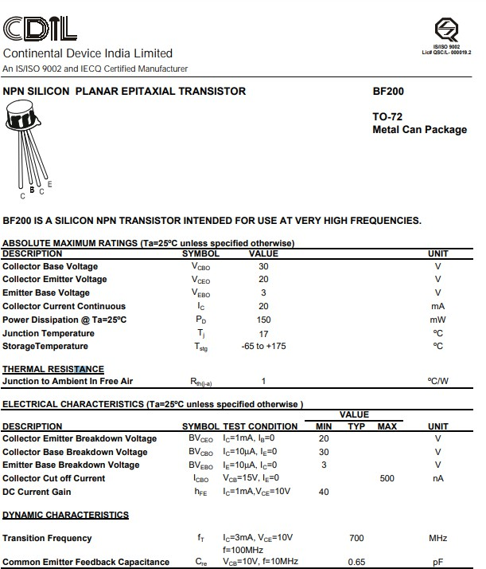

Fig. 2 – BF200 datasheet.

