Experimental Tutorial #4

Safety notes
  - No eating or drinking inside the laboratory.
  - Avoid touching heated or electrically active components.
  - Ensure hands are dry and avoid placing metal objects near powered circuits.
  - Do not modify wiring while the supply is ON.
  - Report damaged cables or unusual odors immediately.
  - Maintain a clean, organized workspace.

Introduction
This laboratory session focuses on the experimental analysis of a Phase-Locked Loop (PLL) implemented on the ASLK PRO board. The experiment aims to familiarize students with the operating principles of PLLs, widely used in frequency synthesis and clock generation. Students will adjust the DC bias, observe the locking behavior, measure the lock range, analyze the VCO control voltage and phase behavior, and investigate harmonic locking phenomena.

Learning objective
By the end of this tutorial, you will be able to:

PLL operation
- Understand the functional blocks of a PLL and their interaction.
- Adjust the DC offset required for correct PLL operation.
- Observe and verify phase and frequency lock with an input signal.

Dynamic behavior
- Measure the PLL lock range.
- Analyze the relationship between input frequency, VCO control voltage, and phase difference.
- Observe the phase behavior of the output signal within the lock range.

Advanced behavior
- Investigate harmonic locking.
- Understand why harmonic locking occurs with non-sinusoidal inputs.

Required equipment
- ASLK PRO board implementing a complete PLL.
- Digital multimeter (DC voltage measurements).
- Oscilloscope (time-domain and phase measurements).
- Signal generator.
- USB pen drive for waveform acquisition.
- Connection wires.

Phase-Locked Loop

Circuit overview
The ASLK PRO board integrates all the blocks required to implement a Phase-Locked Loop, including a phase detector, a low-pass filter, a voltage-controlled oscillator, and output buffers. An implementation is depicted in Fig. 1. The PLL structure, as summarized by Fig. 2, allows the output frequency to synchronize with an external input signal.
When no input signal is applied, the VCO oscillates at its free-running frequency with a corresponding control voltage. When an input signal is applied near this frequency, the PLL adjusts the control voltage to lock the output frequency to the input frequency, producing a fixed phase difference between the two signals.

Background
A Phase-Locked Loop is a feedback system commonly used for frequency synthesis and clock generation. Starting from a low-frequency reference, a PLL can generate stable signals at much higher frequencies.
When the input frequency equals the free-running frequency of the VCO, the PLL operates without adjusting the control voltage, and the phase difference between input and output is approximately 90 degrees.
As the input frequency changes, the PLL modifies the VCO control voltage to maintain frequency lock, causing the phase difference to deviate from 90 degrees.
The range of input frequencies for which the PLL remains locked is defined as the lock range, centered around the free-running frequency.

Key concepts
- Phase Detector: Compares the phase of the input signal with the VCO output and produces an error signal.
- Low Pass Filter: Removes high-frequency components from the phase detector output.
- Voltage-Controlled Oscillator: Generates an output frequency controlled by the filtered error voltage.
- Free-running frequency: Natural oscillation frequency of the VCO without input signal.
- Lock range: Frequency range over which the PLL remains locked after lock is achieved.
- Capture range: Frequency range over which the PLL can initially achieve lock.
- Harmonic locking: Condition in which the PLL locks to an integer multiple of the input frequency, typically caused by strong harmonic content in the input signal.

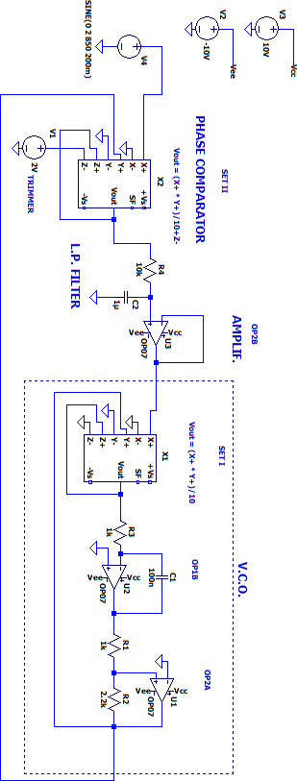

Fig. 1 – PLL implementation in the ASLK PRO board.

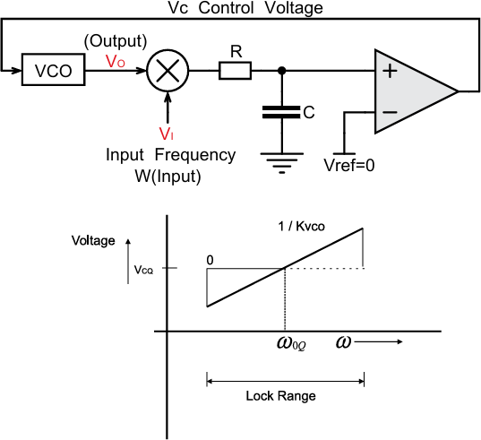

Fig. 1 – PLL and its characteristics.

Experimental Instructions

Offset tuning:
- Verify if the trimmer S1 is generating 2V.
- If needed, adjust the trimmer screw until the measured DC voltage equals 2 V.

Verification of lock:
- Set the signal generator to produce a sine wave with amplitude 4 Volts peak-to-peak and frequency 1.1 kHz.
- Observe the PLL output signal and verify that the system is locked to the input frequency.

Lock range measurement
- Increase the input frequency incrementally and record the frequency at which the PLL loses lock.
- Decrease the input frequency incrementally and record the frequency at which lock is lost again.
- Determine the upper and lower limits of the lock range.

VCO control voltage and phase measurement:
- Within the lock range, vary the input frequency.
- Measure the VCO control voltage at the output of operational amplifier OP2B.

- Measure the phase difference between input and output signals.
- Plot the VCO control voltage as a function of input frequency.
- Analyze the relationship between control voltage variation and phase shift.

Harmonic locking:
- Set the signal generator to output a square wave with frequency 300 Hz and amplitude 6 Volts peak-to-peak.
- Observe whether the PLL locks and determine the output frequency.
- Identify the harmonic responsible for locking.

Follow-up question:
- Explain why harmonic locking occurs when using a square wave input and not when using a sinusoidal input.

Input Frequency (Hz) | VCO control voltage (V) | Phase difference (°)

