December 3rd, 2017

Professor Areej Salaymeh

CSC 2110

**Mustafa Chowdhury**

**Ge3306**

**Test Plan for The Final Project**

***Introduction***

Planning is very important while making a project. Determine what is the project outcome is key to deliver the right code. Proceeding based on the plan is very important while working on a big project. If plan don’t work in a certain point, therefore changing the plan according to the certain point is important but the overall goal of the project should need to remain same.

***Test Strategy***

* Objectives: Make sure the program is being produce based of the project requirements. Create function that will fulfill the project requirements and goal.
* Strategy: First, read the project description carefully and need to determine how many classes that this program should need, including base and derived classes. How many public and private variables need to create in each class. After creating classes, then need to work on how many items you should need to put in your menu system. Based on that create function to do the specific task. After making each function run that function and test is it working properly or not. If not find the mistake and fixed it. Also, if you thought plan need to change slightly then do it and test the function again. Testing function one by one will help to fix errors and bugs easily, rather than testing whole program together.

***Usability Test***

**Function 1 (Show Inventory):**

First, I planned to use vector cartype to creates a catalog and user can add or delete item from that catalog. But I found that for the old and new car the mileage and warranty provider is not showing when I am printing the catalogs. So, I make used vector type as pointer than it shows everything as my desire.

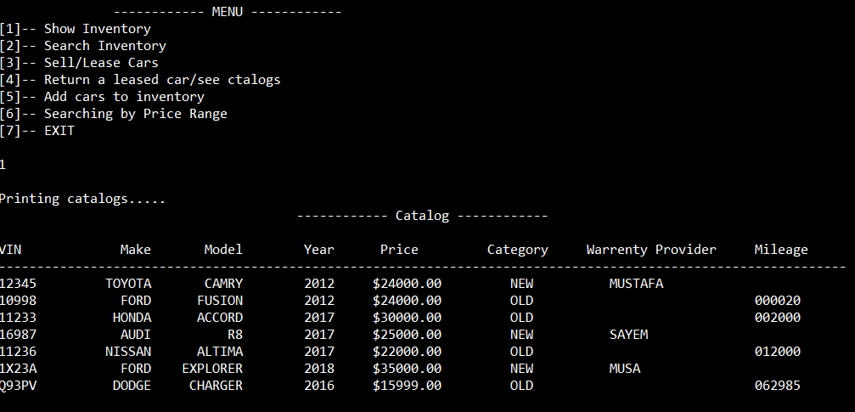

**Function 2 (Search Inventory):**

As program requirement said that the search Inventory should have three options to execute the search cars by make, model and category. So, I make three options for this function and use try and catch block to throw exception if user input any thing else. During working on this function, I found that if users input using lower case keyword, the function fails to identify even if the cars exist in the inventory. So, I made a function to implement all of user input into upper case. Also, I used to try and catch block, if user enter anything that is not appropriate with the search function it will show a message.

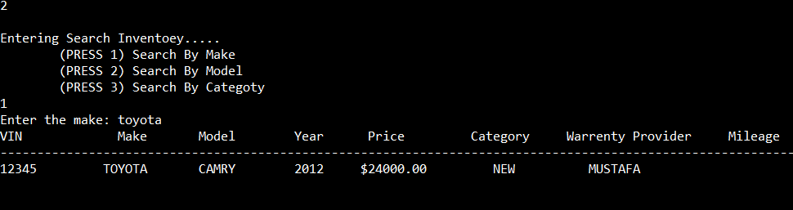

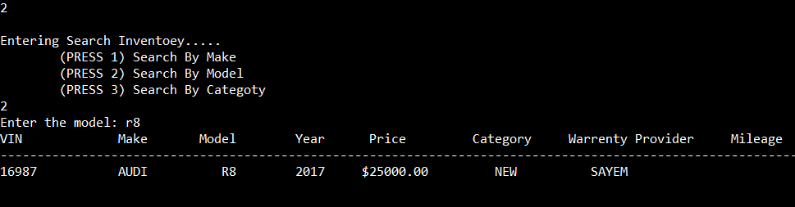

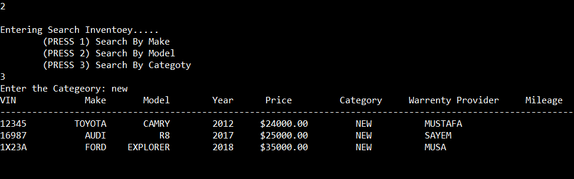

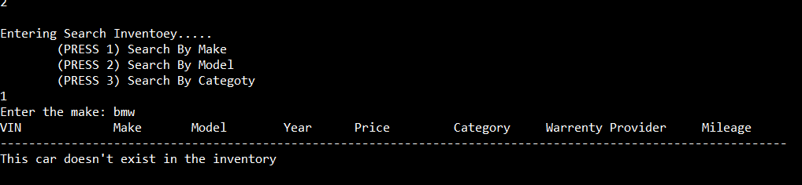

**Function 3 (Sell/Lease Car):**

In this function when user choose to sell or lease car the car is removed from the inventory, for the lease car I made another list that will store the information of the lease car. So, it will keep track lease car information. For the sell/lease car program will ask user to enter the vin number if vin number doesn’t match it will throw an exception.

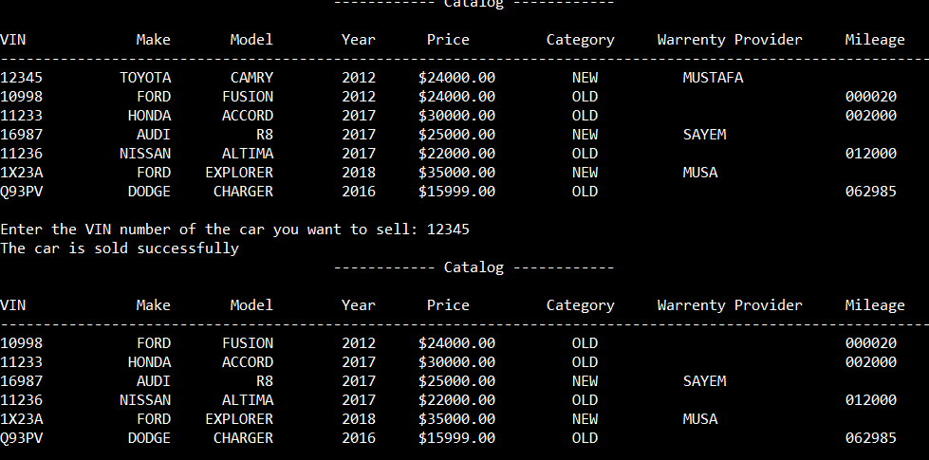

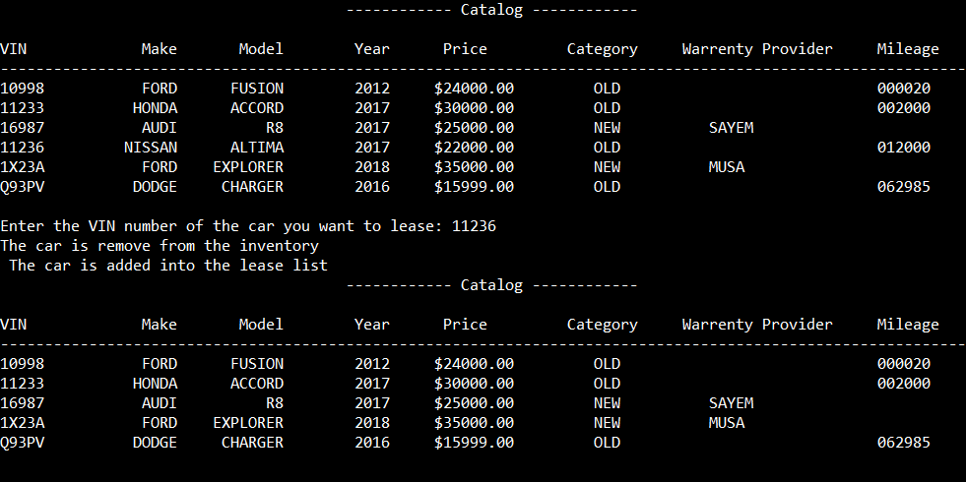

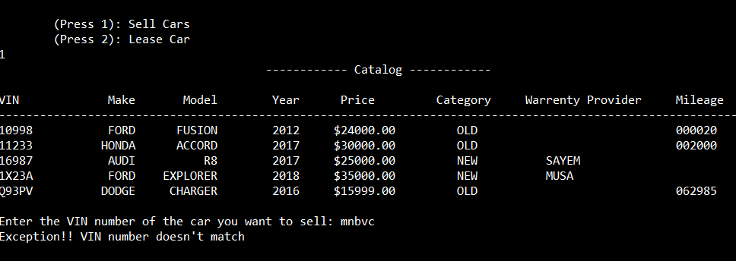

**Function 4(Return a Lease Car/See Catalogs):**

For this function it will print the lease car list, if the list is empty it shows a message, It also convert the new car into the old car and asked for the final odometer to input. For the old car user only need to enter the final odometer mileage and put back the car into the main inventory.

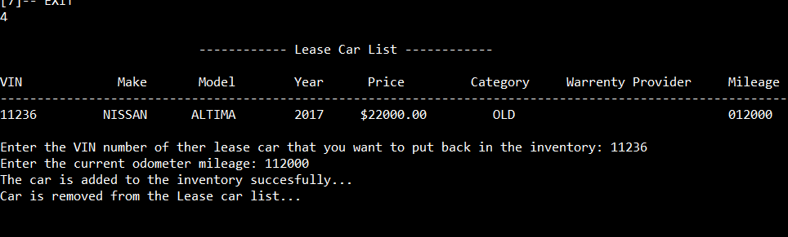

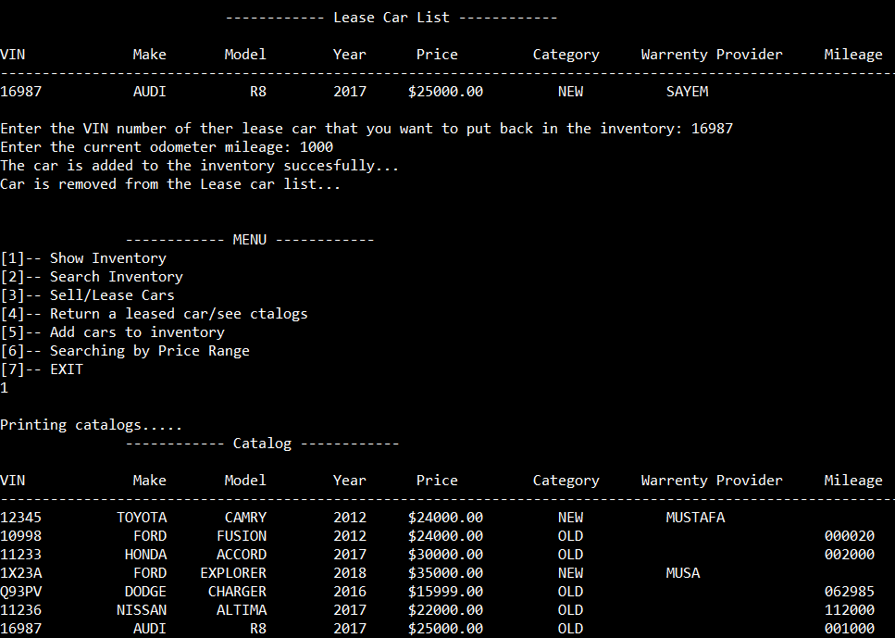

**Function 5 (Add Cars to The Inventory):**

In that function, it allows user to add car into the inventory. For the new car the program will ask for the warranty provider name and for the old car the program will ask for the mileage of the car. The VIN number should be 5 characters long, also if VIN number match with the VIN number that already store into the inventory, it will throw an exception. I also set a certain year range and the price, if it doesn’t match with the minimum requirement it will throw exception.

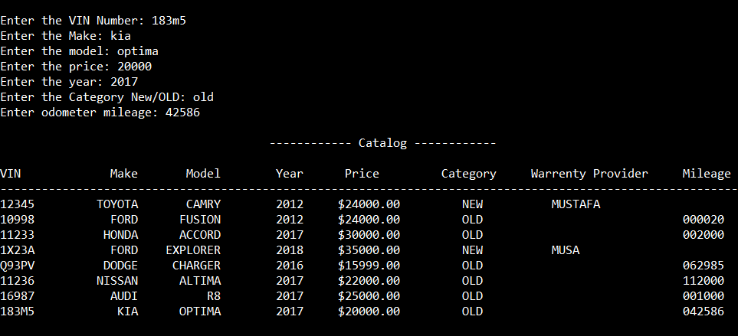

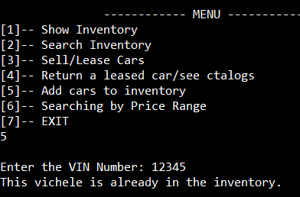 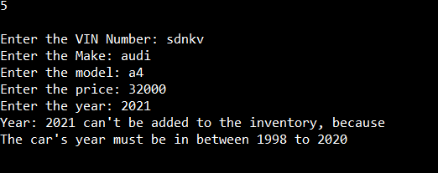

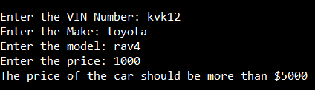

**Function 6 (Searching by Price Range):**

In this function it will ask user to enter a price range to search cars by low to high price. If user enter lower price greater than the high price, it will throw an exception. If there are no cars in the inventory of the given price range, it will throw a message.

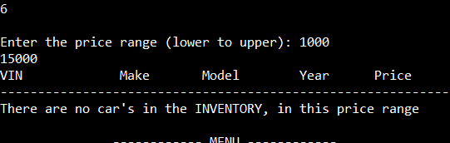

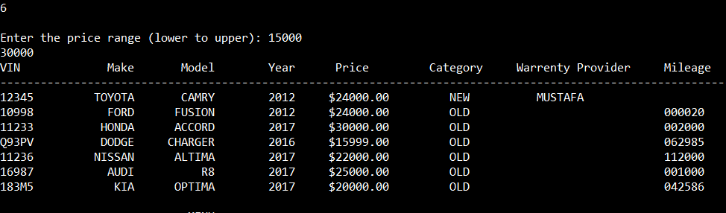

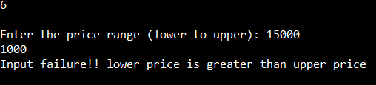

**Function 7 (Sava Data):**

In this function the data saved into a file, while warranty and mileage are not saved into the data. I knew its slicing problem, but couldn’t figure it out. Also, when I was trying to read data, there something unusual error happened with my code.

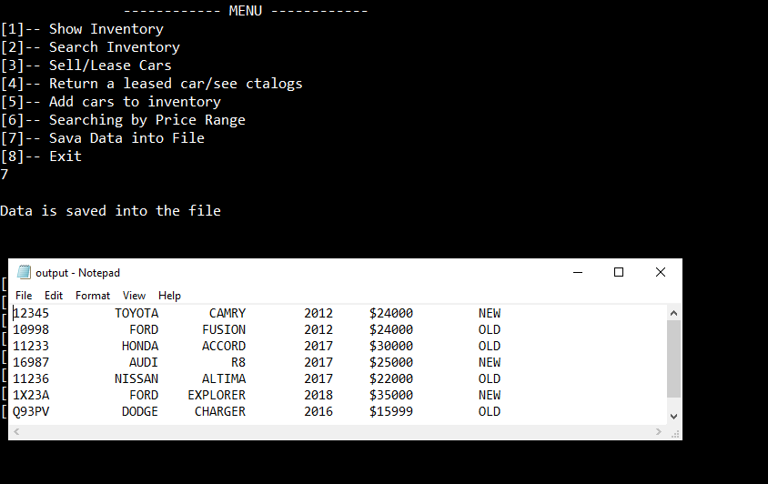

***Result***

The outcome of the project is fine. It meets all the requirement of the project and handle all the exceptions. During usability test, all the function work properly and execute as the project designated goals.

***Conclusion***

The program is designed to handle all the exception that might can be occur during program execution. Also, I tried to do lot of new staffs and learn lot of new technique while working on this project. When I fail to do something in the code, I tried to implement in other way. That made me release, if I need to become expert, I should need to practice more as along read the book.