Project: Job Application System

Group: 2-3 students

Deadline: January 6th at 11:59PM

Submit using link on eLearning (include the names of the team members in a txt file inside the submission)

Following the MVC architectural pattern, develop a Java-based web application using Java Servlets and JSPs to build a Job Application System.

The system has the following users (the user has the first name, last name, and email (user id), phone, address, city, country):

1. Job Applicant (there are many applicants)
2. Hiring Manager (there are many hiring managers)

The system has the following forms:

1. Job applicant form (to create the applicant’s account)
2. Job description (created by the manager and should have the apply button)
3. Job Application form (completed and submitted by the applicant)
4. Interview form (created and filled out by the manager and approved/disapproved by the applicant)
5. Job offer form (created and filled out by the manager and approved/disapproved by the applicant)

Use the figure below to understand the workflow of the system.

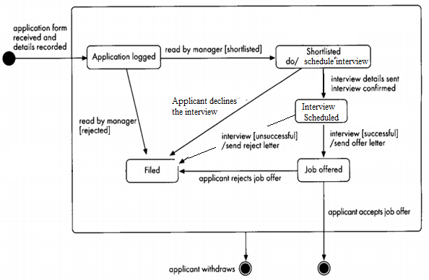

**Requirements:**

* The system can be used by different companies to announce jobs and manage the hiring process
* The job vacancy is posted by a hiring manager (the applicant shall not see the hiring manager’s name).

First, the company shall announce a job vacancy. The job vacancy contains the following:

* The title: contains the position (ex. Software Engineer).
* The position closing date: the deadline for applying
* The position details
* Apply button (clicking this button opens up the Job Application Form)
* The job applicant shall first create an account. The account has the following:
  + First name
  + Last name
  + City
  + Country
  + Email Address
  + Phone Number
  + Highest level of education (College Diploma, Bachelor, Master, PhD)
* The job applicant shall apply for the job by filling out the job application form
* The job application form contains the following information about the applicant:
* Why are you applying for this position; the applicant shall answer this question
* Resume as Attachment
* The Submit Application button
* In addition to the user’s information from the user account (filled automatically)
* Once the application is received, it will have the status (Application Logged). The applicant can’t submit duplicate job applications, but may apply for different positions. The applicant can still update the application if it is still in the *Application Logged* status.
* The applicant shall be able to withdraw the application at any time during the hiring process.
* Once the application is received, the corresponding hiring manager will review it, then the manager shall either reject it and its status shall be (Filed) or the manager shall select it for the interview and the status will be (Shortlisted).
* Then, the manager will schedule the interview. The Interview form shall have the interview date and time. If the applicant accepts the interview, the status of the application will be changed to (Interview Scheduled). If disapproved, he will not have the chance to interview for the position. In case the applicant disapproves, the status will be changed to (Filed)
* If the interview is successful, the applicant will have a job offer, and the status will be (Job Offered).
* The manager shall add the comments about the interview in the form and select Create an Offer.
* If the Interview is not successful, the hiring manager will add the comments and select No Offer. In case of no offer, the status of Job Application will be changed to (Filed).
* The applicant shall accept the offer or decline the offer. If accept, the status will be changed to (Accepted) If decline, the status will be changed to (Declined)

The Interview form has the following fields:

* Interview date and time (make sure to check for valid day/time, not past date are allowed).
* Rate the applicant’s interpersonal skills (1 to 10) where 10 is excellent (make sure to check for valid numbers, or you can choose a dropdown list or a radio button)
* Rate the applications’ technical skills (1 to 10)

The Job Offer form contains the following:

* Position
* Salary
* Job start date

You should use a relational database system to store all the data in the system.