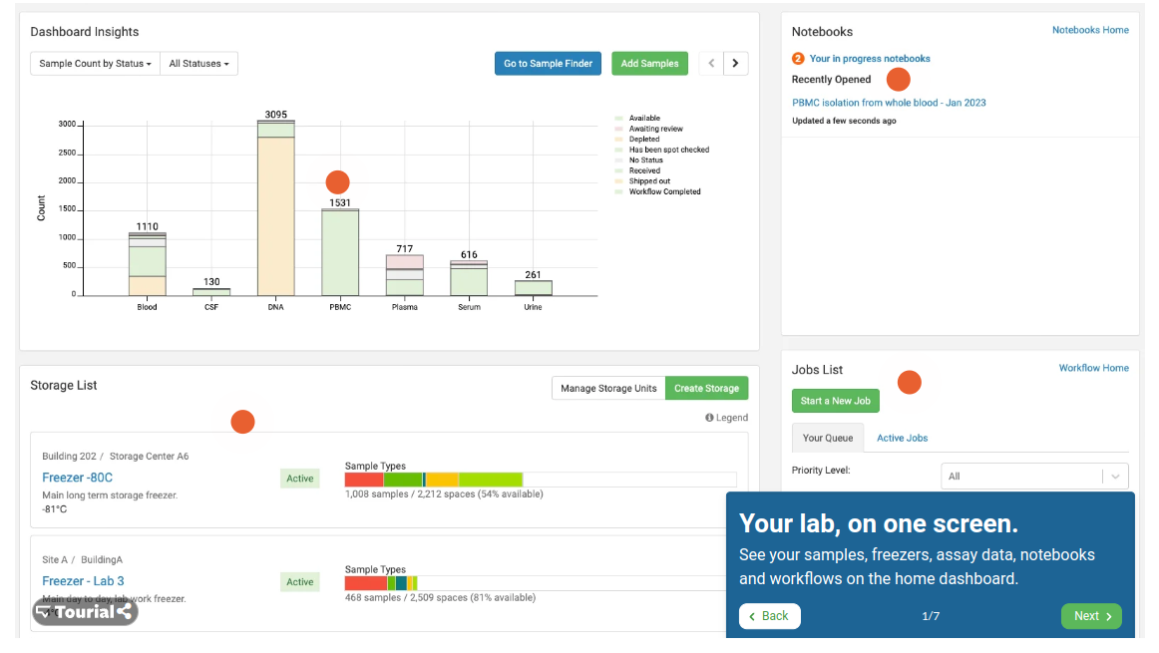

**page one**

**Dashboard Insights:**

In this section I will provide a chart that will take the data as input and in the last as the requirements we will get the same result.

Also, I need to know all types on x-axis like blood, CSF, DNA etc....

**Notebooks**

Did we need this functionality?

**Jobs List**

Did we need this functionality?

**Storage list**

I need to know every possible detail that belongs to the storage section such as the status of freezer, temperature degree, the possible number of samples on each freezer and the location of each freezer.

///////////////////////////////////////////////////////////////

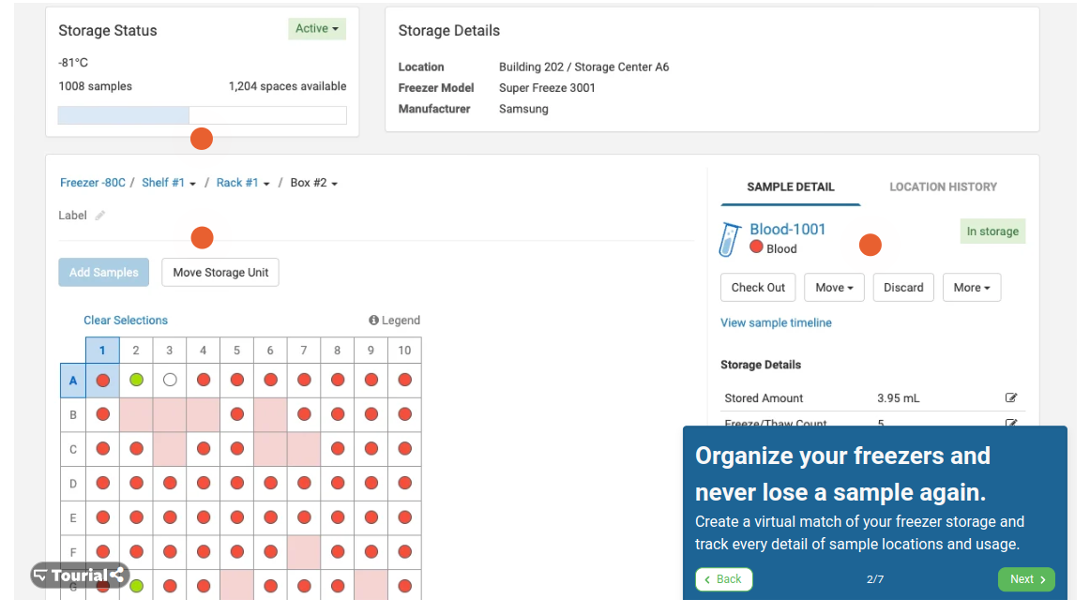

Page 2

**Storage status & storage details**

For this section I need the same information that I indicate on storage section on page one, Also I need to know if we need the freezer model and freezer manufacture?

On the next section I need to know specific information about freezer shelf, rank, box, and label if exist.

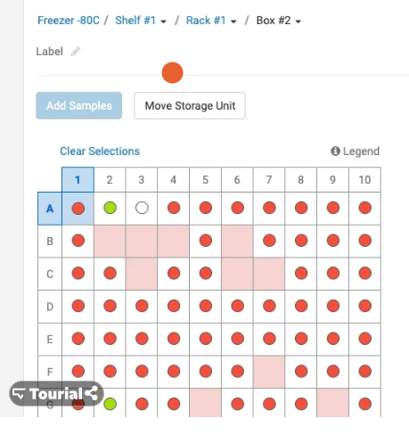

**Add sample** we need to discuss it.

**Move** **storage Unit** we need to discuss it and.

For each cell on matrix, I need to know what the mean for red circle and green.

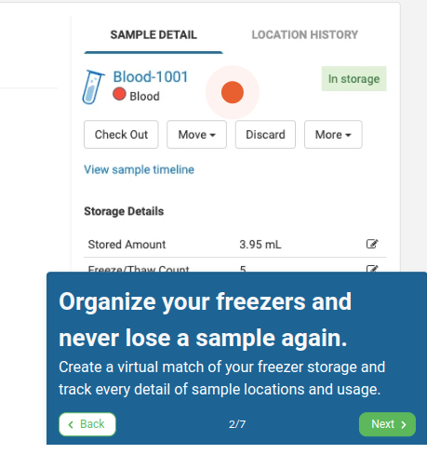

Here we will display the sample details once the user clicks on cell on the matrix and we will discuss about sample details should be appare.

For location history also we well discuss it.

/////////////////////////////////////////////////////////////////

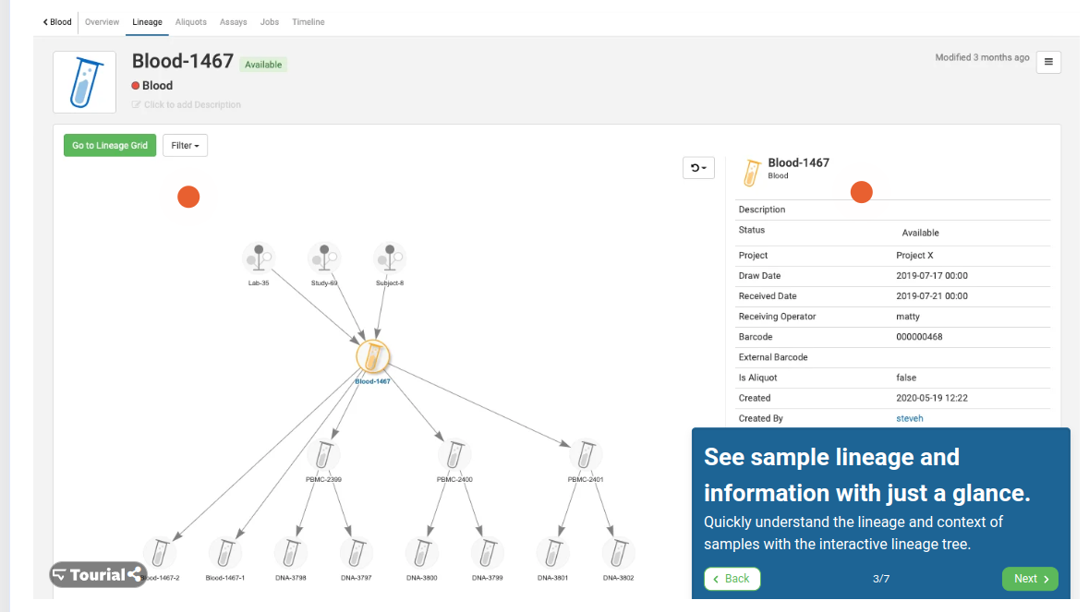

On this page we need to discuss their requirements.

//////////////////////////////////////////////////////////

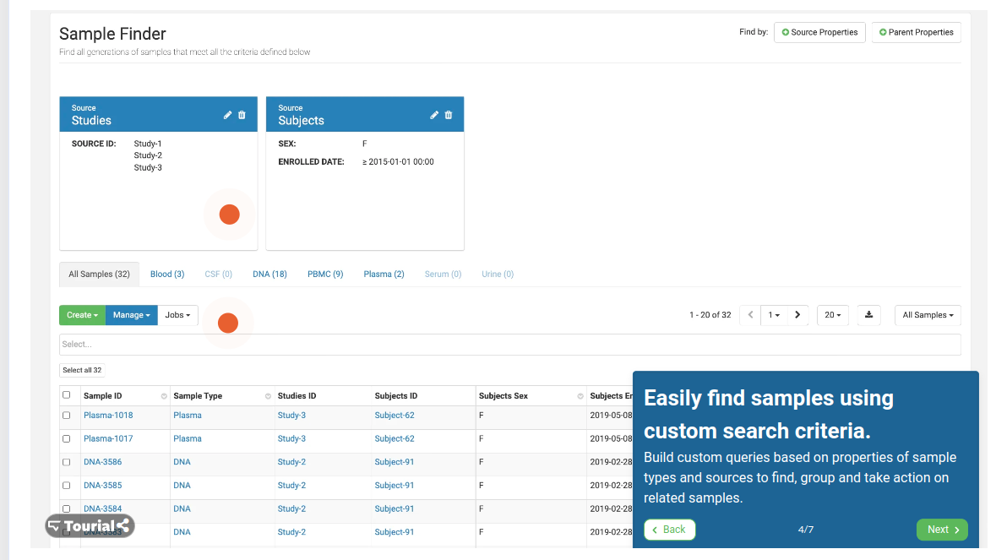

On this page, as I understood from its requirements, the search will only be inside the freezer and not in all freezers, and we will certainly discuss it further.

////////////////////////////////////////////////////////////

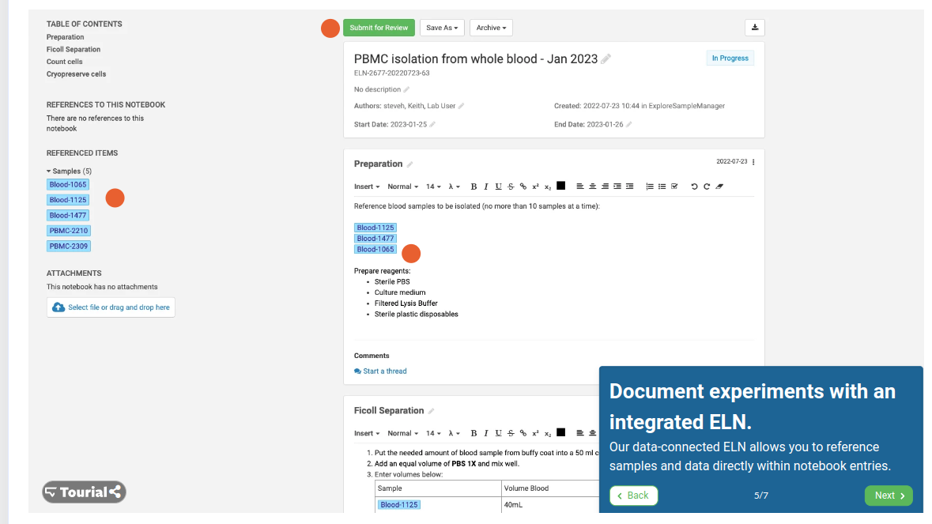

On this page, as I understood from its requirements, we will indicate what should do for sample or described the sample date with extract information, also we will discuss their further.

////////////////////////////////////////////////////////////////////////////////////////////////////////////

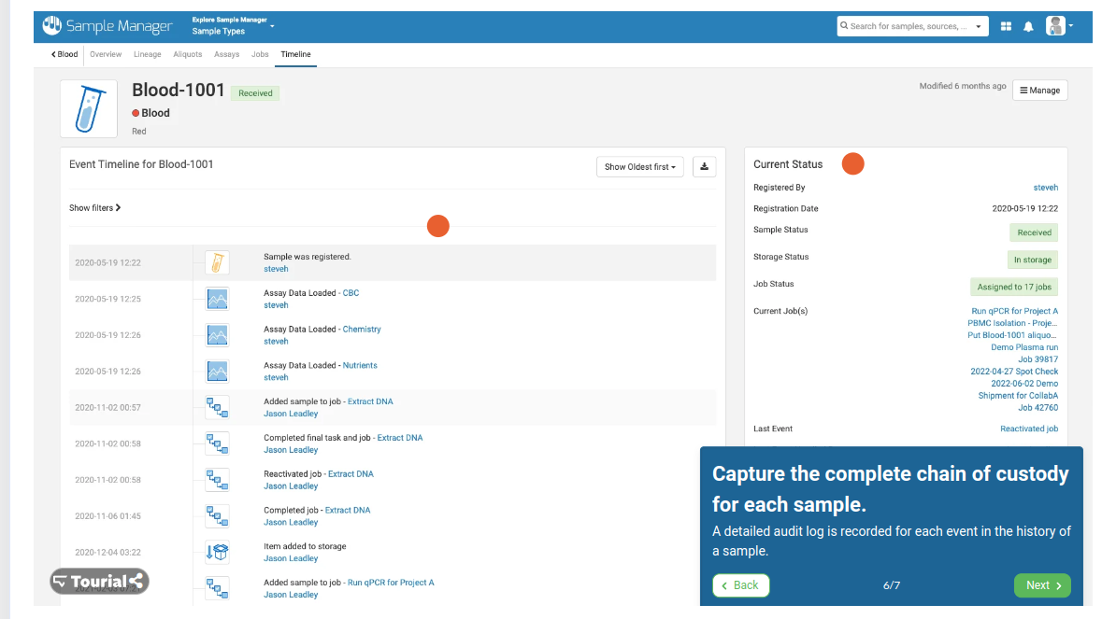

We will discuss the page further.

////////////////////////////////////////////////////////////////