

**Faculty of Engineering and Technology**

**Department of Electrical and Computer Engineering**

**ENCS 3320: Computer Networks**

**Project#2: Cisco Packet Tracer**

**Prepared by:**

**Maysam Habbash 1220075**

**Heba Mustafa 1221916**

**Section: 1**

**18.Jan.2025**

# Abstract

# Table of Contents

Abstract 1

Table of Contents 2

List of Figures 3

List of Tables 3

1 Theory 3

1.1 IP Addressing and Subnetting 3

1.2 Routing Protocols 4

1.3 Address Translation 4

1.4 Wireless LAN Configuration and Security 4

1.5 Network services 4

1.6 Topology 4

2 Procedure 5

2.1 Google Network (AS-300) 5

2.2 Faculty of Engineering and Technology Network (AS-100) 5

2.3 Home-ISP Network (AS-200) 5

3 Results and Discussions 5

Issues and Limitations 6

Teamwork 6

References 6

# List of Figures

Figure ‎1.1: Format of an IP address [2] 5

Figure ‎1.2: Routing Protocols among and within Autonomous Systems [5] 6

# List of Tables

Table ‎3‑1: Address space details of each subnet 8

# Theory

## IP Addressing and Subnetting

Data transferred over a network needs to be directed correctly from source to destination, and both are identified by IP addresses. To send packets between processes on different hosts, the destination process needs both a host address and a process identifier. An IP address includes a network ID, which locates the device's network region, and a host ID, which identifies the specific device within that region [1]. IP addresses have two versions: **IPv4**, which uses 32 bits for addressing, and **IPv6**, which uses 128 bits. Figure 1.1 illustrates the described format of an IP address of version four (IPv4).

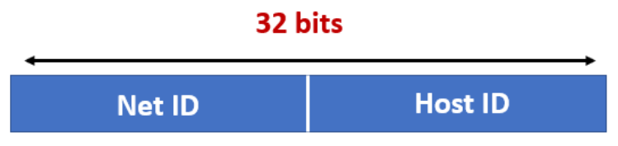

Figure ‎1.1: Format of an IPv4 address [2]

Subnetting refers to dividing networks with huge number of routers into smaller networks (subnets). Each subnet in the network has a unique identifier within the network ID part of the IP address. This creates more manageable networks and furthermore boosts the performance by reducing congestion over the network. Elements in a network are not necessarily evenly-divided between subnets. Therefore, subnet masks are needed to determine which part of an IP address is the network ID and which part is the host ID. This enables devices within the same subnet to communicate directly, while devices in different subnets require routing [3].

## Routing Protocols

Assigning unique IP addresses to the devices in a network ensures that all packets have a clear destination while traveling through a network. However, it is not sufficient to determine the route taken by packet from source to destination. Routing protocols allows efficient transfer of packets across and through networks. Routing algorithms are mainly classifies into static and dynamic routing algorithms.

### Static Routing

This class of routing algorithms requires human intervention to change routing tables in a network. In terms of security, static routing is more secure than dynamic routing. However, in terms of efficiency, dynamic routing dominates [1].

### Dynamic Routing

Dynamic routing algorithms update routing tables according to changes in network traffic, topology and link costs [4]. Most common algorithms of this class are: OSPF and BGP.

#### Open Shortest Path First (OSPF)

OSPF algorithm is an intra-AS routing protocol used to manage routing within a single Autonomous System (AS), which is a network of routers and IP addresses under a common administrative control. OSPF enables routers within an AS to exchange link-state information and construct a complete network topology, from which they compute the shortest-path tree using Dijkstra's algorithm. This allows routers to determine the most efficient routes to each destination within the AS [1].

#### Border Gateway Protocol (BGP)

BGP is an inter-AS routing protocol that enables communication and coordination between multiple Autonomous Systems in the Internet. Each AS uses BGP to advertise the reachability of its subnets to other ASs, ensuring global connectivity (Figure 1.2). This protocol enables the Internet's scalability and ensures that all routers can learn about paths across the global network, effectively gluing the diverse ASs into a single interconnected system [1].

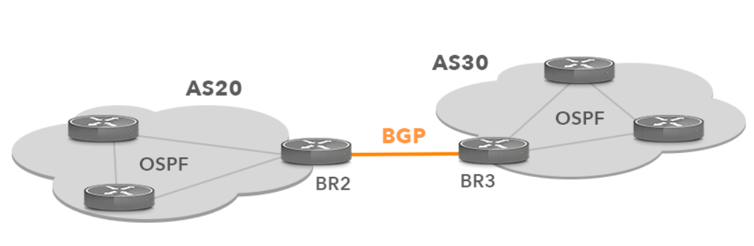

Figure ‎1.2: Routing Protocols among and within Autonomous Systems [5]

## Address Translations

Address translation, such as NAT, is essential due to the shortage of IPv4 addresses, enabling multiple devices in a private network to share a single public IP. It bridges the gap between private networks and the public Internet by mapping private IPs to public ones, allowing efficient use of IP addresses and extends the usability of IPv4 in a world transitioning to IPv6.

### Network Address Translation (NAT)

NAT is a method that allows multiple devices within a private network to share a single public IP address for communication with the Internet. It maps private IP addresses, which are only valid within local networks, to a public IP address assigned to the network’s gateway (like a router). This process conserves IPv4 addresses, provides a layer of security by hiding internal network structures from external entities, and simplifies IP address management [1].

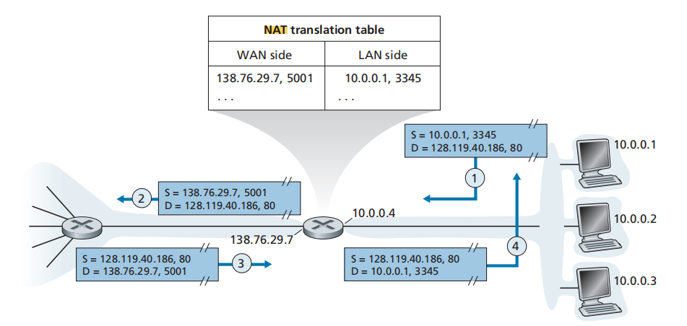

Figure ‎1.3: Network Address Translation

### Port Address Translation (PAT)

PAT is a specific type of NAT where multiple devices share a single public IP address, but each device is assigned a unique port number. When a device sends traffic to the Internet, the router maps the private IP and port to the public IP and a unique external port. This enables multiple devices to communicate simultaneously through the same public IP while maintaining distinct connections. PAT is widely used in home and enterprise networks due to its efficiency and compatibility with IPv4 [6].

## Wireless LAN Configuration and Security

## Network services

### Web and Email Servers

### Domain Name System (DNS)

### Dynamic Host Configuration Protocol (DHCP)

## Topology

The topology comprises three interconnected Autonomous Systems (ASs): Google Network for DNS and email services, Faculty of Engineering and Technology Network with multiple subnets and essential services like web, email, DNS, and DHCP, and Home-ISP Network, integrating wireless LAN, NAT, and BGP for connectivity.

### Google Network

This network primarily handles DNS and email functionalities. Configurations include assigning static IPs to router ports and activating the DNS service with specific resource records (RRs) for domain name resolution. Additionally, an email server utilizing SMTP and POP3 protocols is set up to facilitate communication. The overarching goal is to establish efficient and reliable DNS and email services within the network.

### Faculty of Engineering and Technology Network

This network comprises various subnets, such as Servers, Electrical and Computer Engineering (ECE), and Computer Science (CS), with subnetting employed for optimal IP address allocation. Key configurations include setting up web, email, DNS, and DHCP services. OSPF routing ensures internal communication, while DHCP pools are created to provide dynamic IP addresses to devices within the subnets. The interconnected structure enables seamless communication and access to external resources.

### Home-ISP Network

This network integrates private and public IP address schemes for home and ISP connectivity. A wireless LAN is deployed with WPA2 security, and dynamic NAT combined with PAT enables internet access. DHCP is used for dynamic IP allocation to home devices, while email and web services are configured for local use. Inter-AS routing is managed using BGP to ensure connectivity between the networks.

# Procedure

Cisco packet tracer

## Google Network (AS-300)

## Faculty of Engineering and Technology Network (AS-100)

### Servers Subnet

### Electrical and Computer Engineering (ECE) Subnet

### Computer Science (CS) Subnet

### Backbone Subnet

## Home-ISP Network (AS-200)

# Results and Discussions

Table ‎3‑1: Address space details of all subnet

|  |  |  |  |  |
| --- | --- | --- | --- | --- |
|  | Servers Subnet | ECE Subnet | CS Subnet | Backbone Subnet |
| IP address (CIDR) |  |  |  |  |
| Subnet mask |  |  |  |  |
| Broadcast IP address |  |  |  |  |
| First usable host address |  |  |  |  |
| Last usable host address |  |  |  |  |

# Issues and Limitations

# Teamwork

# References

[1] Computer Networking: A Top-Down Approach, 8th edition, Jim Kurose, Keith Ross Pearson, 2020

[2] [How do IP Addresses Work? | Complete Guide on Working of IP Address](https://www.educba.com/how-do-ip-addresses-work/)

[3] [Introduction to IP addressing and subnetting | TechTarget](https://www.techtarget.com/searchnetworking/tip/Introduction-to-IP-addressing-and-subnetting)

[4] [Static and Dynamic Routing Protocols, Advantages, Disadvantages, and Difference – T4Tutorials.com](https://t4tutorials.com/static-and-dynamic-routing-protocols-advantages-disadvantages-and-difference/)

[5] [BGP Network Optimization with Intelligent Routing Platform](https://www.noction.com/intelligent-routing-platform-bgp-network-optimization)

[6] [How Network Address Translation Works | HowStuffWorks](https://computer.howstuffworks.com/nat.htm)