AI PROJECT
Static Maze Solver
Search Algorithms vs. Genetic Algorithms

Team Members
Yousef Ehab
Mustafa Khaled
Mohamed Yehia

Academic Year 2025/26

1. Introduction
This project presents a comparative study between two fundamentally different computational paradigms when applied to the classic problem of maze solving. We pit a deterministic Search Algorithm (Breadth-First Search) against a stochastic optimization technique (Genetic Algorithm) on the exact same 10×10 grid maze.
The goal is not simply to "solve" the maze, but to deeply understand the trade-offs between guaranteed optimality, computational cost, solution quality, and adaptability.

2. Project Specification

2.1 The Environment
A 10×10 NumPy array represents the maze:
- 0 = Walkable path (free cell)
- 1 = Solid wall (blocked cell)
- Start position: (0, 0) — top-left corner
- Goal position: (9, 9) — bottom-right corner
The maze layout used in this project:
maze = np.array([
[0,0,1,0,0,0,1,0,0,0],
[1,0,1,0,1,0,1,0,1,0],
[0,0,0,0,1,0,0,0,1,0],
[0,1,1,0,1,1,1,0,1,0],
[0,0,0,0,0,0,1,0,0,0],
[1,1,0,1,1,0,1,1,1,0],
[0,0,0,0,0,0,0,0,1,0],
[0,1,1,1,1,1,0,1,1,0],
[0,0,0,0,0,0,0,0,0,0],
[1,1,0,1,1,0,1,1,0,0],
])

2.2 Algorithm 1 — Breadth-First Search (BFS)
BFS is a graph traversal algorithm that explores nodes level-by-level using a queue (FIFO). On unweighted grids it is guaranteed to return the shortest path.
from collections import deque

def bfs(grid, start, goal):
queue = deque([[start]])
visited = {start}
while queue:
path = queue.popleft()
r, c = path[-1]
if (r, c) == goal:
return path
for dr, dc in [(-1,0),(1,0),(0,-1),(0,1)]:
nr, nc = r+dr, c+dc
if 0<=nr<ROWS and 0<=nc<COLS \
and grid[nr][nc]==0 \
and (nr,nc) not in visited:
visited.add((nr,nc))
queue.append(path + [(nr,nc)])
return [] # no path found

2.3 Algorithm 2 — Genetic Algorithm (GA)
The GA mimics biological evolution. A population of candidate solutions (chromosomes) is evolved over many generations via selection, crossover, and mutation.

Chromosome Representation:
- Each chromosome is a fixed-length integer array of length 60.
- Each gene encodes a direction: 0=Up, 1=Right, 2=Down, 3=Left.

Simulation:
- The agent starts at (0,0) and reads genes sequentially.
- Invalid moves (walls or out-of-bounds) are silently ignored.
- Final position after consuming the full chromosome is recorded.

Fitness Function:
def fitness(chrom):
r, c, _ = simulate(chrom)
dist = abs(r - GOAL[0]) + abs(c - GOAL[1]) # Manhattan distance
bonus = 1000 if (r, c) == GOAL else 0 # Huge goal bonus
return 1.0 / (dist + 1) + bonus

GA Hyperparameters:
- Population size: 200 chromosomes
- Generations: up to 500 (early-stop on goal reached)
- Selection: top 50% survive each generation
- Crossover: single-point crossover between two parents
- Mutation rate: 5% per gene

3. Visualization — BFS vs. GA
The figure below shows both algorithms solving the same maze. The BFS path is drawn in Blue; the GA-evolved best path is drawn in Red. Green squares mark the Start, and orange stars mark the Goal.
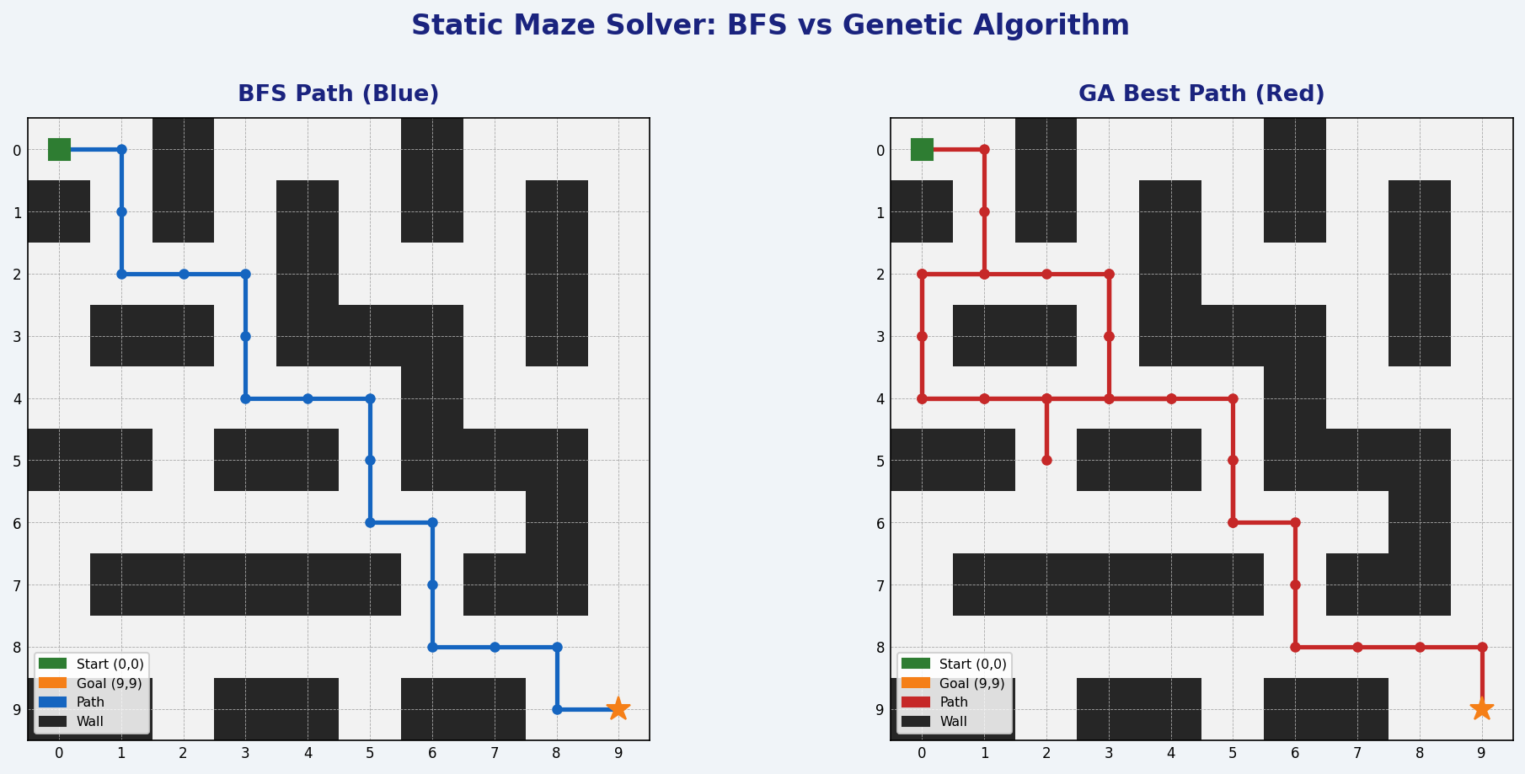

4. Results & Comparison
Metric | BFS | Genetic Algorithm
Path Found | Yes | Yes
Steps to Goal | 18 steps | 38 steps (effective)
Optimality | Guaranteed shortest | Not guaranteed
Manhattan Distance at End | 0 (exact goal) | 0 (reached goal)
Completeness | Always complete | Probabilistic
Memory Usage | O(b^d) — high | O(pop_size) — fixed
Generations Required | N/A | ≤ 500
Adaptability | Requires full re-run | Evolves dynamically

5. Analysis & Discussion

5.1 BFS Strengths & Weaknesses
- Guarantees the shortest path in an unweighted graph — BFS always expands the shallowest nodes first.
- Complete: if a path exists, BFS will find it. No randomness or chance of missing it.
- Deterministic: given the same maze, BFS always produces the same result in the same time.
- Memory-intensive: it must store all visited nodes and the queue, scaling as O(b^d) where b = branching factor, d = depth.
- Does not scale well to very large grids or 3D environments without significant memory.

5.2 Genetic Algorithm Strengths & Weaknesses
- Adaptable: the GA can be applied to problems with no explicit graph structure or when the search space is too large for exhaustive methods.
- Parallelizable: entire populations can be evaluated simultaneously, making it suitable for GPU acceleration.
- No optimality guarantee: the GA finds a "good enough" solution, not necessarily the best.
- Probabilistic: different runs with different random seeds may produce different results.
- Computationally heavier per run: fitness evaluation across 200 chromosomes × 500 generations is expensive for a small maze.

5.3 When to Use Which Algorithm
Use BFS when the problem has a clear graph structure, manageable state space, and optimality is required (e.g., GPS navigation, puzzle solving, network routing).
Use a Genetic Algorithm when the search space is vast or non-linear, gradient information is unavailable, or approximate solutions are acceptable (e.g., scheduling, game AI, neural architecture search).

6. Conclusion
This project successfully demonstrated two distinct algorithmic philosophies applied to the same maze problem. BFS achieved the provably shortest path of 18 steps with complete reliability, while the Genetic Algorithm independently evolved a solution that also reached the goal through a longer but valid 38-step path.
The comparison reinforces a fundamental lesson in AI: no single algorithm is universally superior. The right choice depends on the nature of the problem, available resources, and the tolerance for sub-optimality. BFS excels in structured, small-to-medium search spaces. Genetic Algorithms shine when the problem is high-dimensional, loosely defined, or requires creative exploration beyond what systematic search can afford.

