
Practical Assessment #3 Security Assessment
CST8305 – GNU/Linux Server Administration

November 12, 2025
Mustafa Jawish
012

1- Terminal showing hostname -I with the 172.30.212.48
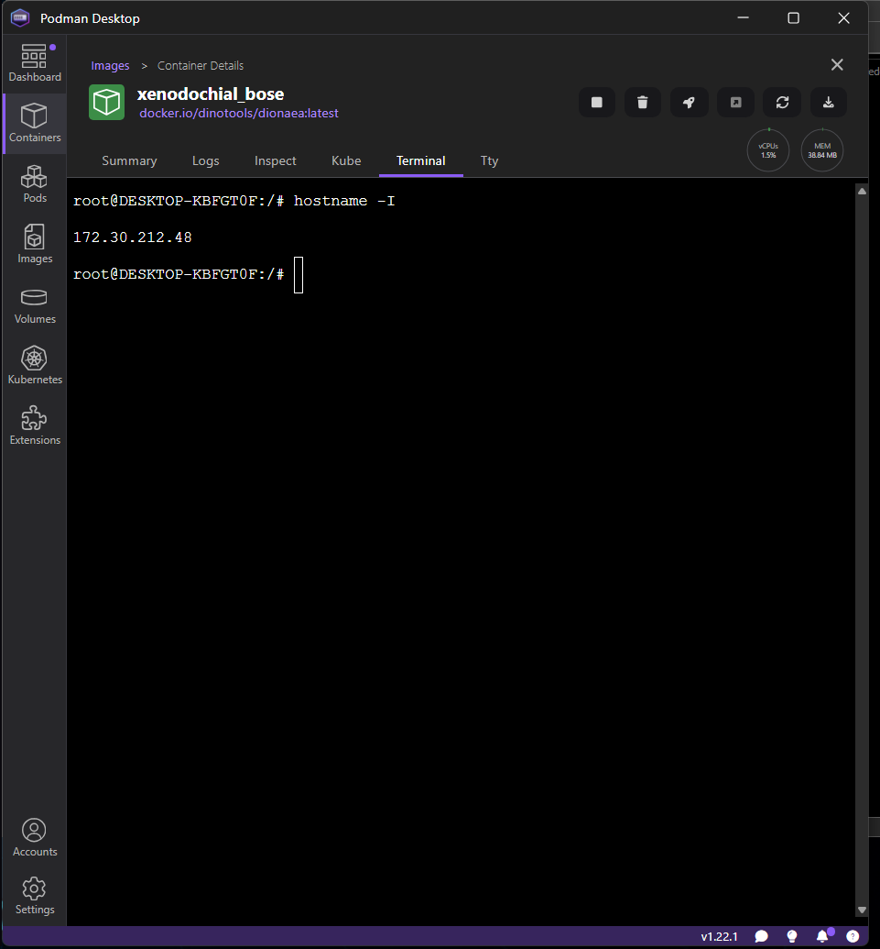

2- Successful ping from Windows to DIONAEA_IP 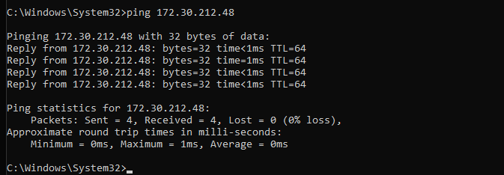

3- The command I ran, A visible chunk of results showing open ports and any identified vulns/CVEs.
C:\Windows\System32>nmap -d --script "vuln and not http-enum" 172.30.212.48
Packet.dll present, library version 1.83
wpcap.dll present, library version: Npcap version 1.83, based on libpcap version 1.10.5
Starting Nmap 7.98 ( https://nmap.org ) at 2025-11-12 12:53 -0500
PORTS: Using ports open on 0% or more average hosts (TCP:1000, UDP:0, SCTP:0)
--------------- Timing report ---------------
hostgroups: min 1, max 100000
rtt-timeouts: init 1000, min 100, max 10000
max-scan-delay: TCP 1000, UDP 1000, SCTP 1000
parallelism: min 0, max 0
max-retries: 10, host-timeout: 0
min-rate: 0, max-rate: 0
---------------------------------------------
NSE: Using Lua 5.4.
NSE: Arguments from CLI:
NSE: Loaded 104 scripts for scanning.
NSE: Script Pre-scanning.
NSE: Starting runlevel 1 (of 1) scan.
Initiating NSE at 12:53
NSE: Starting broadcast-avahi-dos.
NSE: [broadcast-avahi-dos] dns.query() got zero responses attempting to resolve query: _services._dns-sd._udp.local
NSE: Finished broadcast-avahi-dos.
Completed NSE at 12:53, 10.02s elapsed
Initiating ARP Ping Scan at 12:53
Scanning 172.30.212.48 [1 port]
Packet capture filter (device eth7): arp and arp[18:4] = 0x00155D15 and arp[22:2] = 0x5BC5
Completed ARP Ping Scan at 12:53, 0.04s elapsed (1 total hosts)
Overall sending rates: 26.32 packets / s, 1105.26 bytes / s.
mass_dns: Using DNS server 10.254.21.201
mass_dns: Using DNS server 10.254.21.202
Initiating Parallel DNS resolution of 1 host. at 12:53
Completed Parallel DNS resolution of 1 host. at 12:53, 0.51s elapsed
DNS resolution of 1 IPs took 0.52s. Mode: Async [#: 2, OK: 0, NX: 1, DR: 0, SF: 0, TR: 1, CN: 0]
Initiating SYN Stealth Scan at 12:53
Scanning 172.30.212.48 [1000 ports]
Packet capture filter (device eth7): dst host 172.30.208.1 and (icmp or icmp6 or ((tcp or udp or sctp) and (src host 172.30.212.48)))
Completed SYN Stealth Scan at 12:53, 0.12s elapsed (1000 total ports)
Overall sending rates: 8547.01 packets / s, 376068.38 bytes / s.
NSE: Script scanning 172.30.212.48.
NSE: Starting runlevel 1 (of 1) scan.
Initiating NSE at 12:53
NSE: Starting firewall-bypass against 172.30.212.48.
NSE: [firewall-bypass 172.30.212.48] 1 chosen as target port.
NSE: [firewall-bypass 172.30.212.48] Unable to connect to 21 helper port.
NSE: [firewall-bypass 172.30.212.48] no suitable helper found.
NSE: Finished firewall-bypass against 172.30.212.48.
Completed NSE at 12:53, 1.00s elapsed
Nmap scan report for 172.30.212.48
Host is up, received arp-response (0.00053s latency).
Scanned at 2025-11-12 12:53:55 Eastern Standard Time for 1s
All 1000 scanned ports on 172.30.212.48 are in ignored states.
Not shown: 1000 closed tcp ports (reset)
MAC Address: 00:15:5D:D6:E9:D3 (Microsoft)
Final times for host: srtt: 527 rttvar: 582 to: 100000

NSE: Script Post-scanning.
NSE: Starting runlevel 1 (of 1) scan.
Initiating NSE at 12:53
Completed NSE at 12:53, 0.00s elapsed
Read from C:\Program Files (x86)\Nmap: nmap-mac-prefixes nmap-protocols nmap-services.
Nmap done: 1 IP address (1 host up) scanned in 12.26 seconds
Raw packets sent: 1001 (44.028KB) | Rcvd: 1001 (40.028KB)

C:\Windows\System32>

4- RUNNING OPENVAS 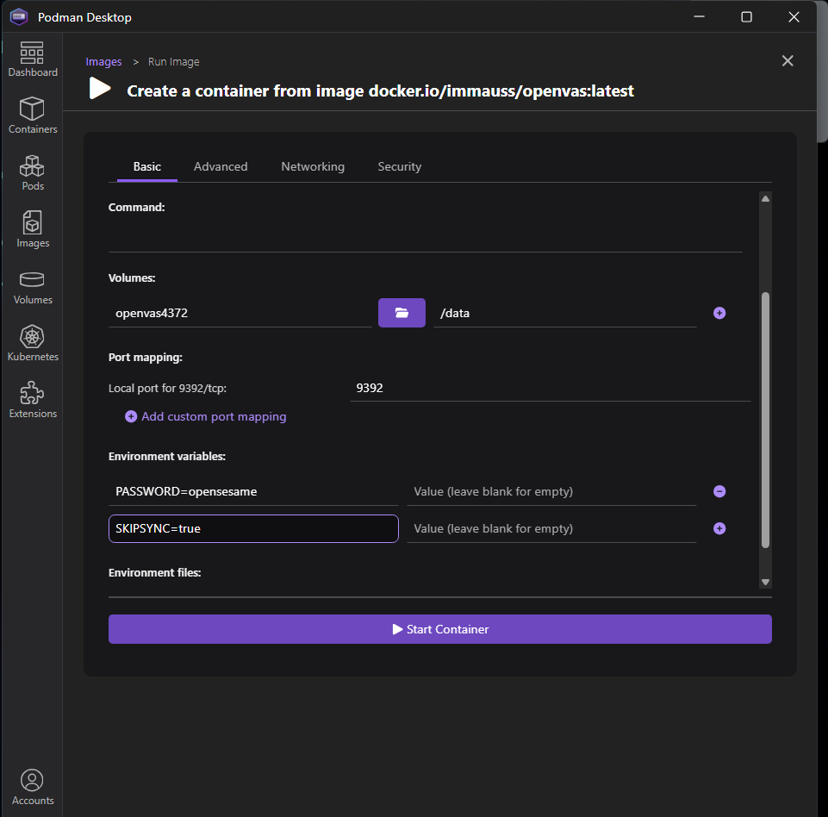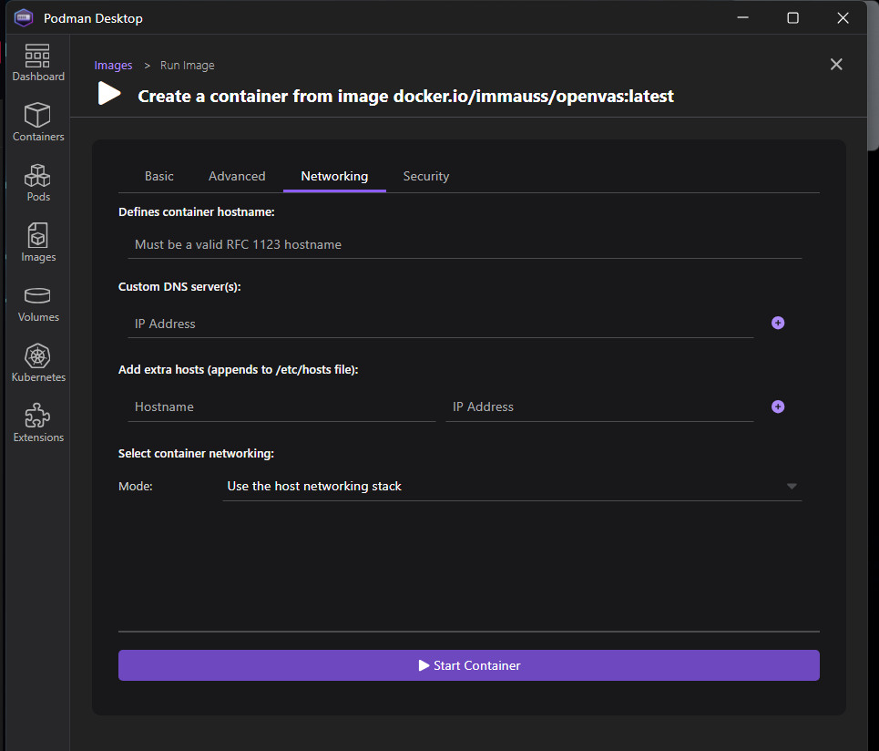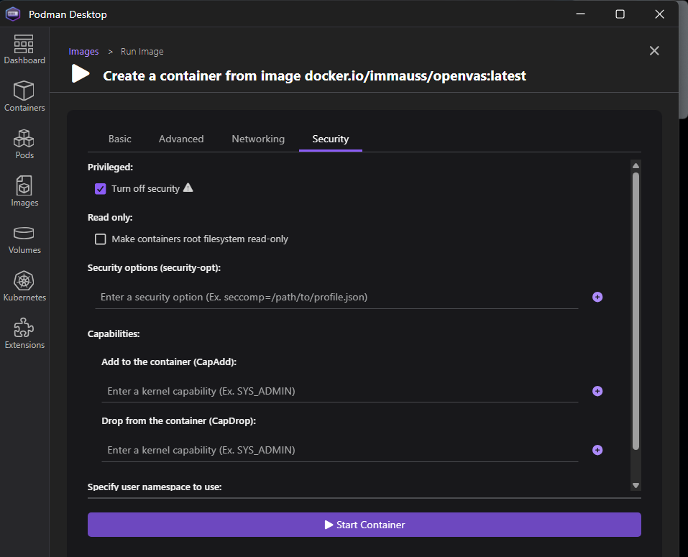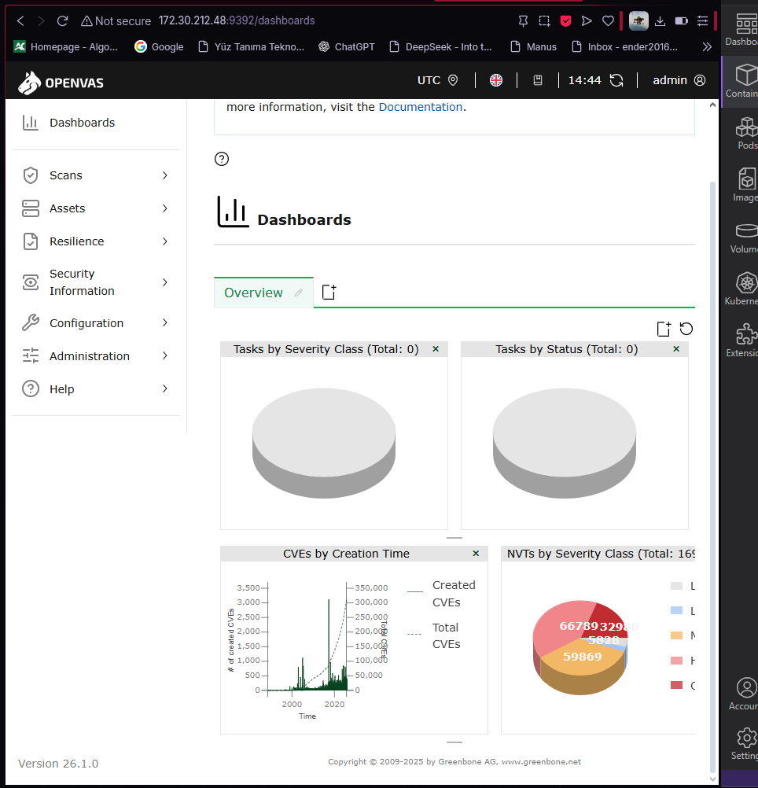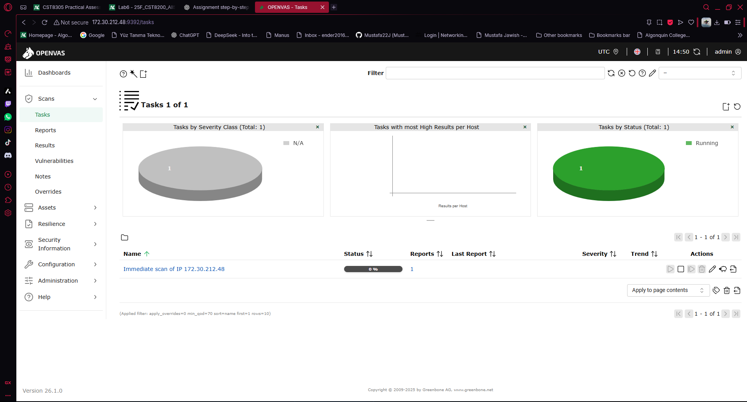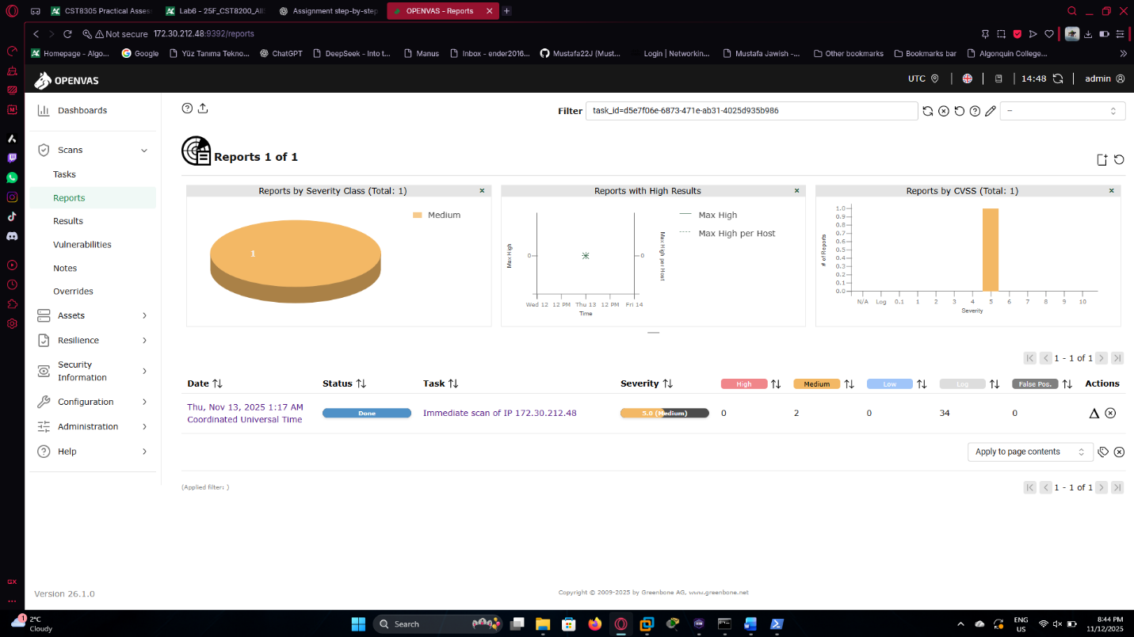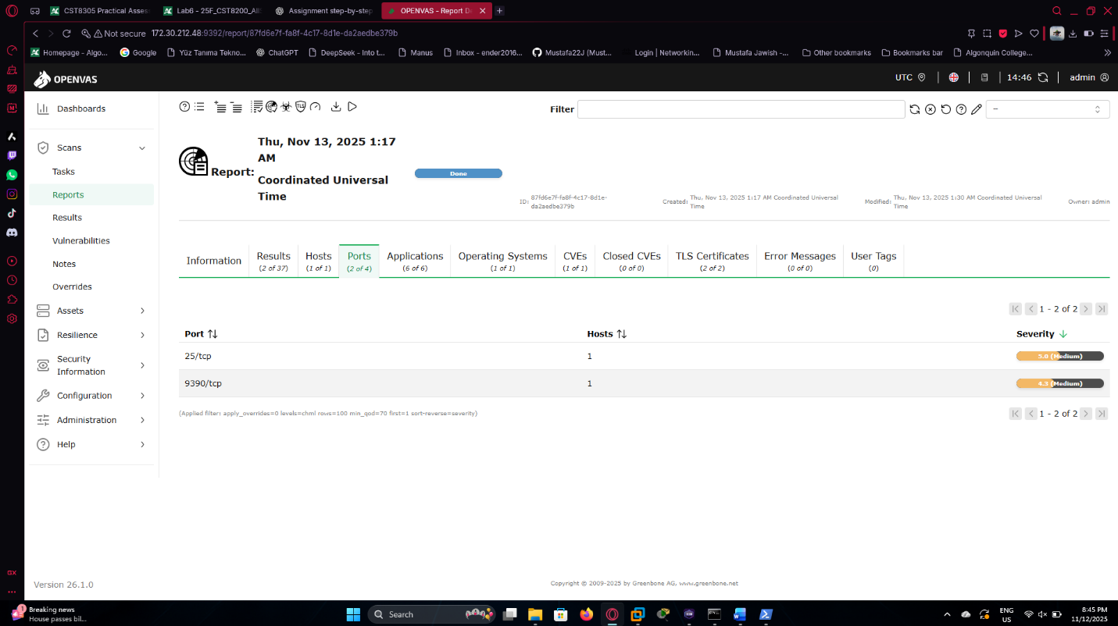 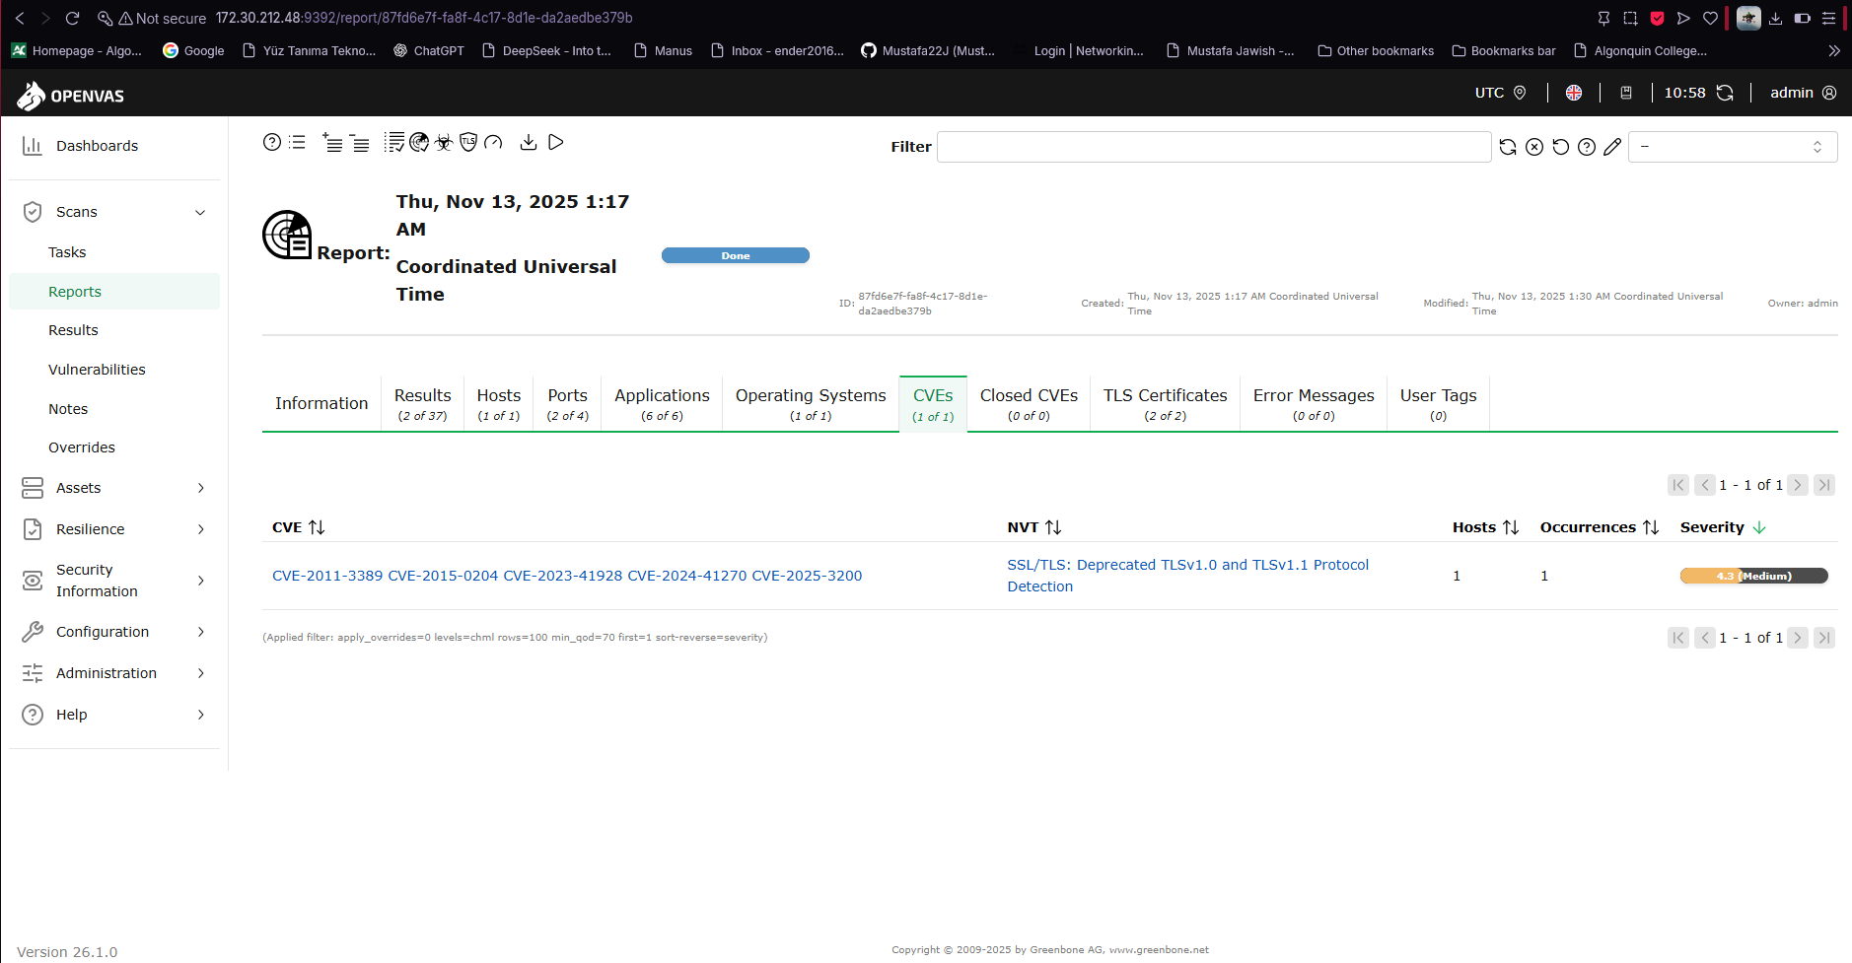
Tool Used:
OpenVAS (Greenbone Vulnerability Manager)

Target System:
Dionaea container (IP address: 172.30.212.48)

Scan Configuration:
Full and Fast

Status:
Completed – Done

Overall Severity:
5.0 (Medium)

Open Ports Detected:

TCP/25 → SMTP (Mail Service)

TCP/9390 → Greenbone/OpenVAS web interface

Detected Vulnerabilities:

Port | Severity | Description | Related CVEs
TCP/9390 | 4.3 (Medium) | SSL/TLS: Deprecated TLSv1.0 and TLSv1.1 Protocol Detection | CVE-2011-3389, CVE-2015-0204, CVE-2023-41928, CVE-2024-41270, CVE-2025-3200

