
Practical Assessment #4: Paperless-ngx
CST8305 – GNU/Linux Server Administration

November 30, 2025
Mustafa Jawish
012

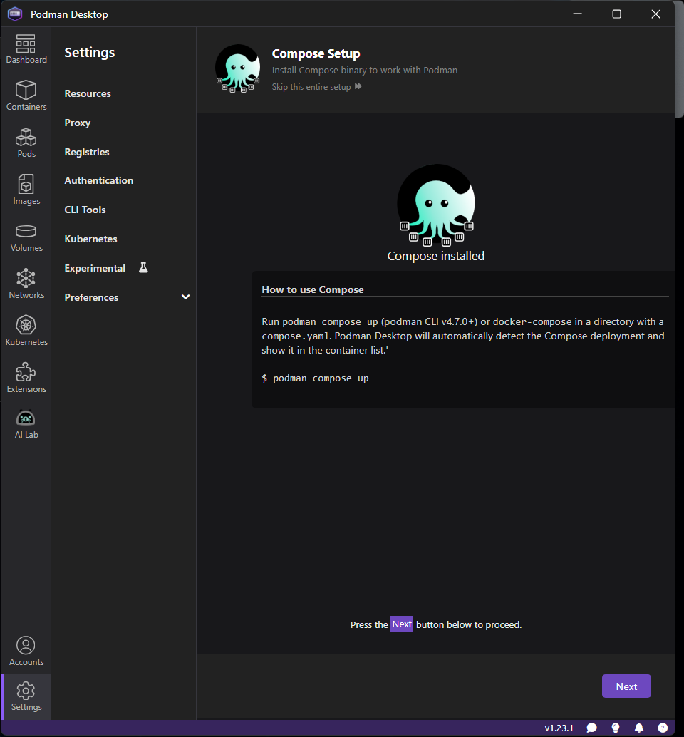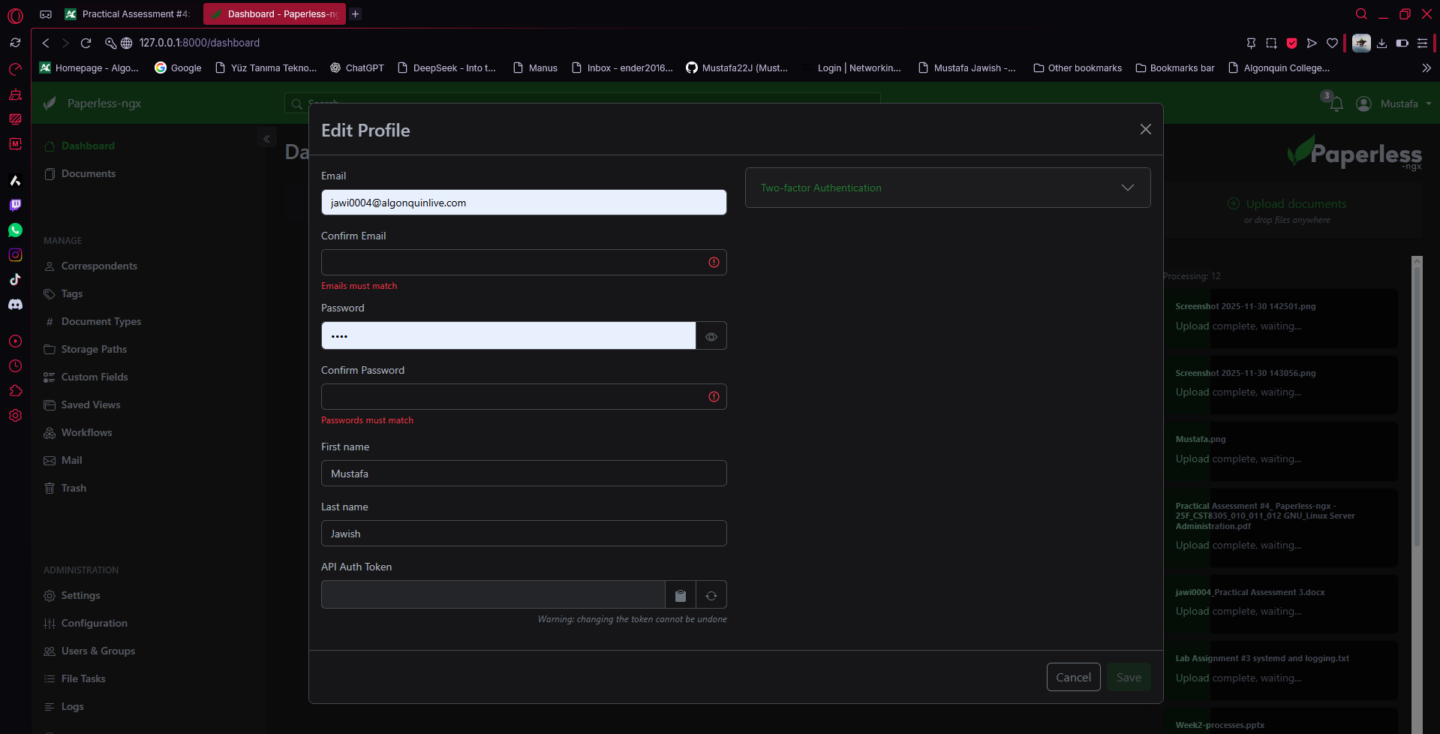
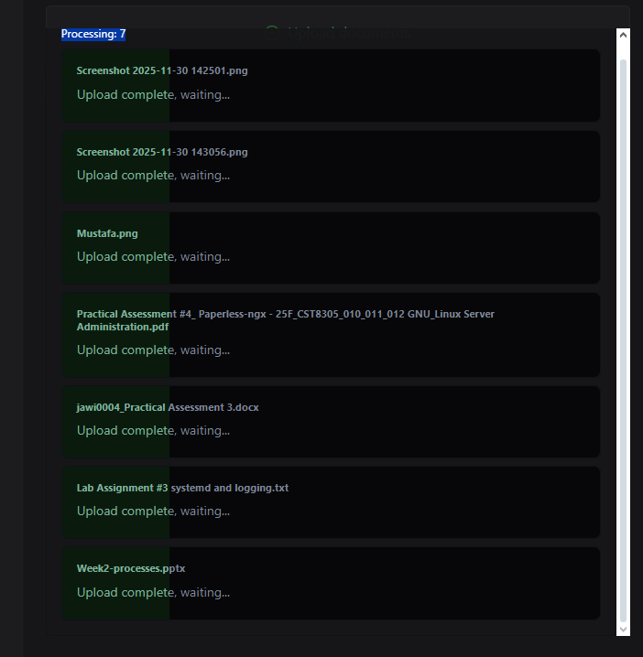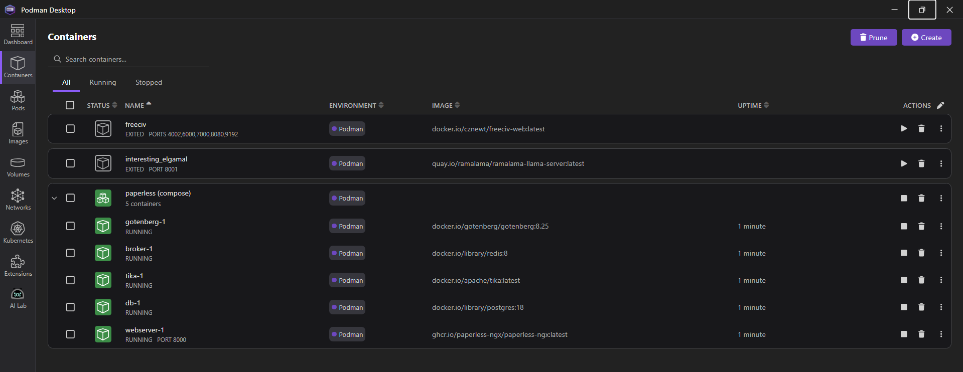
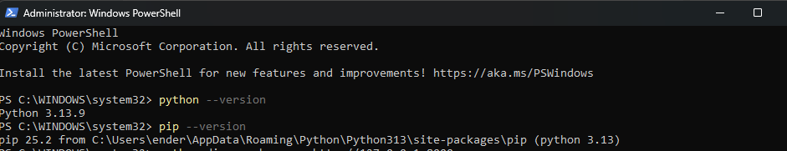
Q: List any hidden directories found by dirsearch.?
/admin/ – Redirects to login page (valid Paperless admin interface)
/accounts/ – Redirects to login (Paperless authentication)
/api/ – API entry point
/api/config.json – 401 Unauthorized (protected API)
/api/users.json – 401 Unauthorized (protected API)
/static/ – Public static assets (CSS/JS)
/favicon.ico – Normal site icon

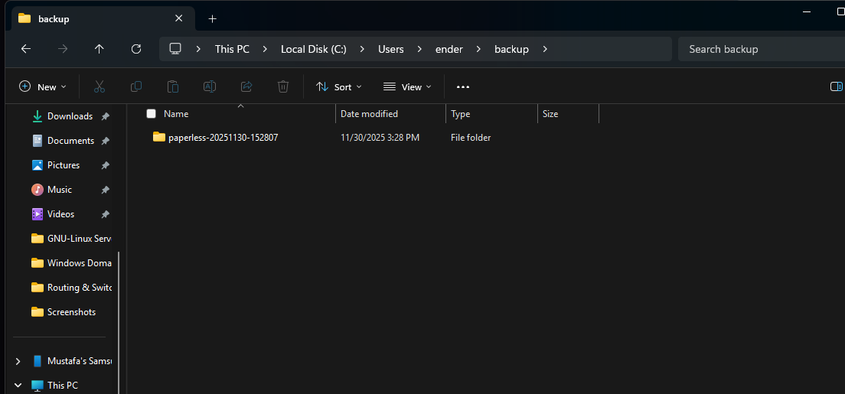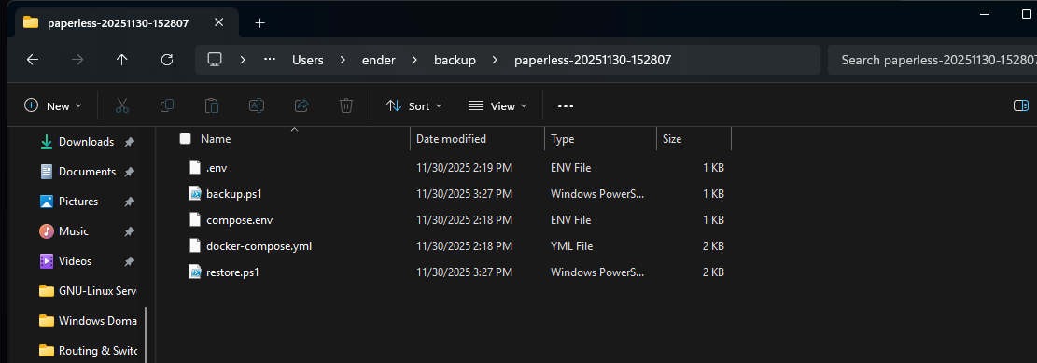PS C:\Users\ender\paperless> .\backup.ps1
>>
Stopping paperless containers...
>>>> Executing external compose provider "C:\\Users\\ender\\AppData\\Local\\Microsoft\\WindowsApps\\docker-compose.exe". Please see podman-compose(1) for how to disable this message. <<<<

[+] Running 6/6
✔ Container paperless-webserver-1 Removed 8.4s
✔ Container paperless-db-1 Removed 1.6s
✔ Container paperless-tika-1 Removed 1.4s
✔ Container paperless-broker-1 Removed 1.1s
✔ Container paperless-gotenberg-1 Removed 0.9s
✔ Network paperless_default Removed 0.0s
Backing up contents of C:\Users\ender\paperless to C:\Users\ender\backup\paperless-20251130-152807 ...
Starting paperless containers...
>>>> Executing external compose provider "C:\\Users\\ender\\AppData\\Local\\Microsoft\\WindowsApps\\docker-compose.exe". Please see podman-compose(1) for how to disable this message. <<<<

[+] Running 6/6
✔ Network paperless_default Created 0.1s
✔ Container paperless-tika-1 Started 1.4s
✔ Container paperless-broker-1 Started 1.3s
✔ Container paperless-db-1 Started 1.1s
✔ Container paperless-gotenberg-1 Started 1.5s
✔ Container paperless-webserver-1 Started 1.6s
Backup complete. Backup stored in C:\Users\ender\backup\paperless-20251130-152807
PS C:\Users\ender\paperless>
