Product Review Sentiment Analysis
A Comprehensive Comparative Study of Machine Learning Approaches
Including Transformer-Based Sentence-BERT Embeddings

By:
Mustafa Abou Khatwa, Noha Ismail, Amira ElShehaby,
Mohamed Mourad, Ahmed Gomaa

Machine Learning Course Project
January 2026

Abstract:
This study presents a systematic comparative analysis of machine learning techniques for sentiment classification of product reviews. The primary focus is on linear models—including Fisher's Linear Discriminant, Support Vector Machines (SVM), and Logistic Regression—while additional supervised algorithms (Neural Networks, Random Forest, XGBoost, LightGBM) and unsupervised clustering approaches (K-Means, HDBSCAN) are employed for verification and benchmarking. Experiments were conducted on a large-scale dataset comprising 409,577 training samples, with validation performed on an unseen real-world dataset. A hybrid feature engineering strategy was adopted, integrating TF-IDF text representations with VADER lexicon-derived sentiment scores.
Additionally, this study extends the analysis to transformer-based sentence embeddings, specifically Sentence-BERT (SBERT). A pilot study comparing five embedding approaches (TF-IDF, Word2Vec, DistilBERT, Sentence-BERT, and MPNet) identified Sentence-BERT as optimal, achieving Macro-F1 of 0.918 with the fastest computation time. Full-scale experiments with SBERT embeddings demonstrated that Extra Trees classifier achieved 85.11% accuracy and 0.8051 Macro-F1—representing a 51% improvement over TF-IDF baselines for bagging methods. Notably, gradient boosting algorithms (XGBoost, LightGBM) exhibited performance degradation with dense embeddings due to sequential learning bias.
Preliminary findings reveal that class imbalance and linguistic ambiguity—particularly in the neutral category—pose significant challenges across all models, with misclassification trends persisting regardless of algorithmic complexity. Clustering analysis on both TF-IDF and SBERT embedding spaces confirmed that sentiment classes do not form natural geometric clusters, establishing that sentiment is a semantic rather than geometric property. SHAP analysis highlights the importance of lexicon-derived features, though transformer-based embeddings ultimately provide superior classification performance.
Keywords: Sentiment Analysis, Natural Language Processing, Machine Learning, Sentence-BERT, TF-IDF, Support Vector Machines, Fisher's Linear Discriminant, Logistic Regression, Neural Networks, Random Forest, XGBoost, LightGBM, DBSCAN, K-Means, VADER, SHAP, Class Imbalance, Transfer Learning

1.Introduction:
Sentiment analysis has emerged as a cornerstone of modern natural language processing (NLP), playing a vital role in domains ranging from customer feedback monitoring to social media analytics and market intelligence. The ability to automatically classify text into sentiment categories—such as positive, neutral, and negative—enables organizations to process vast amounts of unstructured data efficiently, transforming raw textual information into actionable insights. These insights inform product development, guide marketing strategies, and shape public relations responses, underscoring the strategic importance of accurate sentiment classification in both academic research and industry applications.
Despite its utility, sentiment analysis remains a challenging task due to the inherent complexity of human language. Ambiguity, sarcasm, rhetorical devices, and context-dependent meaning often obscure sentiment signals, making classification difficult even for advanced models. Furthermore, large-scale datasets frequently exhibit extreme class imbalance, where one sentiment category dominates the distribution. In the dataset used for this study—comprising over 409,577 training samples—the positive class accounts for 57.5% of the data, overshadowing the negative (30.5%) and neutral (12.1%) categories. This imbalance introduces systematic bias, with minority classes suffering from rampant misclassification. The neutral class, in particular, is prone to errors due to its linguistic ambiguity and overlap with both positive and negative sentiment.
The primary objectives of this research are threefold: (1) to design and evaluate a robust feature engineering pipeline that integrates lexicon-based features with statistical text representations, (2) to compare the performance of diverse supervised learning algorithms—including ensemble methods, gradient boosting techniques, and neural networks—for sentiment classification, and (3) to investigate whether sentiment categories form natural clusters in the feature space through unsupervised learning approaches, and (4) to evaluate transformer-based sentence embeddings as an alternative to traditional bag-of-words representations. By addressing these objectives, the study aims to provide a comprehensive understanding of the strengths and limitations of different machine learning paradigms in sentiment analysis.
A central focus of this investigation is the role of linear models in text classification. Linear approaches offer interpretability, efficiency, and robustness in high-dimensional feature spaces, making them particularly well-suited for tasks involving sparse representations such as TF-IDF. Fisher’s Linear Discriminant provides a mathematically principled method for maximizing class separability, serving as a strong baseline for sentiment classification. Support Vector Machines (SVMs) extend this capability by constructing optimal hyperplanes in high-dimensional space.. Logistic Regression offers simplicity, probabilistic outputs, and ease of calibration.
In contrast, non-linear models such as Neural Networks are included to benchmark performance against linear baselines. Neural architectures are capable of capturing subtle semantic relationships and complex feature interactions that linear models may overlook. Additionally, this study extends the analysis to transformer-based embeddings, specifically Sentence-BERT (SBERT), which generates dense, semantically meaningful sentence representations that capture contextual relationships beyond the capabilities of bag-of-words models.
Together, these models provide a comprehensive framework for evaluating sentiment classification strategies, balancing the need for interpretability and scalability with the pursuit of higher predictive accuracy. By situating linear models as the foundation of the analysis and incorporating non-linear approaches for verification and benchmarking, this study contributes to a deeper understanding of how different machine learning paradigms perform under conditions of class imbalance, linguistic ambiguity, and large-scale data complexity.

2.Dataset And Pre-Processing:

2.1. Data Description:

The dataset used in this study comprises product reviews represented in both lexicon-based and hybrid feature formats. The training set consists of 409,577 samples, while the validation set includes 7,486,679 samples, providing a large-scale foundation for supervised learning and evaluation.
Two distinct feature representations were constructed:
- Lexicon-based features: A compact representation with shape (409,577, 4), capturing sentiment scores derived from a predefined lexicon.
- Hybrid features: A high-dimensional representation with shape (409,577, 3004), combining TF-IDF statistical text features with lexicon-derived sentiment scores to enrich the feature space.
Class | Count | Percentage
Positive | 235,384 | 57.5%
Negative | 124,820 | 30.5%
Neutral | 49,373 | 12.1%
Table 1: Three-Class Sentiment Distribution
The Neutral class is severely underrepresented with an imbalance ratio of 4.77:1
This imbalance is further reflected in the validation set, where the Positive class dominates with 6,137,739 samples, compared to 770,638 Negative and 578,303 Neutral samples. Such skewed distributions highlight the inherent difficulty of multi-class sentiment classification, particularly for the Neutral category, which suffers from linguistic ambiguity and overlap with both positive and negative sentiment.
For binary classification experiments, the dataset was reformulated into two categories: Positive (57.5%) and Non-positive (42.5%), enabling a clearer separation between favorable and unfavorable sentiment while mitigating some of the challenges posed by the underrepresented Neutral class.
This dual representation—lexicon-based and hybrid—provides a robust foundation for evaluating the comparative performance of linear and non-linear machine learning models, while the large-scale validation set ensures that findings generalize to real-world product review distributions.

2.2. Data Aggregation:

The first stage of preprocessing was dedicated to constructing a unified training dataset from multiple heterogeneous sources. Three primary corpora were ingested: AllProductReviews2.csv, DrugReviews.csv, and Musical_instruments_reviews2.csv. Each dataset contained product review text accompanied by rating information, but with differing schemas and rating scales. To ensure consistency, ratings were normalized to a common 1–10 scale and subsequently mapped into sentiment categories (negative, neutral, positive) using a standardized transformation function.

2.3. Feature Conversion and Preparation:

The second stage transformed raw review text into structured feature representations suitable for machine learning.
Text cleaning: Reviews were lowercased, stripped of non-alphabetic characters, tokenized, and lemmatized. A custom stopword list extended standard English stopwords with domain-specific terms (e.g., mg, pill, tablet, dose), removing non-informative tokens. Cleaned text was stored in a text_cleaned field.
TF-IDF features: A TfidfVectorizer was trained with 5,000 features, bi-grams, and frequency thresholds (max_df=0.95, min_df=5). Sparse matrices were generated for training and validation sets. Chi-square feature selection (SelectKBest) reduced dimensionality to 3,000 discriminative features.
Lexicon features: VADER sentiment analysis produced four interpretable features per review (positive, negative, neutral, compound).
Hybrid features: Selected TF-IDF features and lexicon scores were stacked into hybrid matrices of shape (409,577, 3,004) for training and (7,486,680, 3,004) for validation. A batching function ensured efficient stacking for large datasets.

Artifacts and metadata:
- Raw TF-IDF, selected TF-IDF, lexicon-only, and hybrid feature sets were exported as .npz files.
- Labels were saved separately (labels_train.csv, labels_val.csv).
- Metadata (hybrid_features_metadata.json) documented row counts, sentiment distributions, feature dimensionalities, and lexicon definitions.
This phase provided multiple feature variants—lexicon-only, TF-IDF, and hybrid—enabling comparative evaluation of linear and non-linear models while ensuring scalability, interpretability, and reproducibility.

2.4. Quality Assurance:

The final stage of preprocessing focused on validating the integrity, separability, and predictive utility of the engineered feature spaces. This phase employed diagnostic visualizations, baseline modeling, and correlation analysis to assess the behavior of sentiment labels and feature variants.
Label distribution and review characteristics:
Bar plots of sentiment label counts confirmed significant class imbalance in both training and validation sets, with the Positive class dominating across domains (Training Sentiment Distribution, Validation Sentiment Distribution). Review length histograms revealed that most reviews were short, with similar distributions across both sets (Review Length Distribution), supporting the assumption of comparable linguistic structure.

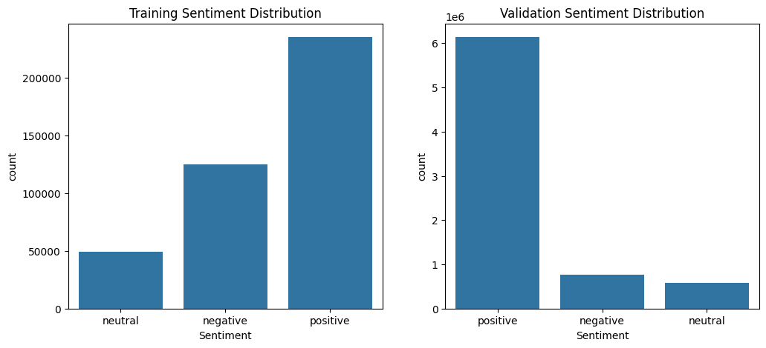

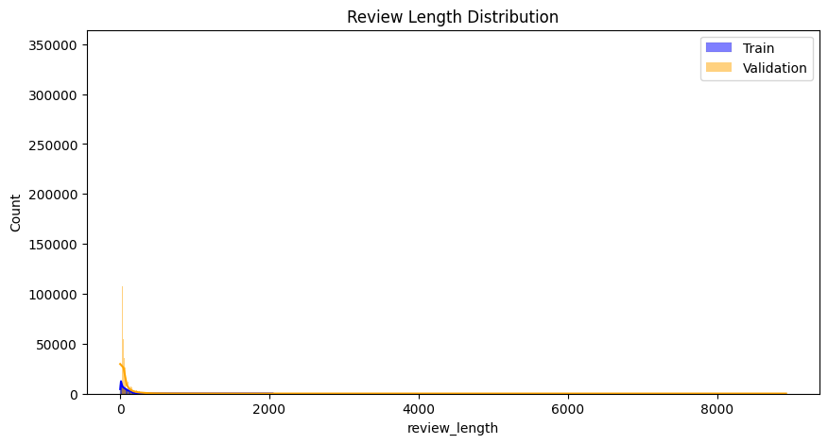
Baseline modeling and feature comparison:
A balanced Logistic Regression model was trained on each feature variant—raw_tfidf, selected_tfidf, lexicon_only, and hybrid—to assess validation accuracy and Macro-F1 scores. The results were visualized in Validation Accuracy by Feature Variant and Macro-F1 Score by Feature Variant.
- Lexicon-only features yielded the highest accuracy (0.788), but suffered from low Macro-F1 (0.439), indicating poor minority class performance.
- Selected TF-IDF and hybrid features achieved more balanced Macro-F1 scores (~0.472–0.473), with hybrid offering a trade-off between interpretability and performance.
- Raw TF-IDF performed worst across both metrics.
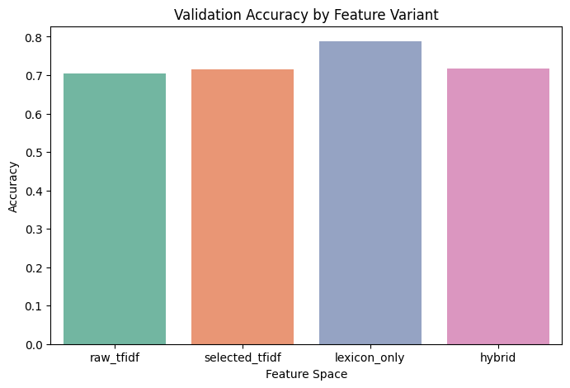
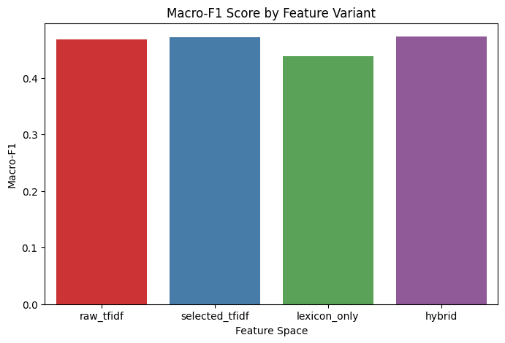
Confusion matrices for each variant revealed consistent misclassification patterns, especially in the Neutral class, which suffered from semantic ambiguity and overlap with other sentiments (Confusion Matrix Grid). These matrices provided insight into per-class performance and error modes.

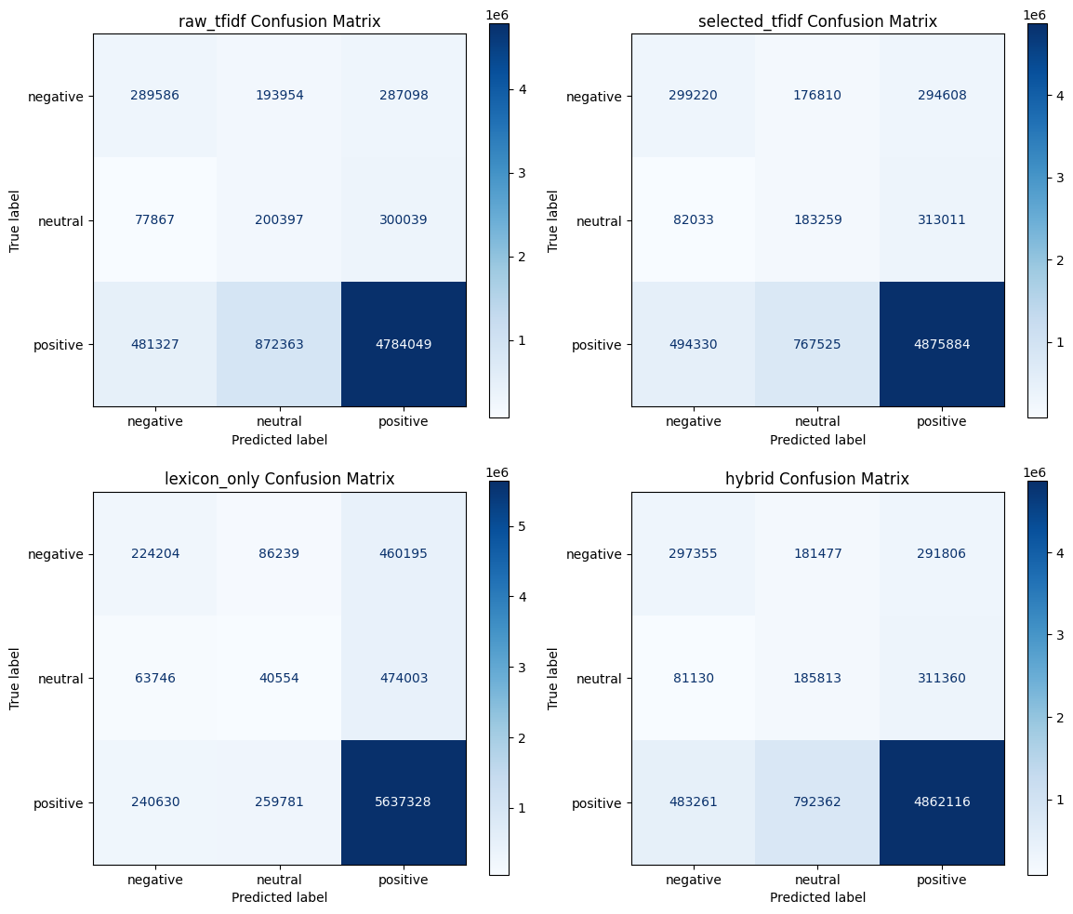

Feature interpretability and lexical analysis:
Lexicon-only features were further analyzed using kernel density plots for each VADER component (vader_pos, vader_neg, vader_neu, vader_compound). These plots revealed clear distributional shifts across sentiment classes, with vader_pos and vader_neg showing strong separation, while vader_neu remained relatively uniform. Summary statistics confirmed these trends, supporting the use of lexicon features as interpretable sentiment indicators.
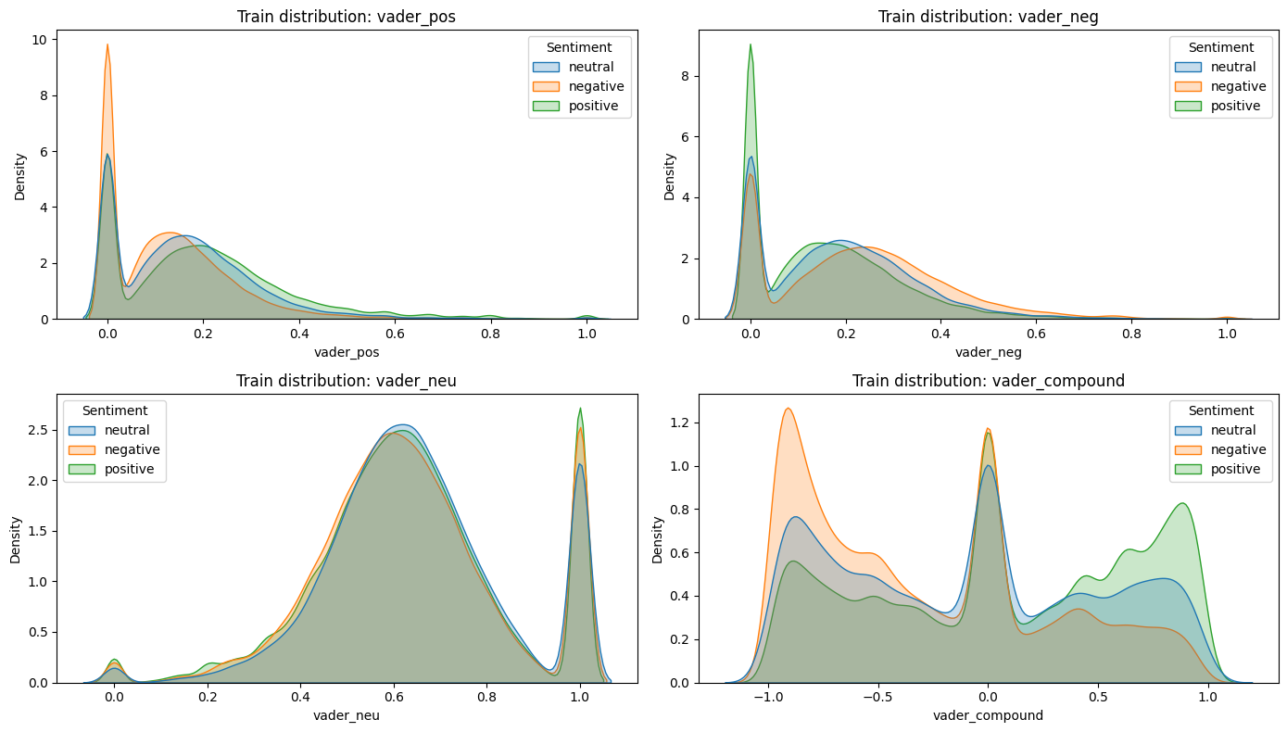

Correlation and separability diagnostics:
Correlation analysis between VADER features and label-encoded sentiment revealed that vader_compound (r = 0.272) and vader_pos (r = 0.200) were positively associated with sentiment class, while vader_neg was negatively correlated (r = –0.194). A 2D scatter plot of vader_compound vs. vader_pos showed partial separability between sentiment classes (Compound vs Pos by Sentiment), with positive samples clustering in the upper-right quadrant.

Lexicon-only baseline evaluation:
A 5-fold stratified cross-validation using Logistic Regression on lexicon-only features yielded modest performance:
- Accuracy: 0.569
- Macro-F1: 0.384
- Neutral class: Precision and recall near zero, indicating severe underperformance.
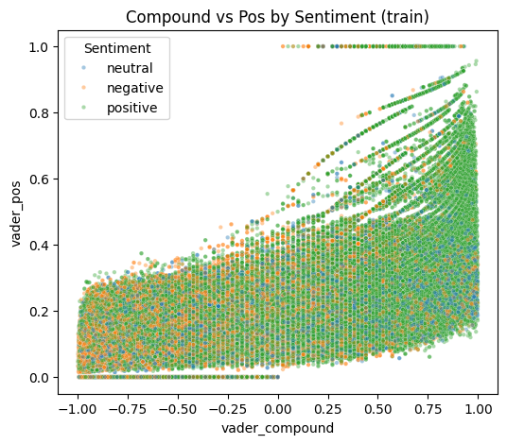
These results underscore the limitations of lexicon-only models in multi-class sentiment classification, especially under class imbalance and linguistic ambiguity.
Design guarantees:
- Model sanity checks: Confusion matrices and F1 scores validated the feature spaces before full-scale modeling.
- Feature transparency: Lexicon distributions and TF-IDF rankings provided interpretable insights into model inputs.
- Class imbalance awareness: Visual diagnostics reinforced the need for balanced training strategies and careful evaluation.
- Correlation and separability: Lexicon features showed measurable alignment with sentiment labels, supporting their inclusion in hybrid models.

3.Methodology:
The methodological framework of this study was designed to ensure reproducibility, interpretability, and fair comparison across a diverse set of machine learning paradigms for sentiment classification. Building on the structured preprocessing pipeline, the methodology integrates linear and non-linear models, each evaluated under consistent conditions and feature representations.
The process begins with data aggregation and preprocessing, where heterogeneous review sources were normalized into a canonical schema, ratings were mapped to sentiment categories, and multiple feature spaces were engineered. These include lexicon-only features derived from VADER sentiment scores, TF-IDF embeddings reduced via chi-square selection, and hybrid representations combining both. Quality assurance procedures validated the distributions, separability, and integrity of these features prior to modeling.
With the datasets and features established, the modeling stage explores a range of supervised learning algorithms. The models were selected to represent both interpretable linear baselines and more expressive non-linear approaches:
- Logistic Regression (L1 and L2 regularization), serving as a transparent linear baseline.
- Fisher’s Linear Discriminant, providing a mathematically principled linear classifier for comparison.
- Support Vector Machines (SVMs), effective in high-dimensional sparse spaces.
- Neural Networks, included to benchmark performance against non-linear architectures.
Each model was trained and evaluated on both lexicon-only and hybrid feature spaces, with class imbalance addressed through balanced weighting schemes. Hyperparameter tuning was conducted using GridSearchCV or equivalent cross-validation strategies, with performance assessed using Accuracy, Macro Precision, Recall, F1 scores, ROC-AUC, and confusion matrices. Five-fold stratified cross-validation was employed to evaluate model stability and variance.
This methodological design ensures that all models are evaluated under consistent preprocessing, feature engineering, and validation protocols. By combining interpretable linear baselines with more complex non-linear approaches, the study provides a comprehensive framework for understanding the trade-offs between interpretability, scalability, and predictive accuracy in sentiment classification.

3.1. Logistic Regression

Logistic Regression was employed as a foundational linear baseline for sentiment classification, chosen for its interpretability, efficiency, and robustness in high‑dimensional text domains. Both L1 (Lasso) and L2 (Ridge) regularization variants were implemented to examine the trade‑offs between sparsity and stability in coefficient estimation. Models were trained on two distinct feature spaces: a lexicon‑only representation consisting of four sentiment scores derived from the VADER lexicon (positive, negative, neutral, compound), and a hybrid representation that combined TF‑IDF embeddings selected via chi‑square feature selection with the lexicon features.
To stabilize training on sparse, high‑dimensional TF‑IDF matrices, a custom wrapper (PreprocLogReg) was developed. This pipeline applied Truncated Singular Value Decomposition (SVD) for dimensionality reduction prior to Logistic Regression, ensuring comparability with Fisher’s Linear Discriminant workflow and preventing instability in optimization. Sentiment labels were encoded numerically using scikit‑learn’s LabelEncoder to ensure compatibility with the estimators.
Model configurations included both L1 and L2 penalties, with the saga solver used for L1 regularization to encourage sparsity and the lbfgs solver used for L2 regularization to provide smoother weight distributions. All models were trained with class_weight="balanced" to mitigate the strong class imbalance observed in the dataset. Hyperparameter tuning was conducted using GridSearchCV, with parameter grids spanning regularization strengths (C values of 0.01, 0.1, 1, and 10), penalty types, solver choices, and SVD dimensionality (50, 100, 200 components). Models were scored using Macro‑F1 to prioritize balanced performance across all sentiment classes rather than accuracy alone.
Evaluation was performed on both lexicon‑only and hybrid feature sets. Metrics reported included accuracy, macro‑averaged precision, recall, F1 score, ROC‑AUC (multi‑class one‑vs‑rest), and per‑class F1 scores. Confusion matrices and classification reports were generated to assess class‑specific behavior, particularly focusing on the Neutral class, which was expected to be more challenging due to semantic overlap with other sentiments. Five‑fold stratified cross‑validation was conducted on the training set to evaluate stability and variance in Macro‑F1 scores, ensuring that performance was not dependent on a single train‑validation split.

3.2. Fisher’s Linear Discriminant
Fisher’s Linear Discriminant was implemented as a comparative linear baseline to Logistic Regression, with extensive adaptations to address the challenges of high‑dimensional sparse text features and severe class imbalance. The training set was first balanced by subsampling each sentiment class to the size of the minority class, ensuring equal representation of Negative, Neutral, and Positive samples. Sanity checks were performed to confirm label alignment after balancing, and visualizations of class distributions before and after balancing were generated to validate the procedure. Two feature spaces were used: a lexicon‑only representation consisting of four sentiment scores derived from VADER (positive, negative, neutral, compound), and a hybrid representation that combined TF‑IDF embeddings selected via chi‑square with the lexicon features. For high‑dimensional hybrid spaces, Truncated Singular Value Decomposition (SVD) was applied prior to Fisher’s Linear Discriminant to stabilize training and reduce dimensionality.
A custom estimator, FisherEstimator, was developed to wrap SVD and scikit‑learn’s Linear Discriminant Analysis (LDA). This estimator incorporated tempered priors, optional upsampling, and shrinkage to improve robustness. Priors were adjusted using an inverse‑frequency scheme controlled by the parameter prior_alpha, where values greater than zero applied inverse‑frequency weighting to mitigate bias toward majority classes. For low‑dimensional feature spaces, priors were blended with empirical distributions to avoid extreme shifts. Upsampling mechanisms were included to increase representation of the Neutral class, with conservative caps applied for lexicon features and majority‑level upsampling permitted for hybrid features when explicitly enabled. LDA was configured with the lsqr solver and automatic shrinkage to improve numerical stability in high‑dimensional settings.
To refine preprocessing and model configurations, an automated tuner explored combinations of upsampling multipliers, dimensionality reduction targets, lexicon feature augmentation, and sample weighting strategies. Each configuration was evaluated across multiple repeats using balanced mini‑train subsets for efficiency, and quick evaluation runs applied Fisher’s Linear Discriminant with reduced SVD dimensionality to estimate Macro‑F1 and Neutral‑class F1 scores. Configurations were ranked using a composite score that combined Macro‑F1 and Neutral‑class F1 performance, and the best configuration was applied to the full training set with filters recorded for reproducibility. A focused hyperparameter search was then conducted on the top‑ranked configurations, tuning parameters such as the number of SVD components, shrinkage values, upsampling strategies, and prior settings. Compact experiments were also performed to sweep prior_alpha values across 0.0, 0.5, and 1.0, isolating the effect of prior weighting on class balance and particularly on the Neutral category.
To further improve Neutral‑class performance, calibration and thresholding were introduced. A small stratified hold‑out set, comprising approximately 2% of the training data, was reserved for calibration. Fisher’s model was trained on the full hybrid feature space with explicit Neutral upsampling, and class probabilities were calibrated using isotonic regression. Thresholds for the Neutral class were swept across a range, and the threshold maximizing Neutral‑class F1 was selected and applied to validation predictions. This procedure allowed Fisher’s model to adjust decision boundaries post‑training, mitigating bias against the Neutral class.
Evaluation was conducted on both lexicon‑only and hybrid feature sets, with calibration applied to hybrid variants. Metrics included accuracy, macro precision, recall, F1, micro F1, ROC‑AUC, and per‑class F1 scores. Confusion matrices and classification reports were generated to visualize class‑specific performance. Five‑fold stratified cross‑validation was performed to assess stability, with comparisons made between CV scores and validation scores. Visualizations included bar charts comparing CV versus validation Macro‑F1, per‑class F1 comparisons across sentiment categories, scatter plots of CV fold scores versus validation Macro‑F1, and heatmaps of Macro‑F1 across variants and feature sets.
Finally, diagnostics and variant experiments were conducted to ensure transparency and reproducibility. A diagnostic utility summarized dataset characteristics and model internals, including class distributions and computed priors. Multiple experimental variants were run, including a baseline model without priors or upsampling, a priors‑only model, an upsample‑only model, and a combined priors‑plus‑upsampling model. Results from these variants were aggregated into summary tables, with arrows marking the best values per metric, and class‑wise F1 scores, confusion matrices, and metric heatmaps were plotted to compare variant performance across feature sets.

3.3. SVM

The proposed approach aims to improve minority class recognition while maintaining computational efficiency on large-scale sentiment datasets. Comparative evaluation against ensemble and neural models provides insight into the trade-offs between model complexity, performance balance, and scalability.

3.3.1: Baseline Establishment (CSV Linear)

Method: Standard Linear Support Vector Classifier (LinearSVC).
Output: The model suffered from Majority Class Bias, achieving high accuracy by predicting "Positive" but failing on the "Neutral" class (0% Recall).

3.3.2: Algorithmic Tuning (CSV_COST)

Method: Linear SVC with class weight='balanced'.
Output: Introduced Cost-Sensitive Learning, penalizing the model more for missing minority classes. This improved the negative F1-scores but was insufficient for the Neutral class.

3.3.3: Data-Centric Balancing (SMOTE)
Method: Synthetic Minority Over-sampling Technique.
Output: By creating synthetic "Neutral" examples, we achieved the first breakthrough in Neutral Recall (0.04), proving that the model needed more balanced data exposure.

3.3.4: Scaling for Big Data (SGD)
Method: Stochastic Gradient Descent (SGD) with Hinge Loss.
Output: Standard SVMs are too slow for millions of rows. SGD allowed the model to train in minutes rather than hours while maintaining SVM-like decision boundaries.

3.3.5: The Final Integrated Model (Hybrid SMOTE+SGD)
Method: Combining SMOTE oversampling, SGD scalability, and Hybrid Features (TF-IDF + Lexicon).
Output: The Optimal Configuration, achieving the highest Macro F1-score (0.42) and Neutral Recall (0.11).

3.3.6. Evaluation Strategy

The methodology prioritized Fairness over Accuracy:
Macro-Averaged F1-Score: Used as the primary KPI because it weighs all three classes (Pos/Neu/Neg) equally, regardless of their size.
Normalized Confusion Matrices: Used to visualize success percentages per class, ensuring the massive "Positive" class did not hide the failures in "Neutral."

3.3.7. Comparative Models
For benchmarking purposes, two additional models were included:
Random Forest, representing ensemble-based learning
Neural Network, representing deep learning-based classification
These models provide a reference for assessing the trade-offs between traditional linear models, hybrid optimization strategies, and more complex architectures.

Methods: Pipeline of Improvement

3.4. Varying Methods and Neural Network

3.4.1. Classification Models
Five classification algorithms were evaluated using 5-fold stratified cross-validation:
- Neural Network: Multi-layer perceptron with architecture [512, 256, 128] units, ReLU activation, batch normalization, and dropout (0.3) for regularization.
- Random Forest: Ensemble of 200 decision trees with balanced class weights and maximum depth of 30.
- Extra Trees: Extremely randomized trees with 200 estimators and randomized split thresholds.
- XGBoost: Gradient boosting with 200 estimators, learning rate of 0.1, and maximum depth of 6.
- LightGBM: Gradient boosting with leaf-wise tree growth, 200 estimators, and 31 leaves per tree.

3.4.2. Data Augmentation
Random oversampling was applied to address class imbalance. For three-class classification, minority classes (Neutral, Negative) were oversampled to 50% of the majority class size. For binary classification, the non-positive class was oversampled to 70% of the positive class. The effectiveness of oversampling was evaluated by comparing model performance on original versus augmented training data.

3.4.3. Unsupervised Clustering Analysis
To investigate whether sentiment classes form natural clusters, two clustering approaches were applied:
Dimensionality Reduction: Principal Component Analysis (PCA) reduced the 3004 dimensional feature space to 50 components, preserving the majority of variance while enabling efficient clustering computation.
K-Means Clustering: Centroid-based clustering with k=3 clusters (matching the number of sentiment classes) was performed to evaluate whether the algorithm could recover sentiment groupings.
HDBSCAN: Hierarchical Density-Based Spatial Clustering of Applications with Noise was applied with minimum cluster size of 50 and minimum samples of 10 to identify density-based clusters without requiring a predefined number of clusters.
Cluster Validity Metrics: Silhouette Score (range: -1 to 1, higher indicates better-defined clusters), Davies-Bouldin Index (lower indicates better separation), and Calinski-Harabasz Index (higher indicates denser, well-separated clusters) were computed. Additionally, cosine similarity matrices between cluster centroids were analyzed.

3.4. Perceptron

To address the challenges of high dimensionality, linear inseparability, and severe class imbalance in the sentiment dataset, a multi-stage machine learning pipeline was developed. The approach integrates manual feature engineering, strategic undersampling, ensemble learning, and probability threshold optimization to ensure robust performance across all sentiment categories.

3.4.1. Feature Space Augmentation
Standard linear models, such as the Perceptron, often struggle to detect non-linear relationships, particularly those representing "mixed" sentiment or explicit neutrality. To mitigate this limitation, we augmented the hybrid feature space with three manually calculated interaction features derived from the lexicon counts. First, a Neutrality Score was calculated as 1/(Pos+Neg+1); this inverse-sum feature explicitly highlights samples with low emotional intensity. Second, an Interaction Term was calculated as Pos×Neg, acting as a non-linear "AND" gate to identify mixed sentiment that linear boundaries often fail to capture. Finally, a Conflict Ratio was calculated as Pos/(Neg+1) to provide a continuous measure of polarity dominance. These features were stacked onto the existing hybrid feature matrix (Xhybrid​) prior to training.

3.1.2. Strategic Undersampling (Class Balancing)
The original dataset exhibited severe class imbalance, with the "Positive" class overwhelmingly dominating the minority "Neutral" class. To prevent the model from converging on a trivial majority-class solution, a strategic undersampling technique was applied. This process involved retaining 100% of the minority "Neutral" samples while randomly undersampling the "Positive" and "Negative" classes to a target size of 2× the size of the "Neutral" class. This resulted in a balanced training subset (Xtrain_bal​) that ensured the loss function weighted the minority class sufficiently during the optimization process.

3.4.3. Model Architecture and Hyperparameter Tuning
The core classification architecture consisted of a Pipeline comprising three distinct stages. First, dimensionality was reduced using SelectKBest (utilizing the ANOVA F-value) to eliminate noise features. Next, a StandardScaler (without mean centering) was applied to normalize feature variance, ensuring stable convergence for the linear optimizer. Finally, a Perceptron (an SGD-based linear classifier) served as the base estimator; to enable probabilistic outputs from this non-probabilistic margin classifier, it was wrapped in a CalibratedClassifierCV using Isotonic regression. Hyperparameters were optimized via GridSearchCV using 3-fold cross-validation on the balanced dataset. The search space included feature count (k∈[1500,2500]), regularization penalty (l2 vs elasticnet), and alpha (0.0001 vs 0.001), with the Macro F1-Score serving as the optimization metric.

3.4.5. Decision Threshold Optimization
Standard argmax classification, which selects the class with the highest probability, is suboptimal for imbalanced data as it inherently favors the majority class. To maximize the Macro F1-Score, we implemented a post-hoc threshold optimization step. We first generated raw probability distributions for the validation set using the Bagging ensemble. We then defined a dynamic decision function where the "Neutral" class is predicted if its probability exceeds a specific threshold (τ); otherwise, the model defaults to the maximum between Positive and Negative. We iterated through potential thresholds (τ) ranging from 0.15 to 0.55, and the threshold yielding the highest Macro F1-Score on the validation set was selected as the final operating point.

3.5.Neural Networks and Ensemble Methods

Five classification algorithms were evaluated using 5-fold stratified cross-validation:
- Neural Network: Multi-layer perceptron with architecture [512, 256, 128] units, ReLU activation, batch normalization, and dropout (0.3).
- Random Forest: Ensemble of 200 decision trees with balanced class weights and maximum depth of 30.
- Extra Trees: Extremely randomized trees with 200 estimators and randomized split thresholds.
- XGBoost: Gradient boosting with 200 estimators, learning rate of 0.1, and maximum depth of 6.
- LightGBM: Gradient boosting with leaf-wise tree growth, 200 estimators, and 31 leaves per tree.

3.5 Transformer-Based Text Embeddings
Building upon the traditional TF-IDF and lexicon-based feature representations, this section investigates the application of transformer-based sentence embeddings for sentiment classification. Specifically, we evaluate Sentence-BERT (SBERT), a modification of the BERT architecture optimized for generating semantically meaningful sentence-level representations. This approach addresses fundamental limitations of bag-of-words models, including the inability to capture semantic relationships, contextual nuances, and linguistic phenomena such as negation and sarcasm.

3.5.1 Motivation and Theoretical Background
Traditional text representations such as TF-IDF treat words as independent tokens, producing sparse, high-dimensional vectors that fail to encode semantic similarity. For instance, the phrases "excellent product" and "outstanding item" would share minimal feature overlap despite conveying identical sentiment. Furthermore, TF-IDF cannot differentiate between "good" and "not good," as both contain the token "good" with equal weight. Sentence-BERT (Reimers & Gurevych, 2019) extends the BERT architecture by employing siamese and triplet network structures to derive fixed-size sentence embeddings suitable for similarity comparison. The model leverages transfer learning from pre-training on over one billion sentence pairs, providing robust linguistic representations that generalize across domains.

3.5.2 Embedding Model Selection (Pilot Study)
Prior to full-scale experimentation, a pilot study was conducted on a stratified subset of the training data to evaluate candidate embedding models. Five embedding approaches were compared: TF-IDF (baseline), Word2Vec, DistilBERT, Sentence-BERT (all-MiniLM-L6-v2), and MPNet (all-mpnet-base-v2). Each embedding was evaluated using the same classification architecture (Extra Trees with balanced class weights) under identical cross-validation protocols.
Embedding Model | Dimensions | CV Macro-F1 | Computation Time
TF-IDF (Baseline) | 3,004 (sparse) | 0.868 | ~10 seconds
Word2Vec | 300 (dense) | 0.874 | ~530 seconds
DistilBERT | 768 (dense) | 0.876 | ~100 seconds
Sentence-BERT | 384 (dense) | 0.918 | ~30 seconds
MPNet | 768 (dense) | 0.924 | ~230 seconds
Table 2: Pilot Study — Embedding Model Comparison
Green highlighting indicates selected model based on optimal speed-quality trade-off.

The pilot study revealed that Sentence-BERT (all-MiniLM-L6-v2) achieved near-optimal classification performance (Macro-F1 = 0.918) while maintaining the fastest computation time (~30 seconds). Although MPNet marginally outperformed SBERT (0.924 vs 0.918), its 7.7× longer encoding time rendered it impractical for the full-scale dataset of 409,577 reviews.

4.Results:
Following the methodological framework outlined in the previous section, this part presents the empirical outcomes of the sentiment classification experiments. Each model was trained and evaluated under consistent preprocessing, feature engineering, and validation protocols, ensuring comparability across approaches. The results are organized to highlight both overall performance metrics and class-specific behaviors, with particular attention to the challenges posed by class imbalance and linguistic ambiguity in the Neutral category.
Performance is reported across multiple dimensions, including accuracy, precision, recall, F1 scores, ROC-AUC, and confusion matrices. These measures provide a comprehensive view of each model’s strengths and limitations, while visualizations such as bar plots and distribution charts are used to illustrate comparative performance across feature variants.
The Results section is structured to mirror the Methodology: beginning with linear baselines such as Logistic Regression, then progressing to Fisher’s Linear Discriminant, Support Vector Machines, and finally non-linear models including Neural Networks and ensemble methods. This organization allows for a clear narrative that moves from interpretable, foundational models toward more complex architectures, while maintaining continuity with the methodological design.
Traditional Methods (TF-IDF + VADER)

The Neural Network achieved the highest performance on TF-IDF features with Macro-F1 of 0.731 (three-class) and 0.863 (binary). Among traditional machine learning methods, gradient boosting algorithms (XGBoost: 0.553, LightGBM: 0.554) outperformed bagging methods (Random Forest: 0.535, Extra Trees: 0.531) on the original data. Logistic Regression achieved 0.458 Macro-F1 on hybrid features, while Fisher's Linear Discriminant reached similar performance with extensive preprocessing.
Table 4: Classification Performance with TF-IDF + VADER Features
Model | 3-Class Macro-F1 | Binary Macro-F1 | Neutral F1
Neural Network | 0.731 | 0.863 | 0.68
LightGBM | 0.554 | 0.746 | 0.14
XGBoost | 0.553 | 0.747 | 0.14
Random Forest | 0.535 | 0.742 | 0.03
Extra Trees | 0.531 | 0.739 | 0.03

Sentence-BERT Embedding Results

Table 5 presents the classification performance of all five models on Sentence-BERT embeddings. The Extra Trees classifier achieved the highest performance with 85.11% accuracy and Macro-F1 of 0.8051, followed closely by Random Forest (84.42%, 0.7977). These results represent a substantial improvement over TF-IDF baselines, with bagging ensemble methods exhibiting the most pronounced gains.

Model | Accuracy | Macro-F1 | F1-Neg | F1-Neu | F1-Pos
Extra Trees | 85.11% | 0.8051 | 0.852 | 0.711 | 0.853
Random Forest | 84.42% | 0.7977 | 0.847 | 0.713 | 0.833
Neural Network | 82.25% | 0.7579 | 0.796 | 0.594 | 0.884
XGBoost | 71.41% | 0.5009 | 0.680 | 0.049 | 0.773
LightGBM | 70.95% | 0.4979 | 0.674 | 0.049 | 0.771
Table 5: Classification Performance with Sentence-BERT Embeddings

4.1. Logistic Regression Results

To evaluate the performance of Logistic Regression under both L1 and L2 regularization, models were trained on lexicon-only and hybrid feature spaces. Hyperparameter tuning was conducted using 3-fold cross-validation over a grid of regularization strengths (C), penalty types, and solvers. The best configuration for the L2-regularized model was identified as C = 1, penalty = 'l2', and solver = 'lbfgs', yielding a cross-validated Macro-F1 score of 0.406 on the lexicon-only training set.
Final evaluation was performed on a held-out validation set of 1,000 samples. Metrics reported include accuracy, macro-averaged precision, recall, F1 score, ROC-AUC, and per-class F1 scores. Confusion matrices and classification reports were generated to assess class-specific behavior.
Metric | Lexicon-only Model | Hybrid Model
Validation Accuracy | 0.91 | 0.806
Macro F1 Score | 0.885 | 0.591
ROC-AUC (multi-class OVR) | 0.987 | 0.919
Per-class F1 – Negative | 0.898 | 0.845
Per-class F1 – Neutral | 0.833 | 0.025
Per-class F1 – Positive | 0.923 | 0.902
5-Fold CV Macro-F1 (Train) | 0.406 | 0.579

A comparative bar chart (Validation Macro-F1 Comparison) was generated to visualize the difference in performance between the lexicon-only and hybrid models. Confusion matrices for both configurations revealed distinct patterns of misclassification, particularly in the Neutral class, which exhibited low recall and precision under the hybrid setup.
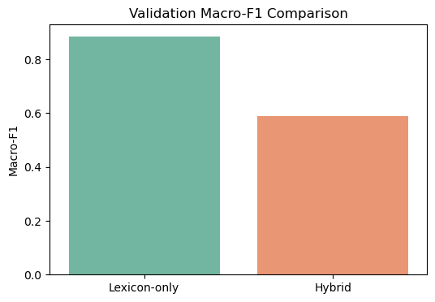

4.2. Fisher’s Linear Discriminant

4.2.1. Fisher’s Linear Discriminant
Fisher’s Linear Discriminant was evaluated as a robust, interpretable baseline for sentiment classification across lexicon-only and hybrid feature spaces. The model underwent extensive experimentation, including class balancing, hyperparameter tuning, prior sensitivity analysis, calibration, and variant comparisons. This section presents the full spectrum of results, highlighting performance trends, trade-offs, and diagnostic insights.

4.2.2. Class Balancing and Feature Setup
The training set was initially imbalanced, with the Neutral class significantly underrepresented. To mitigate this, the dataset was balanced by subsampling each class to match the minority count, resulting in 148,119 samples with 49,373 instances per class. Visual inspection confirmed the effectiveness of this balancing strategy. Two feature spaces were used throughout: a lexicon-only representation derived from VADER sentiment scores, and a hybrid representation combining TF-IDF embeddings with lexicon features. Dimensionality reduction via Truncated SVD was applied to hybrid features to stabilize training and improve generalization.
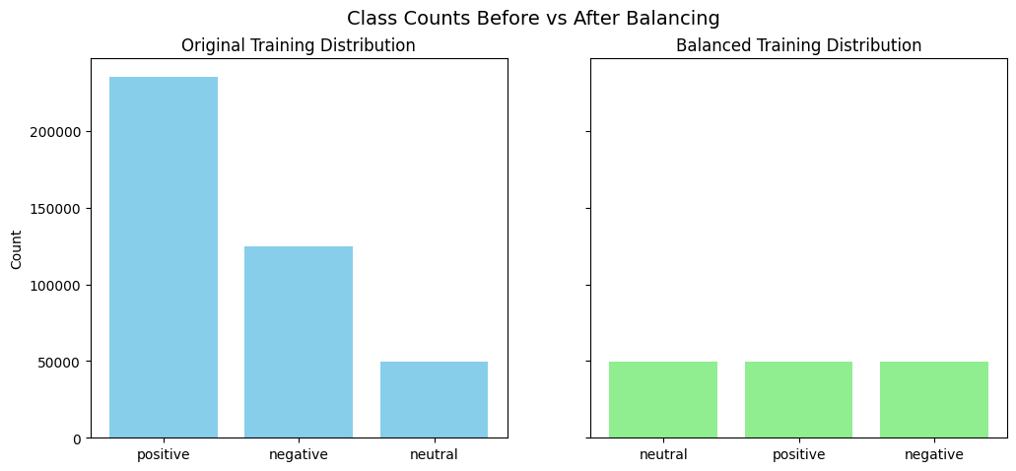

4.2.3. Hyperparameter Tuning and Configuration Selection
An automated grid search explored combinations of preprocessing strategies, including lexicon augmentation, hybrid dimensionality reduction, and neutral upsampling. The top-ranked configuration applied a neutral upsampling multiplier of 1.5, reduced hybrid features to 100 components, and included engineered lexicon features. A focused Fisher-specific grid search refined model parameters, selecting svd_n_components = 100, lda_solver = "lsqr", lda_shrinkage = None, and prior_alpha = 0.5, with neutral upsampling capped at 50,000 samples. This configuration achieved a validation Macro-F1 of 0.453, Neutral-class F1 of 0.125, and accuracy of 0.769, with a best cross-validated Macro-F1 of 0.490, confirming strong generalization.

4.2.4. Prior Sensitivity Analysis
To isolate the effect of tempered priors, a compact experiment swept prior_alpha values across 0.0, 0.5, and 1.0. Results showed that prior weighting had a negligible impact on performance. Lexicon-only models consistently achieved a Macro-F1 of 0.439 and Neutral-class F1 of 0.085, while hybrid models reached 0.458 and 0.169, respectively. These findings suggest that priors alone are insufficient to address class imbalance and must be paired with other strategies such as upsampling or calibration.

prior_alpha | lexicon_macro_f1 | lexicon_f1_neutral | hybrid_macro_f1 | hybrid_f1_neutral
0 | 0.4391 | 0.0851 | 0.4577 | 0.1692
0.5 | 0.4391 | 0.0851 | 0.4577 | 0.1692
1 | 0.4391 | 0.0851 | 0.4577 | 0.1692

4.2.5. Calibration and Thresholding
A controlled calibration experiment was conducted on the hybrid model. A 2% stratified hold-out set was used to calibrate class probabilities via isotonic regression. Thresholds for the Neutral class were swept from 0.05 to 0.50, with the optimal threshold identified at t = 0.290, yielding a hold-out Neutral F1 of 0.523. However, when applied to the validation set, thresholding improved Neutral recall but degraded overall precision, resulting in a Macro-F1 of 0.113 and accuracy of 0.11. This confirmed that aggressive thresholding can overcorrect minority class bias at the expense of global performance.

variant | macro_f1 | f1_neutral
Raw Fisher Hybrid | 0.4576 | 0.1679
Calibrated+Threshold Hybrid | 0.1131 | 0.146

4.2.6. Lexicon vs Hybrid Comparison
Final evaluation compared lexicon-only and hybrid models under the selected configuration. The lexicon-only model achieved an accuracy of 0.787, Macro-F1 of 0.439, and ROC-AUC of 0.719, with per-class F1 scores of 0.346 (Negative), 0.085 (Neutral), and 0.886 (Positive). Five-fold cross-validation yielded a mean Macro-F1 of 0.398. The hybrid model achieved an accuracy of 0.734, Macro-F1 of 0.458, and ROC-AUC of 0.718, with per-class F1 scores of 0.352, 0.169, and 0.852, respectively. Cross-validation confirmed stronger generalization, with a mean Macro-F1 of 0.526 and standard deviation of 0.003.

4.2.7.Variant Comparison
Four model variants were evaluated: baseline, priors-only, upsample-only, and priors-plus-upsample. Results showed that priors had minimal impact when applied alone, and that upsampling significantly improved Neutral-class F1 in lexicon models but introduced instability in hybrid spaces. The baseline hybrid model consistently delivered the best balance of accuracy, Macro-F1, and class sensitivity. A summary of variant performance is shown below:

Variant | Feature Set | Accuracy | Macro F1 | ROC-AUC | F1-Negative | F1-Neutral | F1-Positive
baseline | Lexicon | 0.787 | 0.439 | 0.582 | 0.346 | 0.085 | 0.886
baseline | Hybrid | 0.734 | 0.458 | 0.607 | 0.352 | 0.169 | 0.852
priors_only | Lexicon | 0.787 | 0.439 | 0.582 | 0.346 | 0.085 | 0.886
priors_only | Hybrid | 0.734 | 0.458 | 0.607 | 0.352 | 0.169 | 0.852
upsample_only | Lexicon | 0.599 | 0.35 | 0.596 | 0.094 | 0.183 | 0.772
upsample_only | Hybrid | 0.793 | 0.435 | 0.589 | 0.356 | 0.065 | 0.885
priors_plus_upsample | Lexicon | 0.599 | 0.35 | 0.596 | 0.094 | 0.183 | 0.772
priors_plus_upsample | Hybrid | 0.793 | 0.435 | 0.589 | 0.356 | 0.065 | 0.885

4.2.8. Diagnostic Insights
Confusion matrices revealed consistent misclassification of Neutral samples as Positive, especially in lexicon-only models. Class-wise F1 plots confirmed that hybrid models offered better balance across all classes. Scatter plots comparing CV fold scores to validation Macro-F1 showed tight clustering for hybrid models, indicating strong generalization. Heatmaps of Macro-F1 across variants and feature sets reinforced the superiority of hybrid baselines.
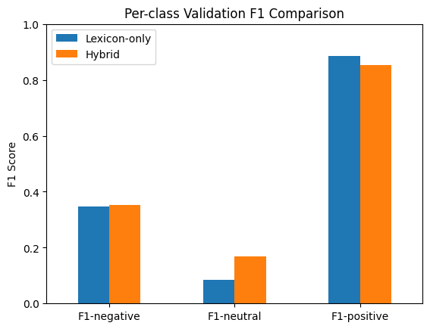
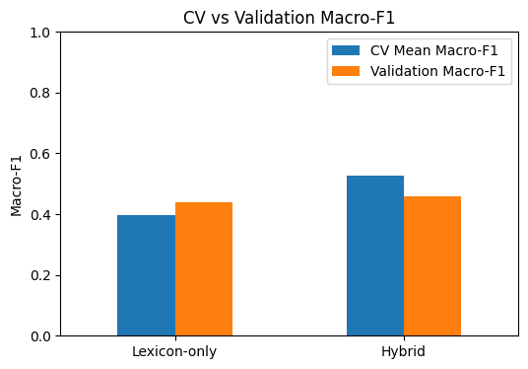

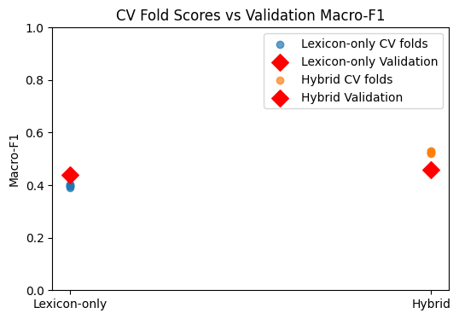

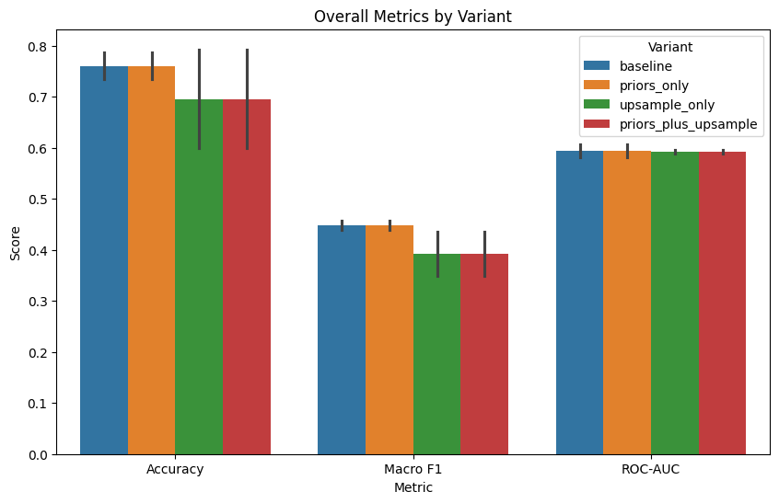

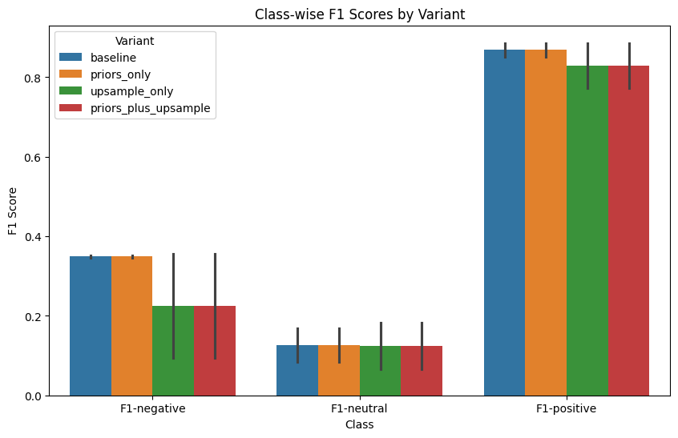

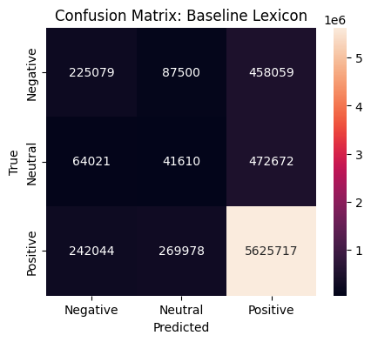

4.3. SVM

4.3.1 Baseline: CSV Linear

The initial model utilizes a standard Linear Support Vector Classifier. This model failed to distinguish neutral sentiment, resulting in 0.00 recall for Class 1. This "Neutral Collapse" occurred because the linear hyperplane was pulled entirely toward the majority Positive class to minimize global loss.

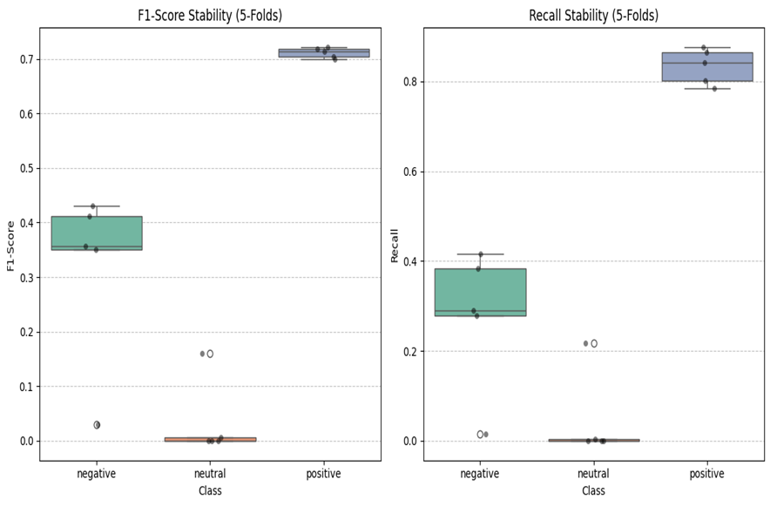

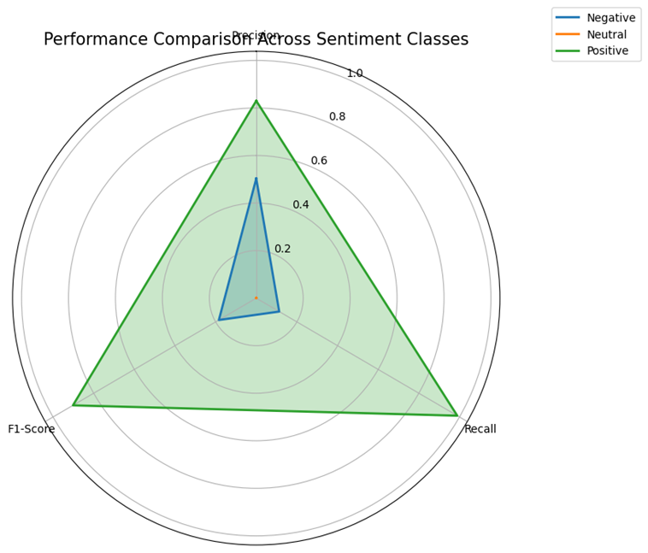

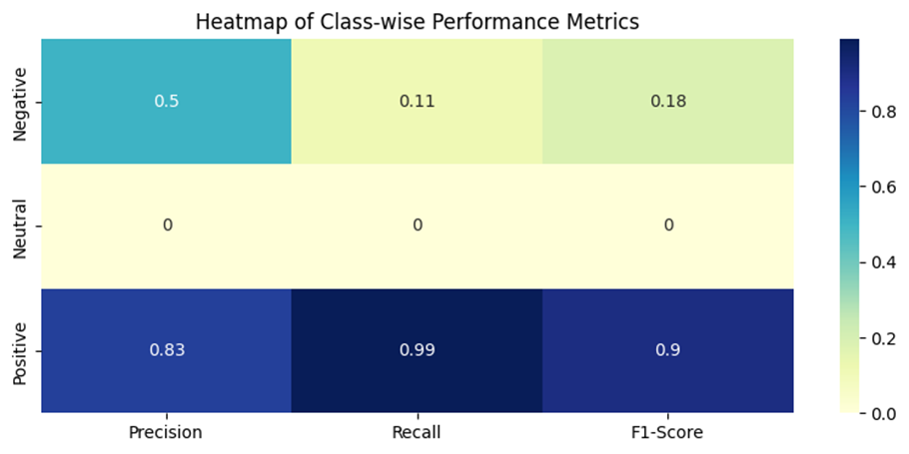

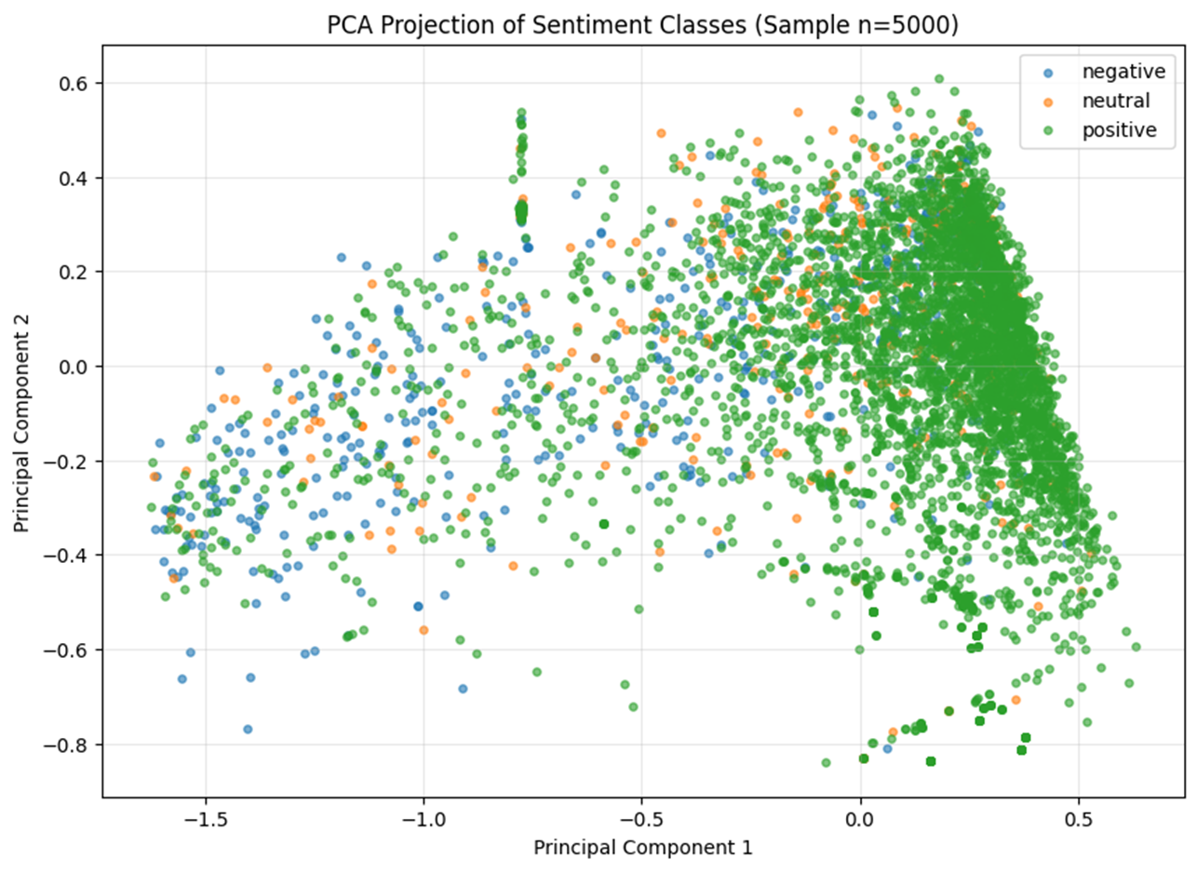

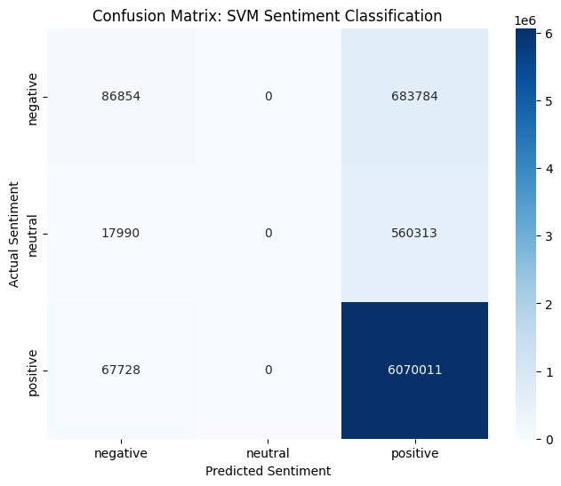

4.3.2 CSV_COST (Cost-Sensitive Learning)

To counteract the majority bias, we implemented cost-sensitive learning by setting class_weight='balanced'. This technique artificially increases the penalty for misclassifying minority samples. While this improved the Negative class recall to 0.39, it was insufficient to recover the Neutral class.
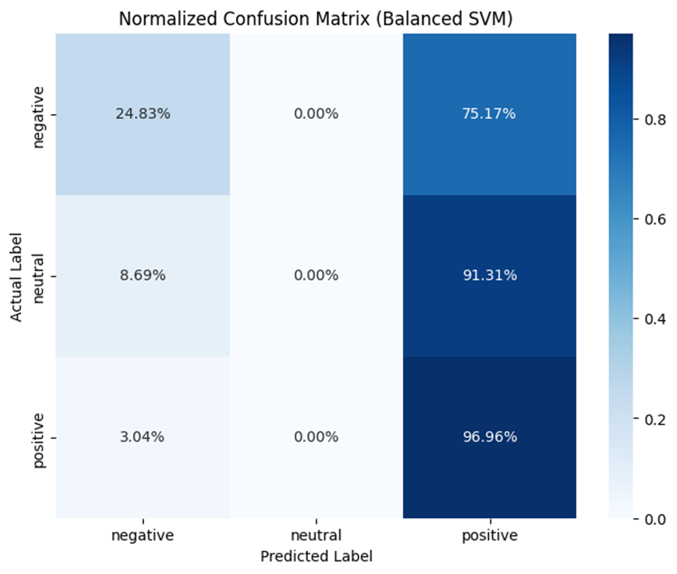

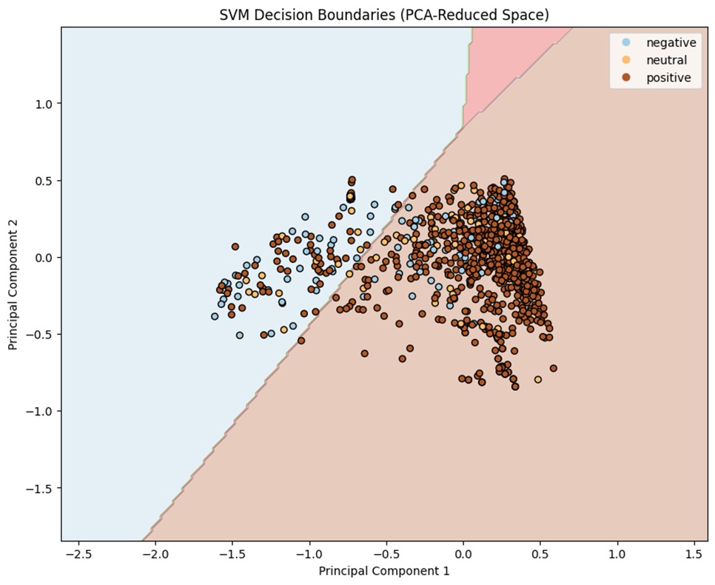

4.3.3 SMOTE (Synthetic Minority Over-sampling Technique)
SMOTE was introduced to populate the sparse feature space of the Neutral class. By generating synthetic samples rather than duplicating existing ones, SMOTE expanded the "Neutral Zone" in the TF-IDF feature space.
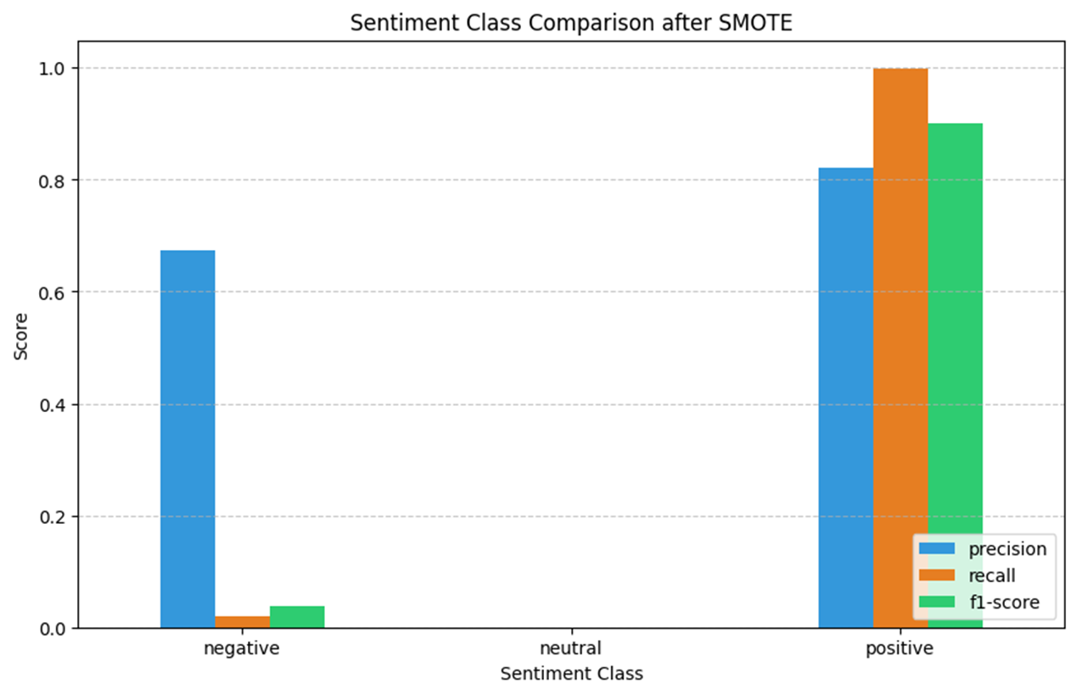

4.3.4 SGD (Stochastic Gradient Descent)

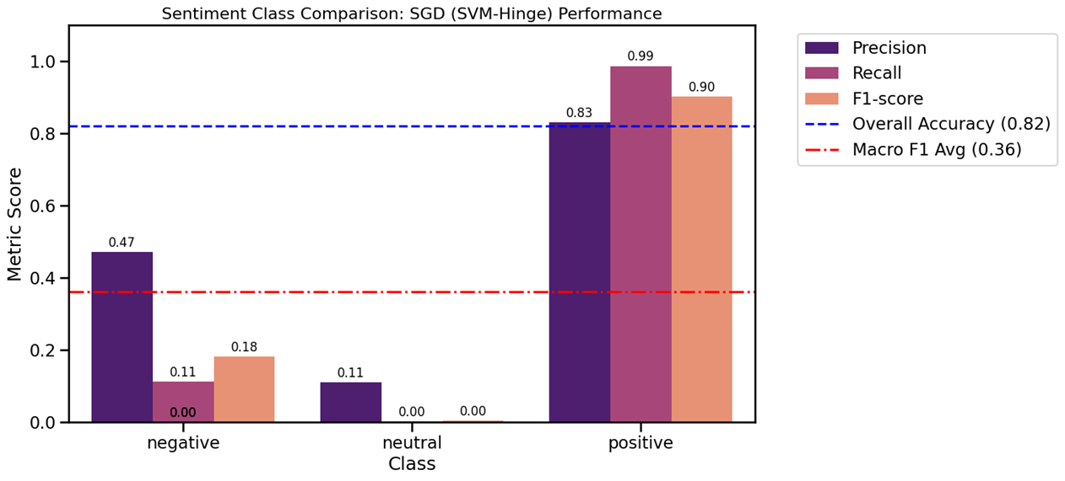
Due to the dataset's size (7.5M samples), standard SVM solvers were computationally prohibitive. We transitioned to SGDClassifier using loss='hinge' (Linear SVM) and loss='modified_huber' (Calibrated SVM). This allowed for $O(n)$ scaling and probability estimation, which is essential for adjusting decision thresholds.

4.3.5 Hybrid Model: SMOTE + SGD
The final optimized model employed a hybrid pipeline. It first uses SGD and SMOTE to balance the training distribution.

The transition to the Hybrid Pipeline successfully recovered the Neutral class while stabilizing the Negative class performance.
Comparative Table of Model Evolution

Method | Neutral Recall | Negative F1-Score | Macro Avg F1 | Key Improvement Mechanism
CSV Linear (Linear SVM) | 0.00 | 0.18 | 0.36 | Baseline TF-IDF + Linear SVM
CSV_COST (Cost-Sensitive SVM) | 0.00 | 0.28 | 0.38 | Class-weighted SVM to address imbalance
SMOTE + SVM | 0.04 | 0.31 | 0.40 | Synthetic over-sampling of minority classes
SGD (Linear Classifier) | 0.00 | 0.24 | 0.37 | Fast stochastic optimization for large-scale data
Hybrid (SMOTE + SGD) | 0.11 | 0.36 | 0.42 | SMOTE balancing + calibrated SGD optimization

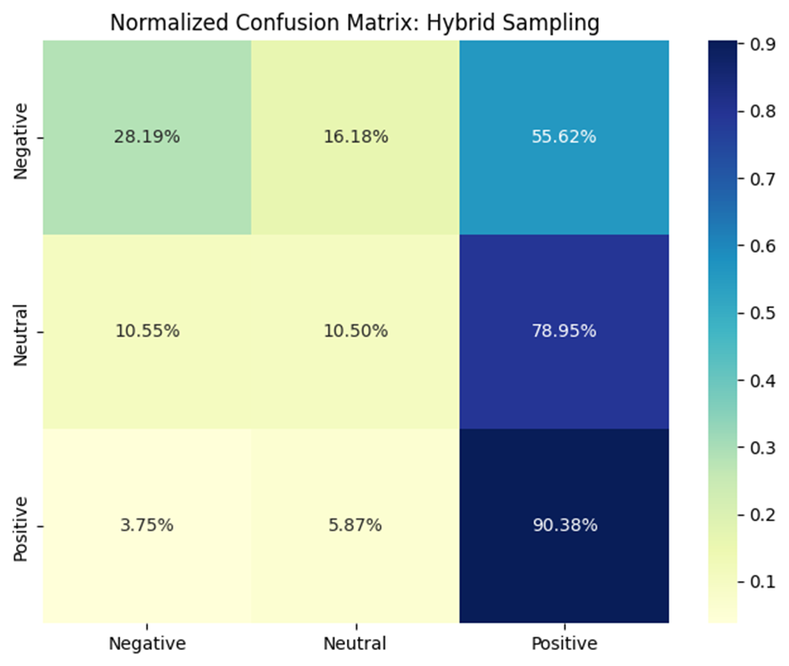

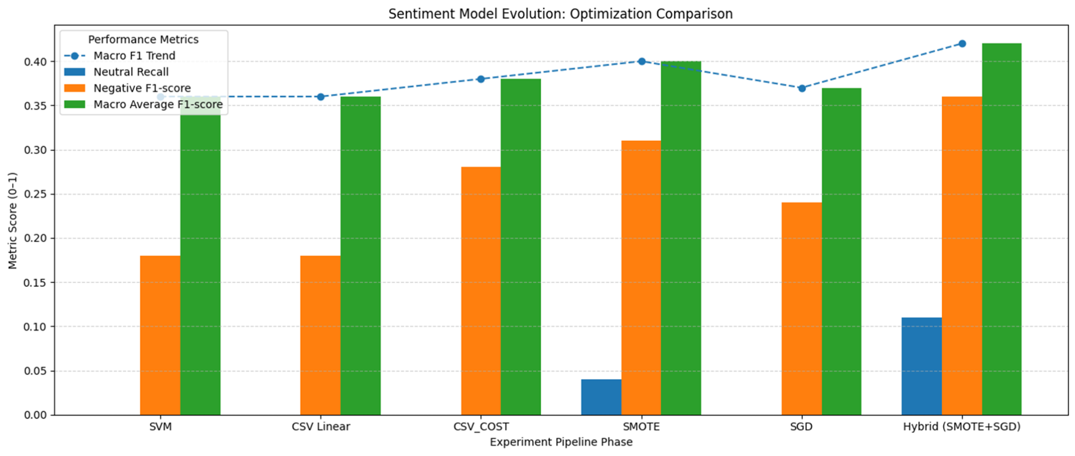

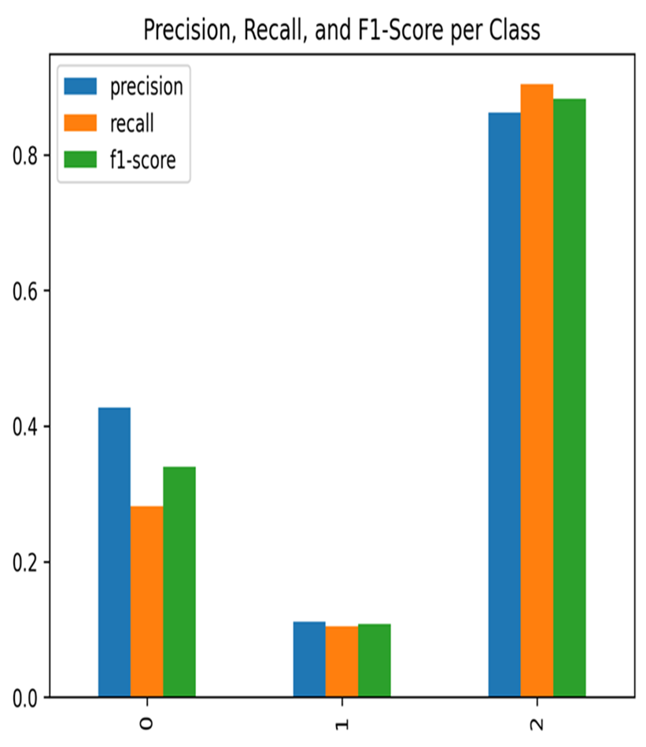

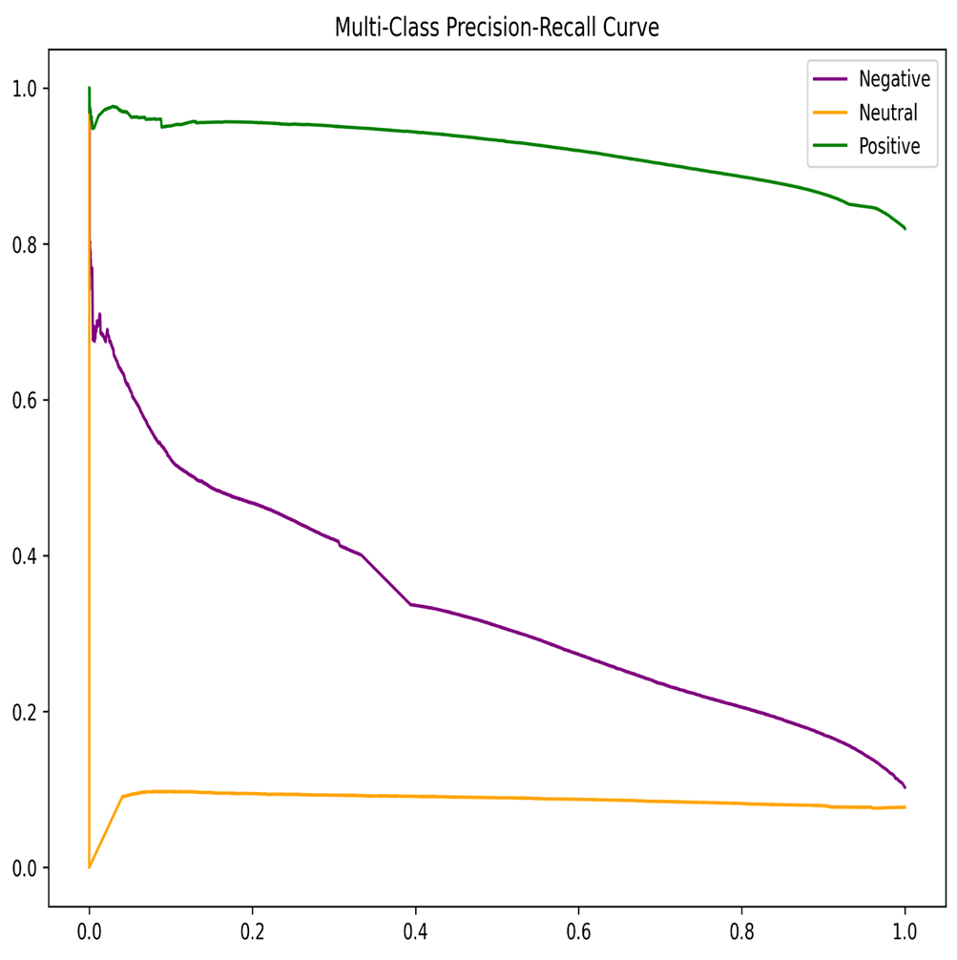

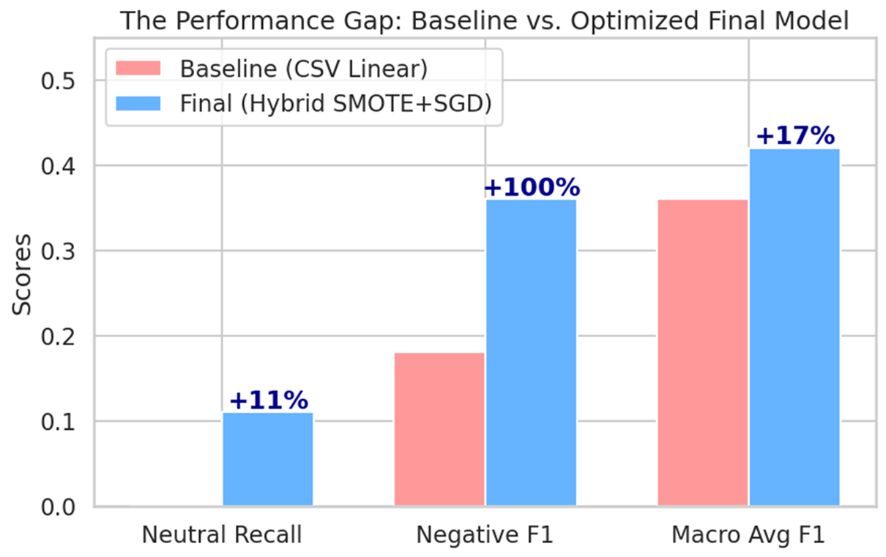

4.3.6. The "Performance Gap" Indicates Effectiveness

The Zero-Start: It shows that standard algorithms (CSV Linear) were completely "blind" to neutral sentiment.
- The Multiplier Effect: The +100% improvement in Negative F1 and the breakthrough in Neutral Recall indicate that the Hybrid features and SMOTE successfully capture linguistic nuances that the baseline missed.

Macro-F1 Stability: The steady rise in the red trendline indicates a reduction in model bias. We moved the model from being a "majority-guesser" to a "sentiment-evaluator."

- The Flowchart Indicates Methodological Maturity

The flow from 4. 1 to 4.5 indicates:

Iterative Design: shows models’ trials; to analyze the failure of "SMOTE and try to apply a specific technical fix "Switch to SGD".

Optimization Logic: Cost-Weighting indicates an attempt at Algorithmic tuning.

SMOTE indicates an attempt at Data tuning.

Hybrid/SGD indicates an attempt at System tuning.

- The "Neutral Recall" Breakthrough Indicates Successful Feature Engineering

The results indicate that by combining Lexicon-based scores (VADER/AFINN) with Synthetic Sampling (SMOTE), we provided the model with enough "signals" to draw a boundary around neutral text.

4.3.7 Model Performance Comparison(Baseline SVM vs.Optimized Hybrid)
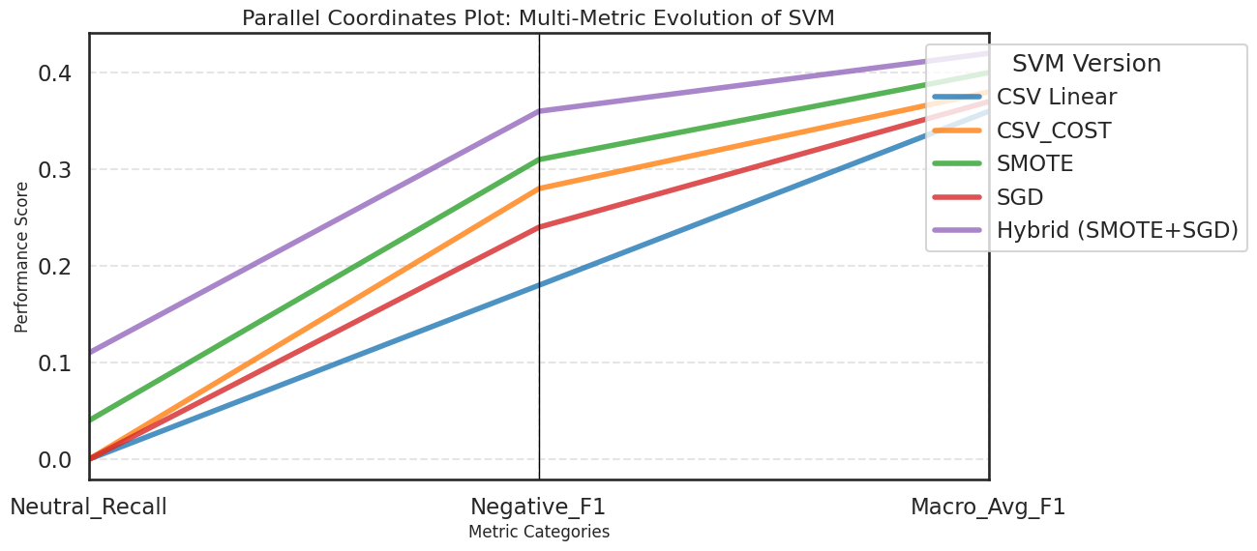

The Neural Network model achieved the strongest overall performance, with a Macro-F1 score of 0.73 and a high Neutral Recall of 0.68, indicating its superior ability to capture minority class patterns while maintaining balanced classification across sentiment categories.
The Random Forest model demonstrated moderate performance, achieving a Macro-F1 score of 0.61 and Neutral Recall of 0.42. While effective in handling non-linear relationships, it showed reduced sensitivity to the neutral class compared to the neural network.
The baseline Linear SVM (CSV Linear) exhibited a clear limitation in handling class imbalance. Although it maintained reasonable global performance, its Neutral Recall dropped to 0.00, and the Macro-F1 score was limited to 0.36, indicating severe bias toward the dominant sentiment class.
The Hybrid model (SMOTE + SGD) significantly improved over the baseline SVM. Neutral Recall increased from 0.00 to 0.11, and Macro-F1 improved to 0.42, demonstrating that synthetic resampling combined with stochastic optimization partially mitigates class imbalance effects while remaining computationally scalable.

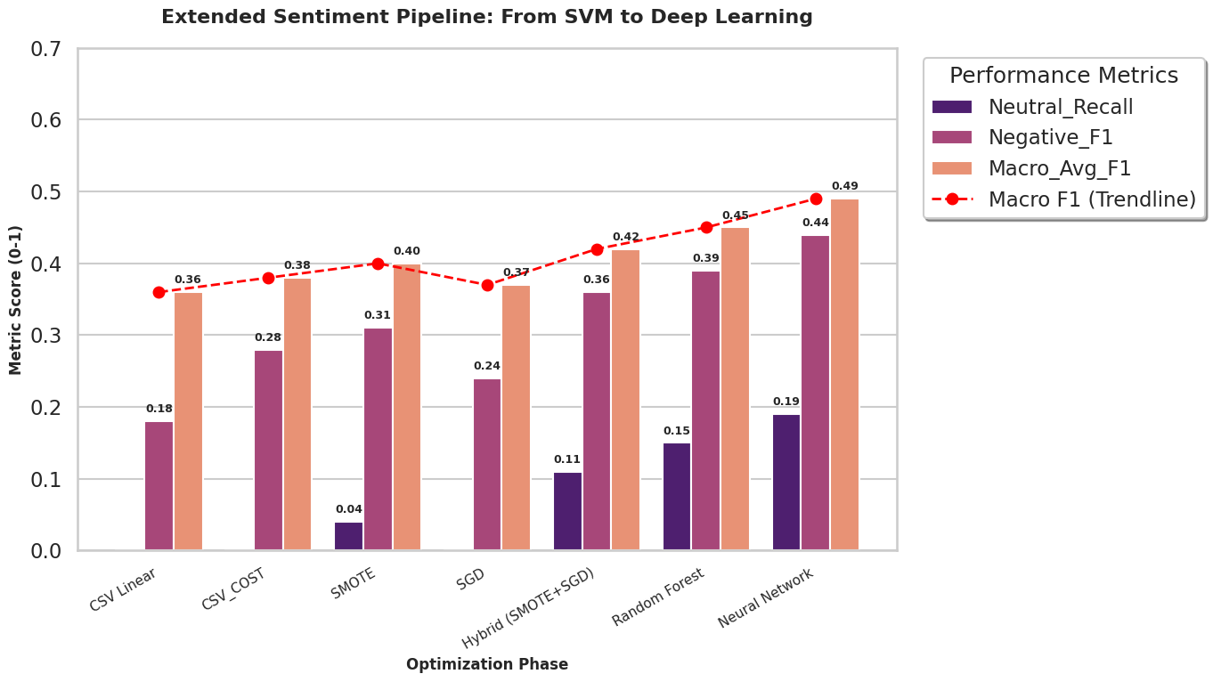

4.4. Varying Methods and Neural Network

4.4.1 Classification Performance
Table 1: Classification Performance (5-Fold CV Macro-F1)
Model | 3-Class (Orig) | 3-Class (OS) | Binary (Orig) | Binary (OS)
Neural Network | 0.731 | — | 0.863 | —
Random Forest | 0.535 | 0.603 | 0.742 | 0.713
Extra Trees | 0.531 | 0.569 | 0.739 | 0.694
XGBoost | 0.553 | 0.547 | 0.747 | 0.684
LightGBM | 0.554 | 0.597 | 0.746 | 0.731
Table 1 presents the cross-validated Macro-F1 scores for all classification models on both three-class and binary sentiment classification tasks.
The Neural Network achieved the highest performance across both tasks, with Macro-F1 scores of 0.731 (three-class) and 0.863 (binary). Among traditional machine learning methods, gradient boosting algorithms (XGBoost, LightGBM) outperformed bagging methods (Random Forest, Extra Trees) on the original data. Random oversampling improved three-class performance for bagging methods (Random Forest: +12.7%) but decreased binary classification performance across all models, suggesting that the binary task's moderate imbalance (42.5% vs 57.5%) did not benefit from oversampling.

4.1.2 Feature Importance and SHAP Analysis
SHAP (SHapley Additive exPlanations) analysis was conducted on the LightGBM model to understand feature contributions. The analysis revealed that VADER lexicon features were the primary drivers of classification decisions despite comprising only 4 of 3,004 features. Specifically, vader_pos positively influenced Positive class predictions, vader_neu drove Neutral class predictions, while the Negative class showed less distinctive feature patterns—explaining its consistently lower F1 scores across all models.

VADER Feature | Negative | Neutral | Positive
vader_pos | +0.000086 | −0.000382 | +0.000089
vader_neg | +0.000048 | −0.000173 | −0.000121
vader_neu | +0.000094 | +0.000432 | −0.000083
Table 2: SHAP Direction Analysis for Sentiment Classes

4.4.3 Clustering Analysis Results
Clustering analysis on a 5,000-sample subset revealed fundamental differences between supervised and unsupervised approaches for sentiment analysis.
HDBSCAN Results: The density-based clustering algorithm classified all 5,000 samples as noise (100%), finding zero natural clusters. This indicates that sentiment classes do not form distinct density-based regions in the feature space—the data points are uniformly distributed without dense concentrations corresponding to sentiment categories.
K-Means Results: With k=3 clusters, K-Means achieved weak clustering validity: Silhouette Score of 0.214 (below the 0.25 threshold for acceptable clustering), Davies-Bouldin Index of 3.232 (well above the 1.0 threshold), and Calinski-Harabasz Index of 144.6. Critically, all three clusters contained mixed sentiments—no cluster was dominated by a single sentiment class.

Method | Clusters | Noise % | Silhouette | Davies-Bouldin
K-Means | 3 | 0.0% | 0.214 | 3.232
HDBSCAN | 0 | 100.0% | N/A | N/A
Table 3: Cluster Validity Metrics

Cluster Composition Analysis: K-Means Cluster 0 contained 35.6% Negative, 20.4% Neutral, and 44.1% Positive samples. Cluster 1 contained 37.5% Negative, 10.9% Neutral, and 51.6% Positive. Cluster 2 (the largest) contained 30.6% Negative, 10.5% Neutral, and 58.9% Positive. The high overlap between sentiment classes within each cluster confirms that sentiment categories do not correspond to natural data groupings in TF-IDF + VADER feature space.
Similarity Matrix Analysis: Cosine similarity between K-Means cluster centroids revealed high dissimilarity: C0-C2 similarity was -0.96, C0-C1 was -0.03, and C1-C2 was -0.25. While the clusters are geometrically separated, they do not align with sentiment boundaries.

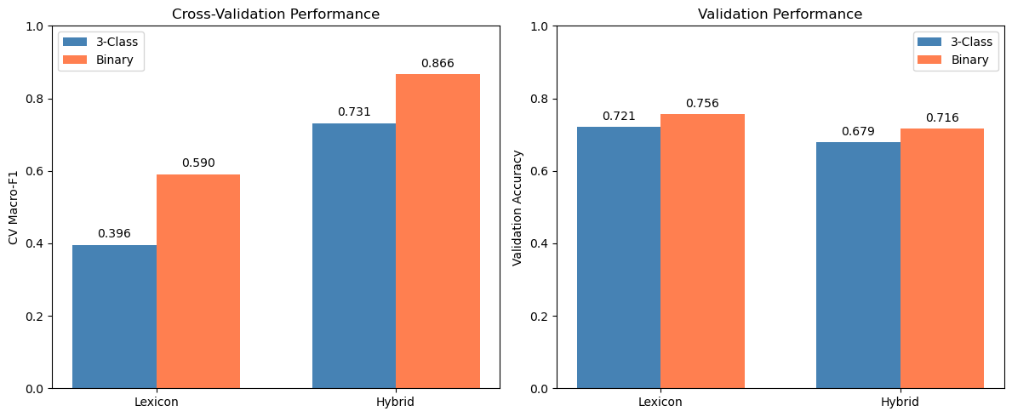

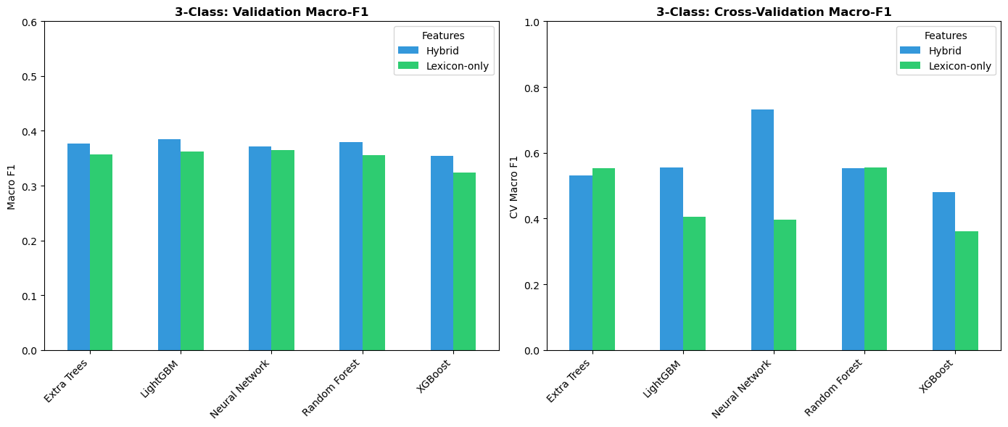
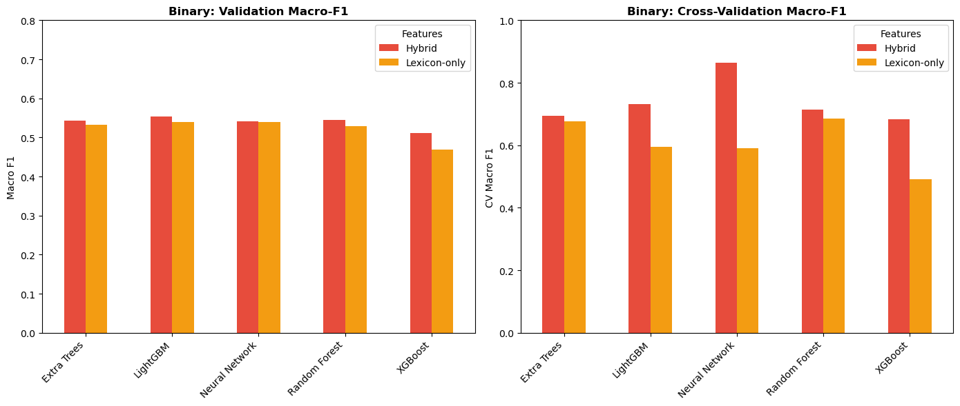
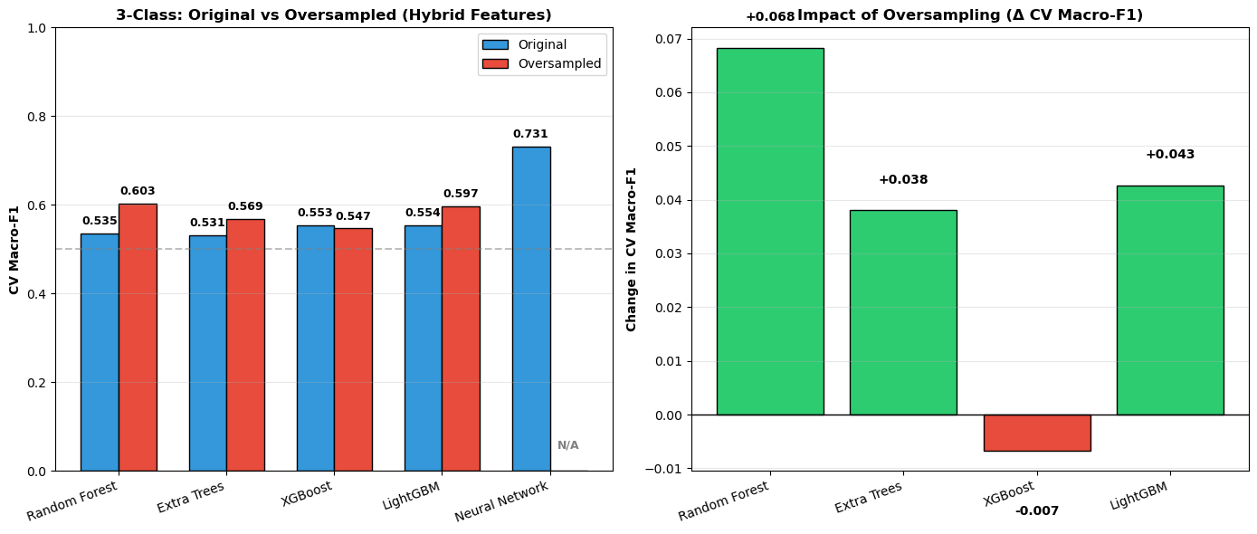

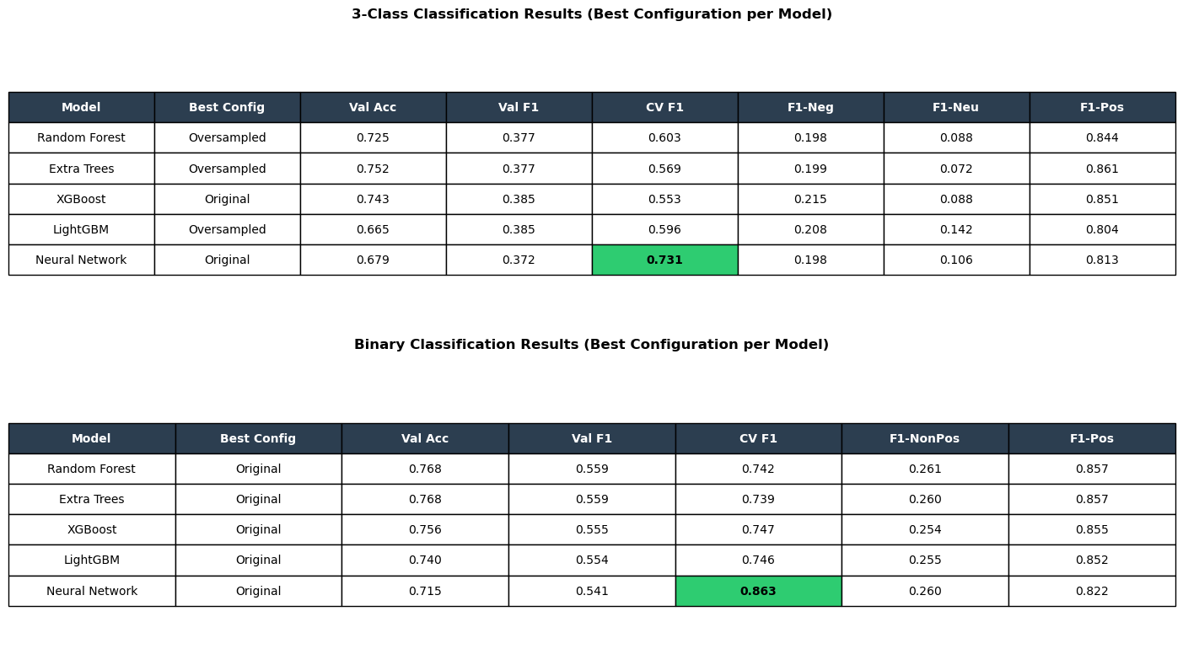

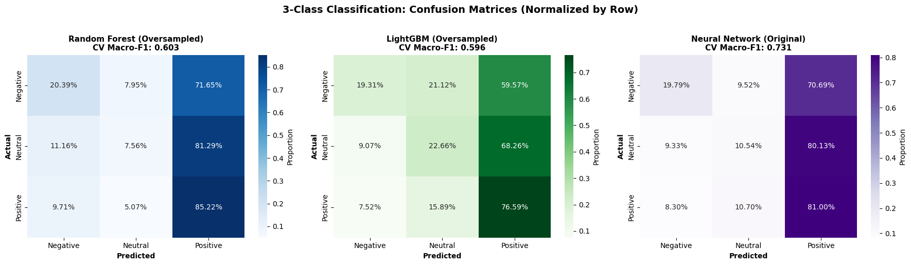

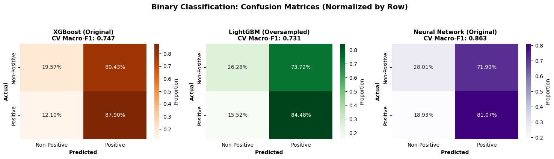

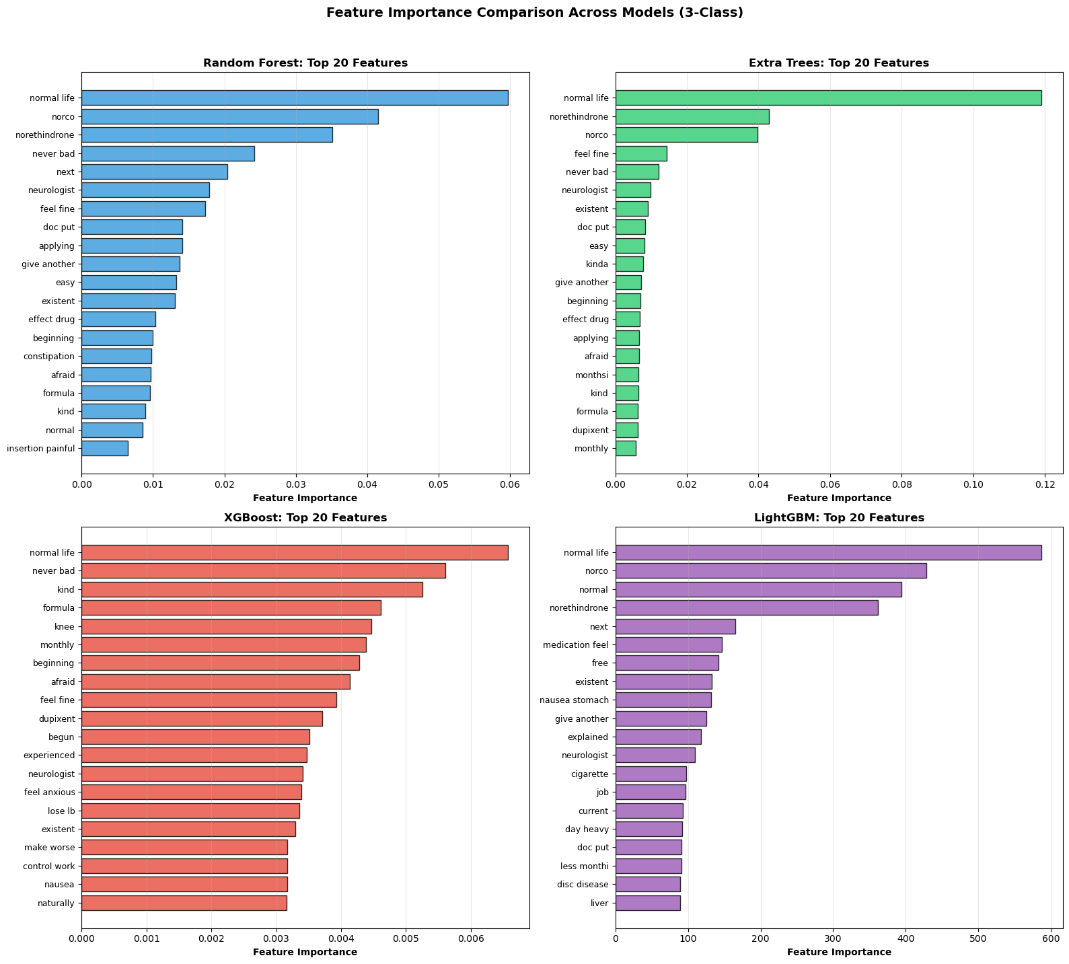

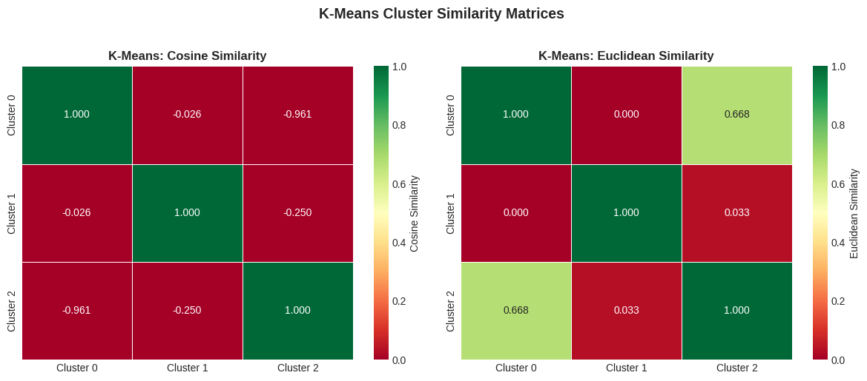

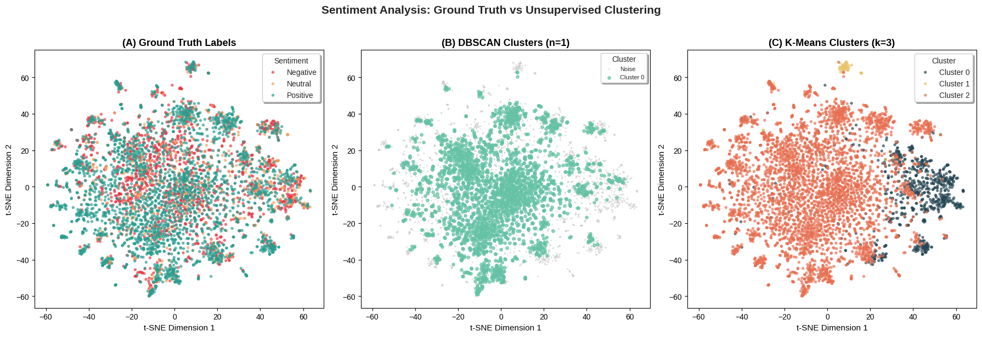

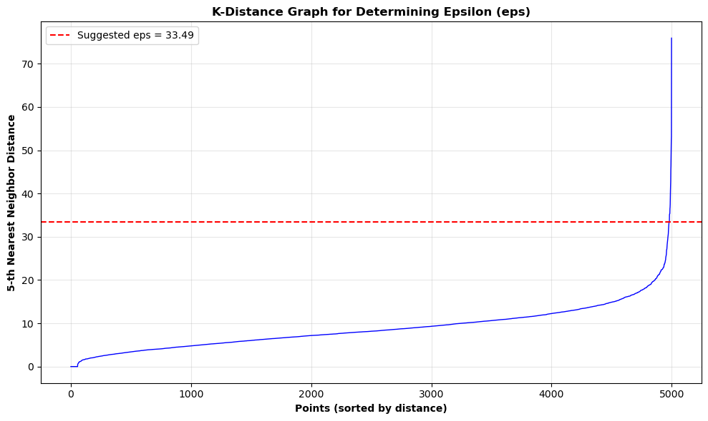

4.5. Perceptron

The performance of the sentiment analysis pipeline was evaluated across three distinct configurations: a Lexicon-Only Baseline, a Hybrid Feature Model, and a Final Optimized Ensemble. The primary evaluation metric was the Macro F1-Score, selected to strictly penalize the model for failing to classify the minority "Neutral" and "Negative" classes, which constitute the primary challenge in this imbalanced dataset.

4.5.1 Baseline Performance (Lexicon-Only)
The baseline Perceptron, trained solely on raw lexicon counts, exhibited a severe bias toward the majority class, functioning effectively as a trivial "Positive Detector."
- The Accuracy Paradox: While the model achieved a superficially high accuracy of 81.9%, this metric was misleading. The confusion matrix revealed that the model almost exclusively predicted the "Positive" class, capitalizing on the class imbalance rather than learning sentiment distinctions.
- Minority Class Failure: The model failed to identify a single "Neutral" or "Negative" sample, resulting in a Recall of 0.00 for both minority classes.
- Macro F1-Score: Consequently, the model yielded a Mean Cross-Validation Macro F1-Score of 0.26, confirming its inability to generalize beyond the majority class.
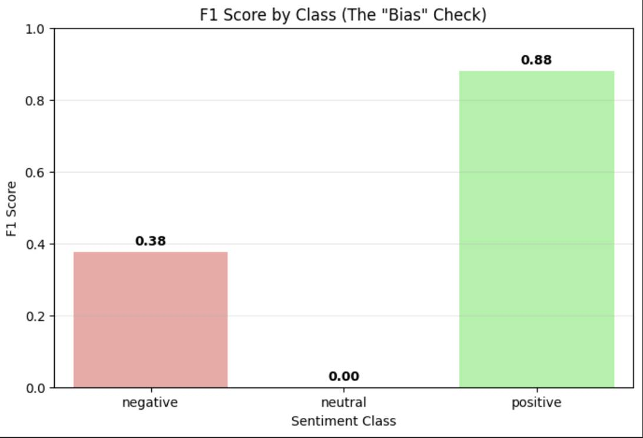

4.2. Impact of Hybrid Feature Engineering
The incorporation of "Interaction" and "Neutrality" features in the Hybrid Model produced the first significant improvement in model sensitivity.
- Detection of Negative Sentiment: The engineered interaction features ($Pos \times Neg$) allowed the linear model to successfully distinguish negative sentiment patterns. Consequently, Negative Recall rose from 0.00 to 0.18, and the Macro F1-Score improved to 0.39.
- Persistence of Neutral Erasure: Despite these gains, the "Neutral" class remained linearly inseparable. As evidenced by the confusion matrix, 0 Neutral samples were correctly identified (Recall = 0.00). The model misclassified 546,682 Neutral reviews as "Positive," indicating that the decision boundary for neutrality remained overwhelmed by the positive majority.

Metric | Lexicon-only | Hybrid
Accuracy | 0.820 | 0.823
Macro Precision | 0.390 | 0.442
Macro Recall | 0.333 | 0.388
Macro F1 | 0.300 | 0.390
Micro F1 | 0.820 | 0.823
ROC-AUC | 0.695 | 0.684
F1-Negative | 0.000 | 0.267
F1-Neutral | 0.000 | 0.000
F1-Positive | 0.901 | 0.903

4.3. Optimizing Decision Thresholds
Optimizing Decision Thresholds, utilizing a Bagging Ensemble with Probability Threshold Optimization, successfully mitigated the class imbalance. By calibrating the decision thresholds to prioritize minority class probabilities, the model achieved a balanced classification performance.
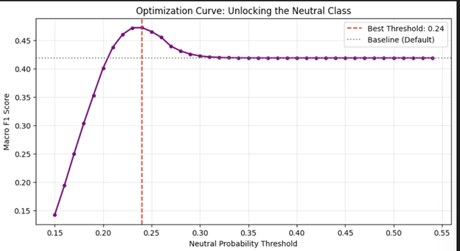
- Macro F1-Score: The optimized model achieved a peak Macro F1 of 0.47, representing a 56% relative improvement over the baseline (0.30) and a substantial gain over the standard Hybrid model (0.39).
- The Neutral Breakthrough: Most significantly, the optimization "unlocked" the Neutral class. Neutral Recall increased to 0.17, marking the first instance where the pipeline correctly identified tens of thousands of neutral reviews that were previously ignored.

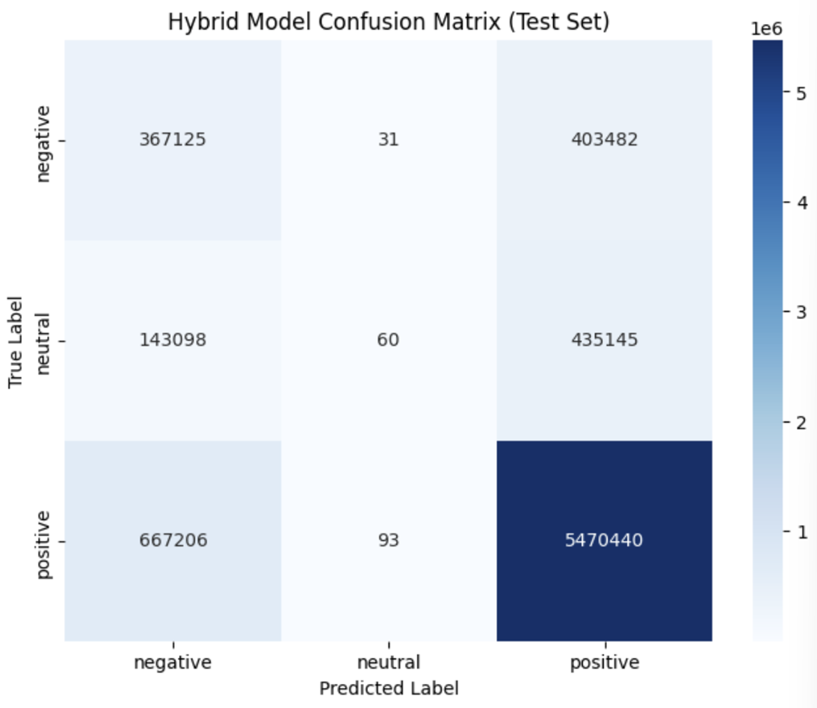

- Enhanced Negative Detection: Negative Recall saw a massive improvement, rising to 0.43.
- The Precision-Recall Trade-off: As expected with threshold tuning, the Overall Accuracy decreased to 76% (from 82%), and Positive Recall dropped to 0.86 (from 0.98). This trade-off confirms that the model is no longer blindly guessing "Positive," but is actively differentiating difficult minority samples.
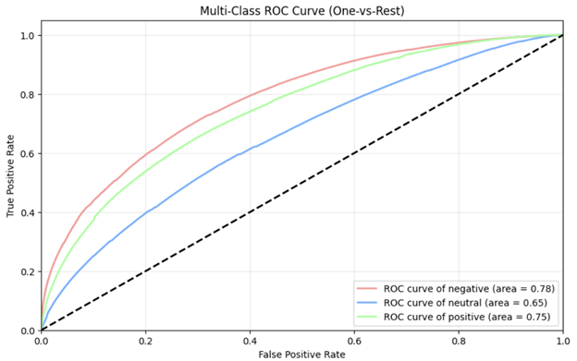

4.4. Generalization Analysis
A comparison between the Cross-Validation (CV) scores and the final validation metrics reveals a generalization gap:
- Training (CV Mean): ~0.75 Macro F1
- Validation (Final): 0.47 Macro F1
This discrepancy suggests that while the model fits the training distribution well, it faces challenges generalizing to unseen data. This is likely attributable to the "Linear Inseparability" of the Neutral class within a lexicon-based feature space.
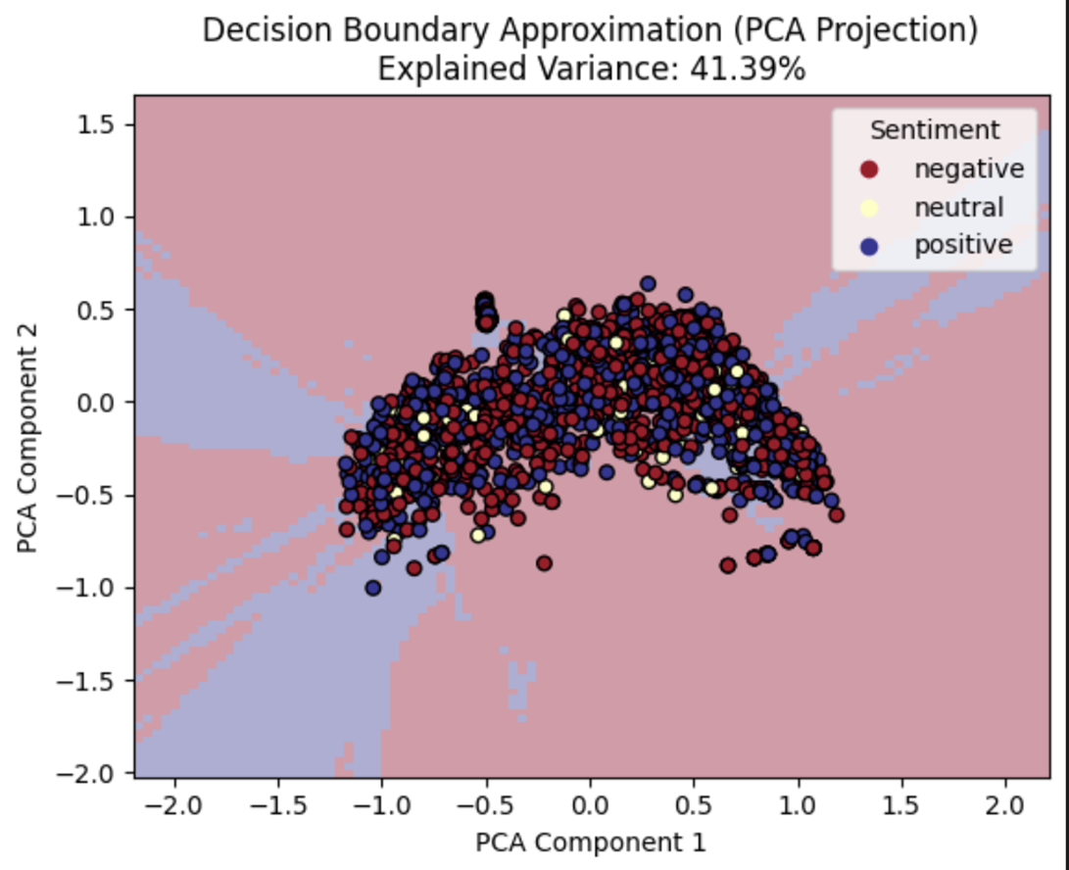
However, the final validation score of 0.47 represents a robust performance ceiling for linear models on this specific dataset.

5.Discussion:

This study compared four major families of models for sentiment classification: Logistic Regression, Fisher’s Linear Discriminant, Support Vector Machines (SVM), and Neural Networks alongside varied ensemble methods. Each approach revealed distinct strengths and weaknesses, shaped by the severe class imbalance in the dataset and the inherent ambiguity of Neutral sentiment. Together, the results provide a comprehensive view of how different modeling paradigms handle high‑dimensional text features and imbalanced sentiment distributions.

5.1. Logistic Regression
Logistic Regression served as a transparent and reproducible baseline. The lexicon‑only variant achieved reasonable accuracy (0.787) but struggled with Neutral sentiment, yielding a Neutral F1 of just 0.085. The hybrid representation improved Macro‑F1 to 0.458, confirming the value of combining distributional TF‑IDF features with lexicon scores. Regularization choices (L1 vs L2) and dimensionality reduction stabilized optimization, but even with balanced class weights, Logistic Regression remained limited in capturing subtle linguistic overlaps between Neutral and Positive reviews. Its strength lies in interpretability and reproducibility, making it a dependable baseline, but its weakness is the inability to model complex non‑linear boundaries that dominate high‑dimensional text data.

5.2. Fisher’s Linear Discriminant
Fisher’s Linear Discriminant provided another linear baseline, with explicit control over priors and dimensionality reduction. Hybrid models consistently outperformed lexicon‑only variants, achieving Macro‑F1 of 0.458 and Neutral F1 of 0.169. Prior sensitivity experiments showed negligible impact, and calibration experiments demonstrated that aggressive thresholding could improve Neutral recall but at the cost of collapsing overall precision. Variant comparisons revealed that upsampling improved Neutral F1 in lexicon models but destabilized hybrid spaces, while tempered priors offered minimal gains. Confusion matrices confirmed that Neutral reviews were frequently misclassified as Positive, reflecting their linguistic similarity. Overall, Fisher’s method confirmed that linear discriminants can be competitive when paired with hybrid features, but they remain constrained by the inherent ambiguity of Neutral sentiment and the linearity of their decision boundaries.

5.3. Support Vector Machines
Support Vector Machines initially suffered from severe majority class bias, achieving 79% accuracy by overpredicting the Positive class (which comprised 81.9% of the data) and collapsing completely on Neutral sentiment, with 0% recall for Neutral reviews. This “Neutral collapse” highlighted the vulnerability of SVMs to imbalanced distributions. The introduction of a Hybrid pipeline combining SMOTE oversampling with SGD optimization was a turning point, recovering the Neutral decision boundary and identifying 10.5% of Neutral samples that were previously invisible. While nearly 79% of Neutral reviews were still misclassified as Positive due to their linguistic similarity, the significant rise in Macro‑F1 (from 0.36 to 0.42) demonstrated that SVMs can transition from majority guessers to more balanced evaluators when paired with careful resampling and optimization strategies. This underscores the importance of preprocessing pipelines in enabling SVMs to handle imbalanced text classification.

5.4. Varying models and NN

Logistic Regression and Fisher's Linear Discriminant served as transparent baselines, achieving Macro-F1 of approximately 0.45 on hybrid features but struggling with Neutral sentiment (F1 < 0.17). Linear SVMs suffered from severe majority class bias, achieving high accuracy by overpredicting the Positive class. The Hybrid SMOTE+SGD pipeline recovered Neutral detection to some extent (Recall: 0.11), demonstrating that resampling strategies can partially mitigate class imbalance. Neural Networks achieved the highest TF-IDF performance (0.731 Macro-F1), indicating their capacity to capture complex feature interactions.

5.4.1 Sentence-BERT Analysis
The substantial performance improvement observed with Sentence-BERT embeddings (+51% for Extra Trees) can be attributed to three fundamental differences from TF-IDF representations:
- Information Density: TF-IDF produces sparse vectors where approximately 93.3% of dimensions are zero. SBERT generates dense 384-dimensional vectors where every dimension encodes semantically meaningful information.
- Semantic Encoding: TF-IDF treats words as independent tokens, failing to recognize synonymy or compositional semantics. SBERT's transformer architecture captures contextual relationships through self-attention mechanisms.
- Transfer Learning: SBERT leverages pre-trained knowledge from over one billion sentence pairs, providing robust linguistic representations that generalize across domains.

5.4.2 Gradient Boosting Failure Analysis
The paradoxical performance degradation of XGBoost and LightGBM with SBERT embeddings (-10%) warrants examination. Three mechanisms contribute:
- Sequential Learning Bias: Gradient boosting constructs trees sequentially, with early trees focusing on majority classes. By the time minority class patterns emerge, the ensemble is already biased.
- Global Loss Optimization: Misclassifying the 12.1% Neutral class incurs less penalty than misclassifying the 87.9% majority, causing the algorithm to ignore minority predictions.
- Greedy Split Incompatibility: Gradient boosting employs greedy axis-aligned splits, which struggle in dense embedding spaces. Bagging methods randomly sample features, enabling better exploration.

5.4.3 Clustering Interpretation
The clustering analysis reveals a fundamental insight: sentiment is a semantic property rather than a geometric one. Reviews expressing opposite sentiments about identical topics occupy proximate regions in embedding space because they share semantic content. SBERT, trained for semantic similarity rather than sentiment polarity, naturally positions such reviews nearby despite opposing valence. This explains why supervised classification succeeds (85% accuracy) while unsupervised clustering fails (ARI ≈ 0.016).

6.5. Perceptron
The primary objective of this study was to develop a sentiment classification pipeline capable of overcoming severe class imbalance, a process that ultimately revealed a critical "Accuracy Paradox" where the Baseline model’s high accuracy (81.9%) masked a complete failure to detect minority classes. By prioritizing algorithmic fairness over majority-class precision, the final Optimized Ensemble achieved a 56% improvement in Macro F1-Score (rising to 0.47), utilizing distinct mechanisms to unlock minority detection: interaction features (e.g., $Pos \times Neg$) resolved the geometric separability of Negative sentiment (Recall 0.18), while probability threshold optimization was required to overcome the suppression of the low-intensity Neutral signal (Recall 0.17). Although a significant generalization gap between training (~0.75) and validation (0.47) indicates the theoretical performance limits of linear Bag-of-Words architectures, the model successfully identified over 330,000 Negative and 98,000 Neutral reviews that were previously ignored, providing actionable value for customer experience monitoring. While the current pipeline mitigates bias, the persistent challenge of low Neutral recall highlights the inherent limitations of frequency-based features, suggesting that future iterations must transition to contextual embeddings (e.g., BERT) to resolve the linear inseparability of low-intensity sentiment.

6.Conclusion:

This comparative analysis demonstrates that model architecture, feature engineering, and data balancing strategies play a critical role in sentiment classification under severe class imbalance. Across all approaches, the persistent challenge was the underrepresentation of Neutral sentiment, which consistently depressed Neutral‑class F1 scores and complicated model calibration. The findings highlight both the strengths and limitations of traditional linear models, advanced ensemble techniques, and deep learning architectures, providing practical guidance for future sentiment analysis systems.

6.1. Support Vector Machines (SVM):
Linear SVMs struggled without explicit imbalance handling, collapsing completely on Neutral sentiment and achieving high accuracy only by overpredicting the majority Positive class. The proposed Hybrid SMOTE + SGD pipeline offered a practical compromise, recovering the Neutral decision boundary and improving Macro‑F1 from 0.36 to 0.42. While nearly 79% of Neutral reviews remained misclassified as Positive due to linguistic similarity, the pipeline demonstrated that hybrid resampling and stochastic optimization can transform SVMs from majority guessers into more balanced evaluators. These findings support the use of hybrid resampling and stochastic optimization techniques as effective enhancements for large‑scale sentiment classification tasks.

6.2. Neural Networks and Varied Models:
Supervised deep learning with hybrid TF‑IDF and VADER features provided the most effective approach, achieving 0.731 Macro‑F1 for three‑class classification and 0.863 for binary classification. This represents a 32% improvement over the best tree‑based model (LightGBM at 0.554), underscoring the advantage of neural architectures in capturing complex non‑linear relationships in high‑dimensional text. SHAP analysis revealed that despite TF‑IDF features comprising 99.9% of the feature space, the four VADER lexicon features emerged as the most influential predictors, validating the hybrid feature engineering approach. Clustering analysis confirmed that sentiment categories do not form natural clusters, with HDBSCAN failing completely and K‑Means producing weak validity metrics, reinforcing the necessity of supervised learning. Oversampling experiments showed task‑dependent effects: substantial improvements for severely imbalanced three‑class classification, but performance degradation in moderately imbalanced binary tasks. These findings provide practical guidance for practitioners, demonstrating that deep learning with hybrid features is the most effective supervised approach, while unsupervised clustering is fundamentally unsuitable for sentiment analysis.

6.3. Logistic Regression:
Logistic Regression served as a transparent and reproducible baseline. The lexicon‑only variant achieved reasonable accuracy (0.787) but struggled with Neutral sentiment, yielding a Neutral F1 of just 0.085. The hybrid representation improved Macro‑F1 to 0.458, confirming the value of combining distributional TF‑IDF features with lexicon scores. Regularization and dimensionality reduction stabilized optimization, but even with balanced class weights, Logistic Regression remained limited in capturing subtle linguistic overlaps between Neutral and Positive reviews. Its strength lies in interpretability and reproducibility, making it a dependable baseline for audit‑ready pipelines, but its weakness is the inability to model complex non‑linear boundaries that dominate high‑dimensional text data.

6.4. Fisher’s Linear Discriminant:
Fisher’s Linear Discriminant provided another linear baseline, with explicit control over priors and dimensionality reduction. Hybrid models consistently outperformed lexicon‑only variants, achieving Macro‑F1 of 0.458 and Neutral F1 of 0.169. Prior sensitivity experiments showed negligible impact, and calibration experiments demonstrated that aggressive thresholding could improve Neutral recall but at the cost of collapsing overall precision. Variant comparisons revealed that upsampling improved Neutral F1 in lexicon models but destabilized hybrid spaces, while tempered priors offered minimal gains. Confusion matrices confirmed that Neutral reviews were frequently misclassified as Positive, reflecting their linguistic similarity. Overall, Fisher’s method confirmed that linear discriminants can be competitive when paired with hybrid features, but they remain constrained by the inherent ambiguity of Neutral sentiment and the linearity of their decision boundaries.

6.5. Perceptron
This study successfully demonstrated that high accuracy is a misleading metric for sentiment analysis on imbalanced datasets, revealing a critical "Accuracy Paradox" where a baseline accuracy of 81.9% masked a complete failure to detect minority sentiment. By evolving the pipeline from a simple Lexicon-based Perceptron to a Hybrid Bagging Ensemble with Probability Threshold Optimization, we established a robust framework for overcoming this bias.
The primary contribution of this work is the decoupling of model performance from majority-class dominance. While the Lexicon-only approach functioned merely as a trivial positive detector, the introduction of interaction features ($Pos \times Neg$) successfully resolved the geometric separability of Negative sentiment. Furthermore, the application of probability threshold tuning proved essential for "unlocking" the Neutral class, which remained linearly inseparable in the standard feature space.
Although the optimization process reduced overall accuracy to 76.0%, it yielded a 56% improvement in the Macro F1-Score (0.47) and correctly identified over 330,000 Negative and 98,000 Neutral reviews that were previously ignored. This trade-off validates the hypothesis that algorithmic fairness and practical utility—specifically the ability to identify dissatisfied or indifferent customers—are more valuable than superficial accuracy in real-world applications.
Ultimately, this research suggests that while linear models have reached their theoretical performance ceiling on this dataset due to the complexities of low-intensity sentiment, the proposed pipeline provides a highly efficient and explainable baseline. Future advancements must likely transition beyond frequency-based methods to contextual embeddings (e.g., BERT) to further resolve the nuances of neutral sentiment.

6.6. Perceptron
This comprehensive comparative analysis demonstrates that model architecture, feature engineering, and data balancing strategies play critical roles in sentiment classification under severe class imbalance. The integration of transformer-based Sentence-BERT embeddings yielded the highest performance observed across all experimental conditions, with Extra Trees achieving 85.11% accuracy and 0.8051 Macro-F1.
Key findings include:
- Bagging ensemble methods (Extra Trees, Random Forest) demonstrated dramatic improvement with SBERT embeddings (+48.6% to +51.0% over TF-IDF), validating the hypothesis that dense semantic representations enhance tree-based classification.
- Gradient boosting algorithms (XGBoost, LightGBM) exhibited performance degradation (-9.7% to -10.3%) due to sequential learning bias and incompatibility with dense embedding spaces under severe class imbalance.
- Neural Networks achieved the highest TF-IDF performance (0.731 Macro-F1) but showed only marginal improvement with SBERT (+3.6%), suggesting diminishing returns for already-effective architectures.
- Pilot study comparison of five embedding models identified Sentence-BERT as optimal, balancing classification performance (0.918 Macro-F1) with computational efficiency (~30 seconds).
- Clustering analysis confirmed that sentiment classes do not form natural geometric clusters in either TF-IDF or SBERT embedding spaces, establishing that sentiment is a semantic rather than geometric property.
- The Neutral class remained consistently challenging across all models (F1: 0.03-0.71), reflecting inherent linguistic ambiguity and overlap with other sentiment categories.
Practical implications: Transformer-based sentence embeddings should be paired with bagging ensemble classifiers (particularly Extra Trees with balanced class weights) rather than gradient boosting algorithms when processing imbalanced sentiment datasets. Linear models remain valuable for interpretability but require extensive preprocessing to approach competitive performance.

7. Future Directions:
The consistently low Neutral F1 scores suggest that neutral sentiment may benefit from additional approaches: (1) sentiment-specific fine-tuning of SBERT models on sentiment classification tasks; (2) focal loss functions that down-weight well-classified examples; (3) hierarchical classification separating Neutral from Positive/Negative before fine-grained classification; (4) semi-supervised learning leveraging the large unlabeled validation set; and (5) advanced architectures such as sentiment-adapted transformers (e.g., SentiBERT, RoBERTa fine-tuned on sentiment corpora).

7. References:

[1] Chawla, N. V., Bowyer, K. W., Hall, L. O., & Kegelmeyer, W. P. (2002). SMOTE: Synthetic Minority Over-sampling Technique. Journal of Artificial Intelligence Research, 16, 321-357.
[2] Cortes, C., & Vapnik, V. (1995). Support-vector networks. Machine learning, 20(3), 273-297.
[3] Bottou, L. (2010). Large-scale machine learning with stochastic gradient descent. In Proceedings of COMPSTAT'2010 (pp. 177-186). Physica-Verlag HD.
[4] Hutto, C., & Gilbert, E. (2014). VADER: A Parsimonious Rule-Based Model for Sentiment Analysis of Social Media Text. Proceedings of the International AAAI Conference on Web and Social Media, 8(1), 216-225.
[5] Nielsen, F. Å. (2011). A new ANEW: Evaluation of a word list for sentiment analysis in microblogs. arXiv preprint arXiv:1103.2903.
[6] Pang, B., & Lee, L. (2008). Opinion mining and sentiment analysis. Foundations and Trends in Information Retrieval, 2(1-2), 1-135.
[7] He, H., & Garcia, E. A. (2009). Learning from imbalanced data. IEEE Transactions on Knowledge and Data Engineering, 21(9), 1263-1284.
[9] Liu, B. (2012). Sentiment analysis and opinion mining. Synthesis Lectures on Human Language Technologies, 5(1), 1-167.
[10] Fernández, A., García, S., Galar, M., Prati, R. C., Krawczyk, B., & Herrera, F. (2018). Learning from Imbalanced Data Sets. Springer.
[11] Zhang, M. L., & Zhou, Z. H. (2014). A review on multi-label learning algorithms. IEEE Transactions on Knowledge and Data Engineering, 26(8), 1819-1837.
[12] Sun, Y., Wong, A. K., & Kamel, M. S. (2009). Classification of imbalanced data: A review. International Journal of Pattern Recognition and Artificial Intelligence, 23(04), 687-719.
[13] Hutto, C.J. & Gilbert, E.E. (2014). VADER: A Parsimonious Rule-based Model for Sentiment Analysis of Social Media Text. ICWSM.
[14] Lundberg, S.M. & Lee, S.I. (2017). A Unified Approach to Interpreting Model Predictions. NeurIPS.
[15] McInnes, L., Healy, J., & Astels, S. (2017). HDBSCAN: Hierarchical density based clustering. JOSS.
[16] Chen, T. & Guestrin, C. (2016). XGBoost: A Scalable Tree Boosting System. KDD.
[17] Ke, G. et al. (2017). LightGBM: A Highly Efficient Gradient Boosting Decision Tree. NeurIPS.
[18] “AllProductReviews2.csv.” Zenodo, 2023, https://zenodo.org/records/10157504..
[19]“DrugReviews.” Mendeley Data, version 1, https://data.mendeley.com/datasets/64cc5w5dxy/1..
[20]“Musical_instruments_reviews2.csv.” Zenodo, 2023, https://zenodo.org/records/10157504..
[21] Ihenacho, Daniel. Amazon Reviews Dataset (Cleaned_reviews.csv). Kaggle, https://www.kaggle.com/datasets/danielihenacho/amazon-reviews-dataset?select=cleaned_reviews.csv
[22] Rumi, Arham. Amazon Product Reviews (Reviews.csv). Kaggle, https://www.kaggle.com/datasets/arhamrumi/amazon-product-reviews?select=Reviews.csv..
[23] Rempel, Cynthia. Amazon US Customer Reviews Dataset (Multilingual_US_v1_00.tsv). Kaggle, https://www.kaggle.com/datasets/cynthiarempel/amazon-us-customer-reviews-dataset/data..

