Distributed Online Voting System
Systematic Testing & Performance Evaluation Report
Unit Testing • Concurrency / Correctness • Performance Benchmarking • Experimental Analysis
Generated 2026-06-02

Contents

1. System overview
A full-stack electronic voting platform: a React (Vite) front end, a Node.js / Express REST API, and MongoDB for storage. It runs in two modes: a single-node mode (synchronous vote writes) and a distributed mode in which an Nginx load balancer fans requests across two API instances, votes are queued in Redis (BullMQ) and processed by a dedicated worker, and MongoDB runs as a replica set for transactional, exactly-once vote commits.
Distributed topology under test: Browser → Nginx (:8080) → api-1 / api-2 → Redis queue + vote lock → vote worker → MongoDB replica set (rs0).

2. Environment & configuration
- Host: Windows + Docker Desktop (WSL2 backend). Node.js v22.
- Whole distributed stack launched with a single docker compose up --build (redis, mongo + init, api1, api2, worker, nginx).
- Front end (Vite) served on :5173, pointed at the load balancer (VITE_API_URL = http://localhost:8080/api).
- A single-node API container (:3001, DISTRIBUTED_VOTING=false) ran on the same network for an apples-to-apples comparison.
- Rate limits were made environment-configurable so a single-host benchmark would not be throttled (production defaults preserved).

3. Testing methodology

3.1 Unit testing
Pure in-memory tests (npm test) covering vote hashing/integrity, vote-cast helpers, and auth validation. Result: 12 / 12 passed.

3.2 Concurrency / correctness
20 simultaneous vote requests for the same voter and election. The system must record exactly one ballot. Verified via receipt count = 1; surplus requests returned 409 VOTE_IN_PROGRESS (Redis vote lock) or were de-duplicated by the deterministic queue job id and the unique MongoDB index on {voter, election}.

3.3 Performance benchmarking & 3.4 experimental analysis
A concurrency sweep (10, 25, 50 simultaneous voters), 60 votes per data point, 2 repetitions, freshly seeded each time, run against both the distributed stack and the single-node API. Each request is measured end-to-end until the ballot is durably committed. 720 votes total.

4. Results & analysis
Mode | Conc. | Reps | Throughput (v/s) | Mean (ms) | p95 (ms) | p99 (ms) | OK | Err
distributed | 10 | 2 | 10.19 ± 2.44 | 998.35 | 2563.02 | 4881.57 | 120 | 0
distributed | 25 | 2 | 12.96 ± 0.36 | 1559.41 | 2917.29 | 3972.44 | 120 | 0
distributed | 50 | 2 | 24.41 ± 1.19 | 1285.84 | 1918.52 | 2463.51 | 120 | 0
single-node | 10 | 2 | 14.87 ± 1.3 | 617.31 | 2528.73 | 3979.21 | 120 | 0
single-node | 25 | 2 | 11.27 ± 0.2 | 1891.47 | 4779.54 | 5052.14 | 120 | 0
single-node | 50 | 2 | 11.18 ± 0.16 | 3621.84 | 4933.63 | 5293.32 | 120 | 0

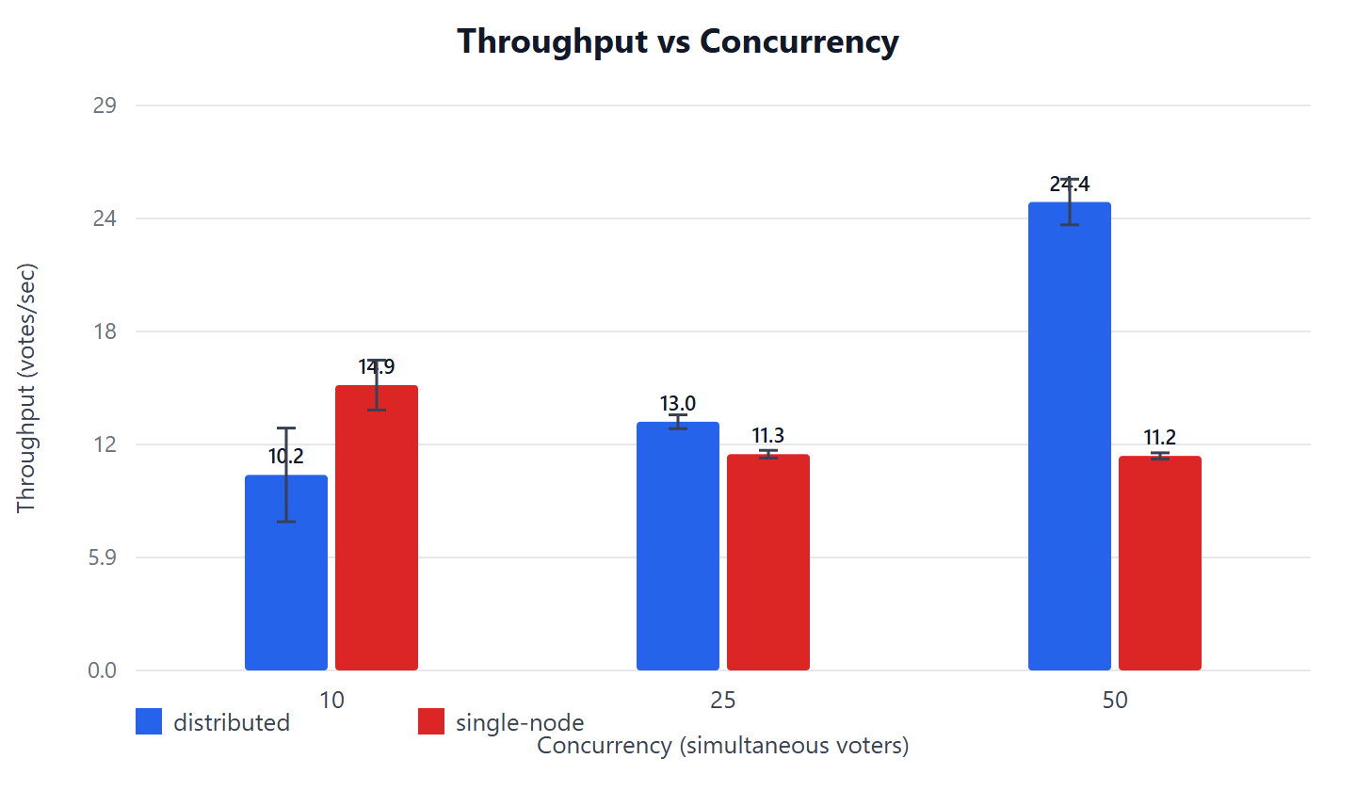
Figure 1. Throughput vs concurrency (error bars = std dev across repetitions).
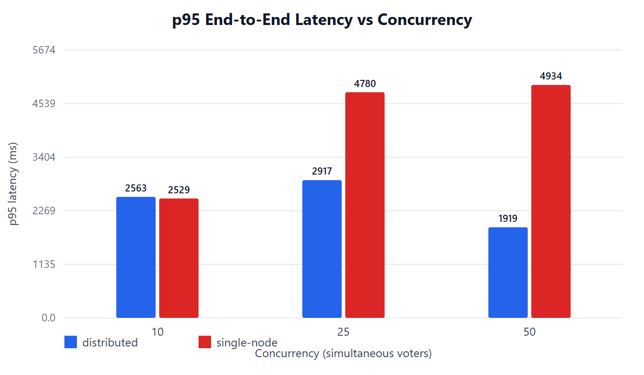
Figure 2. p95 end-to-end latency vs concurrency.
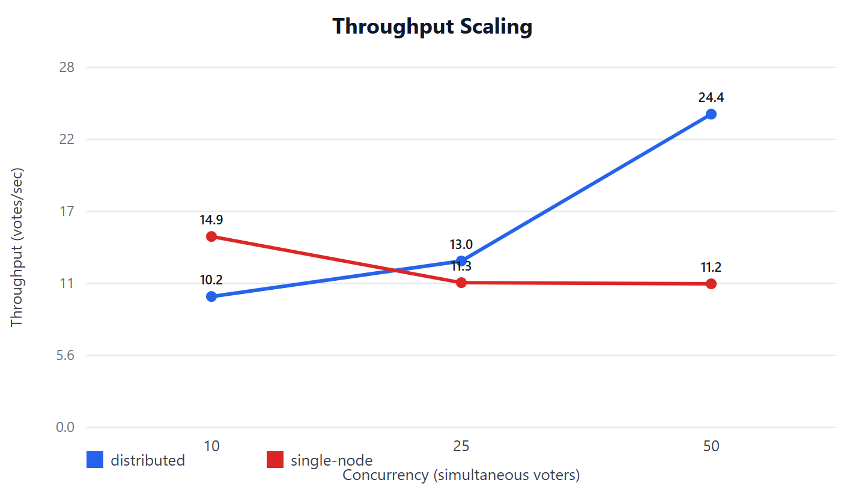
Figure 3. Throughput scaling — the lines cross over as load increases.

Interpretation
- Low load: single-node is faster (no queue / polling overhead).
- High load: the distributed architecture scales up (10→13→24 votes/s) while single-node saturates and degrades (15→11→11 votes/s) with latency rising sharply.
- At concurrency 50: distributed delivers ~2.2x throughput and ~2.6x lower p95 latency.
- Correctness held throughout: 720 votes, 0 errors, 0 double votes.

5. Defects found & fixed during testing
- Broken async vote poll: completed queue jobs were deleted immediately, so GET /vote/jobs/:id always returned 404 although the vote committed. Fixed by retaining completed jobs briefly.
- Reverse-proxy client IP: added trust proxy so rate limiting and req.ip use the real client IP behind Nginx.
- Rate-limit store reuse: each limiter now uses its own Redis store prefix (required by express-rate-limit v8).
- Non-tunable limits: global, vote, and auth limits made environment-configurable for benchmarking; production defaults unchanged.
A detailed issue-by-issue log is provided in the companion document, "E-Voting — Issues & Resolutions".

6. User-interface walkthrough

6.1 Public & authentication

Figure 4. Login screen — voters use national ID, admins use username/email.

Figure 5. Voter self-registration (ID, profile, district, password).

Figure 6. Administrator registration with role selection.

6.2 Voter journey (vote cast through the distributed queue)
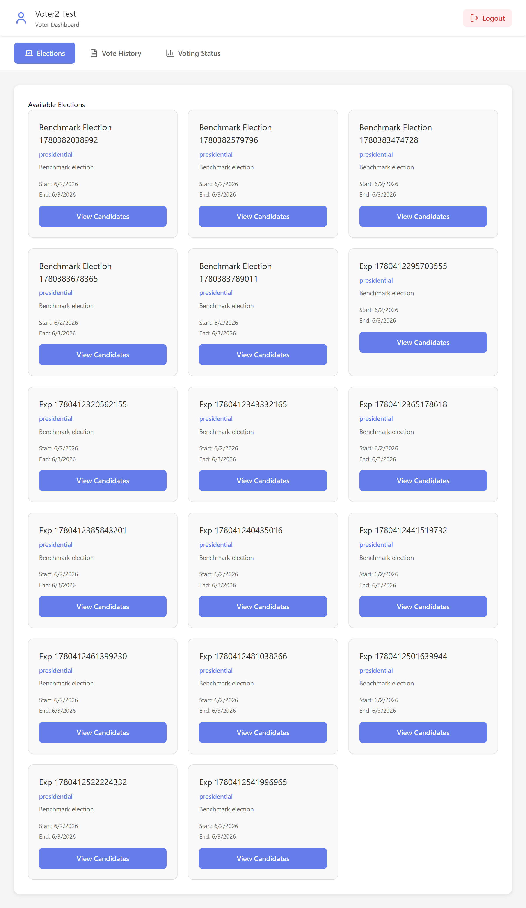
Figure 7. Voter dashboard — eligible active elections.
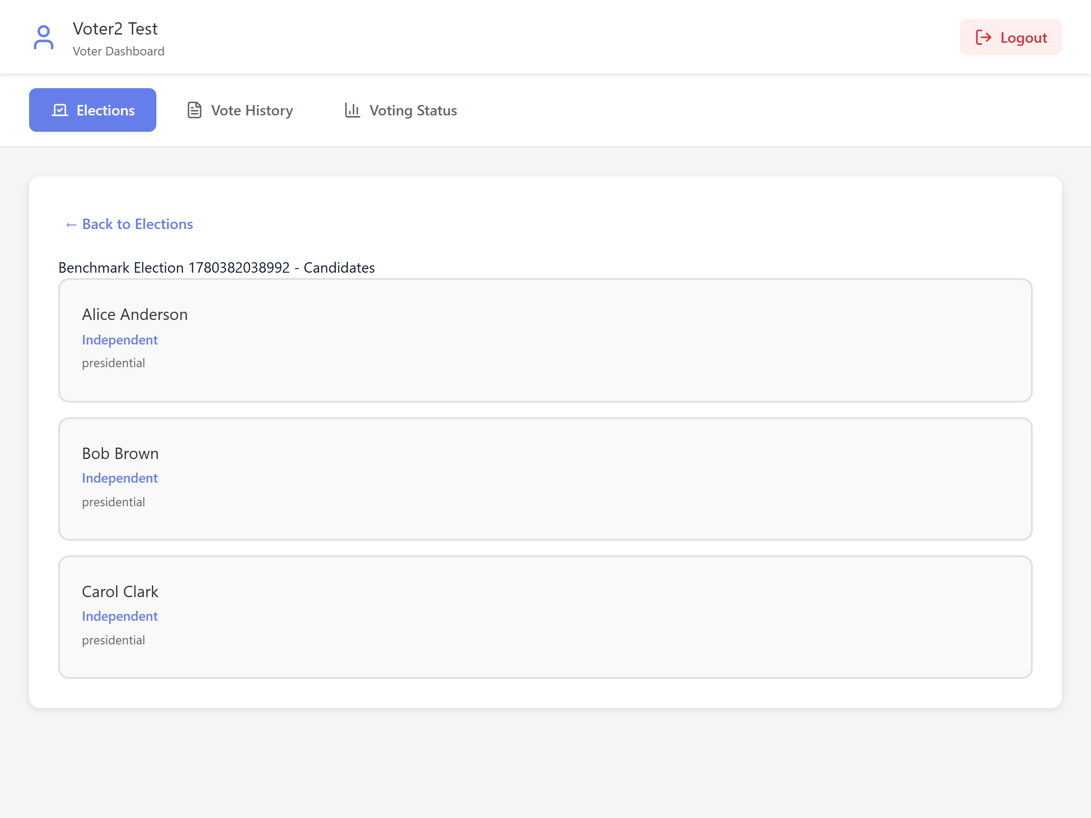
Figure 8. Candidate selection for a chosen election.
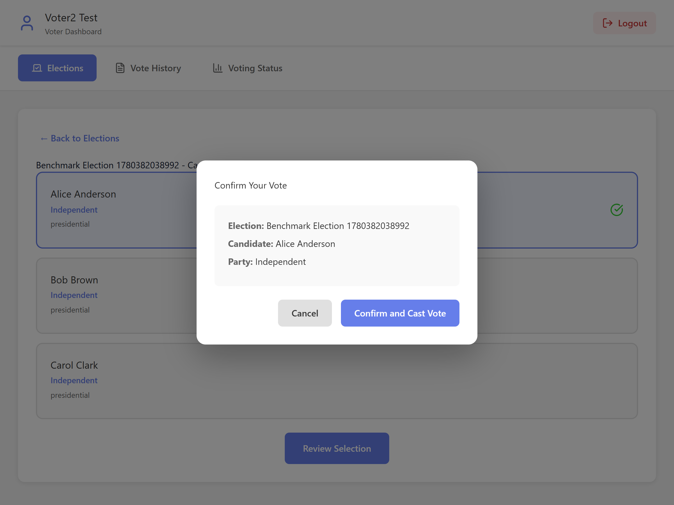
Figure 9. Vote confirmation modal (election, candidate, party).
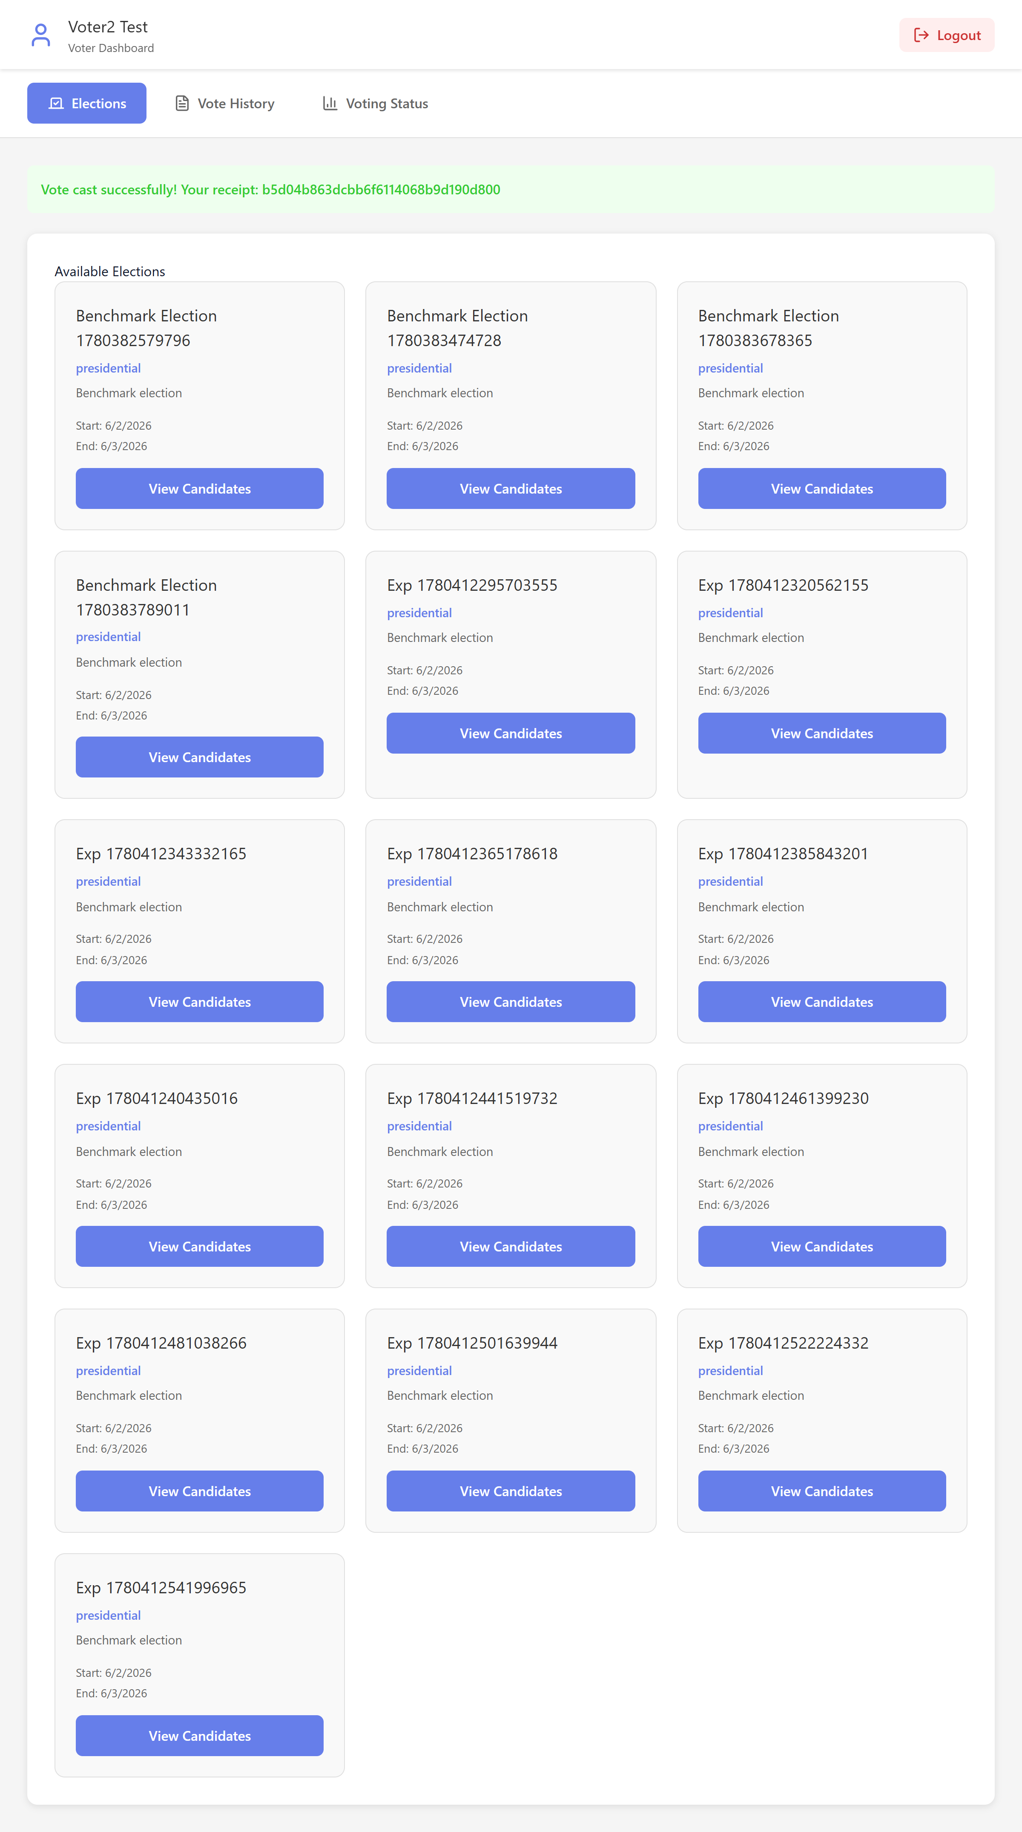
Figure 10. Vote accepted via the distributed queue, with receipt ID.
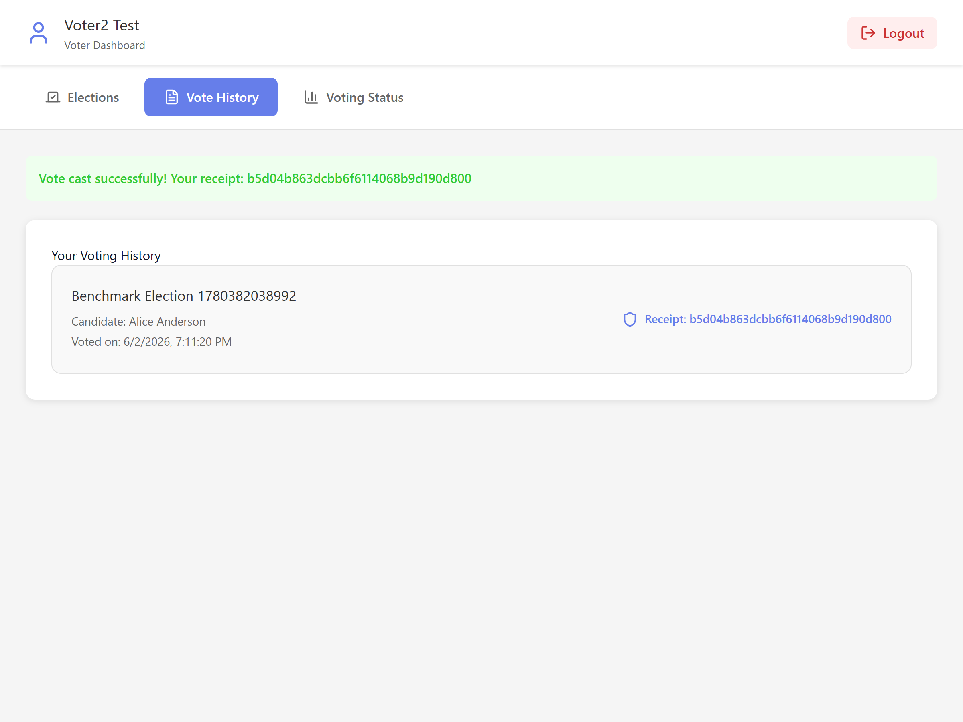
Figure 11. Voter vote history with the immutable receipt.
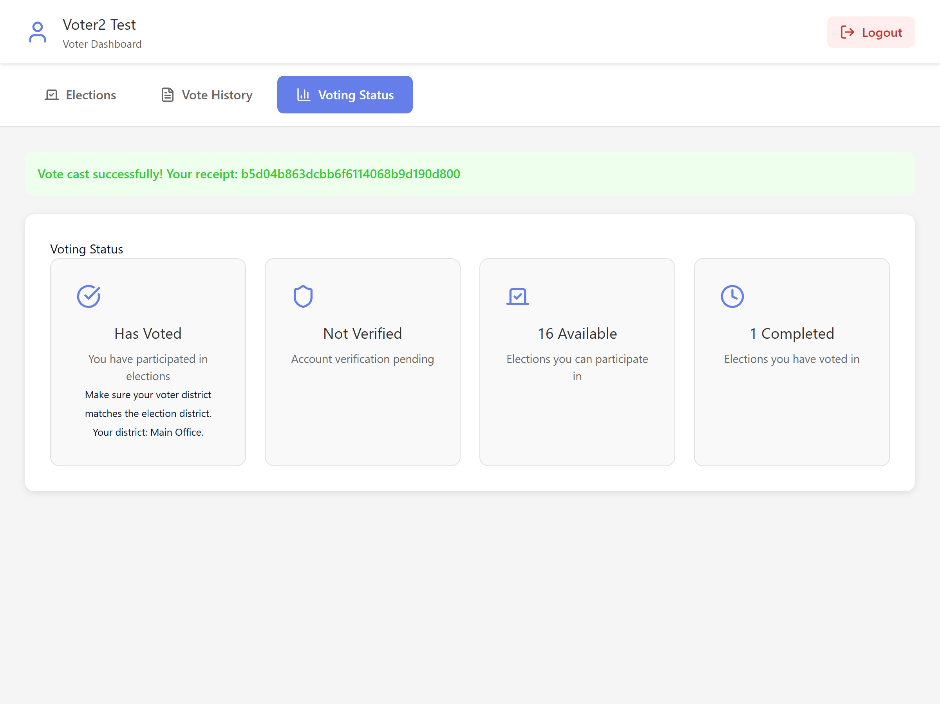
Figure 12. Voter voting-status summary.

6.3 Administrator
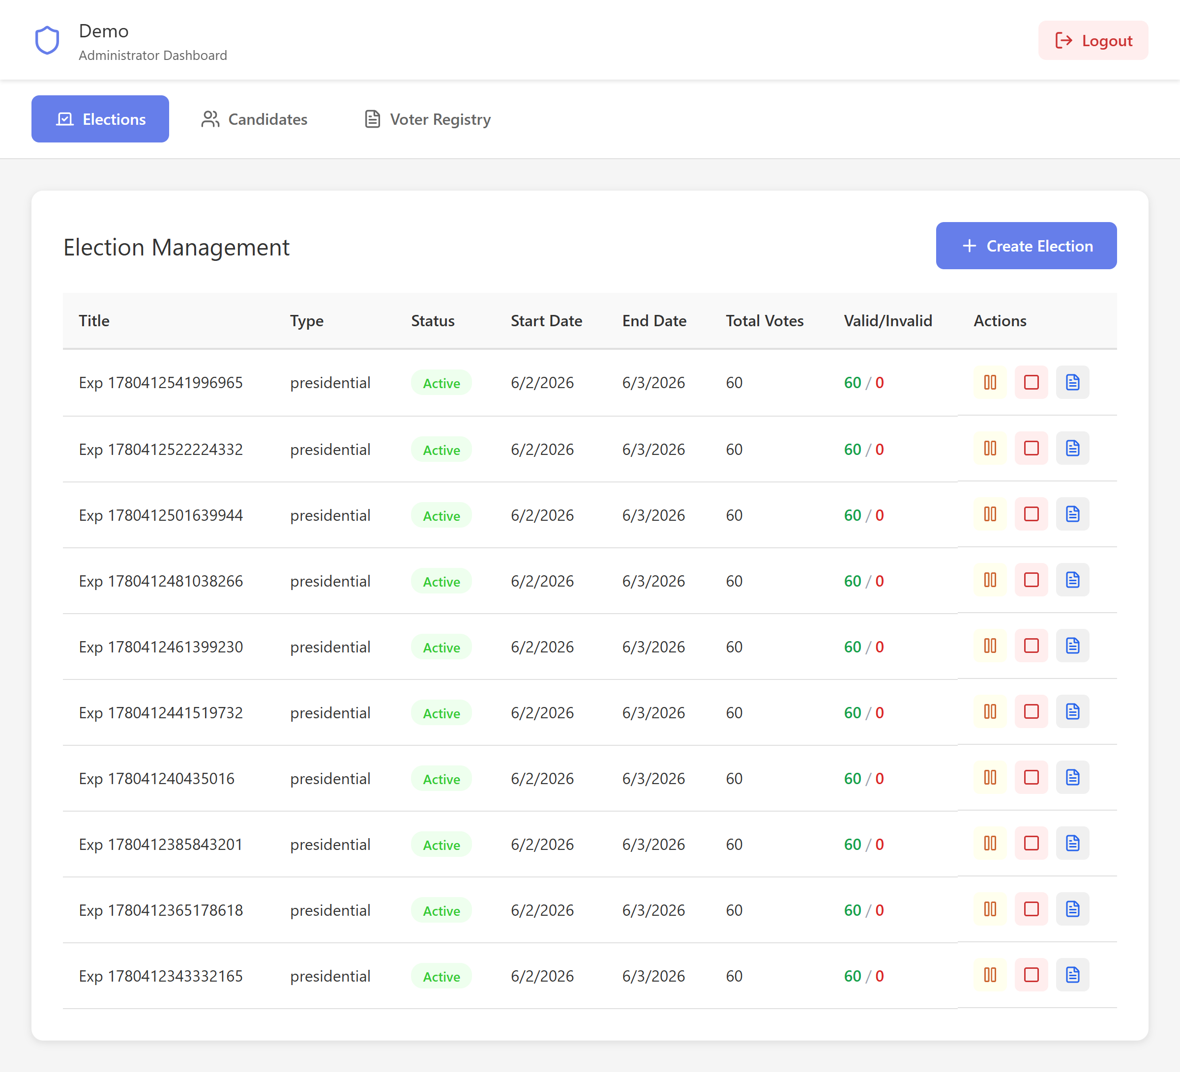
Figure 13. Admin election management with live tallies.
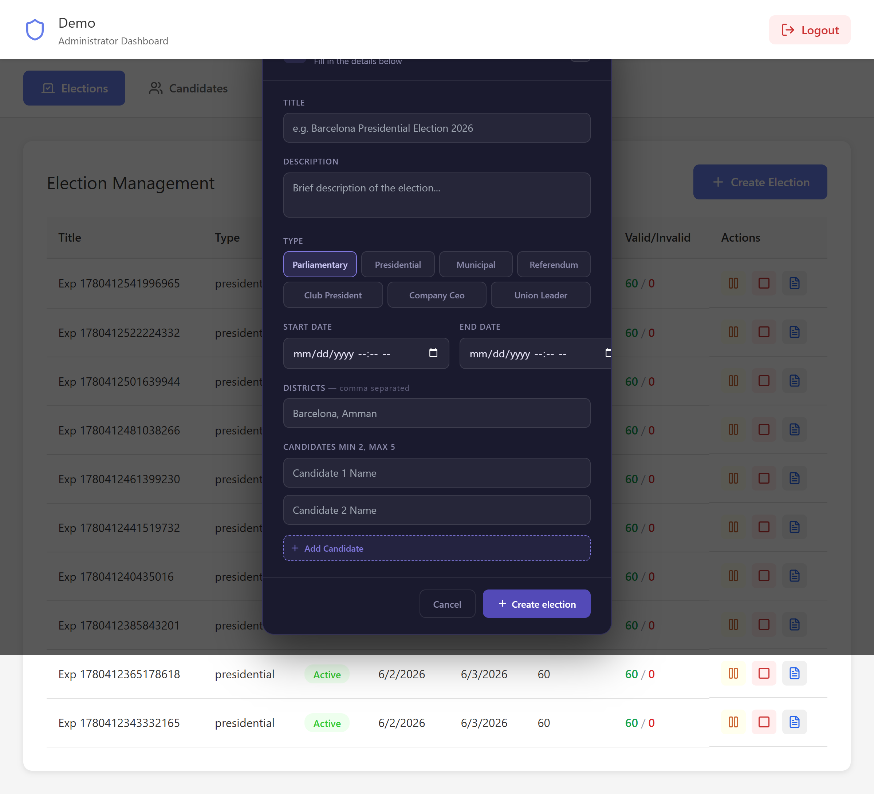
Figure 14. Create Election form (type, dates, districts, candidates).
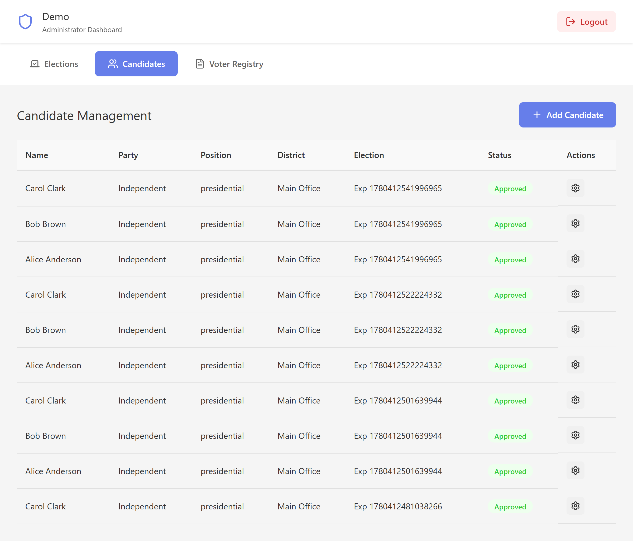
Figure 15. Admin candidate management.
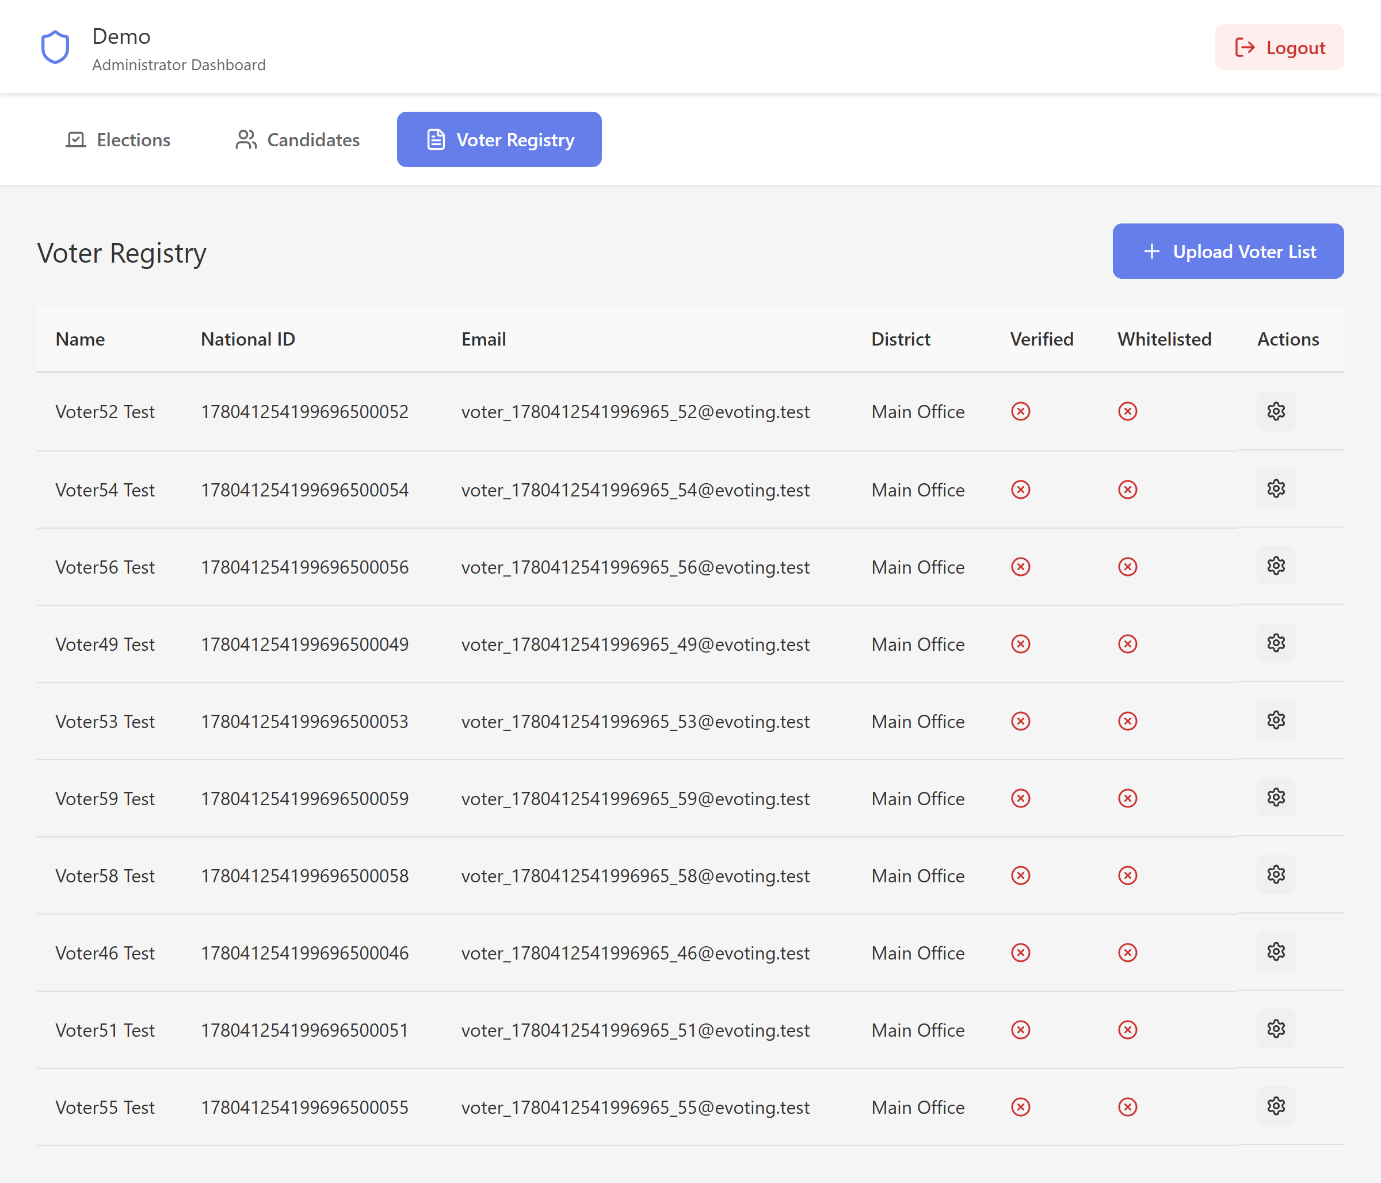
Figure 16. Admin voter registry / whitelist.

6.4 Auditor
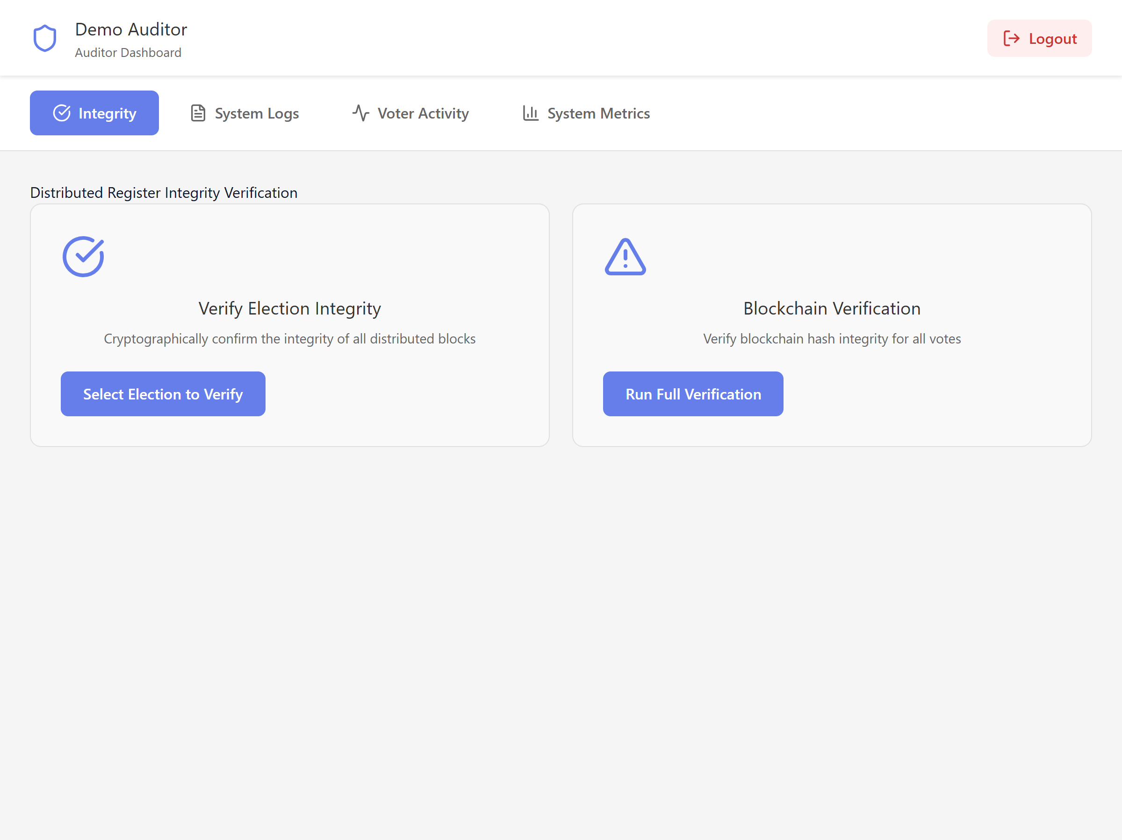
Figure 17. Auditor — register integrity verification.
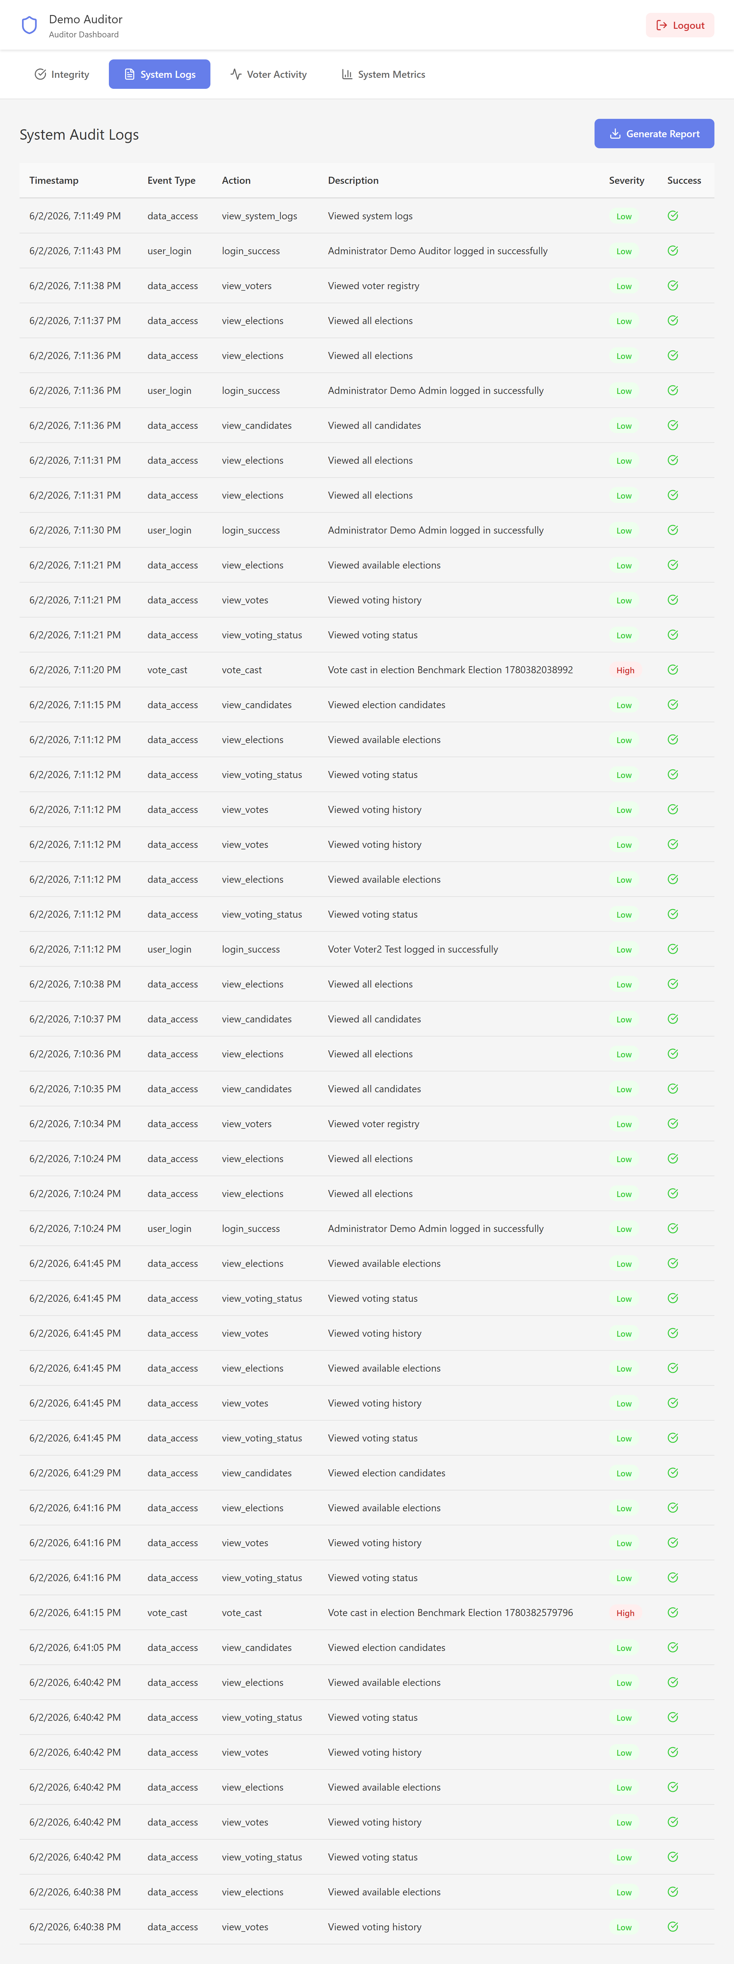
Figure 18. Auditor — full system audit log.
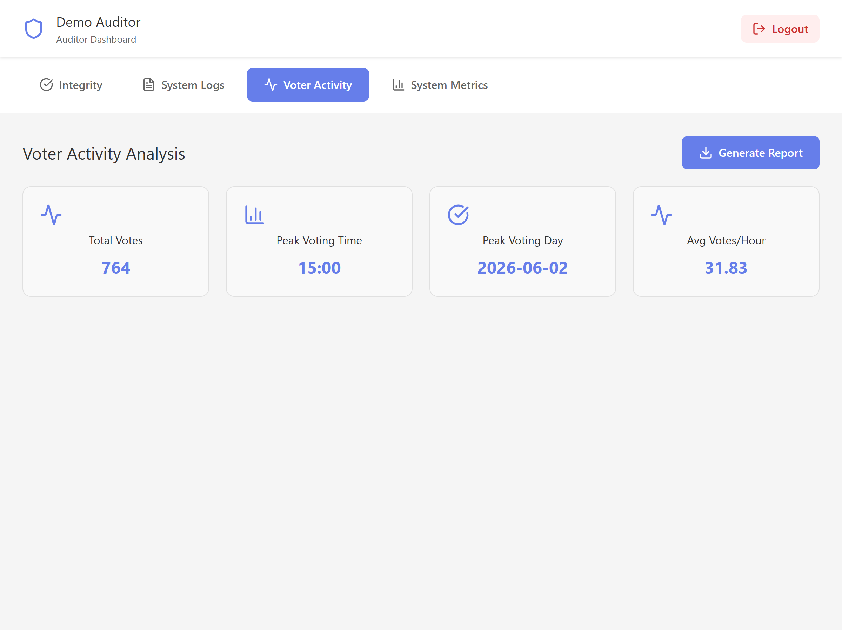
Figure 19. Auditor — voter activity analytics.
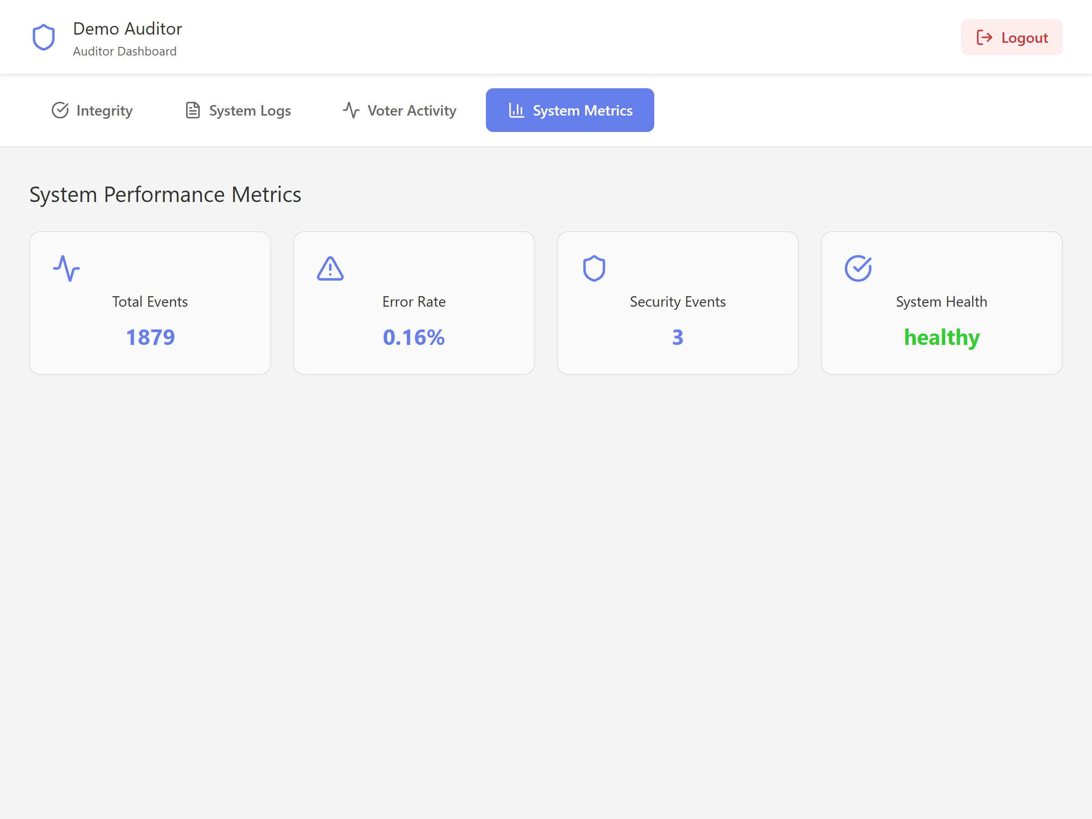
Figure 20. Auditor — system performance metrics.

7. Conclusion
The distributed online voting system is functionally complete and behaves correctly under concurrency: it guarantees one ballot per voter per election even under 20-way simultaneous contention, and produces verifiable receipts and a full audit trail. The experimental analysis confirms the central distributed-systems trade-off: the queue-based, load-balanced architecture pays a small fixed overhead at low load but scales with concurrency, achieving roughly double the throughput and far lower tail latency than a single node once the system is busy — all while preserving correctness.

