Bank Management System

Software Requirements Specification

(SRS)

# Table of Contents

**REVISION HISTORY** **II**

**DOCUMENT APPROVAL** **II**

1. **INTRODUCTION** **1**
   1. PURPOSE 1
   2. SCOPE 1
   3. DEFINITIONS, ACRONYMS, AND ABBREVIATIONS 1
   4. REFERENCES 1
   5. OVERVIEW 1
2. **GENERAL DESCRIPTION** **2**
   1. PRODUCT PERSPECTIVE 2
   2. PRODUCT FUNCTIONS 2
   3. USER CHARACTERISTICS 2
   4. GENERAL CONSTRAINTS 2
   5. ASSUMPTIONS AND DEPENDENCIES 2
3. **SPECIFIC REQUIREMENTS** **2**
   1. EXTERNAL INTERFACE REQUIREMENTS 3
      1. *User Interfaces* *3*
      2. *Hardware Interfaces* *3*
      3. *Software Interfaces* *3*
      4. *Communications Interfaces* *3*
   2. FUNCTIONAL REQUIREMENTS 3
      1. *<Functional Requirement or Feature #1>* *3*
      2. *<Functional Requirement or Feature #2>* *3*
   3. USE CASES 3
      1. *Use Case #1* *3*
      2. *Use Case #2* *3*
   4. CLASSES / OBJECTS 3
      1. *<Class / Object #1>* *3*
      2. *<Class / Object #2>* *3*
   5. NON­FUNCTIONAL REQUIREMENTS 4
      1. *Performance* *4*
      2. *Reliability* *4*
      3. *Availability* *4*
      4. *Security* *4*
      5. *Maintainability* *4*
      6. *Portability* *4*
   6. INVERSE REQUIREMENTS 4
   7. DESIGN CONSTRAINTS 4
   8. LOGICAL DATABASE REQUIREMENTS 4
   9. OTHER REQUIREMENTS 4
4. **ANALYSIS MODELS** **4**
   1. SEQUENCE DIAGRAMS 5

4.3 DATA FLOW DIAGRAMS (DFD) 5

4.2 STATE­TRANSITION DIAGRAMS (STD)...................................................................................................................

1. **1. Introduction**

## Purpose

* Online banking system provides is specifically developed for internet banking for Balance Enquiry, Funds Transfer to another account in the same bank, Request for cheque book/change of address/stop payment of cheques, Mini statements (Viewing Monthly and annual statements).

The Traditional way of maintaining details of a user in a bank was to enter the details and record them. Every time the user need to perform some transactions he has to go to bank and perform the necessary actions, which may not be so feasible all the time. It may be a hard­hitting task for the users and the bankers too. The project gives real life understanding of Internet banking and activities performed by various roles in the supply chain. Here, we provide an automation for banking system through Internet. Internet banking system project captures

activities performed by different roles in real life banking which provides enhanced techniques for maintaining the required in­ formation up­to­date, which results in efficiency. The project gives real life understanding of Internet banking and activities performed by various roles in the supply chain.

## Scope

* *This Product will automate of banking transaction process.This Project investigates the entry threshold for providing a new transaction service channel via the real options approach, where the entry threshold is established by using an Internet banking system designed for the use of normal users(individuals), Industrialists, Entrepreneurs, Educational Institutions(Financial sections), Organizations and Academicians under transaction rate uncertainty.*

## Definitions, Acronyms, and Abbreviations

*BMS­Bank Management System*

## References

[www.w3schools.com](http://www.w3schools.com/) [www.roseindia.net](http://www.roseindia.net/) [www.dbforums.com](http://www.dbforums.com/) [www.ibm.com](http://www.ibm.com/) <http://tomcat.apache.org/>

1. **2. General Description**

## Product Perspective

The client will have client interface in which he can interact with the banking sys­ tem. It is a web based interface which will be the web page of the banking application. Starting a page is displayed asking the type of customer he is whether ordinary or a corporate customer. Then the page is redirected to login page where the user can enter the login details. If the login particulars are valid then the user is taken to a home page where he has the entire transaction list that he can perform with the bank. All the above activities come under the client interface.

The administrator will have an administrative in­ terface which is a GUI so that he can view the entire system. He will also have a login page where he can enter the login particulars so that he can perform all his actions. This administrative interface provides different environment such that he can maintain data­ base & provide backups for the information in the database. He can register the users by providing them with username, password & by creating account in the database. He can view the cheque book request & perform action to issue the cheque books to the clients.

## Product Functions

This section provides the functional overview of the product. The project will require the PHP as a front end and at the back end the database MYSQL will be running. Various functional modules that can be implemented by the product will be

1. Login
2. Validation
3. Get balance information
4. Withdrawal of money
5. Transfer Money
6. Customer info.

### Login:

Customer logins by entering customer name & a login pin.

## Validation:

When a customer enters the ATM card, its validity must be ensured. Then customer is allowed to enter the valid PIN. The validation can be for following conditions

Validation for lost or stolen card

When card is already reported as lost or stolen then the message “Lost/Stolen card!!!”.

Validation for card’s expiry date

If the card inserted by the customer has crossed the expiry date then the system will prompt “Expired Card”.

Validation for PIN

After validating the card, the validity of PIN must be ensured. If he/she fails to enter valid code for three times then the card will not be returned to him. That means the account can be locked. The counter for number of logins must be maintained

Get balance information:

This system must be networked to the bank’s computer. The updated

database of every customer is maintained with bank. Hence the balance information of every account is available in the database and can be displayed to the customer.

## Payment of Money:

A customer is allowed to enter the amount which he/she wishes to withdraw. If the entered amount is less than the available balance and if after withdraw if the minimum required balance is maintained then allow the transaction.

## Transfer of Money:

The customer can deposit or transfer the desired amount of money.

## Technical Issues

This product will work on client-server architecture. It will require an internet server and which will be able to run PHP applications. The product should support some commonly used browsers such as Internet Explorer, Mozilla Firefox.

### Aircraft Check­in

**Description:** This process allows a passenger to board in Aircraft and allowed to produce Valid Tickets details. If the Details are invalid , Passenger is not allowed to board in.

## User Characteristics

**Bank Front­end Employees :** The Bank Employees would be the main users of the BankMan

Systems. They may perform banking functions using EWS

or may facilitate customer in using ATM, as per bank's policy.

**Bank Customers :** The customers would be able to use ATM­Login, if bank wants to provide user with direct access, otherwise they may use ATM via. Bank Employee.

## General Constraints

1. The information of all the users must be stored in a database that is accessible by the On­ line Banking System.
2. The Online Banking System is connected to the computer and is running all 24hours a day.
3. The users access the Online Banking System from any computer that has Internet browsing capabilities and an Internet connection.
4. The users must have their correct usernames and passwords to enter into the Online Banking System.

## Assumptions and Dependencies

* All users are assumed to be equipped with GUI terminals.
* All master data entry will be undertaken jointly by RMA.
* All CAM users have undergone user training.
* Reports which are not freeze must be freeze before the completion of High level design.
* All the data requirement section given in all process will be given during the High level design stage
* Input parameters for report needs further discussion with the end users.

# 3. Specific Requirements

## External Interface Requirements

### 3.1.1 User Interfaces

* The system shall provide a help (explanation) to Customer that how to use particular System.

### 3.1.2 Hardware Interfaces

Various interfaces for the product could be

1. Touch screen/Monitor
2. Keypad
3. Continuous battery backup
4. Printer which can produce the hard copy.
5. Interface that connects the device to bank’s computer.
6. An interface that can count currency notes.

### 3.1.3 Software Interfaces

1. 1. Any windows operating system.
2. The PHP must be installed. For the database handling MYSQL must be installed. These products are open source products.
3. The final application must be packaged in a set up program, so that the products can be easily installed on machines. This application must be networked to corresponding banks.

### 3.1.4 Communications Interfaces

* Customer should ask clerk to confirm the acceptance of Account signature.
* Customer should submit slip to the clerk for transaction.

## Functional Requirements

The details of the functionalities and major use case covered in the CAM module are:

* Master File Maintenance
* Ngultrum Accounting
* Normal Voucher Preparation
* Normal Voucher Authorization
* Reverse Voucher Preparation
* Reverse Voucher Authorization
* Process Journal Report
* Staff Salary Saving
* Withdrawal of salary
* Deposit
* Interest Calculation
* Bank Cheque Maintenance
* Record new cheque book
* Control Cancel Cheque
* Bank Reconciliation
* Bank Statements Entry
* Bank Statements Authorization
* Reconcile accounts
* Foreign Currency Accounting
* Normal Voucher Preparation
* Normal Voucher Authorization
* Normal Reserve Voucher Preparation
* Normal Reverse Voucher Authorization
* BK01 Voucher Preparation
* BK01 Voucher Authorization
* BK02 Voucher Preparation
* BK02 Voucher Authorization
* BK03 Voucher Preparation
* BK03 Voucher Authorization
* BK04 Voucher Preparation
* BK04 Voucher Authorization
* BK07 Voucher Preparation
* BK07 Voucher Authorization
* BK08 Voucher Preparation
* BK08 Voucher Authorization
* BK09 Voucher Preparation
* BK09 Voucher Authorization
* BK10 Voucher Preparation
* BK10 Voucher Authorization
* Revaluation
* Forex Holding Rates
* Prepare Table of conversion
* Generate Revaluation Vouchers
* Revaluation Journal
* Linkage with other modules
* Issue Division
* Forex Division
* Personnel and Administration Division
* Research and Statistical Division
* Financial Institution Supervision Division
* Payment and Settlement System
* General Reports
* MIS/Time Series Reports

## 

1. **3.3.1 #1**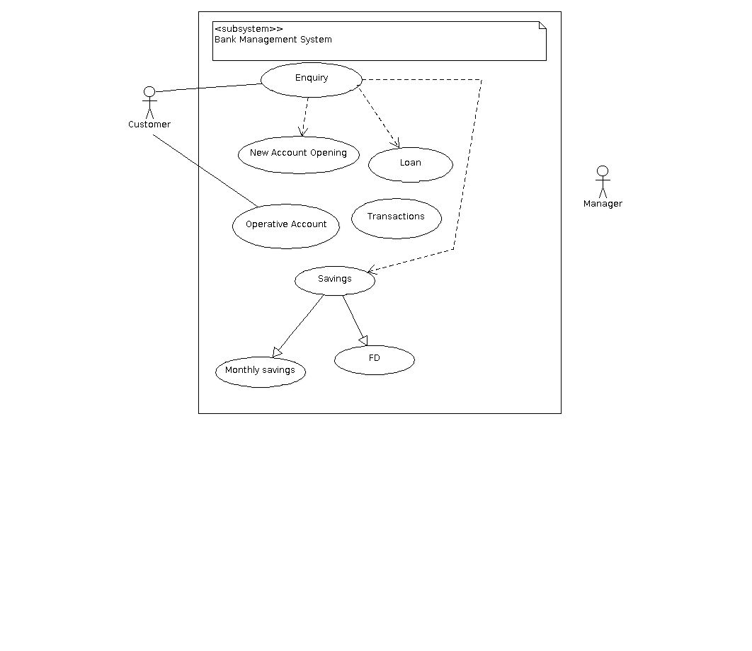

## #2

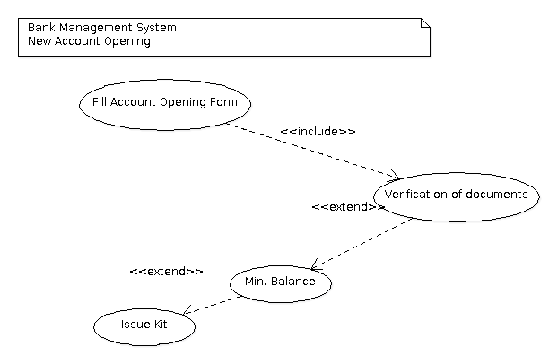

* + 1. **#3**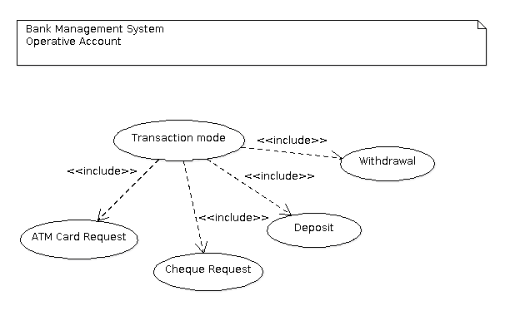

## #4

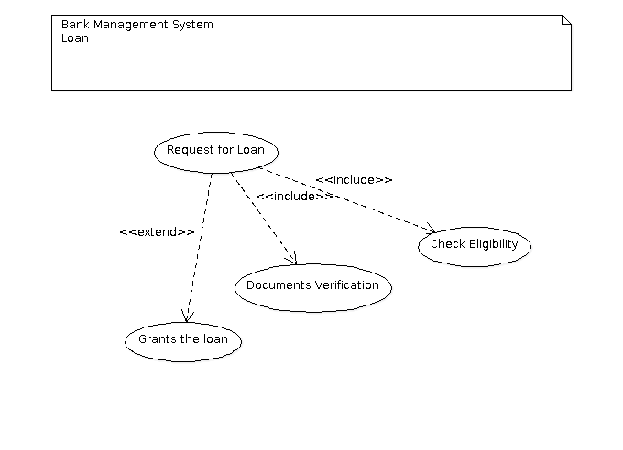

## Classes / Objects

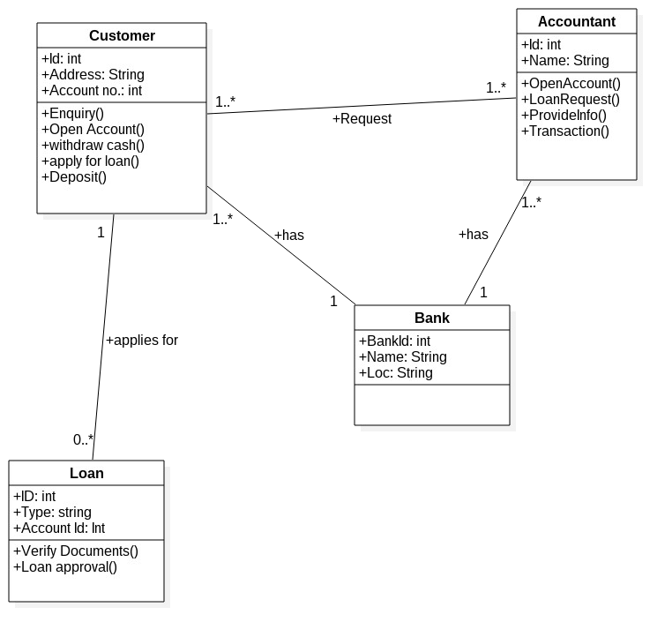

### 1. 3.4.1 Customer

* + - 1. .Attributes: 1.ID 2.Address 3.Account No.
      2. .Functions:
         1. Open Account 2.Withdraw Cash 3.Apply for loan 4.Deposit

### Accountant

* + - 1. .Attributes: 1.ID 2.Name
      2. .Functions:
         1. Enquiry
         2. Loan Request
         3. 3.Provide Info.
         4. 4.Transaction

### Bank

* + - 1. .Attributes:
         1. BankID 2.Name

3. Loc

## Non­Functional Requirements.

### 3.5.1 Performance

* + The system shall update all accounts information after every transaction
  + Responses to queries shall take no longer than 10 seconds to load onto the screen after the user payment is in Process.

### 3.5.2 Reliability

* + The User Verification process should access the database faster and Confirmation message must be display.
  + No breakdown of server problems and accounts status should not be delayed.

### 3.5.3 Availability

* + Availability to seek help from any staff should be Provided.

### 3.5.4 Security:

* The user details inside the database must be safe and should be produce whenever necessary.
* The confirmation message after payment must be safely send to customer emails.

### 3.5.5 Maintainability

* The customer details inside the database must be safely maintained.
* The details of the transaction must be maintained.

## Inverse Requirements

*No Inverse Requirements.*

## Design Constraints

*No Design Constraints.*

## Logical Database Requirements

* REQ-LD1:The database backend system in use will be Oracle 10i.
* REQ-LD2:The Front-end and middle logic will be written using JavaEE.
* REQ-LD3:Code will be stored on the Google Code SVN repository. [<http://code.google.com/p/afirs/>]
* REQ-LD4:Our development environment will be the latest NetBeans Integrated Development Environment.
* REQ-LD5:We will use Apache as our web server.
* REQ-LD6:We may write scripts to create synthetic code in Python/Perl.
* REQ-LD7:We may make changes to any of the above system requirement at anytime and for any reason

## Other Requirements

*Catch all section for any additional requirements.*

1. **4. Analysis Models**

## 4.1 Sequence Diagrams

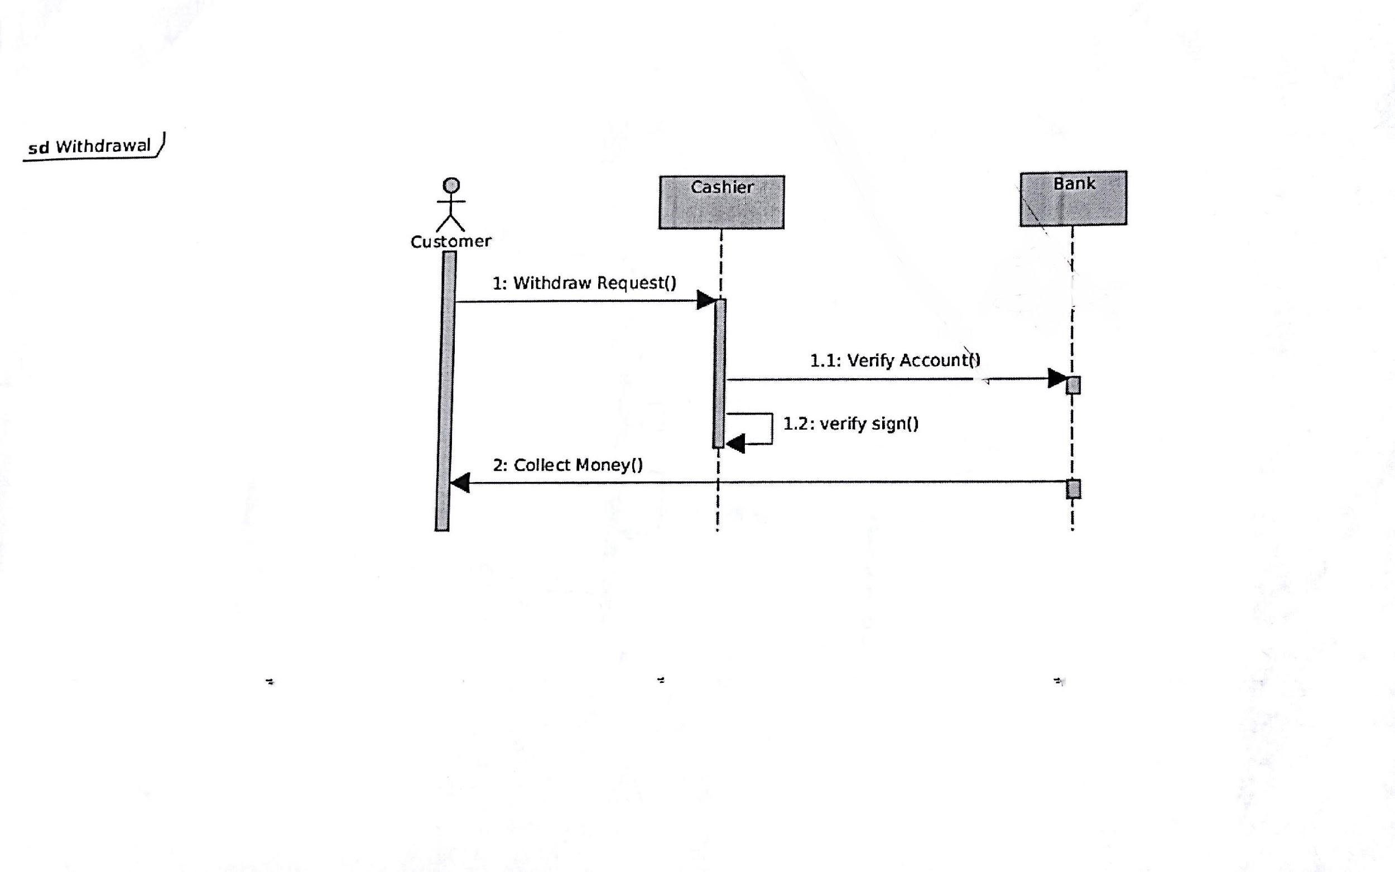

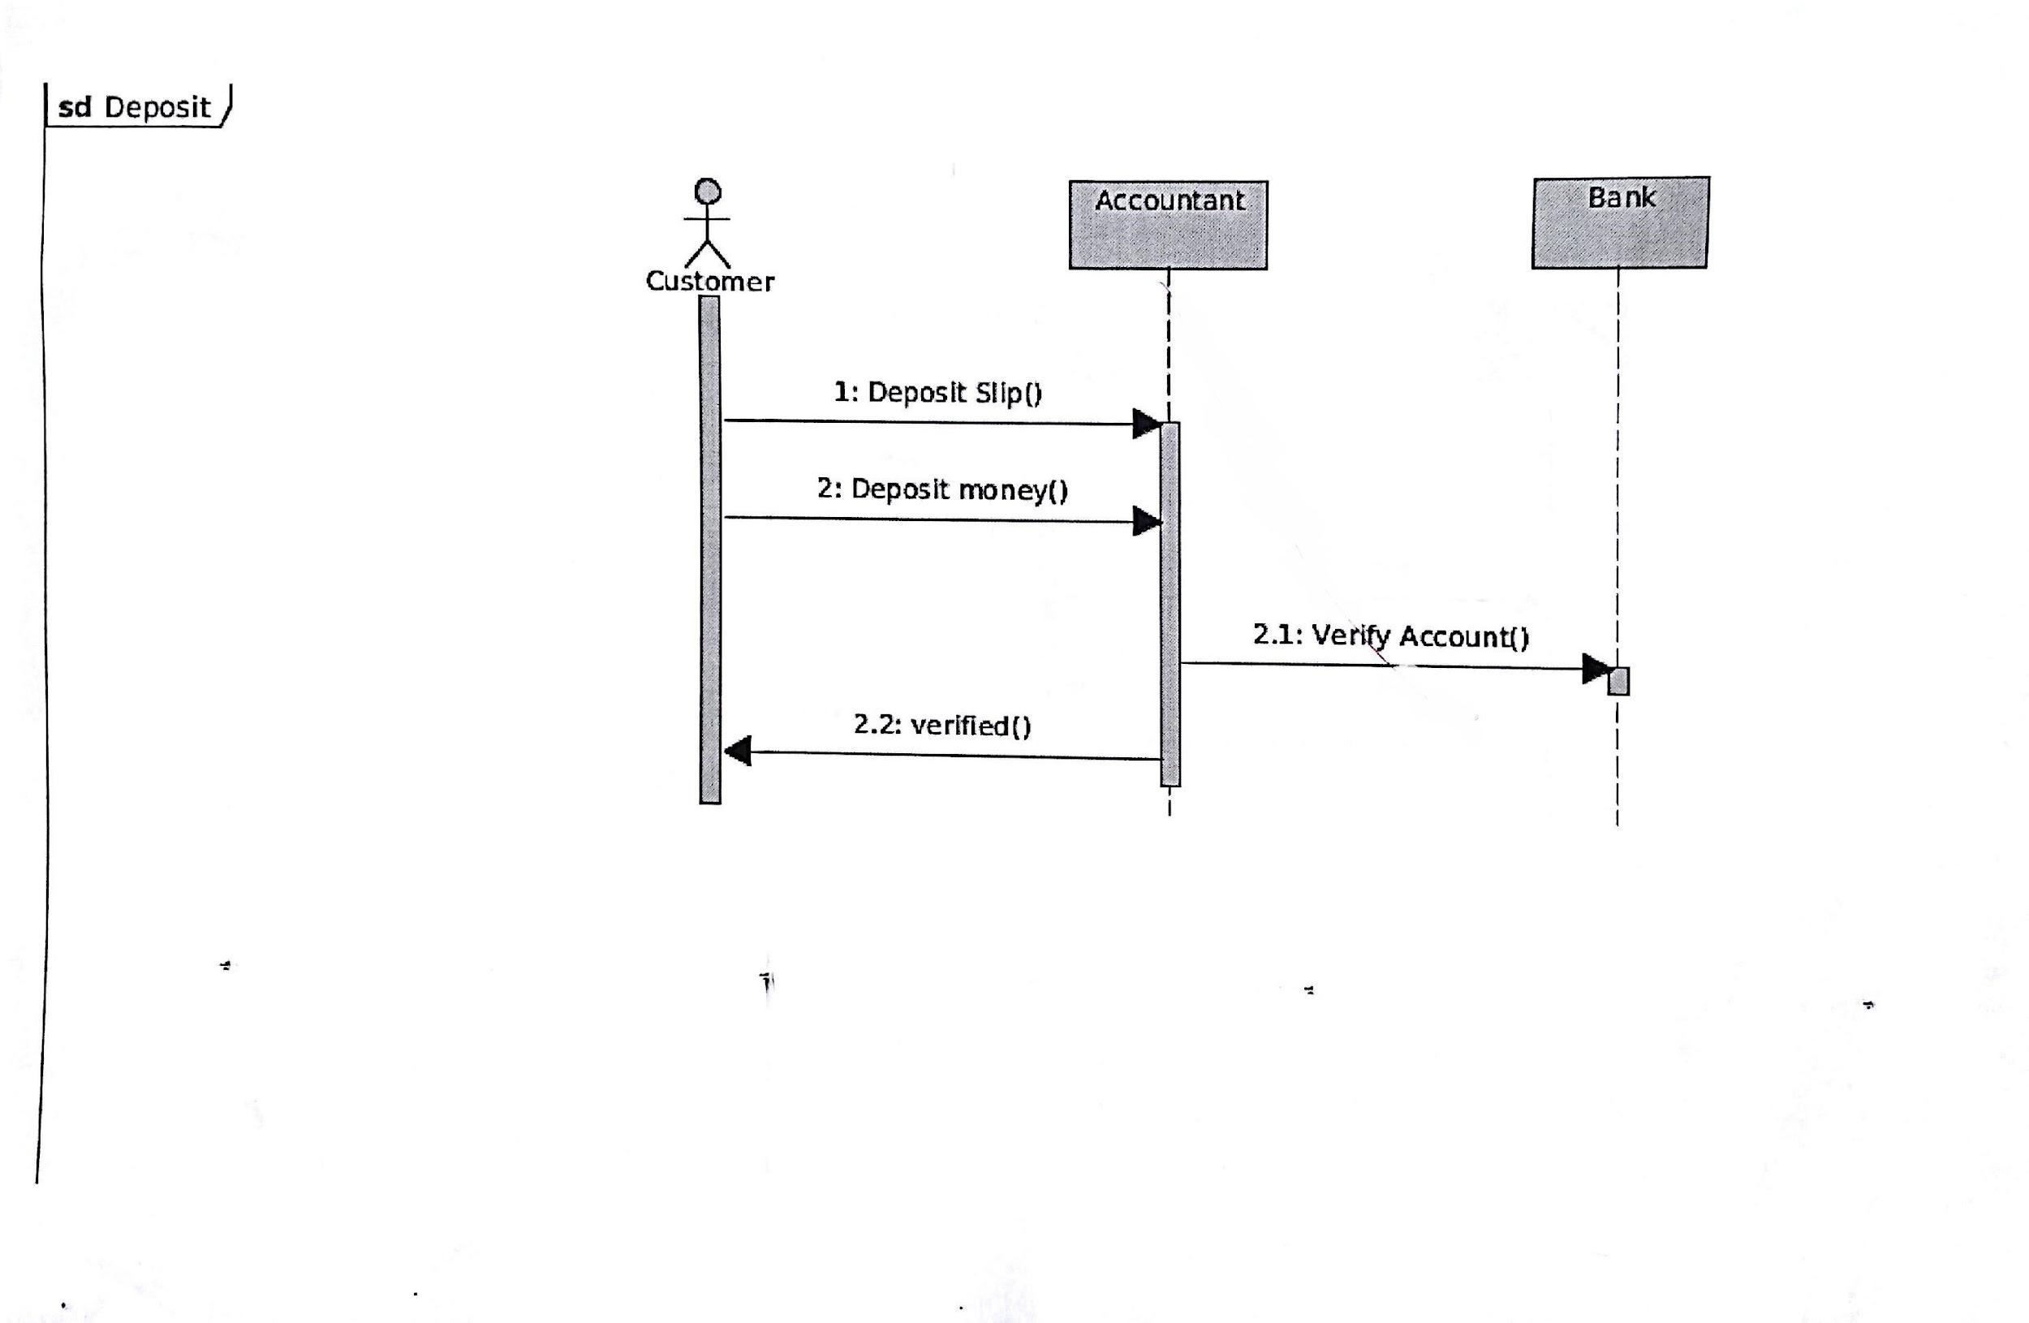

## 4.3 Data Flow Diagrams (DFD)

## 4.2 State­Transition Diagrams (STD)

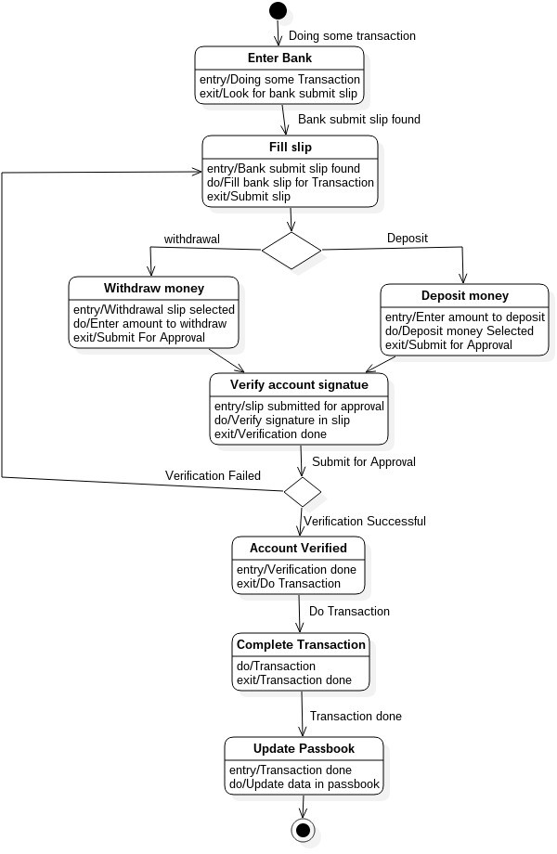

### 1. 5. Change Management Process

*Identify and describe the process that will be used to update the SRS, as needed, when project scope or requirements change. Who can submit changes and by what means, and how will these changes be approved.*