Clustering Turkish Provinces by Winter Heating-Degree-Day Profiles
A province-level heating-demand segmentation using daily HDD time-series patterns

Executive summary
This project groups Türkiye's 81 provinces according to the shape of their winter heating-degree-day (HDD) profiles. The objective is not only to identify where the country is colder, but to separate provinces that display similar daily heating-demand dynamics during the winter season. The dataset covers 151 daily observations from 2024-11-01 to 2025-03-31. The main result is a three-cluster structure separating western/coastal, transition/inland and eastern-highland profiles.
The analysis uses province-level standardisation, Euclidean distance, hierarchical clustering with complete linkage, cluster-number diagnostics and a k-means robustness check. The three-cluster solution is retained as the main segmentation because it balances statistical separation with geographic and energy-planning interpretability.
Data and preprocessing
The input matrix contains 81 provinces as observations and 151 daily HDD values as variables. Each province is treated as a daily winter profile. Before calculating distances, each province series is standardised using a row-wise z-score. This makes the comparison focus on the within-winter pattern of HDD movements rather than the absolute level alone.
This choice is important. A raw-HDD clustering would mostly rank provinces by average coldness. The row-standardised approach instead asks whether provinces warm up, cool down and react to seasonal changes in a similar temporal pattern. Raw HDD averages are then used after clustering to interpret each group in physical terms.
Method
The standardised province profiles are compared using Euclidean distance. Single-linkage and complete-linkage hierarchical clustering are both tested. Single linkage is useful as a diagnostic, but it tends to form long chains. Complete linkage is preferred for the final solution because it penalises large within-cluster distances and produces more compact groups.
The number of clusters is assessed with the Calinski-Harabasz index and the average silhouette score over k = 2 to 10. The Calinski-Harabasz index favours k = 3, while silhouette favours k = 2. The project retains k = 3 because it provides a more informative regional segmentation while remaining stable and interpretable.
Cluster-number diagnostics
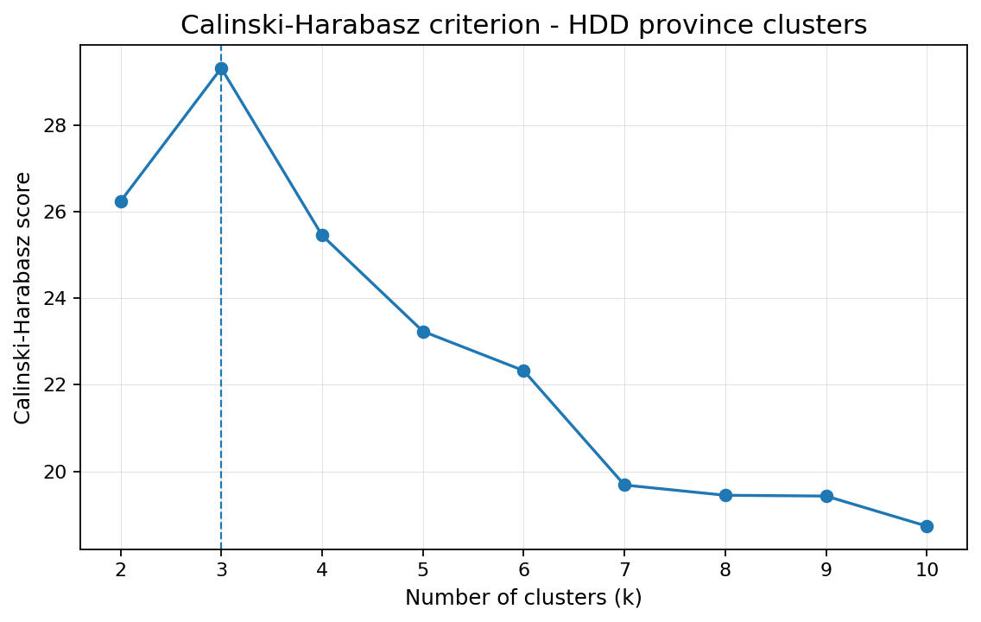
Figure 1. Calinski-Harabasz criterion. The maximum score is obtained at k = 3.
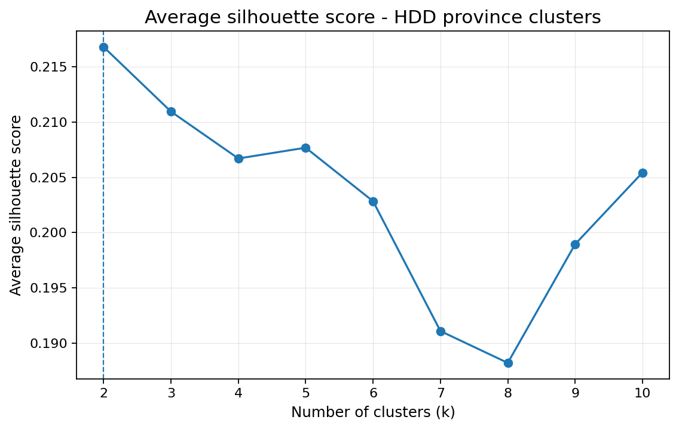
Figure 2. Average silhouette score. The most parsimonious split is k = 2, but k = 3 is close and more useful for planning interpretation.
Hierarchical clustering results
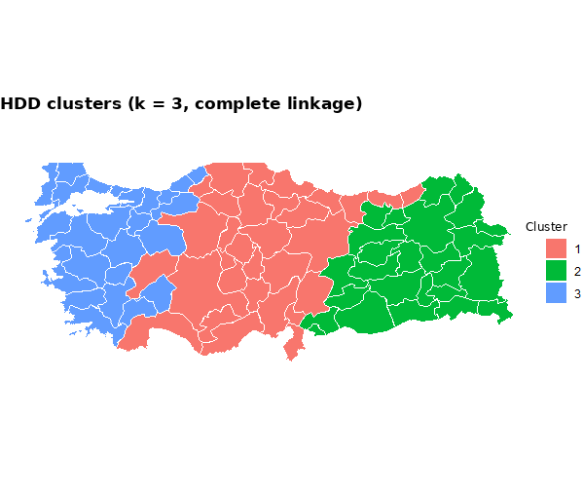
Figure 3. Three-cluster complete-linkage segmentation of province HDD profiles.
Cluster | Province count | Mean HDD | Interpretation
1 | 30 | 13.45 | Transition / intermediate heating profile
2 | 26 | 16.94 | Cold continental / eastern highland profile
3 | 25 | 11.35 | Milder western and coastal profile
The three-cluster solution divides the country into a milder western/coastal profile, a colder continental/eastern-highland profile and an intermediate transition profile. This is a practical level of aggregation for electricity-demand modelling, heating-load sensitivity analysis and regional energy-planning work.
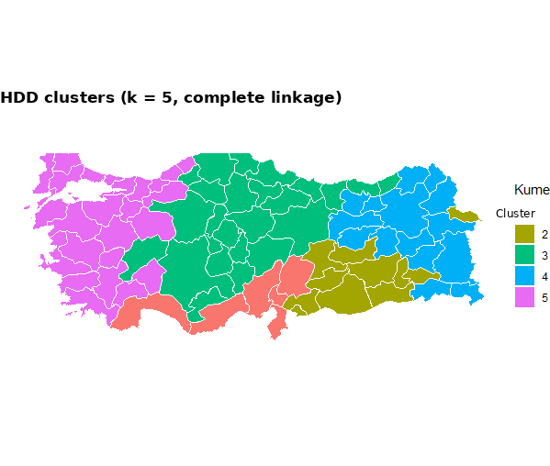
Figure 4. Five-cluster complete-linkage segmentation used as a supplementary, higher-resolution view.
Cluster | Province count | Mean HDD | Interpretation
1 | 6 | 8.25 | Mild Mediterranean coastal zone
2 | 11 | 11.89 | Southeastern transitional continental zone
3 | 24 | 14.75 | Central Anatolian and northern inland zone
4 | 15 | 20.65 | Cold eastern highland zone
5 | 25 | 11.35 | Mild Marmara-Aegean-western zone
The five-cluster segmentation adds detail by separating Mediterranean, Marmara-Aegean-western, Southeastern transition, Central Anatolian/northern inland and eastern-highland groups. It is useful when a finer regional segmentation is needed, but the three-cluster solution is more stable as the main portfolio result.
Profile interpretation
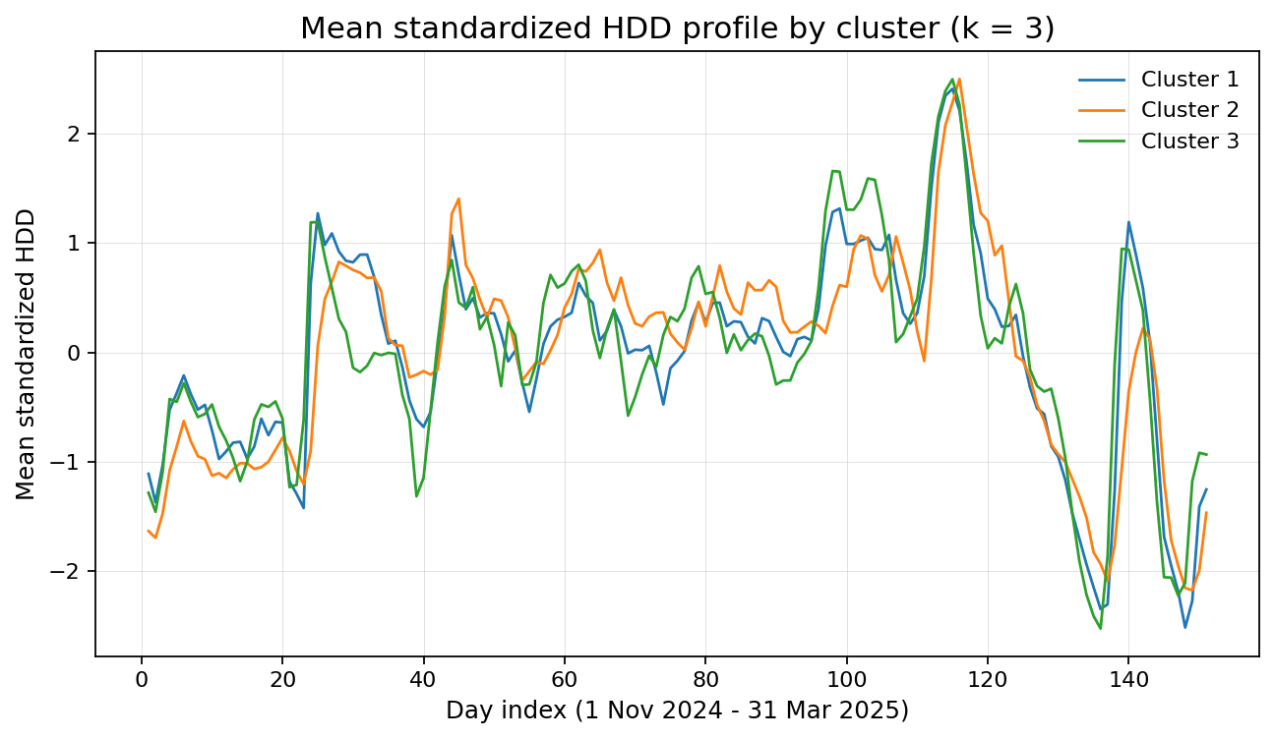
Figure 5. Mean standardised HDD profiles for the three main clusters.
All clusters follow the same broad national winter pattern, which is expected because national weather systems affect all provinces. The relevant distinction is in the amplitude and timing of deviations, especially during seasonal transition periods. This is why the clusters are meaningful for heating-demand modelling rather than being a simple cold-versus-warm ranking.
Robustness check with k-means
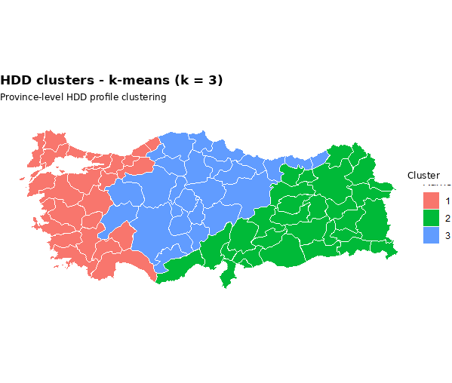
Figure 6. K-means clustering with k = 3 used as an algorithmic robustness check.
The k-means comparison supports the presence of three major HDD profile groups. The adjusted Rand index between the complete-linkage and k-means k = 3 solutions is 0.754. For k = 5, the adjusted Rand index is 0.726, indicating that the finer segmentation remains informative but is less stable than the three-cluster structure.
Use cases
Regional electricity demand modelling and heating-load sensitivity analysis.
Grouping provinces before building HDD-based demand forecasts.
Designing regional energy-efficiency or electrification scenarios.
Reducing dimensionality when 81 province-level HDD series are too detailed for a forecasting model.
Limitations
The analysis is exploratory and descriptive. It does not claim that HDD alone determines electricity demand, nor does it replace a full demand model with population, income, building stock, heating technology and calendar effects. Because the profiles are standardised by province, the clustering is designed to compare pattern similarity. Raw HDD statistics should be used alongside the clusters whenever absolute heating requirement is important.

