# 2. Simulations

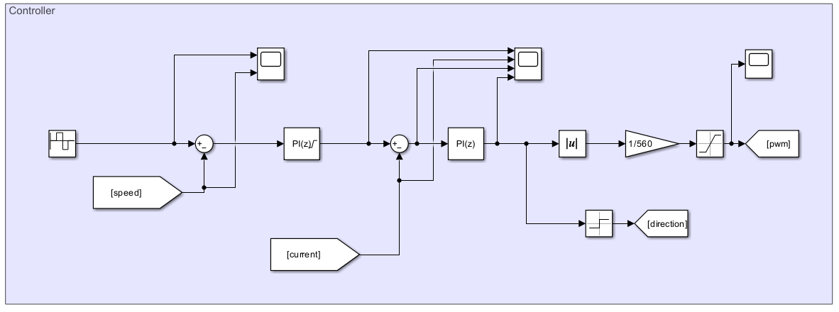

Figure 2.1 Controller Diagram

To achieve four-quadrant speed control, two PI controllers are employed: one for speed control and the other for current control. The speed control PI controller calculates the current reference, which is then saturated to ensure it does not exceed 20 A. The parameters are designed such that the output of the current control PI controller represents the desired motor voltage. By analyzing the sign of this output, the system determines whether to operate in forward or backward mode. Subsequently, the absolute value of the reference voltage is divided by the DC input voltage—supplied by the diode rectifier—to calculate the desired duty cycle. Finally, the duty cycle is verified to ensure the motor voltage does not exceed 180 V.

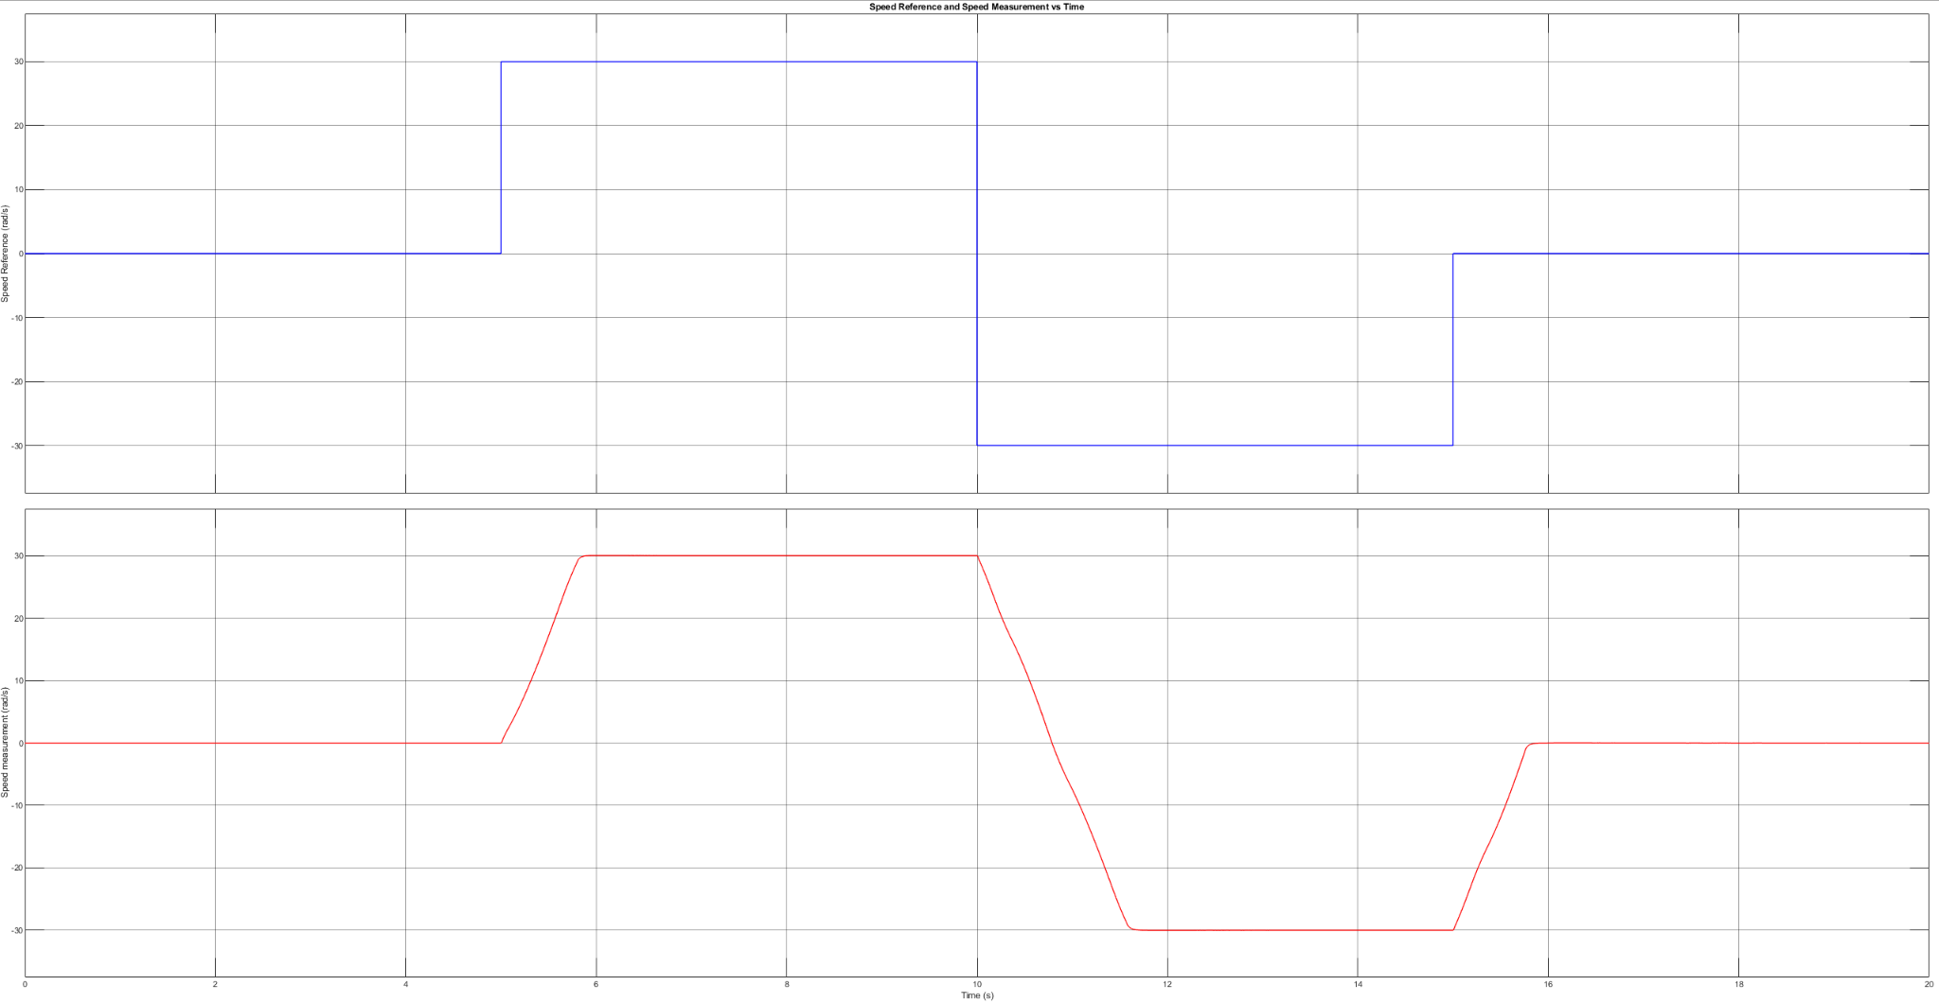

Figure 2.2 Speed Reference and Measured Speed

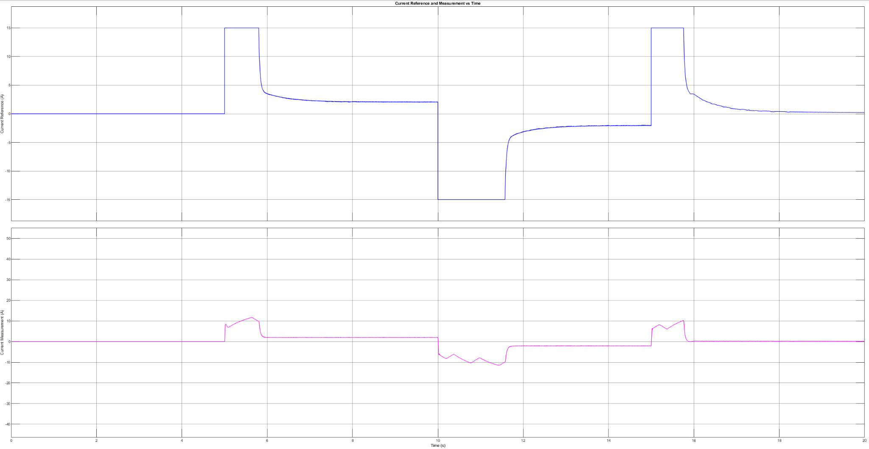

Figure 2.3 Motor Current Reference and Measured Motor Current

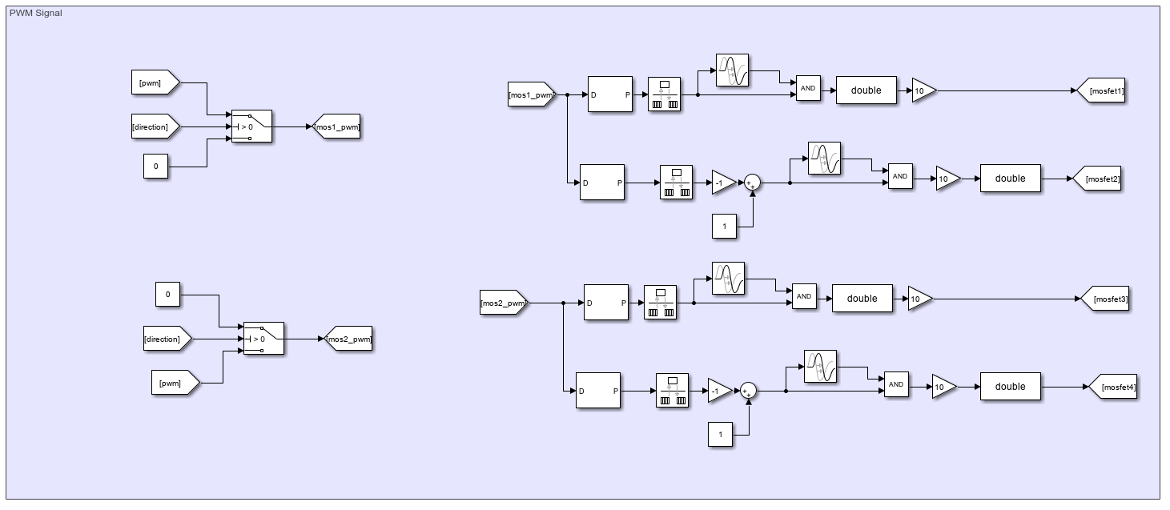

Figure 2.4 PWM Generation for 4 MOSFET

Once the duty cycle is determined by the controller, PWM waves are generated. To enable four-quadrant motor operation, four MOSFETs are utilized. Based on the direction calculated by the controller, the appropriate half-bridge is supplied with the duty cycle, while the other half-bridge is configured to establish a low-side connection between the motor and the power supply. For a duty cycle of 0.1 the following 4 PWM signals are generated:

MOSFET 1: PWM with 0.1 duty cycle

MOSFET 2: PWM with 0.9 duty cycle

MOSFET 3: PWM with 0 duty cycle

MOSFET 4: PWM with 1 duty cycle

Between MOSFET 1 and 2, MOSFET 3 and 4 a dead time of 1 microsecond is selected. Moreover, the switching frequency is selected as 25 kHz.

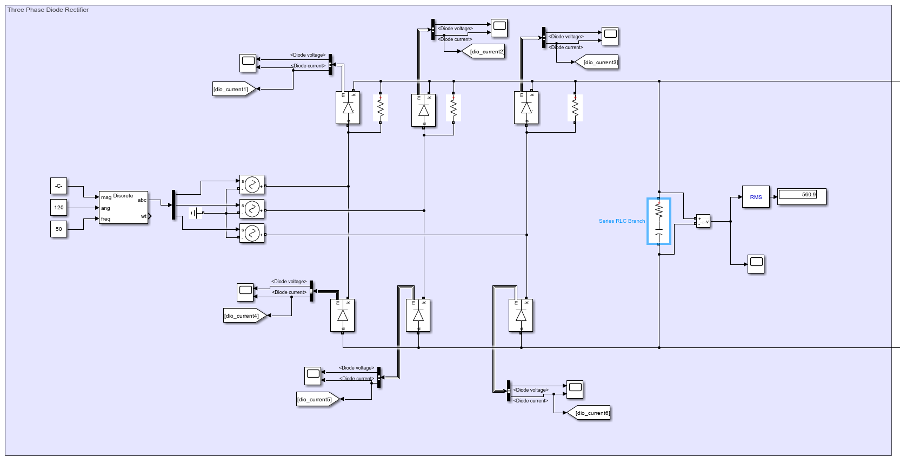

Figure 2.5 Diode Rectifier

Three phase diode rectifier is utilized for rectifying AC input to DC. At the output of the rectifier 200 capacitor is utilized and it is connected to full bridge buck converter and the parallel resistors in the high side are for running simulation without errors (1e11 ohm resistance is selected to not affect the system).

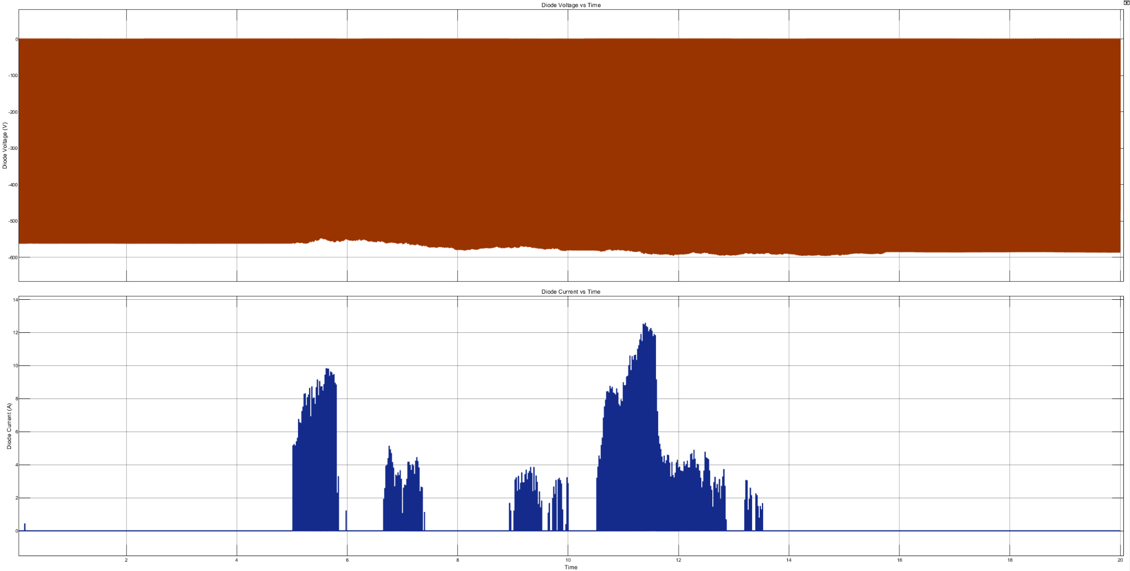

Figure 2.6 Diode Voltage, Diode Current

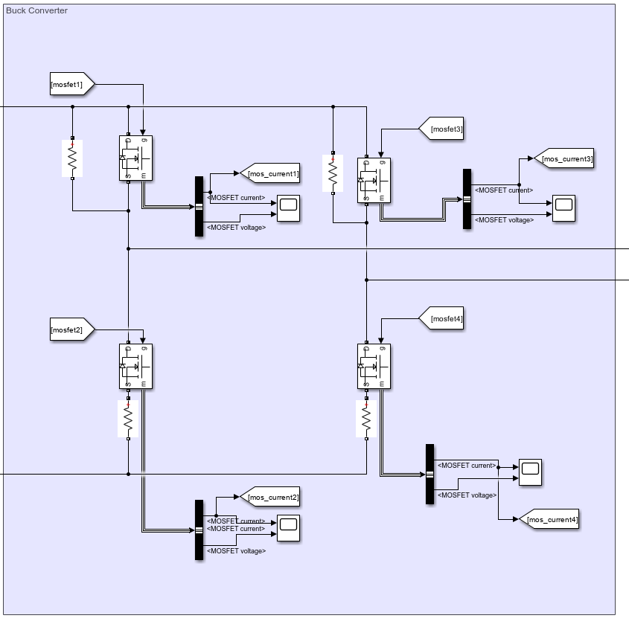

Figure 2.7 Full Bridge Buck Converter

To regulate input voltage to a desired output voltage, a buck converter is employed. For four-quadrant operation, an H-bridge configuration of the buck converter is utilized. Shunt resistors are incorporated for the gate drivers, while high-side parallel resistors are included to ensure error-free simulations. These resistors are assigned an extremely high resistance value (1 × 10¹¹ ohms) to minimize their impact on the system.

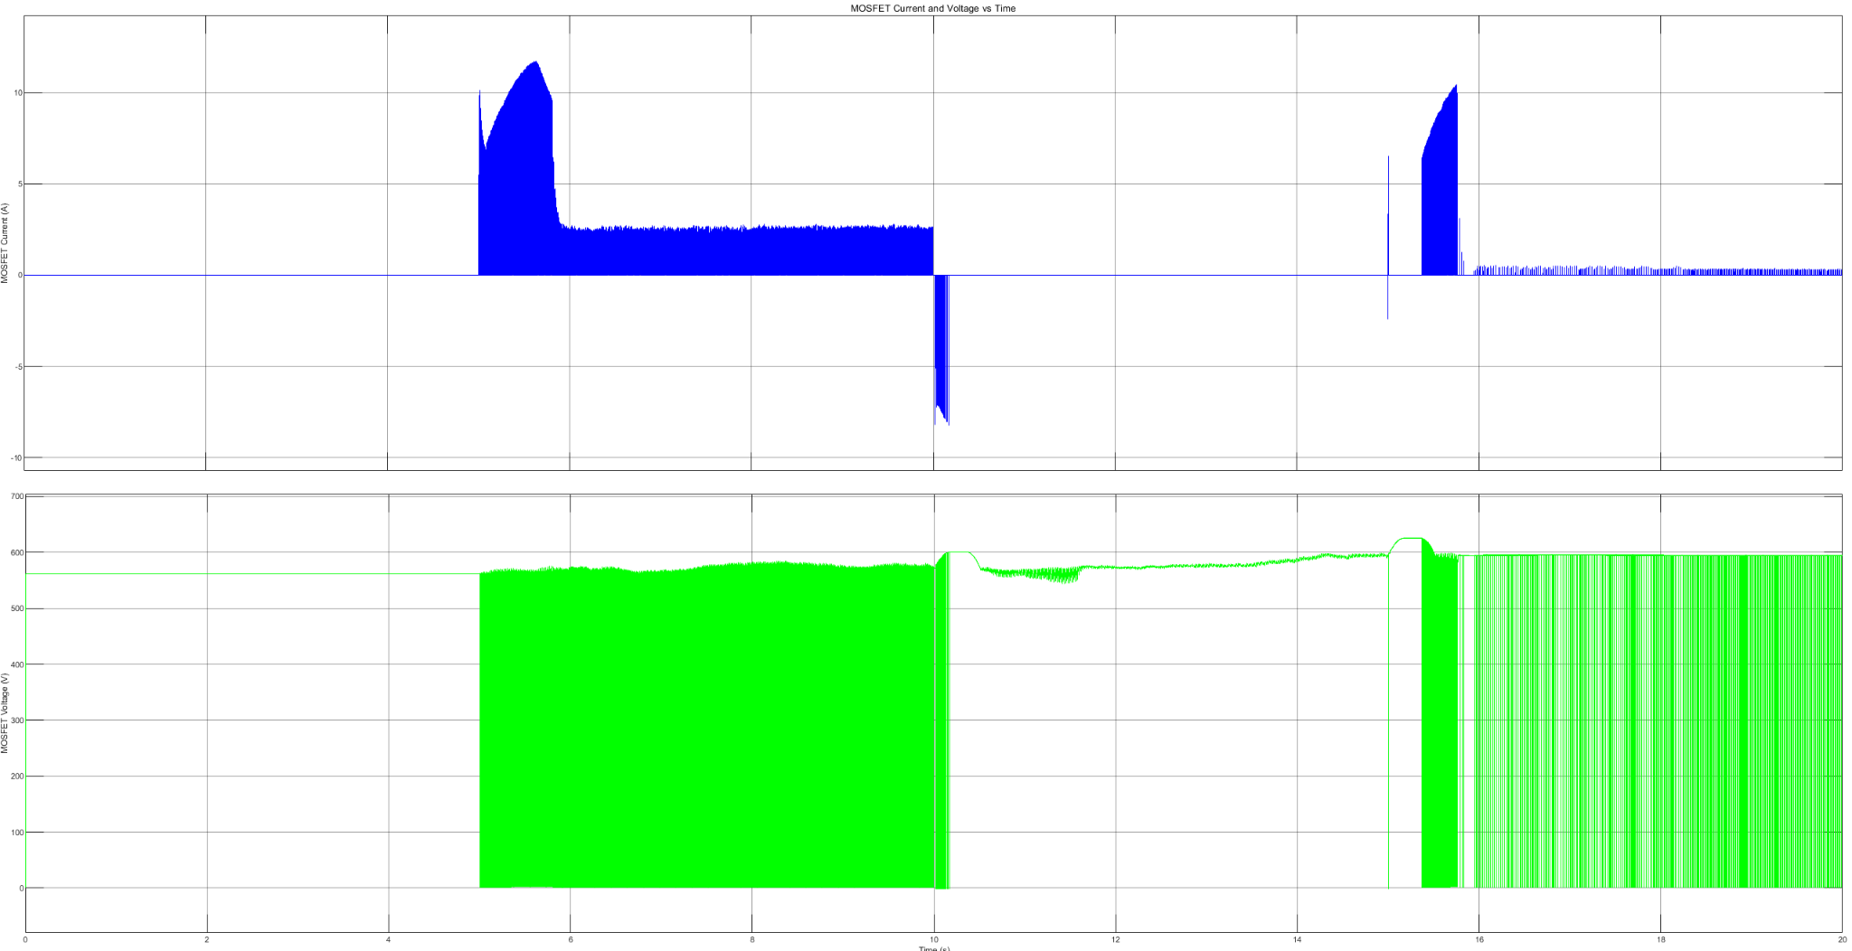

Figure 2.8 MOSFET Voltage, MOSFET Current

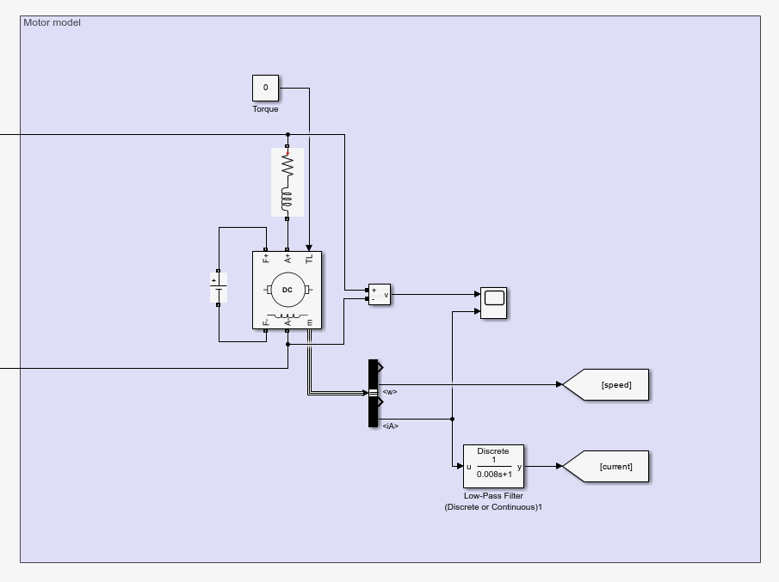

Figure 2.9 Motor Model

In the simulations, the motor is assumed to operate under no-load conditions. Current measurements are smoothed using a low-pass filter with a time constant of 0.008, ensuring more stable readings. The interpole winding impedance is modeled as an RL load connected in series with the motor. Additionally, the field windings are excited with a 220V supply.

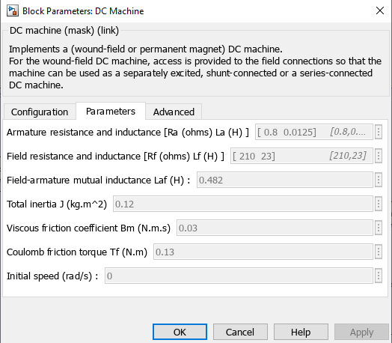

Figure 2.10 Motor Parameters

Armature and field resistances and inductances were given however field-armature mutual inductance, total inertia and friction constants are assumed as given in figure 2.10.

# 3. Thermal Analysis

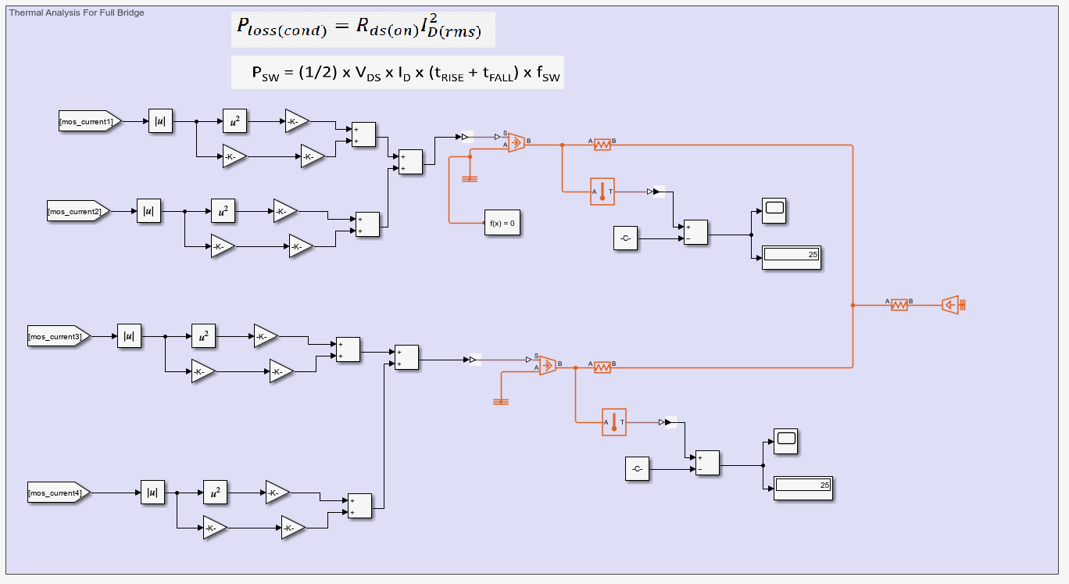

Figure 3.1 Thermal Analysis for Full Bridge Buck Converter

For the thermal analysis of the MOSFETs, two types of losses are calculated: switching losses and conduction losses. Conduction losses arise from the MOSFET's on-resistance, while switching losses are determined by factors such as voltage, current, on-time, off-time, and switching frequency.

For the component SH32N65DM6AG, each module contains two MOSFETs, and their losses are summed accordingly. On the PCB, two SH32N65DM6AG components share a single heat sink, and this configuration is mirrored in the simulation.

The thermal pad Non-Silicone Heat Transfer Compound Plus has a thermal conductivity of 2.5 W/m·K. With a thickness of 1 mm, its thermal resistance is calculated to be 0.0025 W/K. The junction-to-case thermal resistance of the MOSFET is 0.6 W/K, while the heat sink, utilizing forced convection, has a thermal resistance of 0.47 W/K.

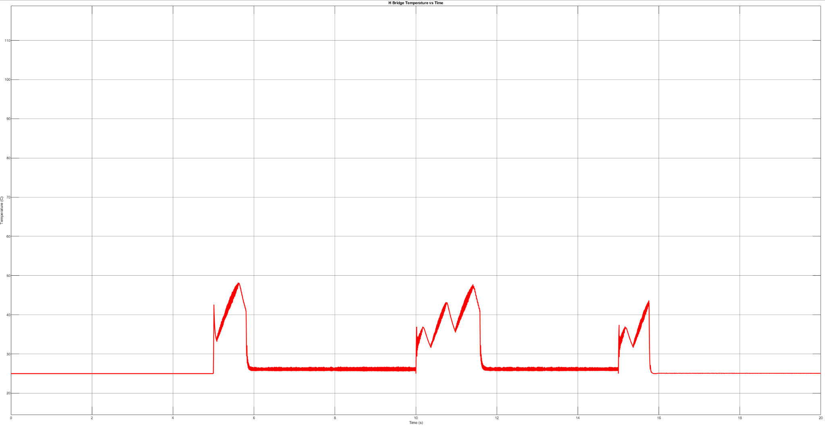

Figure 3.2: Temperature of SH32N65DM6AG

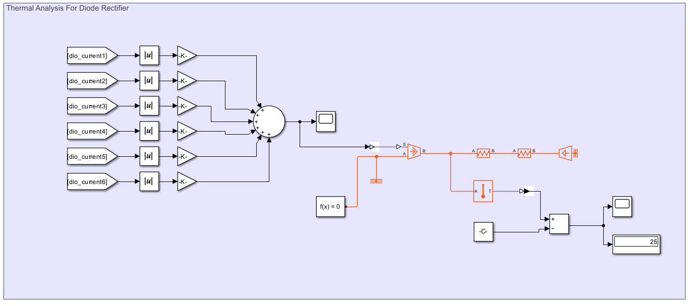

Figure 3.2 Thermal Analysis for Diode Rectifier

For the diode rectifier, turn-on and turn-off times are not specified in the datasheet. Since the operation occurs at 50 Hz, switching losses are considered negligible. Conduction losses are calculated by multiplying the diode current with its forward voltage.

The DB35-12 component includes all six diodes, so the losses for each diode are summed. The junction-to-case thermal resistance is 1.8 W/K, and the heat sink, operating with forced convection, has a thermal resistance of 0.56 W/K.

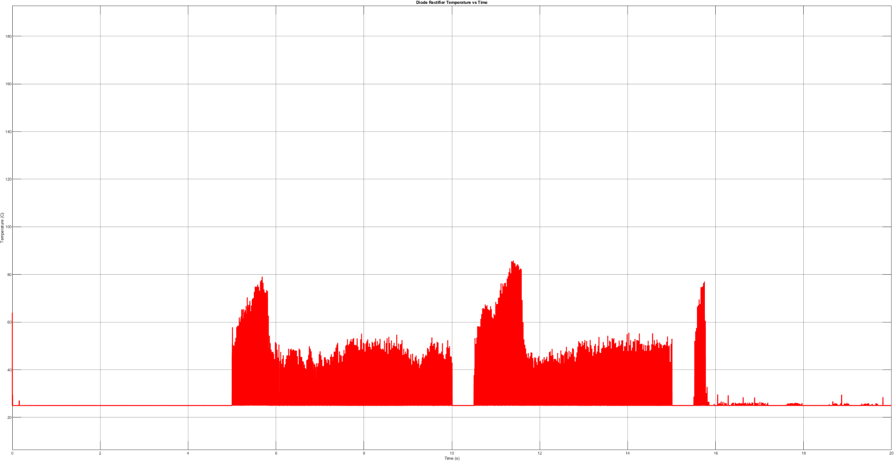

Figure 3.3 Temperature of DB35-12

# 4. Component Selection

For this project there are several types of components which should be put to circuit for different purposes. Some of them are; different values of resistors, capacitors, inductors, diodes, MOSFETs, control cards etc. Firstly, one of the diode bridge components is DB35-12 diode bridge rectifier. DB35-12 can overcome 1.2 kV which is inside of the safety margin for our circuits, it is clear that the diodes of our circuit should be able to overcome until 550 V (from figure 2.6.). From figure 2.6. it is also clear that diodes have 12 A peak current and DB35-12 can overcome until 35 A (for average rectified situation). Also, this bridge rectifier operating temperature interval is 50-150 Celsius, which is inside of our margin. For voltage stability at the output of the diode rectifier there should be 200 uF capacitor and it was put to circuit (figure 2.6.). For PCB, 2 100 uF capacitors were used parallel (100+100 = 200 uF) for this purpose.

At the output of the diode rectifier, we used full bridge topology before the buck converter. 2 identical SH32N65DM6AG half bridge topology is used for this purpose. This bridge’s MOSFETs can withstand up to 650 V blocking voltage and 20A drain current at 100 Celsius. For this project, MOSFET should be able to withstand up to 550 V blocking voltage and 10 A drain current maximum, so this bridge has quantities according to our requirements. L6491D is used for gate driving of the bridge’s MOSFETs.

SC0915 Raspberry pi is used for pwm generation. Since this card can work with 3.3V and 5V there is also another process inside of our circuit to be able to produce these voltages (their components will be mentioned). We do not use this raspberry pi for complex purposes. There are four PWM outputs from this card, and it take current senser output information as input, two fault analysis point as inputs, and two encoder inputs. This card has capability to be able to produce these PWM if necessary inputs can be given to the card.

For high inputs and low inputs of L6491D gate drivers, there are RC filters. Since PWM of the circuit has 25kHz frequency, and it is optimal to have cut off frequency higher than the operation frequency, 250 kHz filtering is selected (which is 10 times of frequency of PWMs. 10 time means 1 logarithmic scale, so it is enough good). From f = 1/(2*pi*R*C), resistor and capacitor were selected as 820 ohm and 820 pF. These filters are put at low inputs and high inputs of the L6491D gate drivers. For comparator pins of gate driver there is a filter for high frequency noises. To be able to eliminate high frequencies properly at the comparator positive pins, this time it is chosen 3 times safety instead of 10 times safer. So, filter is designed for 75 kHz, and resistance is 10 Kohm, capacitance is 220 pF were selected. For comparator negative pins, VCP- = 0.9 for noise margin. From voltage divider (it can be seen from PCB layout):

0.9 = RP2/(RP1+RP2) *3.3

RP1 = 27 Kohm, and RP2 = 10 Kohm.

Also, for voltage divider stabilization, capacitance is selected as 100nF.

For current sensing, ACS712ELCTR30AT hall effect current sensor is selected. Rise time of this sensor is 5 microseconds which is enough for us. Also 80 kHz bandwidth is quite enough for our circuit. Total output error is quite low (1.5% at 25 Celsius) which is desired value for controlling. Also, 5V singly supply operation is quite easy to implement. From figure 4.1 it can be seen 30A-T model of this current sensor can read current until -+30 A which is enough for our project (we need mostly 20 A).

metin, ekran görüntüsü, yazı tipi, sayı, numara içeren bir resim

Açıklama otomatik olarak oluşturuldu

Figure 4.1 Current sensor datasheet information for current sensing.