# 2. Simulations

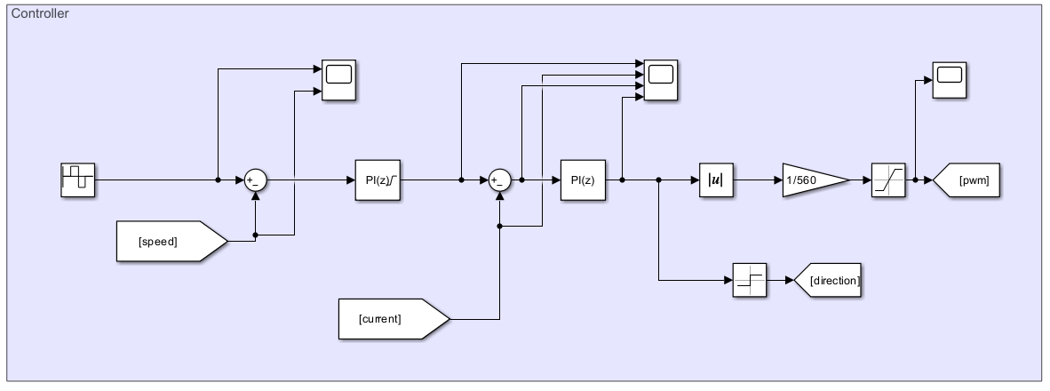

Figure 2.1 Controller Diagram

To achieve four-quadrant speed control, two PI controllers are employed: one for speed control and the other for current control. The speed control PI controller calculates the current reference, which is then saturated to ensure it does not exceed 20 A. The parameters are designed such that the output of the current control PI controller represents the desired motor voltage. By analyzing the sign of this output, the system determines whether to operate in forward or backward mode. Subsequently, the absolute value of the reference voltage is divided by the DC input voltage—supplied by the diode rectifier—to calculate the desired duty cycle. Finally, the duty cycle is verified to ensure the motor voltage does not exceed 180 V.

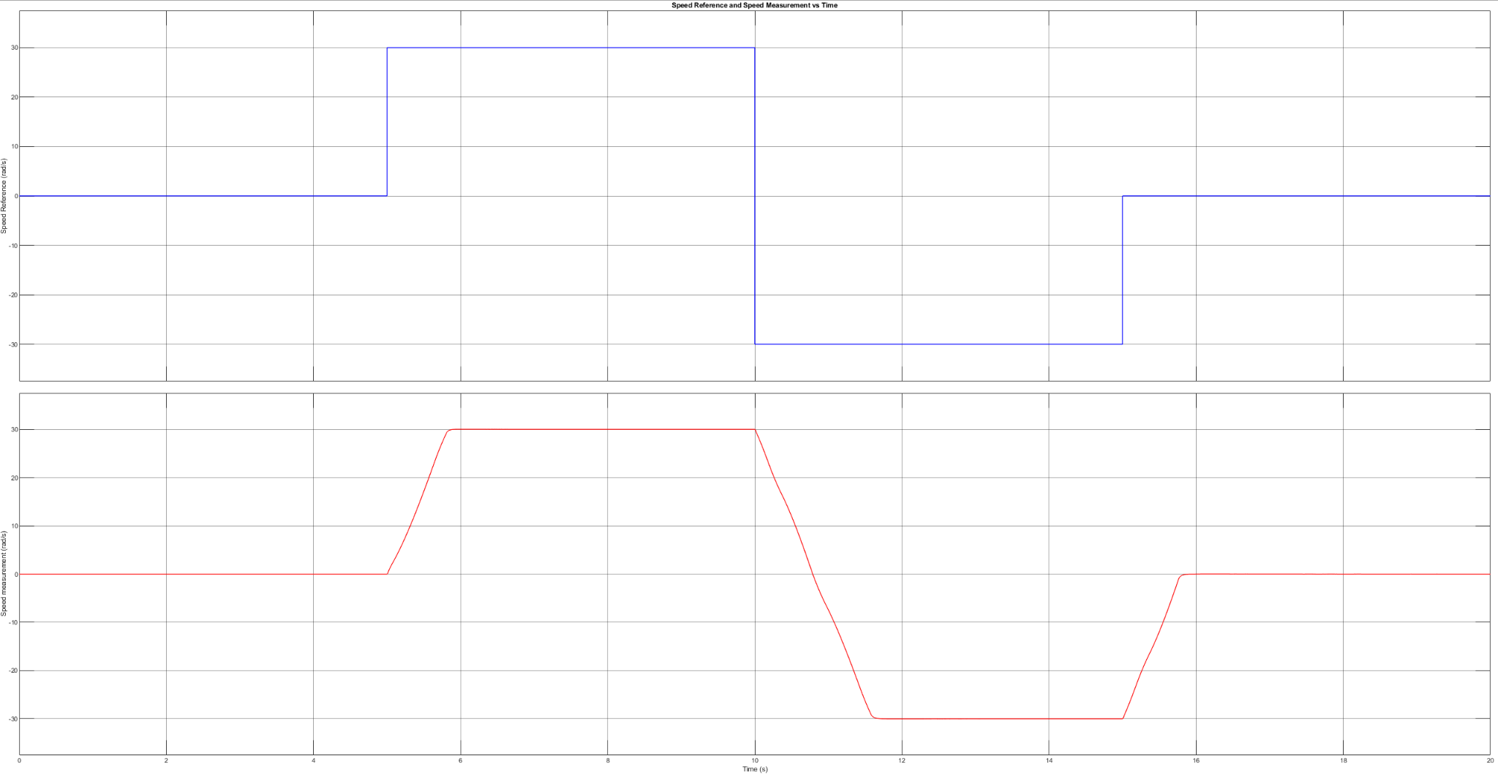

Figure 2.2 Speed Reference and Measured Speed

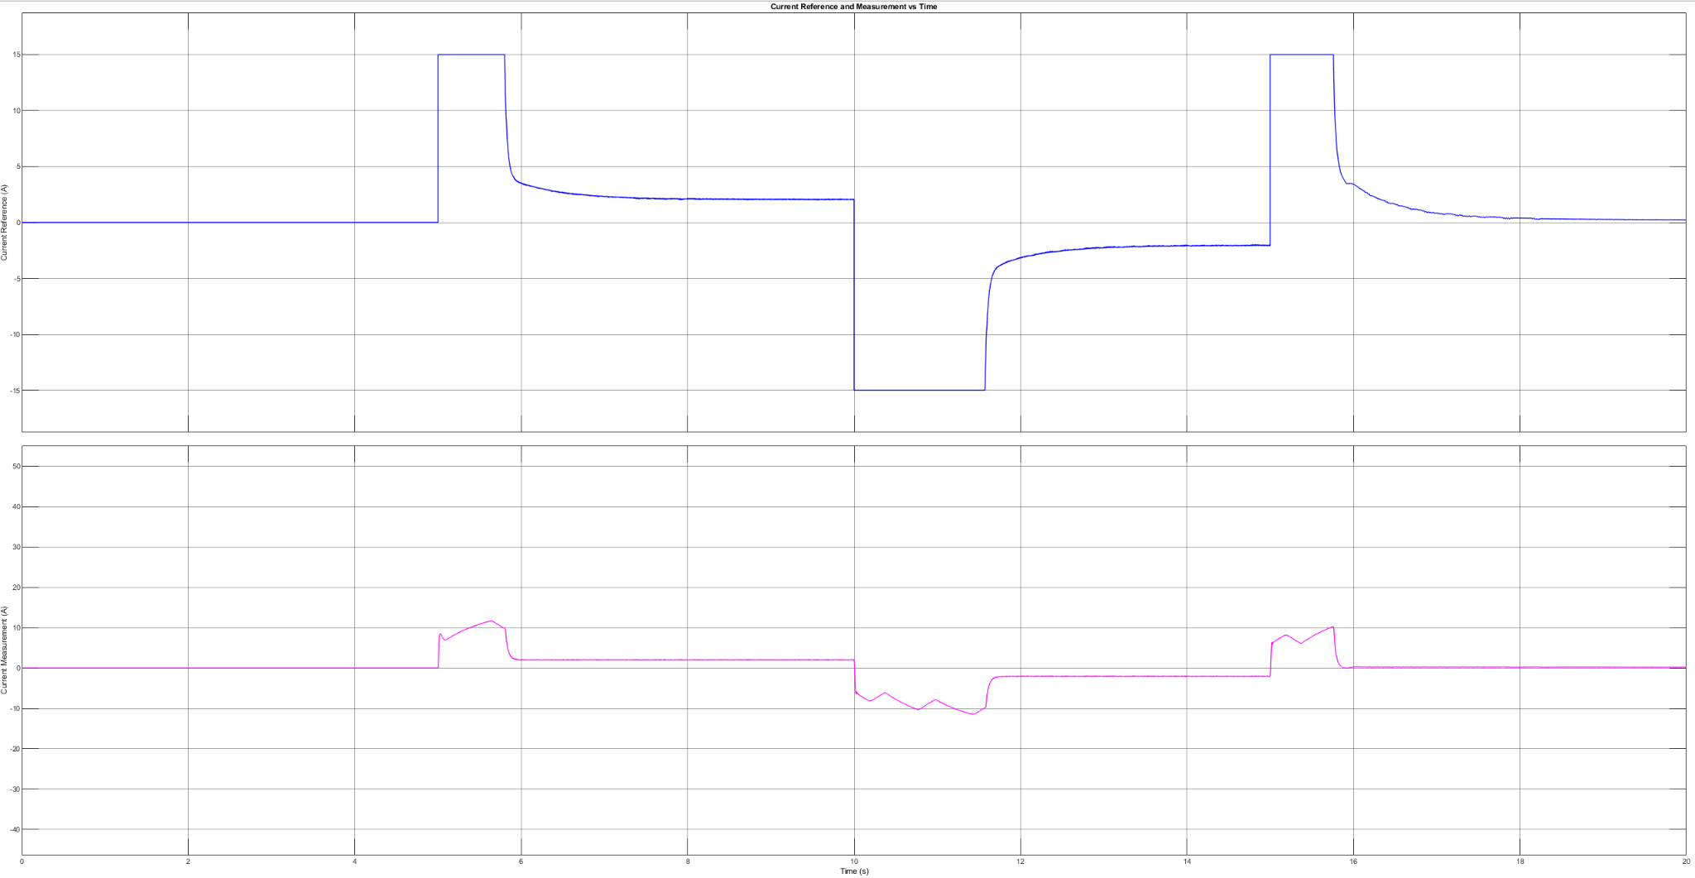

Figure 2.3 Motor Current Reference and Measured Motor Current

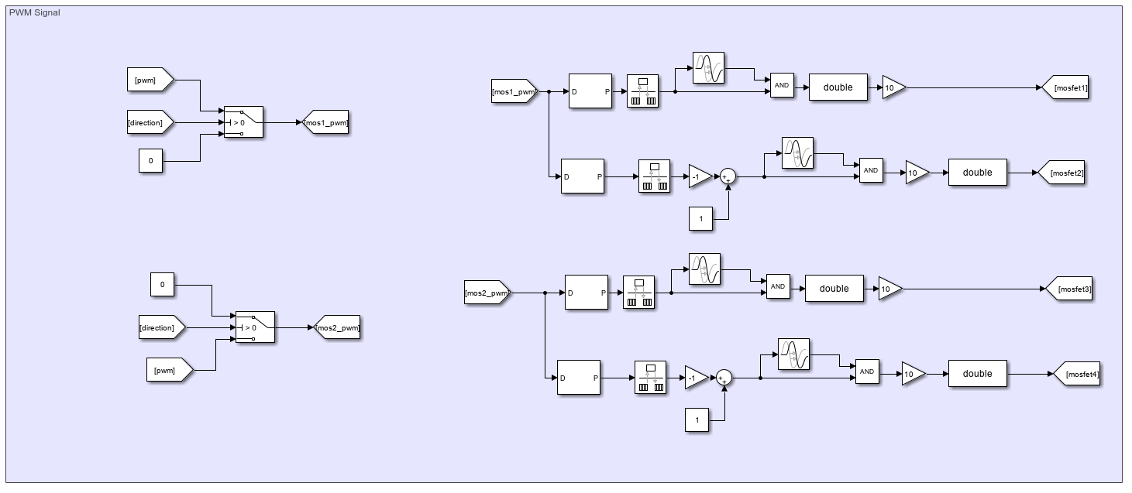

Figure 2.4 PWM Generation for 4 MOSFET

Once the duty cycle is determined by the controller, PWM waves are generated. To enable four-quadrant motor operation, four MOSFETs are utilized. Based on the direction calculated by the controller, the appropriate half-bridge is supplied with the duty cycle, while the other half-bridge is configured to establish a low-side connection between the motor and the power supply. For a duty cycle of 0.1 the following 4 PWM signals are generated:

MOSFET 1: PWM with 0.1 duty cycle

MOSFET 2: PWM with 0.9 duty cycle

MOSFET 3: PWM with 0 duty cycle

MOSFET 4: PWM with 1 duty cycle

Between MOSFET 1 and 2, MOSFET 3 and 4 a dead time of 1 microsecond is selected. Moreover, the switching frequency is selected as 25 kHz.

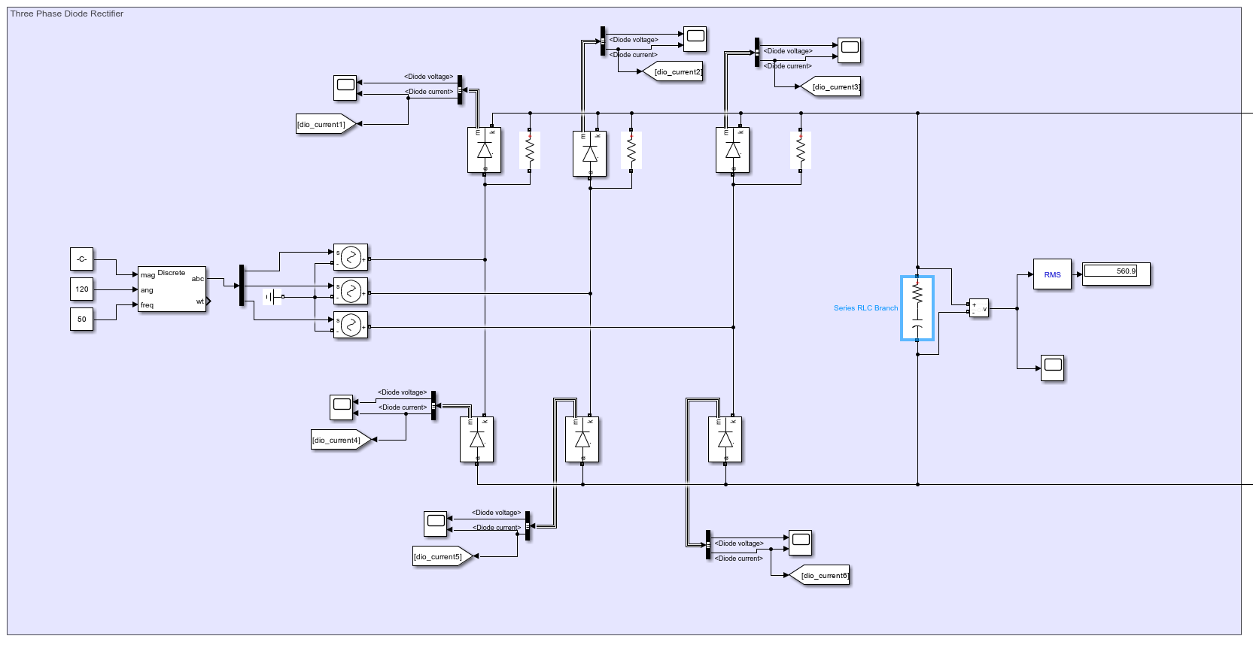

Figure 2.5 Diode Rectifier

Three phase diode rectifier is utilized for rectifying AC input to DC. At the output of the rectifier 200 $μF$ capacitor is utilized and it is connected to full bridge buck converter and the parallel resistors in the high side are for running simulation without errors (1e11 ohm resistance is selected to not affect the system).

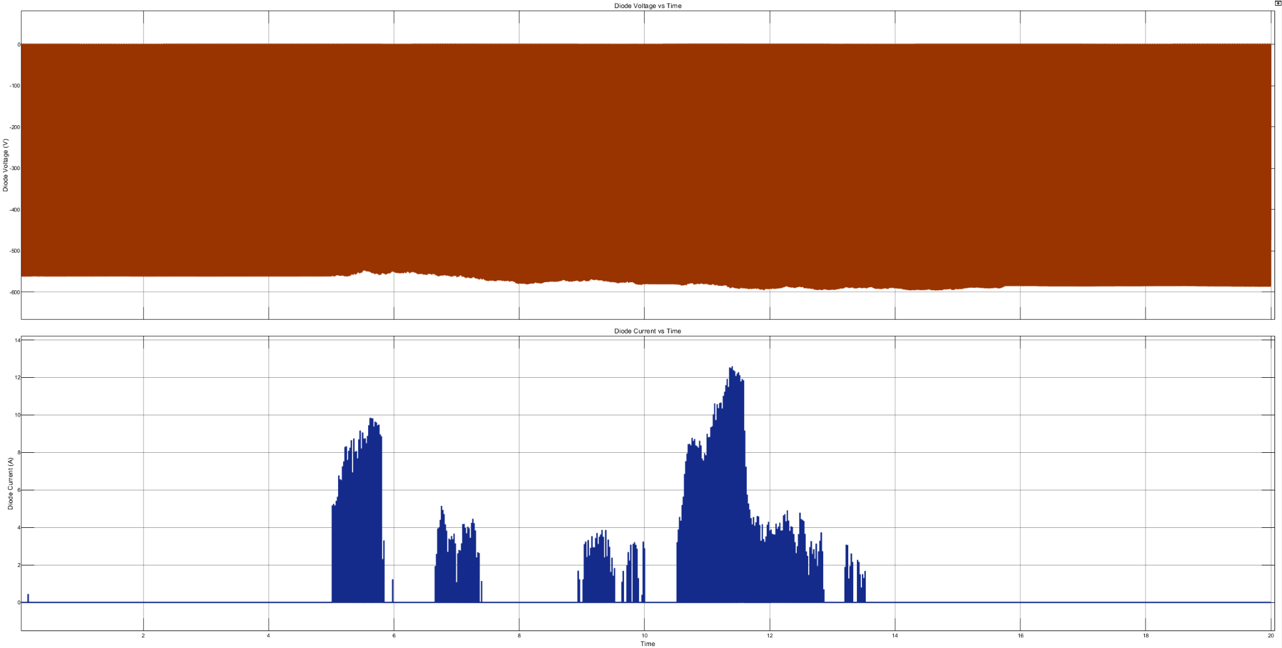

Figure 2.6 Diode Voltage, Diode Current

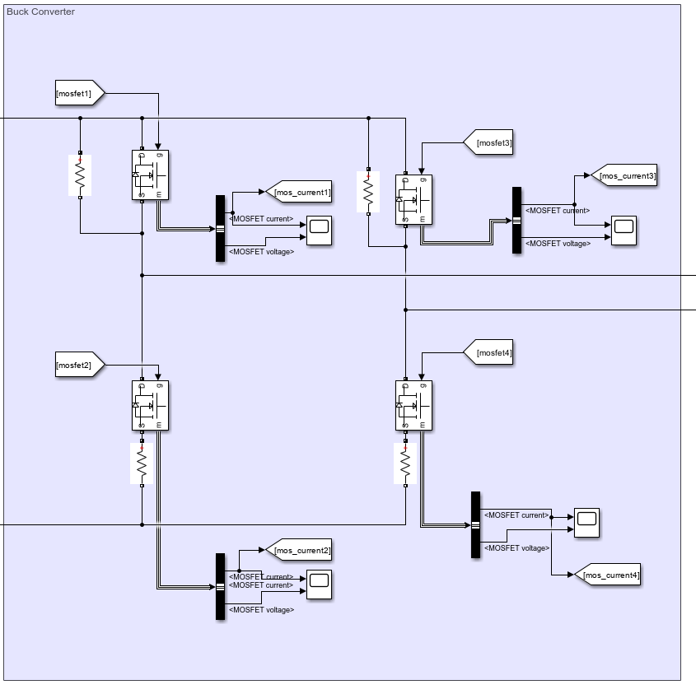

Figure 2.7 Full Bridge Buck Converter

To regulate input voltage to a desired output voltage, a buck converter is employed. For four-quadrant operation, an H-bridge configuration of the buck converter is utilized. Shunt resistors are incorporated for the gate drivers, while high-side parallel resistors are included to ensure error-free simulations. These resistors are assigned an extremely high resistance value (1 × 10¹¹ ohms) to minimize their impact on the system.

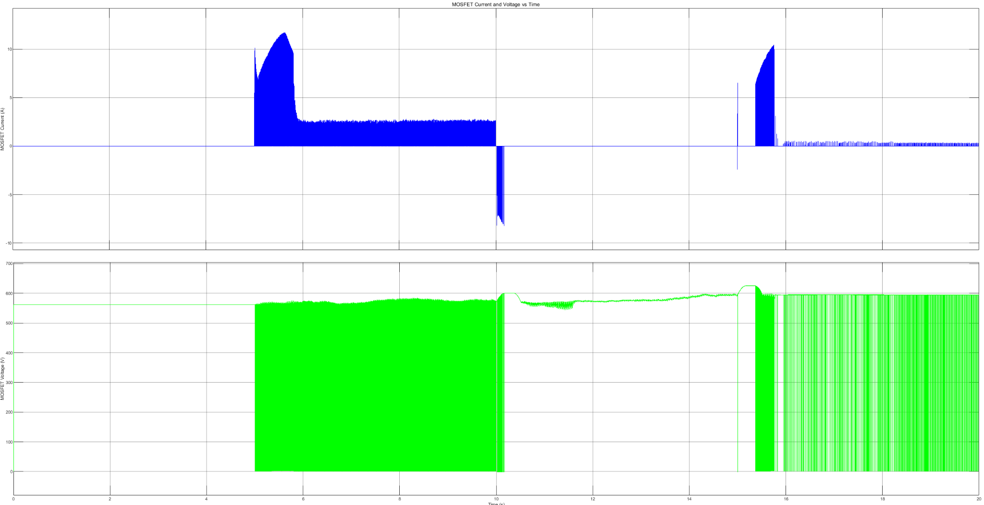

Figure 2.8 MOSFET Voltage, MOSFET Current

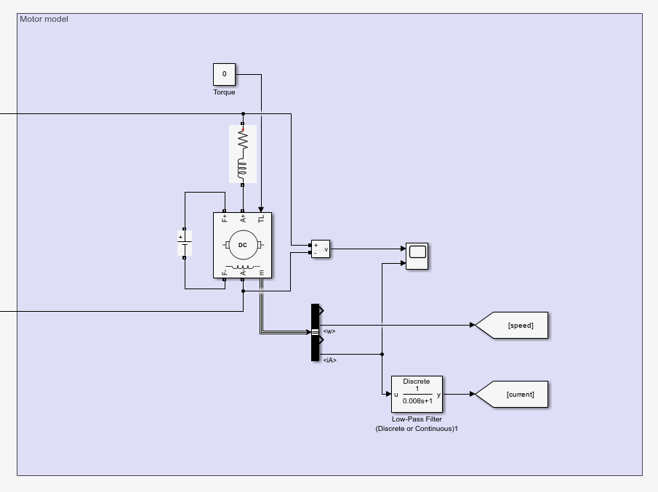

Figure 2.9 Motor Model

In the simulations, the motor is assumed to operate under no-load conditions. Current measurements are smoothed using a low-pass filter with a time constant of 0.008, ensuring more stable readings. The interpole winding impedance is modeled as an RL load connected in series with the motor. Additionally, the field windings are excited with a 220V supply.

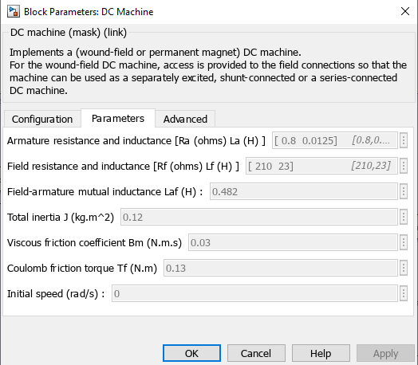

Figure 2.10 Motor Parameters

Armature and field resistances and inductances were given however field-armature mutual inductance, total inertia and friction constants are assumed as given in figure 2.10.

# 3. Thermal Analysis

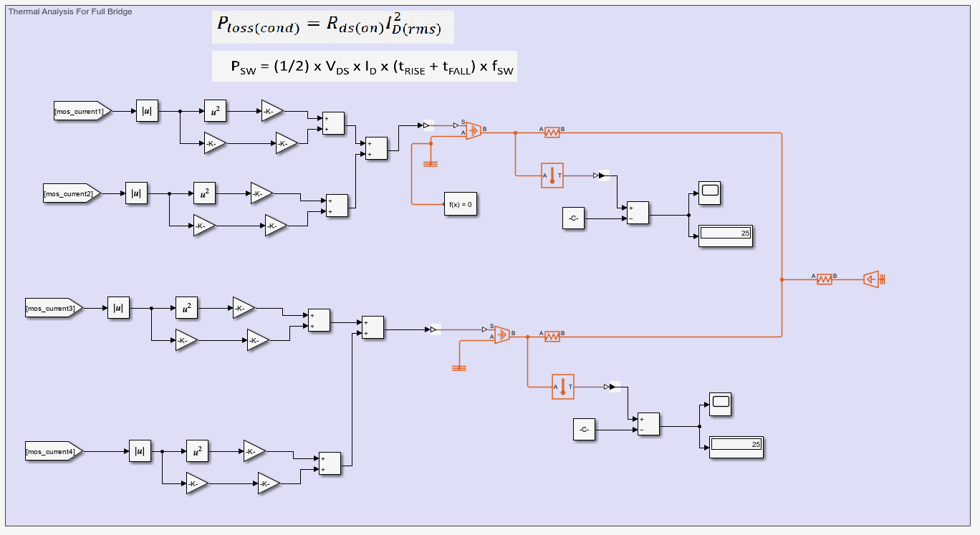

Figure 3.1 Thermal Analysis for Full Bridge Buck Converter

For the thermal analysis of the MOSFETs, two types of losses are calculated: switching losses and conduction losses. Conduction losses arise from the MOSFET's on-resistance, while switching losses are determined by factors such as voltage, current, on-time, off-time, and switching frequency.

For the component SH32N65DM6AG, each module contains two MOSFETs, and their losses are summed accordingly. On the PCB, two SH32N65DM6AG components share a single heat sink, and this configuration is mirrored in the simulation.

The thermal pad Non-Silicone Heat Transfer Compound Plus has a thermal conductivity of 2.5 W/m·K. With a thickness of 1 mm, its thermal resistance is calculated to be 0.0025 W/K. The junction-to-case thermal resistance of the MOSFET is 0.6 W/K, while the heat sink, utilizing forced convection, has a thermal resistance of 0.47 W/K.

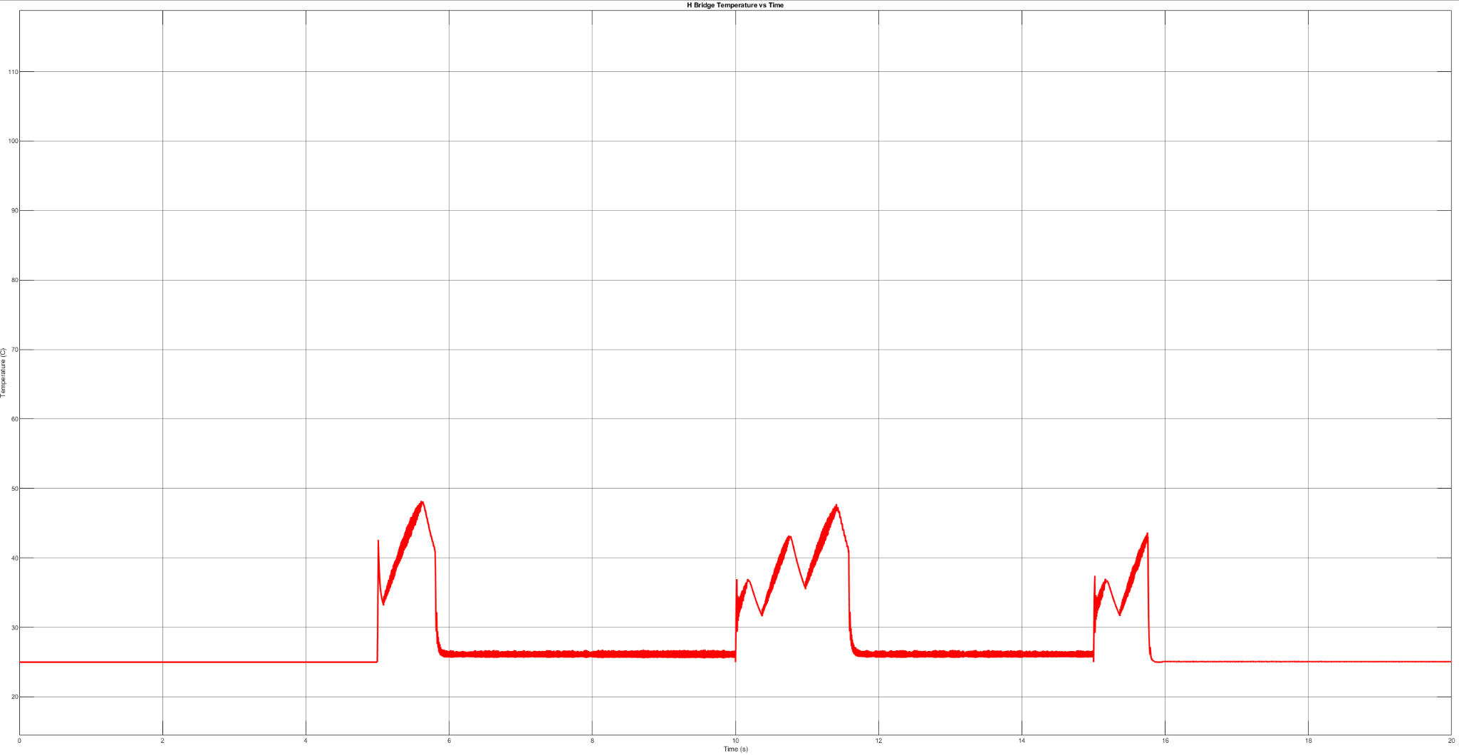

Figure 3.2: Temperature of SH32N65DM6AG

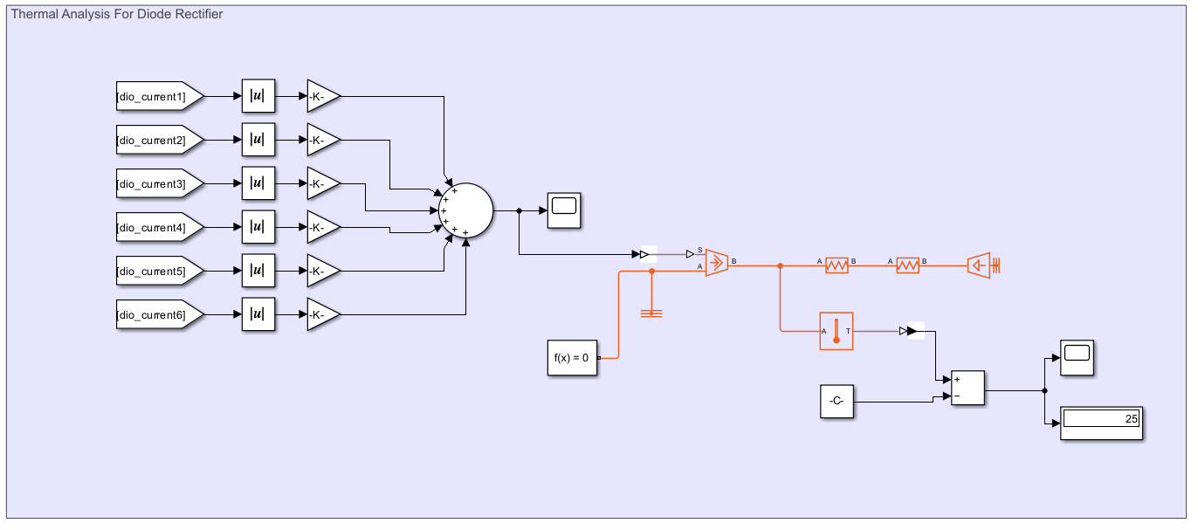

Figure 3.2 Thermal Analysis for Diode Rectifier

For the diode rectifier, turn-on and turn-off times are not specified in the datasheet. Since the operation occurs at 50 Hz, switching losses are considered negligible. Conduction losses are calculated by multiplying the diode current with its forward voltage.

The DB35-12 component includes all six diodes, so the losses for each diode are summed. The junction-to-case thermal resistance is 1.8 W/K, and the heat sink, operating with forced convection, has a thermal resistance of 0.56 W/K.

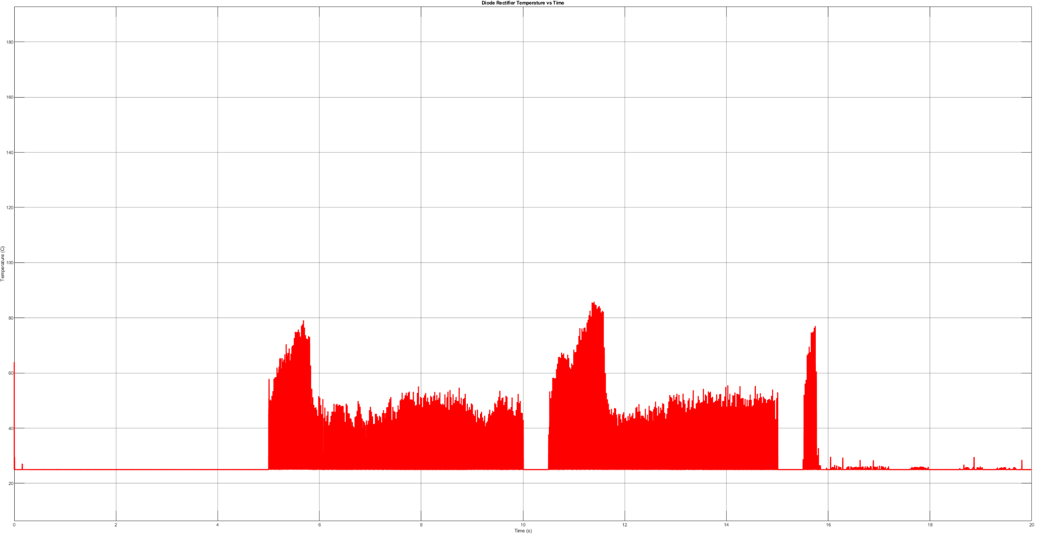

Figure 3.3 Temperature of DB35-12