**Faculty of Enigeering** **Cairo University**

**Digital Communications Project 1**

**Transmit Path & Line Codes**

Presented for **ELC 3070** MATLAB Project

**Presented to:**

**Dr.** Mohamed Nafea

**T.A:** Mohamed Khaled

|  |  |
| --- | --- |
| (3rd Year Electronics and Electrical Communication Engineers) | |
| مجدي أحمد عباس عبد الحميد الابرق | Sec: 3 / I.D: 9210899 / BN: 36 |
| كريم ايمن محمد فخر الدين محمد علي عفيفي | Sec: 3 / I.D: 9210836 / BN: 26 |
| مصطفى ابراهيم محمد ابراهيم | Sec: 4 / I.D: 9211158 / BN: 19 |
| يحيى خالد عبد الفتاح محمد | Sec: 4 / I.D: 9211362 / BN: 40 |
| Role of each member:  Each one of us created his own code, and in one meeting we came together on  the best version by merging the 4 codes and wrote the documentation  0 | |

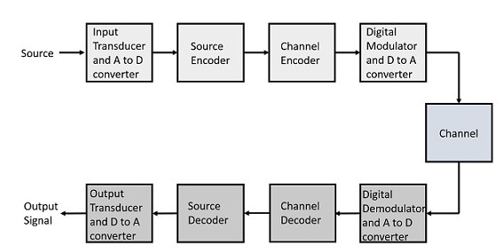

I

**Comm Project 1**

**Problem Description**

**Transmitter & Receiver Path**

In our system, there's a transmitter (Tx) and a receiver (Rx) connected by a channel. We create three ensembles, each using a different line code (unipolar, polar NRZ, polar RZ), where the transmitter generates random bits. These bits are turned into continuous signals, but since MATLAB works with arrays and vectors, we discretize them using a Digital to Analog Converter (DAC) with a sampling period of 10 ms. Each sample in the line code lasts 70 ms, resulting in 7 bits per sample. Our goal is to send these bits through a band-limited channel without interference. At the receiver (Rx), the transmitted bits are received, and the receiver tries to accurately estimate them with minimal error probability. Moreover, the receiver aims to find the most efficient line code in terms of bandwidth usage.

**Introduction**

II

The process begins by creating a sequence of random binary bits based on a specified flag indicating the number of bits per waveform (Realization). Each bit is then replicated according to another flag determining the number of samples per bit. These generated bits are then converted into corresponding line code symbols. Next, a random time shift is introduced, controlled by a time delay flag, to provide each waveform (Realization) with a random starting point. This entire process is iterated a specified number of times, governed by an ensemble size flag. The resulting ensemble is utilized to compute statistical metrics such as mean and autocorrelation. It's assessed whether each line code is stationary and ergodic, with ergodic processes being preferred as they simplify statistical analysis by requiring only a single realization rather than an entire ensemble.

**Control Flags**

III

|  |  |  |
| --- | --- | --- |
| Flag Name  in MATLAB | Flag Value | Its Function |
| A | User defined | Controls the Signal Amplitude of the pulses in the line codes |
| Frame Length | 100 | Controls the Number of Bits in each Waveform (Realization) |
| DAC Samples | 7 | Controls the Number of Samples for each Bit in each Realization DAC Samples = |
| Ensemble Width | 500 | Controls the Number of Waveforms (Realizations) in the Ensemble |
| Delay period | Random value between 0 to 6 | Controls Where each Realization Randomly Starts From 0 to  DAC Samples - 1 (0 ) |
| Symbol Rate |  | Is the Rate of Line Coding by Tx (User) |
| Bit Rate |  | Is the Rate of The DAC Sampling |

Table 1: Control Flags Table

|  |
| --- |
|  |

Snippet 1: Control Flags Snippet

 **User Defined A = 4 in this Report for Run**

**Generation of Data**

IV

|  |
| --- |
|  |

Snippet 2: Generation of Data (Tx Stream) Snippet

This Snippet describes the process of generating random binary transmission sequences for a digital communication system. It creates a matrix named "tx" where each row represents a different transmission sequence, and each column represents a symbol in the sequence. These symbols are randomly chosen from 0 and 1, forming a random digital transmission stream. The size of "tx" is determined by parameters such as “Ensemble_width” (the number of realizations) and “frame_length + 1” (the length of each transmission frame, plus an extra bit for delay). This extra bit accounts for a delay introduced by the last transmitted frame. Subsequently, each symbol in the "tx" matrix is repeated "DAC_samples" times to simulate the conversion to analog waveforms using a digital-to-analog converter (DAC). The resulting matrix "tx_DAC_out" contains the digital transmission stream repeated multiple times, representing an analog waveform ready for further processing in the digital communication system. Overall, this process prepares random binary transmission streams for multiple realizations, ensuring they are converted to analog waveforms for subsequent system processing.

**Creation of Line Codes Ensemble**

|  |
| --- |
|  |

Snippet 3: Line Codes Signaling Snippet

This MATLAB snippet allows the user to choose a signaling line code for further processing.   
Here's a breakdown of how it works:

* This line creates a cell array named   
  containing the names of three different signaling line codes:   
  'Unipolar NRZ', 'Polar NRZ', and 'Polar RZ'.

* This line opens a dialog box prompting the user to select one   
  of the signaling line codes from the options provided in the   
   cell array.
* The function returns the index of the selected item in   
  indices and a Boolean indicating whether the user made a  
  selection in check.
* This block of code checks if the user made a selection (check is true).   
  If the user didn't make a selection (meaning check is false), it defaults the index   
  indices to 1, which corresponds to 'Unipolar NRZ' signaling line code.

**Unipolar Signaling**

V

Unipolar NRZ Signaling Line Code If indices is 1

**Polar NRZ Signaling**

VI

Polar NRZ Signaling Line Code If indices is 2

**Polar RZ Signaling**

VII

Polar RZ Signaling Line Code If indices is 3

VIII

**Applying Random Initial Shifts for each Waveform**

|  |
| --- |
|  |

Snippet 4: Realizations Delay Snippet

This code section starts by generating random delay periods for each realization, sampled from a discrete uniform distribution between (0 and 1) .   
The delay periods are stored in a row vector. Then, a matrix is initialized to hold the delayed versions of the transmitted signals. Each signal is circularly shifted by its corresponding delay period to introduce the delays. Finally, the shifted frames are selected from the delayed signal matrix for further processing. Overall, this code snippet introduces random delays to transmission realizations and prepares the shifted frames for subsequent analysis.

**Getting the Cell arrays ready to calculate**

**The Statistical Mean and Auto Correlation**

IX

|  |
| --- |
|  |

|  |
| --- |
|  |

Snippet 5: Preparation of Functions for mean and Auto Correlation Calculations

This MATLAB code segment aims to analyze the stationarity of a signal using statistical methods, particularly focusing on mean and autocorrelation function (ACF) analysis. Here's a breakdown of the code:

1. **Compute Mean and ACF:**

* Calculates the mean of the signal across different time instants.
* Computes the autocorrelation function (ACF) for positive part.
* Reverses the ACF for negative part.
* Combines the positive and negative ACF to obtain the complete ACF.

1. **Generate Domains:**
   * Determines the length of the ACF.
   * Generates the domain (parts) for the ACF.
   * Generates the time domain for the signal.
2. **Stationarity Criteria:**
   * In order to assess the mean and the auto correlation function for the practical frame and ensemble we need to quantify the properties of the wide sense stationary in terms of the following properties
3. Mean Constant with Time
4. Mean has Certain Theoretical value.

Average across time instants This Theoretical value.

* + In the Comments provide guidelines to interpret the mean and ACF characteristics to determine stationarity for different signal types (unipolar and polar).

|  |
| --- |
|  |

1. **Generate Strings for Display:**
   * Formats mean statistics into a string for display.
   * Formats ACF statistics into a string for display.
2. **Helper Functions:**
   * Computes the average of elements in an array.
   * Computes the mean of each column of the input matrix.
   * Computes the autocorrelation function of the input matrix considering positive part.

|  |
| --- |
|  |

Snippet 6: Mean and Auto Correlation Plotting

**Calculating and Plotting**

**The Statistical Mean**

X + XI

Figure 1: Stat Unipolar NRZ Signaling Mean

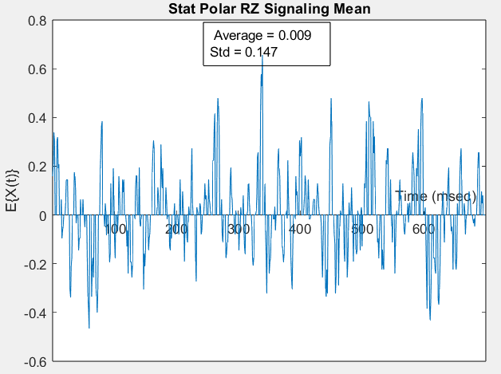

Figure 2: Stat Polar NRZ Signaling Mean Figure 3: Stat Polar RZ Signaling Mean

**ACF Calculation Concept for Statistical and Time Mean**

**Theoretical:** There is infinite Ensemble and infinite frame (Smooth Shape for ACF).

**Practical:** There is a finite frame (Has less Number of Correlations for each time instant)

**Disadvantages:**   
Ripples and distortions (results from the unequal number of correlations between time instants)  
At ACF Calculated from tau’s Domain Positive part.  
At and so on for which , at and we can exploit the even symmetry of the ACF by substituting the negative tau domain for the positive one this doesn’t force the ACF to be even but exercises the even domain to see if the ACF will average out to the theoretical shape or not.  
**Expectations:**we will have an approximate waveform of the ACF with some ripples due to the practical data set.

**Calculating and Plotting**

**The Statistical Auto Correlation**

XII + XIII

Figure 4: Stat Unipolar NRZ Signaling ACF Normalization on x - axis Figure 5: Stat Unipolar NRZ Signaling ACF (Zooming Version)

Figure 6: Stat Polar NRZ Signaling ACF Normalization on x - axis Figure 7: Stat Polar NRZ Signaling ACF (Zoomed Version)

Figure 8: Stat Polar RZ Signaling ACF Normalization on x - axis Figure 9: Stat Polar RZ Signaling ACF (Zoomed Version)

**Is the Process Stationary?**

XIV

|  |  |  |  |  |
| --- | --- | --- | --- | --- |
| P.O.C | | Unipolar NRZ | Polar NRZ | Polar RZ |
| Mean | **Theoretical** |  |  |  |
| **Practical** |  |  |  |
| Comment: Mean is Constant with time , Practical Theoretical | | | | |
| Autocorrelation | **Theoretical** |  |  |  |
|  |  |  |
| **Practical** |  |  |  |
|  |  |  |
| Comment: Autocorrelation depends on time shift | | | | |
| Result (WSS) | | **Stationary** | **Stationary** | **Stationary** |

Table 2: WSS Proof Table

**Computing The Time Mean**

**& Auto Correlation of One**

**Realization**

XV

Figure 10: Time Unipolar NRZ Signaling Mean

Figure 11: Time Unipolar NRZ Signaling ACF Figure 12: Time Unipolar NRZ Signaling ACF (Zoomed Version)

Figure 13: Time Polar NRZ Signaling Mean

Figure 14: Time Polar NRZ Signaling ACF Figure 15: Time Polar NRZ Signaling ACF (Zoomed Version)

Figure 16: Time Polar RZ Signaling Mean

Figure 17: Time Polar RZ Signaling ACFFigure 18: Time Polar RZ Signaling ACF (Zoomed Version)

|  |
| --- |
|  |

Snippet 7: Plotting Time Mean and Autocorrelation

XVI

**Is the RP Ergodic?**

|  |
| --- |
|  |

Snippet 8: Plotting Time Mean and Autocorrelation

|  |  |  |
| --- | --- | --- |
| **Line Code** | **Statistical ACF** | **Time ACF** |
| **Unipolar NRZ** |  |  |
| **Polar NRZ** |  |  |
| **Polar RZ** |  |  |
| **Result** | **Since the value of the zero crossing in the Statistical ACF = Time ACF**  **Therefore, the Random Process is Ergodic.** | |

**Plotting PSD of the Ensemble**

XVII

|  |
| --- |
|  |

Figure 19: PSD for Unipolar NRZ Signaling Normalized Frequency

Figure 20: Normalized PSD Magnitude for Polar NRZ Figure 21: Un - Normalized PSD Magnitude for Polar NRZ  
Signaling Normalized Frequency Signaling Normalized Frequency

Figure 22: Normalized PSD Magnitude for Polar RZ Figure 23: Un - Normalized PSD Magnitude for Polar RZ  
Signaling Normalized Frequency Signaling Normalized Frequency

**BW of Tx Signal**

XVIII

|  |  |  |  |  |
| --- | --- | --- | --- | --- |
| P.O.C | | Unipolar NRZ | Polar NRZ | Polar RZ |
| BW (HZ) | **Theoretical** |  |  |  |
| **Practical** |  |  |  |
| Comments: Polar RZ gives better Synchronization but for BW Efficiency = 50 % | | | | |
| PSD S (0) | **Theoretical** |  |  |  |
| **Practical** |  |  |  |

Table 3: Bandwidth of the transmitted Signal

**Comment:**

* PSD for Polar NRZ / RZ is Normalized for the fs to give a better intuition for the duty cycle used for RZ line coding.
* Frequency axis is also normalized for fs to give a better intuition for BW efficiency.

**Full MATLAB Code**

XIX

|  |
| --- |
|  |

**The END Thank You**