

OBJECT ORİENTED PROGRAMMİNG

Project Phase 1

Project 10

Library Management System

Mustafa Emirhan ALKAN Nazlıcan Sümbül

180444044 170444017

Computer Engineering Departmant

University of Turkish Aeronautical Association

TABLE OF CONTENTS

1. Introduction

1.1 Purpose of the system

1.2 Scope of the system

1.3 Objectives and success criteria of the project

1.4 Definitions, acronyms, and abbreviations

1.5 References

1.6 Overview

2. Current system

3. Proposed system

3.1 Overview

3.2 Functional requirements

3.3 Nonfunctional requirements

3.3.1 Usability

3.3.2 Reliability

3.3.3 Performance

3.3.4 Supportability

3.3.5 Implementation

3.3.6 Interface

3.3.7 Packaging

3.3.8 Legal

3.4 System models

3.4.1 Scenarios

3.4.2 Use case model

3.4.3 Object model

3.4.4 Dynamic model

3.4.5 User interface—navigational paths and screen mock-ups

*1.INTRODUCTION*

*1.1. Purpose Of The System*

The purpose of this system is to provide a Library Management System online, with registration and password protection. Users can easily access the book that they want to access by logging in, giving feedback for books and using the books in a rotating / functional way.

*1.2. Scope Of The System*

* The system allows users to search for a book, take book, and give feedback. It allows librarian to see customers and what they ordered.
* Librarian can add/delete book, book info, and manage book/library database.
* Admin can set user permission, add/delete user, search and view feedback, update library database as well.

*1.3. Objectives and Success Criteria Of The Project*

The main objective is to provide a secure and basic documentation management system for the specified user types. Success is the system's ability to function flawlessly and respond quickly to additional interactions.

1.4. Definitions, Acronyms and Abbreviation

RAD - Requirement Analysis Document

LMS - Library Management System

UML - Unified Modeling language

1.5. References

Object-Oriented Software Engineering Using UML, Patterns, and Java™ Third Edition

1.6. Overview

This RAD is arranged into two parts. The first is the overall description and second section is the Specific Requirements.

2.CURRENT SYSTEM

3.REQUİREMENTS

3.1. Overwiev

This RAD is arranged into two parts. The first is the overall description and second section is the Specific Requirements.

3.2. Functional Requirements

• Users, Librarians and Admin should be able to register to the system with user name.

• Users must be able to search and take a book from the system.

• Users must be able to give feedback to the books.

• Librarian must be able to add/delete book, book info, and manage book/library database.

• Admin must be able to can set user permission, add/delete user, search and view feedback, update library database as well.

3.3. Nonfunctional requirements

3.3.1. Usability

The system should be user-friendly and easy to understand by any user. The interface should be easy to learn and navigate; buttons, headings, and help/error messages are simple to understand.

3.3.2. Reliability

All informations about actors are encapsulated. System has password protection.

3.3.3. Performance

System shall be able to respond to interactions within seconds. The program supposed to work in best way and best performance unless the operating system won’t crash.

3.3.4. Supportability

System must be without bugs and flaws. System must be able to be re-coded if necessery.

3.3.5. Implementation

Java Development Kit

3.3.6. Interface

Java Development Kit

3.3.7. Packaging

Windows Operating System

3.3.8. Legal

Certificates if necessary.

3.4 System Models

3.4.1 SCENARIOS

Scenerio 1)

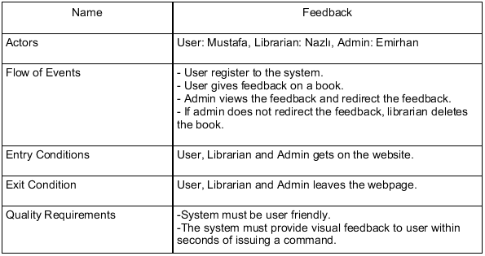

Scenerio 2)

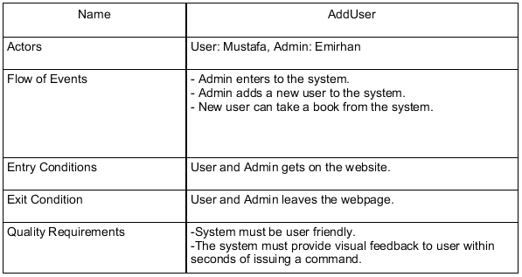

Scenerio 3)

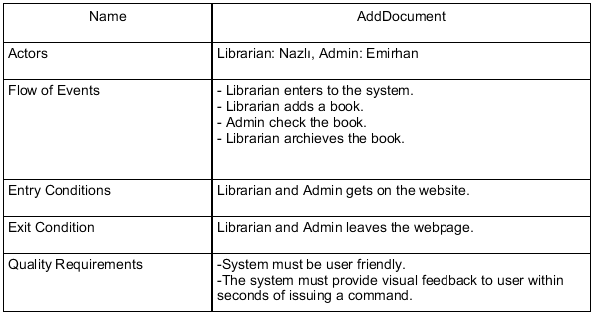

Scenerio 4)

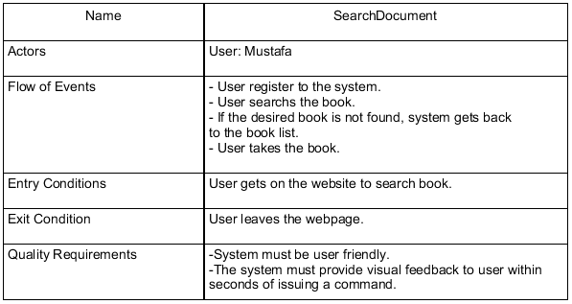

Scenerio 5)

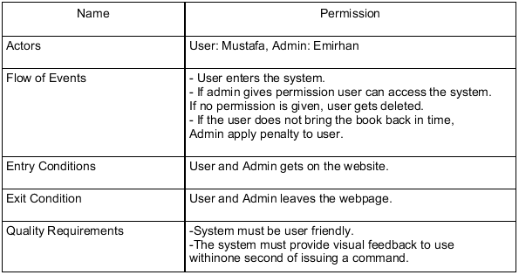

Scenerio 6)

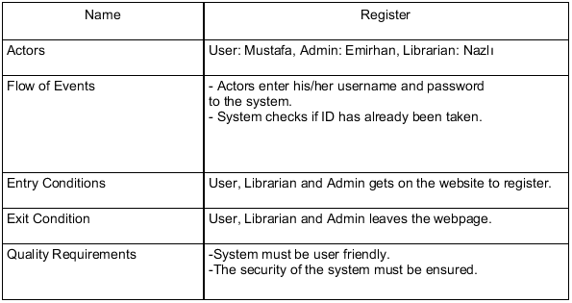

3.4.2. Use Case Model

USE CASE

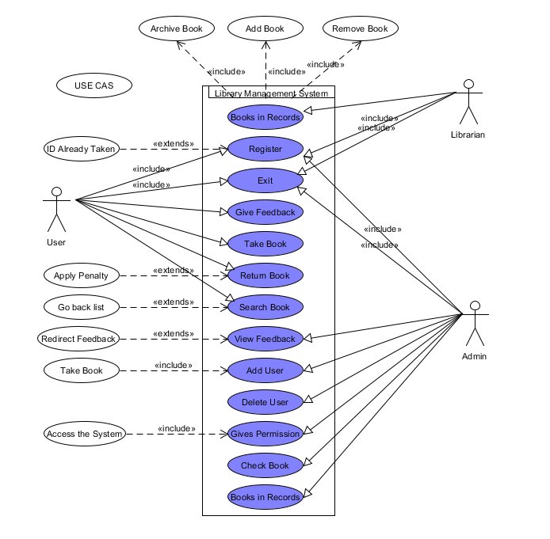

3.4.3. Object Model

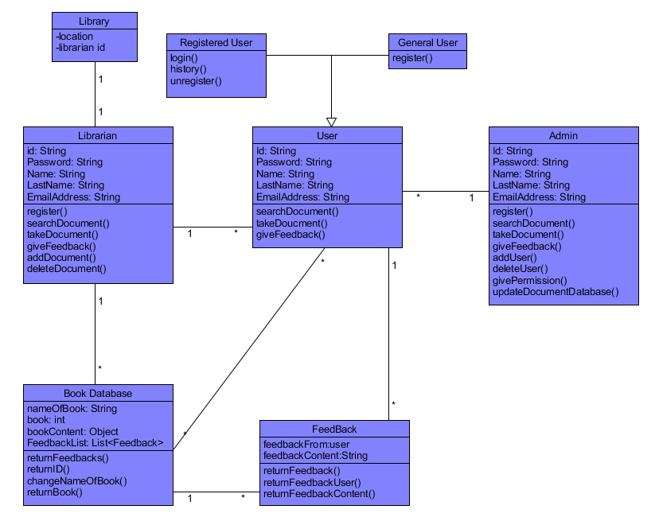

3.4.4. Dynamic Model

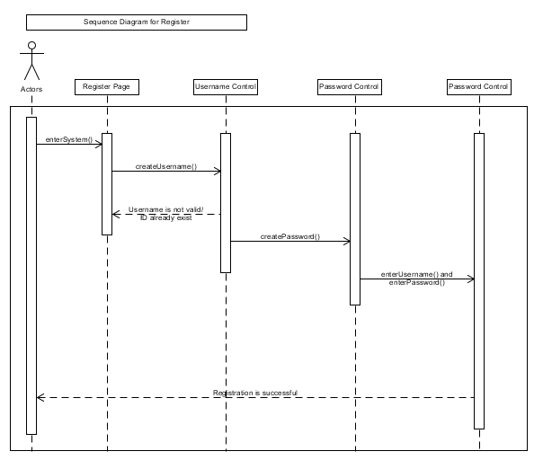3.4.4.1 Sequence Model

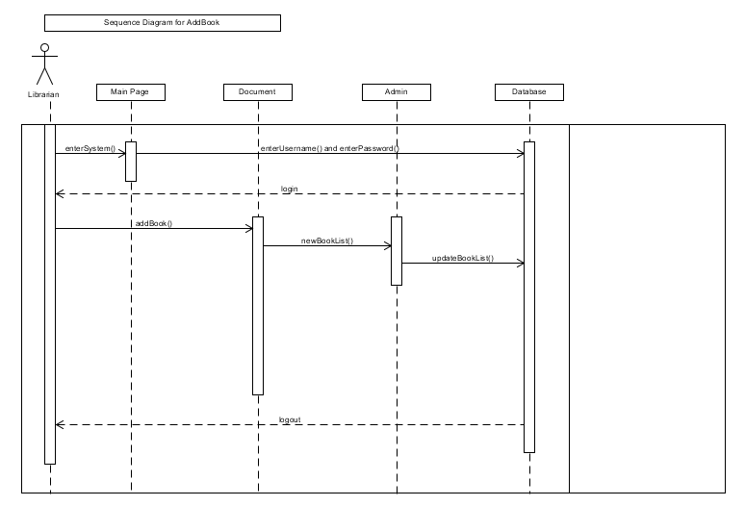

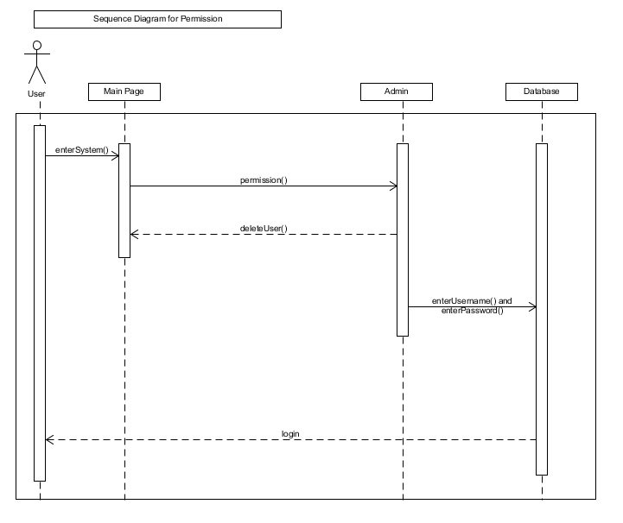

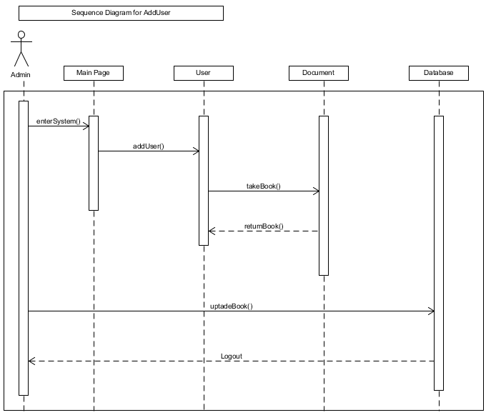

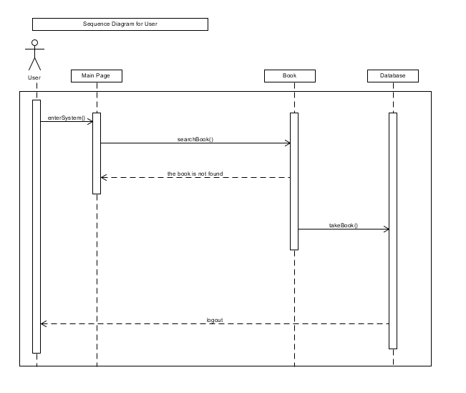

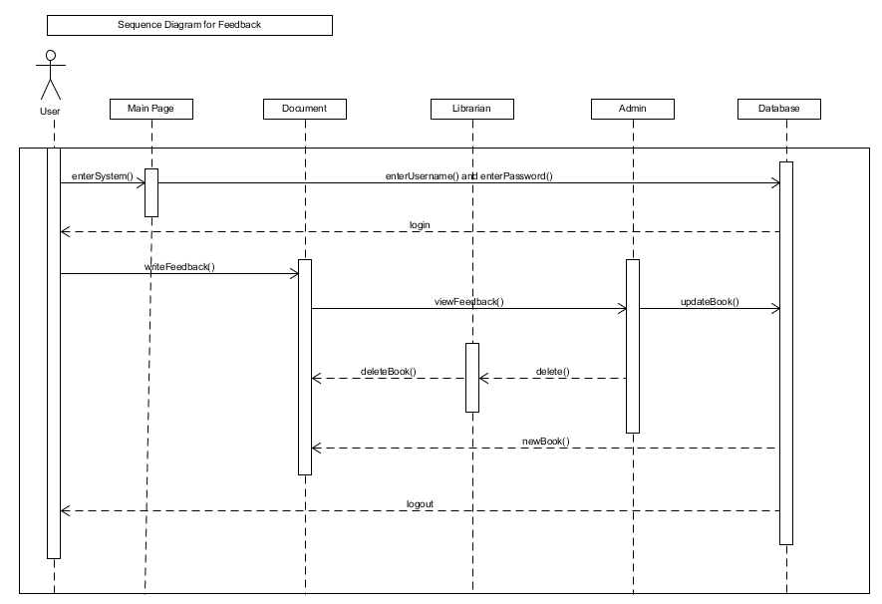

3.4.4.2. Activity Model

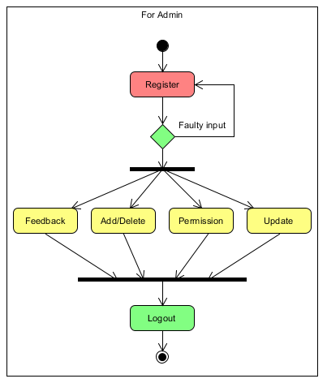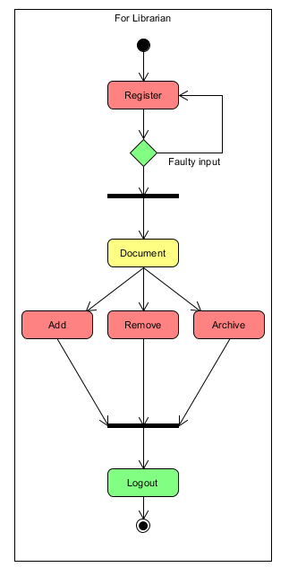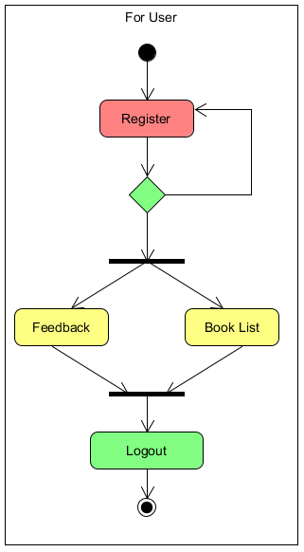

3.4.4.3. State Machine Model

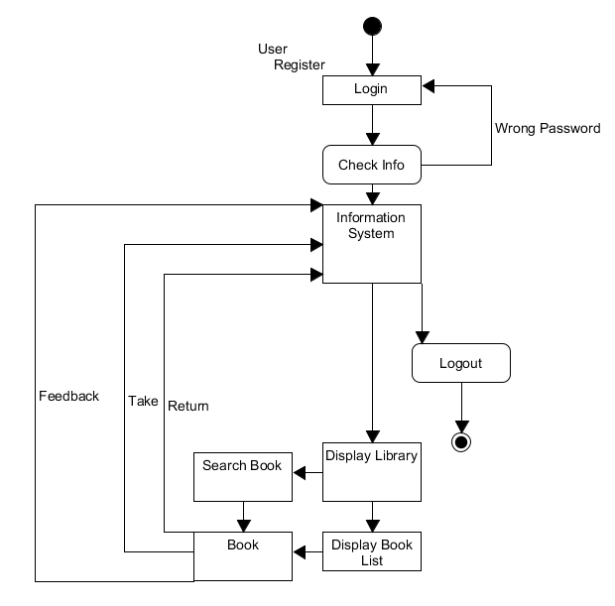

User State Machine Model;

Librarian State Machine Model

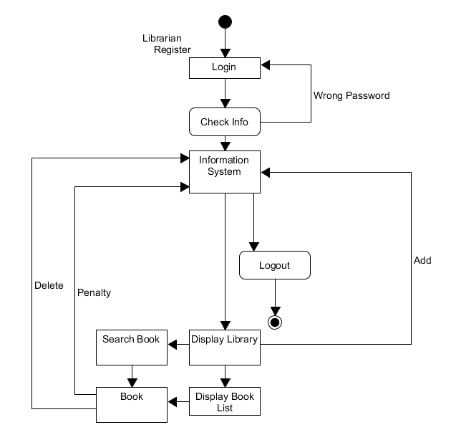

Admin State Machine Model

