Lecture101 — Foundations of AI, Data Science and Emerging Paradigms

PART I — Artificial Intelligence and Data Science Foundations

Artificial Intelligence (AI): The Umbrella Field
Artificial Intelligence (AI) is a broad field of computer science focused on building systems capable of performing tasks that typically require human intelligence, such as reasoning, learning, perception, language understanding, and decision-making.
AI includes several major subfields:
- Machine Learning
- Deep Learning
- Data Mining
- Generative AI
- Agentic AI

Machine Learning and Deep Learning

Machine Learning (ML)
Machine Learning enables systems to learn patterns from data and make predictions or decisions without explicit rule-based programming.
- Common ML Tasks
- Classification
- Regression
- Clustering

Deep Learning (DL)
Deep Learning is a specialized branch of ML that uses multi-layer neural networks to learn hierarchical feature representations from large and complex datasets. Deep learning powers:
- Large Language Models (LLMs)
- Image generation systems
- Speech recognition
- Modern generative models

Data Mining vs Data Science

Data Mining
Data Mining focuses on discovering meaningful patterns and relationships from large datasets using statistical and machine learning techniques. Primary emphasis:
- Pattern discovery
- Knowledge extraction
- InterpretationData Science
Data Science is an interdisciplinary field integrating:
- Mathematics & Statistics
- Data Mining & Data Engineering
- Machine Learning & Deep Learning
- Domain Knowledge
Goal: Extract actionable insights, predictions, and decisions from data.
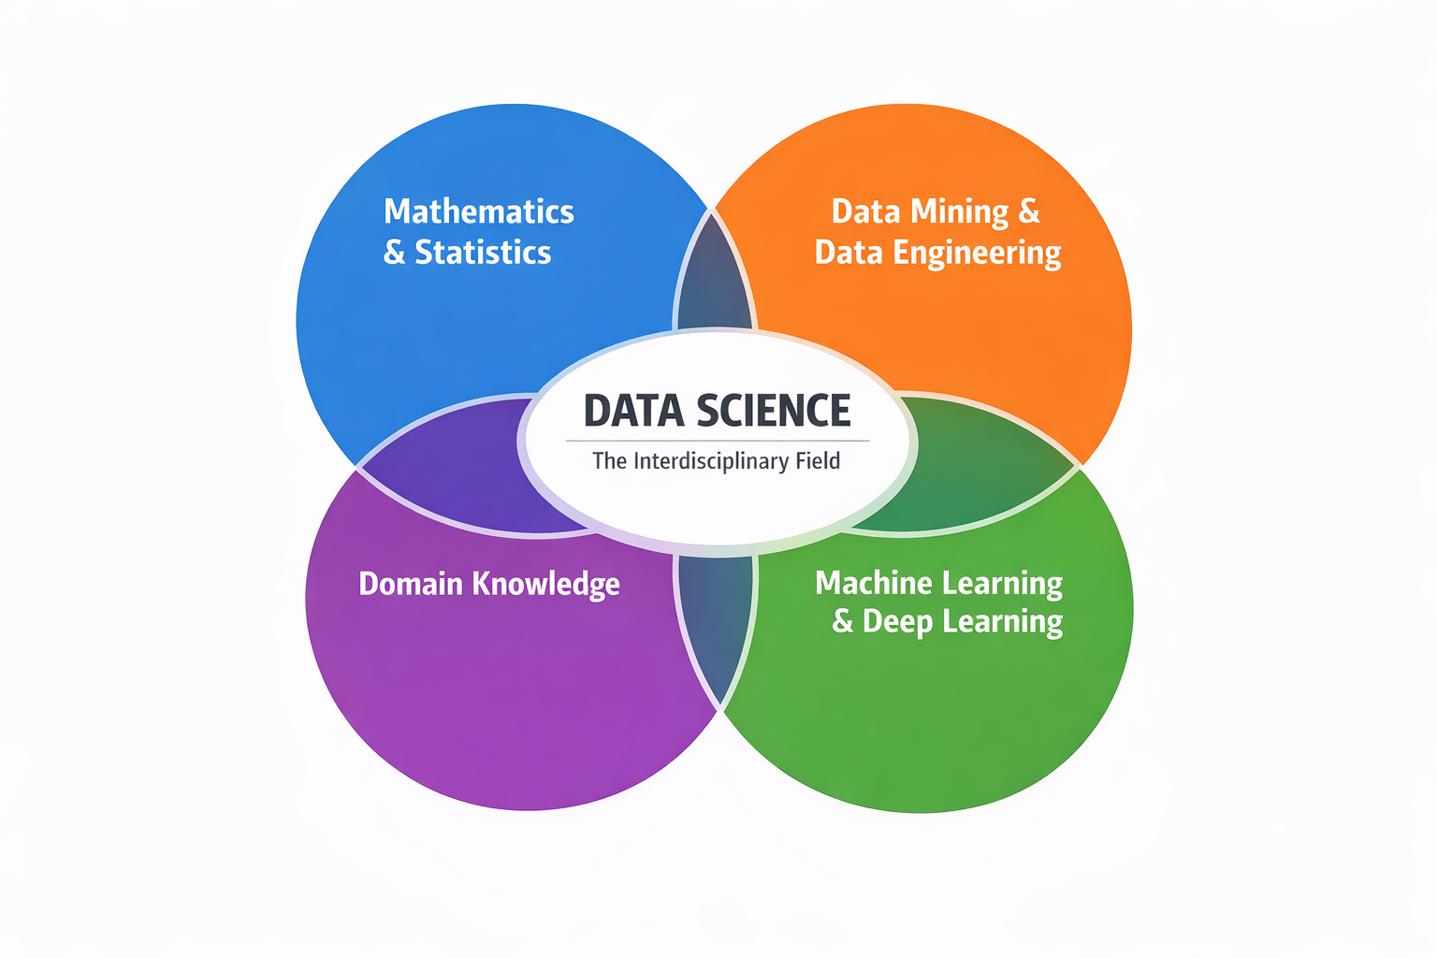
Unlike traditional data mining, Data Science emphasizes:
- End-to-end pipelines
- Automation
- Model deployment
- Decision support
✔ Data mining is one component within the broader Data Science lifecycle.

PART II — The Data Science Lifecycle

4. Extended Knowledge Discovery Process
- Problem / Business Understanding
- Data Collection
- Data Cleaning & Preprocessing
- Exploratory Data Analysis (EDA)
- Feature Engineering
- Modeling (ML / DL)
- Evaluation & Validation
- Deployment & Monitoring
This lifecycle transforms raw data into deployed, value-generating systems.

PART III — Data Foundations

5. Core Data Concepts

Dataset
A structured, semi-structured, or unstructured collection of observations representing real-world entities.

Subject (Entity of Analysis)
Defines what the dataset represents.
Examples:
Students → Educational analytics
Patients → Healthcare analytics
Customers → Business analytics

Observation / Instance
Each row represents one entity or event
Also called: instance, record, sample
✔ Correct identification of subject and observation unit is essential for valid modeling.
Column/variable/feature/attribute

Column / Variable / Feature / Attribute
A column represents a specific characteristic or measurable property of the observation unit. Each column contains values describing one aspect of all entities in the dataset.
These terms are often used interchangeably, though their usage depends on context:
- Column – Database or spreadsheet terminology; refers to vertical data organization.
- Variable – Statistical term; represents a measurable characteristic that can vary across observations.
- Feature – Machine Learning term; an input used by a model to learn patterns.
- Attribute – General data modeling term; describes a property of an entity.
Conceptual Role in Data Science
Each column defines what is measured, while each row defines who or what is measured.
For example, in an educational analytics dataset:
Student_ID | GPA | Attendance | Study_Hours
S001 | 3.2 | 85% | 12
- Each row = one student (observation).
- Each column = one variable/feature describing that student.
Types of Variables
- Numerical Variables
  - Continuous (e.g., GPA, income)
  - Discrete (e.g., number of courses)
- Categorical Variables
  - Nominal (e.g., department, gender)
  - Ordinal (e.g., grade level: Freshman, Sophomore)
- Binary Variables
  - Two categories (e.g., Pass/Fail)
Role in Machine Learning
In predictive modeling:
- Columns used as inputs are called independent variables or features.
- The column being predicted is called the target variable or label.
- Feature quality directly impacts model performance.
- Feature engineering transforms raw attributes into informative representations.
✔ Clear identification of columns and their data types ensures correct preprocessing, encoding, scaling, and model selection.
A well-structured dataset maintains a consistent mapping:
- Rows → Observations
- Columns → Variables
- Cells → Individual data values

6. Structure of Data

Structured Data
Tabular (rows × columns)
Easily modeled using classical ML
Examples:
- CSV files
- Excel sheets
- Relational databases

Semi-Structured Data
Flexible schema
Examples:
- JSON
- XML
- Logs
- API responses

Unstructured Data
No fixed schema
Requires feature extraction
- Examples:
- Text (NLP)
- Images (Computer Vision)
- Audio / Video
✔ Modern AI heavily focuses on semi-structured and unstructured data.

7. Features and Variables

Features (Independent Variables)
- Characteristics describing the subject.
- Example (Student dataset):
- Attendance rate
- Prior GPA
- LMS activity time

Target Variable (Label)
- The outcome to be predicted.
- Examples:
- Final GPA
- Pass / Fail
- Dropout risk
✔ Feature engineering is a core Data Science skill.

8. Measurement Scales and Data Types
Understanding data types is essential for:
- Algorithm selection
- Distance computation
- Feature encoding

Nominal (Categorical – Unordered)
No intrinsic order
Requires encoding (e.g., One-Hot Encoding).

Ordinal (Categorical – Ordered)
Order matters
Distance does not
Order must be preserved during encoding.

Numerical (Quantitative)
Discrete – Countable integersContinuous – Real-valued measurements
Required for:
- Regression
- Distance-based algorithms
- Neural networks

9. Labeled vs Unlabeled Data
Labeled Data
- Features + known output
- Used in supervised learning
Unlabeled Data
- No target variable
- Used in unsupervised learning
✔ Semi-supervised learning combines both.

10. Sources of Data
Primary Data
- Collected directly
- High control, higher cost
Secondary Data
- Pre-existing datasets
- Widely used in research
- Open
- Public
- Proprietory

PART IV — Analytics Levels in Data Science

Descriptive / Exploratory Analytics
Question: What happened? Uses summary statistics, visualization, and pattern discovery.

Predictive Analytics
Question: What will happen? Uses classification, regression, forecasting with ML/DL.

Prescriptive Analytics
Question: What should we do? Uses optimization, recommendation systems, and decision support.
✔ Highest level of analytics maturity.

PART V — Levels of Analytical Maturity in Data Mining and Machine Learning

Association Rule Mining
(Exploratory Relationship Discovery)
Association Rule Mining represents an initial stage of analytical maturity focused on discovering hidden relationships and co-occurrence patterns within data. It does not require labeled outcomes. Instead, it identifies rules of the form If A occurs, B is likely to occur.
This technique is widely used in market basket analysis, recommendation systems, and behavioral pattern analysis. The strength of discovered rules is evaluated using metrics such as Support (frequency), Confidence (conditional probability), and Lift (strength of association beyond chance).

Clustering
(Structural Pattern Identification)
Clustering reflects a deeper exploratory stage where the objective is to identify natural groupings or segments in data based on similarity measures. Unlike association mining, clustering organizes the entire dataset into meaningful subgroups.
It is commonly applied in customer segmentation, learner profiling, anomaly detection, and social network analysis. Algorithms such as K-Means, Hierarchical Clustering, and DBSCAN group observations to maximize intra-cluster similarity and minimize inter-cluster similarity.

Classification
(Supervised Categorical Prediction)
Classification represents a transition from exploration to predictive modeling. It requires labeled data and aims to assign new observations to predefined categories.
Examples include spam detection, disease diagnosis, and student performance classification (Pass/Fail, Grade categories). Models learn decision boundaries from training data using algorithms such as Logistic Regression, Decision Trees, Random Forest, Support Vector Machines, and Neural Networks.

Regression
(Supervised Quantitative Prediction and Forecasting)
Regression reflects a more advanced predictive level focused on estimating continuous numerical outcomes. Instead of predicting categories, regression models estimate real-valued quantities.
Applications include GPA prediction, price estimation, sales forecasting, and demand prediction. Techniques such as Linear Regression, Ridge/Lasso Regression, Random Forest Regressor, and Neural Networks model relationships between independent variables and a continuous target variable.

Summary of Progression
The maturity sequence can be understood as:
Relationship Discovery → Structural Grouping → Categorical Prediction → Numerical Forecasting
This progression illustrates the evolution from descriptive analytics to fully predictive modeling within Data Science and Machine Learning.

PART VI — Generative AI

What is Generative AI?
Generative AI refers to models that learn the underlying probability distribution of data and generate new, synthetic content that resembles training data.
Unlike predictive models, generative models create new data instances.

Core Characteristics
- Learns data distributions
- Produces novel outputs (text, images, audio, code, video)
- Probabilistic and stochastic
- Trained on large-scale datasets

Common Generative Models
- Autoregressive Models (e.g., LLMs)
- Variational Autoencoders (VAEs)
- Generative Adversarial Networks (GANs)
- Diffusion Models

Generative AI in Practice: AI Coding Assistants
One practical and widely adopted example of Generative AI is GitHub Copilot.

What is GitHub Copilot?
GitHub Copilot is an AI-powered code generation assistant integrated into development environments (e.g., VS Code). It is trained on large-scale code and natural language data and uses deep learning models (LLMs) to:
- Autocomplete code
- Generate functions from natural language prompts
- Suggest algorithms
- Create test cases
- Explain existing code

Why It Matters in Data Science
For Data Scientists, GitHub Copilot can:
- Generate data preprocessing pipelines
- Suggest feature engineering code
- Produce visualization scripts
- Assist with model implementation (e.g., regression, classification)
- Speed up experimentation and prototyping
✔ Copilot is an example of Generative AI applied to software development workflows.

PART VII — Agentic AI
What is Agentic AI?
Agentic AI refers to autonomous AI systems that:
- Perceive environments
- Reason about goals
- Plan actions
- Execute decisions
- Adapt over time
- Agentic systems emphasize autonomy and goal-directed behavior.

Core Components of an AI Agent
- Perception – Observing inputs/environment
- Reasoning – Interpreting and deciding
- Planning – Sequencing actions
- Action – Executing via tools/APIs
- Memory – Retaining context

Applications of Agentic AI
- Autonomous research assistants
- Intelligent tutoring systems
- Workflow automation agents
- Academic advising systems
- Decision-support systems
Agentic systems may use generative models (like those powering GitHub Copilot) as their reasoning engine, but extend them with planning, memory, and tool-use capabilities.

PART VIII — Integration and Comparison

Generative AI vs Agentic AI
Generative AI vs. Agentic AI
Aspect | Generative AI | Agentic AI
Primary Focus | Creation of new content | Execution of goal-oriented tasks
Core Capability | Produces data such as text, images, or code | Makes decisions and performs actions
Level of Autonomy | Typically limited to responding to prompts | Operates with a high degree of autonomy
Mode of Interaction | Prompt-driven interaction | Environment-aware and context-driven interaction
Memory Handling | Commonly short-term or session-based | Maintains persistent and structured memory
Typical Output | Text, visuals, audio, program code | Plans, decisions, task execution, system actions
Note: Generative AI frequently functions as the reasoning or content-generation component embedded within broader agentic systems, enabling them to interpret context, formulate plans, and produce intermediate outputs required for autonomous operation.

Architectural Perspectives

Generative Model Flow
Training Data→ Deep Neural Network→ Learned Probability Distribution→ Generated Output

Agentic Feedback Loop
Environment↔ AI Agent (Perception → Reasoning → Planning → Action → Memory)↔ Environment

Combined Architecture
Agent→ Generative Model (LLM)→ Planning Logic→ Tool Execution→ Environment
Modern intelligent systems increasingly integrate:
- Data-centric modeling
- Generative intelligence
- Autonomous agent architectures

PART IX — Ethical and Practical Considerations
- Ensuring fairness and mitigating algorithmic bias
- Managing hallucinations and improving system reliability
- Avoiding excessive dependence on AI-generated code (e.g., outputs from tools such as GitHub Copilot should undergo rigorous review and validation)
- Safeguarding data privacy and maintaining robust security standards
- Promoting responsible implementation within educational and research contexts

Final Integrated Summary
- Data Science establishes a systematic lifecycle that converts raw data into actionable value.
- Machine Learning and Deep Learning enable the development of predictive and adaptive systems.
- Generative AI facilitates the creation of novel content, including text, images, and program code.
- Agentic AI supports the design of autonomous, goal-oriented systems capable of planning and decision-making.
The advancement of intelligent systems depends on the effective integration of:
- Solid data infrastructure and governance
- Reliable and well-validated modeling methodologies
- Generative intelligence for content synthesis
- Autonomous agent frameworks
These elements must be combined into scalable, ethically grounded, and domain-sensitive solutions suitable for real-world deployment.

PART X — Definitions of Related Fields &Relevance to Data Science
- Business Analytics: The practice of using data analysis and quantitative methods to support business decision-making, often focused on descriptive and diagnostic analytics to improve operations and strategy.
- Business analytics overlaps with data science on data cleaning, visualization, and modeling; data scientists provide predictive models while BA focuses on translating insights to business action.
- Health Analytics: Application of data analysis, statistical models, and machine learning to health-care data to improve patient outcomes, operational efficiency, and public health decisions.
- Health analytics leverages data science methods (EHR analysis, predictive risk modeling) to enable evidence-based clinical decisions and population health management.
- Business Intelligence (BI): Tools and systems that play a key role in the strategic planning process of a corporation, transforming raw data into meaningful and useful information for business analysis.
- BI provides dashboards and historical reporting; data science complements BI by adding predictive and prescriptive analytics for forward-looking decisions.
- Learning Analytics: Measurement, collection, analysis and reporting of data about learners and their contexts, for purposes of understanding and optimizing learning and the environments in which it occurs.
- Learning analytics uses data science to personalize learning pathways, detect at-risk students, and measure educational interventions.
- FinTech: Technology-driven innovation in financial services, using data analytics, machine learning, and software to improve financial activities and customer experiences.
- FinTech applies machine learning for credit scoring, fraud detection, and algorithmic trading—areas where data science models are core.
- Digital Marketing: Use of digital channels and data-driven techniques to reach and engage customers, optimize campaigns, and measure marketing performance.
- Digital marketing relies on data science for customer segmentation, recommendation systems, A/B testing, and campaign optimization.

The following table provides a summary of fields related to data science.
Field | Typical Data Sources | Typical Models | Primary Goal
Business Analytics | Sales, ERP, CRM | Descriptive stats, Regression | Improve operations & decisions
Health Analytics | EHR, Clinical Trials, Sensors | Survival models, Classification | Improve patient outcomes
Business Intelligence (BI) | Transaction logs, Warehouses | Aggregations, OLAP | Reporting & KPIs
Learning Analytics | LMS logs, Assessments | Clustering, Predictive models | Personalize learning
FinTech | Transaction data, Market feeds | Time-series, ML classifiers | Risk scoring, fraud detection
Digital Marketing | Clickstream, CRM, Social | Recommendation systems, A/B testing | Optimize engagement & ROI

