Software Design Document
Sequence Analysis of Student Learning Paths in Online Courses



Submitted by
Hasan Mustafa (F22BINFT1M01247)
Submitted to
Dr. Mustafa Hameed

Department of Information Technology
Faculty of Computing
The Islamia University of Bahawalpur

Table of Contents
1. Executive Summary 4
2. Application Architecture 5
2.1 System Context 5
2.2 Component Architecture 5
2.3 Design Patterns 7
3. Data Model Schema 7
3.1 Entity Definitions 7
3.2 Database Relationships 9
4. User Interface Design 10
4.1 Design Philosophy 10
4.2 Dashboard Components 10
Instructor Dashboard: 11
5. API Design 13
6. System Workflows 14
6.1 Daily Data Ingestion Workflow 14
6.2 Weekly Pattern Mining Workflow 14
6.3 Weekly Model Retraining Workflow 14
6.4 Weekly At-Risk Alert Generation 14
7. Technology Stack & Justification 16
8. Security & Privacy Considerations 17
8.1 Authentication & Authorization 17
8.2 Data Privacy 17
8.3 Data Protection 17
8.4 Audit & Compliance 17
9. Deployment Architecture 18
9.1 Scaling Strategy 18
10. Testing Strategy 19
10.1 Unit Testing 19
10.2 Integration Testing 19
10.3 End-to-End Testing 19
10.4 Security Testing 19
10.5 Performance Testing 19

1. Executive Summary

The Learning Analytics Prediction System is a comprehensive web-based analytics platform designed to analyze student learning behaviors in online courses at The Islamia University of Bahawalpur. This document outlines the software design and architecture of the system, detailing how it will ingest LMS data, apply sequence mining algorithms, train predictive models, and deliver actionable insights to instructors and administrators.
The system comprises three integrated layers: a data pipeline backend (Python Flask), an analytics processing engine (Pandas, Scikit-learn, SPMF), and an interactive web frontend (React with D3.js). It supports role-based access control for three user types: Course Instructors, Department Administrators, and System Administrators.
Key design considerations include:
• Modularity and scalability to handle growing data volumes
• Privacy-first architecture with full student anonymization
• Asynchronous job processing to prevent UI blocking
• Containerized deployment for consistency across environments
• Comprehensive logging and audit trails for compliance

2. Application Architecture

2.1 System Context
The system is designed as a standalone analytics layer that sits alongside the existing Moodle Learning Management System. It maintains read-only access to the LMS database and operates independently to avoid impacting day-to-day teaching operations.
Key external systems:
• Moodle LMS: Source of raw student interaction data
• University Directory Service: For user authentication
• Email Service: For sending alerts and notifications
• File Storage: For storing exported reports and generated data

2.2 Component Architecture
The system follows a three-tier architecture with clear separation of concerns:
PRESENTATION TIER (Frontend)
• React 18+ single-page application
• Material-UI for consistent component library
• D3.js for custom interactive visualizations
• Axios for API communication
BUSINESS LOGIC TIER (Backend)
• Flask 2.3 REST API server
• Flask blueprints for modular route organization
• JWT-based authentication and authorization
• Celery for asynchronous task processing
• Redis as message broker and cache
DATA TIER
• MySQL 8.0 relational database
• SQLAlchemy ORM for data access
• Secure read-only connection to LMS
• SPMF library (via JPype) for sequence mining algorithms

Components:
Component | Technology | Responsibility
Data Ingestion Worker | Python + Celery | Scheduled extraction from Moodle, data validation, anonymization
Sequence Mining Engine | SPMF + JPype | Pattern discovery using GSP/SPADE/PrefixSpan algorithms
ML Prediction Service | Scikit-learn | Model training and inference for at-risk student prediction
Web API Server | Flask + SQLAlchemy | REST endpoints for frontend, request routing, business logic
Analytics Dashboard | React + D3.js | Interactive visualizations, user interface for all roles

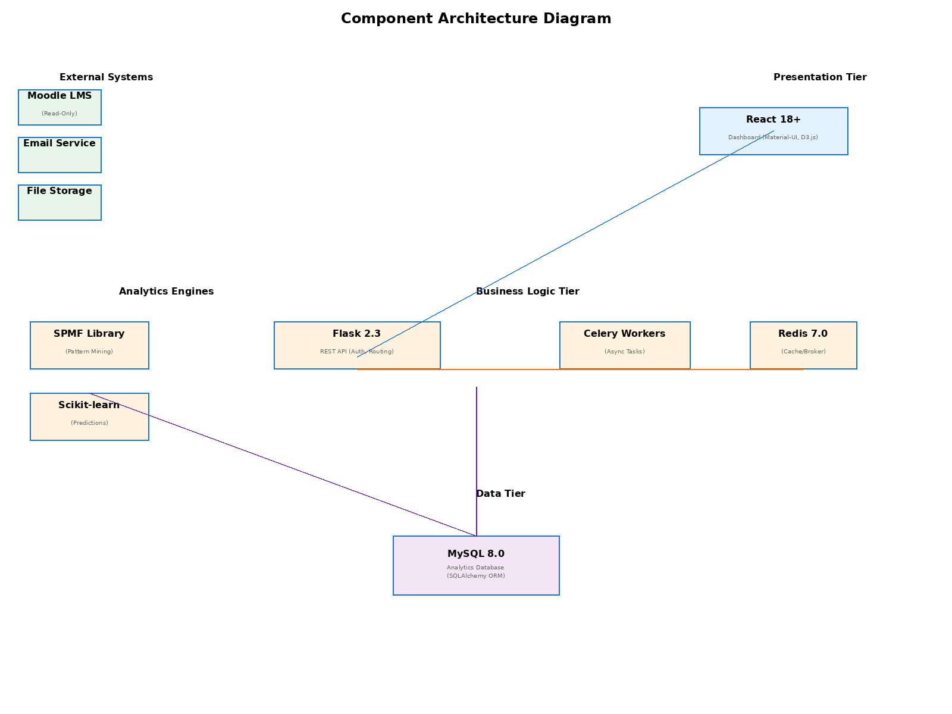
Figure 1: Component Architecture Diagram

2.3 Design Patterns
The system employs several well-established design patterns:
• Model-View-Controller (MVC): Separation of data models, business logic, and presentation
• Repository Pattern: Database access abstraction through SQLAlchemy models
• Factory Pattern: Creating different visualization types (Sankey, Flow, Timeline)
• Observer Pattern: Event-driven alerts when at-risk thresholds are met
• Pipeline Pattern: Data transformation flow from ingestion through analysis
• Singleton Pattern: Single connection pool to database and Redis cache
• Strategy Pattern: Multiple sequence mining algorithms can be swapped without code changes

3. Data Model Schema

3.1 Entity Definitions
students
- student_id (PK) - Unique auto-incremented identifier
- anonymous_id - Hashed pseudonym for privacy
- course_id (FK) - Reference to course
- enrollment_date - When student joined course
- status - active/completed/dropped
- created_at - Timestamp of record creation
course_resources
- resource_id (PK) - Unique identifier
- course_id (FK) - Parent course
- resource_name - Name of resource (Video 1, Quiz 1, etc)
- resource_type - video/quiz/reading/assignment/forum
- sequence_order - Position in course structure
- created_at - Record timestamp
student_interactions
- interaction_id (PK) - Unique identifier
- student_id (FK) - Which student
- resource_id (FK) - What they accessed
- interaction_type - viewed/downloaded/submitted/attempted
- duration_minutes - How long spent
- timestamp - When it happened (UTC)
- ip_address_hash - For security tracking (hashed)

learning_patterns
- pattern_id (PK) - Unique identifier
- course_id (FK) - Which course
- pattern_sequence - JSON array of resource IDs
- frequency - How many students followed this path
- avg_grade - Average final grade of students who followed it
- support - Percentage of students following this pattern
- confidence - Correlation strength with success
- discovered_at - When pattern was mined
predictions
- prediction_id (PK) - Unique identifier
- student_id (FK) - Student being predicted
- week_number - Week of semester prediction made
- predicted_grade - Predicted final grade
- confidence_score - 0-100 confidence percentage
- risk_level - low/medium/high/critical
- model_version - Which ML model generated this
- created_at - When prediction was made
alerts
- alert_id (PK) - Unique identifier
- student_id (FK) - At-risk student
- instructor_id (FK) - Recipient instructor
- alert_type - risk_detected/intervention_suggested
- severity - low/medium/high
- description - Details about the alert
- status - new/read/dismissed
- created_at - When alert was generated
users
- user_id (PK) - Unique identifier
- username - Login username
- password_hash - Bcrypt-hashed password
- full_name - User display name
- email - University email
- role - admin/instructor/dept_admin
- assigned_courses - JSON array of course IDs (for instructors)
- last_login - Timestamp of last access
- created_at - Account creation date

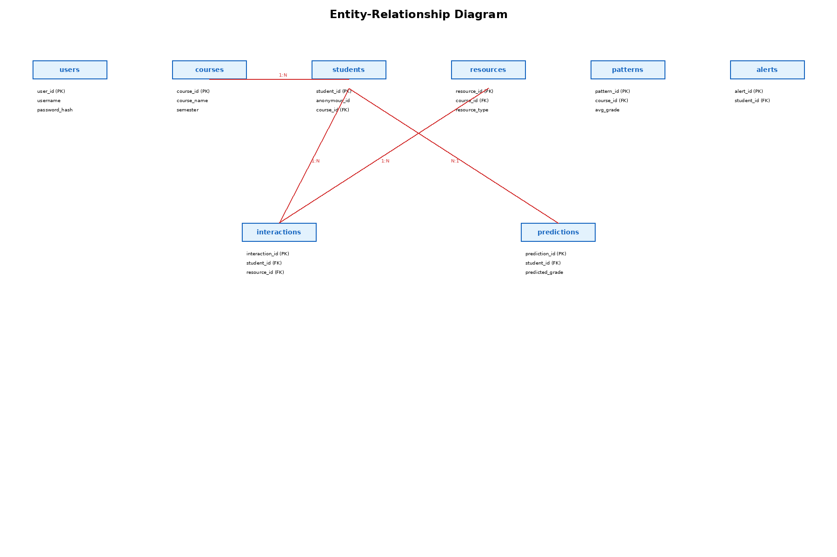
Figure 2: Entity-Relationship Diagram

3.2 Database Relationships
Key relationships in the schema:
• students (1:N) student_interactions - Each student has many interactions
• course_resources (1:N) student_interactions - Each resource is accessed many times
• students (1:N) predictions - Multiple weekly predictions per student
• students (1:N) alerts - Multiple alerts can be generated for a student
• course_resources (1:N) learning_patterns - Patterns are sequences of resources
• courses (1:N) students - Each course enrolls many students
• users (1:N) alerts - Instructors receive multiple alerts
• predictions (N:1) learning_patterns - Predictions based on discovered patterns
Indices are created on frequently-queried columns: student_id, course_id, timestamp, resource_id for performance optimization.

4. User Interface Design

4.1 Design Philosophy
Design Principles:
• Clarity: Complex data presented in intuitive visualizations
• Actionability: Every insight includes suggested next steps
• Role-Based: Different dashboards for different user types
• Responsive: Works on desktop and tablets
• Accessible: WCAG 2.1 AA compliance, keyboard navigation
• Bilingual: English and Urdu language support
Color Scheme:
• Primary Blue (#1976D2): Headers, important actions
• Success Green (#4CAF50): Positive indicators, good performance
• Warning Orange (#FF9800): At-risk, requires attention
• Error Red (#F44336): Critical, immediate action needed
• Neutral Gray (#757575): Secondary information
• Background White (#FFFFFF): Main content area
Typography:
• Headers: Roboto Bold, 20-24pt
• Body: Roboto Regular, 14pt
• Captions: Roboto Regular, 12pt

4.2 Dashboard Components
Instructor Dashboard
Purpose: Main view for course instructors
- Course selector dropdown
- Key metrics cards: Total students, avg engagement, at-risk count
- Student list table with risk indicators
- Learning path visualization (Sankey diagram)
- Alerts panel showing new warnings
- Export button for reports

Administrator Dashboard
Purpose: Department-level analytics view
- Multi-course selector
- Department-wide metrics dashboard
- Cross-course comparison charts
- Trend analysis over multiple semesters
- Pattern comparison across courses
- Bulk export functionality

System Admin Dashboard
Purpose: System health and configuration
- System health status gauge
- Data pipeline monitoring
- Celery worker status
- Recent error logs
- User management interface
- Model retraining controls

Wireframes:

Instructor Dashboard: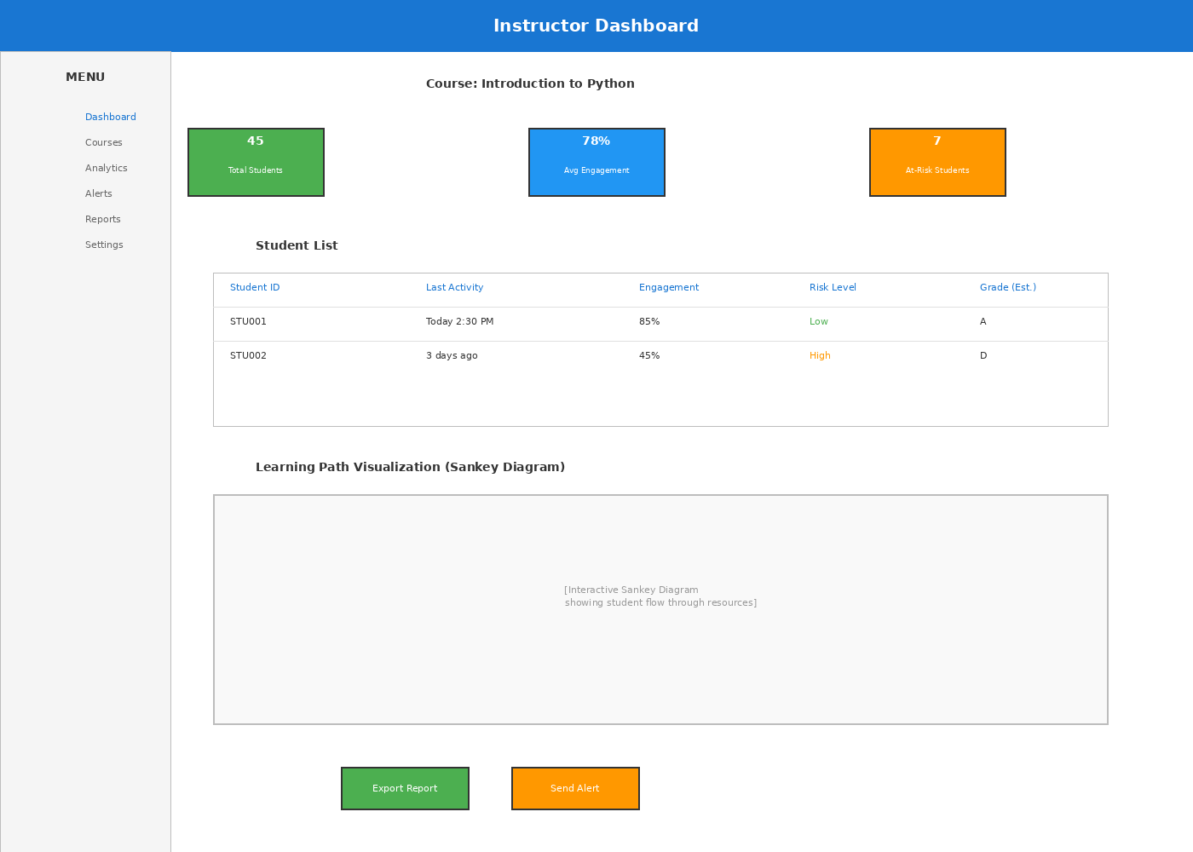

Login Screen
- Username input field
- Password input field (masked)
- Remember Me checkbox
- Forgot Password link
- Login button
- Error message area for invalid credentials
- University logo/branding

Learning Path Visualization
- Sankey diagram showing flow between resources
- Color-coded by student performance (green/yellow/red)
- Node labels showing resource names and access count
- Filter controls: date range, performance level, resource type
- Hover tooltips showing detailed statistics
- Download as SVG/PNG option

At-Risk Student List
- Table with columns: Student ID, Risk Score, Last Activity, Intervention
- Sortable headers
- Color-coded risk levels
- Click row to see detailed analysis
- Bulk action buttons (dismiss alert, send message)
- Pagination for large datasets

Analytics Export
- Format selector (CSV, Excel, PDF)
- Date range picker
- Course multi-select
- Data type checkboxes (patterns, predictions, raw interactions)
- Anonymization level toggle
- Submit button, progress bar for generation

5. API Design
The system exposes a RESTful API with JSON request/response format. All endpoints require JWT authentication (except /auth/login).
Base URL: /api/v1/
Authentication Endpoints:
• POST /auth/login - Username/password login, returns JWT token
• POST /auth/refresh - Refresh expired token
• POST /auth/logout - Invalidate current session
Course Data Endpoints:
• GET /courses - List all courses user has access to
• GET /courses/{course_id} - Get course details
• GET /courses/{course_id}/students - Student roster with risk scores
• GET /courses/{course_id}/patterns - Discovered learning patterns
• GET /courses/{course_id}/analytics - Aggregate course statistics
Student Data Endpoints:
• GET /students/{student_id}/interactions - Raw interaction history
• GET /students/{student_id}/prediction - Current risk prediction
• GET /students/{student_id}/recommendations - Suggested next resources
• GET /students/{student_id}/alerts - All alerts for this student
Visualization Endpoints:
• GET /visualizations/sankey/{course_id} - Sankey diagram data
• GET /visualizations/timeline/{student_id} - Student timeline data
• GET /visualizations/heatmap/{course_id} - Resource access heatmap
Analytics Endpoints:
• POST /analytics/export - Queue export job
• GET /exports/{export_id}/status - Check export status
• GET /exports/{export_id}/download - Download generated file
Admin Endpoints:
• GET /admin/health - System health status
• GET /admin/jobs - Celery job queue status
• POST /admin/retrain-models - Trigger model retraining
• POST /admin/users - Create/manage user accounts
All API responses include:
• status: success/error
• data: Response payload (or null if error)
• message: Human-readable message
• timestamp: ISO 8601 timestamp

6. System Workflows

6.1 Daily Data Ingestion Workflow
- Scheduler triggers at 2 AM UTC
- Connection established to Moodle database with read-only credentials
- Query new/updated interaction records since last sync
- Validate data: check timestamps, required fields, data types
- Anonymize student IDs using salted hash function
- Standardize timestamps to UTC
- Detect and flag duplicate records
- Load into staging table
- Generate ingestion report: records processed, errors, quality metrics
- Alert admin if error rate exceeds 5%

6.2 Weekly Pattern Mining Workflow
- Scheduled Sunday midnight
- Pull all interaction sequences from database
- Group by student and course
- Format sequences for SPMF algorithm
- Execute PrefixSpan with minimum support threshold
- Calculate correlation with student grades
- Rank patterns by predictive strength
- Store results in learning_patterns table
- Cache results in Redis for fast dashboard access
- Email admin with top patterns discovered

6.3 Weekly Model Retraining Workflow
- Scheduled Sunday 3 AM
- Extract all completed student records from past 2 semesters
- Engineer 20+ features: access frequency, patterns matched, quiz scores, etc
- Split 70% historical / 30% validation
- Train Random Forest and SVM models
- Evaluate on validation set (target: >75% accuracy)
- Compare performance to previous model version
- If improvement >2%, promote new model to production
- Archive old model for rollback capability
- Log metrics: accuracy, precision, recall, F1-score

6.4 Weekly At-Risk Alert Generation
- Scheduled Sunday 5 AM
- Run prediction model on all active students
- Calculate risk index: 60% failure probability + 40% pattern deviation
- Identify students with risk_index >= threshold (default 70)
- For each at-risk student:
- - Get examples of successful peer paths
- - Identify specific interventions (review resource X, redo quiz Y)
- - Calculate expected benefit of each action
- Create alert records
- Batch alerts by instructor
- Deliver via configured channel (email digest or instant)
- Update instructor dashboard badge count
- Log all alerts for audit trail
Workflow Sequence Diagrams:
Figure: Daily Data Ingestion

Figure: Weekly Pattern Mining
Figure: Weekly Model Retraining
Figure: Weekly At-Risk Alert Generation

7. Technology Stack & Justification
Layer | Technology | Justification
Frontend | React 18+ | Component-based, excellent ecosystem, mature community, fast rendering
Frontend | Material-UI | Comprehensive component library, accessibility built-in, professional look
Frontend | D3.js | Powerful custom visualizations, Sankey diagrams, flow charts
Backend | Python 3.11 | Data science lingua franca, excellent ML libraries
Backend | Flask 2.3 | Lightweight, flexible, blueprint system for modular code
Backend | Celery 5.3 | Asynchronous task processing, prevents UI blocking
Backend | Redis 7.0 | Fast message broker, caching, session storage
Analytics | Pandas 2.0 | Data manipulation, complex transformations
Analytics | Scikit-learn | ML models: Random Forest, SVM, evaluation metrics
Analytics | SPMF Library | GSP/SPADE/PrefixSpan algorithms not in standard Python
Database | MySQL 8.0 | Reliable, performant, supports transactions, well-understood by IT
Database | SQLAlchemy | ORM abstraction, reduces SQL errors, more maintainable
Infrastructure | Docker | Containerization, "works on my machine" guarantee
Infrastructure | Nginx | Web server, reverse proxy, load balancing, SSL termination
Security | bcrypt | Password hashing, properly salted, resistant to brute force

8. Security & Privacy Considerations

8.1 Authentication & Authorization
• Username/password login with 8-character minimum requirement including numbers
• Passwords hashed with bcrypt (cost factor 12) and stored securely
• JWT tokens issued on login with 24-hour expiration
• Multi-factor authentication required for System Admins
• Role-based access control: Admin, Instructor, Department Admin
• All API requests validated for proper authorization
• Session tokens stored in httpOnly cookies to prevent XSS attacks

8.2 Data Privacy
• Student IDs anonymized using salted SHA-256 hashing before any storage
• All PII removed from analytics database
• De-anonymization table kept in separate, restricted database
• GDPR compliance: "right to erasure" implemented for 30-day deletion window
• Data governance policy reviewed by university Data Protection Officer
• Annual privacy audit required
• Data retention: interaction logs deleted after 7 years
• Pseudonymization enables research without privacy violation

8.3 Data Protection
• SSL/TLS encryption for all data in transit (HTTPS only)
• Database encryption at rest (MySQL encrypted tablespace)
• Read-only connection from analytics system to production LMS database
• API credentials stored in environment variables, never in code
• Database credentials rotated every 90 days
• Secure backup storage with encryption
• Disk access controls: data files readable only by system user

8.4 Audit & Compliance
• Complete audit trail: who accessed what, when, from where
• All data exports logged with timestamp and user ID
• Failed login attempts recorded and monitored
• Suspicious access patterns trigger alerts
• System logs retained for 2 years minimum
• Regular security scanning of codebase and infrastructure
• Compliance with IUB Data Governance Policy
• Regular penetration testing scheduled

9. Deployment Architecture
Production Deployment Stack:
CONTAINERIZATION
• All components run in Docker containers
• Docker Compose for local development
• Kubernetes for production orchestration (scalability)
INFRASTRUCTURE
• Ubuntu Server 22.04 LTS base image
• Nginx reverse proxy (port 443 for HTTPS)
• Flask API servers (port 5000, multiple instances)
• Celery workers for background jobs (scaled based on queue depth)
• MySQL 8.0 database (primary + read replica)
• Redis cache/message broker (clustered setup)
NETWORKING
• Private network for inter-service communication
• Firewall rules: only ports 80/443 open to external
• VPN for admin access to system management interfaces
• SSL certificates renewed automatically with Let's Encrypt
MONITORING & LOGGING
• Prometheus for metrics collection
• ELK Stack (Elasticsearch, Logstash, Kibana) for log aggregation
• Health check endpoints on all services
• Automated alerts for critical issues
• Daily backup verification

9.1 Scaling Strategy
Horizontal Scaling:
• Frontend: Serve multiple instances behind load balancer
• Backend: Multiple Flask instances auto-scale based on CPU/memory
• Workers: Celery workers scale based on job queue length
• Database: Read replicas for scaling read-heavy queries
Vertical Scaling:
• Increase resources (CPU, RAM) as data volume grows
• Database indexing optimization for slow queries
• Redis cluster setup for distributed caching
Monitoring Triggers:
• Add worker when queue depth >100 jobs
• Add API server when response time >2 seconds
• Add database replica when CPU >75% sustained

10. Testing Strategy

10.1 Unit Testing
Target: >80% code coverage using pytest
Test Areas:
• Data validation functions (anonymization, timestamp conversion)
• ML feature engineering (correct calculations)
• Pattern mining output (algorithm correctness)
• API endpoint logic (auth, authorization, data retrieval)
• Database queries (proper SQL generation)
• Alert generation logic (correct threshold application)

10.2 Integration Testing
• Database integration: CRUD operations, transactions
• API integration: full request/response cycles
• Authentication flow: login to protected endpoints
• Celery task execution and error handling
• Redis caching behavior
• File upload/download operations
• Export generation with various filters

10.3 End-to-End Testing
• Full workflow from data ingestion to visualization
• Instructor login → view course → generate report
• At-risk student detection → alert generation → email delivery
• Permission testing: verify role-based access works
• Performance testing: response times with 50 concurrent users
• Load testing: system behavior under heavy data processing

10.4 Security Testing
• SQL injection vulnerability checks
• Cross-site scripting (XSS) prevention validation
• Cross-site request forgery (CSRF) token validation
• Authentication bypass attempts
• Authorization bypass attempts
• Data exposure checks

10.5 Performance Testing
• Dashboard load time <3 seconds with 50 users
• Pattern mining completes <6 hours for 500-student course
• API responses <5 seconds for 1M record queries
• Model training <4 hours for weekly retraining
• Memory usage stays <2GB for core services
• Database query optimization and index effectiveness

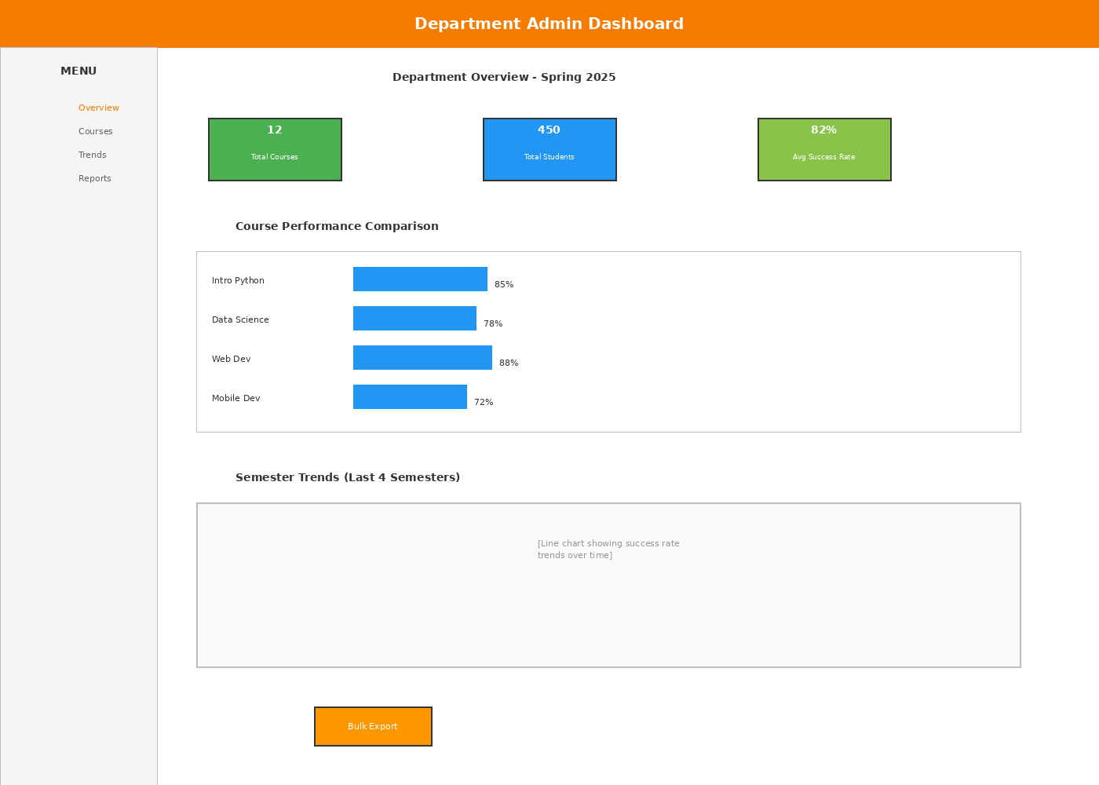
Figure 3: Department Admin Dashboard
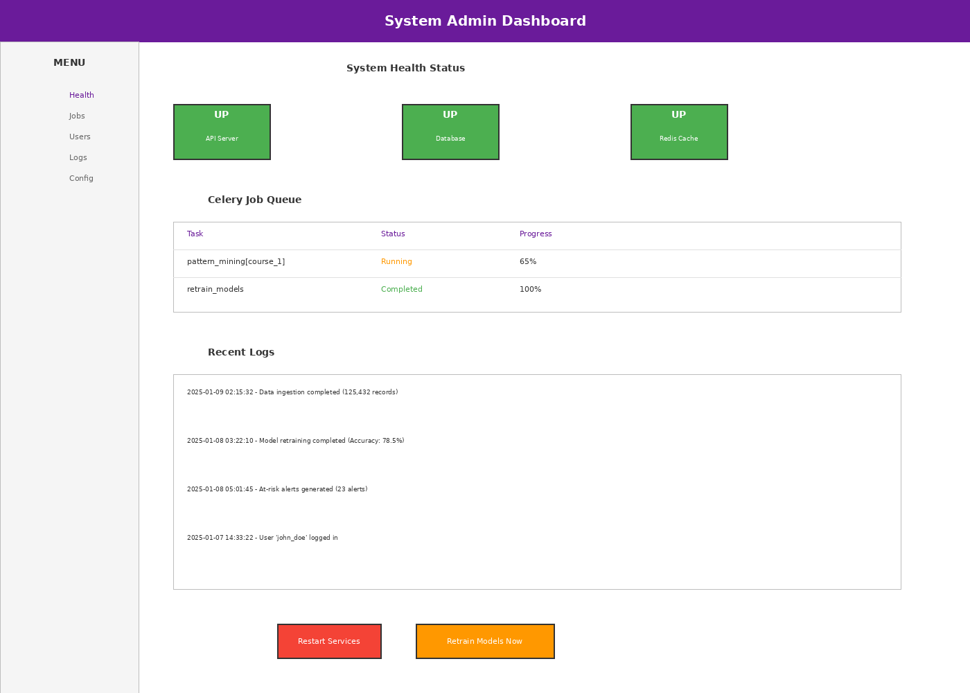
Figure 4: System Admin Dashboard

