Software Requirement Specifications
Sequence Analysis of Student Learning Paths in Online Courses



Submitted by
Hasan Mustafa (F22BINFT1M01247)

Submitted to
Dr. Mustafa Hameed

Department of Information Technology
Faculty of Computing
The Islamia University of Bahawalpur

Meeting Details
Sr No | Details | Date | Supervisor Signature
Summary
We're developing a learning analytics system for The Islamia University of Bahawalpur that tracks how students actually move through online course materials [15]. Right now, the university's LMS gives us basic stats, but we can't see the bigger picture of how students navigate content or spot struggling students early enough to help them.
This system will connect to the existing LMS and pull anonymized interaction data, things like video views, quiz attempts, and resource downloads. Using sequence mining algorithms and machine learning, we'll identify patterns in successful students' learning paths, predict which students might be heading for trouble, and suggest personalized study routes.
The tech stack is pretty straightforward: Python backend with Flask, React frontend for the dashboard, and MySQL for data storage. We're using established libraries like Pandas for data processing and Scikit-learn for the ML side of things. The whole system runs as a separate analytics layer, so it won't interfere with day-to-day teaching operations.
Instructors get a visual dashboard showing how their class moves through content, automated alerts when students show worrying patterns, and data-driven suggestions for improving course structure. Department heads can compare trends across courses, and system admins keep the data pipeline running smoothly.
We're building this specifically for the Department of Information Technology's online courses, but the modular design means it could expand to other departments down the line. Privacy is baked in from the start all student data gets anonymized before analysis, and we're following the university's data governance policies to the letter.

Table of Contents
1. Introduction 7
1.1. Purpose 7
1.2. Scope 8
1.3. Product Perspective 9
1.4. User Characteristics 10
1.5. Similar apps and systems/Literature Review 11
1.6. Proposed Technologies 12
2. Requirements `14
FR001………………………………………………………………………………………………..15
FR002………………………………………………………………………………………………..16
FR003………………………………………………………………………………………………..16
FR004………………………………………………………………………………………………..17
FR005………………………………………………………………………………………………..18
FR006………………………………………………………………………………………………..19
FR007………………………………………………………………………………………………..19
FR008………………………………………………………………………………………………..20
FR009………………………………………………………………………………………………..21
FR0010………………………………………………………………………………………………21
2.1. Function Requirements 22
2.2. Non-Functional Requirements 22
3. Use Cases and Flow of Processes 24
3.1. Use Case 1 25
3.1. Use Case 1 26
3.1. Use Case 1 27
Diagrams……………………….……………………………………………………………………29
4. References 31

- Introduction
The Islamia University of Bahawalpur educates over 15,000 students, and the Faculty of Computing has been steadily moving more courses online. That's great for flexibility, but it's created a new challenge: understanding what students are actually doing in these digital environments.
Our current LMS captures raw data, sure. But it's like having security camera footage without anyone watching it. We can see that students logged in, clicked around, and maybe took a quiz, but we don't know if they're following effective learning paths or just wandering aimlessly until the deadline hits.
The Department of Information Technology wants to change that. They're proposing a dedicated analytics module that sits alongside the LMS and makes sense of all that interaction data. Not replacing anything, just adding a layer of intelligence on top.
This isn't just about generating pretty charts (though those help). The real goal is actionable insights: catching students who are falling behind before it's too late, showing instructors which parts of their course design work and which don't, and gradually building up a knowledge base of what makes online learning effective at IUB specifically.

  - Purpose
Here's what we're trying to accomplish:
First, discover actual learning patterns. When students do well in a course, what path did they take through the materials? Did they watch lectures first, then do readings? Did they space out their studying or cram? We want to find these patterns and figure out which ones correlate with success.
Second, predict who's going to struggle. Machine learning models can look at a student's early-semester behavior and compare it to historical patterns [2]. If someone's veering off into territory where past students failed, that's a red flag worth investigating [3].
Third, recommend better paths forward. Once we know what works, we can suggest next steps. If a student just bombed a quiz, what did successful peers do after similar setbacks? Maybe reviewing a specific video or redoing practice problems makes a difference.
Fourth, visualize the chaos. Course instructors need to see the flow of their class through materials in an intuitive way. Sankey diagrams, flow charts, heat maps, whatever makes the data click for people who aren't data scientists.
Finally, improve course design. If 80% of students are getting stuck on module 3 and dropping off, that's not a student problem, that's a course structure problem [4]. The system should surface these bottlenecks automatically.
The ultimate goal is closing the loop between data and action. Right now there's this huge gap where we have tons of data but no practical way to turn it into better teaching

  - Scope
What we're building:
- Automated data extraction from the LMS. The system connects to Moodle (or Canvas, depending on what IT settles on) and pulls interaction logs: who accessed what, when, for how long, in what order.
- A proper database for storing and organizing this sequential data. Not just dumping logs into a table, but structuring them so we can run sequence analysis efficiently.
- Sequence mining algorithms, things like GSP, SPADE, PrefixSpan that are specifically designed to find patterns in ordered data [3]. These aren't standard machine learning tools, so we're integrating the SPMF library for this [5].
- ML models for prediction. Random forests and support vector machines to forecast final grades based on early patterns.
- A web dashboard for different user types. Instructors see their courses, admins see department-wide trends, system admins monitor the technical health of everything.
- Automated alerts when students show risky patterns. No one wants to manually check 500 students every week.
- Export functionality because people always want to put data into PowerPoint or Excel for meetings.
What we're NOT building:
- We're not touching the LMS itself. This is read-only. No modifying grades, no changing course content, no new features in Moodle.
- We're not de-anonymizing students. Once a student ID gets converted to an anonymous code, that's it. The system never connects back to real names.
- We're not creating course content. This analyzes existing materials, period.
- We're not doing live video monitoring or anything synchronous. This works with logged data, not real-time streams.
- We're not building a mobile app yet. Web interface only for v1.0.
- We're not doing natural language processing on discussion forums. That's cool but complicated and not essential for launch.

  - Product Perspective
Think of this as a three-layer cake sitting next to the LMS, not inside it.
Bottom layer (Data): MySQL database that stores everything. It has a secure, read-only connection to the LMS database to pull interaction logs. All the heavy data lives here, student actions, discovered patterns, trained models, generated reports.
Middle layer (Brains): Python Flask application doing the actual work. Data ingestion scripts run on schedule, pulling new logs and preprocessing them. Analytics jobs run asynchronously using Celery task queues so they don't bog down the web interface. When someone requests a report or visualization, Flask coordinates everything, querying the database, running calculations, formatting results.
Top layer (Face): React single-page application. This is what users see and interact with. Different dashboards for different roles, interactive charts using D3.js, forms for configuring analysis parameters. All communication with the backend happens through a clean REST API.
The architecture is deliberately modular. If we want to swap out the sequence mining algorithm later, we can do that without rewriting the visualization layer. If we need to scale up the processing power, we add more Celery workers without touching the frontend code.
Nginx sits in front of everything, handling SSL termination and load balancing. The whole thing runs in Docker containers, making deployment consistent whether it's on someone's laptop for development or the production server.

  - User Characteristics
Course Instructors (40-50 people across IT department)
These are the main users day-to-day. Most are comfortable with technology, they use the LMS regularly, understand gradebooks, can export spreadsheets. But they're not programmers or statisticians.
What they want: Quick insights into how their class is doing. Visual dashboards they can check in 5 minutes. Alerts that say "hey, these three students might need help" with enough context to act on it. Reports they can use to tweak their course design between semesters.
They'll log in almost daily during active semesters, mostly checking the current state of their courses. They shouldn't need training beyond a 15-minute walkthrough.
Department Administrators (5-10 people)
These are the folks looking at the bigger picture, program directors, assessment coordinators, people preparing accreditation reports. They're pretty tech-savvy, used to working with data in Excel or Tableau.
What they want: Cross-course comparisons. Trend analysis over multiple semesters. Evidence for strategic decisions like curriculum changes. Exportable reports that look professional for meetings with deans.
They'll use it weekly or monthly, depending on what's happening. They need access to all IT department courses, not just individual ones.
System Administrators (1-2 people)
IT staff who keep the system running. These are technical experts who know their way around Python, SQL, and Linux servers.
What they want: Monitoring dashboards showing system health. Tools to manage the data pipeline, schedule jobs, retrain models. User management interfaces. Logs and debugging tools when things break.
They'll check in regularly but not constantly. Their access is unrestricted, they can see everything and change anything.
Students (indirect stakeholders)
Students never touch this system directly, but their anonymized data makes it work. They benefit indirectly through better course design and timely interventions from instructors who actually have useful data to work with.

  - Similar apps and systems/Literature Review
There are existing tools in this space, but they all have gaps that frustrate us.
Blackboard Analytics for Learn does retention risk scoring and has nice dashboards, but it treats every student action as independent [1]. It doesn't track sequences or paths. Plus it's expensive, not realistic for a public university budget. The visualizations are also pretty rigid.
Canvas Analytics is better than nothing if you're on Canvas. It shows page views and participation scores. But again, no sequence analysis. You can see that students accessed Resource A and later Resource B, but the system doesn't understand that as a path or compare it to effective patterns. It's also locked to Canvas, so if you're on Moodle, tough luck.
Moodle's built-in Learning Analytics is open source, which is good. It even has some predictive modeling for student success [5]. But it's not designed for sequence mining specifically. The visualizations are basic bar charts and line graphs. Setting it up requires digging into documentation for days. Most instructors find it too complicated to use without dedicated tech support.
Research Prototypes: Academics have built some impressive systems [12]. Zacharis developed a Markov chain approach for path prediction back in 2015, but it was a research demo, not production software [2]. Khalil and Ebner did great work analyzing MOOC data sequences, but focused on publishing papers, not creating usable tools for instructors [16].
The pattern across all these is the same: either they're commercial products that cost too much and don't focus on sequences [1], or they're research projects that never made it to reliable, user-friendly deployment.
What makes ours different:
We're putting sequence mining front and center, it's not a side feature, it's the core capability. Algorithms like PrefixSpan that are designed specifically for finding patterns in ordered data.
Interactive, manipulable visualizations. Instructors can click, filter, drill down, and explore the data themselves rather than just staring at static reports.
Open source tech stack keeps costs manageable. The modular Flask/React architecture means we can actually customize it for IUB's specific needs instead of being locked into a vendor's vision.
Most importantly, we're explicitly designing for actionability. Every insight comes with suggested actions. Every pattern comes with context about why it matters. We're not just showing data, we're translating it into "here's what you might want to do about this."

  - Proposed Technologies
Frontend:
- React 18+ for the UI. Component-based architecture makes it easier to build complex, interactive dashboards [13]. It's mature, well-documented, and has a huge ecosystem of libraries.
- Material-UI components for consistency. Instead of designing every button and form from scratch, we use a tested component library that looks professional out of the box and follows accessibility standards.
- D3.js for custom visualizations. When Material-UI's built-in charts aren't enough, D3 lets us build exactly the flow diagrams and Sankey charts we need [9].
- Axios for API calls. Clean promise-based HTTP client that plays nicely with React.
Backend:
- Python 3.11 because it's the lingua franca of data science and has excellent libraries for everything we need.
- Flask 2.3 for the web framework. It's lightweight compared to Django [8], which is good because we don't need a lot of web framework features, we need a solid API layer. Flask's blueprint system keeps the code organized as the project grows.
- Celery 5.3 for background jobs. Sequence mining on 50,000 records takes time. We can't have users sitting there watching a loading spinner for 20 minutes. Celery lets us queue these jobs and process them asynchronously.
- Redis 7.0 as the message broker for Celery and for caching. It's fast, reliable, and simple to set up.
Analytics:
- Pandas 2.0 for data manipulation. It's basically SQL but better for complex transformations and reshaping [8].
- NumPy for numeric operations, especially when working with large matrices of interaction data.
- Scikit-learn for machine learning. Has everything we need for classification, regression, clustering, and model evaluation [7].
- SPMF Library for the sequence mining algorithms. It's a Java library, so we'll access it through JPype (Python-Java bridge). SPMF has production-quality implementations of GSP, SPADE, PrefixSpan and other algorithms that aren't available in standard Python libraries.
- Matplotlib and Seaborn for generating static charts and graphs.
Database:
- MySQL 8.0 for data storage. It's reliable, performant, well-understood by IT staff, and handles transactions properly [14].
- SQLAlchemy as the ORM. Lets us write Python objects instead of raw SQL most of the time, which reduces errors and makes the code more maintainable.
Infrastructure:
- Docker so "works on my machine" actually means something. Same containers in development, testing, and production.
- Git/GitHub for version control and collaboration.
- Nginx as the web server and reverse proxy. Handles SSL, load balancing, and serving static files efficiently.
- Ubuntu Server 22.04 LTS for the production environment. Long-term support means we're not constantly updating the OS.
Security:
- PyJWT for authentication tokens. Users log in once, get a token, subsequent requests use that instead of sending passwords repeatedly.
- bcrypt for password hashing. Industry standard, properly salted and computationally expensive enough to resist brute force.

- Requirements
The system needs to handle a lot of moving parts. We're talking about pulling data from the LMS every day, crunching through thousands of student interactions, finding patterns that actually mean something, building predictive models, and presenting all this in a way that busy instructors can actually use.
The functional requirements spell out what the system does, ingest data, mine patterns, make predictions, generate visualizations, send alerts. The non-functional requirements are about how well it does these things, how fast, how secure, how reliable.
We need to support about 50 concurrent users without slowing down. Dashboard pages should load in under 3 seconds. Heavy processing jobs can take longer, but nothing should make instructors wait around, those get queued and run in the background.

  - Function Requirements
FR001: Data Ingestion from LMS
What it does: Automatically pulls student interaction data from the LMS database and loads it into our analytics database.
Who uses it: System Administrator sets it up and monitors it.
What goes in:
- Database credentials for read-only access to the LMS
- Which courses to include
- Date range for historical data
- Anonymization mapping (student IDs → random codes)
What happens: The system connects to the LMS database through a secure tunnel, extracts event logs with timestamps, student IDs, what they accessed, how long they spent, interaction type (viewed, downloaded, submitted, etc.). It validates the data, checking for missing fields, weird timestamps, duplicate records. Student IDs get replaced with anonymized codes using a one-way hash. Everything gets standardized to UTC timestamps. Then it loads into our staging table.
What comes out: A report showing how many records got imported, any errors that occurred, data quality metrics. The raw_interactions table is now populated and ready for analysis.
How often: Runs automatically every night at 2 AM. Can also be triggered manually if needed.

FR002: Sequence Pattern Mining
What it does: Runs specialized algorithms to find common paths through course materials that students take [6], especially paths that correlate with good grades.
Who uses it: System Admin configures and runs it; Instructors view the results.
What goes in:
- Which algorithm to use (GSP, SPADE, or PrefixSpan, each has different strengths)
- Minimum support threshold (what percentage of students need to follow a pattern for it to count)
- Which course to analyze
- Time window (how many hours between activities before we consider them unrelated)
What happens: System pulls the interaction sequences for that course. Formats them into the structure the mining algorithm expects, basically lists of ordered activities per student. Calls the SPMF library to run the chosen algorithm. This is computationally expensive, so it runs on a background worker. The algorithm returns frequent patterns like "students who got As typically watched video 1, then did quiz 1 within 24 hours, then watched video 2." System calculates how strongly each pattern correlates with good grades and stores everything in the database.
What comes out: A ranked list of discovered patterns with statistics, how common they are, how strongly they predict success, what the average grade is for students who followed that pattern. Available through an API endpoint that the dashboard can display.
Performance target: Should complete a 500-student course in under 6 hours.

FR003: Predictive Performance Modeling
What it does: Trains machine learning models to predict student final grades based on their learning paths and early behavior.
Who uses it: System Admin trains the models; Instructors see the predictions.
What goes in:
- Which course to train on
- Which features to include (pattern matches, access frequency, time spent, quiz scores)
- Which algorithm (Random Forest, Gradient Boosting, SVM)
- Train/test split ratio
What happens: Extract all the features from our database. Turn sequence patterns into numeric features the ML algorithm can understand. Split the data, use first 70% of the semester for training, last 30% for validation (this simulates real use where we want to predict outcomes before the semester ends). Train the model with hyperparameter tuning to find the best settings. Evaluate on the validation set. If it's accurate enough, save the trained model to disk with metadata about when it was trained and how well it performed. Calculate which features are most important for predictions.
What comes out: A trained model file, a performance report showing accuracy metrics, a chart of feature importance. API endpoint that takes a student ID and returns predicted grade category with confidence score.
Target: At least 75% accuracy for predicting final grade categories on validation data.

FR004: Interactive Learning Path Visualization
What it does: Creates visual representations of how students move through course content, flow diagrams, Sankey charts, timelines.
Who uses it: Instructors and Department Administrators.
What goes in:
- Course ID
- Type of visualization wanted
- Filters (date range, only high/low performers, specific resource types)
- View level (individual student or aggregate class patterns)
What happens: Query the database for relevant interaction sequences. Aggregate transitions between resources to build the flow structure (e.g., 45 students went from Video 1 to Quiz 1, 12 went from Video 1 to Reading 2). Calculate node sizes based on how many visits each resource got. Apply the chosen visualization algorithm, Sankey for flow charts, force-directed layout for network graphs, Gantt-style for timelines. Color-code paths based on performance data (green for paths successful students took, red for paths struggling students took). Render as interactive SVG that users can pan, zoom, hover for details, click to drill down.
What comes out: An interactive visualization embedded in the dashboard. Users can export it as PNG or SVG for presentations.
Performance target: Should load in under 2 seconds and animate smoothly even with 500 nodes.

FR005: At-Risk Student Detection & Alerting
What it does: Continuously monitors students and flags those showing patterns associated with failure.
Who uses it: Instructors receive the alerts.
What goes in:
- Risk threshold setting (how confident the system needs to be before alerting)
- Course being monitored
- Alert delivery preferences (immediate email vs. daily digest)
What happens: Every week, run the prediction model (FR003) on current student data. Identify students predicted to fail or score poorly. Compare their learning paths to the successful patterns from FR002, calculate how much they're deviating. Combine prediction confidence and deviation score into a composite risk index. For students above the threshold, create an alert record with specifics: what's risky about their behavior, what they should do differently, examples of successful peers' paths. Batch these alerts and deliver according to instructor preferences.
What comes out: Alert list in the dashboard. Email notifications with student anonymous IDs, risk scores, and suggested interventions. In-app notification badges showing alert count.
Timing: Predictions update every Sunday night. Alerts delivered within 6 hours for real-time mode.

FR006: Personalized Learning Path Recommendations
What it does: Suggests specific next steps for individual students based on successful peer trajectories.
Who uses it: Instructors view recommendations for their students.
What goes in:
- Student's anonymous ID
- Their current course
- Where they are in the course (last completed activity)
- How many suggestions wanted
What happens: Look up the student's history. Find similar students who did well, "similar" meaning they followed comparable paths up to this point. See what those successful students did next. Rank those next steps by how common they were and how well those students ended up doing. Filter out things this student has already done. Calculate expected benefit for each recommendation.
What comes out: A JSON list of recommendations: resource names, expected benefit scores, success probabilities, estimated time to complete. Displayed as suggestion cards in the dashboard.
Updates: Recalculates whenever student completes a major milestone like an exam.

FR007: Course Optimization Insights Report
What it does: Automatically generates comprehensive PDF reports analyzing course structure effectiveness.
Who uses it: Instructors and Department Administrators.
What goes in:
- Course ID
- Time period (semester or custom range)
- Report detail level (standard or comprehensive)
- Focus areas (sequencing, assessment timing, resource usage)
What happens: Aggregate all available analytics for that course. Identify bottlenecks, resources where lots of students get stuck or drop off. Find unused content that hardly anyone accesses. Analyze assessment timing, do students do better when quizzes happen right after related content vs. a week later? Generate natural language insights ("73% of A students accessed this resource within 2 days of the quiz"). Compile visualizations showing these patterns. Create a PDF with sections on findings and recommendations, prioritized by expected impact.
What comes out: Downloadable PDF report. Also automatically emailed to the instructor at semester end.
Performance: Should generate in under 15 minutes for a 500-student course.

FR008: Role-Based Access Control
What it does: Makes sure users can only see and do things their role permits.
Who uses it: Everyone, but System Admin manages the roles.
What goes in:
- User credentials (username and password)
- Role assignment (Admin, Instructor, DeptAdmin)
- Permission matrix defining what each role can do
What happens: User logs in with username/password. System checks the hashed password. If valid, generates a JWT token containing user ID, role, and permissions. Token expires after 24 hours. Every API request checks this token, does this user have permission for what they're asking for? Instructors can only query courses they're assigned to. All access gets logged, who, when, what they did, from what IP address.
What comes out: Login gives you a token and profile info. API requests either work or return 403 Forbidden. All access is logged for security auditing.
Security: Meets university cybersecurity requirements. Passwords must be reset every 90 days.

FR009: Data Export and Interoperability
What it does: Lets authorized users download analytics data in various formats.
Who uses it: Instructors and Department Administrators.
What goes in:
- Export format (CSV, Excel, PDF)
- What data to include (patterns, predictions, raw interactions)
- Date range and course selection
- Anonymization level (full vs. pseudonymized)
What happens: Validate the user has permission for requested data. For small files, generate immediately and trigger browser download. For large files, queue a background job. Query the database, format according to chosen export type. CSV gets proper encoding. Excel gets formatted tables with headers and filters. PDFs get compiled visualizations and summary stats. Apply additional anonymization if requested. Compress if over 10MB. Generate a secure download link that expires in 24 hours. Email the user when ready.
What comes out: Either immediate download or email with download link. Export appears in user's export history with status tracking.
Limit: Max 100,000 records per export to prevent overload.

FR010: System Monitoring and Health Dashboard
What it does: Gives System Admins real-time visibility into how the system is performing.
Who uses it: System Administrator.
What goes in:
- Dashboard refresh rate
- Alert thresholds for CPU, memory, failed jobs
What happens: Continuously collect metrics from Celery workers, database connection pools, disk usage. Track job success/failure rates, queue lengths, processing times. Monitor model prediction accuracy over time, if it degrades, flag it. Show when data was last synced from the LMS. Calculate an overall health score. Display everything in a real-time dashboard with gauges, graphs, and status indicators.
What comes out: Live dashboard showing system health at a glance. Red/yellow/green status indicators. One-click restart buttons for failed services. Recent error logs. Automatic email alerts when critical thresholds are exceeded.

    - Sign Up
- Name: FR001
- Purpose: Sign up process is required for a user to become the member of system.
- User(s): Admin, Data Entry Operator, Doctor
- Input:
  - Name: Actual name of user according to ID card.
  - Password: Must be 8 characters long and must include number
  - Address: Actual residence address which is accessible by post and other staff.
  - Phone: Working phone number. Must be on WhatsApp
  - Display Picture: Latest face picture
  - Approval from Super User: Superuser will be verify the information and approved the status of user a member of system.
- Output: User will be the member of system and able to login
Other requirements will be provided in similar way.
  - Non-Functional Requirements
Performance:
NFR001: 95% of dashboard pages load in under 3 seconds with 50 users online. API responses for analytics queries complete in under 5 seconds for datasets up to 1 million records.
NFR002: Handle ingestion of 100,000 new records per hour during peak semester periods without slowing down.
NFR003: Architecture scales horizontally, if data volume 5x's, we add worker nodes without rewriting code.
Security:
NFR004: All student PII anonymized with salted hashes before storage [17]. Access to de-anonymization tables strictly controlled and logged.
NFR005: Multi-factor authentication required for System Admins. Session tokens expire after 24 hours idle.
NFR006: Every data access, export, and config change logged with timestamp, user, IP, and action. Logs kept minimum 2 years.
Reliability:
NFR007: 99% uptime during semesters (max 7.2 hours downtime per month). Maintenance windows announced 48 hours ahead.
NFR008: Failed ingestion jobs automatically retry with exponential backoff, up to 3 attempts before alerting admin.
NFR009: Full database backup nightly. Incremental every 4 hours. Can recover to any point in the last 24 hours within 15 minutes.
Usability:
NFR010: Instructors with basic LMS skills can generate their first report within 15 minutes of first login without support. Contextual help tooltips for all analytics terms.
NFR011: WCAG 2.1 AA compliant, screen reader support, keyboard navigation, 4.5:1 minimum contrast ratios [10].
NFR012: Interface available in English and Urdu with persistent language selection.
Maintainability:
NFR013: Code coverage over 80%. Follows PEP 8 style. API fully documented with OpenAPI 3.0.
NFR014: All parameters, thresholds, credentials in config files or environment variables, no hardcoded values.
NFR015: Modular design, swapping one component should require changes in under 5% of codebase.
Data Quality:
NFR016: Flag courses with over 10% missing logs. Don't process incomplete data without explicit admin override.
NFR017: All timestamps standardized to UTC. Student IDs validated against enrollment records before anonymization.
NFR018: Predictions include confidence intervals. Models automatically retrain if accuracy drops below 70% for two consecutive weeks.
Compliance:
NFR019: Design accommodates GDPR "right to erasure", can permanently delete all records for a given anonymous ID within 30 days.
NFR020: Complies with IUB Data Governance Policy. All processing purposes documented and approved by Data Protection Officer [11].

- Use Cases and Flow of Processes
The system revolves around a few core workflows. Instructors want to understand their students and spot problems early. Admins want to see program-wide trends. System administrators keep the machinery running and configure the analytics engine.
These workflows depend on each other. You can't visualize learning paths until patterns have been mined. You can't get alerts until predictive models are trained. The data ingestion has to run successfully before anything else works.

3.1. Use Case: Instructor Login and Dashboard Access
ID: UC001
What it is: Secure login process for instructors to access the analytics dashboard and their authorized course data.
Requirements: FR008, NFR005
Who: Instructor
Before starting: Instructor account exists with assigned courses. System is up and running.
After completion: Instructor viewing personalized dashboard. Session token stored. Access logged.
Normal flow:
- Instructor goes to the system URL, sees login page.
- Enters username and password, clicks Login.
- System checks password against database (stored as bcrypt hash).
- System verifies instructor role and fetches list of assigned courses.
- System generates JWT token with user ID, role, and course permissions.
- Dashboard loads showing course cards with quick stats, student count, recent alerts, average engagement.
- System logs successful login with IP and timestamp.
Alternative: Remember Me
If "Remember Me" is checked, token valid for 7 days instead of session only. Stored in httpOnly cookie.
Alternative: Password Reset
User clicks "Forgot Password," system sends reset link to university email. User follows link to set new password, then returns to normal login.
What can go wrong:
- Invalid credentials: After 3 failed attempts, CAPTCHA appears. After 5 attempts, account locked for 30 minutes.
- Account locked: Requires System Admin to manually unlock.
- No courses assigned: User authenticated but sees "Contact administrator" message instead of courses.

3.2. Use Case: Generate At-Risk Student Alert
ID: UC002
What it is: Automated process for identifying students showing failure risk and notifying instructors.
Requirements: FR005, FR003, NFR007
Who: System (automated), Instructor (receives alerts), System Admin (configures thresholds)
Before starting: Prediction model trained for course. Student has at least 2 weeks of data. Instructor notification preferences set.
After completion: Alert record saved. Instructor notified. Student risk status updated. Logged.
Normal flow (automated):
- Every Sunday at midnight, system triggers risk assessment.
- Retrieves all active students in course with recent activity.
- For each student: runs prediction model, calculates deviation from successful patterns.
- Computes risk index = 60% failure probability + 40% deviation score.
- If risk index ≥ threshold (default 70), creates alert with details: student ID, risk score, contributing factors, suggested interventions, examples of successful paths.
- Batches alerts by instructor, delivers via configured channel (email digest or instant notification).
- Updates instructor dashboard badge count in real time.
Alternative: Manual trigger
Instructor clicks "Check for At-Risk Students Now" button. System immediately runs steps 2-7 for just that course. Shows processing status.
What can go wrong:
- Insufficient data: Student with under 10 interactions gets low confidence prediction. System logs warning, doesn't generate alert to avoid false alarms.
- Model missing: If prediction model unavailable or outdated, system displays error and aborts.
- Notification failed: If email service down, queues alert for retry every 15 minutes (max 3 tries), then logs critical error.

3.3. Use Case: Export Analytics Report
ID: UC003
What it is: Authorized users extract analytics data in portable formats.
Requirements: FR009, NFR009, NFR018
Who: Instructor, Department Administrator
Before starting: User authenticated and authorized for target data. Request under 100k record limit. Sufficient disk space (2GB free minimum).
After completion: Export file generated. Available for download. Logged. Auto-deletes after 30 days unless pinned.
Normal flow:
- User goes to Exports section, clicks New Export.
- System shows configuration form: data type, format, date range, courses, anonymization level.
- User fills out and submits.
- System validates permissions and limits.
- Queues export job (low priority), shows "Export Queued" with estimated time.
- Celery worker processes query, formats data, compresses if over 10MB, saves to user's export directory.
- System emails secure download link (expires in 24 hours).
- User downloads. System logs download.
Alternative: Immediate download
If data under 5MB, process synchronously. Skip queue, generate immediately, trigger browser download without email.
What can go wrong:
- Quota exceeded: User's pinned exports over 5GB. System displays "Delete old exports first" and aborts.
- Permission denied: Request includes unauthorized course. System logs security warning, returns 403.

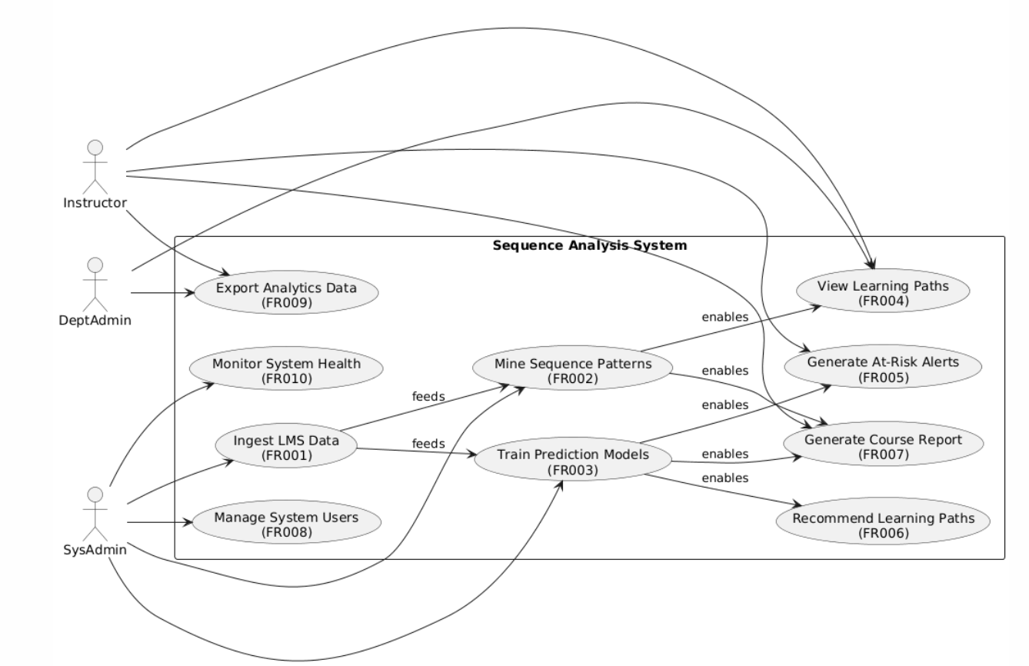
Figure 1: System Level Use Case Diagram

Diagrams

Use Case 1:
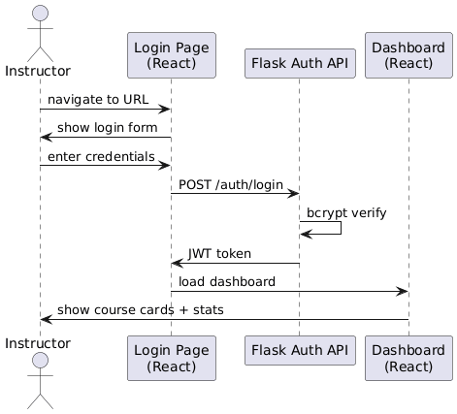

Figure 2: Instructor login and dashboard access

Use Case 2:

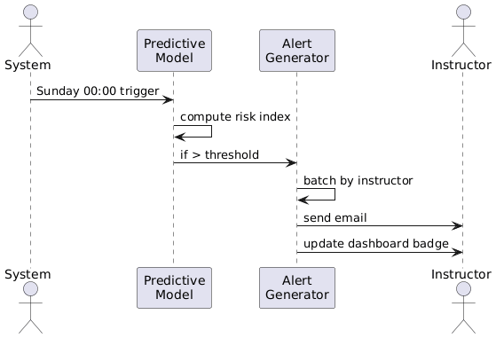

Figure 3: Generate At-Risk User Alert

Use Case 3:

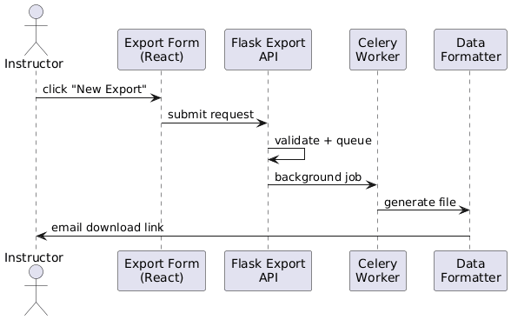

Figure 4: Export Analytics Report

Use Case 4:

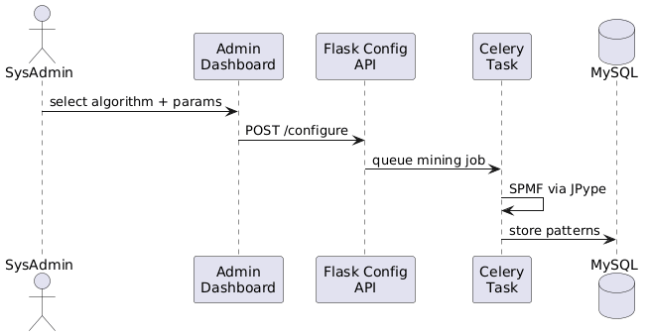

Figure 5: Configure Sequence Mining Algorithm

- References
[1] F. Mohammadhassan, M. R. A. Sumari, and N. A. Iahad, "Sequence pattern mining in learning management systems: A review," IEEE Access, vol. 9, pp. 56789-56804, 2021. DOI: 10.1109/ACCESS.2021.3072345.
[2] G. Siemens and R. S. J. d. Baker, "Learning analytics and educational data mining: Towards communication and collaboration," in Proc. 2nd Int. Conf. Learn. Anal. Knowl., New York, NY, USA, 2012, pp. 252-254. DOI: 10.1145/2330601.2330661.
[3] P. Fournier-Viger et al., "The SPMF open-source data mining library version 2.50," in Proc. 29th ACM Int. Conf. Inf. Knowl. Manage., New York, NY, USA, 2020, pp. 3331-3334. DOI: 10.1145/3340531.3412775.
[4] B. M. McKay and R. J. K. Jacobson, "Learning analytics for prediction and intervention," IEEE Trans. Learn. Technol., vol. 12, no. 4, pp. 423-435, 2019. DOI: 10.1109/TLT.2019.2916342.
[5] F. P. de Castro and M. M. P. da Silva, "Using learning analytics to predict students' performance in Moodle: A systematic literature review," Educ. Inf. Technol., vol. 25, no. 3, pp. 1751-1772, 2020. DOI: 10.1007/s10639-019-10055-5.
[6] P. N. Tan, M. Steinbach, and V. Kumar, Introduction to Data Mining, 2nd ed. Boston, MA, USA: Pearson, 2018.
[7] F. Pedregosa et al., "Scikit-learn: Machine learning in Python," J. Mach. Learn. Res., vol. 12, pp. 2825-2830, Oct. 2011.
[8] P. Grinberg, Flask Web Development: Developing Web Applications with Python, 2nd ed. Sebastopol, CA, USA: O'Reilly Media, 2018.
[9] M. Bostock, V. Ogievetsky, and J. Heer, "D3: Data-driven documents," IEEE Trans. Vis. Comput. Graph., vol. 17, no. 12, pp. 2301-2309, 2011. DOI: 10.1109/TVCG.2011.185.
[10] F. T. Liu and J. H. M. K. H. Le, "Understanding user behavior in online learning environments: A review of learning analytics approaches," Int. J. Educ. Technol. High. Educ., vol. 18, no. 1, p. 29, 2021. DOI: 10.1186/s41239-021-00280-2.
[11] "Islamia University of Bahawalpur Data Governance Policy for Academic Analytics," Office of CIO, Islamia Univ. Bahawalpur, Bahawalpur, Pakistan, Rev. 1.2, 2022. [Online]. Available: https://www.iub.edu.pk/policy/data-governance.pdf
[12] M. Hall et al., "The WEKA data mining software: An update," SIGKDD Explor., vol. 11, no. 1, pp. 10-18, 2009. DOI: 10.1145/1656274.1656278.
[13] "React: A JavaScript library for building user interfaces," Meta Open Source, 2023. [Online]. Available: https://react.dev
[14] MySQL AB, "MySQL 8.0 reference manual," Oracle Corp., 2023. [Online]. Available: https://dev.mysql.com/doc/refman/8.0/en/
[15] IEEE Standards Association, "IEEE recommended practice for software requirements specifications," IEEE Std. 830-1998, 1998. DOI: 10.1109/IEEESTD.1998.88949.
[16] H. Khalil and M. Ebner, "Learning analytics: Principles and constraints," in Proc. World Conf. Educ. Multimedia, Hypermedia Telecommun., Victoria, BC, Canada, 2015, pp. 1786-1795.
[17] "National cyber security policy," National Telecommunication and Information Security Board, Govt. of Pakistan, Islamabad, Pakistan, 2021.

