**1. PROBLEM DEFINITION:**

Binary Classification on Predicting Cervical Cancer

1. **Client:**

Medical staff:

Cervical Cancer one of the most cancer types which females face off, and diagnosing the cancer in early stages are extremely important to cure the disease. Thus, Medical Staff’s early detection of Cancer makes huge different on the treatment phase.

Female patients:

Females mostly need to get smear test to be sure that any kind of complication is not going to be occur in the cervical area of their bodies. They should also know that some symptoms can help them to determine at the early stages of the disease and there are some precautions to keep them away from Cancer.

Scholars:

This study also can help Scholars to analyze what kind of algorithms can lead them to predict the disease at the early stages.

**b. Data Set:**

1. The dataset was collected at 'Hospital Universitario de Caracas' in Caracas, Venezuela.

<https://archive.ics.uci.edu/ml/datasets/Cervical+cancer+%28Risk+Factors%29>

1. The dataset comprises demographic information, habits, and historic medical records of 858 patients.

1. Several patients decided not to answer some of the questions because of privacy concerns (missing values).
2. Data set has 36 features and 858 data points.
3. Since target variable (‘Dx:Cancer’) consists of 18 positive samples (1) and 840 negatives (0), the data set is extremely **imbalanced.**

**2. DATA WRANGLING:**

Features:

(int) Age

(int) Number of sexual partners

(int) First sexual intercourse (age)

(int) Num of pregnancies

(bool) Smokes

(bool) Smokes (years)

(bool) Smokes (packs/year)

(bool) Hormonal Contraceptives

(int) Hormonal Contraceptives (years)

(bool) IUD (intrauterine device)

(int) IUD (years)

(bool) STDs (Sexually transmitted disease)

(int) STDs (number)

(bool) STDs:condylomatosis

(bool) STDs:cervical condylomatosis

(bool) STDs:vaginal condylomatosis

(bool) STDs:vulvo-perineal condylomatosis

(bool) STDs:syphilis

(bool) STDs:pelvic inflammatory disease

(bool) STDs:genital herpes

(bool) STDs:molluscum contagiosum

(bool) STDs:AIDS

(bool) STDs:HIV

(bool) STDs:Hepatitis B

(bool) STDs:HPV

(int) STDs: Number of diagnosis

(int) STDs: Time since first diagnosis

(int) STDs: Time since last diagnosis

(bool) Dx:Cancer

(bool) Dx:CIN (Cervical intraepithelial neoplasia)

(bool) Dx:HPV (Human papillomavirus infection)

(bool) Dx

(bool) Hinselmann: target variable

(bool) Schiller: target variable

(bool) Cytology: target variable

(bool) Biopsy: target variable

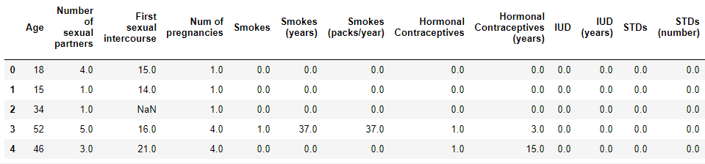

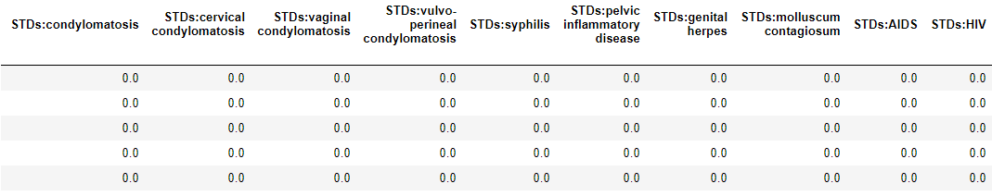

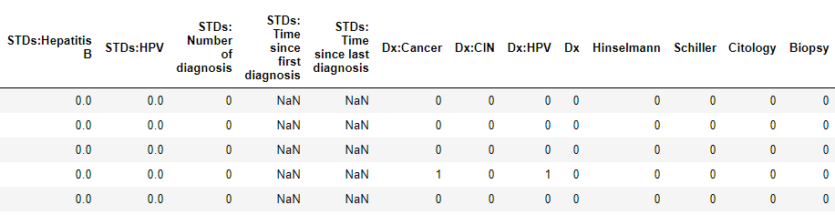

1. **Missing Values:**

26 out of 36 features have missing values in the data set. Missing values of each feature and the respective percentages are written below:

**Missing Values % of Total Values**

STDs: Time since last diagnosis 787 91.7

STDs: Time since first diagnosis 787 91.7

IUD 117 13.6

IUD (years) 117 13.6

Hormonal Contraceptives 108 12.6

Hormonal Contraceptives (years) 108 12.6

STDs:vulvo-perineal condylomatosis 105 12.2

STDs:HPV 105 12.2

STDs:Hepatitis B 105 12.2

STDs:HIV 105 12.2

STDs:AIDS 105 12.2

STDs:molluscum contagiosum 105 12.2

STDs:genital herpes 105 12.2

STDs:pelvic inflammatory disease 105 12.2

STDs:syphilis 105 12.2

STDs:cervical condylomatosis 105 12.2

STDs:vaginal condylomatosis 105 12.2

STDs:condylomatosis 105 12.2

STDs (number) 105 12.2

STDs 105 12.2

Num of pregnancies 56 6.5

Number of sexual partners 26 3.0

Smokes (packs/year) 13 1.5

Smokes (years) 13 1.5

Smokes 13 1.5

First sexual intercourse 7 0.8

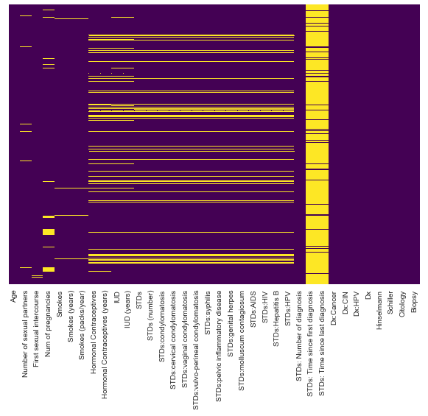

Since ‘STDs: Time since last diagnosis’ and ‘STDs: Time since first diagnosis’ features have more than %91 percent missing values, they were dropped off.



For the rest numeric features which had missing values were applied mean statistical method.

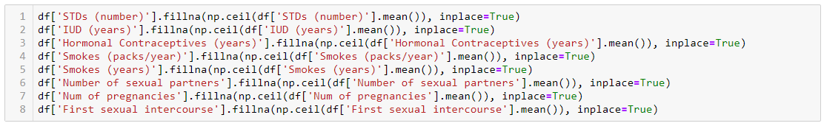

But categorical features which had missing values were applied pd.get_dummies() function to create dummy variables for all categorical values including the missing value (‘NaN’).

Before doing that, we converted the string type of values to categorical ones and then applied the function.

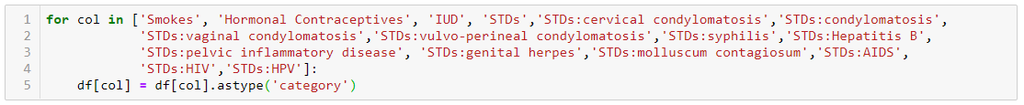

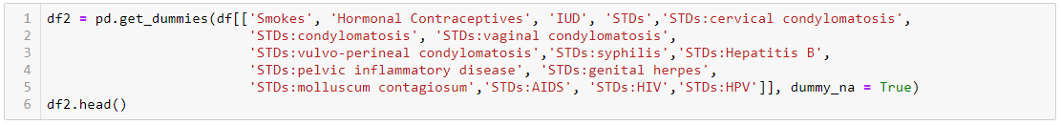

After concatenating the new data set consisted of dummy features to the main data set, we dropped the features from which we produced the dummy ones from the main data set.



The cleaned data set had 64 features and 848 data points and all the features consisted of numeric values.

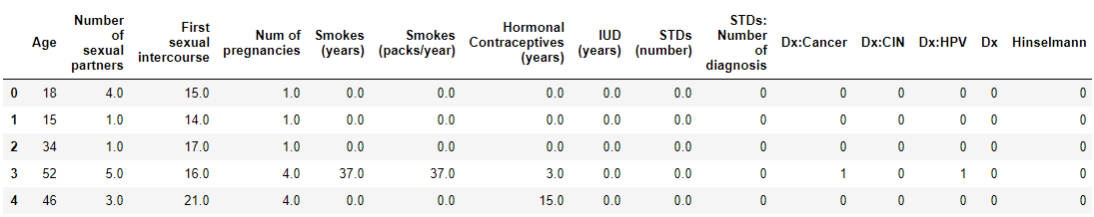

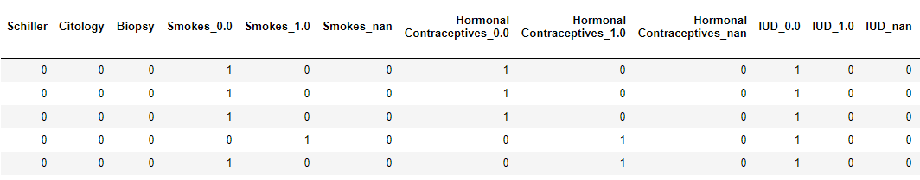

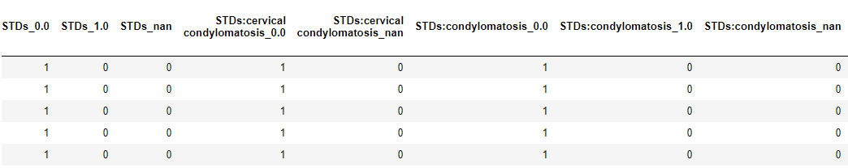

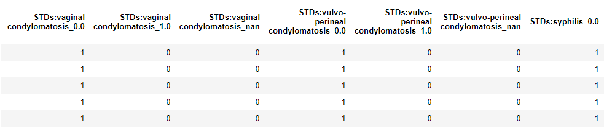

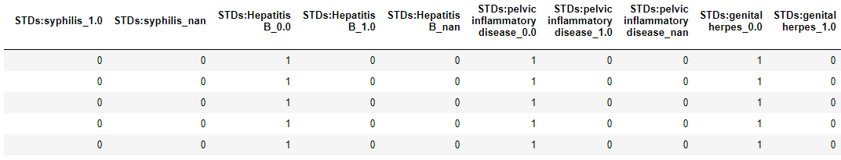

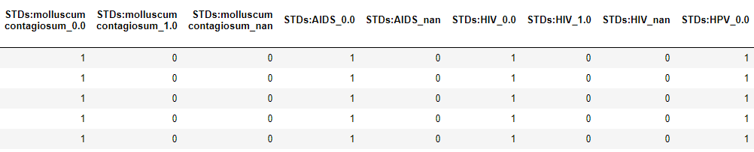

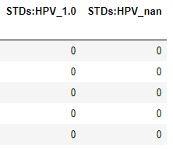

**3. EXPLORATORY DATA ANALYSIS (EDA)-DATA VISUALIZATION**

**a. Age, Number of Sexual Partners, First Sexual Intercourse vs. Cancer Graph:**

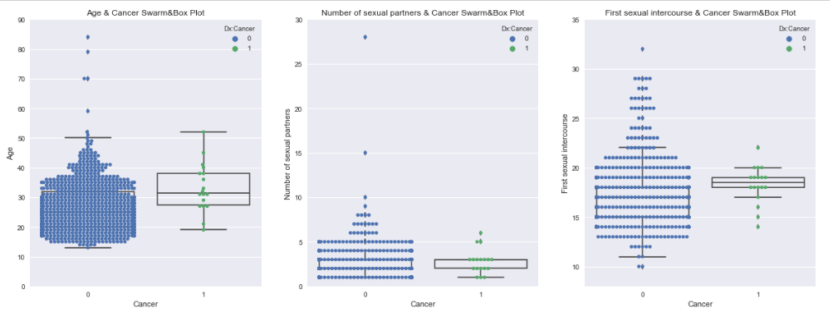

This graphic shows that;

1. Cancer diagnosed patient's age are cumulated between 27 to 42. Cancer patient's median age is higher than non-cancers.
2. Cancer diagnosed patient's number of sexual partners are cumulated between 1 to 5. Most of the patients have had either 5 or less partners.
3. Cancer diagnosed patient's first sexual intercourses are cumulated between 17 to 20. There is outlier even at 10. Cancer patient's median first sexual intercourse age is higher than non-cancer ones.

**b. Number of Pregnancies, Smokes (Year), Hormonal Contraceptives vs. Cancer Graph:**

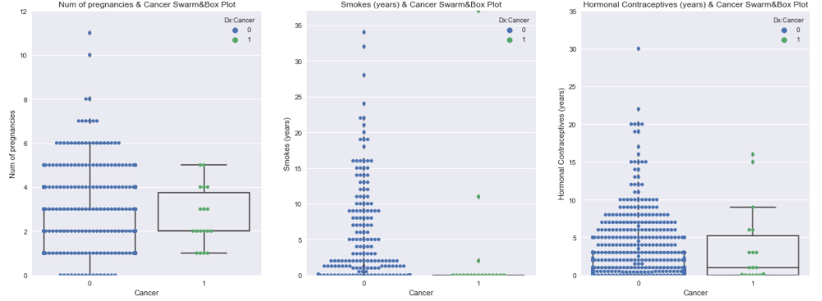

This graphic shows that;

1. Cancer patient's median number of pregnancies is higher than non-cancer.
2. Most of non-cancer patients smoke more than 3 years. Most of the cancer patients do not smoke.
3. Most of the non-cancer patients use hormonal contraceptives. More than %50 of the cancer patients also use hormonal contraceptives.

**c. Distribution of Age, Number of Sexual Partners and First Sexual Intercourse Graph:**

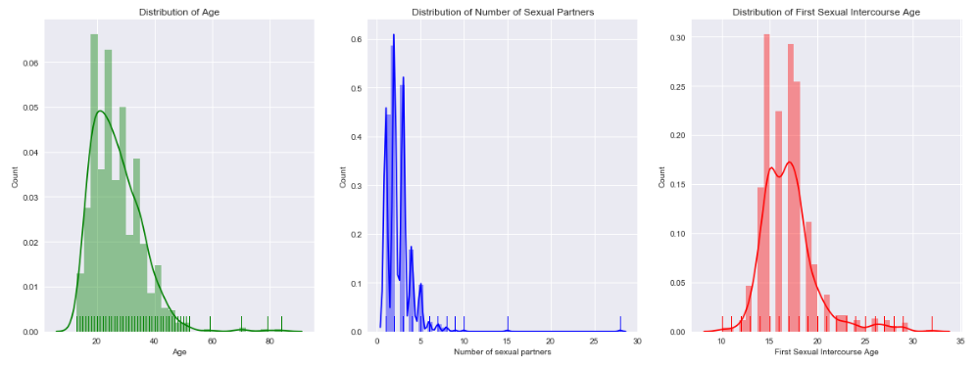

**The graphic shows that all three features look like normally distributed but skewed to right.  There are some outliers in all three features.**

**d. Correlation Between First Sexual Intercourse and Number of Sexual Partners Graph:**

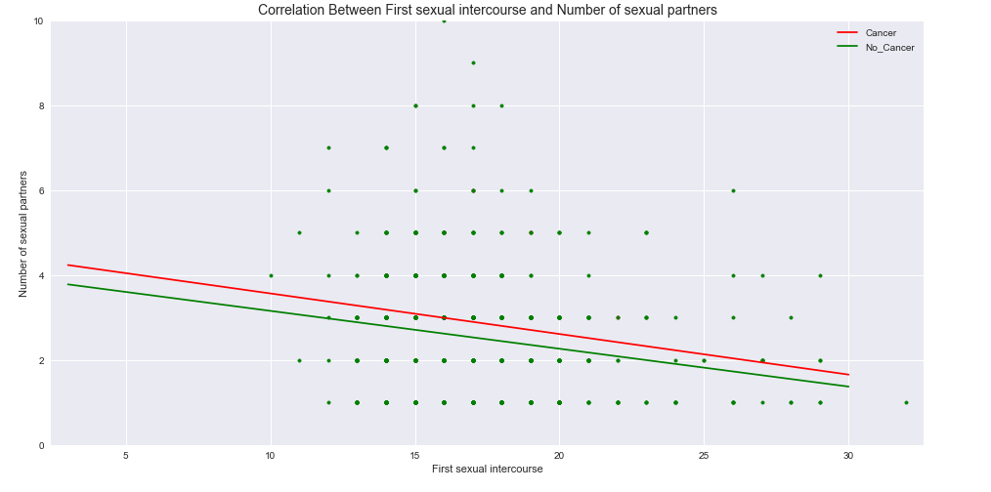

The graph shows that There is negative regression between First sexual intercourse and Number of sexual partners for both Cancer and Non-cancer diagnosed patients.

**e. Correlation Between Non-Categorical Features Graph:**

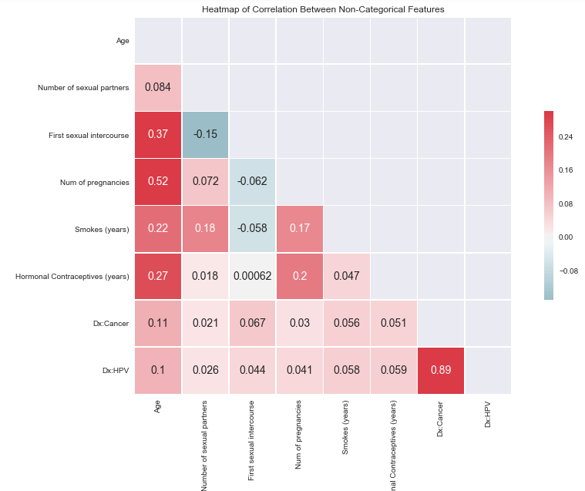

The graph shows that there is strong correlation between Cervical Cancer and Human papillomavirus infection (HPV) and the other correlations are stated below;

Age 0.1

First sexual intercourse 0.044

Number of Pregnancy 0.041

Smokes (year) 0.058

Hormonal Contras 0.059

**f. Patients’ Age Distribution Graph:**

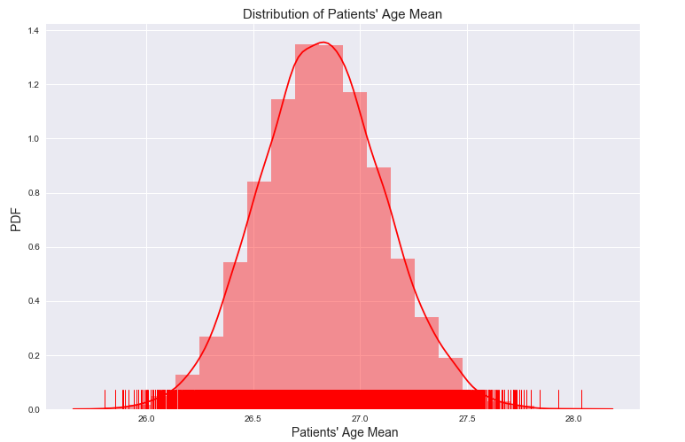This graph shows that patients’ age are normally distributed and average age of the patients is around 26-27 years old.

**4. MACHINE LEARNING MODELS**

This is a supervised binary classification problem. We are trying to predict whether a patient is cancer or not. We used Python Scikit Learn libraries to solve our problem. But since our data set is extremely imbalanced, we applied Synthetic Minority Oversampling Technique (SMOTE) to create more data points synthetically.

**a.** In the first stage, we split our data into training (%75) and test (%25) set then we used Logistic Regression with 5-Fold Cross Validation. To overcome the overfitting problem we used Logistic Regression with Grid Search L1 (Lasso) Hyper Parameter Tuning, Logistic Regression with Grid Search L2 (Ridge) Hyper Parameter Tuning, and finally Random Forest Classifier algorithms.

We applied SMOTE to the training data set and then used Logistic Regression and Random Forest Classifier algorithms to get best prediction.

1. In the second stage, we tweak the proportion of our training and test sets as (0.6/0.4) and applied almost the same methods and algorithms. As an evaluation metric we used Classification reports and Confusion Matrices.

### **c. Train/Test Set Size Proportion is 0.75/0.25**

### **1) Logistic Regression with 5-Fold Cross-Validation:**

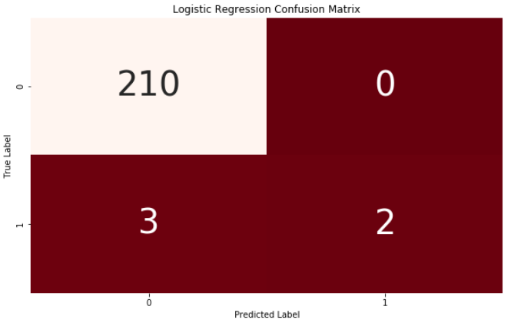

Despite Logistic Regression works well with the Non-Cancer patients, it misclassified 3 Cancer patients as Non-Cancer out of 5 patients with %40 prediction accuracy.

### **2) Logistic Regression with Grid Search CV (Lasso) Hyper Parameter Tuning:**

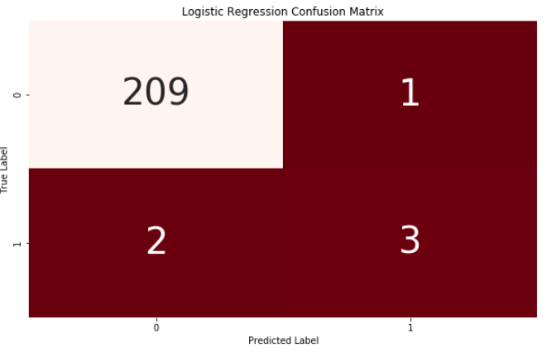

With the Lasso hyper parameter tuning our model worsen on Nan-Cancer patients and misclassified 1 patient but it predicted accurately one patient more than default Logistic Regression algorithm.

**3) Logistic Regression with Grid Search CV (Ridge) Hyper Parameter Tuning:**

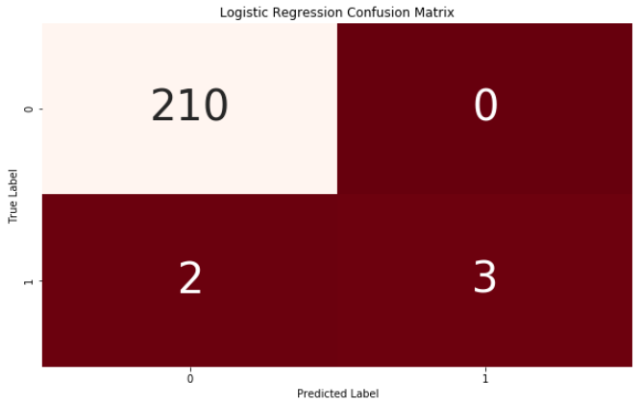

With the Ridge hyper parameter tuning our model outperformed Lasso and Nan-Cancer patients were predicted with %100 accuracy and but there was no changing on the recall, Cancer patients.

**4) Random Forest Classifier:**

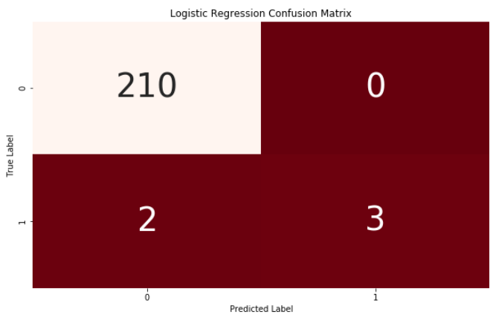

Random Forest Classifier was better than default Logistic Regression but there was no marginal changing comparatively with Lasso and Ridge.

**5) Logistic Regression after SMOTE:**

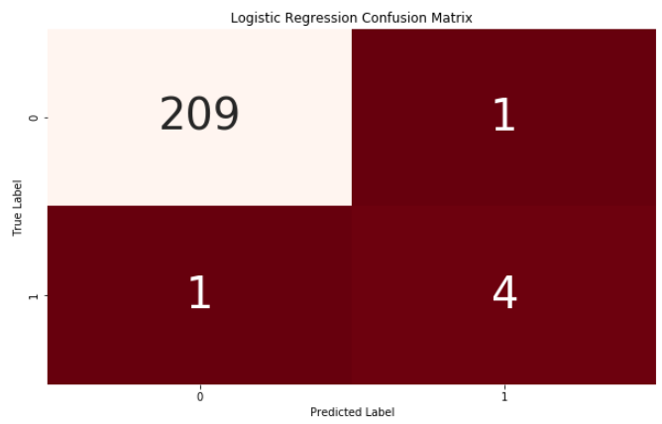

After SMOTE application, our default Logistic Regression model got better prediction than the previous models on Cancer patients but missed one non-cancer patients. The accuracy of prediction of Cancer patients increased up to %80.

**6) Random Forest Classifier after SMOTE:**

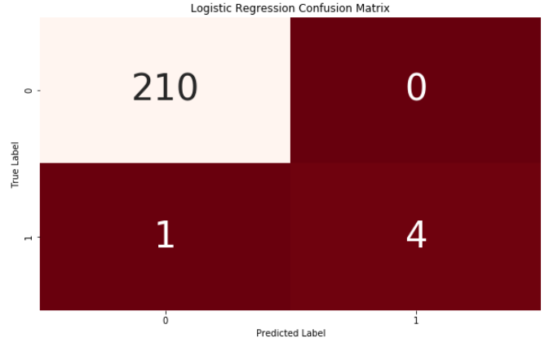

We got the best prediction results with Random Forest Classifier after SMOTE application. Our model predicted non-cancer patients with %100 accuracy and for the Cancer patients with %80 accuracy.

### **d. Train/Test Set Size Proportion is 0.60/0.40**

### **1) Logistic Regression with 5-Fold Cross-Validation:**

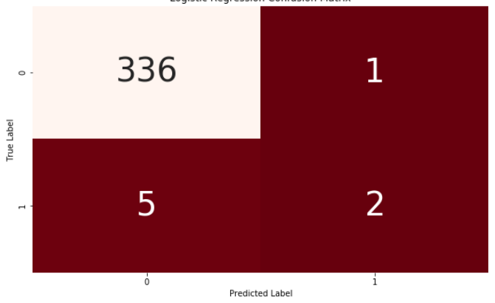

Despite Logistic Regression works well with the Non-Cancer patients, it misclassified 5 Cancer patients as Non-Cancer out of 7 patients with %29 prediction accuracy.

### **2) Logistic Regression with Grid Search CV (Lasso) Hyper Parameter Tuning:**

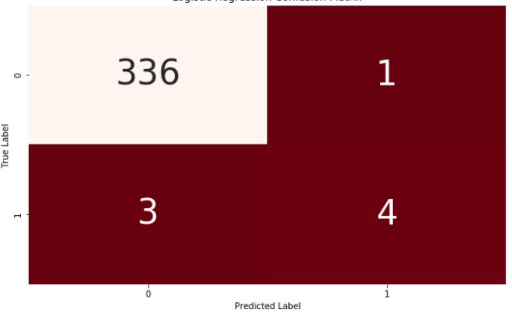

With the Lasso hyper parameter tuning, our model made better prediction and recall increased almost double from %20 to %57 and our model predicted 4 Cancer patients accurately out of 7 patients.

**3) Logistic Regression with Grid Search CV (Ridge) Hyper Parameter Tuning:**

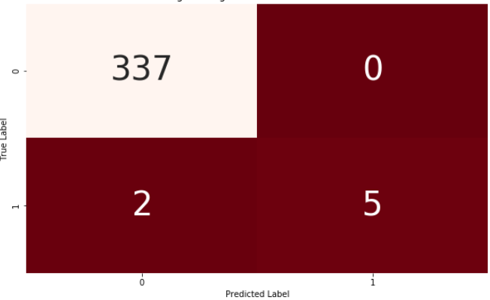

With the Ridge hyper parameter tuning our model outperformed Lasso and Nan-Cancer patients were predicted with %100 accuracy and Cancer patients prediction increased from 4 to 5 patients.

**4) Random Forest Classifier:**

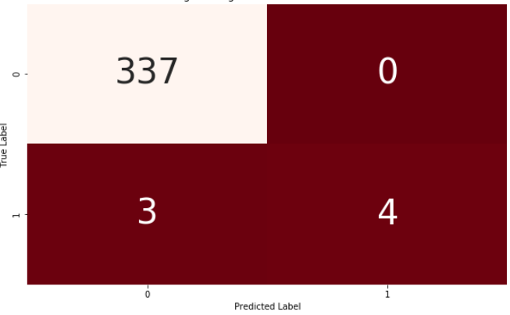

Random Forest Classifier worsen than Lasso and Ridge on Cancer patient but there was no changing on the non-cancer patients.

**5) Logistic Regression after SMOTE:**

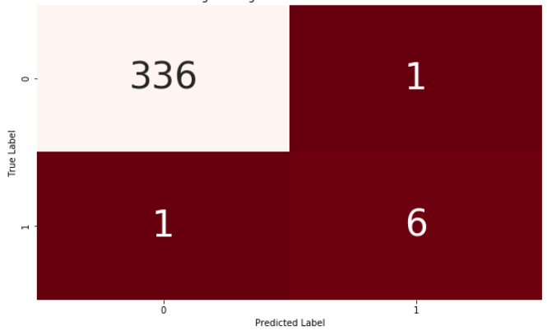

After SMOTE application, our default Logistic Regression model got better prediction than the previous models on Cancer patients but missed one Cancer patient and non-cancer patient. The accuracy of prediction of Cancer patients increased up to %86.

**6) Random Forest Classifier after SMOTE:**

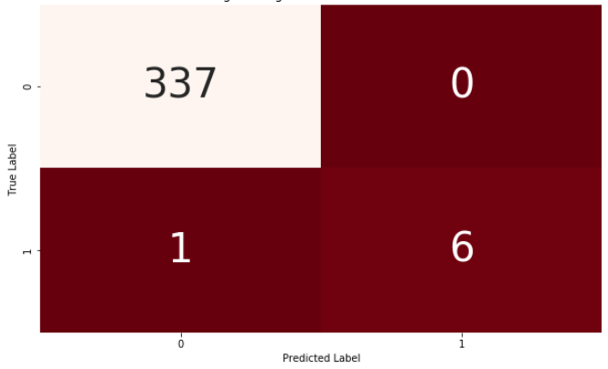

We got the best prediction results with Random Forest Classifier after SMOTE application. Our model predicted non-cancer patients with %100 accuracy and for the Cancer patients with %86 accuracy.

**e. Model Comparison:**

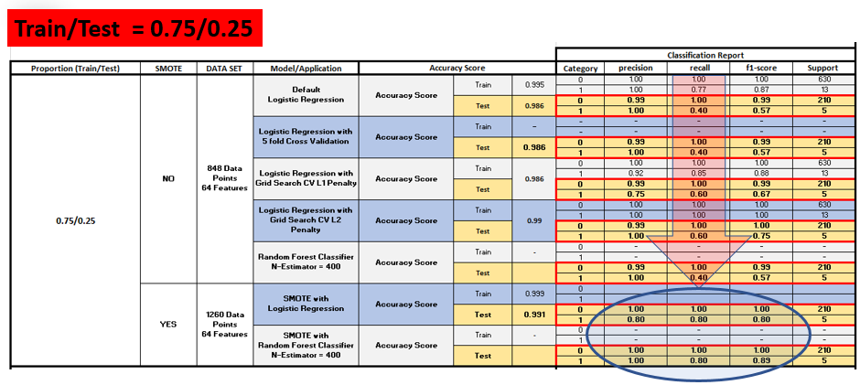

Random Forest Classifier is the best algorithm after SMOTE and Logistic Regression is the worst one for our problem.

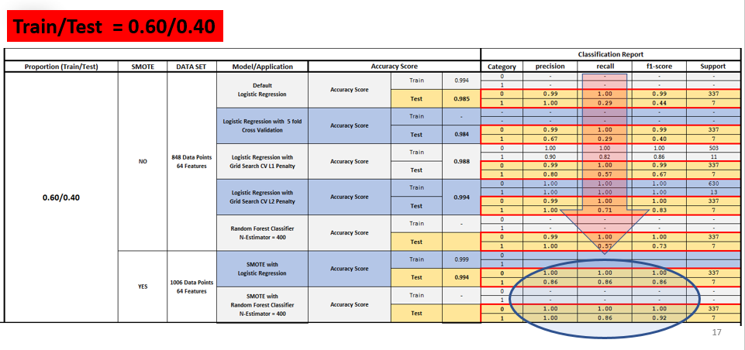

Again, Random Forest Classifier is the best algorithm after SMOTE and Logistic Regression is the worst one for our problem.

**5. CONCLUSION:**

In our study we have used all necessary features (all the one left after the dropped ones) in our model. In our model, Random Forest Classifier showed the best performance after SMOTE in both proportions. Despite studying with the imbalanced data is very hard, we could manage to catch up %86 accuracy with 18 positive samples total. Hyper parameter tuning also showed us that using proper parameters also increases the accuracy of the algorithm.

**6. FUTURE STUDY:**

In this study we focused on proportion selection of train and test set, hyper parameter tuning and SMOTE. As a future study we will concentrate the other algorithms such as Ada Boost Classifier and Gradient Boost Classifier to see their performance with the imbalanced data set.