Agriculture Techniques
In this modern age, agriculture is rapidly developing, and the integration of robotics and automation technologies is revolutionizing traditional farming practices; offering a more innovative, efficient, optimizing productivity. Hence, this utilization, in an indoor environment setting would present a promising opportunity to enhance agriculture in controlled indoor environments. This exploration aims to shed light on the potential farming techniques that would integrate with TurtleBot to optimize results.

Hydroponics:
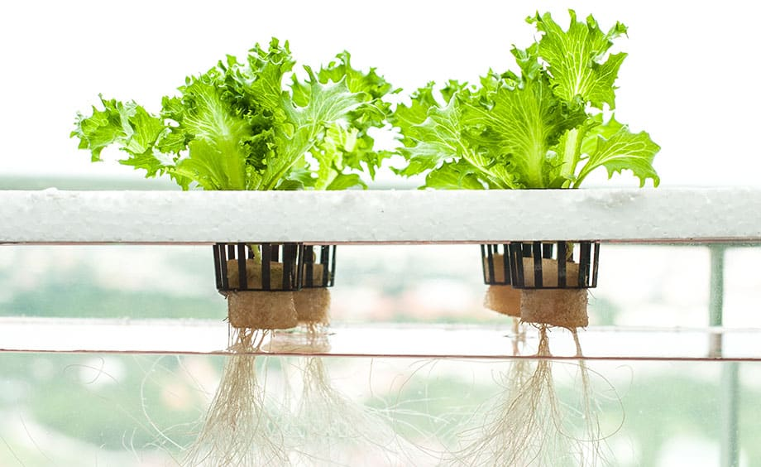
Hydroponics represents a modern approach for growing plants without soil, as rich nutrients and water solutions already deliver the essential requirements directly into the plant’s roots. By circumventing the soil, hydroponic systems show much greater plant growth rates than most normal agriculture procedures. The reason is that the meticulous management of pH levels, nutrient concentrations within the water and environmental parameters all play a crucial part in ensuring a plant’s health and growth.

To link it to TurtleBot, TurtleBot could be equipped with arrays of sensors, as the TurtleBot could help ensure to monitor the pH levels and nutrient intake of the plant with real-time insights into the hydroponic environment; with all that embedded in Turtlebot, the bot can autonomously manage nutrient solution delivery, adjusting the levels necessary for an optimal plant’s growth.

Aeroponics:
Aeroponics is another modern approach which epitomizes innovation in farming and plant control. In this method, the plant’s roots hang suspended in the air in a vertical form where it is bathed in nutrient-rich mist which facilitates efficient nutrient uptake and accelerates growth rates. This method is overall very efficient as it proved to provide control plant growth and less waste consumption than most soil methods. On the other hand, this method is very complex and expensive to build making this method highly unrealistic to even link to a robotic approach in a short period of time.
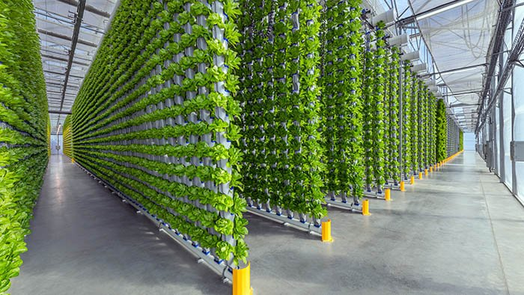
Basic Soil Farming:
The basic soil farming technique is a more traditional method of farming which can still benefit from the integration of robotics such as Turtlebot. TurtleBot will be equipped with a precession planting mechanism to navigate through the fields to the designated planting locations. This can be done by sensors that can obstacles avoid, or by manually controlling TurtleBot.

By utilizing the 3D design DC motor generated system that will be designed specifically for the TurtleBot, the robotic system can deposit seed into the prepared furrows or holes to ensure optimal placement. By leveraging sensors and computer vision methods, the TurtleBot can accurately measure and adjust soil conditions and evaluate back the state of the environment. This will be very complex to complete as it will require many sources and data analysis to perform.

Overall, the convergence of robotics and agriculture is the main concept of my capstone project as this field holds an immense promise for the future of farming. After researching the numerous different ways, I have decided to go with the traditional method of farming and connect it to TurtleBot.
This will allow me to demonstrate the practical application of robotics in optimizing and modernizing farming practices, which will showcase how the integration of technology can enhance efficiency, productivity and sustainability in the field of agriculture. Focusing on the intersection of this field will benefit me in my capstone project to aim to bridge the gap between innovation and traditional practices. In addition, paves the way for future advancement and provides me with a clear start in the field of robotic systems for my future.

References
Eden Green. (29AD). Hydroponics vs aeroponics: Key differences explained. Eden Green. https://www.edengreen.com/blog-collection/aeroponics-vs-hydroponics-explained
Hydroponics. / RHS Gardening. (n.d.). https://www.rhs.org.uk/vegetables/hydroponics
Loh, N. (n.d.). What is hydroponics and why is it a good idea?. marlo hydroponic skincare. https://www.marlohydroponics.com/what-is-hydroponics-and-why-is-it-a-good-idea-2/
Niu, G., & Masabni, J. (2022). Aeroponics. Aeroponics - an overview | ScienceDirect Topics. https://www.sciencedirect.com/topics/agricultural-and-biological-sciences/aeroponics#:~:text=Aeroponics%20is%20the%20practice%20of,or%20aerosol%20of%20nutrient%20solution.

