Arduino Research
Arduino is an open-source platform that is used to produce electronic projects that consist of both hardware and software components. The Arduino board is the physical board that contains the microcontroller chips and the input/output pins. The input is used to read data while the output’s role is to send signals. Those pins allow the user to connect sensors, actuators and other useful electronic components to the Arduino board itself. This can either be digital or analogue.

There are various types of Arduino boards that the individual should be aware of based on the project that is being worked on. The most common board is the “Arduino Uno” The power source of those Arduino boards can be powered through a USB connection from a computer, or an electronic device or even operating an external power supply such as a battery for instance.

Moving on to the software side, Arduino uses an IDE that communicates directly to the board itself. Arduino IDE is the software that is employed to program, compile, and upload code to the Arduino board.
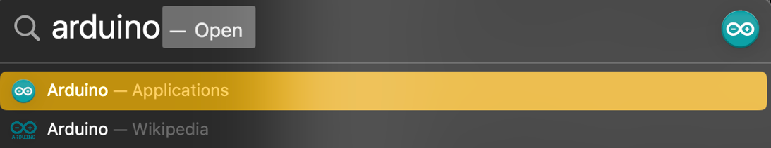
Arduino IDE also comes with a set of unique built-in libraries that provide pre-written code which would be extremely useful for common tasks, such as controlling LEDs, signal processing, as well as embedded systems.
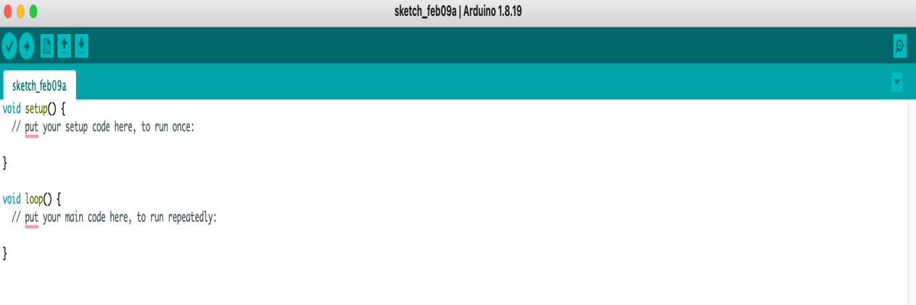

In addition, Arduino programs are called Sketches. A Sketch usually consists of two main functions, those being ‘setup()’ and ‘loop()’,
- ‘setup()’ function: This function is called once when the Arduino board launches, its role is to initialize variables, set pin modes and perform setup tasks that would help predetermine and read the code for others to grasp a brief understanding of the code.
- ‘loop()’ function: This function will continuously run after the ‘setup()’ function is completed. This is where the programmer will put the main logic of the program such as reading sensor data, signal processing and other decision-making tasks that are relevant to the project.

To get started
- Install Arduino IDE.
- Connect the Arduino board to the computer using its built-in USB cable.
- Write the sketch relevant to the project in the Arduino IDE.
- Debug and run.
- Observe the behaviour of the code and finalize any necessary changes.

References
Arduino sketch: Structure and flow. STEMpedia Education. (n.d.). https://ai.thestempedia.com/docs/evive/evive-arduino-ide-tutorials/arduino-sketch-structure-and-flow/
Arduino sketches. docs.arduino.cc. (n.d.). https://docs.arduino.cc/learn/programming/sketches/

